MYCODEAGENT
Solution Approach and Implementation Plan
Product: MyCodeAgent
External meta-harness: Omnigent
Initial sub-agent brain: Codex
Provider routing: Omnigent/LiteLLM configuration; no provider adapters in MyCodeAgent
Workflow limit: Maximum five implementation–test–review cycles
Delivery: Approval-gated pull-request creation; no automatic merge
Implementation decision
Build deterministic orchestration services in MyCodeAgent, execute the supervisor and Codex sub-agents through Omnigent, and keep model-provider routing outside application code. The first release reads TODO.md; GitHub Issue ingestion follows through the same TaskSource contract.

1. Scope
The implementation will transform the current fixed four-stage prompt into a controlled agentic workflow. MyCodeAgent will parse and validate tasks, create isolated worktrees, invoke role-scoped Codex agents through Omnigent, execute deterministic tests and policy gates, route review findings back to implementation, and create a pull request only after final approval.

1.1 In scope
- Complete TODO.md task-section parsing and normalized TaskSpec generation.
- Intent classification for feature, bug fix, refactor, test, review, documentation, and investigation tasks.
- MyCodeAgent main orchestrator with a hard maximum of five implementation–test–review cycles.
- Omnigent execution of Explorer, Implementer, Test Writer, and Reviewer roles using Codex initially; the Implementer owns both initial coding and remediation.
- Git branch/worktree isolation, workspace-boundary enforcement, deterministic pytest execution, review fingerprinting, logs, traces, state, and artifacts.
- Structured Reviewer → Implementer remediation handoff and approval-gated PR creation.
- Model aliases so Omnigent/LiteLLM can later route to Anthropic or Gemini through configuration.

1.2 Deferred
- Automatic pull-request merge.
- Unbounded autonomous retries.
- Provider-specific SDK adapters inside MyCodeAgent.
- Parallel writes by multiple agents to the same worktree.
- Production GitHub Issue polling; the interface is created now, with live ingestion delivered in a later increment.

2. Runtime Architecture
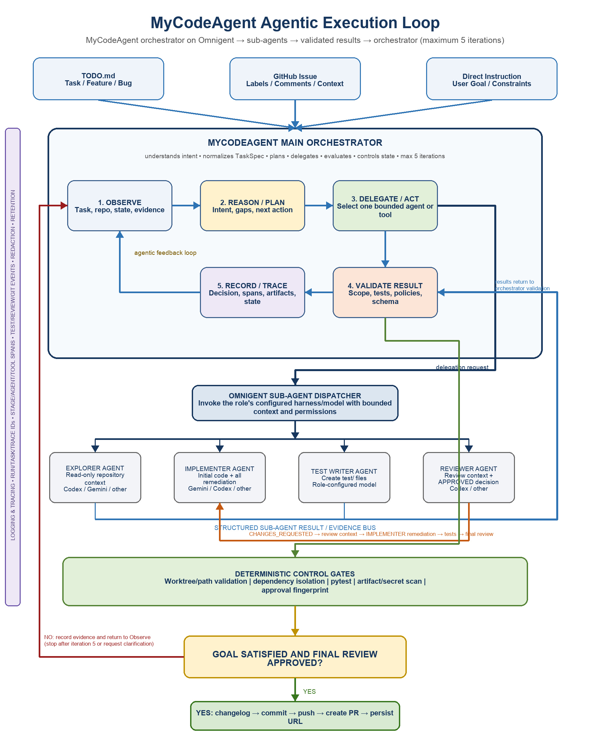
Figure 1. MyCodeAgent orchestration running on Omnigent with bounded sub-agent delegation and deterministic gates.
Component | Implementation responsibility
MyCodeAgent CLI | Accept commands, select task source, display status, and return stable exit codes.
MyCodeAgent orchestrator | Own the five-cycle state machine, action selection contract, handoffs, evidence, and terminal decisions.
Omnigent | Execute the orchestrator and role-scoped sub-agent sessions with configured harness, model, sandbox, and policies.
Codex agents | Perform repository exploration, initial implementation, implementation remediation, test authoring, and semantic review.
LiteLLM/gateway | Resolve configured model aliases and provider credentials outside MyCodeAgent.
Deterministic services | Manage worktrees, validate paths, run tests/scans, fingerprint changes, persist state, and publish PRs.

3. Proposed Repository Structure
src/mycodeagent/
├── __main__.py
├── cli.py
├── orchestrator.py
├── models.py
├── errors.py
├── config.py
├── agent_executor.py
├── state_store.py
├── test_runner.py
├── validator.py
├── workspace.py
├── delivery.py
├── sources/
│ ├── base.py
│ ├── todo.py
│ ├── github.py
│ └── direct.py
└── observability/
├── logger.py
├── tracer.py
└── artifacts.py
agents/
├── supervisor.yaml
├── explorer.yaml
├── implementer.yaml
├── test_writer.yaml
└── reviewer.yaml
tests/
├── unit/
├── integration/
└── fixtures/

4. Python Module Responsibilities
Module | Primary responsibility | Must not do
__main__.py | Delegate to cli.main(). | Contain workflow logic.
cli.py | Commands: submit, status, resume, test, review, deliver. | Edit source or choose providers.
models.py | Provider-neutral task, action, agent-result, review, test, trace, and state schemas. | Perform I/O.
config.py | Load runtime, role/model aliases, policy, timeout, and five-cycle settings. | Store credentials.
sources/todo.py | Parse the full Markdown task section into TaskSpec. | Invoke agents.
sources/github.py | Normalize GitHub Issue data through TaskSource. | Contain orchestration rules.
workspace.py | Validate repository and create/retain/remove task worktrees safely. | Interpret task intent.
agent_executor.py | Render role prompts and invoke Omnigent with bounded context. | Implement provider SDK adapters.
orchestrator.py | Own cycle count, stage transitions, handoffs, validation ordering, and terminal decisions. | Trust unvalidated agent claims.
validator.py | Enforce allowed paths, required files, artifacts, symlinks, secrets, and fingerprints. | Modify implementation.
test_runner.py | Create isolated environment, run approved commands, parse authoritative results. | Ask an LLM whether tests passed.
state_store.py | Atomic status, cycle counter, fingerprints, run metadata, and resume support. | Change state without validation.
observability/* | Structured logs, spans, redaction, metrics, and artifact references. | Persist secrets or raw credentials.
delivery.py | Validate approval, update changelog, commit, push, create PR, persist URL. | Merge the PR.

5. Core Data Contracts

5.1 TaskSpec
TaskSpec
task_id: str
source: todo | github | direct
intent: feature | bug_fix | refactor | test | review | docs | investigation
title: str
outcome: str
repository: RepositorySpec
workspace: WorkspaceBoundary
architecture_requirements: list[str]
required_files: list[str]
dependencies: list[str]
acceptance_criteria: list[str]
delivery_requested: bool

5.2 Agent handoffs
Contract | Key fields | Produced by / consumed by
RepositoryContext | Relevant files, conventions, dependencies, risks, test commands | Explorer → orchestrator/other agents
ImplementationResult | Changed files, acceptance evidence, blockers, fingerprint | Implementer → validators/tests/reviewer
TestResult | Command, exit code, counts, logs, fingerprint | Test runner → orchestrator/reviewer
ReviewResult | APPROVED or CHANGES_REQUESTED, findings, reviewed fingerprint | Reviewer → orchestrator
ImplementationRemediationRequest | Findings, failures, current fingerprint, permitted paths, cycle | Orchestrator → Implementer
DeliveryResult | Commit, branch, remote, PR URL, final fingerprint | Delivery service → state/artifacts

6. Five-Cycle Orchestration Algorithm
Cycle definition
Cycle 1 is the initial implementation–test–review attempt. Cycles 2–5 are remediation–retest–rereview attempts. Individual agent/tool calls have attempt IDs but do not each consume a workflow cycle.

for cycle in range(1, 6):
state.start_cycle(cycle)
context = observe(task, workspace, prior_evidence)
if repository_context_missing(context):
context.add(invoke(EXPLORER, context))
if cycle == 1:
invoke(IMPLEMENTER, context)
invoke(TEST_WRITER, context)
else:
invoke(IMPLEMENTER, implementation_remediation_request(context))
validate_workspace_and_required_files()
test_result = run_tests_deterministically()
if not test_result.passed:
record_failure_and_continue()
continue
fingerprint = fingerprint_current_change()
review = invoke(REVIEWER, task, diff, test_result, fingerprint)
if review.approved_for(fingerprint):
deliver_if_authorized()
return success
persist_findings(review)
return needs_input_or_failed # never start cycle 6

7. Omnigent Agent Execution
Each role has an Omnigent YAML definition containing its role prompt, harness/model alias, tools, sandbox, and output contract. MyCodeAgent passes a serialized request and receives a schema-validated result. Codex is configured initially for every role.
# Illustrative role configuration
name: mycodeagent-implementer
executor:
harness: codex
model: coding-default
os_env:
cwd: ${TASK_WORKTREE}
sandbox:
write_paths:
- ${CODING_DIR}
prompt: |
Implement the supplied TaskSpec.
Write only inside the permitted Coding directory.
Return an ImplementationResult matching the supplied schema.

7.1 Model-provider plug-and-play
MyCodeAgent stores stable aliases such as coding-default and review-default. Omnigent/LiteLLM resolves those aliases to the configured provider. Moving implementation from an OpenAI model to Gemini or review to Anthropic must not change Python orchestration code, prompts, permissions, or result schemas.
MyCodeAgent role | Stable alias | Initial route | Future configuration-only route
Explorer | coding-default | Codex/OpenAI | Anthropic or Gemini
Implementer | coding-default | Codex/OpenAI | Gemini
Test Writer | coding-default | Codex/OpenAI | Anthropic or Gemini
Reviewer | review-default | Codex/OpenAI | Anthropic

8. Worktree and Workspace Isolation
- Resolve and validate repository, approved remote, default branch, and starting commit before writes.
- Create one branch and worktree per task; run all agents and deterministic tools inside that worktree.
- Resolve every allowed path and reject traversal, escaping symlinks, and writes outside the task workspace.
- Implementation may write only Coding/; Test Writer only test/; Reviewer and Explorer remain read-only.
- After every write-capable invocation inspect tracked, modified, staged, and untracked files—not only git diff.
- Retain failed worktrees and evidence; cleanup only through an explicit validated command.

9. Deterministic Validation and Testing
Gate | Evidence | Failure behavior
Task validation | Complete TaskSpec and safe workspace paths | Stop before worktree creation
Scope validation | Complete changed-file inventory | Reject and route finding for remediation
Required files | Every task-declared file exists | Do not review
Artifact scan | No pycache, bytecode, caches, logs, or unexpected binaries | Remove/remediate and rerun
Secret scan | No credential-pattern findings | Fail safely; redact logs
Unit tests | Actual command, exit code, pass/fail counts, stdout/stderr | Route TestFailureContext to Implementer
Review fingerprint | Approval fingerprint equals current change fingerprint | Invalidate approval and rereview
Delivery policy | Approved repo, identity, branch, fingerprint, and authorization | Do not push or create PR

10. Logging, Tracing, and State
- Generate run_id, task_id, trace_id, cycle, stage, agent_invocation_id, workspace_id, branch, base commit, and fingerprint correlations.
- Create nested spans for task ingestion, preflight, worktree, each cycle, every agent invocation, validation, tests, review, Implementer remediation, and delivery.
- Write sanitized JSON events and store large outputs as referenced artifacts.
- Persist STATUS.json atomically after every valid transition and support status/resume commands.
- Redact credentials, authorization headers, configured secrets, and sensitive values before persistence.
- Record selected model alias and resolved runtime metadata exposed by Omnigent without embedding provider credentials.
.mycodeagent/
├── tasks/<task-id>/latest.json
└── runs/<run-id>/
├── status.json
├── events.jsonl
├── trace.json
└── artifacts/
├── task-spec.json
├── diff.patch
├── test-result.json
├── review-result.json
└── delivery-result.json

11. Delivery Flow
- Confirm the final ReviewResult is APPROVED for the current fingerprint.
- Re-run final scope, artifact, secret, test, Git identity, and remote checks.
- Update CHANGELOG.md using deterministic code when delivery policy permits it.
- Stage only approved paths and show the staged inventory.
- Commit with the task ID, push the task branch, and create or update the pull request.
- Persist commit SHA, branch, base, remote, PR number/URL, timestamp, and fingerprint.
- Transition to delivered. Do not merge automatically.

12. Implementation Phases
Phase | Deliverable | Exit criteria
1. Foundation | Models, config, full TODO parser, errors, unit-test fixtures | Malformed/valid task cases pass
2. Controls | State store, structured logs/traces, validators, test runner | Deterministic components pass unit tests
3. Workspace | Repository policy and safe worktree manager | Dirty main checkout remains untouched
4. Agents | Omnigent executor and Codex role YAML definitions | Fake executor and one controlled Codex run validate contracts
5. Loop | Five-cycle orchestrator and Reviewer-to-Implementer remediation routing | No sixth cycle; approved fingerprint terminates
6. Delivery | Changelog, commit, push, PR services with dry-run mode | Delivery refuses unapproved or mismatched changes
7. Hardening | Integration tests, resume, failure injection, docs, migration | End-to-end fixture task produces reviewable PR in test repo

13. Test Strategy

13.1 Unit tests
- TODO parsing: multiple tasks, multiline sections, missing fields, duplicate IDs, unsafe paths, priority and state selection.
- Configuration: defaults, role aliases, invalid cycle count, missing model alias, and no provider-specific code paths.
- State machine: valid/invalid transitions, atomic persistence, cycle 1–5, and refusal of cycle 6.
- Validators: tracked/untracked inventory, required files, path escapes, symlinks, generated artifacts, secret patterns, and fingerprints.
- Test runner: timeout, missing pytest, pass/fail parsing, stdout/stderr capture, and isolated environment.
- Agent executor: prompt rendering, permissions, timeout, invalid schema, nonzero Omnigent exit, and sanitized artifacts.
- Delivery: remote mismatch, identity mismatch, stale approval, empty change, push failure, duplicate PR, and dry-run behavior.

13.2 Integration scenarios
- Feature task approved on cycle 1 and delivered.
- Review fails on cycle 1, Implementer remediates, tests pass, review approves on cycle 2, then PR is created.
- Tests fail repeatedly and the workflow stops after cycle 5 without creating a PR.
- Reviewer approves, a file changes afterward, fingerprint mismatch invalidates approval and triggers rereview.
- Existing dirty main checkout remains unchanged because all work occurs in the task worktree.
- Model alias changes in Omnigent/LiteLLM configuration while MyCodeAgent contracts remain unchanged.

14. Migration from Current Implementation
- Preserve the existing mycodeagent console entry point while reducing __main__.py to a thin wrapper.
- Move heading parsing out of __main__.py and replace it with the complete TaskSource parser.
- Replace the fixed stage_map; verify must call the deterministic TestRunner rather than implement_task.
- Replace textual $TASK_ID/$TASK_DIR handoffs with structured RunContext fields.
- Split coding_agent.yaml into supervisor and role definitions while keeping Codex as the initial harness.
- Make git_approval.toml an enforced policy and reconcile it with the actual MyCodeAgent remote before delivery.
- Add project ignore rules for runtime state, worktrees, virtual environments, caches, bytecode, and OS artifacts.
- Keep existing task workspaces and unrelated dirty changes untouched during migration.

15. Implementation Acceptance Criteria
- MyCodeAgent, Omnigent, Codex, and LiteLLM responsibilities are unambiguous in code and documentation.
- The first ready TODO.md task is completely parsed into a validated TaskSpec.
- All changes occur in a validated task worktree and permitted paths.
- Codex agents communicate through structured orchestrator handoffs and evidence artifacts.
- Review failure returns to implementation, followed by deterministic tests and review again.
- The workflow never starts a sixth implementation–test–review cycle.
- APPROVED is accepted only for the exact current fingerprint.
- PR creation occurs only after deterministic final gates and never performs merge.
- Logs, traces, state, test evidence, review findings, commits, and PR metadata are correlated and sanitized.
- Changing an Omnigent/LiteLLM model alias does not require a MyCodeAgent code change.
- The MyCodeAgent unit and integration test suites pass.

16. First Coding Increment
Recommended starting slice
Implement models.py, config.py, sources/base.py, sources/todo.py, state_store.py, observability/logger.py, and their unit tests first. This creates the stable task, configuration, state, and evidence contracts needed before worktree or live-agent execution is introduced.

The first increment should not push branches, create pull requests, or invoke a live provider. It should end with a validated TaskSpec for TASK-107, a persisted run state, correlated local events, and passing tests. Subsequent increments add worktrees, fake agent execution, live Codex execution, the five-cycle loop, and delivery in that order.

16.1 Final specialized-agent contract
Agent | Responsibility | Handoff
Explorer | Read-only repository context | RepositoryContext → Supervisor memory
Implementer | Initial coding and every remediation | ImplementationResult → tests/review
Test Writer | Acceptance and regression test authoring | Test changes → deterministic TestRunner
Reviewer | Read-only final review and semantic approval decision | ReviewContext or APPROVED → Supervisor

Mandatory sequence: Implementer → Test Writer as needed → deterministic tests pass → Reviewer final review → APPROVED for current fingerprint → Status Manager persists APPROVED → deterministic PR creation.
Failure sequence: Reviewer CHANGES_REQUESTED → ReviewContext stored in Supervisor memory → Implementer remediation → tests rerun → Reviewer final review again. No separate Remediator agent exists.

