 ADM Networks Scripts run documents

Contents
Prerequisites: 1
Test setup: 9
Test Execution: 10
Reporting: 12

Prerequisites:
- JDK (Java Development Kit): Download the JDK from http://www.filewatcher.com/m/jdk-1_5_0_11-windows-i586-p.exe.53394464.0.0.html link.
After finishing the download, install the executable file into your system.
Set Java home as Environmental variable into your system, see screen:

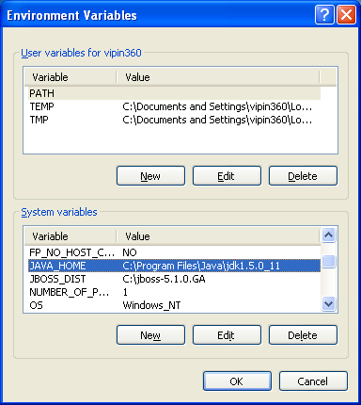

User can see the above screen if he follows the following steps:
- Right click on the My Computer icon from your desktop
- Click Properties
- Click Advanced tab
- Click Environment Variables button
- User would see Environment Variables interface
- Click New associated with System variables section
- You would see New System Variable interface
- Put JAVA_HOME into the variable name field
- Path of your JDK into the variable value field, as into the above screen my JAVA Home directory is installed into C:\Program Files\Java\jdk1.5.0_11
- Click Ok
User can check if java is successfully installed on the system or not, follow two screens which are below:

Run java –version command into the command prompt like:
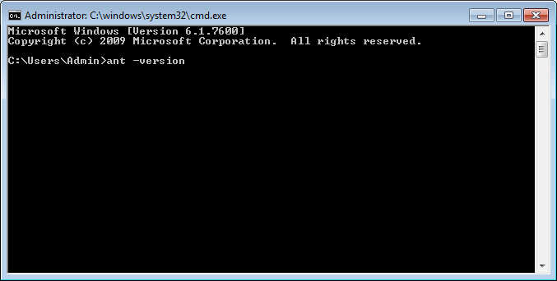

After execution of above command you would see the following screen:
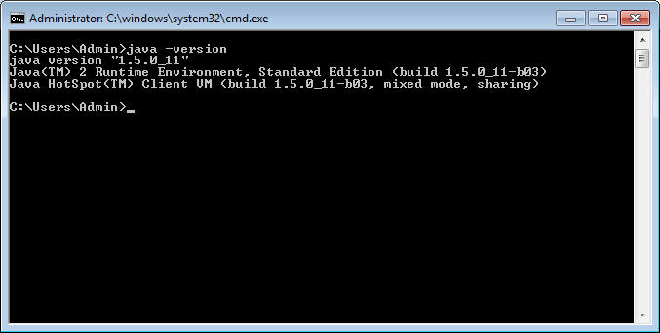

- Ant as build tool:
Download the binary distribution of Ant from http://ant.apache.org/bindownload.cgi link.
After finishing with download, unzip the zipped file into directly your C:\Program files and put the same folder into the C:\Program Files\JAVA folder as well. See the screen:

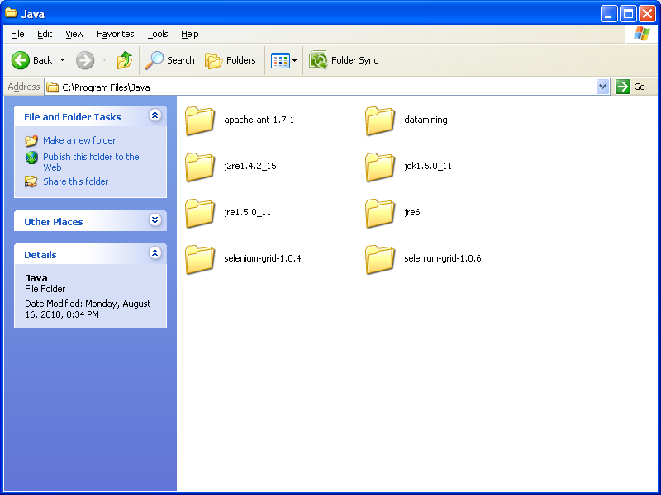
After unzip you would see a folder like this, in my case it’s version 1.7.1

Set ANT home as Environmental variable into your system, see screen:
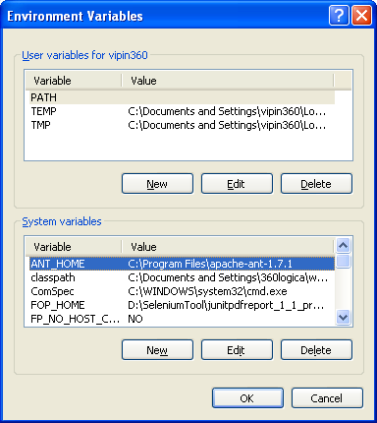
User can see the above screen if he follows the following steps:
- Right click on the My Computer icon from your desktop
- Click Properties
- Click Advanced tab
- Click Environment Variables button
- User would see Environment Variables interface
- Click New associated with System variables section
- You would see New System Variable interface
- Put ANT_HOME into the variable name field
- Path of your ANT into the variable value field, as into the above screen my ANT Home directory is installed into C:\Program Files\apache-ant-1.7.1
- Click Ok
- In the System Variables you would see variable Path, select the row, click Edit and define two paths(C:\Program Files\apache-ant-1.7.1\bin, C:\Program Files\java\apache-ant-1.7.1\bin) like into the following screen, in my case path of ANT bin folder is C:\Program Files\apache-ant-1.7.1\bin
- Click OK
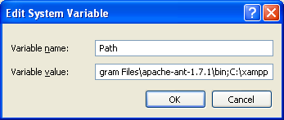

User can check if ANT is successfully installed on the system or not, follow two screens which are below:

Run ant –version command into the command prompt like:
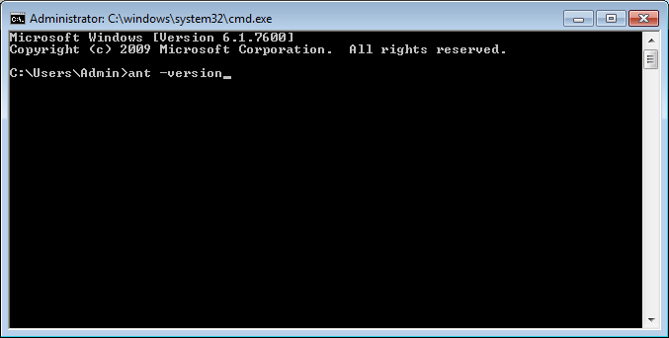
Version and date will be according to yours ant version and compiled date. 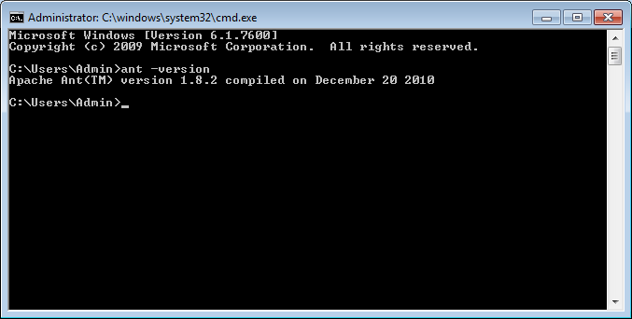

- Jar Files setup:
  - Download selenium-server-standalone-2.14.0.jar file from here
http://code.google.com/p/selenium/downloads/detail?name=selenium-server-standalone-2.14.0.jar&can=2&q=
Put selenium-server-standalone-2.14.0.jar under your framework lib folder.
  - Download selenium-java-2.14.zip file from here
http://code.google.com/p/selenium/downloads/detail?name=selenium-java-2.14.0.zip&can=2&q= Extract selenium-java-2.14.zip file copy selenium-java-2.14.0.jar and selenium-java-2.14.0-srcs.jar from selenium-java-2.14 root folder and put under your framework lib folder.

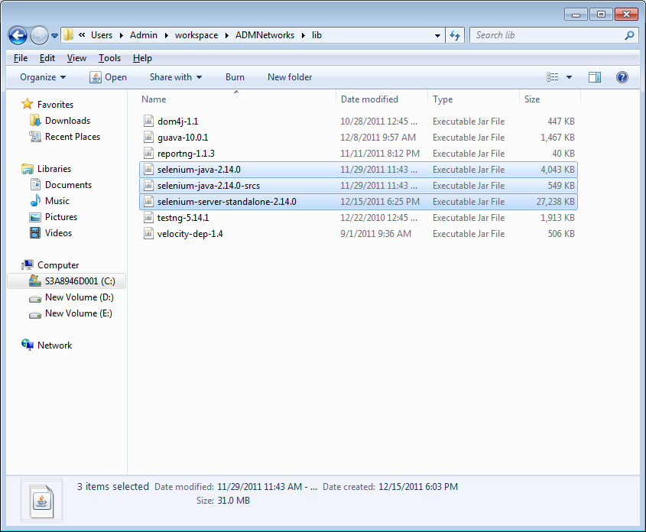

- TESTNG:
We have already placed the required jars file what are necessary in using of TESTNG with ReportNG jar files into the project’s library folder as Reference, in the screen you can see testng.jar and testng-5.14.1.jar and other jar files which are responsible for compilation/execution of tests written into TESTNG:

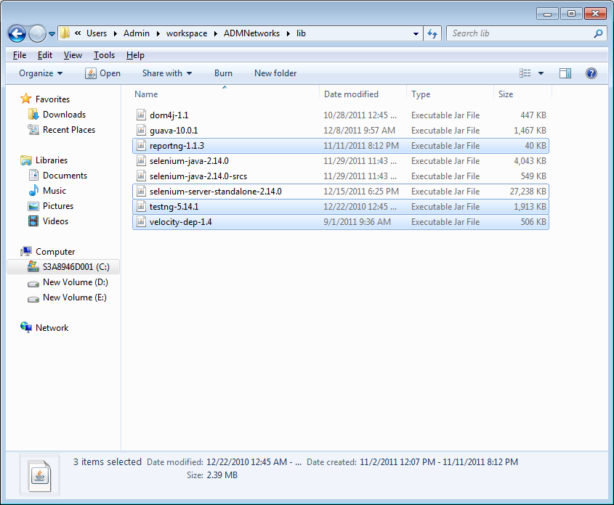

Test setup:
Edit build.properties file and change the ws.home path accordingly, see the build properties file, you need to change only the path define for the variable “ws.home” nothing else.

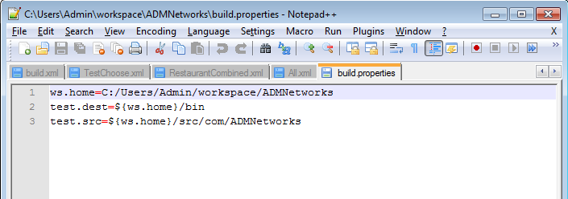

Test Execution:
Now when you are done with the launching of selenium remote control servers, then run the TESTNG tests with the help of following commands:
- Open a new command prompt terminal
- Go into the project’s dir, example if your project folder is into C:\Users\Admin\workspace\ADMNetworks, and then go under this.
- You would see the target name which we have created in bulid.xml in order to run the tests, for example if we need to run Test Choose test scripts, we need to run ant Test Choose in the command prompt.
- For executing the all test, run ant runAll command
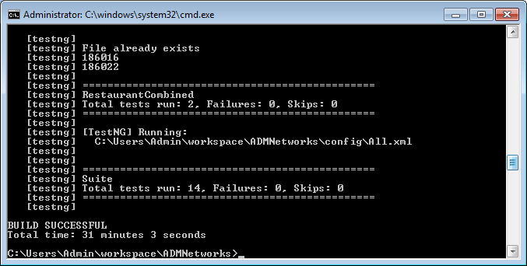

Reporting:
After execution of different tests, you can see the execution result; result will be shown into the “C:\Users\Admin\workspace\ADMNetworks \test-output” folder. You need to go into the test folder and by opening the index.html file you would be able to see the results. See an example:
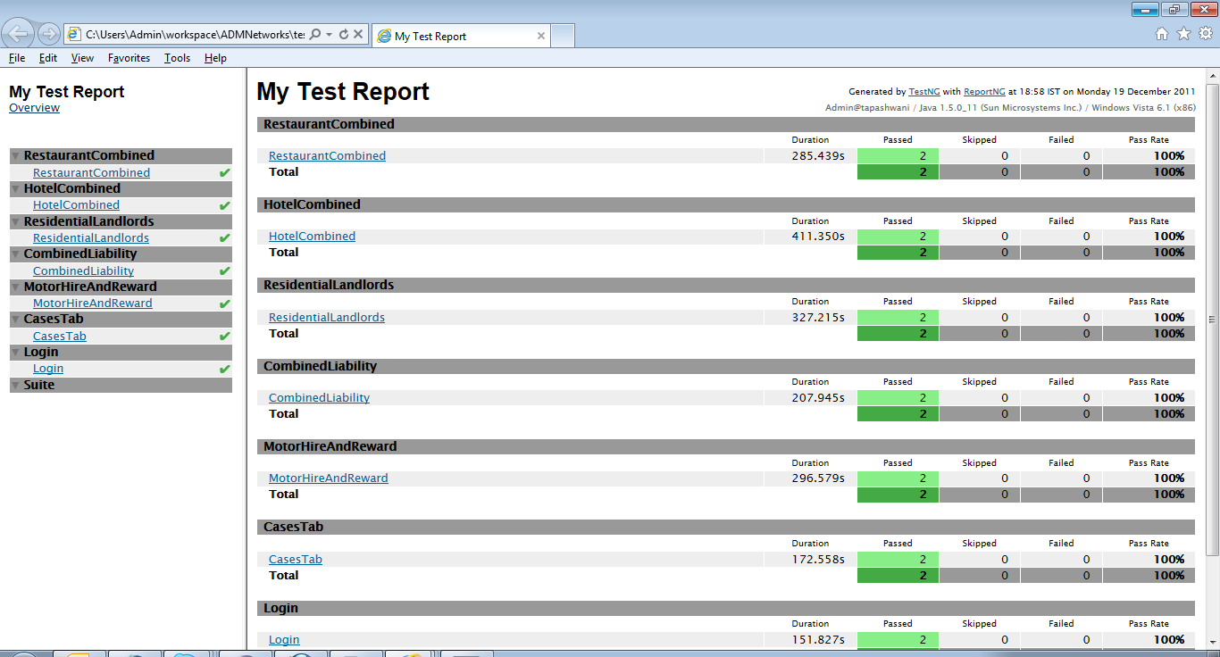
Note: Passed tests will be displaying into Green color and failed tests into the red color.
Thank you…

