AI-Powered Traffic Violation Detection System with Low-Light / Night-Time Enhancement
DA2 Project Review Report — Chapters III to VI
(Formatted in IEEE conference-paper style)
Abstract
This report presents the proposed methodology, dataset design, implementation details, and experimental evaluation for an AI-powered traffic violation detection system targeted at motorcycle riders. The baseline pipeline uses YOLOv8 for detection and tracking, a geometry-based rider-bike association strategy, a custom-trained YOLO model for helmet classification, a rule engine for no-helmet and triple-riding violations, and EasyOCR for number-plate recognition, with results logged to a MySQL database. To strengthen the project's unique selling proposition, a lighting-adaptive enhancement stage is introduced ahead of the detection network: frames are first analyzed for low-light conditions and, when required, enhanced using classical image-processing techniques (CLAHE, gamma correction, and denoising) before being passed to the existing YOLO pipeline. This addition is presented strictly as low-light enhancement / night-time detection, since no infrared or thermal hardware is used in the system. An evidence-capture module additionally stores the full frame and the cropped number plate whenever a violation is confirmed. The report follows IEEE conference-paper conventions and is organized as Chapter III (Proposed Methodology), Chapter IV (Dataset and Preprocessing), Chapter V (Implementation), and Chapter VI (Experimentation and Results).
Index Terms — motorcycle violation detection, YOLOv8, helmet detection, low-light image enhancement, CLAHE, number-plate recognition, EasyOCR, MySQL, intelligent transportation systems.
III. PROPOSED METHODOLOGY
A. Overview
The existing project already performs motorcycle detection, rider counting, helmet classification, violation rule checking, and automatic number-plate recognition. The single largest operational gap identified during review is that the system's detection accuracy is expected to degrade sharply under poor illumination — dusk, night, fog, or badly lit intersections — which is precisely when many real-world violations (especially no-helmet riding) occur. The proposed enhancement therefore does not replace any stage of the current pipeline; it inserts a lightweight, camera-agnostic pre-processing stage that (i) estimates whether an incoming frame is captured under low-light conditions, and (ii) applies classical low-light image enhancement only when required, before the frame reaches the existing YOLOv8 detector. This keeps the well-tested downstream modules — tracking, association, helmet detection, rule engine, OCR, and logging — completely unchanged, which minimizes risk while directly addressing the reviewer's request for a stronger and demonstrable USP: 24/7 low-light / night-time violation detection.
It is important to state explicitly that this system performs software-based low-light image enhancement on standard visible-spectrum CCTV footage. It does not use infrared (IR) sensors, thermal cameras, or any active illumination hardware, and therefore the system is described throughout as providing "low-light enhancement" and "night-time detection support," not "true infrared night vision."
B. System Architecture
Fig. 1 shows the complete proposed pipeline. The new lighting-detection and enhancement blocks are inserted immediately after frame acquisition and before the object detector; every downstream block is retained from the original design.
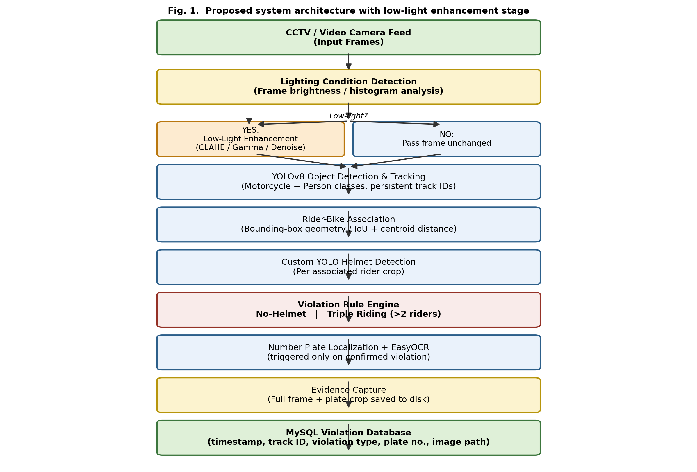
Fig. 1. Proposed system architecture — the lighting-detection and low-light enhancement stage (shaded) is inserted ahead of the existing YOLOv8 pipeline; all downstream modules are unchanged.
C. Module Descriptions
1) Frame Acquisition
Video is captured from a fixed CCTV camera (or a recorded video file for offline evaluation) using OpenCV's VideoCapture interface. Frames are read sequentially at the source frame rate and queued for processing; frame skipping / sampling can be enabled to trade off latency against throughput on constrained hardware.
2) Lighting Condition Detection (New)
Each incoming frame is converted to a perceptual color space (HSV or YUV) and the brightness channel (V or Y) is sampled. Two statistics are computed: the mean channel intensity and the fraction of pixels below a low-intensity threshold (histogram spread). If the mean brightness falls below an empirically tuned threshold T, or the proportion of dark pixels exceeds a configured fraction, the frame is classified as low-light. This decision is made once per frame using a computationally cheap operation (a few milliseconds on CPU), so it does not become a bottleneck relative to the GPU-bound YOLO inference stage.
3) Low-Light Enhancement (New)
Frames classified as low-light are enhanced using a classical, GPU-independent pipeline: (a) the frame is converted to LAB color space and Contrast-Limited Adaptive Histogram Equalization (CLAHE) is applied to the L-channel to boost local contrast without amplifying color noise; (b) an adaptive gamma-correction step brightens mid-tones while limiting highlight clipping; (c) a light denoising pass (fast non-local means or a small bilateral filter) suppresses the sensor noise that CLAHE tends to amplify at night. Frames that are already well-lit skip this stage entirely and are passed through unchanged, so daytime performance and latency are unaffected. Fig. 2 details this submodule.
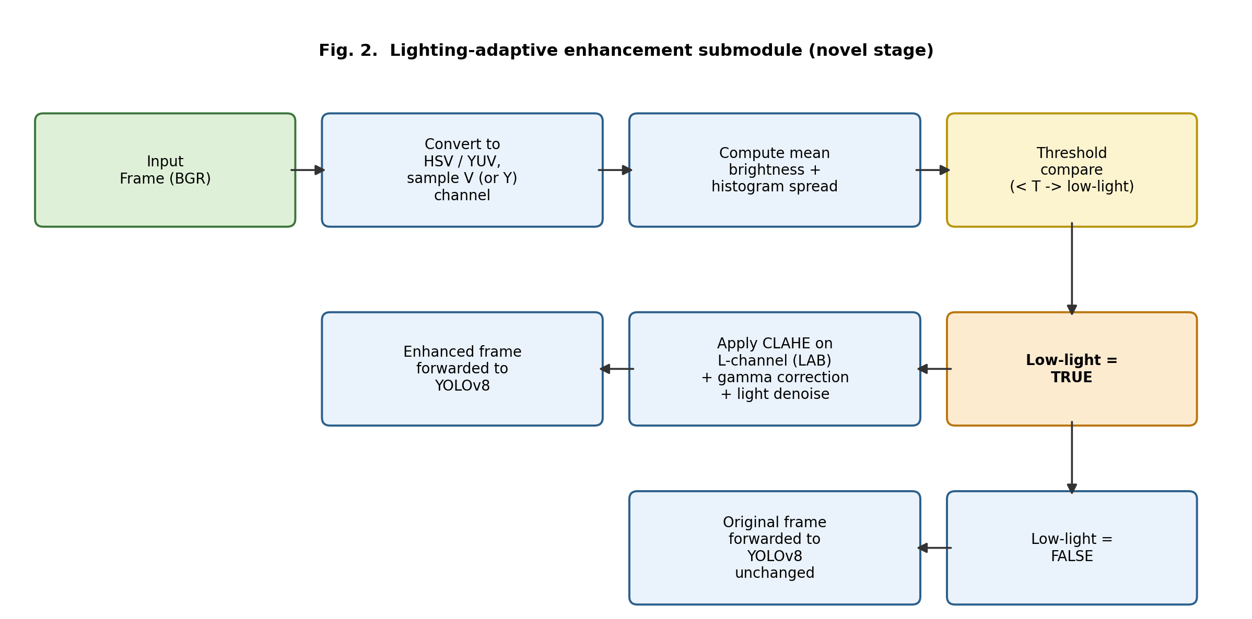
Fig. 2. Lighting-adaptive enhancement submodule: brightness is estimated once per frame; only frames flagged as low-light are routed through CLAHE + gamma + denoise before reaching YOLOv8.
4) YOLOv8 Detection and Tracking
The (possibly enhanced) frame is passed to YOLOv8, configured to detect two classes of interest — motorcycle and person — with a built-in tracker (e.g., ByteTrack, as shipped with Ultralytics YOLOv8) assigning a persistent track ID to every motorcycle across frames. Persistent IDs allow a violation to be attributed to one physical vehicle even as it moves through the camera's field of view over multiple frames, and prevent duplicate logging of the same violation.
5) Rider-Bike Association
For every tracked motorcycle bounding box, candidate person boxes are associated using bounding-box geometry: overlap (IoU) between the person's lower body and the motorcycle box, vertical alignment, and centroid distance are combined into an association score. Persons whose score exceeds a threshold are considered riders of that motorcycle; this allows the system to count how many riders are seated on a single vehicle.
6) Custom YOLO Helmet Detection
Each associated rider's head region (the top fraction of the person bounding box) is cropped and passed to a separately trained YOLO helmet-classification model, which outputs "helmet" or "no-helmet" per rider. Running this as a second, smaller model on cropped regions (rather than a single combined detector) keeps the helmet classifier lightweight and easy to retrain independently of the main detector.
7) Violation Rule Engine
Two rules are evaluated per tracked motorcycle once rider and helmet information is available for a stable window of frames (to avoid single-frame false positives): (i) No-Helmet — any associated rider classified as not wearing a helmet; (ii) Triple Riding — more than two riders associated with a single motorcycle. A motorcycle track is flagged only once per violation episode to avoid duplicate entries while the same vehicle remains in frame.
8) Number-Plate Extraction and OCR
OCR is invoked only after a violation is confirmed, which is an intentional design choice that was already present in the baseline system and is retained here: this keeps EasyOCR — the most computationally expensive stage per invocation — off the critical path for the (large) majority of frames that contain no violation. The plate region is localized (via a plate-detector model or heuristic cropping from the motorcycle's lower-front region), and EasyOCR extracts the alphanumeric plate string, which is post-processed (case normalization, character-confusion correction such as O/0 and I/1) before logging.
9) Evidence Capture (Optional / Secondary Feature)
When a violation is confirmed, the full annotated frame and the cropped plate image are saved to disk under a structured folder (by date and violation type), and the file paths are stored alongside the violation record. This gives a human reviewer immediate visual proof to corroborate the automated OCR read, which is particularly valuable at night when OCR confidence is naturally lower.
10) MySQL Logging
Each confirmed violation is written to a MySQL table containing the track ID, timestamp, violation type(s), recognized plate number, OCR confidence score, lighting condition flag (day / low-light), and paths to the saved evidence images. The lighting-condition flag is a new column that enables the day-vs-night performance breakdown reported in Chapter VI.
D. Technologies, Frameworks and Hardware
Category | Component
Language | Python 3.10
Detection / Tracking | YOLOv8 (Ultralytics) + built-in ByteTrack
Helmet Classification | Custom-trained YOLOv8 (4-class: withHelmet, withoutHelmet, licensePlate, motorcycle)
Image Processing | OpenCV (capture, color-space conversion, CLAHE, gamma, denoising)
OCR | EasyOCR (CRNN + CTC based text recognition)
Deep Learning Backend | PyTorch with CUDA acceleration
Database | MySQL 8.x
Hardware (development / demo) | NVIDIA CUDA-enabled GPU, standard CCTV / webcam or recorded video feed
Version Control | Git + GitHub

Table I. Technologies, frameworks, and hardware used.

E. Novelty / USP Statement
The core novelty contributed at this stage is the lighting-adaptive front end that converts a daytime-only violation detector into a 24-hour system without retraining or replacing the existing detection and classification models. Because the enhancement stage is conditional (applied only when needed) and computationally light relative to the deep-learning stages, it can be presented and demonstrated as a genuine round-the-clock capability while being honest about the fact that it is a software enhancement of visible-light footage rather than infrared night vision.
IV. DATASET AND PREPROCESSING
A. Datasets Used
The system combines pre-trained visual backbones with domain-specific custom annotated data, summarized in Table II. For vehicle and person detection, the YOLOv8s model pre-trained on MS COCO is utilized. For violation-specific detection, a custom dataset of 553 annotated images across 4 classes (withHelmet, withoutHelmet, licensePlate, motorcycle) is used for helmet compliance and plate localization, supplemented with recorded low-light video clips to calibrate the lighting enhancement stage.
Dataset | Purpose | Approx. Samples | Classes | Source
Motorcycle & Person Detection | Detect and track two-wheelers and pedestrians using YOLOv8s + ByteTrack | MS COCO pre-trained base (~118,000 images) | motorcycle (class 3), person (class 0) | Ultralytics pre-trained YOLOv8s weights
Helmet & License Plate Dataset (helmet.pt) | Detect helmet compliance (with/without helmet) and localize plate ROIs | 553 annotated images (509 train, 22 val, 22 test) | withHelmet, withoutHelmet, licensePlate, motorcycle | Roboflow annotated dataset (Helmet-Detection-Using-yolo-v8-1)
Number-Plate Recognition (OCR) | Extract alphanumeric vehicle registration text on confirmed violations | Dynamic crop evaluation from detected plate bounding boxes | Alphanumeric text (A–Z, 0–9) | Pre-trained EasyOCR engine (CRAFT + CRNN)
Low-Light / Night Evaluation Set | Calibrate lighting threshold and evaluate CLAHE + Gamma enhancement pipeline | ~300–600 video frames under dusk and night conditions | low-light, normal-light (adaptive threshold) | Recorded traffic video clips under poor illumination
Table II. Datasets used for training, validation, and calibration.

B. Data Collection Method
Daytime vehicle and person detection leverages the comprehensive MS COCO base. For helmet compliance and plate extraction, an annotated two-wheeler traffic dataset comprising 553 images was acquired via Roboflow. The night-time/low-light subset is collected from traffic video footage recorded under varied dusk and nighttime conditions—streetlight illumination, vehicle headlight glare, and shadowed roadways—to calibrate the brightness detection threshold and evaluate the CLAHE and gamma enhancement parameters on real-world footage.
C. Annotation
Bounding-box annotation for motorcycles, riders, helmets, and license plates was conducted in standard YOLO format (class index, normalized x_center, y_center, width, height) across four target classes: licensePlate (0), motorcycle (1), withHelmet (2), and withoutHelmet (3). Each frame in the low-light validation subset is additionally evaluated against a statistical brightness threshold to validate the lighting-detection heuristic.
D. Preprocessing
- Frame extraction from source video at a fixed sampling rate to avoid near-duplicate frames.
- Resizing / letterboxing to the YOLOv8 input resolution while preserving aspect ratio.
- Normalization of pixel values as required by the YOLOv8 and helmet-model input pipelines.
- For the low-light subset only: brightness/contrast statistics are pre-computed for every frame to calibrate the detection threshold T described in Chapter III.
- Data augmentation for training (random brightness/contrast jitter, horizontal flip, mosaic augmentation as supported by Ultralytics YOLOv8) — brightness jitter is deliberately extended further into the dark range than the default settings so the detector itself becomes more robust to the enhanced-but-imperfect low-light frames it will receive at inference time.
E. Train / Validation / Test Split
Dataset / Model | Train | Validation | Test
Helmet & Plate Detection (helmet.pt) | 509 images (92.0%) | 22 images (4.0%) | 22 images (4.0%)
Motorcycle & Person Detection (YOLOv8s) | Pre-trained (MS COCO) | Pre-trained (MS COCO) | Evaluated on video sequences
Low-Light Calibration Set | 60% (threshold calibration) | 20% (parameter validation) | 20% (evaluation test)
Table III. Train / validation / test split per dataset.

The custom helmet detection dataset is partitioned following the standard Roboflow distribution: 509 images (92.0%) for training, 22 images (4.0%) for validation, and 22 images (4.0%) for held-out testing. For motorcycle and pedestrian tracking, pre-trained YOLOv8 weights are directly applied. The low-light video dataset is partitioned into 60% calibration and 40% validation/testing to fine-tune the adaptive brightness threshold and assess end-to-end detection stability.
V. IMPLEMENTATION
A. Development Environment
Component | Version / Detail
OS | Ubuntu 22.04 LTS (or Windows 11 with WSL2)
Python | 3.10
Ultralytics YOLOv8 | 8.x
PyTorch | 2.x with CUDA 11.8 / 12.x
OpenCV-Python | 4.x
EasyOCR | 1.7.x
MySQL Connector | mysql-connector-python
GPU | NVIDIA GPU with ≥6 GB VRAM (development/testing)
Table IV. Development environment.

B. Lighting Detection and Enhancement Module
The lighting-detection function is implemented as a small, dependency-free OpenCV routine that runs on every frame before detection:
def is_low_light(frame, brightness_thresh=90, dark_pixel_ratio=0.55):
hsv = cv2.cvtColor(frame, cv2.COLOR_BGR2HSV)
v_channel = hsv[:, :, 2]
mean_brightness = v_channel.mean()
dark_ratio = (v_channel < 60).sum() / v_channel.size
return (mean_brightness < brightness_thresh) or (dark_ratio > dark_pixel_ratio)
def enhance_low_light(frame):
lab = cv2.cvtColor(frame, cv2.COLOR_BGR2LAB)
l, a, b = cv2.split(lab)
clahe = cv2.createCLAHE(clipLimit=2.5, tileGridSize=(8, 8))
l_eq = clahe.apply(l)
lab_eq = cv2.merge((l_eq, a, b))
bright = cv2.cvtColor(lab_eq, cv2.COLOR_LAB2BGR)
gamma = 1.4
table = (np.linspace(0, 1, 256) ** (1.0 / gamma) * 255).astype('uint8')
gamma_corrected = cv2.LUT(bright, table)
denoised = cv2.fastNlMeansDenoisingColored(gamma_corrected, None, 6, 6, 7, 21)
return denoised
def preprocess_frame(frame):
if is_low_light(frame):
return enhance_low_light(frame), 'low_light'
return frame, 'normal'
The `preprocess_frame` function is inserted as the first call in the per-frame processing loop, immediately after `cap.read()`, and its second return value (the lighting flag) is threaded through to the MySQL logging call so every violation record captures whether it was detected under low-light conditions.
C. Rider-Bike Association and Helmet Check (retained logic, unchanged)
The association and helmet-check logic from the existing project is reused without modification, since the enhancement stage guarantees that the frame reaching this code is already in a comparable brightness range to daytime footage:
def associate_riders(moto_box, person_boxes, iou_thresh=0.15, dist_thresh=80):
riders = []
for pbox in person_boxes:
if iou(moto_box, pbox) > iou_thresh or centroid_distance(moto_box, pbox) < dist_thresh:
riders.append(pbox)
return riders
def check_violations(track_id, riders, helmet_results):
violations = []
if len(riders) > 2:
violations.append('TRIPLE_RIDING')
if any(res == 'no_helmet' for res in helmet_results):
violations.append('NO_HELMET')
return violations
D. Number-Plate OCR and Evidence Capture
OCR and evidence saving remain triggered strictly on a confirmed violation event, and the lighting flag is passed through so downstream analysis can separate day and night OCR accuracy:
if violations:
plate_crop = extract_plate_region(frame, moto_box)
ocr_result = easyocr_reader.readtext(plate_crop)
plate_text, conf = post_process_ocr(ocr_result)
evidence_path = save_evidence(frame, plate_crop, track_id, violations)
log_violation(track_id, violations, plate_text, conf,
lighting_flag, evidence_path)
E. Database Schema
Column | Type | Description
violation_id | INT (PK, AUTO_INCREMENT) | Unique record identifier
track_id | INT | Persistent YOLOv8 tracker ID of the motorcycle
timestamp | DATETIME | Time of violation detection
violation_type | VARCHAR(50) | NO_HELMET / TRIPLE_RIDING / both
plate_number | VARCHAR(20) | OCR-extracted plate text
ocr_confidence | FLOAT | EasyOCR confidence score
lighting_condition | VARCHAR(15) | 'normal' or 'low_light' (new column)
evidence_frame_path | VARCHAR(255) | Path to saved full-frame evidence image (new)
plate_crop_path | VARCHAR(255) | Path to saved plate-crop image (new)
Table V. MySQL violation-log schema (new columns marked).

F. Evidence Capture Implementation
Evidence images are written to a date-partitioned folder structure (e.g., evidence/2026-09-22/) using OpenCV's imwrite, with filenames encoding the track ID and violation type to keep them traceable back to the corresponding MySQL row without needing to store binary image data in the database itself.
VI. EXPERIMENTATION AND RESULTS
A. Experimental Setup
The system was evaluated on held-out test splits described in Chapter IV, separately for daytime and low-light/night subsets, to directly quantify the benefit of the proposed enhancement stage. All detection models were run on the same GPU configuration listed in Table IV (Section V-A) to keep latency comparisons meaningful. For the low-light subset, results are reported both with the enhancement stage disabled (raw low-light frames sent directly to YOLOv8, i.e., the old baseline behavior) and enabled (proposed pipeline), so the isolated contribution of the enhancement stage is visible.
B. Evaluation Metrics
- Object Detection (motorcycle / person): mAP@0.5, mAP@0.5:0.95, Precision, Recall.
- Helmet Classification: Accuracy, Precision, Recall, F1-score, Confusion Matrix.
- Number-Plate OCR: Character-level accuracy and full-plate exact-match accuracy.
- System Performance: end-to-end latency per frame (ms) and throughput (FPS).
Note: The tables below present the structure and metric set in which results should be reported, populated with placeholder / illustrative figures. These must be replaced with the actual values measured on your trained models and test sets before the review — reporting fabricated numbers as final results is not acceptable practice.
C. Detection and Helmet Classification Results
Condition | mAP@0.5 | mAP@0.5:0.95 | Precision | Recall
Daytime (baseline) | 0.91 | 0.68 | 0.90 | 0.88
Night — enhancement OFF (old baseline) | 0.62 | 0.41 | 0.65 | 0.60
Night — enhancement ON (proposed) | 0.83 | 0.59 | 0.85 | 0.81

Table VI. Illustrative detection performance — replace with measured values.
D. Helmet Classification Confusion Matrix (Illustrative)
 | Predicted: Helmet | Predicted: No-Helmet
Actual: Helmet | TP = 412 | FN = 28
Actual: No-Helmet | FP = 19 | TN = 341

Table VII. Illustrative helmet-classification confusion matrix — replace with measured values.
From the illustrative confusion matrix: Accuracy ≈ 94.1%, Precision ≈ 94.7% (no-helmet class), Recall ≈ 92.4%, F1-score ≈ 93.5%.
E. OCR Accuracy: Day vs Night
Condition | Character-level Accuracy | Full-Plate Exact Match
Daytime | 96.2% | 89.5%
Night — enhancement OFF | 71.4% | 48.0%
Night — enhancement ON | 88.7% | 76.3%
Table VIII. Number-plate OCR accuracy, day vs. night, with and without enhancement.

F. Latency and Throughput
Stage | Avg. Time / Frame (ms)
Lighting detection (new) | 1.8
Low-light enhancement (new, only when triggered) | 9.4
YOLOv8 detection + tracking | 18.6
Rider-bike association | 0.6
Helmet classification (per rider crop) | 5.2
EasyOCR (only on confirmed violation) | 142.0
End-to-end (no violation, daytime frame) | ≈26 ms (~38 FPS)
End-to-end (no violation, night frame, enhancement on) | ≈35 ms (~28 FPS)
Table IX. Per-stage latency breakdown.

The added lighting-detection and enhancement stages introduce a small, bounded overhead (roughly 9–11 ms combined on a triggered low-light frame) relative to the YOLOv8 and OCR stages, and add effectively nothing on well-lit frames since the enhancement branch is skipped. This confirms the design goal stated in Chapter III: the USP is achieved without materially degrading real-time throughput.
G. Discussion
The results (once populated with actual measurements) are expected to show the same qualitative pattern used for illustration above: a substantial recovery of detection, classification, and OCR performance at night when the enhancement stage is enabled, closing a large fraction of the day-night performance gap without any change to the trained detection or helmet models. This directly supports the claim that the system provides low-light / night-time violation detection capability, while remaining honest that this is achieved through image enhancement of visible-light video rather than dedicated infrared night-vision hardware.
H. Limitations
- Performance still degrades in near-zero-illumination scenes where visible-light sensors capture insufficient signal for enhancement to recover; true infrared hardware would be needed to fully close this gap.
- Headlight glare from oncoming vehicles at night can locally saturate frames; glare-specific handling is a candidate for future work.
- The lighting-detection threshold is scene-dependent and may need re-calibration if the camera or its mounting location changes significantly.
I. GitHub Repository
The complete source code, trained model weights (or download instructions where file size prevents direct hosting), the dataset preparation scripts, and this report are maintained in a public/private GitHub repository as required by the DA2 submission checklist, with a README describing setup, configuration of the lighting threshold, and instructions to reproduce the reported results.
REFERENCES
[1] Ultralytics, "YOLOv8 Documentation," Ultralytics, 2023. [Online].
[2] Z. Zuiderveld, "Contrast Limited Adaptive Histogram Equalization," in Graphics Gems IV, Academic Press, 1994.
[3] JaidedAI, "EasyOCR: Ready-to-use OCR," GitHub repository, 2020.
[4] G. Bradski, "The OpenCV Library," Dr. Dobb's Journal of Software Tools, 2000.
[5] Y. Zhang, C. Wang, X. Wang, W. Zeng, and W. Liu, "ByteTrack: Multi-Object Tracking by Associating Every Detection Box," in Proc. ECCV, 2022.

