**High Quality Software Programing**

**Group Project**

**Group 1**

**Carlos Abaffy – 8867837**

**Harsh Patel – 8885199**

**Ishneet Kaur – 8877533**

**Tapaswee Dixit – 8859139**

**Caller Log Application**

**Project Objective:**

Monitoring calls in an organization is extremely important. Organizations that do not have call monitoring generally have difficulty tracking customer interactions and monitoring the performance of their employees. Our plan is to develop a caller log, which is a valuable tool for any organization that handles a high volume of phone calls, as it allows them to keep a detailed record of all incoming and outgoing calls.

The users can search out the contact details from the directory and make any update in the call logs.

**User stories**:

* As a user I should be able to securely login in the system.
* As a user, I should be able to add a new call to the log.
* As a user, I should be able to view the list of calls added.
* As a user, I should be able to search a particular entry in the log.
* As a user, I should be able to edit an existing entry in the call log.
* As a user, I should be able to delete a call log entry.
* As an admin, I should be able to securely login in the system.
* As an admin, I should be able to manage, add, and remove user accounts from the system.
* As an admin, I should be able to manage the view/edit permissions for the users in the system.

**User Scenario Specifications**:

User scenario specifications are a set of detailed descriptions that outline the various steps a user takes to carry out a specific task or goal when using a product or service. These specifications provide a clear and concise outline of the user's interactions with the product or service, including their goals, motivations, and pain points.

Our system have main user scenario like,

* Login into the system.
* Selection of function (different as per user)
* Managing users
* Managing permissions
* Adding a new call
* Viewing call logs
* Searching for a specific call
* Editing a call
* Deleting a call

**User Scenario Specifications for Normal User and Admin:**

* **User:**

1. Login as a normal user: with ID and password.

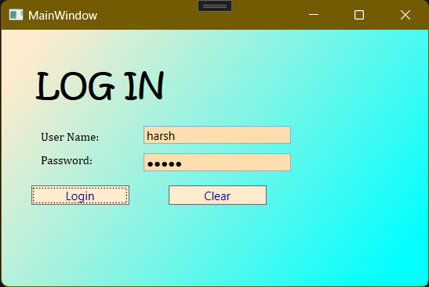

1. Selection of function on main screen:

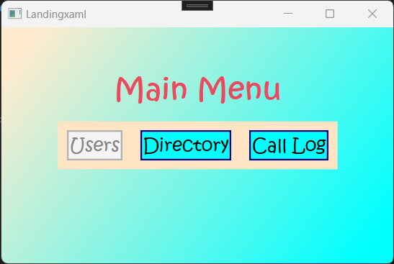

1. Adding a new call: The user should be able to add a new call to the log by supplying the caller's name, phone number, call date, call time, and any notes related to the call.

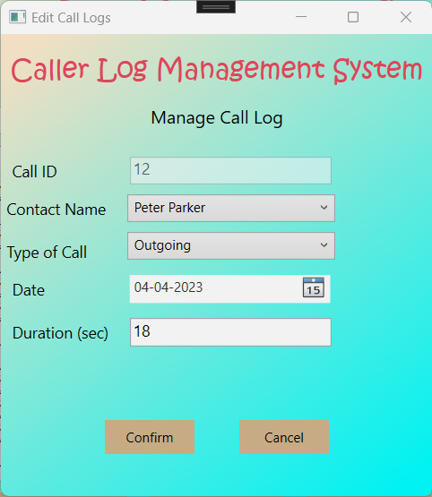

1. Viewing call logs: The user should be able to view a list of all calls that have been added to the log. The list should include the caller's name, phone number, call date, call time, and any notes related to the call.

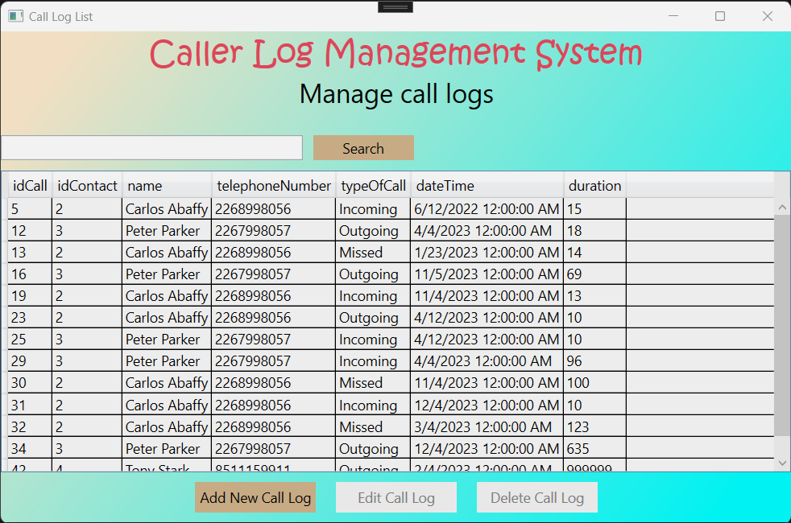

1. Searching for a specific call: The user should be able to search for a specific call in the log by entering the caller's name, phone number, or date of the call.

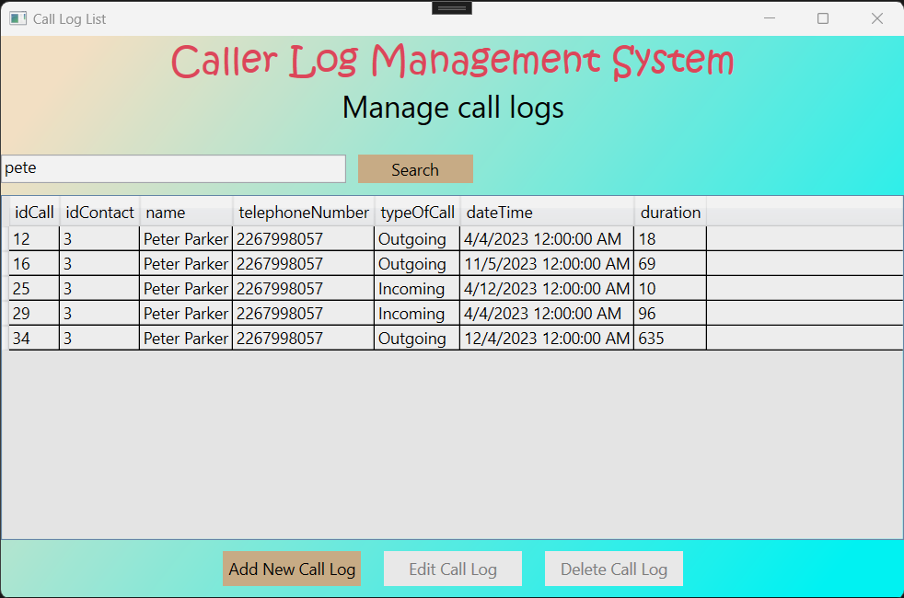

1. Editing a call: The user should be able to edit an existing call in the log by changing the caller's name, phone number, call date, call time, or any notes related to the call.



1. Deleting a call: The user should be able to delete a call from the log if they no longer need it.

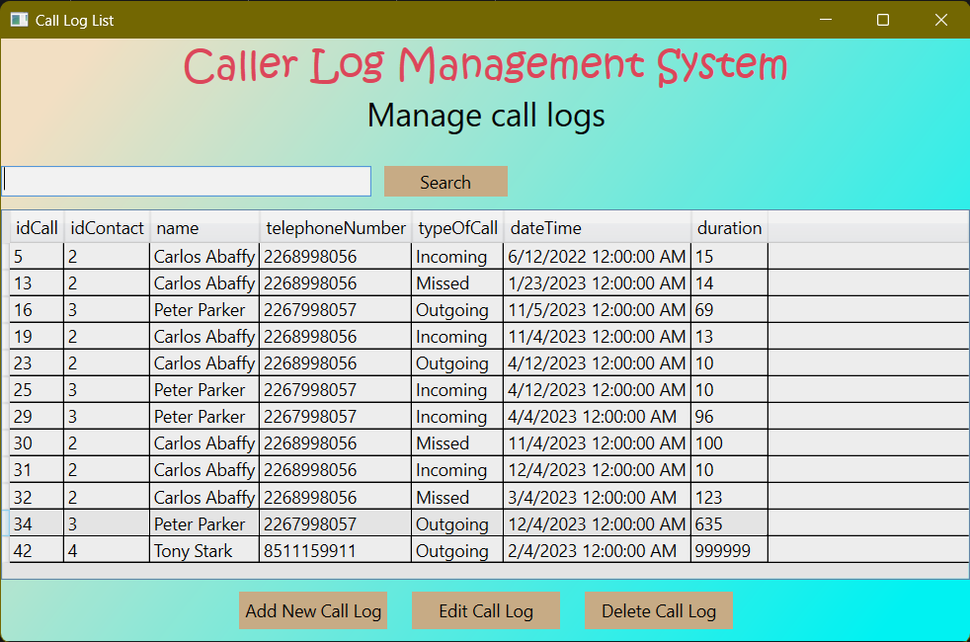

* **Admin:**

1. Login as Admin: with ID and password.



1. Selection of function on main screen:

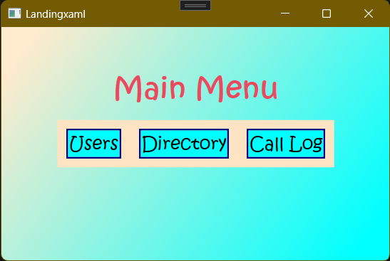

1. Managing users: The admin should be able to add, remove, and manage user accounts for the system.

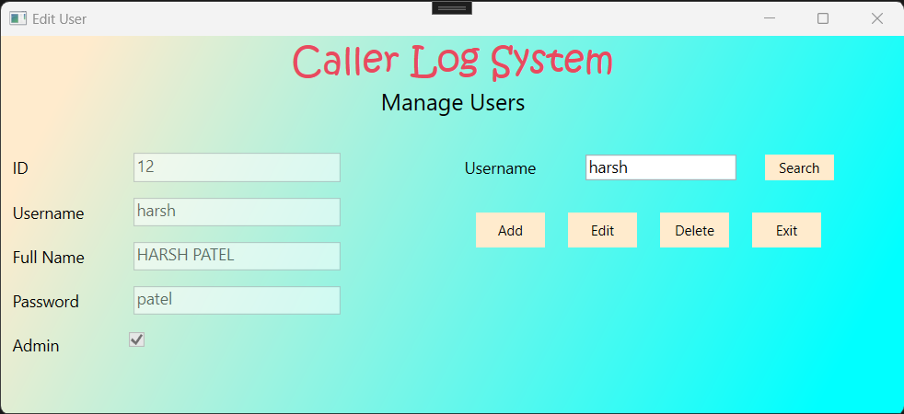

1. Managing permissions: The admin should be able to set permissions and access levels for each user based on their role and responsibilities.

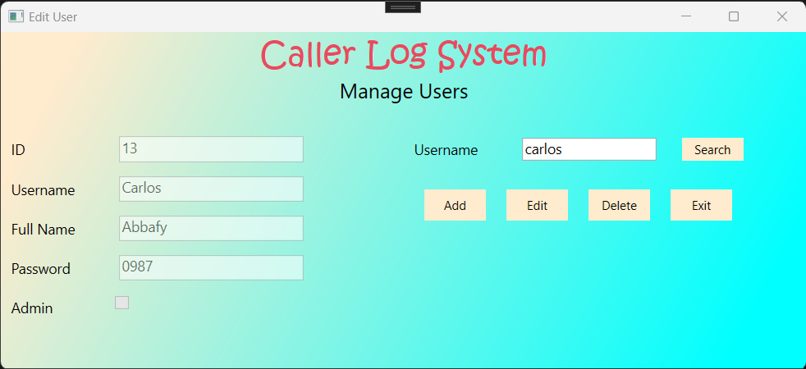

**Context Diagram**:

Caller Log management application is used by two external entities, Normal user and admin which use the application for different purposes.

Level 0:

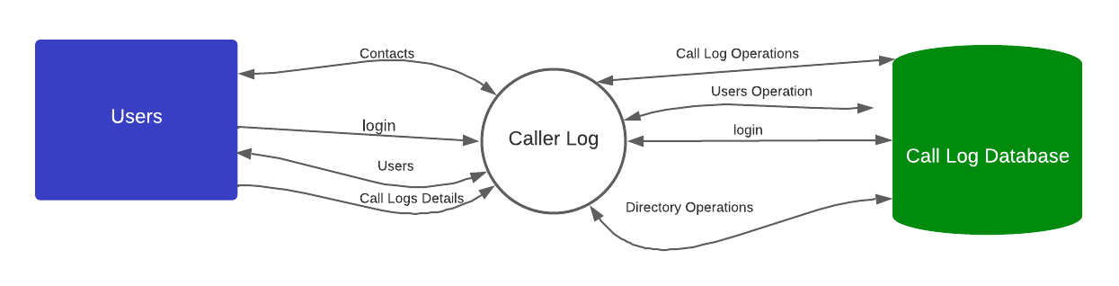

Level 1:

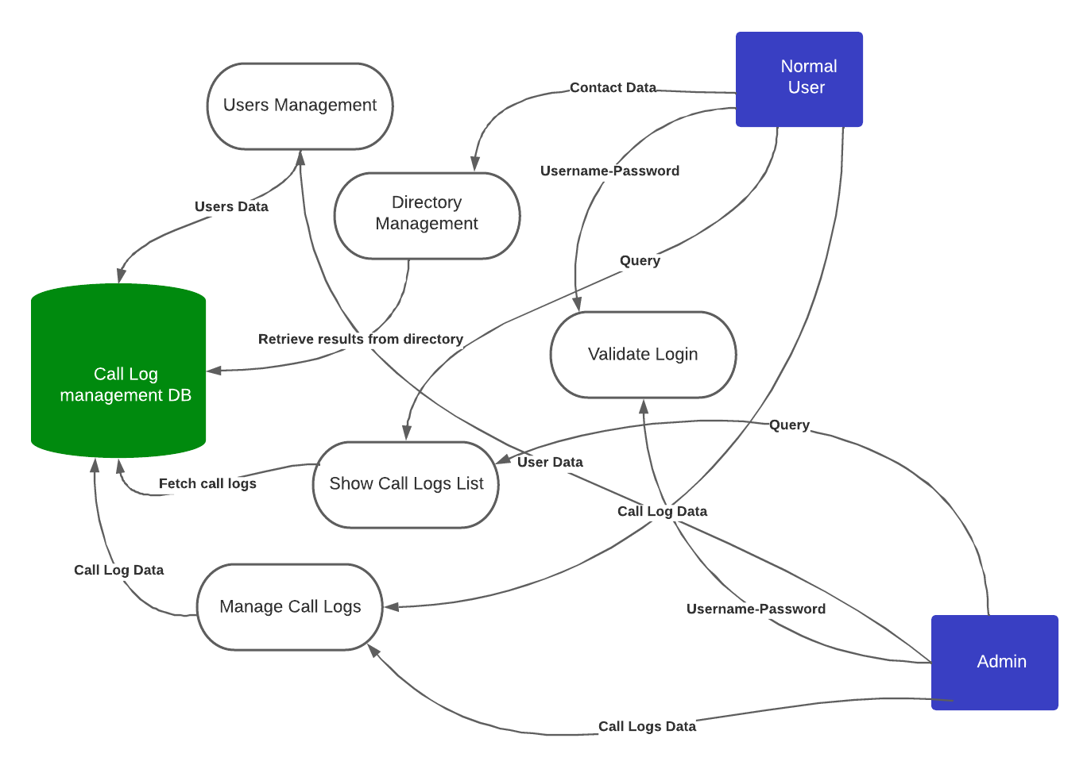

Context diagram and data entities:

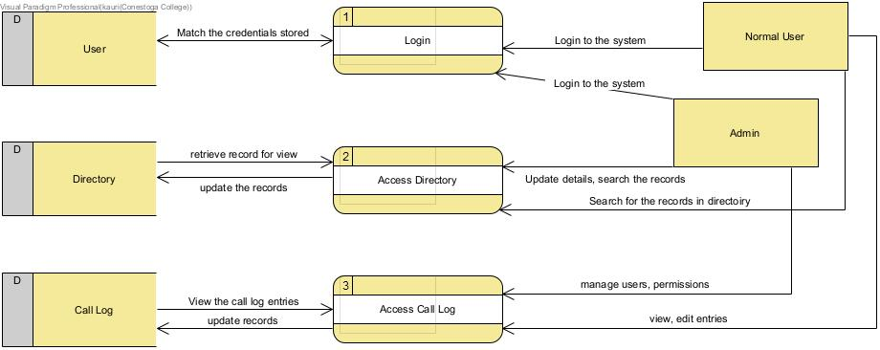

**Architecture:**

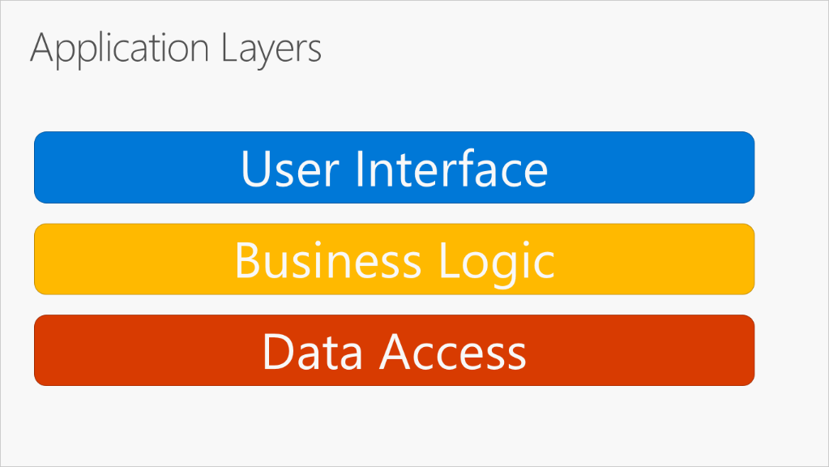

User interfaces include the screens that are visible to user and allow the input output with the application. The caller log application use WPF (Windows Presentation Foundation) to create the front end of the system.

Business logic includes the code written to process the information which is designed in C# programming language in Visual Studio.

The data access layer takes input request from business layer, retrieve the data stored in database and outputs the requested service with the data.

Class Diagram:

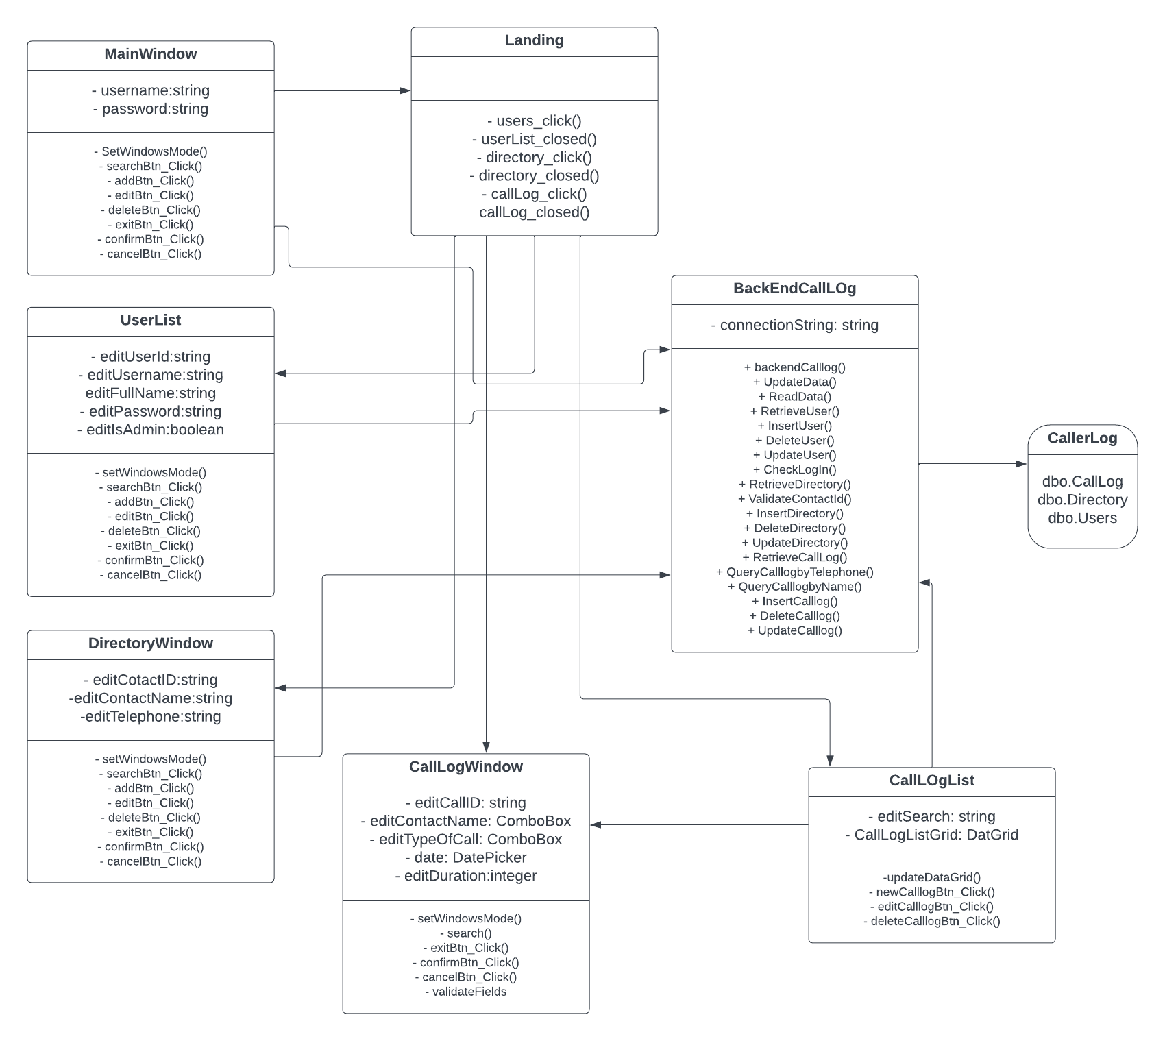

**Database:**

Database for the application is developed in SQL server. There are three tables created to store the user's information, call logs data and directory data. The tables are shown as follows:

Call Log data:

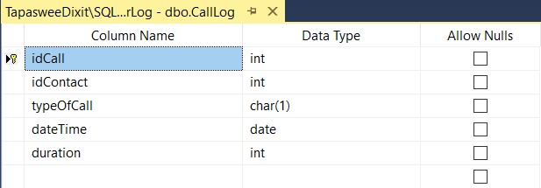

Users' information:

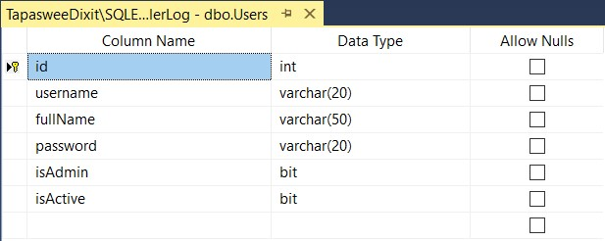

Directory data:

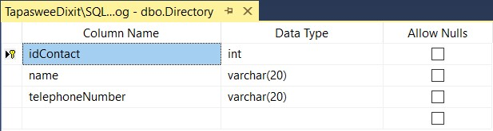

ER Diagram:

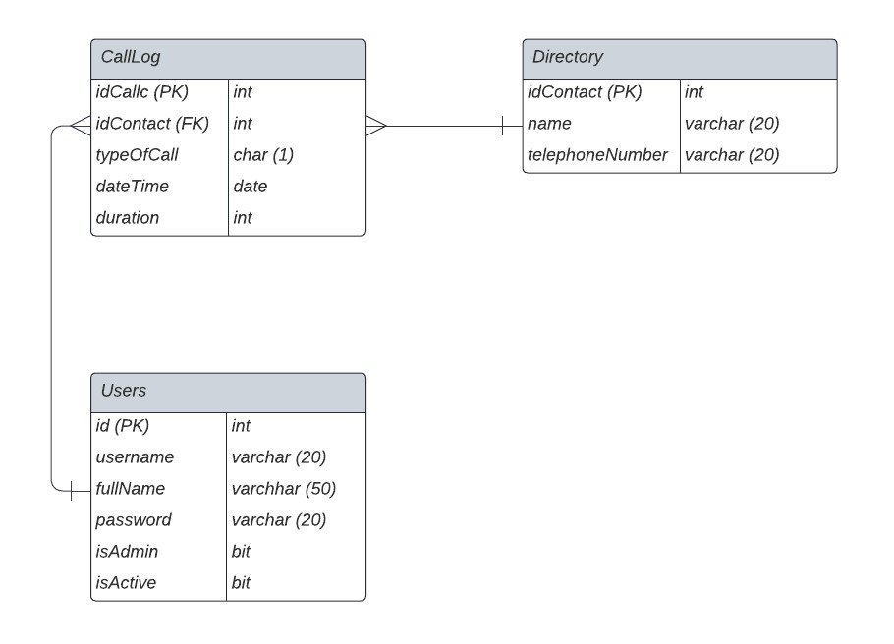

**Front end**:

Front end of the application is developed using WPF feature in the Visual Studio.

1. Login page:



1. Main Menu:



1. Users





1. Directory

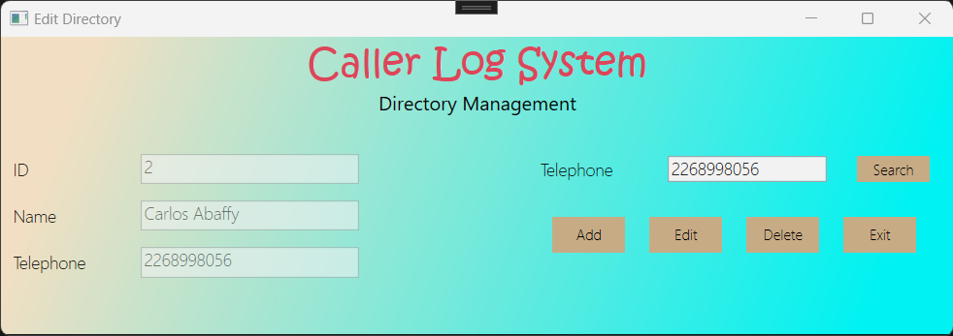

1. Call Log









**Back end**:

Back end is designed in C# programming language using Visual Studio IDE.

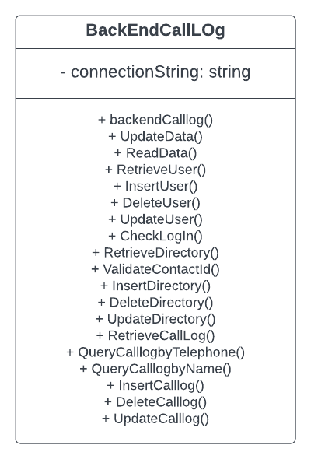

**Test Cases:**

|  |  |  |
| --- | --- | --- |
| **ID**: UC001 | **Name**: Login as a normal user | |
| **Description**: A regular user must be able to login in the system | | |
| **Priority:** High | |  |
| **Steps** | | **Expected Result** |
| Launch the system. | | The Login Page is presented. |
| The user introduces his credentials. | | The system validates the user’s credential. |
| The user is granted access to the system. | | The user can see the Main menu with 2 options: manage directory and manage call logs. |

|  |  |  |
| --- | --- | --- |
| **ID**: UC002 | **Name**: Login as an admin user | |
| **Description**: Admin user must be able to login in the system for manage the users. | | |
| **Priority:** High | |  |
| **Steps** | | **Expected Result** |
| Launch the system. | | The Login Page is presented. |
| The user introduces his credentials. | | The system validates the user’s credential. |
| The user is granted access to the system. | | The user can see the Main menu with 3 options: manage users, manage directory, and manage call logs. |

|  |  |  |
| --- | --- | --- |
| **ID**: UC003 | **Name**: Manage users (Only for admin users) | |
| **Description**: Admin user must be able to manage the users of the system | | |
| **Priority:** High | |  |
| **Steps** | | **Expected Result** |
| Login in the system. | | The system validates the user’s credential. |
| The user gets in the Main menu and press the user button. | | The system allows the user to get into the user management option. |
| The user manages the users of the system. | | The system allows to **add,** **edit** and **delete** the users of the system. |

|  |  |  |
| --- | --- | --- |
| **ID**: UC006 | **Name**: Search Call Logs | |
| **Description**: User can **search** for call logs using either name or number. | | |
| **Priority:** High | |  |
| **Steps** | | **Expected Result** |
| Login in the system. | | The system validates the user’s credential. |
| The user gets in the Main menu and press the Call Log button. | | The system allows the user to get into the manage Call log option. |
| The user searches for call logs using name of contact. | | The system allows to **search** the call logs using the name of the contacts. |

|  |  |  |
| --- | --- | --- |
| **ID**: UC008 | **Name**: Add a new Call Log | |
| **Description**: User must be able to add a new call log. | | |
| **Priority:** High | |  |
| **Steps** | | **Expected Result** |
| Login in the system. | | The system validates the user’s credential. |
| The user gets in the Main menu and press the Call log button. | | The system allows the user to get into the manage call log option. |
| The user logs a new call. | | The system allows to add a call log to the list of call logs. |

|  |  |  |
| --- | --- | --- |
| **ID**: UC009 | **Name**: Edit a Call Logs | |
| **Description**: User can edit a selected call log. | | |
| **Priority:** High | |  |
| **Steps** | | **Expected Result** |
| Login in the system. | | The system validates the user’s credential. |
| The user gets in the Main menu and press the Call Log button. | | The system allows the user to get into the manage call log option. |
| User edits the call log. | | The system allows to edit an existing call log from the list of call logs. |

|  |  |  |
| --- | --- | --- |
| **ID**: UC010 | **Name**: Delete a Call Log | |
| **Description**: User can a delete a call log. | | |
| **Priority:** High | |  |
| **Steps** | | **Expected Result** |
| Login in the system. | | The system validates the user’s credential. |
| The user gets in the Main menu and press the call log. | | The system allows the user to get into the manage call log option. |
| User deletes a call log. | | The system allows the user to delete an existing call log. |

|  |  |  |
| --- | --- | --- |
| **ID**: UC011 | **Name**: Search Call Logs by number | |
| **Description**: User can **search** for call logs using number. | | |
| **Priority:** High | |  |
| **Steps** | | **Expected Result** |
| Login in the system. | | The system validates the user’s credential. |
| The user gets in the Main menu and press the Call Log button. | | The system allows the user to get into the manage Call log option. |
| The user searches for call logs using number. | | The system allows the user to **search** the call logs using the number of the contacts. |

|  |  |  |
| --- | --- | --- |
| **ID**: UC012 | **Name**: Search Call Logs by Contact Name | |
| **Description**: User can **search** for call logs using name. | | |
| **Priority:** High | |  |
| **Steps** | | **Expected Result** |
| Login in the system. | | The system validates the user’s credential. |
| The user gets in the Main menu and press the Call Log button. | | The system allows the user to get into the manage Call log option. |
| The user searches for call logs using name. | | The system allows the user to **search** the call logs using the name of the contacts. |

|  |  |  |
| --- | --- | --- |
| **ID**: UC005 | **Name**: Manage Contacts | |
| **Description**: User must be able to **search, add, edit** and **delete.** | | |
| **Priority:** High | |  |
| **Steps** | | **Expected Result** |
| Login in the system. | | The system validates the user’s credential. |
| The user gets in the Main menu and press the ‘Directory’ button. | | The system allows the user to get into the contacts management option. |
| The user tries to search contacts in the directory. | | The system allows to **search** the contacts in the directory. |
| The user tries to manage contacts in the directory. | | The system allows the user to **add**, **edit** and **delete** the contacts in the system. |

|  |  |  |
| --- | --- | --- |
| **ID**: UC013 | **Name**: Delete a Contact with Call Logs | |
| **Description**: User tries to delete a contact that has call logs. | | |
| **Priority:** High | |  |
| **Steps** | | **Expected Result** |
| Login in the system. | | The system validates the user’s credential. |
| The user gets in the Main menu and press the ‘Directory’ button. | | The system allows the user to get into the contacts management option. |
| User tries to delete a contact that has call logs. | | The system allow DOES NOT allow the user to delete the contacts and shows messages “contact CANNOT BE DELETED, has registered call logs.” |

|  |  |  |
| --- | --- | --- |
| **ID**: UC014 | **Name**: Register the same contact twice. | |
| **Description**: User tries to register the same number twice. | | |
| **Priority:** High | |  |
| **Steps** | | **Expected Result** |
| Login in the system. | | The system validates the user’s credential. |
| The user gets in the Main menu and press the ‘Directory’ button. | | The system allows the user to get into the contacts management option. |
| The user tries to register the same number twice. | | The system allow DOES NOT allow the user to add the same number twice. |

**Future plans**:

The future prospects for the call log application includes:

* Exporting call logs: The user should be able to export the call logs to a file, such as a CSV or Excel file, for further analysis or record keeping.
* Adding tags: The user should be able to add tags to calls to categorize them and make them easier to find later.
* Sorting calls: The user should be able to sort the list of calls by date, time, or caller name.
* Customizing the system: The admin should be able to customize the system to meet the needs of the organization, such as adding new fields to the call log or creating custom reports.
* Backing up data: The admin should handle backing up the data in the system regularly to ensure that it can be restored in case of a data loss event.
* Monitoring system performance: The admin should watch system performance to ensure that it is running smoothly and efficiently and take steps to optimize performance if necessary.
* Managing security: The admin should handle managing system security, such as setting up user authentication and authorization, implementing data encryption, and monitoring for security threats.
* Managing system upgrades: The admin should handle managing system upgrades, such as installing updates and patches, and ensuring that the system remains up-to-date and secure.