For the assignment 3, you have been asked to generate colorized depth image. For each pixel in the depth image, find corresponding pixel in the color image. You need to use intrinsic calibration parameters for depth and color camera and the transformation between them.

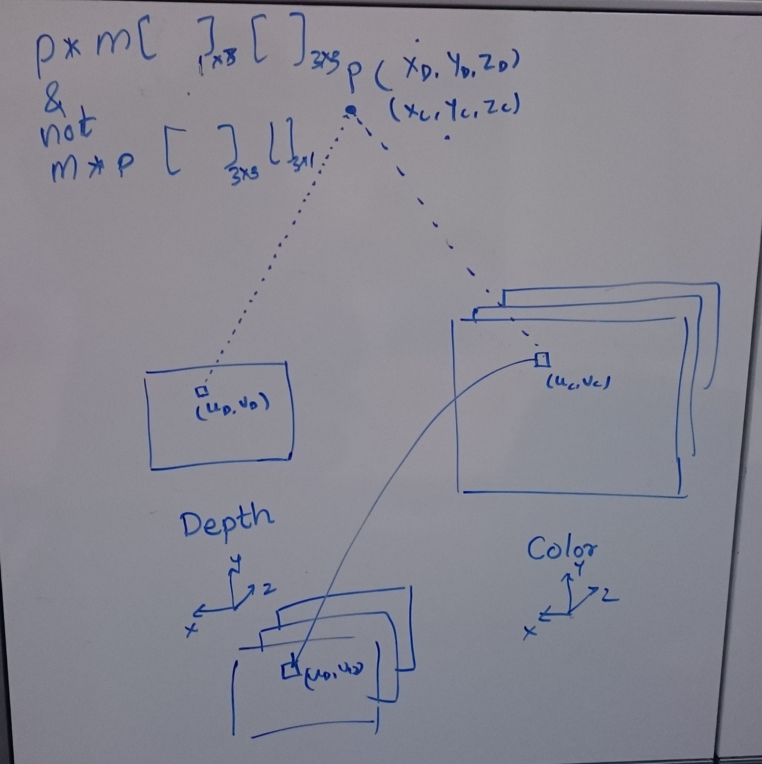

The above picture shows all the transformation involved. (uD, vD) is a pixel in depth image, it's corresponding 3D point (XD, YD, ZD) in the depth camera's coordinate system, corresponding 3D point (XC, YC, ZC) in the color camera's coordinate system and (uC, vC) is corresponding pixel in color image.

To briefly describe about the calibration:

Projecting a 3D point (X,Y,Z) on 2D (u,v) will need to solve following equation

[u v 1] = [X/Z Y/Z 1]\*[Intrinsic Matrix]

(1x3 row vector) = (1x3 row vector) \* (3x3 matrix)

Hence, for projecting 2D point back into 3D , one can invert the above equation as

[X/Z Y/Z 1] = [u v 1]\*[Inverse Intrinsic Matrix]

Z values can be obtained from depth image.

All the transformations should be done considering the row measure computations.