 | Meow Airline: Booking Database Report  953212 (SE212) Database Systems · Term project · Thursday 15 October 2026  Patarawadee Kunna 682115034 · Kawinthida Kantong 682115002 · Kornnaphat Uttama 682115001  Source code: github.com/tapimeow/Meow-Airline-SE212

1 · INTRODUCTION AND BACKGROUND OF THE BUSINESS
A small regional airline run on Excel and LINE
Meow Airline is a small regional airline that flies 6 aircraft on domestic Thai routes and to Singapore and Vientiane. Its agents book passengers, take payment and check them in at the airport. This report designs and builds the MySQL database that replaces the airline's spreadsheet.
How the business works today. Every booking lives in one shared Excel file, and agents coordinate in LINE chats. Nothing stops two agents from selling the same seat, because the file has no rules. A booking takes about 8 minutes, and every report is counted by hand.
Who uses the system
User | What they do
Booking staff | Create reservations for passengers, issue tickets after payment
Check-in staff | Check passengers in at the counter, record baggage, print boarding passes
Passenger | Books (online or through an agent) and travels on one or more tickets
Manager | Reads the income and seat reports

Our goals (from the proposal)
# | Goal | How the database meets it
O1 | Zero double-booked seats | A UNIQUE key on TICKET refuses a second live ticket for a seat (BR10)
O2 | A booking in under 2 minutes (now about 8) | One booking page and one transaction for the reservation and all its tickets
O3 | The income report in under 10 seconds | Income per route is one SQL query (Q3)
O4 | Live free seats per flight by class | The view v_flight_load (Q14)

2 · MOTIVATION
Why the airline needs a database
A spreadsheet has no rules: it cannot stop two agents from selling seat 2A on the same flight, and it cannot tell the manager which route earned the least last month without counting by hand. We want one MySQL database that every agent shares, that refuses a double booking by itself, and that answers the airline's three key questions in seconds: how many seats are free on a flight (Q1), what a passenger has booked and paid (Q2), and how much each route earned (Q3). Putting the business rules into the database, not into people's memory, is what makes the data trustworthy.

3 · BUSINESS RULES
19 rules the system must keep
BR1–BR15 come from the proposal; BR16–BR19 were added when the team reviewed the ERD. 15 are enforced by MySQL itself; the other 4 need several rows or the clock and are checked in the backend.
BR | Rule | Enforced by
BR1 | A flight has exactly one origin airport | DB: NOT NULL FK ROUTE.OriginCode
BR2 | A flight has exactly one destination airport | DB: NOT NULL FK ROUTE.DestinationCode
BR3 | A flight uses exactly one aircraft | DB: NOT NULL FK FLIGHT.AircraftID
BR4 | A seat belongs to exactly one aircraft | DB: NOT NULL FK SEAT.AircraftID
BR5 | A reservation is made by exactly one passenger | DB: NOT NULL FK RESERVATION.PassengerID
BR6 | Reservation ⇄ flight is many-to-many, through TICKET | DB: the TICKET table
BR7 | Origin and destination must differ | DB: CHECK ROUTE_Airports_CK
BR8 | A ticket is issued only after payment | Backend: ticket controller
BR9 | Baggage is optional | DB: no required FK to BAGGAGE
BR10 | A seat is on only one live ticket per flight | DB: UNIQUE TICKET_Seat_On_Flight_UQ
BR11 | Seats of an aircraft ≤ its TotalSeat | Backend: seat controller
BR12 | Bags per ticket ≤ 20 / 30 / 40 kg by class | Backend: baggage controller
BR13 | Check in only issued tickets, before departure | Backend: check-in controller
BR14 | Staff is booking or check-in staff, never both | DB: composite FK (StaffID, StaffRole) + CHECK
BR15 | A ticket's fare must be for the ticket's flight | DB: composite FK TICKET_FARE_FK
BR16 | Booking staff create reservations (at most one each) | DB: FK RESERVATION.BookingStaffID
BR17 | Check-in staff process check-ins (at most one each) | DB: FK CHECKIN.CheckInStaffID
BR18 | Each ticket names one traveller, one live ticket per flight | DB: FK + UNIQUE TICKET_Passenger_On_Flight_UQ
BR19 | Fares carry conditions, each pair with a fee | DB: FARE_RULE, composite PK, CHECK Fee >= 0

Two more TICKET rules span several tables, so triggers check them: the seat must be on the flight's aircraft, and the seat class must match the fare class.

4 · ERD AND TABLES
16 entity types become 17 tables
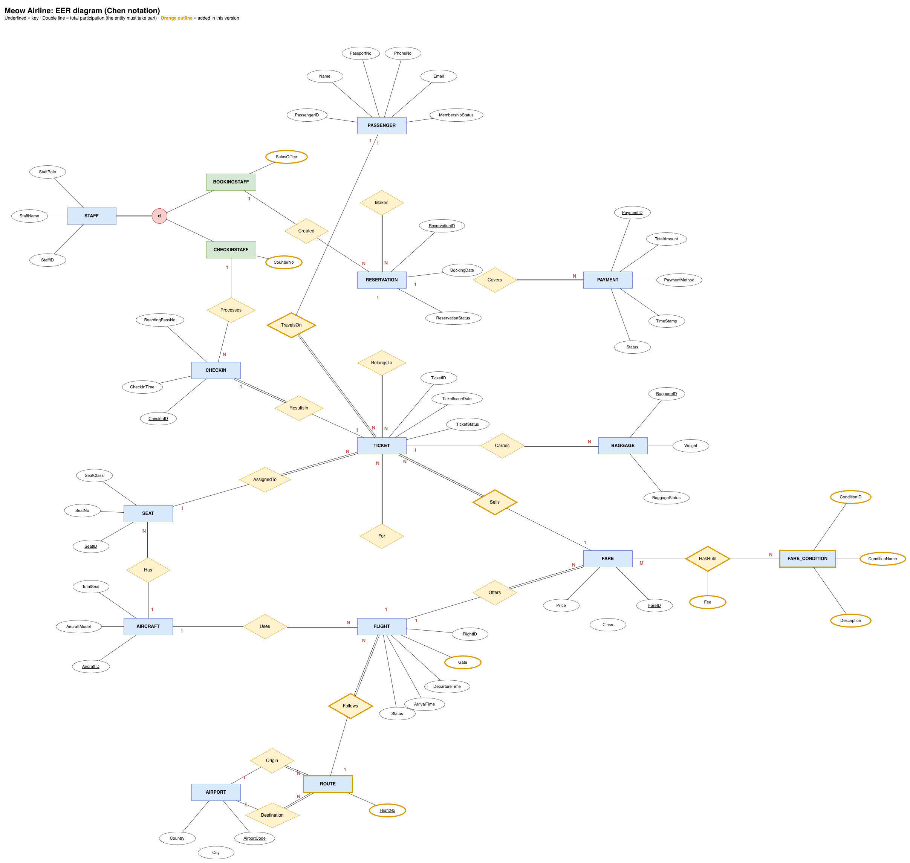
Chen notation. Underlined = key; double line = total participation; orange = added after review. Below: the 17 relations, primary keys underlined, foreign keys in italics.
AIRPORT (AirportCode, City, Country)
AIRCRAFT (AircraftID, AircraftModel, TotalSeat)
PASSENGER (PassengerID, Name, PassportNo, PhoneNo, Email, MembershipStatus)
STAFF (StaffID, StaffName, StaffRole)
BOOKINGSTAFF (StaffID, StaffRole, SalesOffice)
CHECKINSTAFF (StaffID, StaffRole, CounterNo)
SEAT (SeatID, AircraftID, SeatNo, SeatClass)
ROUTE (FlightNo, OriginCode, DestinationCode)
FLIGHT (FlightID, FlightNo, AircraftID, DepartureTime, ArrivalTime, Status, Gate)
FARE (FareID, FlightID, Class, Price)
FARE_CONDITION (ConditionID, ConditionName, Description)
FARE_RULE (FareID, ConditionID, Fee)
RESERVATION (ReservationID, PassengerID, BookingStaffID, BookingDate, ReservationStatus)
TICKET (TicketID, ReservationID, PassengerID, FlightID, SeatID, FareID, TicketIssueDate, TicketStatus, ActiveSeat)
PAYMENT (PaymentID, ReservationID, TotalAmount, PaymentMethod, TimeStamp, Status)
BAGGAGE (BaggageID, TicketID, Weight, BaggageStatus)
CHECKIN (CheckInID, TicketID, CheckInStaffID, CheckInTime, BoardingPassNo)

5 · NORMALIZATION STEPS AND FDS
Three steps to 3NF
Step | Rule | What broke it in our first draft | Fix
1NF | Every cell holds one atomic value | FARE.Rule held several values: a Business fare is refundable, changeable, free seat selection and priority boarding | Conditions moved to FARE_CONDITION, linked by FARE_RULE (FareID, ConditionID, Fee)
2NF | No column depends on only part of a composite key | FLIGHT's key was (FlightNo, DepartureTime), but FlightNo alone decided the route, so MW101's route repeated on every date | FlightNo → OriginCode, DestinationCode moved to the new ROUTE table
3NF | No non-key column depends on another non-key column | FlightID → FlightNo → route was transitive. Gate sat on CHECKIN, so one gate change updated every passenger's row | ROUTE fixes the first; Gate moved to FLIGHT

Functional dependencies (from the business rules, not the sample data)
Table | Functional dependencies | Note
PASSENGER | PassengerID → Name, PassportNo, PhoneNo, Email, MembershipStatus; PassportNo → PassengerID | both determinants are keys
AIRPORT · AIRCRAFT | AirportCode → City, Country · AircraftID → AircraftModel, TotalSeat | City ↛ Country, Model ↛ TotalSeat
ROUTE | FlightNo → OriginCode, DestinationCode | split out of FLIGHT
FLIGHT | FlightID → FlightNo, AircraftID, DepartureTime, ArrivalTime, Status, Gate | (FlightNo, DepartureTime) is UNIQUE
SEAT | SeatID → AircraftID, SeatNo, SeatClass; (AircraftID, SeatNo) → SeatID | both are keys
FARE · FARE_RULE | FareID → FlightID, Class, Price · (FareID, ConditionID) → Fee | Fee needs the whole key (2NF)
RESERVATION | ReservationID → PassengerID, BookingStaffID, BookingDate, ReservationStatus
TICKET | TicketID → ReservationID, PassengerID, FlightID, SeatID, FareID, TicketIssueDate, TicketStatus | kept on purpose: FareID → FlightID
PAYMENT · BAGGAGE | PaymentID → ReservationID, TotalAmount, … · BaggageID → TicketID, Weight, BaggageStatus
CHECKIN | CheckInID → TicketID, CheckInStaffID, CheckInTime, BoardingPassNo; TicketID → CheckInID | every determinant is a key
STAFF + subtypes | StaffID → StaffName, StaffRole; StaffID → SalesOffice / CounterNo | role fixed by CHECK

The one exception. TICKET keeps FareID → FlightID because the BR10 and BR18 UNIQUE keys need FlightID. The composite FK (FareID, FlightID) → FARE makes MySQL reject a fare from another flight, so this redundancy cannot cause an update anomaly. All other tables are in 3NF.

6 · MAPPING · STEP 1 OF 10
Strong entity → one table
Rule
Each strong entity becomes a table with its simple attributes; its key becomes the primary key.
In our EER
PASSENGER, with the key PassengerID and the attributes Name, PassportNo, PhoneNo, Email and MembershipStatus.
In the tables
PASSENGER (PassengerID, Name, PassportNo, PhoneNo, Email, MembershipStatus)

CREATE TABLE PASSENGER (
PassengerID INT NOT NULL AUTO_INCREMENT,
Name VARCHAR(100) NOT NULL,
PassportNo VARCHAR(20) NOT NULL,
PhoneNo VARCHAR(20),
Email VARCHAR(120),
MembershipStatus ENUM('Normal', 'Silver', 'Gold') NOT NULL DEFAULT 'Normal',
CONSTRAINT PASSENGER_PK PRIMARY KEY (PassengerID),
CONSTRAINT PASSENGER_PassportNo_UQ UNIQUE (PassportNo)
);

Why it matters
13 tables come from this step: AIRPORT, AIRCRAFT, PASSENGER, STAFF, SEAT, ROUTE, FLIGHT, FARE, FARE_CONDITION, RESERVATION, PAYMENT, BAGGAGE and CHECKIN. Keys are AUTO_INCREMENT surrogates, except the natural keys AirportCode ('BKK') and FlightNo ('MW101'). PassportNo is UNIQUE: a second candidate key.

6 · MAPPING · STEP 2 OF 10
Weak entity → table with the owner's key
Rule
A weak entity becomes a table whose primary key is the owner's key plus its own partial key.
In our EER
We have no weak entity. SEAT was the candidate: seat number '2A' is only unique inside one aircraft, so SEAT could have been weak, owned by AIRCRAFT.
In the tables
SEAT (SeatID, AircraftID, SeatNo, SeatClass)

CREATE TABLE SEAT (
SeatID INT NOT NULL AUTO_INCREMENT,
AircraftID INT NOT NULL,
SeatNo VARCHAR(4) NOT NULL,
SeatClass ENUM('Economy', 'Business', 'FirstClass') NOT NULL DEFAULT 'Economy',
CONSTRAINT SEAT_PK PRIMARY KEY (SeatID),
CONSTRAINT SEAT_Aircraft_SeatNo_UQ UNIQUE (AircraftID, SeatNo),
CONSTRAINT SEAT_AIRCRAFT_FK FOREIGN KEY (AircraftID)
REFERENCES AIRCRAFT (AircraftID)
ON DELETE CASCADE ON UPDATE CASCADE
);

Why it matters
We gave SEAT its own surrogate key so that TICKET points at one column. The owner rule is kept by UNIQUE (AircraftID, SeatNo) and ON DELETE CASCADE: deleting an aircraft deletes its seats.

6 · MAPPING · STEP 3 OF 10
Binary 1:1 relationship → FK plus UNIQUE
Rule
Put the foreign key on the side with total participation, and make it UNIQUE so each parent row appears at most once.
In our EER
TICKET 1:1 CHECKIN (ResultsIn). A ticket is checked in at most once, and every check-in needs a ticket (double line on the CHECKIN side).
In the tables
CHECKIN (CheckInID, TicketID, CheckInStaffID, CheckInTime, BoardingPassNo)

CREATE TABLE CHECKIN (
CheckInID INT NOT NULL AUTO_INCREMENT,
TicketID INT NOT NULL,
CheckInStaffID INT,
CheckInTime DATETIME NOT NULL DEFAULT CURRENT_TIMESTAMP,
BoardingPassNo VARCHAR(20) NOT NULL,
CONSTRAINT CHECKIN_PK PRIMARY KEY (CheckInID),
CONSTRAINT CHECKIN_Ticket_UQ UNIQUE (TicketID),
CONSTRAINT CHECKIN_BoardingPass_UQ UNIQUE (BoardingPassNo),
CONSTRAINT CHECKIN_TICKET_FK FOREIGN KEY (TicketID)
REFERENCES TICKET (TicketID) ON DELETE CASCADE ON UPDATE CASCADE,
CONSTRAINT CHECKIN_CHECKINSTAFF_FK FOREIGN KEY (CheckInStaffID)
REFERENCES CHECKINSTAFF (StaffID) ON DELETE SET NULL ON UPDATE CASCADE
);

Why it matters
UNIQUE (TicketID) keeps it one-to-one: a second check-in for the same ticket fails with error 1062 (duplicate entry).

6 · MAPPING · STEP 4 OF 10
Binary 1:N relationship → FK on the N side
Rule
The primary key of the 1 side goes into the N side as a foreign key. If the N side has total participation (double line), the FK is NOT NULL.
In our EER
PASSENGER 1:N RESERVATION (Makes). Every reservation must have a booker.
In the tables
RESERVATION (ReservationID, PassengerID, BookingStaffID, BookingDate, ReservationStatus)

PassengerID INT NOT NULL,
...
CONSTRAINT RESERVATION_PASSENGER_FK FOREIGN KEY (PassengerID)
REFERENCES PASSENGER (PassengerID)
ON DELETE RESTRICT ON UPDATE CASCADE

Why it matters
Our most common step, used 12 times: Makes, Has, Uses, Follows, Offers, Covers, BelongsTo, For, AssignedTo, Carries, TravelsOn and Sells. ON DELETE RESTRICT keeps the booking history: a passenger who has bookings cannot be deleted (error 1451).

6 · MAPPING · STEP 5 OF 10
Partial participation → nullable FK
Rule
When the N side of a 1:N relationship may take no part (single line), its foreign key allows NULL.
In our EER
BOOKINGSTAFF 1:N RESERVATION (Created). A reservation made online has no staff member.
In the tables
RESERVATION (ReservationID, PassengerID, BookingStaffID, BookingDate, ReservationStatus)

BookingStaffID INT, -- NULL: booked online, or the staff member left
...
CONSTRAINT RESERVATION_BOOKINGSTAFF_FK FOREIGN KEY (BookingStaffID)
REFERENCES BOOKINGSTAFF (StaffID)
ON DELETE SET NULL ON UPDATE CASCADE

Why it matters
ON DELETE SET NULL keeps a booking when the staff member who made it leaves. CHECKIN.CheckInStaffID works the same way, for self check-in (Processes).

6 · MAPPING · STEP 6 OF 10
Binary M:N relationship → bridge table
Rule
A new table holds the keys of both sides as foreign keys; together they form its primary key. The relationship's own attributes move into it.
In our EER
FARE M:N FARE_CONDITION (HasRule), with the attribute Fee on the relationship: for example, a 500 THB change fee on an Economy fare.
In the tables
FARE_RULE (FareID, ConditionID, Fee)

CREATE TABLE FARE_RULE (
FareID INT NOT NULL,
ConditionID INT NOT NULL,
Fee DECIMAL(10,2) NOT NULL DEFAULT 0.00,
CONSTRAINT FARE_RULE_PK PRIMARY KEY (FareID, ConditionID),
CONSTRAINT FARE_RULE_Fee_CK CHECK (Fee >= 0),
CONSTRAINT FARE_RULE_FARE_FK FOREIGN KEY (FareID)
REFERENCES FARE (FareID) ON DELETE CASCADE ON UPDATE CASCADE,
CONSTRAINT FARE_RULE_CONDITION_FK FOREIGN KEY (ConditionID)
REFERENCES FARE_CONDITION (ConditionID) ON DELETE RESTRICT ON UPDATE CASCADE
);

Why it matters
Fee needs both parts of the key, so there is no partial dependency (2NF). This is BR19. RESTRICT stops deleting a condition that fares still use (Q18d, error 1451).

6 · MAPPING · STEP 7 OF 10
Associative entity → its own table
Rule
An M:N relationship that has its own data and its own relationships is drawn as an associative entity. It becomes a table, and each of its relationships becomes a foreign key.
In our EER
RESERVATION M:N FLIGHT is drawn as the entity TICKET, because each ticket also has a seat, a fare and a traveller.
In the tables
TICKET (TicketID, ReservationID, PassengerID, FlightID, SeatID, FareID, TicketIssueDate, TicketStatus, ActiveSeat)

CONSTRAINT TICKET_Seat_On_Flight_UQ UNIQUE (FlightID, SeatID, ActiveSeat), -- BR10
CONSTRAINT TICKET_Passenger_On_Flight_UQ UNIQUE (FlightID, PassengerID, ActiveSeat), -- BR18
CONSTRAINT TICKET_FARE_FK FOREIGN KEY (FareID, FlightID)
REFERENCES FARE (FareID, FlightID) ON DELETE RESTRICT ON UPDATE RESTRICT -- BR15

Why it matters
Five foreign keys, covering BR6, BR10, BR15 and BR18. TICKET keeps its own key, not (ReservationID, FlightID), because a family of 3 on one reservation holds 3 tickets on the same flight. ActiveSeat is generated from TicketStatus (NULL when cancelled), so a cancelled seat can be sold again.

6 · MAPPING · STEP 8 OF 10
Multivalued attribute → separate table
Rule
A multivalued attribute gets its own table, holding the owner's key and one value per row, so every cell is atomic (1NF).
In our EER
In our first draft FARE had one Rule attribute, but a Business fare is refundable, changeable, free seat selection and priority boarding: four values in one cell.
In the tables
FARE_CONDITION (ConditionID, ConditionName, Description)

CREATE TABLE FARE_CONDITION (
ConditionID INT NOT NULL AUTO_INCREMENT,
ConditionName VARCHAR(40) NOT NULL,
Description VARCHAR(200),
CONSTRAINT FARE_CONDITION_PK PRIMARY KEY (ConditionID),
CONSTRAINT FARE_CONDITION_Name_UQ UNIQUE (ConditionName)
);

Why it matters
Because the same 4 conditions repeat across many fares, we made them an entity of their own and linked them to FARE through the FARE_RULE bridge (step 6), instead of a plain (FareID, Rule) table.

6 · MAPPING · STEP 9 OF 10
Specialisation → one table per subtype
Rule
The supertype gets a table, and each subtype gets a table that shares the supertype's key as its primary key and a foreign key, plus its own attributes.
In our EER
STAFF is either BOOKINGSTAFF or CHECKINSTAFF: disjoint (d) and total (double line).
In the tables
BOOKINGSTAFF (StaffID, StaffRole, SalesOffice)

CREATE TABLE BOOKINGSTAFF (
StaffID INT NOT NULL,
StaffRole ENUM('BookingStaff', 'CheckInStaff') NOT NULL DEFAULT 'BookingStaff',
SalesOffice VARCHAR(50) NOT NULL,
CONSTRAINT BOOKINGSTAFF_PK PRIMARY KEY (StaffID),
CONSTRAINT BOOKINGSTAFF_Role_CK CHECK (StaffRole = 'BookingStaff'),
CONSTRAINT BOOKINGSTAFF_STAFF_FK FOREIGN KEY (StaffID, StaffRole)
REFERENCES STAFF (StaffID, StaffRole) ON DELETE RESTRICT ON UPDATE RESTRICT
);

Why it matters
STAFF (StaffID, StaffName, StaffRole) is the supertype; CHECKINSTAFF (StaffID, StaffRole, CounterNo) mirrors BOOKINGSTAFF. Each subtype stores the role, fixed by a CHECK, and its FK points at (StaffID, StaffRole), so MySQL itself makes the split disjoint (BR14).

6 · MAPPING · STEP 10 OF 10
Two roles on the same entity → two FKs
Rule
When an entity takes part in two relationships with the same entity, each relationship becomes its own foreign key, named after its role.
In our EER
AIRPORT 1:N ROUTE twice: once as the Origin and once as the Destination of a route.
In the tables
ROUTE (FlightNo, OriginCode, DestinationCode)

CREATE TABLE ROUTE (
FlightNo VARCHAR(6) NOT NULL,
OriginCode CHAR(3) NOT NULL,
DestinationCode CHAR(3) NOT NULL,
CONSTRAINT ROUTE_PK PRIMARY KEY (FlightNo),
CONSTRAINT ROUTE_Airports_CK CHECK (OriginCode <> DestinationCode),
CONSTRAINT ROUTE_ORIGIN_FK FOREIGN KEY (OriginCode)
REFERENCES AIRPORT (AirportCode) ON DELETE RESTRICT ON UPDATE RESTRICT,
CONSTRAINT ROUTE_DESTINATION_FK FOREIGN KEY (DestinationCode)
REFERENCES AIRPORT (AirportCode) ON DELETE RESTRICT ON UPDATE RESTRICT
);

Why it matters
Both FKs point at AIRPORT (BR1, BR2). The CHECK then stops a route from BKK to BKK (BR7): Q18a fails with error 3819.

7 · DDL AND DML
DDL builds the rules in; DML fills and tests them
Three files, all running with 0 errors on MySQL 8.4: db/schema.sql (42 DDL statements), db/seed.sql (sample data for all 17 tables) and db/queries.sql (20 queries).
DDL: CREATE DATABASE and the 17 tables, in the Lecture 8 order
Step | What we used | Example
Data types | INT AUTO_INCREMENT keys, CHAR(3), VARCHAR, DECIMAL(10,2) money, DATETIME, ENUM | Price DECIMAL(10,2), AirportCode CHAR(3)
Nullable | NOT NULL everywhere except 7 optional columns | BookingStaffID NULL = booked online
Unique | 10 UNIQUE keys | TICKET_Seat_On_Flight_UQ (BR10)
PK / FK | 17 PKs, 21 FKs, each with a chosen ON DELETE / ON UPDATE | RESTRICT, CASCADE, SET NULL
Defaults | 12 defaults | MembershipStatus 'Normal', BookingDate CURRENT_DATE
Domain checks | 9 CHECK constraints | OriginCode <> DestinationCode (BR7)
Triggers | 2 triggers for rules across tables | seat on the right aircraft, seat class = fare class

DML: sample data and the 20 queries
Group | Queries | What they show
3 business questions | Q1–Q3 | free seats per class (O4), a passenger's bookings and payments, income per route (O3)
Single table | Q4–Q6 | BETWEEN, ORDER BY, LIKE, IS NULL, GROUP BY + HAVING
Joins | Q7–Q13, Q19, Q20 | 3–5 table joins, LEFT JOIN + IS NULL, CASE, IN
View | Q14 | CREATE VIEW v_flight_load
UPDATE / DELETE | Q15–Q17 | UPDATE by PK, DELETE refused by RESTRICT (1451), DELETE that CASCADEs
Rules refused | Q18a–f | CHECK 3819, UNIQUE 1062 ×2, RESTRICT 1451, trigger 1644 ×2

INSERT INTO ROUTE (FlightNo, OriginCode, DestinationCode) VALUES ('MW999', 'BKK', 'BKK');
-- Error Code: 3819. Check constraint 'ROUTE_Airports_CK' is violated.

8 · DATABASE SYSTEM ARCHITECTURE
How the web page reaches MySQL
Three tiers: the browser shows EJS pages, an Express server runs the business logic, and MySQL stores the data and enforces the rules. The browser never talks to MySQL directly.
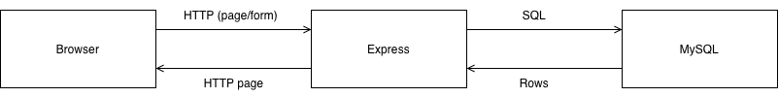
One request, step by step (an agent books a ticket)
1. The agent submits the booking form; the browser sends an HTTP POST to Express.
2. Express matches the URL to a route in routes/, which calls its controller in controllers/.
3. The controller checks the input, takes a connection from the shared pool in config/db.js and sends SQL with ? placeholders.
4. MySQL runs it in one transaction and checks every constraint and trigger: it commits the reservation and all its tickets, or rolls everything back.
5. Express renders an EJS page from views/ with the result (or MySQL's error as a friendly message) and sends the HTML back.
Part | Where | What it does
Connection pool | config/db.js (mysql2) | One shared pool of MySQL connections for every controller
Credentials | .env, not in Git | Host, user, password and database name
Routes | routes/ | Map each URL to a controller function
Controllers | controllers/ | Validate input, run SQL in transactions, handle errors
Views | views/ (EJS) | HTML pages and forms, including the 3 report pages

Safety. Every query uses ? placeholders, so typed input never runs as SQL. A booking is all or nothing. The rules live in MySQL, so even a backend bug cannot double-book a seat.

9 · TECH STACK
The tools we used
Free, widely used tools from the course: MySQL for the data, Node.js with Express for the server, and EJS for the pages.
Layer | Tool | Used for
Database | MySQL 8.4 | 17 tables, constraints, 2 triggers, 1 view
Database tools | MySQL Workbench, DBeaver | Running the SQL files, screenshots
Backend | Node.js, Express | Routes and controllers
Database driver | mysql2 | Connection pool, ? placeholders, transactions
Frontend | EJS templates, HTML, CSS, JavaScript | Booking, check-in and report pages
Design | draw.io (diagrams.net) | The EER diagram
Teamwork | Git, GitHub | One shared main branch; each person confirms before pushing
Hosting | Local laptop | The live demo runs MySQL and the Node server on one laptop; no cloud

10 · MILESTONES
Ten days, from proposal to presentation
Mon 5 – Thu 15 October 2026, split into phases with one owner and one reviewer each.
Phase | What | Dates | Owner | Reviewer | Status
1 | Proposal and pitch | Before 5 Oct | All | — | Done
0 | Setup, learn MySQL, practice Passenger CRUD | Mon 5 – Tue 6 | All | — | Done
2 | Fix the ERD, relational model, FDs and 3NF | Mon 5 – Tue 6 | Patarawadee | Kawinthida, Kornnaphat | Done
3 | schema.sql and seed.sql running; schema frozen | Wed 7 – Thu 8 | Patarawadee | Kawinthida | Done (frozen Wed 7)
4 | Backend routes and controllers | Fri 9 – Mon 12 | Kawinthida | Patarawadee | Done (Thu 8)
5a | queries.sql and result captures | Fri 9 – Sun 11 | Kawinthida, Kornnaphat | Patarawadee | Done (Thu 8)
5b | Frontend pages and the 3 report pages | Sat 10 – Mon 12 | Kornnaphat | Patarawadee | Done (Thu 8)
6 | Report, slides, rehearsal, Mango upload | Tue 13 – Wed 14 | All | — | In progress
— | Presentation | Thu 15 Oct | All | —

Until Wed 7 Oct changes reached main through GitHub pull requests; from Thu 8 Oct everyone pushes straight to main after confirming the push.

11 · THE UI
The UI: the whole demo on one shared database
Book the Jaidee family of 3 on MW101 (seats 3B, 3C, 3D) → pay 4,500 THB → issue the tickets → check in → read the reports.
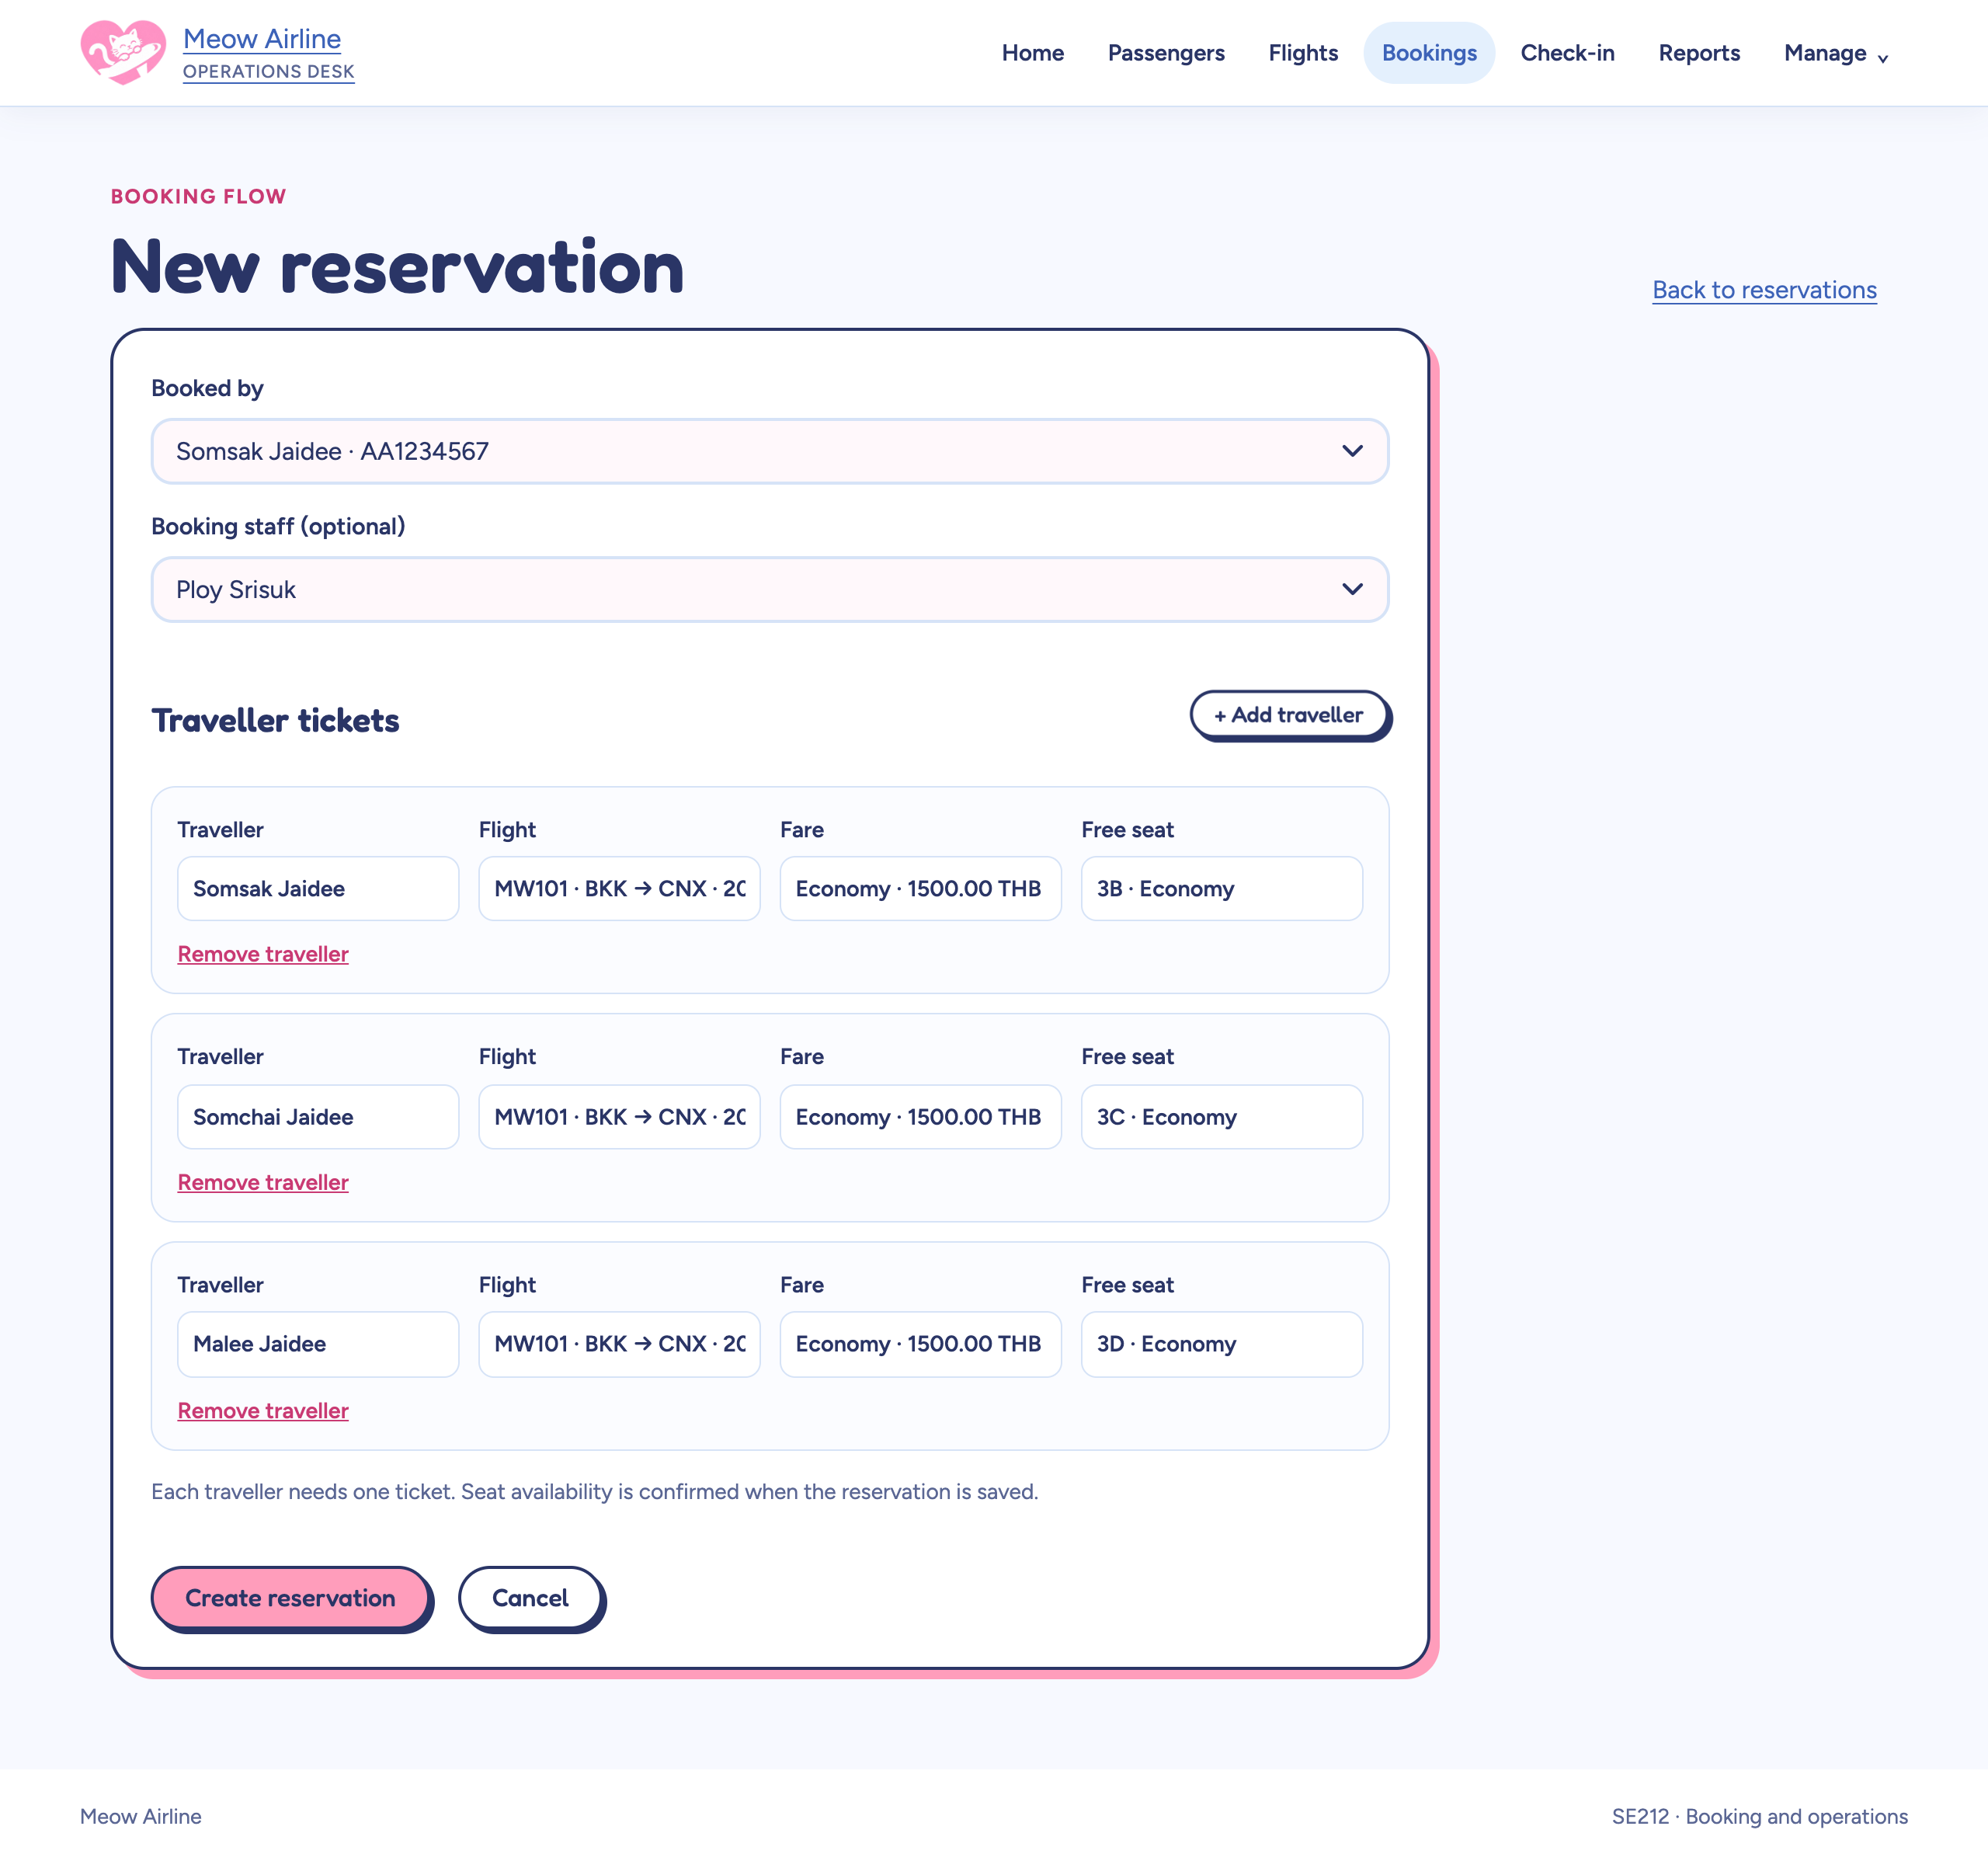  1 · Book a family of 3 | 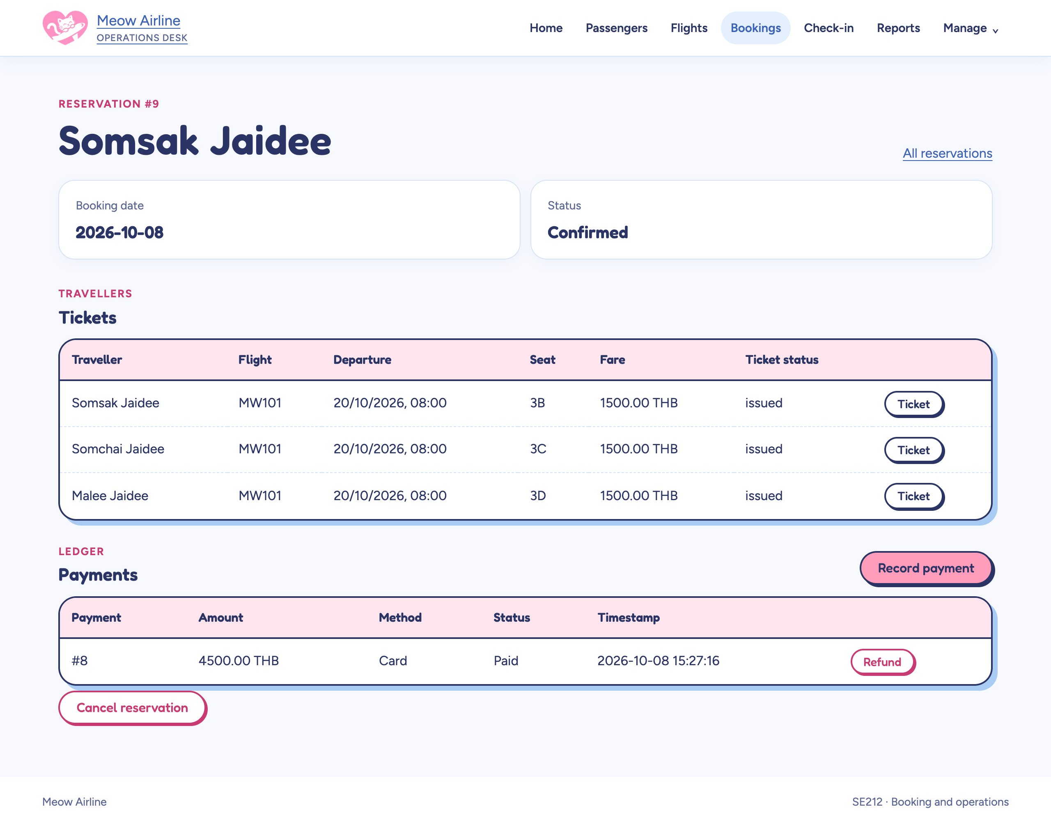  2 · Pay and issue
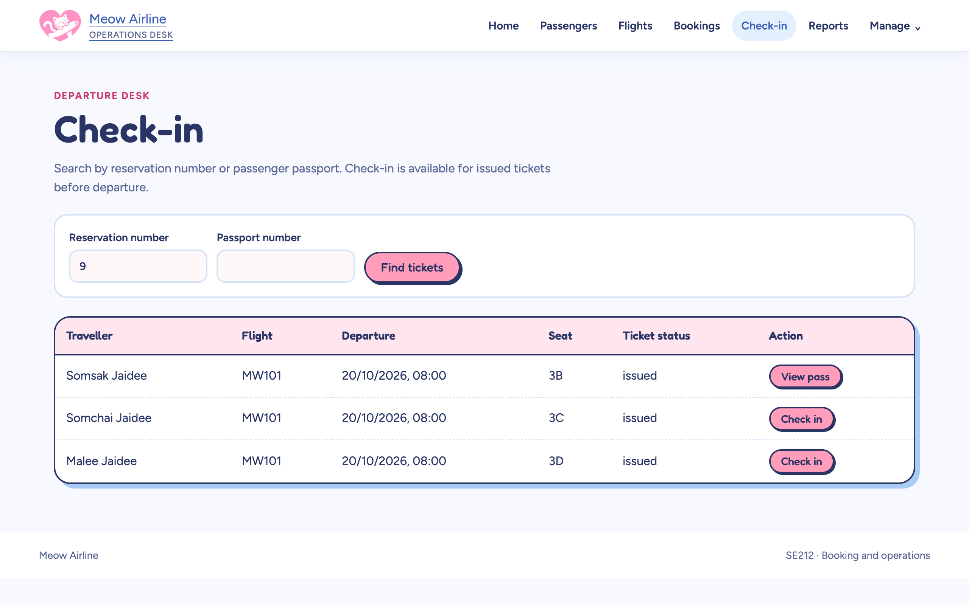  3 · Check in | 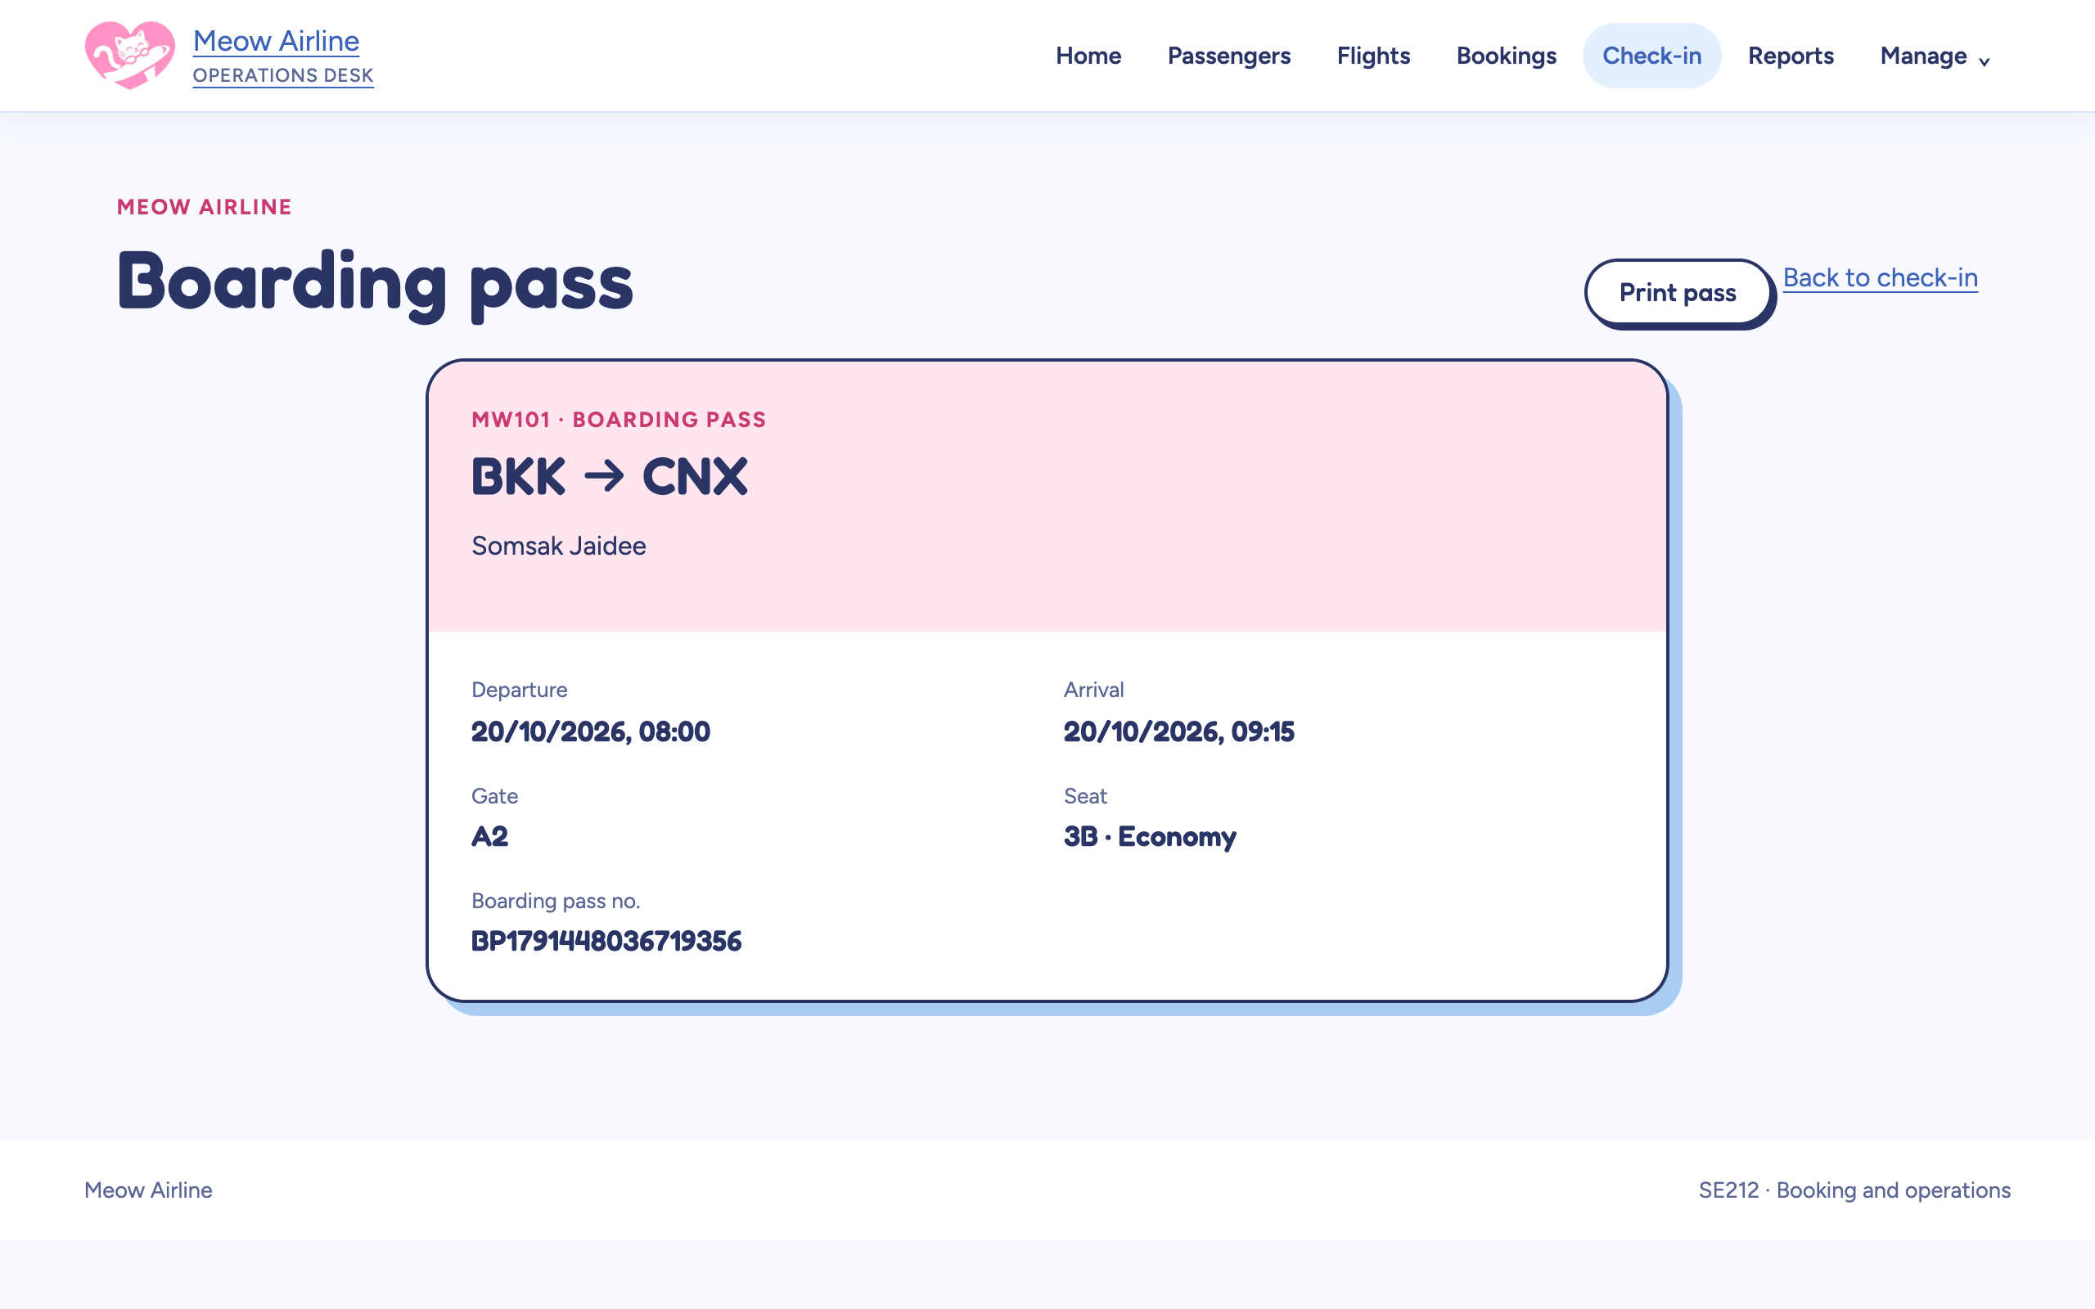  4 · Boarding pass
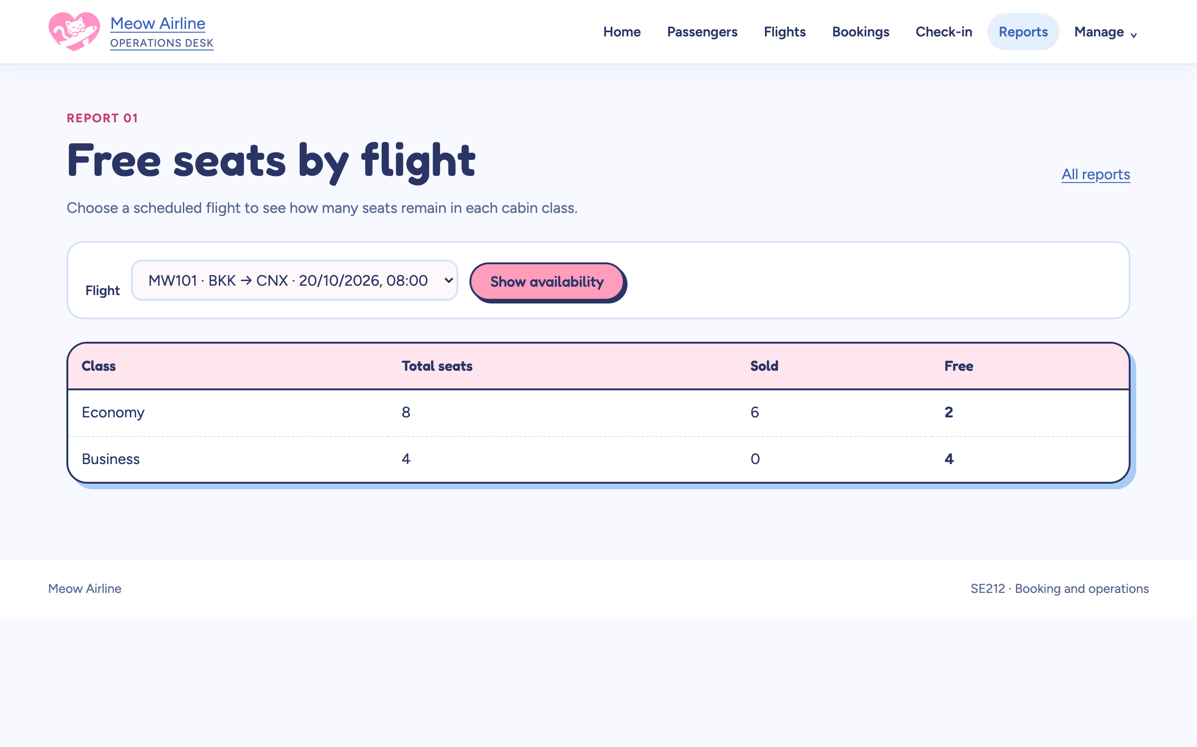  5 · Report: free seats (Q1) | 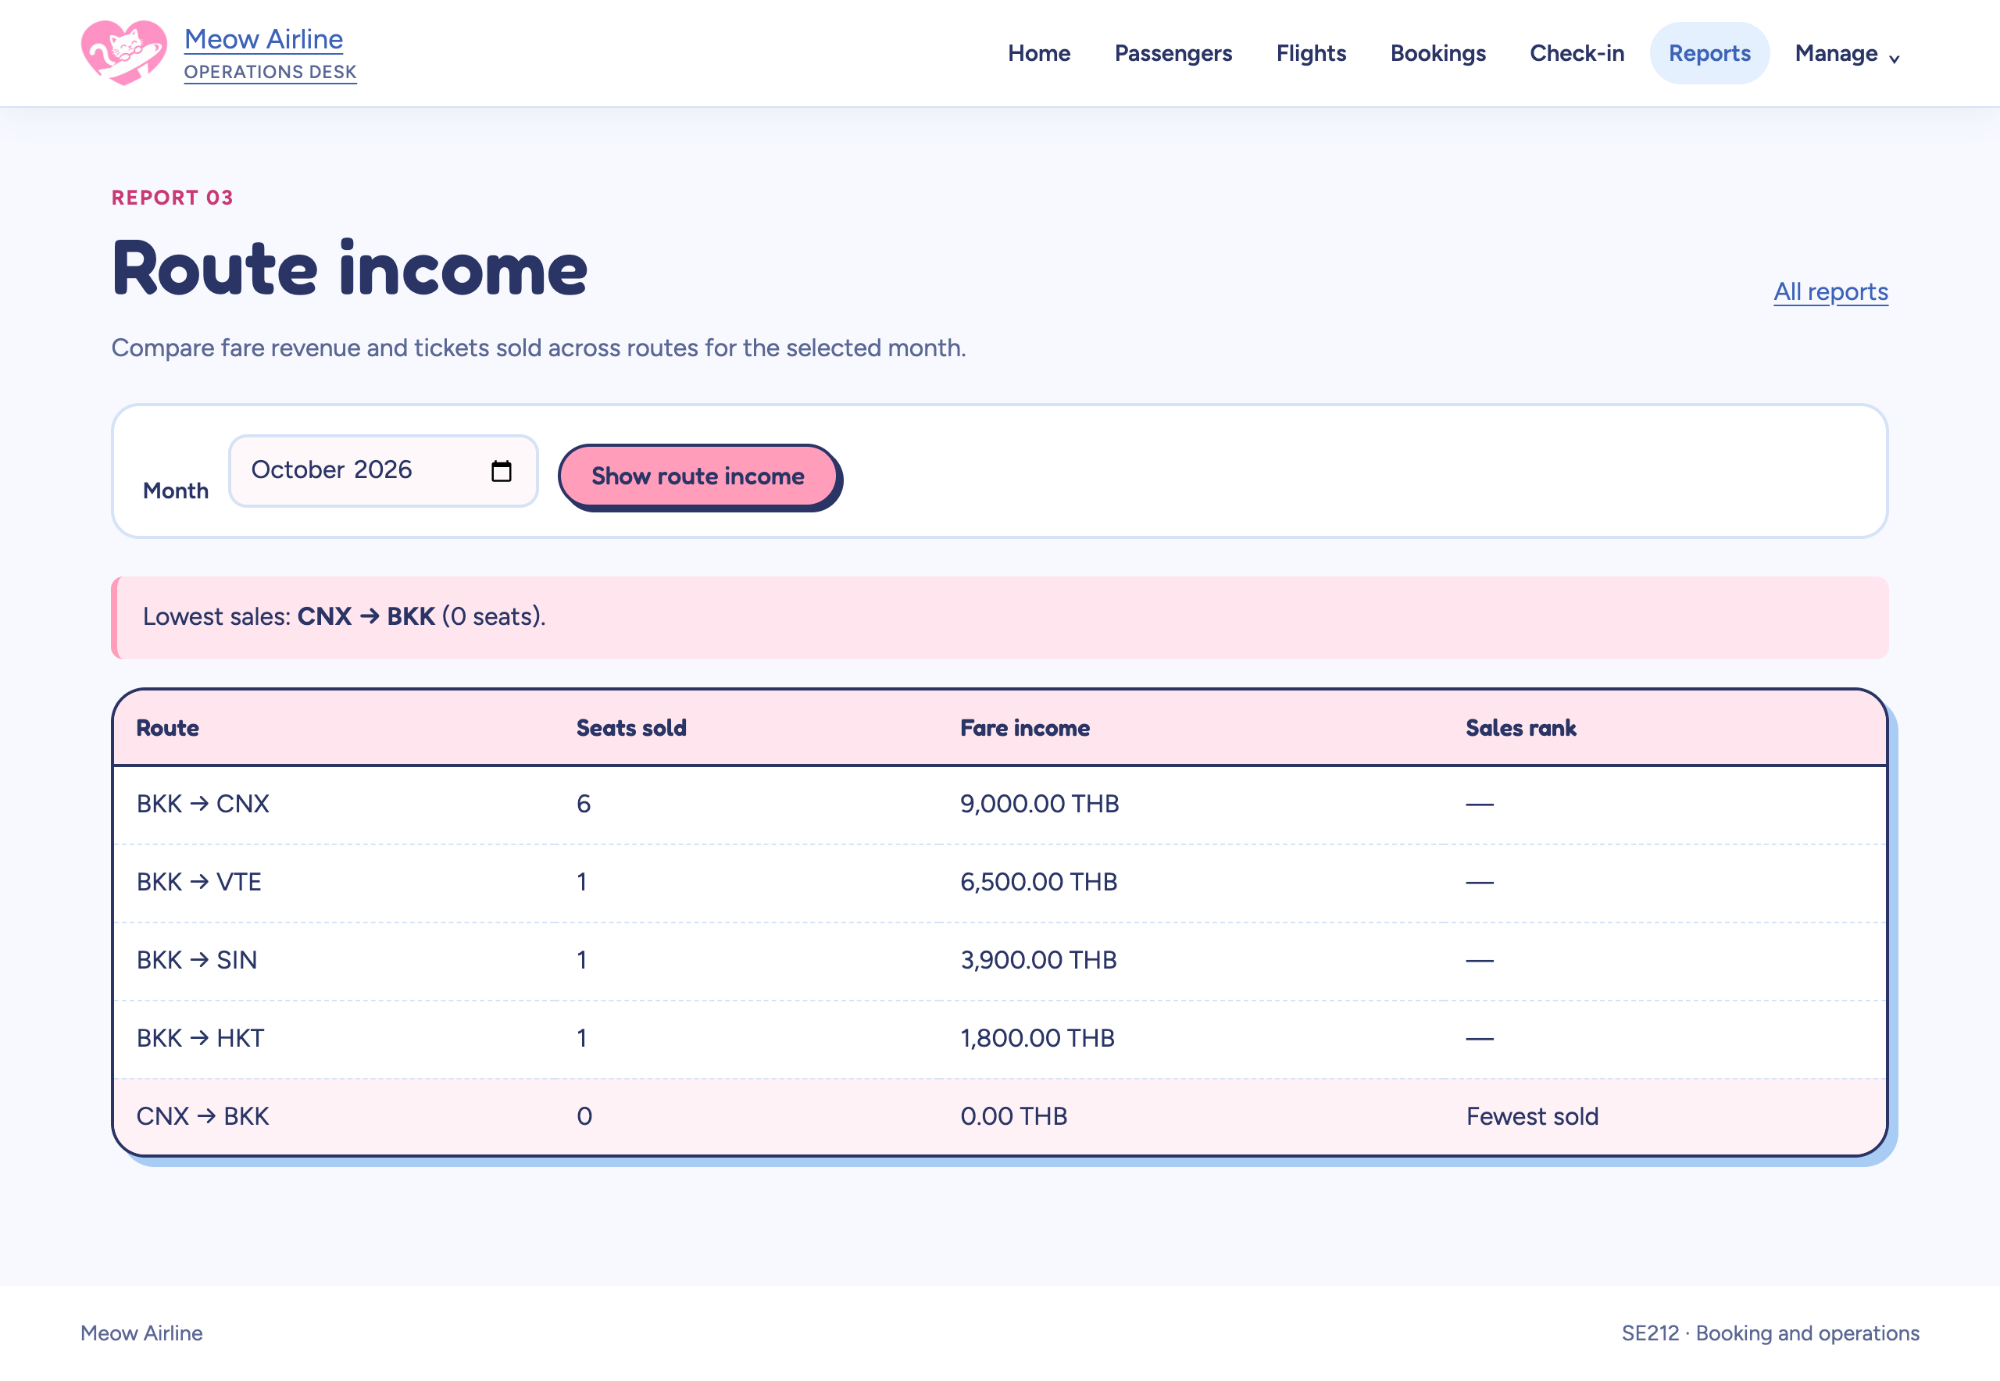  6 · Report: route income (Q3)
Every rule shown in this report holds in the app: a second sale of 3B is refused, a ticket cannot be issued before payment, and a checked-in booking cannot be cancelled.

