Table of Contents

Meow Airline: Booking Database Report
Patarawadee Kunna, Kawinthida Kantong, Kornnaphat Uttama · 8 October 2026
Course: 953212 (SE212) Database Systems · Term project report
Presentation and submission: Thursday 15 October 2026
Member | Student ID | Role
Patarawadee Kunna | 682115034 | Database: EER, relational model, 3NF, schema and seed data
Kawinthida Kantong | 682115002 | Backend: Express routes, controllers and SQL queries
Kornnaphat Uttama | 682115001 | Frontend: EJS pages, the 3 report pages and SQL queries
Source code: github.com/tapimeow/Meow-Airline-SE212

1. Introduction and business background
Meow Airline is a small regional airline that flies 6 aircraft on domestic Thai routes and to Singapore and Vientiane. Its agents book passengers, take payment and check them in at the airport. This report designs and builds the MySQL database that replaces the airline’s spreadsheet.
How the business works today. Every booking lives in one shared Excel file, and agents coordinate in LINE chats. Nothing stops two agents from selling the same seat, because the file has no rules. A booking takes about 8 minutes, and every report is counted by hand.
Who uses the system.
User | What they do
Booking staff | Create reservations for passengers, issue tickets after payment
Check-in staff | Check passengers in at the counter, record baggage, print boarding passes
Passenger | Books (online or through an agent) and travels on one or more tickets
Manager | Reads the income and seat reports
Our goals (from the proposal).
# | Goal | How the database meets it
O1 | Zero double-booked seats | A UNIQUE key on TICKET refuses a second live ticket for a seat (BR10)
O2 | A booking in under 2 minutes (now about 8) | One booking page and one transaction for the reservation and all its tickets
O3 | The income report in under 10 seconds | Income per route is one SQL query (Q3)
O4 | Live free seats per flight by class | The view v_flight_load (Q14)

2. Motivation
A spreadsheet has no rules: it cannot stop two agents from selling seat 2A on the same flight, and it cannot tell the manager which route earned the least last month without counting by hand. We want one MySQL database that every agent shares, that refuses a double booking by itself, and that answers the airline’s three key questions in seconds: how many seats are free on a flight (Q1), what a passenger has booked and paid (Q2), and how much each route earned (Q3). Putting the business rules into the database, not into people’s memory, is what makes the data trustworthy.

3. Business rules
The system keeps 19 business rules. BR1–BR15 come from the proposal; BR16–BR19 were added when the team reviewed the ERD. 15 of them are enforced by MySQL itself, so no program can break them; the other 4 need data from several rows or the clock and are checked in the backend.
BR | Rule | Enforced by
BR1 | A flight has exactly one origin airport | DB: NOT NULL FK ROUTE.OriginCode, and FLIGHT.FlightNo → ROUTE
BR2 | A flight has exactly one destination airport | DB: NOT NULL FK ROUTE.DestinationCode
BR3 | A flight uses exactly one aircraft | DB: NOT NULL FK FLIGHT.AircraftID
BR4 | A seat belongs to exactly one aircraft | DB: NOT NULL FK SEAT.AircraftID
BR5 | A reservation is made by exactly one passenger | DB: NOT NULL FK RESERVATION.PassengerID
BR6 | A reservation can cover many flights and a flight many reservations (M:N, through TICKET) | DB: the TICKET table
BR7 | Origin and destination must differ | DB: CHECK ROUTE_Airports_CK
BR8 | A ticket is issued only after payment | Backend: ticket controller
BR9 | Baggage is optional | DB: no required FK from TICKET to BAGGAGE
BR10 | A seat can be on only one live ticket per flight | DB: UNIQUE TICKET_Seat_On_Flight_UQ
BR11 | The seats of an aircraft cannot exceed its TotalSeat | Backend: seat controller
BR12 | Bag weight per ticket ≤ class limit: Economy 20 kg, Business 30 kg, FirstClass 40 kg | Backend: baggage controller
BR13 | Check-in only for an issued ticket, before the flight departs | Backend: check-in controller
BR14 | A staff member is booking staff or check-in staff, never both | DB: composite FK (StaffID, StaffRole) + CHECK on the role
BR15 | A fare belongs to one flight, and a ticket’s fare must be for the ticket’s flight | DB: composite FK TICKET_FARE_FK (FareID, FlightID)
BR16 | Booking staff create reservations; each reservation has at most one creator | DB: FK RESERVATION.BookingStaffID
BR17 | Check-in staff process check-ins; each check-in has at most one processor | DB: FK CHECKIN.CheckInStaffID
BR18 | Each ticket names one traveller, who holds at most one live ticket per flight | DB: FK TICKET.PassengerID + UNIQUE TICKET_Passenger_On_Flight_UQ
BR19 | A fare can have many conditions and a condition many fares; each pair records its fee | DB: FARE_RULE (composite PK, 2 FKs, CHECK Fee >= 0)
Two more TICKET rules span several tables, so triggers check them: the seat must be on the flight’s aircraft, and the seat class must match the fare class (section 7.2, step 7).

4. ERD and tables

4.1 EER diagram
Meow Airline’s EER diagram (Chen notation) has 16 entity types (including the two staff subtypes), one disjoint and total specialisation (STAFF), and two many-to-many relationships.
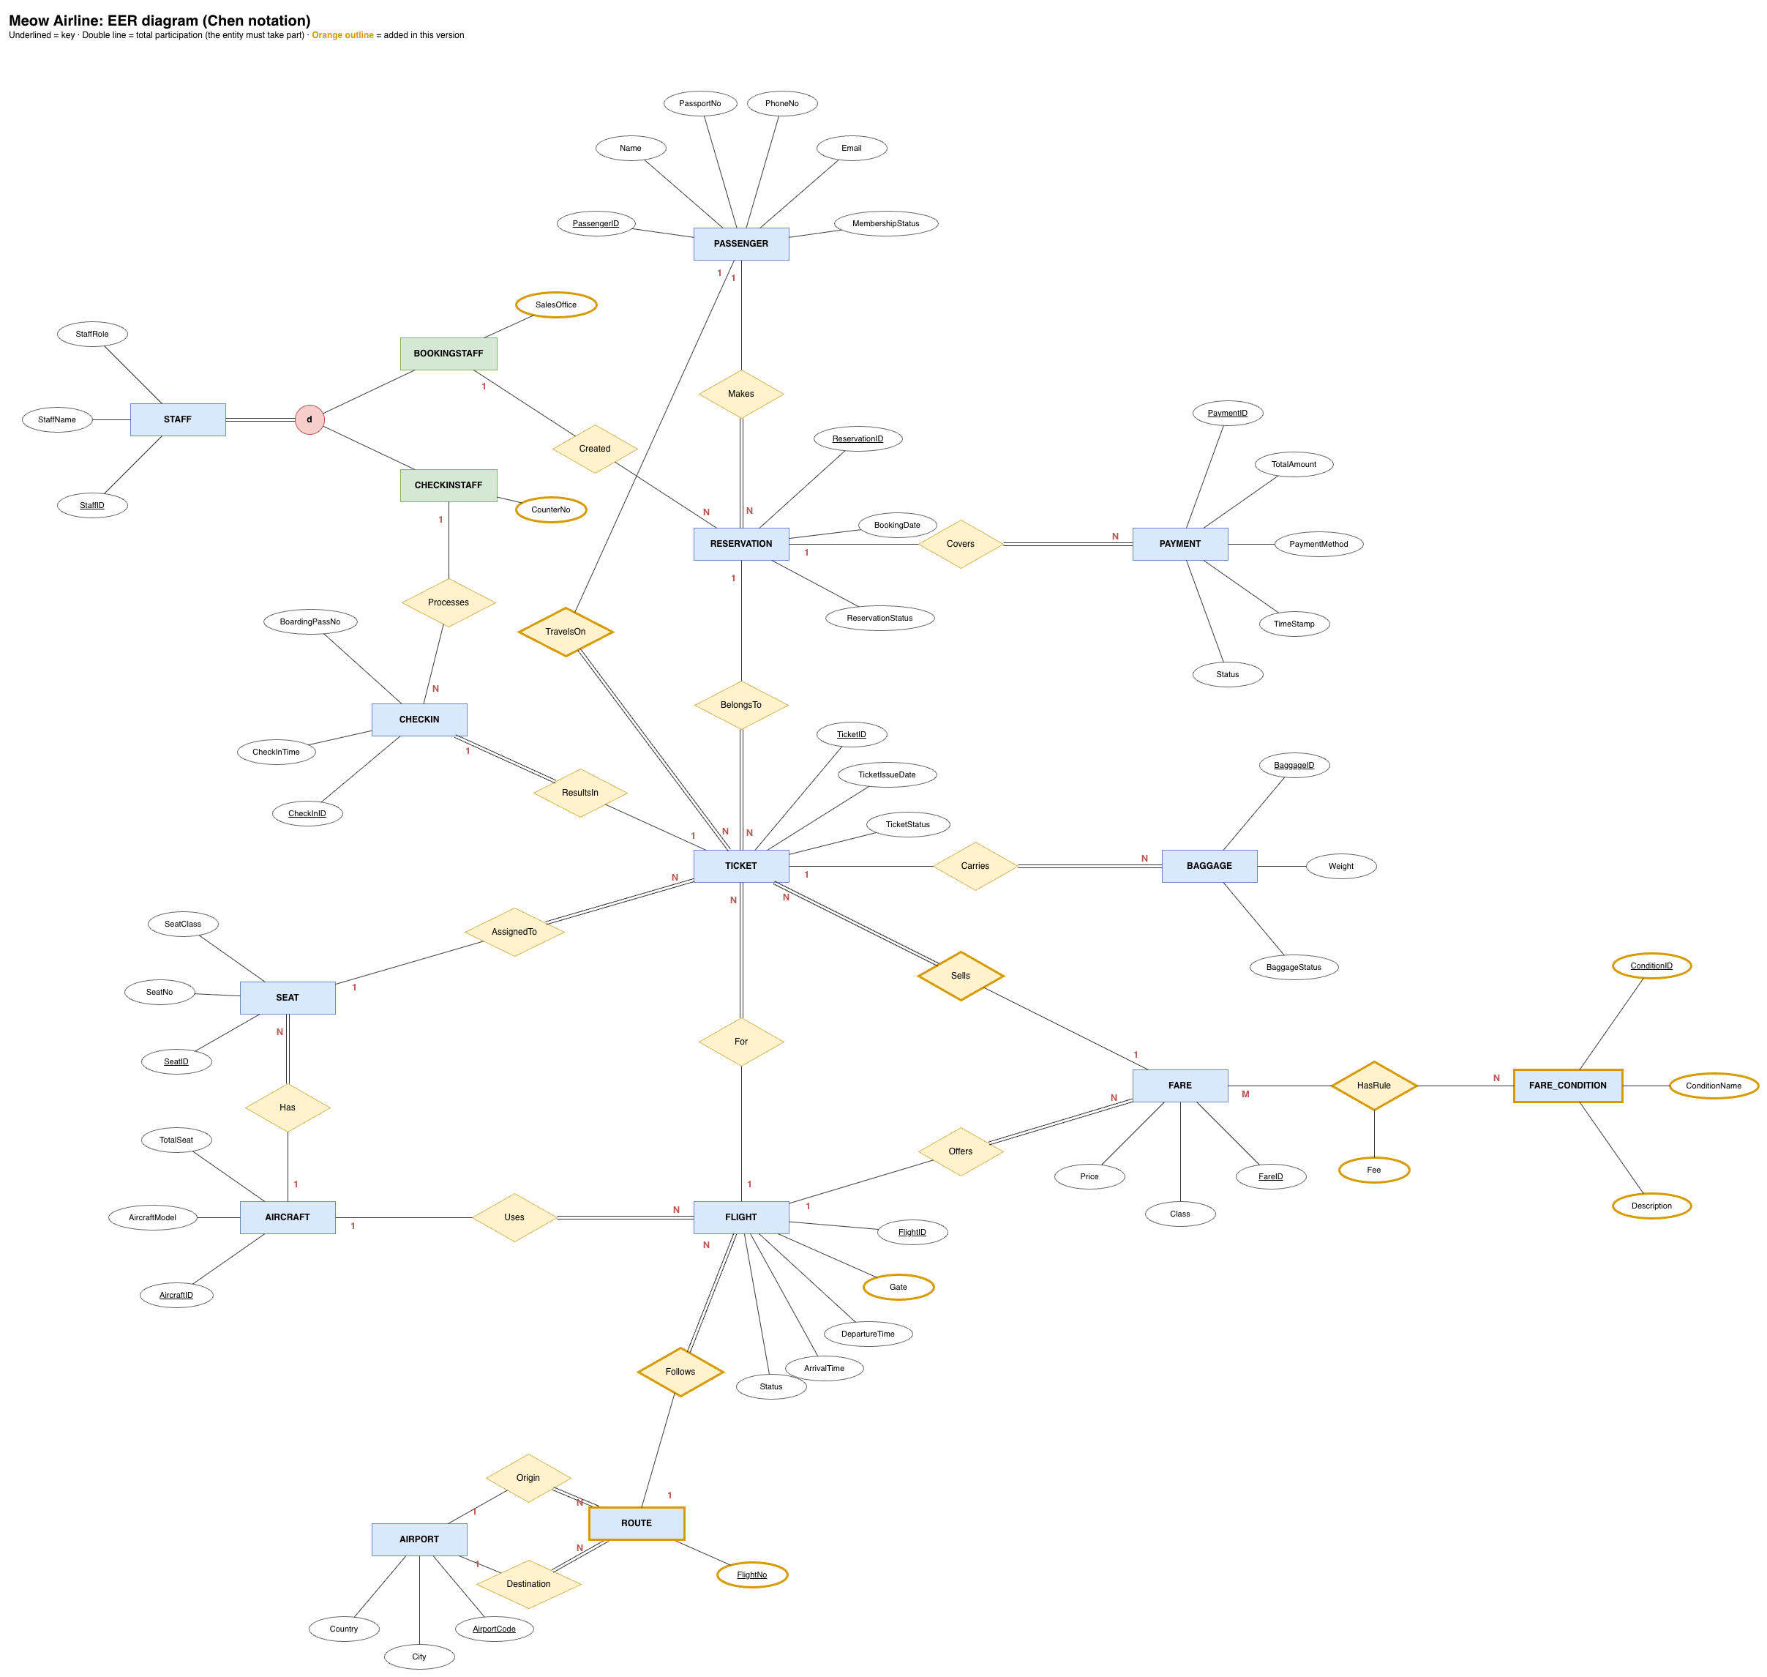
Meow Airline EER diagram in Chen notation
Underlined attributes are keys. A double line means total participation: every TICKET must belong to a RESERVATION, for example. Orange outlines mark what was added after the first review.
How to read it:
- Booking core. A PASSENGER Makes RESERVATIONs (1:N). Each RESERVATION holds TICKETs (BelongsTo, 1:N), and each TICKET names its traveller (TravelsOn), so one booker can book a family of 3.
- First M:N: RESERVATION ⇄ FLIGHT, resolved by TICKET. A ticket links a reservation to one FLIGHT (For), one SEAT (AssignedTo) and one FARE (Sells).
- Second M:N: FARE ⇄ FARE_CONDITION (HasRule). The relationship carries its own attribute, Fee: the cost of that condition on that fare.
- Flights and aircraft. An AIRCRAFT Has SEATs and flies FLIGHTs (Uses). Each FLIGHT Follows one ROUTE, whose Origin and Destination are AIRPORTs, and Offers FAREs.
- After booking. A RESERVATION is Covered by PAYMENTs, and a TICKET Carries BAGGAGE and ResultsIn at most one CHECKIN (1:1).
- Staff specialisation (d, double line). Every STAFF member is exactly one of BOOKINGSTAFF or CHECKINSTAFF. Booking staff Create reservations; check-in staff Process check-ins.
Updated Wed 7 Oct for the team’s 3NF decisions: the new ROUTE entity (Follows, ROUTE 1:N FLIGHT, with FlightNo as its key), Gate moved from CHECKIN to FLIGHT, and SalesOffice / CounterNo on the two staff subtypes. All are outlined in orange.

4.2 Tables: the 17 relations
The EER maps to 17 relations, all in 3NF except one deliberate, database-guarded exception in TICKET. Bold = primary key (underline it in the final report), italic = foreign key, UQ = another candidate key.
Relations, parents first in create order:
- AIRPORT (AirportCode, City, Country)
- AIRCRAFT (AircraftID, AircraftModel, TotalSeat)
- PASSENGER (PassengerID, Name, PassportNo, PhoneNo, Email, MembershipStatus). UQ: PassportNo
- STAFF (StaffID, StaffName, StaffRole). UQ: (StaffID, StaffRole)
- BOOKINGSTAFF (StaffID, StaffRole, SalesOffice)
- CHECKINSTAFF (StaffID, StaffRole, CounterNo)
- SEAT (SeatID, AircraftID, SeatNo, SeatClass). UQ: (AircraftID, SeatNo)
- ROUTE (FlightNo, OriginCode, DestinationCode)
- FLIGHT (FlightID, FlightNo, AircraftID, DepartureTime, ArrivalTime, Status, Gate). UQ: (FlightNo, DepartureTime)
- FARE (FareID, FlightID, Class, Price). UQ: (FareID, FlightID)
- FARE_CONDITION (ConditionID, ConditionName, Description). UQ: ConditionName
- FARE_RULE (FareID, ConditionID, Fee)
- RESERVATION (ReservationID, PassengerID, BookingStaffID, BookingDate, ReservationStatus)
- TICKET (TicketID, ReservationID, PassengerID, FlightID, SeatID, FareID, TicketIssueDate, TicketStatus, ActiveSeat). UQ: (FlightID, SeatID, ActiveSeat), (FlightID, PassengerID, ActiveSeat)
- PAYMENT (PaymentID, ReservationID, TotalAmount, PaymentMethod, TimeStamp, Status)
- BAGGAGE (BaggageID, TicketID, Weight, BaggageStatus)
- CHECKIN (CheckInID, TicketID, CheckInStaffID, CheckInTime, BoardingPassNo). UQ: TicketID, BoardingPassNo

5. Normalization steps and FDs
All 17 tables reach 3NF except one deliberate, database-guarded exception in TICKET (section 5.2). We normalized in three steps, each removing one kind of bad dependency.

5.1 The three steps
Step | Rule | What broke it in our first draft | Fix
1NF | Every cell holds one atomic value | FARE.Rule held several values: a Business fare is refundable, changeable, free seat selection and priority boarding | Conditions moved to FARE_CONDITION, linked by FARE_RULE (FareID, ConditionID, Fee)
2NF | No non-key column depends on only part of a composite key | FLIGHT’s key was (FlightNo, DepartureTime), but FlightNo alone decided OriginCode and DestinationCode, so MW101’s route repeated on every date | FlightNo → OriginCode, DestinationCode moved to the new ROUTE table
3NF | No non-key column depends on another non-key column | FlightID → FlightNo → route was transitive. Gate sat on CHECKIN, so one gate change updated every passenger’s row | ROUTE fixes the first; Gate moved to FLIGHT
The key FDs after normalization:
- FlightNo → OriginCode, DestinationCode (ROUTE)
- (FareID, ConditionID) → Fee (FARE_RULE)
- SeatID → AircraftID, SeatNo, SeatClass; (AircraftID, SeatNo) → SeatID (SEAT)
- TicketID → ReservationID, PassengerID, FlightID, SeatID, FareID, TicketIssueDate, TicketStatus (TICKET)

5.2 Functional dependencies and the 3NF check per table
FDs come from the business rules, not from the sample data (Lecture 7). Each table is checked for 1NF (atomic values), 2NF (no dependency on part of a composite key) and 3NF (no non-key → non-key dependency).
Table | Functional dependencies | 1NF | 2NF | 3NF | Why
PASSENGER | PassengerID → Name, PassportNo, PhoneNo, Email, MembershipStatus; PassportNo → PassengerID | ✓ | ✓ | ✓ | Both determinants are candidate keys
AIRPORT | AirportCode → City, Country | ✓ | ✓ | ✓ | City → Country is not an FD: city names repeat across countries (decision A)
AIRCRAFT | AircraftID → AircraftModel, TotalSeat | ✓ | ✓ | ✓ | AircraftModel → TotalSeat is not an FD: one model can have different cabin layouts (decision B)
ROUTE | FlightNo → OriginCode, DestinationCode | ✓ | ✓ | ✓ | Split out of FLIGHT (decision C)
FLIGHT | FlightID → FlightNo, AircraftID, DepartureTime, ArrivalTime, Status, Gate; (FlightNo, DepartureTime) → FlightID | ✓ | ✓ | ✓ | The route moved to ROUTE, so FlightNo no longer decides other columns here
SEAT | SeatID → AircraftID, SeatNo, SeatClass; (AircraftID, SeatNo) → SeatID | ✓ | ✓ | ✓ | SeatClass needs the whole (AircraftID, SeatNo)
FARE | FareID → FlightID, Class, Price | ✓ | ✓ | ✓ | The old multi-valued Rule column moved to FARE_RULE (1NF)
FARE_CONDITION | ConditionID → ConditionName, Description; ConditionName → ConditionID | ✓ | ✓ | ✓ | Both determinants are candidate keys
FARE_RULE | (FareID, ConditionID) → Fee | ✓ | ✓ | ✓ | Fee needs both parts of the key, so no partial dependency
RESERVATION | ReservationID → PassengerID, BookingStaffID, BookingDate, ReservationStatus | ✓ | ✓ | ✓ | BR5, BR16
TICKET | TicketID → ReservationID, PassengerID, FlightID, SeatID, FareID, TicketIssueDate, TicketStatus; FareID → FlightID; TicketStatus → ActiveSeat | ✓ | ✓ | ✗ | Two transitive FDs kept on purpose (below)
PAYMENT | PaymentID → ReservationID, TotalAmount, PaymentMethod, TimeStamp, Status | ✓ | ✓ | ✓ | TotalAmount is what was actually paid, not derived
BAGGAGE | BaggageID → TicketID, Weight, BaggageStatus | ✓ | ✓ | ✓ | BR9
CHECKIN | CheckInID → TicketID, CheckInStaffID, CheckInTime, BoardingPassNo; TicketID → CheckInID; BoardingPassNo → CheckInID | ✓ | ✓ | ✓ | Every determinant is a candidate key
STAFF | StaffID → StaffName, StaffRole | ✓ | ✓ | ✓ | (StaffID, StaffRole) is UNIQUE only as the subtype FK target
BOOKINGSTAFF | StaffID → StaffRole, SalesOffice | ✓ | ✓ | ✓ | StaffRole fixed to ‘BookingStaff’ by a CHECK
CHECKINSTAFF | StaffID → StaffRole, CounterNo | ✓ | ✓ | ✓ | StaffRole fixed to ‘CheckInStaff’ by a CHECK
Why TICKET keeps its two transitive FDs.
- TicketStatus → ActiveSeat. ActiveSeat is a generated column that MySQL computes from TicketStatus, so the two can never disagree. It exists so a UNIQUE index can stop double booking (BR10) while letting a cancelled seat be sold again.
- FareID → FlightID. FlightID stays in TICKET because the BR10 and BR18 UNIQUE constraints need it. The composite FK (FareID, FlightID) → FARE makes MySQL reject a fare from another flight, so the redundancy cannot cause an update anomaly.

5.3 Design decisions behind the 3NF check
The team decided on Tue 6 Oct which apparent dependencies in the sample data are real business rules.
# | Possible FD | Decision | Effect
A | City → Country | Not an FD | AIRPORT unchanged
B | AircraftModel → TotalSeat | Not an FD | AIRCRAFT unchanged
C | FlightNo → OriginCode, DestinationCode | Real FD | New ROUTE table. With the route in FLIGHT, MW101’s route repeated on every date (breaks 2NF and 3NF)
D | TICKET.FareID → FlightID | Real FD, kept | Guarded by the composite FK TICKET_FARE_FK
E | Gate on CHECKIN | Moved to FLIGHT | A gate change no longer updates every passenger’s check-in row

6. Mapping the EER to tables
The EER in section 4.1 becomes the 17 tables in section 4.2 through 10 mapping steps, one per kind of EER construct. Each step below shows the construct in our EER, the table it produced, and the rule. Every step is one page in the printed report.

6.1 Step 1: Strong entity → one table
Rule. Each strong entity becomes a table with all its simple attributes; its key attribute becomes the primary key.
In our EER. PASSENGER, with the key PassengerID and the attributes Name, PassportNo, PhoneNo, Email and MembershipStatus.
In the tables. PASSENGER (PassengerID, Name, PassportNo, PhoneNo, Email, MembershipStatus). PassportNo is also UNIQUE, so it is a second candidate key.
CREATE TABLE PASSENGER (
PassengerID INT NOT NULL AUTO_INCREMENT,
Name VARCHAR(100) NOT NULL,
PassportNo VARCHAR(20) NOT NULL,
PhoneNo VARCHAR(20),
Email VARCHAR(120),
MembershipStatus ENUM('Normal', 'Silver', 'Gold') NOT NULL DEFAULT 'Normal',
CONSTRAINT PASSENGER_PK PRIMARY KEY (PassengerID),
CONSTRAINT PASSENGER_PassportNo_UQ UNIQUE (PassportNo)
);
Where we used it. 13 tables come from this step: AIRPORT, AIRCRAFT, PASSENGER, STAFF, SEAT, ROUTE, FLIGHT, FARE, FARE_CONDITION, RESERVATION, PAYMENT, BAGGAGE and CHECKIN. Keys are AUTO_INCREMENT surrogates, except the natural keys AirportCode (‘BKK’) and FlightNo (‘MW101’).

6.2 Step 2: Weak entity → table with the owner’s key
Rule. A weak entity becomes a table whose primary key is the owner’s key plus its own partial key.
In our EER. There is no weak entity. SEAT was the candidate: seat number ‘2A’ is only unique inside one aircraft, so SEAT could have been weak, owned by AIRCRAFT.
In the tables. SEAT (SeatID, AircraftID, SeatNo, SeatClass), with UNIQUE (AircraftID, SeatNo). We gave SEAT its own surrogate key so that TICKET points at a single column. The owner rule is kept by the UNIQUE pair and by ON DELETE CASCADE: deleting an aircraft deletes its seats.
CREATE TABLE SEAT (
SeatID INT NOT NULL AUTO_INCREMENT,
AircraftID INT NOT NULL,
SeatNo VARCHAR(4) NOT NULL,
SeatClass ENUM('Economy', 'Business', 'FirstClass') NOT NULL DEFAULT 'Economy',
CONSTRAINT SEAT_PK PRIMARY KEY (SeatID),
CONSTRAINT SEAT_Aircraft_SeatNo_UQ UNIQUE (AircraftID, SeatNo),
CONSTRAINT SEAT_AIRCRAFT_FK FOREIGN KEY (AircraftID)
REFERENCES AIRCRAFT (AircraftID)
ON DELETE CASCADE ON UPDATE CASCADE
);

6.3 Step 3: Binary 1:1 relationship → FK plus UNIQUE
Rule. Put the foreign key on the side with total participation, and make it UNIQUE so each parent row appears at most once.
In our EER. TICKET 1:1 CHECKIN (ResultsIn). A ticket is checked in at most once, and every check-in needs a ticket (double line on the CHECKIN side).
In the tables. CHECKIN (CheckInID, TicketID, CheckInStaffID, CheckInTime, BoardingPassNo), with UNIQUE (TicketID). A second check-in for the same ticket fails with error 1062 (duplicate entry).
CREATE TABLE CHECKIN (
CheckInID INT NOT NULL AUTO_INCREMENT,
TicketID INT NOT NULL,
CheckInStaffID INT,
CheckInTime DATETIME NOT NULL DEFAULT CURRENT_TIMESTAMP,
BoardingPassNo VARCHAR(20) NOT NULL,
CONSTRAINT CHECKIN_PK PRIMARY KEY (CheckInID),
CONSTRAINT CHECKIN_Ticket_UQ UNIQUE (TicketID),
CONSTRAINT CHECKIN_BoardingPass_UQ UNIQUE (BoardingPassNo),
CONSTRAINT CHECKIN_TICKET_FK FOREIGN KEY (TicketID)
REFERENCES TICKET (TicketID)
ON DELETE CASCADE ON UPDATE CASCADE,
CONSTRAINT CHECKIN_CHECKINSTAFF_FK FOREIGN KEY (CheckInStaffID)
REFERENCES CHECKINSTAFF (StaffID)
ON DELETE SET NULL ON UPDATE CASCADE
);

6.4 Step 4: Binary 1:N relationship → FK on the N side
Rule. The primary key of the 1 side goes into the N side as a foreign key. If the N side has total participation (double line), the FK is NOT NULL.
In our EER. PASSENGER 1:N RESERVATION (Makes). Every reservation must have a booker.
In the tables. RESERVATION (ReservationID, PassengerID, BookingStaffID, BookingDate, ReservationStatus), with PassengerID NOT NULL → PASSENGER. ON DELETE RESTRICT keeps the booking history: a passenger who has bookings cannot be deleted.
PassengerID INT NOT NULL,
...
CONSTRAINT RESERVATION_PASSENGER_FK FOREIGN KEY (PassengerID)
REFERENCES PASSENGER (PassengerID)
ON DELETE RESTRICT ON UPDATE CASCADE
Where we used it. Our most common step, 12 times: Makes, Has, Uses, Follows, Offers, Covers, BelongsTo, For, AssignedTo, Carries, TravelsOn and Sells.

6.5 Step 5: Partial participation → nullable FK
Rule. When the N side of a 1:N relationship may take no part (single line), its foreign key allows NULL.
In our EER. BOOKINGSTAFF 1:N RESERVATION (Created). A reservation made online has no staff member.
In the tables. RESERVATION.BookingStaffID is INT NULL → BOOKINGSTAFF, with ON DELETE SET NULL, so a booking stays when the staff member who made it leaves. CHECKIN.CheckInStaffID works the same way, for self check-in (Processes).
BookingStaffID INT, -- NULL: booked online, or the staff member left
...
CONSTRAINT RESERVATION_BOOKINGSTAFF_FK FOREIGN KEY (BookingStaffID)
REFERENCES BOOKINGSTAFF (StaffID)
ON DELETE SET NULL ON UPDATE CASCADE

6.6 Step 6: Binary M:N relationship → bridge table
Rule. A new table holds the keys of both sides as foreign keys; together they form its primary key. The relationship’s own attributes move into this table.
In our EER. FARE M:N FARE_CONDITION (HasRule), with the attribute Fee on the relationship: for example, a 500 THB change fee on an Economy fare.
In the tables. FARE_RULE (FareID, ConditionID, Fee). Fee needs both parts of the key, so there is no partial dependency (2NF). This is BR19.
CREATE TABLE FARE_RULE (
FareID INT NOT NULL,
ConditionID INT NOT NULL,
Fee DECIMAL(10,2) NOT NULL DEFAULT 0.00,
CONSTRAINT FARE_RULE_PK PRIMARY KEY (FareID, ConditionID),
CONSTRAINT FARE_RULE_Fee_CK CHECK (Fee >= 0),
CONSTRAINT FARE_RULE_FARE_FK FOREIGN KEY (FareID)
REFERENCES FARE (FareID)
ON DELETE CASCADE ON UPDATE CASCADE,
CONSTRAINT FARE_RULE_CONDITION_FK FOREIGN KEY (ConditionID)
REFERENCES FARE_CONDITION (ConditionID)
ON DELETE RESTRICT ON UPDATE CASCADE
);

6.7 Step 7: Associative entity → its own table
Rule. An M:N relationship that has its own data and its own relationships is drawn as an associative entity. It becomes a table, and each of its relationships becomes a foreign key.
In our EER. RESERVATION M:N FLIGHT is drawn as the entity TICKET, because each ticket also has a seat, a fare and a traveller.
In the tables. TICKET (TicketID, ReservationID, PassengerID, FlightID, SeatID, FareID, TicketIssueDate, TicketStatus, ActiveSeat): five foreign keys, covering BR6, BR10, BR15 and BR18. TICKET keeps its own key, not (ReservationID, FlightID), because a family of 3 on one reservation holds 3 tickets on the same flight. The full CREATE TABLE is in section 7.2.

6.8 Step 8: Multivalued attribute → separate table
Rule. A multivalued attribute gets its own table, holding the owner’s key and one value per row, so every cell is atomic (1NF).
In our first draft. FARE had one Rule attribute, but a Business fare is refundable, changeable, free seat selection and priority boarding: four values in one cell.
In the tables. FARE (FareID, FlightID, Class, Price) and FARE_CONDITION (ConditionID, ConditionName, Description). Because the same 4 conditions repeat across many fares, we made them an entity of their own and linked them to FARE through the FARE_RULE bridge from step 6, instead of a plain (FareID, Rule) table.
CREATE TABLE FARE_CONDITION (
ConditionID INT NOT NULL AUTO_INCREMENT,
ConditionName VARCHAR(40) NOT NULL,
Description VARCHAR(200),
CONSTRAINT FARE_CONDITION_PK PRIMARY KEY (ConditionID),
CONSTRAINT FARE_CONDITION_Name_UQ UNIQUE (ConditionName)
);

6.9 Step 9: Specialisation → one table per subtype
Rule. The supertype gets a table, and each subtype gets a table that shares the supertype’s key as both its primary key and a foreign key, plus its own attributes.
In our EER. STAFF is either BOOKINGSTAFF or CHECKINSTAFF: disjoint (d) and total (double line).
In the tables. STAFF (StaffID, StaffName, StaffRole), BOOKINGSTAFF (StaffID, StaffRole, SalesOffice) and CHECKINSTAFF (StaffID, StaffRole, CounterNo). Each subtype stores the role, fixed by a CHECK, and its FK points at (StaffID, StaffRole). So MySQL itself makes the split disjoint (BR14): a booking staff member can never also be added as check-in staff.
CREATE TABLE BOOKINGSTAFF (
StaffID INT NOT NULL,
StaffRole ENUM('BookingStaff', 'CheckInStaff') NOT NULL DEFAULT 'BookingStaff',
SalesOffice VARCHAR(50) NOT NULL,
CONSTRAINT BOOKINGSTAFF_PK PRIMARY KEY (StaffID),
CONSTRAINT BOOKINGSTAFF_Role_CK CHECK (StaffRole = 'BookingStaff'),
CONSTRAINT BOOKINGSTAFF_STAFF_FK FOREIGN KEY (StaffID, StaffRole)
REFERENCES STAFF (StaffID, StaffRole)
ON DELETE RESTRICT ON UPDATE RESTRICT
);

6.10 Step 10: Two roles on the same entity → two FKs
Rule. When an entity takes part in two relationships with the same entity, each relationship becomes its own foreign key, named after its role.
In our EER. AIRPORT 1:N ROUTE twice: once as the Origin and once as the Destination of a route.
In the tables. ROUTE (FlightNo, OriginCode, DestinationCode), both FKs → AIRPORT (BR1, BR2). A CHECK then stops a route from BKK to BKK (BR7, error 3819).
CREATE TABLE ROUTE (
FlightNo VARCHAR(6) NOT NULL,
OriginCode CHAR(3) NOT NULL,
DestinationCode CHAR(3) NOT NULL,
CONSTRAINT ROUTE_PK PRIMARY KEY (FlightNo),
CONSTRAINT ROUTE_Airports_CK CHECK (OriginCode <> DestinationCode),
CONSTRAINT ROUTE_ORIGIN_FK FOREIGN KEY (OriginCode)
REFERENCES AIRPORT (AirportCode)
ON DELETE RESTRICT ON UPDATE RESTRICT,
CONSTRAINT ROUTE_DESTINATION_FK FOREIGN KEY (DestinationCode)
REFERENCES AIRPORT (AirportCode)
ON DELETE RESTRICT ON UPDATE RESTRICT
);

6.11 All 21 foreign keys and their actions
Each of the 21 foreign keys has an ON DELETE and ON UPDATE action chosen for a business reason.
Child | FK column(s) | Parent | ON DELETE | ON UPDATE | Why
BOOKINGSTAFF | StaffID, StaffRole | STAFF | RESTRICT | RESTRICT | BR14; MySQL forbids CASCADE on a column with a CHECK
CHECKINSTAFF | StaffID, StaffRole | STAFF | RESTRICT | RESTRICT | BR14, same reason
SEAT | AircraftID | AIRCRAFT | CASCADE | CASCADE | A seat cannot exist without its aircraft
ROUTE | OriginCode | AIRPORT | RESTRICT | RESTRICT | Column is in the BR7 CHECK, so no CASCADE
ROUTE | DestinationCode | AIRPORT | RESTRICT | RESTRICT | Same
FLIGHT | FlightNo | ROUTE | RESTRICT | CASCADE | Cannot delete a route that has flights
FLIGHT | AircraftID | AIRCRAFT | RESTRICT | CASCADE | Cannot delete an aircraft that has flights
FARE | FlightID | FLIGHT | CASCADE | CASCADE | A fare means nothing without its flight
FARE_RULE | FareID | FARE | CASCADE | CASCADE | The rules go with their fare
FARE_RULE | ConditionID | FARE_CONDITION | RESTRICT | CASCADE | Cannot delete a condition still in use
RESERVATION | PassengerID | PASSENGER | RESTRICT | CASCADE | Keep booking history
RESERVATION | BookingStaffID | BOOKINGSTAFF | SET NULL | CASCADE | Booking stays if the staff member leaves
TICKET | ReservationID | RESERVATION | CASCADE | CASCADE | Deleting a reservation deletes its tickets
TICKET | PassengerID | PASSENGER | RESTRICT | CASCADE | Cannot delete a passenger who has tickets
TICKET | FlightID | FLIGHT | RESTRICT | RESTRICT | Cannot delete or renumber a flight that sold tickets
TICKET | SeatID | SEAT | RESTRICT | CASCADE | Cannot delete a sold seat
TICKET | FareID, FlightID | FARE | RESTRICT | RESTRICT | BR15: the fare must be for the ticket’s flight
PAYMENT | ReservationID | RESERVATION | RESTRICT | CASCADE | Never lose money records
BAGGAGE | TicketID | TICKET | CASCADE | CASCADE | Bags go with their ticket
CHECKIN | TicketID | TICKET | CASCADE | CASCADE | A check-in goes with its ticket
CHECKIN | CheckInStaffID | CHECKINSTAFF | SET NULL | CASCADE | Check-in stays if the staff member leaves
The two TICKET FKs on FlightID are RESTRICT on update because FlightID reaches TICKET by two paths (directly and through FARE). With CASCADE on both, MySQL failed with error 1452 when a ticketed flight was renumbered.

6.12 Summary: every EER construct and its rule
EER construct | Mapping rule | Result
Strong entity | One table; its key becomes the PK | AIRPORT, AIRCRAFT, PASSENGER, STAFF, ROUTE, FLIGHT, SEAT, FARE, FARE_CONDITION, RESERVATION, PAYMENT, BAGGAGE, CHECKIN
1:N relationship | PK of the 1 side goes into the N side as an FK | Has, Uses, Origin, Destination, Follows, Offers, Makes, Created, Covers, BelongsTo, For, TravelsOn, Sells, AssignedTo, Carries, Processes
Total participation on the N side | FK is NOT NULL | Every TICKET has a ReservationID
Partial participation | FK is nullable | RESERVATION.BookingStaffID, CHECKIN.CheckInStaffID
1:1 relationship | FK on one side, plus UNIQUE | ResultsIn: CHECKIN.TicketID
M:N relationship | Bridge table with FKs to both sides; relationship attributes move into it | HasRule: FARE_RULE, with Fee
Associative entity | Own table; its relationships become FKs | TICKET resolves RESERVATION ⇄ FLIGHT
Disjoint, total specialisation | One table per supertype and subtype, sharing the PK; StaffRole is the discriminator | STAFF, BOOKINGSTAFF, CHECKINSTAFF
Multi-valued attribute | Separate table | The old FARE.Rule became FARE_RULE
TICKET keeps its own surrogate key instead of (ReservationID, FlightID), because one reservation can hold several tickets on the same flight (a family of 3, BR18).

7. DDL and DML
DDL (CREATE, DROP) builds the database and puts the business rules into it; DML (INSERT, SELECT, UPDATE, DELETE) fills it and tests those rules. Three files hold it all: db/schema.sql (42 statements), db/seed.sql (18 statements) and db/queries.sql (20 queries). All run with 0 errors on MySQL 8.4.

7.1 DDL: create the database
db/schema.sql creates the meow_airline database, then drops any old objects children first so the script can be re-run from scratch.
CREATE DATABASE IF NOT EXISTS meow_airline;
USE meow_airline;
-- Drop children before parents
-- Dropping TICKET also drops its triggers; the procedure they call is separate.
DROP VIEW IF EXISTS v_flight_load;
DROP PROCEDURE IF EXISTS ticket_check_seat_and_fare;
DROP TABLE IF EXISTS CHECKIN;
DROP TABLE IF EXISTS BAGGAGE;
DROP TABLE IF EXISTS PAYMENT;
DROP TABLE IF EXISTS TICKET;
DROP TABLE IF EXISTS RESERVATION;
DROP TABLE IF EXISTS FARE_RULE;
DROP TABLE IF EXISTS FARE_CONDITION;
DROP TABLE IF EXISTS FARE;
DROP TABLE IF EXISTS FLIGHT;
DROP TABLE IF EXISTS ROUTE;
DROP TABLE IF EXISTS SEAT;
DROP TABLE IF EXISTS CHECKINSTAFF;
DROP TABLE IF EXISTS BOOKINGSTAFF;
DROP TABLE IF EXISTS STAFF;
DROP TABLE IF EXISTS PASSENGER;
DROP TABLE IF EXISTS AIRCRAFT;
DROP TABLE IF EXISTS AIRPORT;
- IF NOT EXISTS / IF EXISTS let the script run on a new or an existing database without errors.
- Drop order is the reverse of create order. A parent such as FLIGHT cannot be dropped while a child such as TICKET still references it, so the deepest children (CHECKIN, BAGGAGE) go first.
- The view v_flight_load and the procedure behind the TICKET triggers are dropped first because they depend on the tables.
Run it with mysql -u root -p < db/schema.sql, then load the sample data with mysql -u root -p meow_airline < db/seed.sql. Both run without errors on MySQL 8.4.
The create-database block in Workbench:
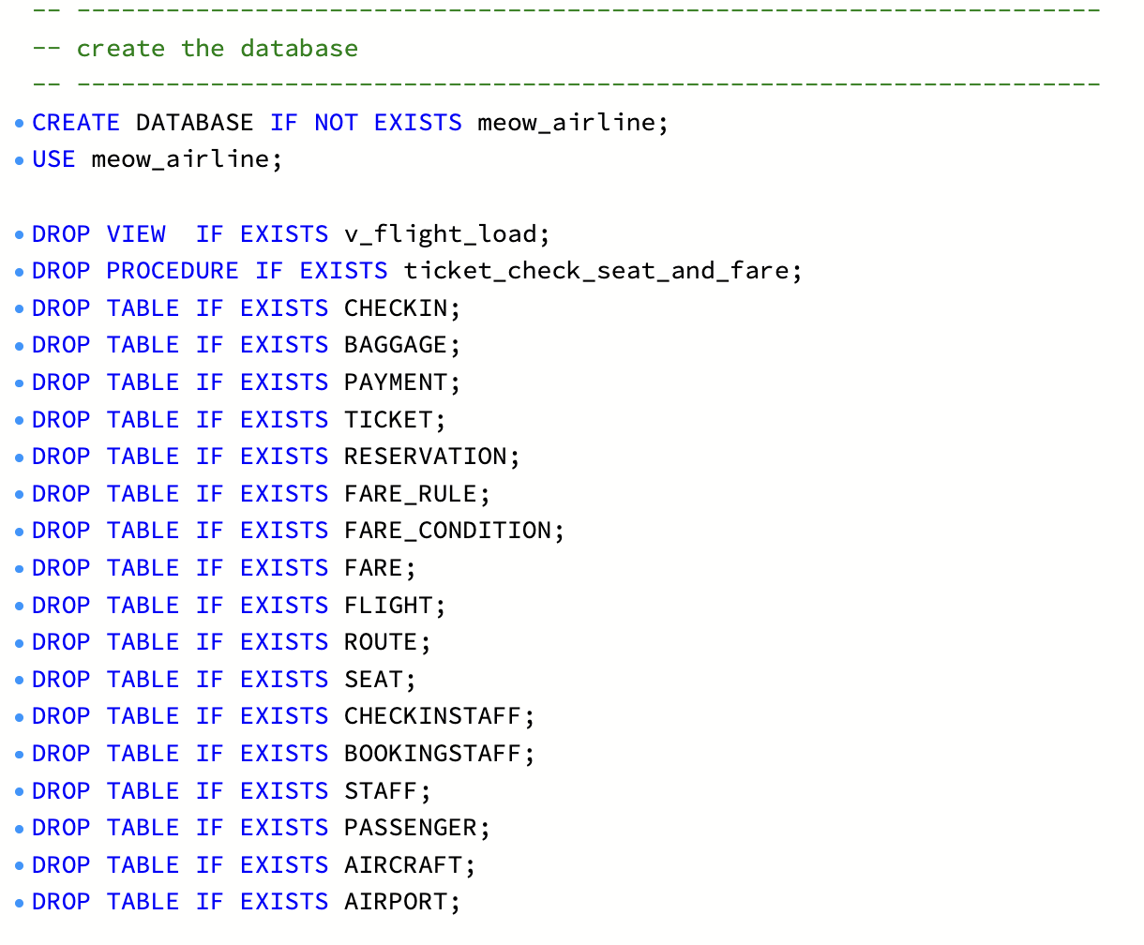
schema.sql: CREATE DATABASE, USE and the DROP statements
Running schema.sql: 42 statements executed successfully.
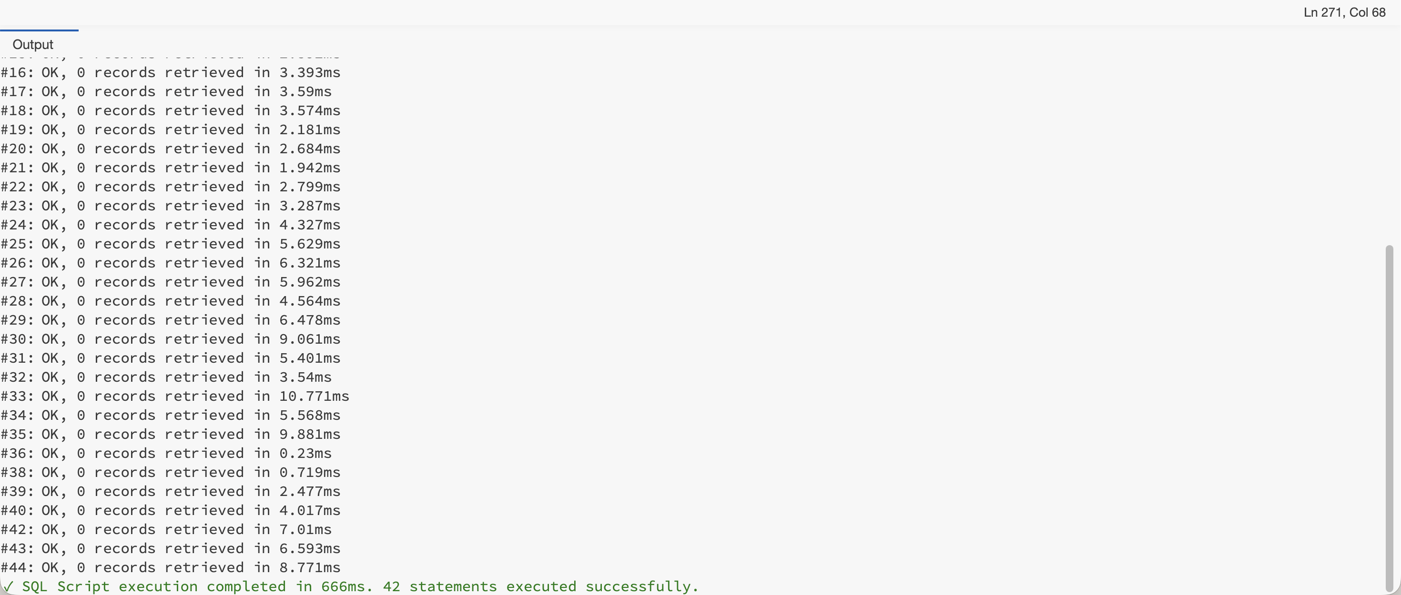
Workbench output after running schema.sql

7.2 DDL: create the 17 tables
The 17 tables are created parents first, following the Lecture 8 order: data types → nullable → unique → PK/FK → defaults → domain checks. Two cross-table rules are added as triggers. The full script is db/schema.sql.
Create order: AIRPORT, AIRCRAFT, PASSENGER, STAFF → BOOKINGSTAFF, CHECKINSTAFF, SEAT, ROUTE → FLIGHT → FARE, FARE_CONDITION → FARE_RULE, RESERVATION → TICKET → PAYMENT, BAGGAGE, CHECKIN. A foreign key can only point at a table that already exists (Lecture 8.2).

Step 1: Data types
Kind of data | Type | Examples | Why
Surrogate keys | INT AUTO_INCREMENT | PassengerID, FlightID, TicketID (12 tables) | MySQL numbers new rows itself
Fixed-length code | CHAR(3) | AirportCode (‘BKK’), OriginCode | IATA codes are always 3 letters
Text | VARCHAR(n) | Name VARCHAR(100), PassportNo VARCHAR(20), FlightNo VARCHAR(6) | Uses only the space it needs
Money | DECIMAL(10,2) | Price, Fee, TotalAmount | Exact to the satang; FLOAT would round
Weight | DECIMAL(5,2) | BAGGAGE.Weight (kg) | Two decimals
Date and time | DATETIME | DepartureTime, CheckInTime | Flights need the time
Date only | DATE | BookingDate, TicketIssueDate | Time of day not needed
Fixed list | ENUM(…) | MembershipStatus, SeatClass, TicketStatus | MySQL rejects values not on the list
Generated helper | TINYINT AS (…) STORED | TICKET.ActiveSeat | Computed from TicketStatus for BR10

Step 2: Nullable columns
Every column is NOT NULL unless the business allows it to be empty. Only 7 are nullable: PASSENGER.PhoneNo and Email (optional contact), FARE_CONDITION.Description, RESERVATION.BookingStaffID (booked online), CHECKIN.CheckInStaffID (self check-in), FLIGHT.Gate (not assigned yet) and TICKET.TicketIssueDate (empty until payment, BR8). Every FK for a total participation in the EER is NOT NULL.

Step 3: Unique values
Constraint | Column(s) | Business reason
PASSENGER_PassportNo_UQ | PassportNo | One passport = one passenger
SEAT_Aircraft_SeatNo_UQ | (AircraftID, SeatNo) | No two seats ‘12A’ on one aircraft
FLIGHT_No_Departure_UQ | (FlightNo, DepartureTime) | MW101 flies once per departure time
FARE_CONDITION_Name_UQ | ConditionName | No duplicate ‘Refundable’
CHECKIN_Ticket_UQ | TicketID | 1:1: a ticket is checked in once
CHECKIN_BoardingPass_UQ | BoardingPassNo | Every boarding pass number differs
TICKET_Seat_On_Flight_UQ | (FlightID, SeatID, ActiveSeat) | BR10: no double-booked seat
TICKET_Passenger_On_Flight_UQ | (FlightID, PassengerID, ActiveSeat) | BR18: one live seat per traveller per flight
STAFF_ID_Role_UQ | (StaffID, StaffRole) | Target of the subtype FKs (BR14)
FARE_ID_Flight_UQ | (FareID, FlightID) | Target of TICKET’s fare FK (BR15)
The two TICKET constraints rely on ActiveSeat being NULL for a cancelled ticket. UNIQUE ignores NULLs, so a cancelled seat can be sold again, but two live tickets for one seat are refused.

Step 4: Primary and foreign keys
Every table has a primary key named <TABLE>_PK. AIRPORT uses its natural key (AirportCode) and ROUTE uses FlightNo; FARE_RULE has the only composite PK (FareID, ConditionID). The 21 foreign keys, each with a deliberate ON DELETE / ON UPDATE action, are listed in section 6.11. Two are composite so MySQL enforces a business rule itself: (StaffID, StaffRole) → STAFF for BR14, and TICKET (FareID, FlightID) → FARE for BR15.

Step 5: Default values
Column | Default | Meaning
PASSENGER.MembershipStatus | ‘Normal’ | New passengers start at the lowest tier
SEAT.SeatClass | ‘Economy’ | Most seats are Economy
FLIGHT.Status | ‘OnTime’ | Until the airline says otherwise
RESERVATION.BookingDate | (CURRENT_DATE) | Booked today
RESERVATION.ReservationStatus | ‘Held’ | Held until paid
TICKET.TicketStatus | ‘booked’ | Issued only after payment (BR8)
PAYMENT.TimeStamp | CURRENT_TIMESTAMP | Recorded when paid
PAYMENT.Status | ‘Paid’ | A refund is a separate row
BAGGAGE.BaggageStatus | ‘CheckedIn’ | A bag starts at the counter
CHECKIN.CheckInTime | CURRENT_TIMESTAMP | Checked in now
FARE_RULE.Fee | 0.00 | Most conditions are free
BOOKINGSTAFF / CHECKINSTAFF.StaffRole | ‘BookingStaff’ / ‘CheckInStaff’ | Fixed for each subtype

Step 6: Domain checks
Constraint | Rule | Business reason
ROUTE_Airports_CK | OriginCode <> DestinationCode | BR7
FLIGHT_Times_CK | ArrivalTime > DepartureTime | A flight lands after it leaves
AIRCRAFT_TotalSeat_CK | TotalSeat > 0 | An aircraft has seats
FARE_Price_CK | Price > 0 | No free fares
FARE_RULE_Fee_CK | Fee >= 0 | A fee can be zero, never negative
PAYMENT_Amount_CK | TotalAmount > 0 | A payment moves money
BAGGAGE_Weight_CK | Weight > 0 AND Weight <= 32 | 32 kg single-bag safety limit
BOOKINGSTAFF_Role_CK | StaffRole = ‘BookingStaff’ | BR14
CHECKINSTAFF_Role_CK | StaffRole = ‘CheckInStaff’ | BR14

Step 7: Triggers for rules that span tables
A CHECK sees only one row of one table. Two TICKET rules compare TICKET with SEAT, FLIGHT and FARE, so the triggers TICKET_Seat_Fare_BI and TICKET_Seat_Fare_BU check them before every insert and update: the seat must be on the flight’s aircraft, and the seat class must match the fare class. A broken rule stops the statement with error 1644. BR8, BR11, BR12 and BR13 are enforced in the backend.

Example: the TICKET table
TICKET is the bridge for RESERVATION ⇄ FLIGHT and carries most of the booking rules.
CREATE TABLE TICKET (
TicketID INT NOT NULL AUTO_INCREMENT,
ReservationID INT NOT NULL,
PassengerID INT NOT NULL, -- BR18: the traveller
FlightID INT NOT NULL,
SeatID INT NOT NULL,
FareID INT NOT NULL,
TicketIssueDate DATE, -- NULL until issued (BR8)
TicketStatus ENUM('booked', 'issued', 'used', 'cancelled') NOT NULL DEFAULT 'booked',
ActiveSeat TINYINT AS (IF(TicketStatus = 'cancelled', NULL, 1)) STORED,
CONSTRAINT TICKET_PK PRIMARY KEY (TicketID),
CONSTRAINT TICKET_Seat_On_Flight_UQ UNIQUE (FlightID, SeatID, ActiveSeat), -- BR10
CONSTRAINT TICKET_Passenger_On_Flight_UQ UNIQUE (FlightID, PassengerID, ActiveSeat), -- BR18
CONSTRAINT TICKET_RESERVATION_FK FOREIGN KEY (ReservationID)
REFERENCES RESERVATION (ReservationID) ON DELETE CASCADE ON UPDATE CASCADE,
CONSTRAINT TICKET_PASSENGER_FK FOREIGN KEY (PassengerID)
REFERENCES PASSENGER (PassengerID) ON DELETE RESTRICT ON UPDATE CASCADE,
CONSTRAINT TICKET_FLIGHT_FK FOREIGN KEY (FlightID)
REFERENCES FLIGHT (FlightID) ON DELETE RESTRICT ON UPDATE RESTRICT,
CONSTRAINT TICKET_SEAT_FK FOREIGN KEY (SeatID)
REFERENCES SEAT (SeatID) ON DELETE RESTRICT ON UPDATE CASCADE,
CONSTRAINT TICKET_FARE_FK FOREIGN KEY (FareID, FlightID) -- BR15
REFERENCES FARE (FareID, FlightID) ON DELETE RESTRICT ON UPDATE RESTRICT
);

Screenshots: creating the tables
Each CREATE TABLE statement as run in MySQL Workbench, in create order. The run output is in section 5.
AIRPORT and AIRCRAFT
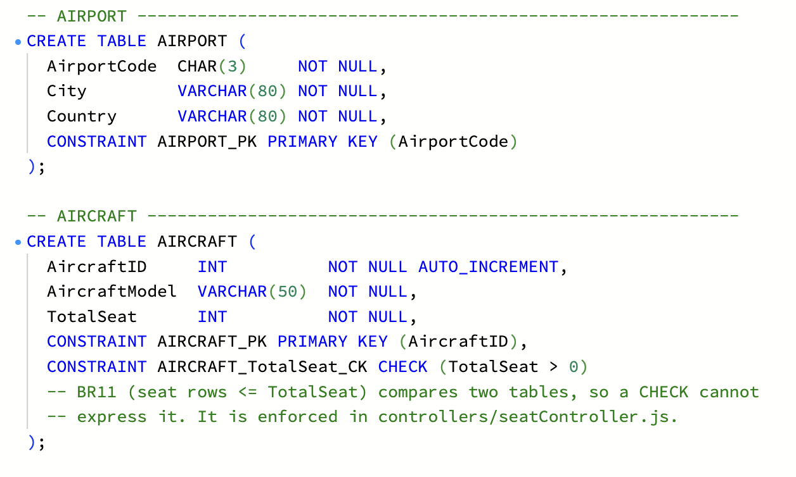
CREATE TABLE AIRPORT and AIRCRAFT
PASSENGER and STAFF
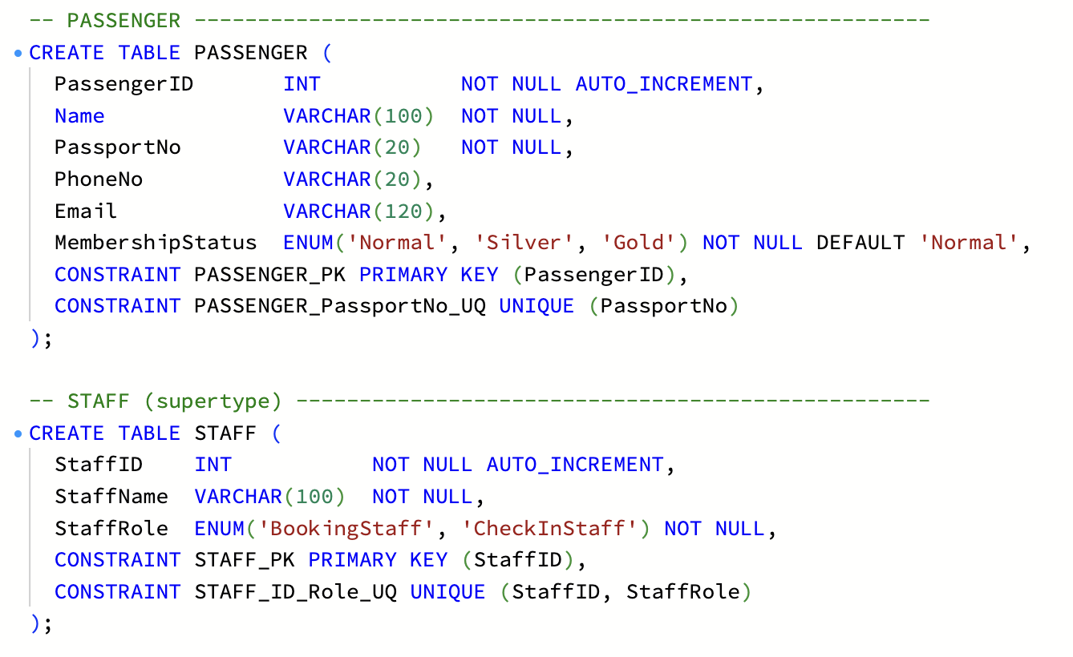
CREATE TABLE PASSENGER and STAFF
BOOKINGSTAFF and CHECKINSTAFF
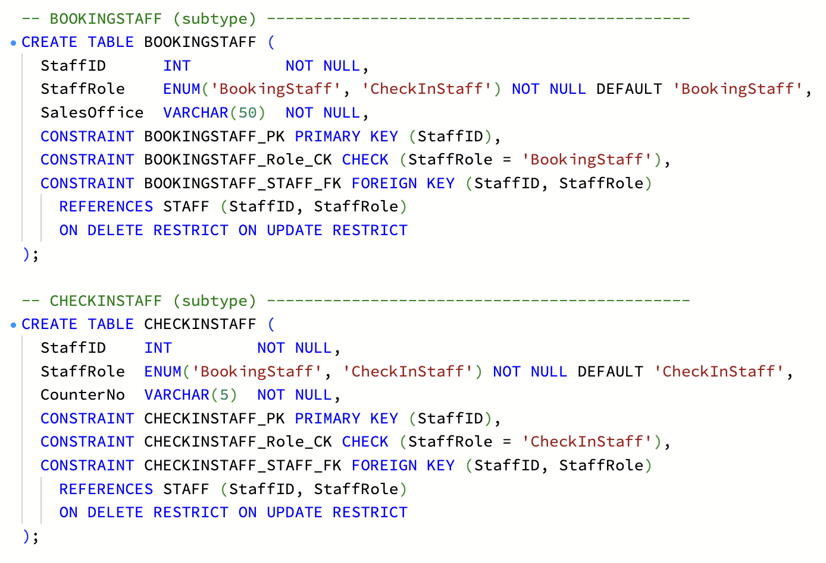
CREATE TABLE BOOKINGSTAFF and CHECKINSTAFF
SEAT
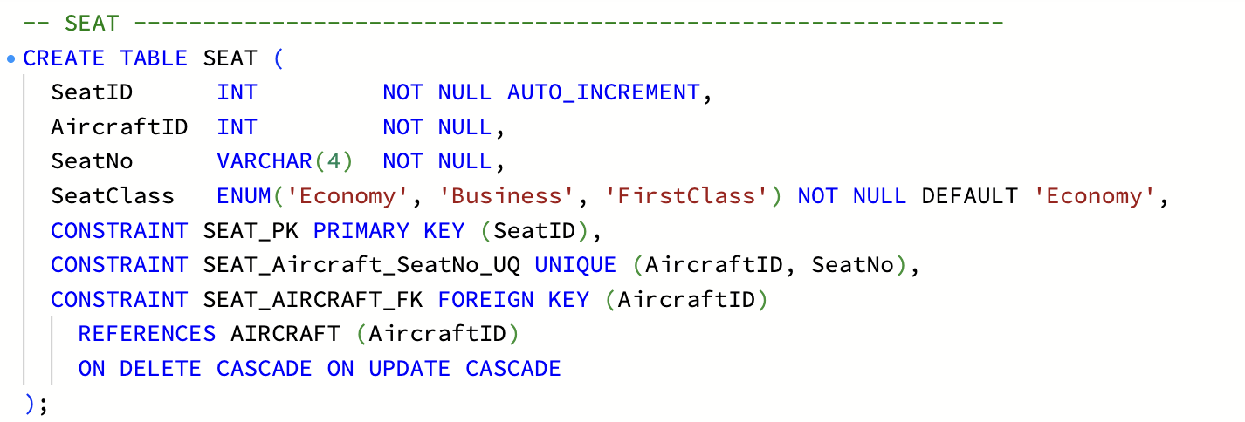
CREATE TABLE SEAT
ROUTE
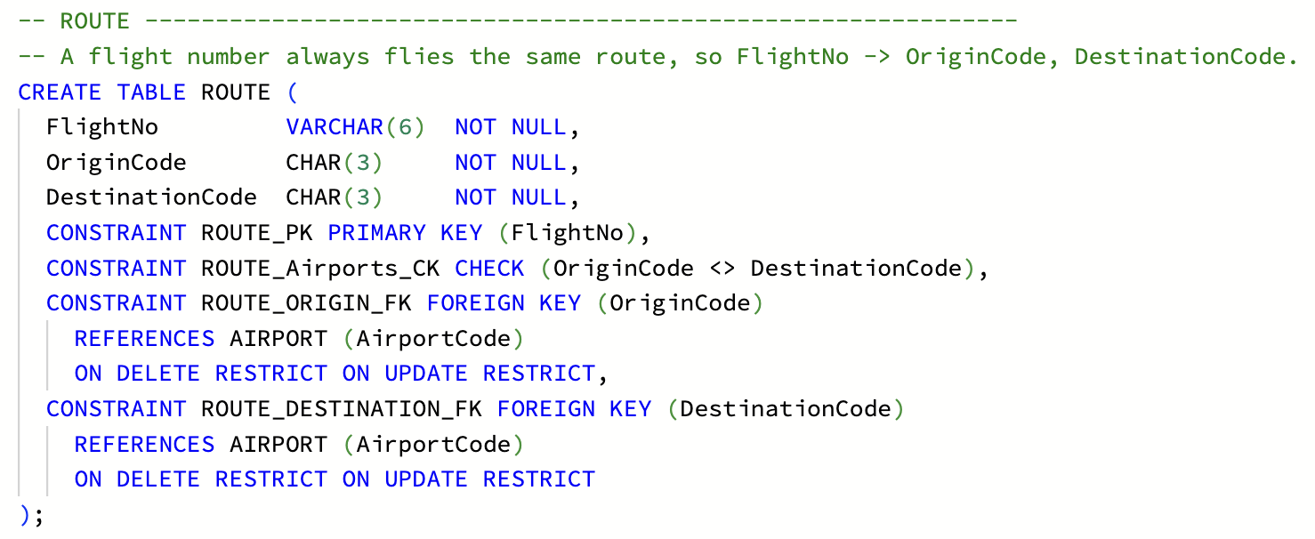
CREATE TABLE ROUTE
FLIGHT
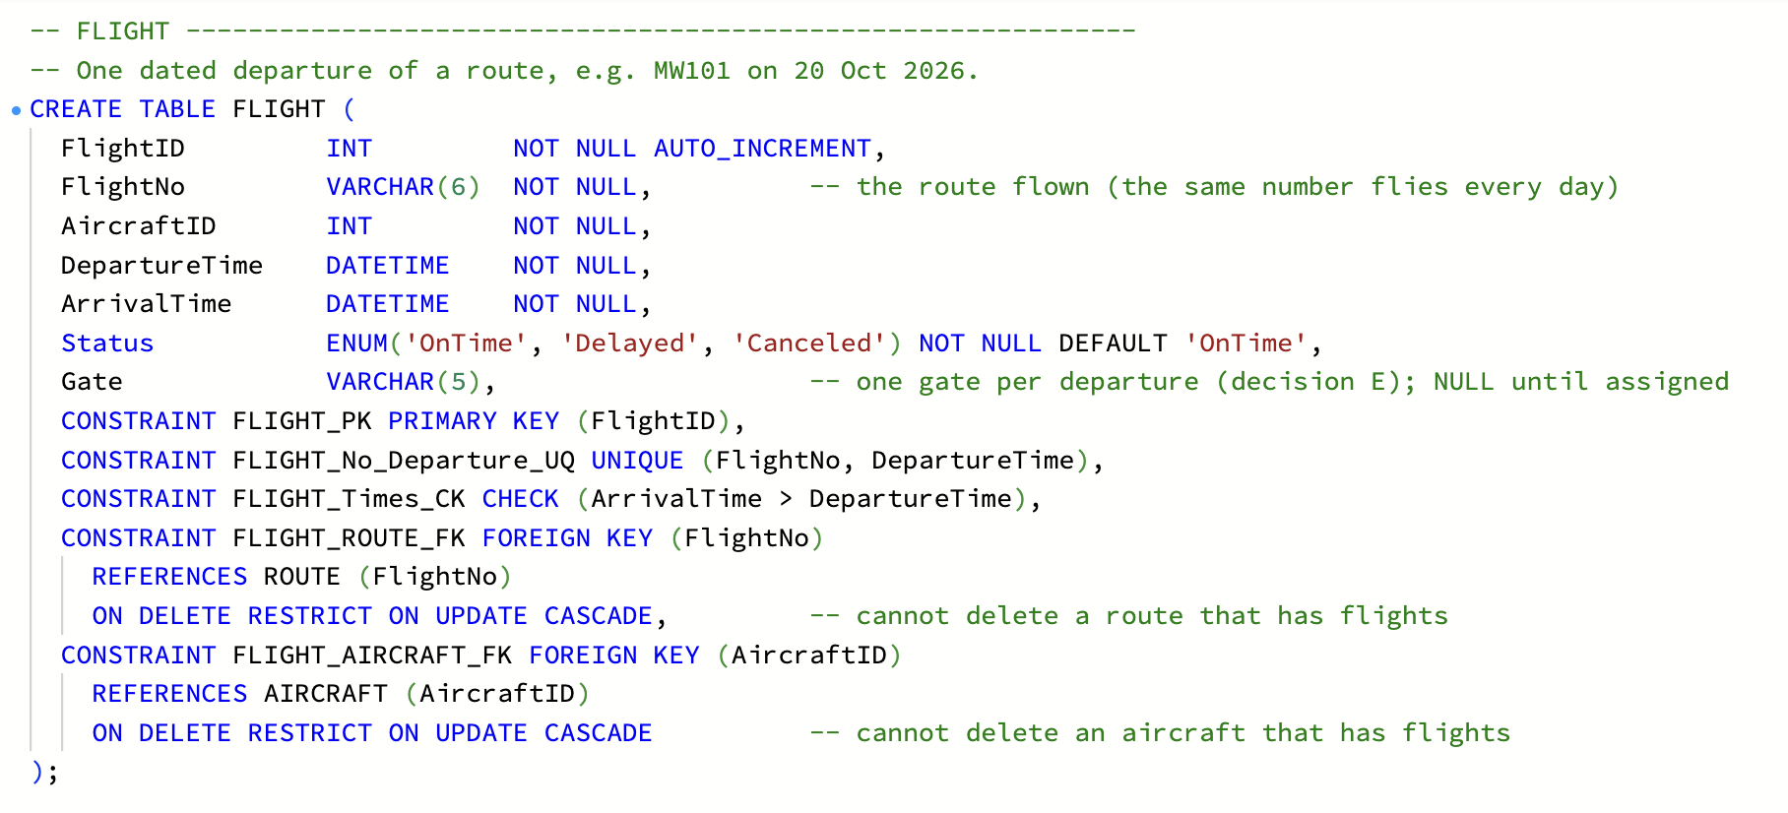
CREATE TABLE FLIGHT
FARE
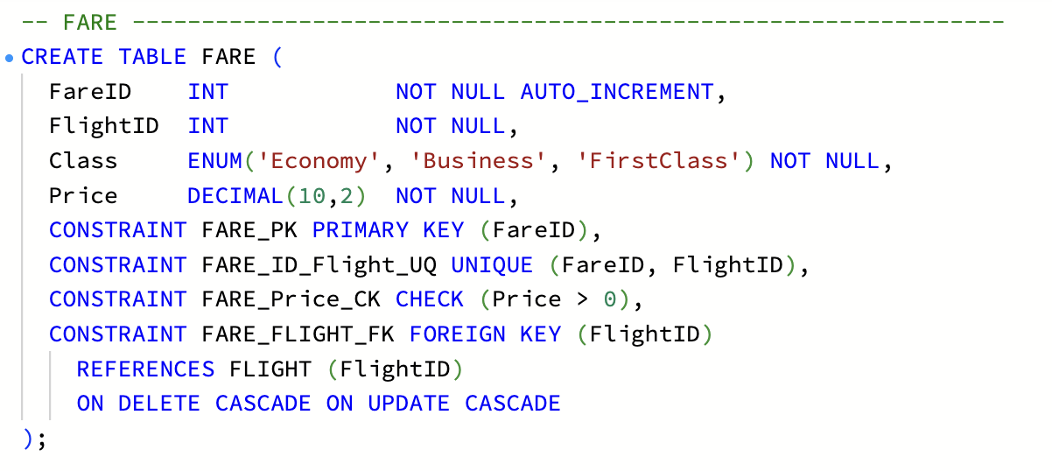
CREATE TABLE FARE
FARE_CONDITION and FARE_RULE
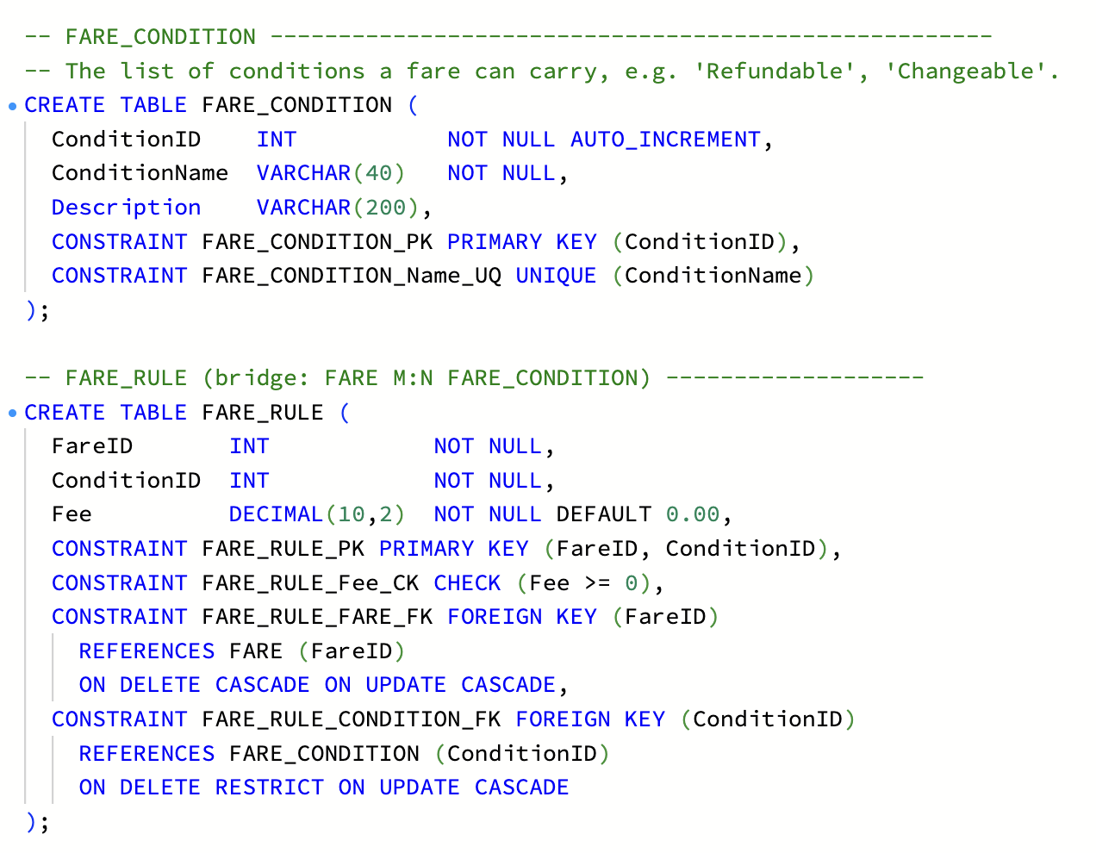
CREATE TABLE FARE_CONDITION and FARE_RULE
RESERVATION
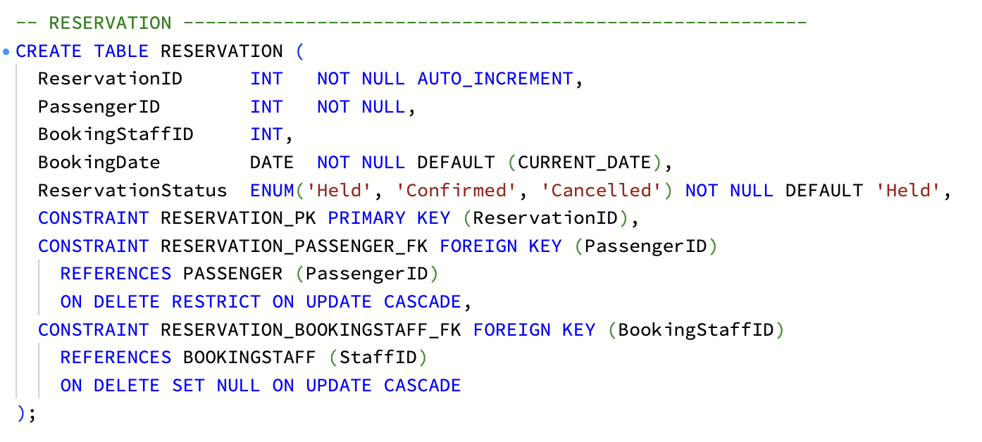
CREATE TABLE RESERVATION
TICKET
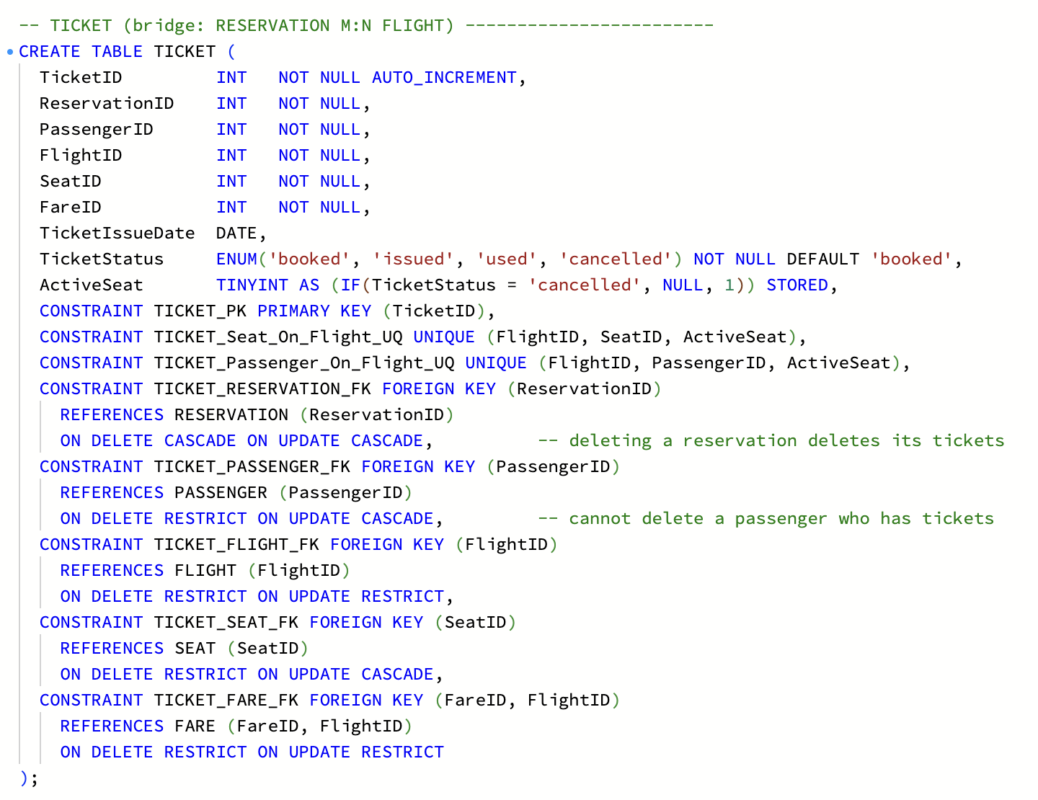
CREATE TABLE TICKET
The procedure behind the TICKET triggers
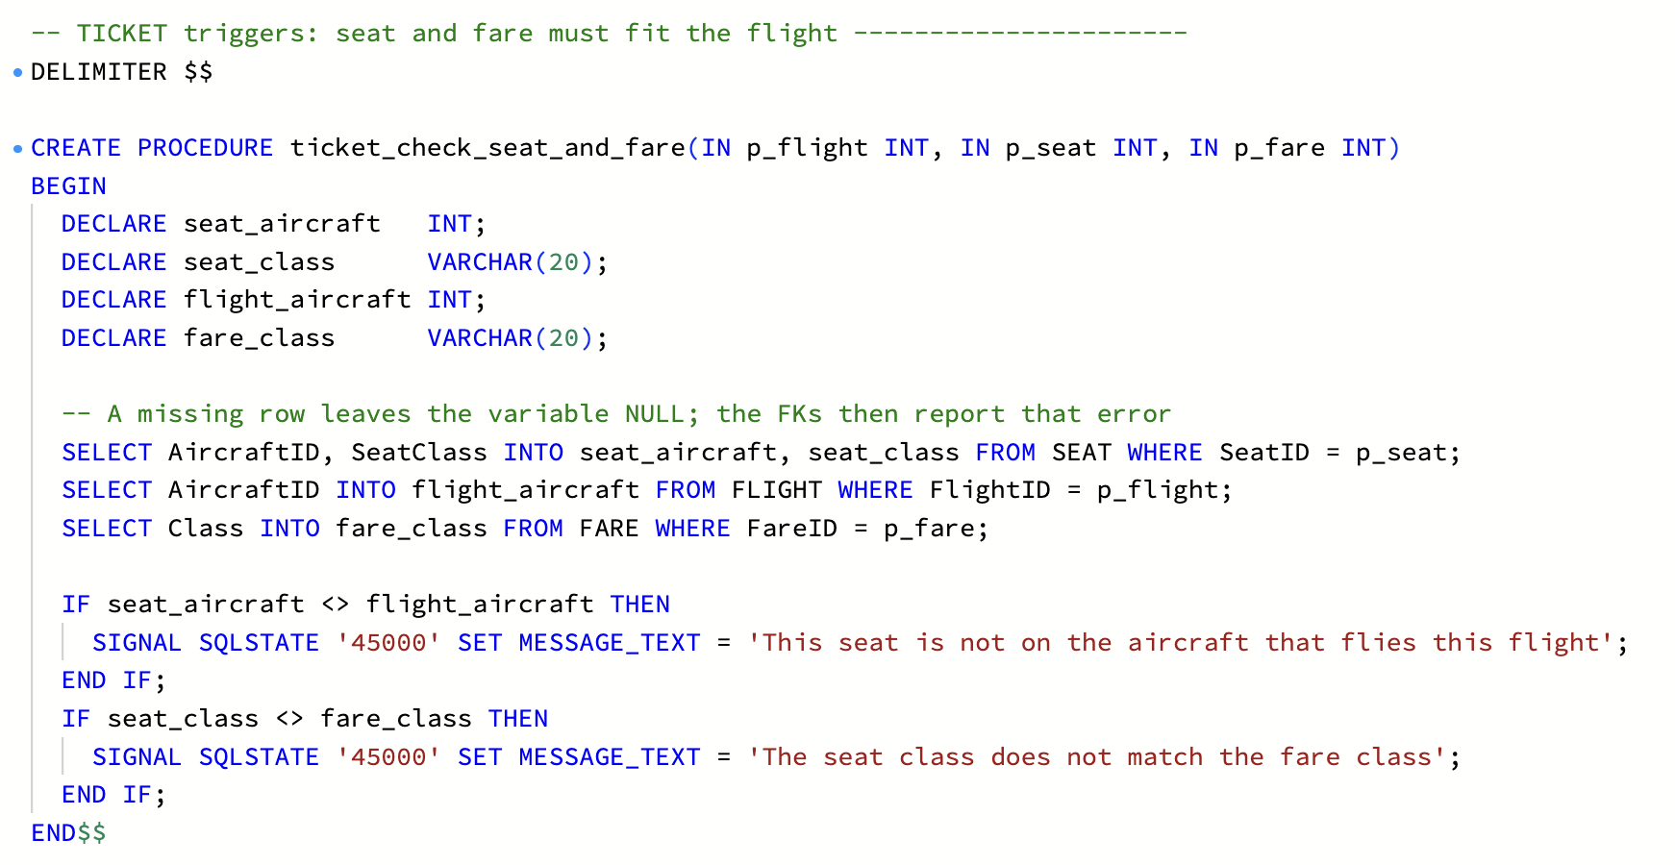
CREATE PROCEDURE ticket_check_seat_and_fare
The two TICKET triggers
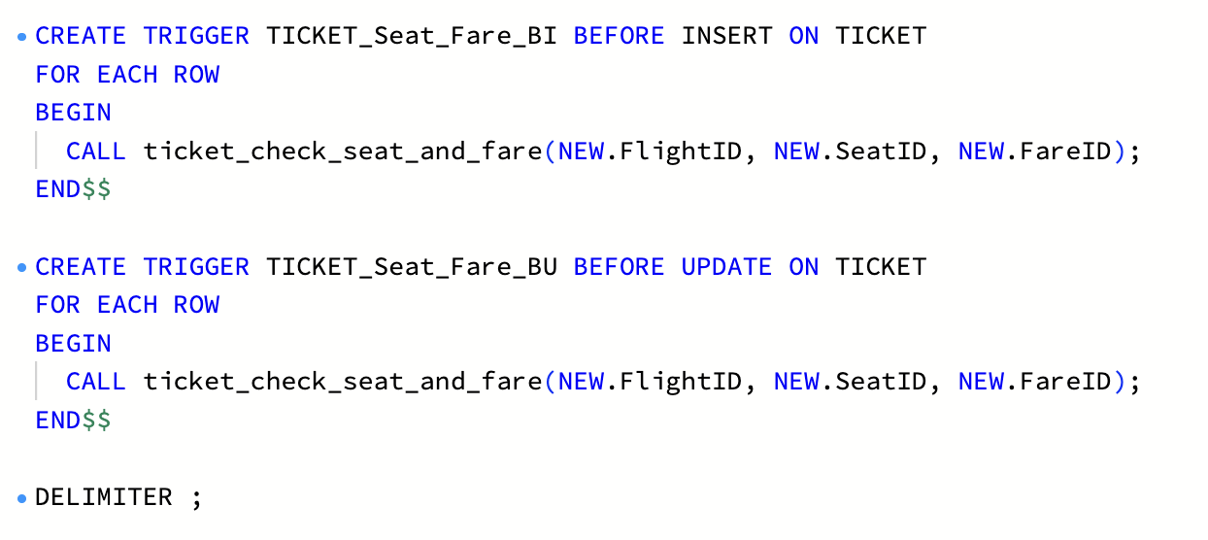
CREATE TRIGGER TICKET_Seat_Fare_BI and TICKET_Seat_Fare_BU
PAYMENT and BAGGAGE
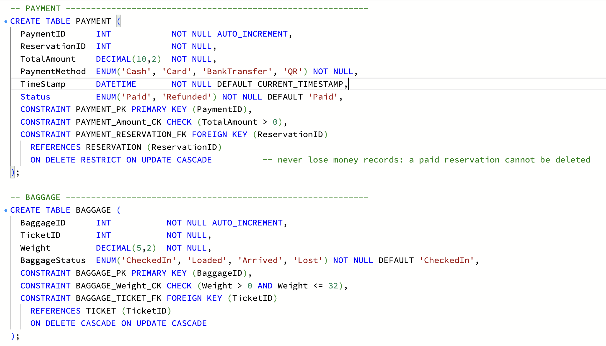
CREATE TABLE PAYMENT and BAGGAGE
CHECKIN
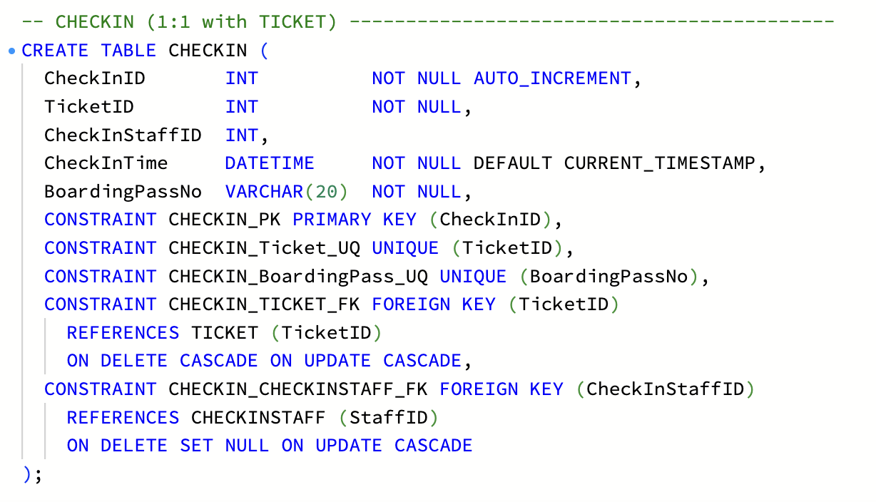
CREATE TABLE CHECKIN

7.3 DML: insert the sample data (seed.sql)
db/seed.sql inserts sample rows into every table: 7 airports, 6 aircraft, 100 passengers, 4 staff, 72 seats, 6 routes, 10 flights, 20 fares, 4 fare conditions, 50 fare rules, 41 reservations, 74 tickets, 38 payments, 30 bags and 40 check-ins. All people are fake; airport codes are real IATA codes.
AIRPORT and AIRCRAFT
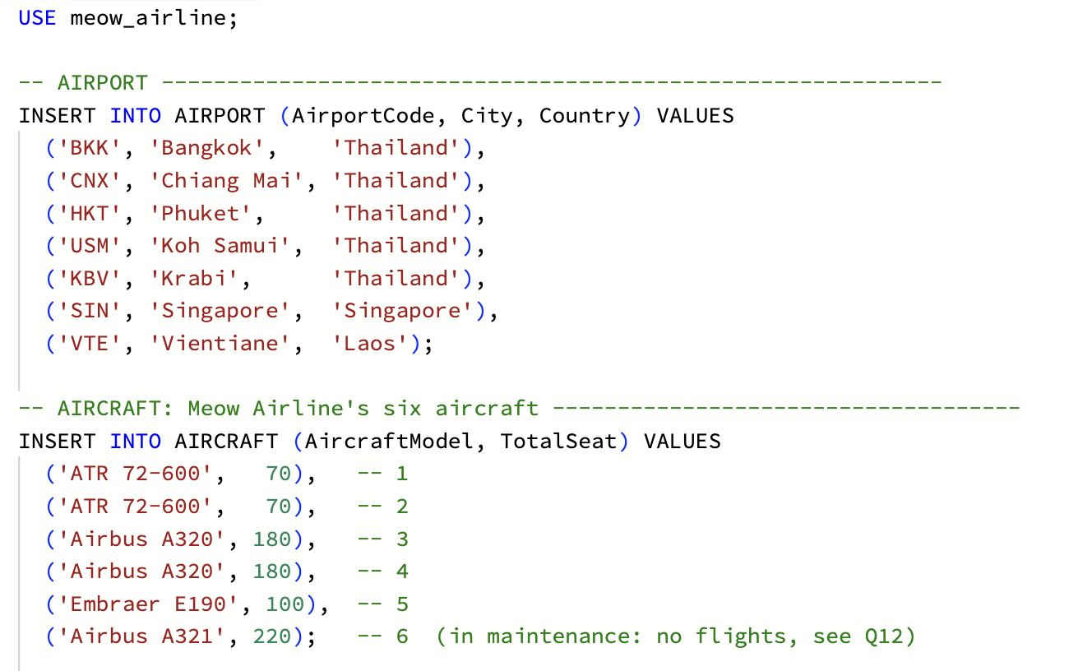
INSERT INTO AIRPORT and AIRCRAFT
PASSENGER
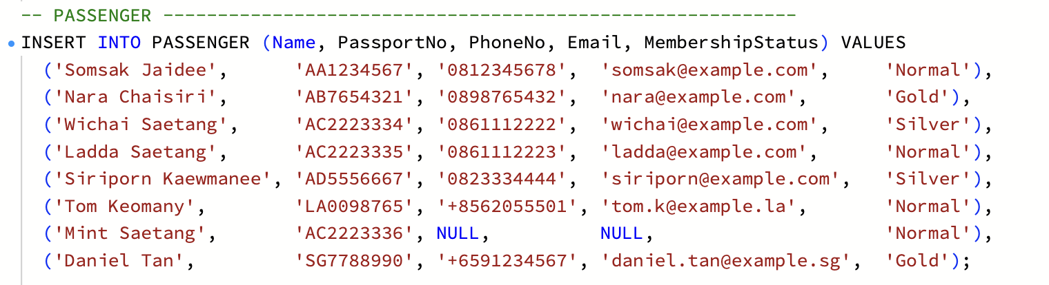
INSERT INTO PASSENGER
STAFF, BOOKINGSTAFF and CHECKINSTAFF
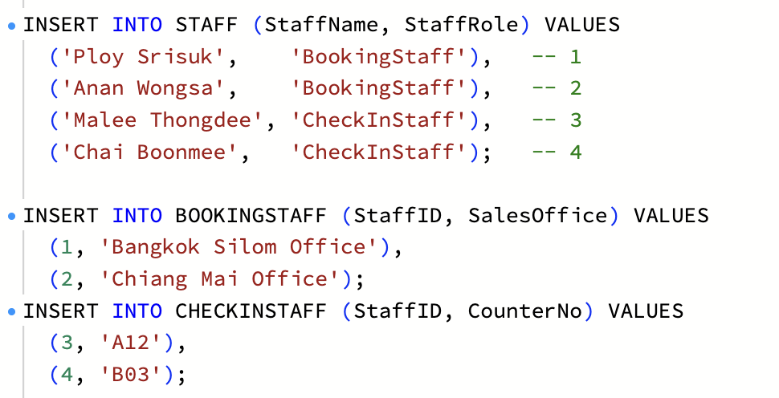
INSERT INTO STAFF and the two subtypes
SEAT
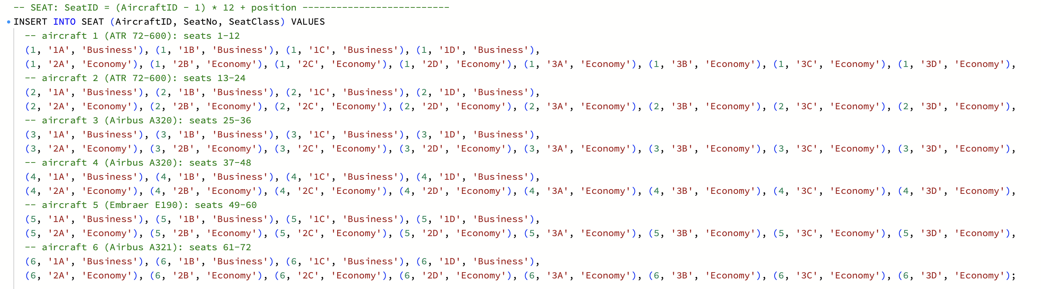
INSERT INTO SEAT, 12 seats per aircraft
ROUTE
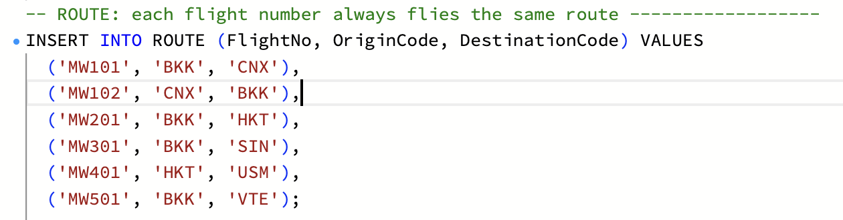
INSERT INTO ROUTE
FLIGHT
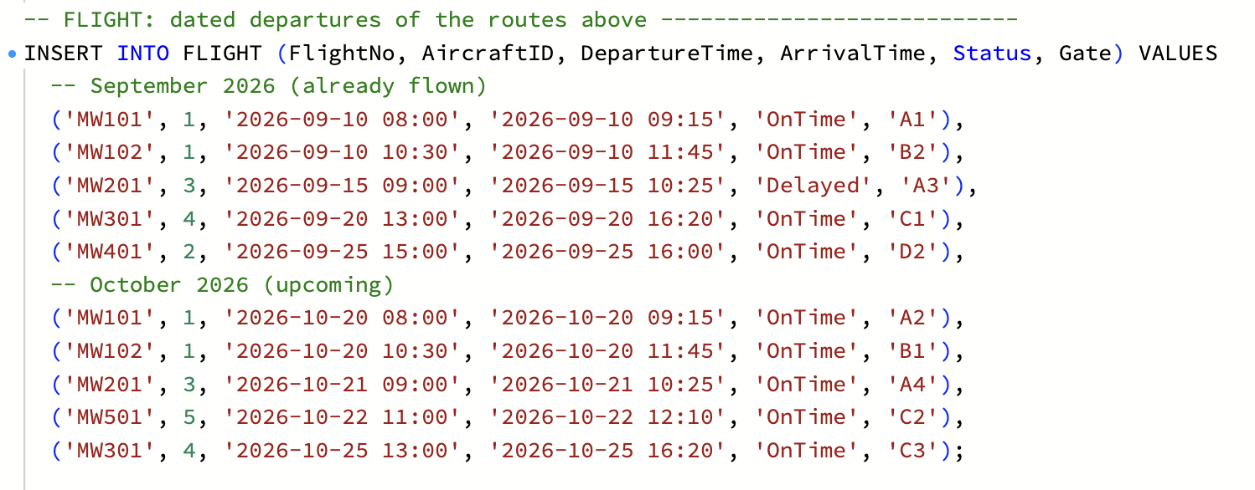
INSERT INTO FLIGHT
FARE and FARE_CONDITION
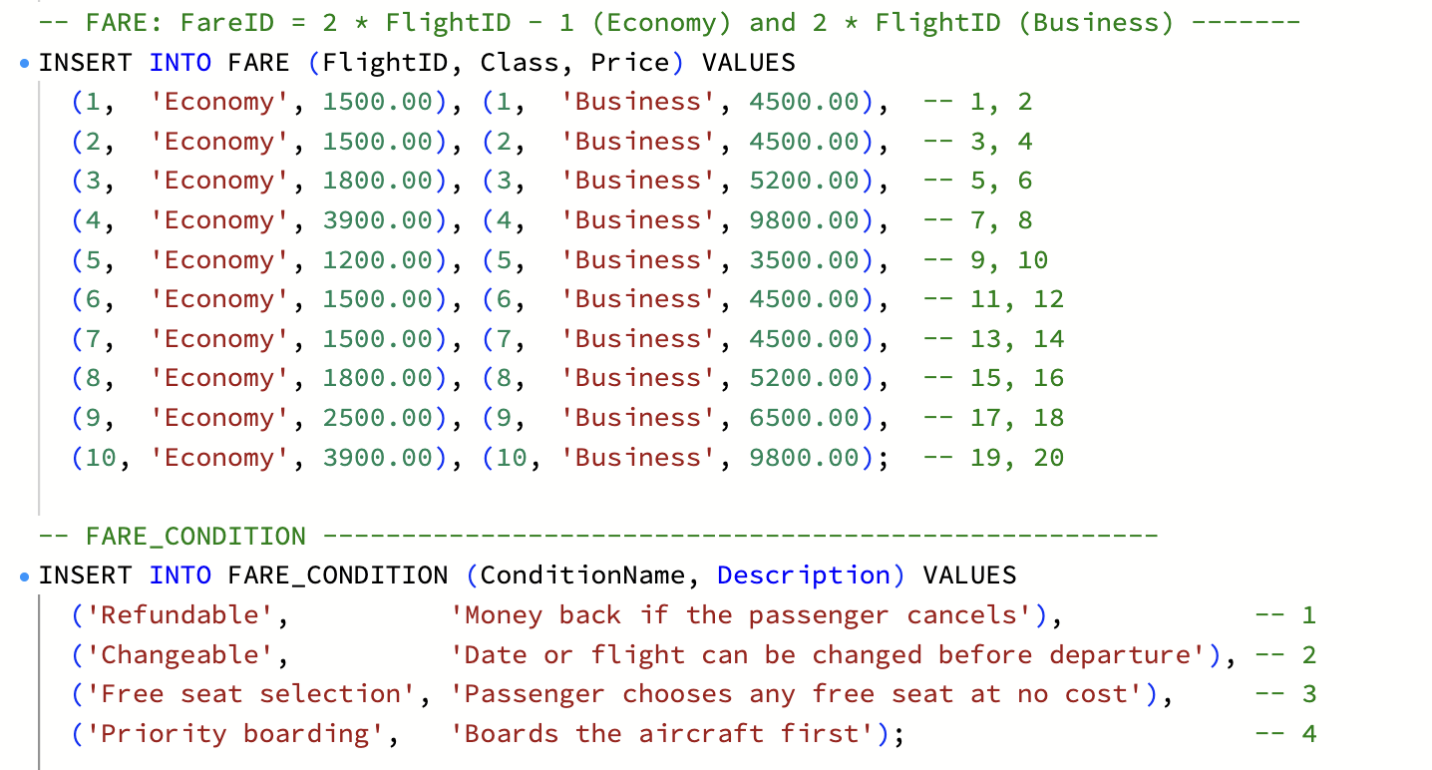
INSERT INTO FARE and FARE_CONDITION
FARE_RULE
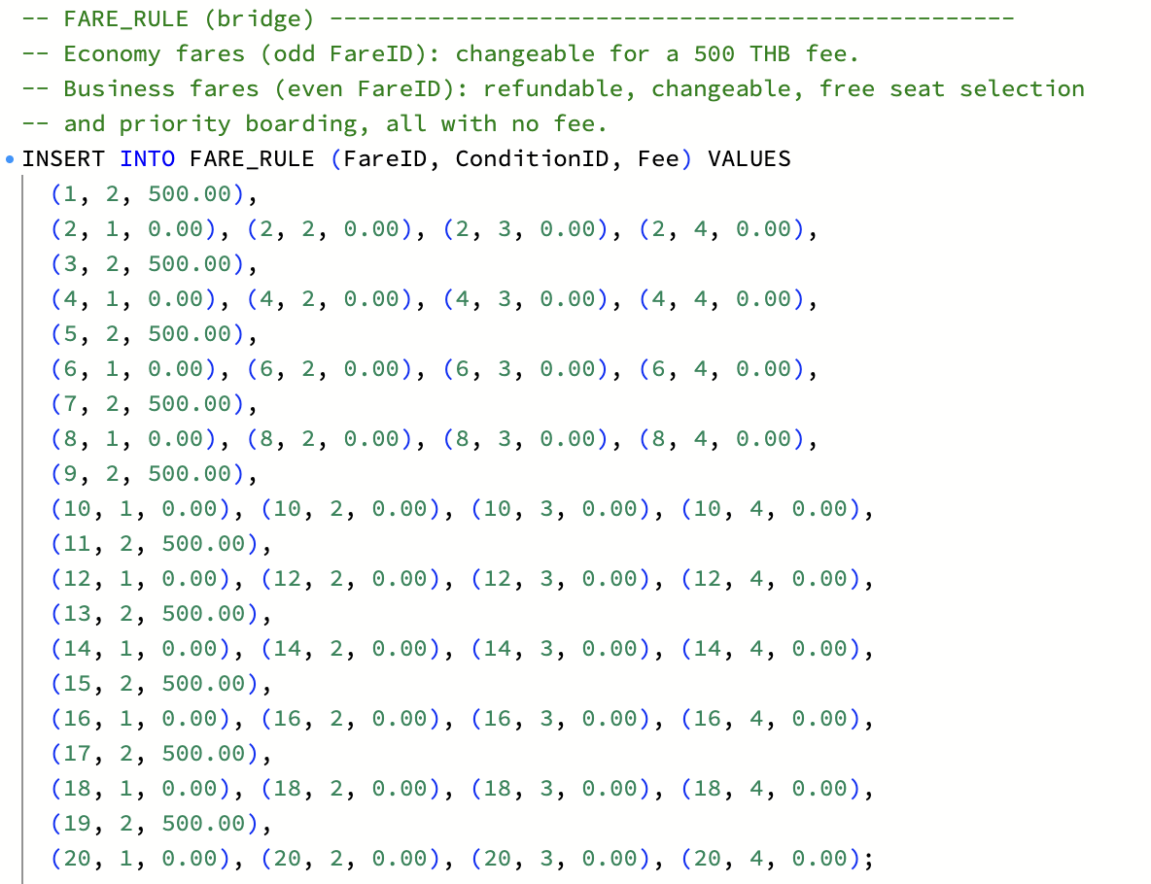
INSERT INTO FARE_RULE
RESERVATION and TICKET
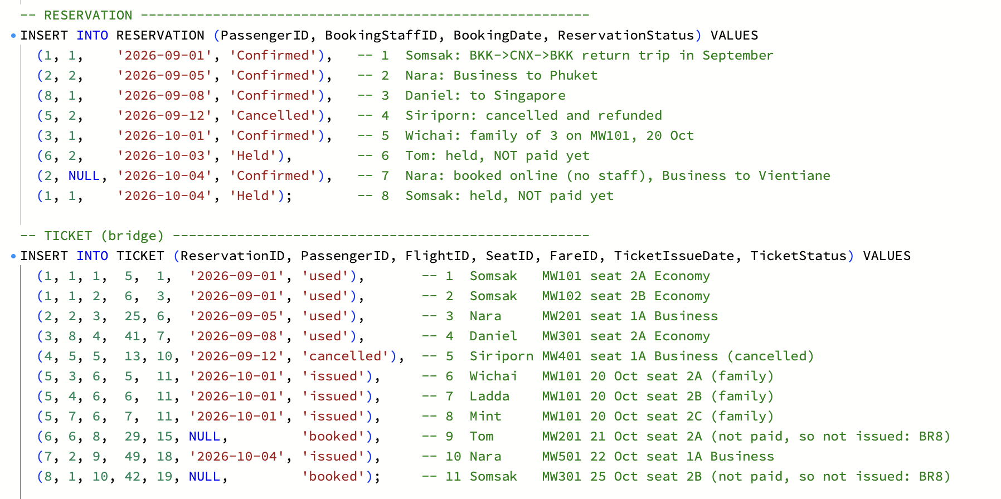
INSERT INTO RESERVATION and TICKET
PAYMENT and BAGGAGE
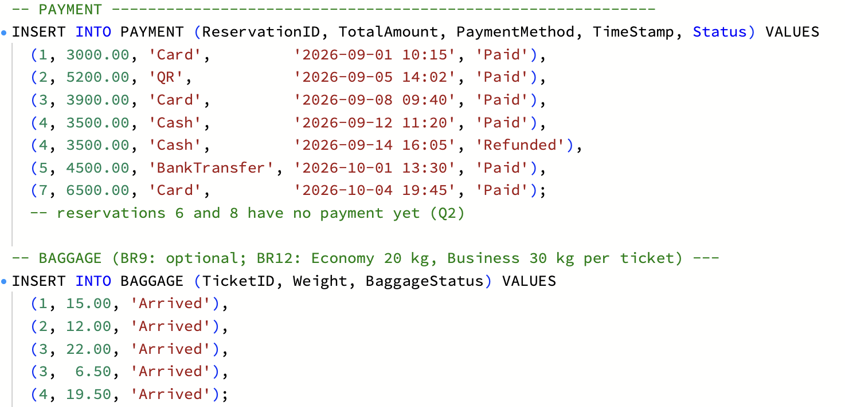
INSERT INTO PAYMENT and BAGGAGE
CHECKIN
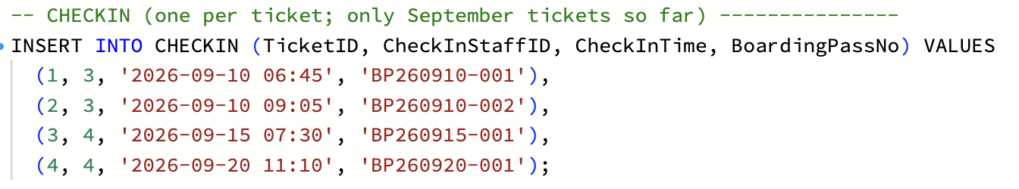
INSERT INTO CHECKIN
Running seed.sql: 18 statements executed successfully, with the row count of each insert.
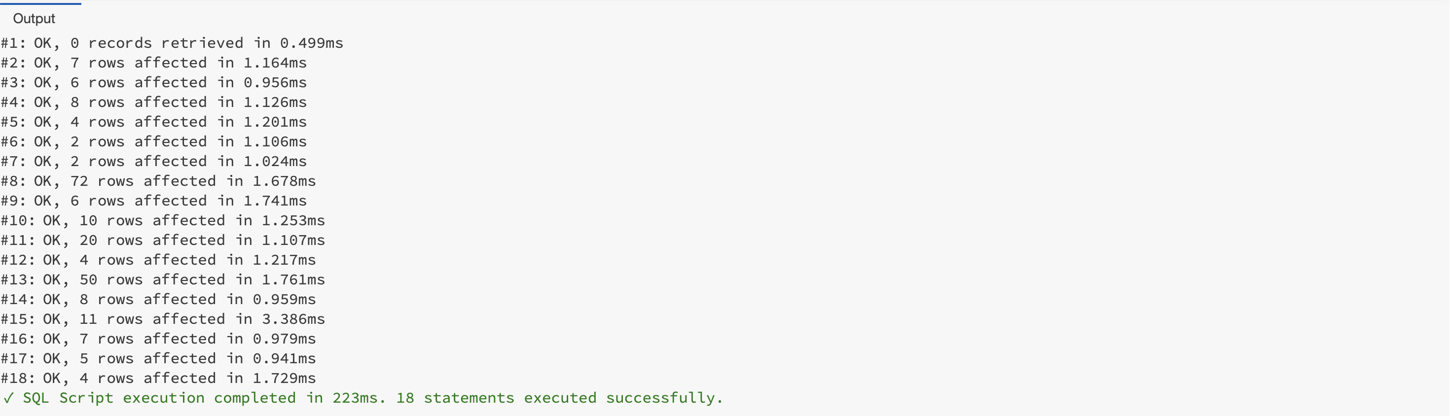
Workbench output after running seed.sql

Loaded rows
SELECT * after running seed.sql shows the sample data in the tables.
AIRPORT: 7 rows
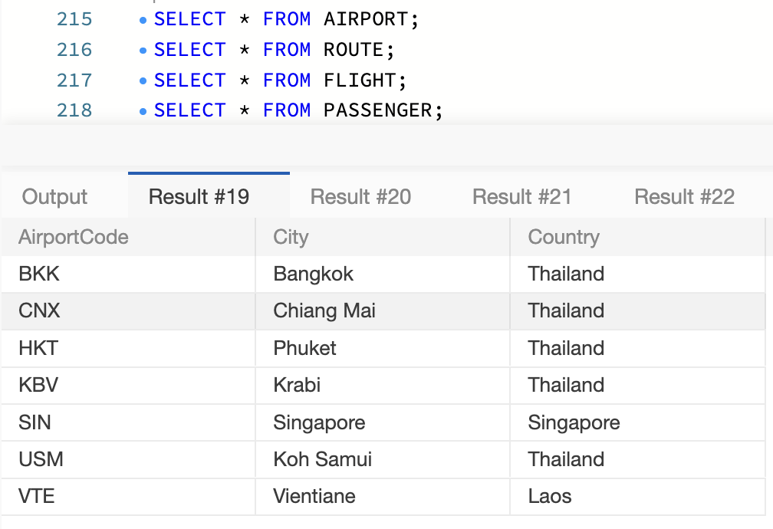
SELECT * FROM AIRPORT
ROUTE: 6 rows
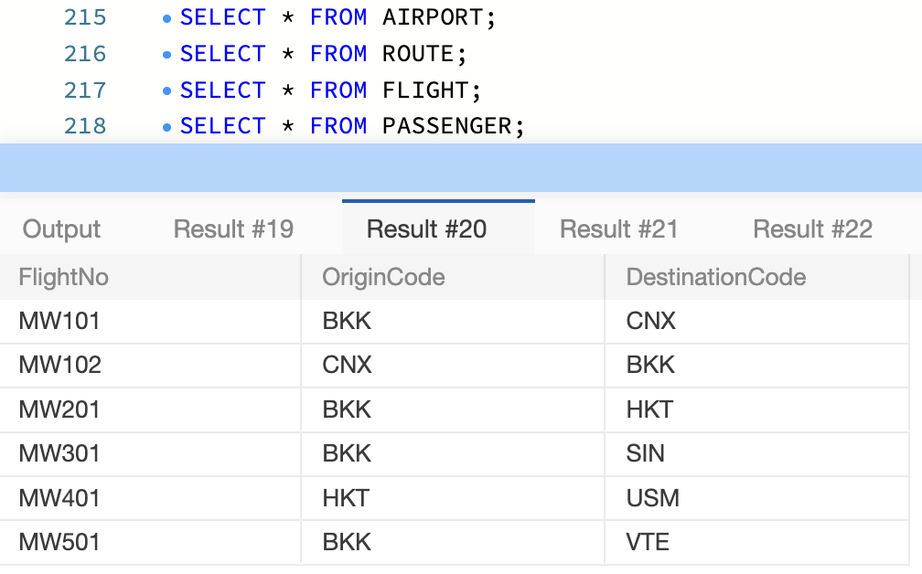
SELECT * FROM ROUTE
FLIGHT: 10 rows (September flights have flown; October flights are upcoming)
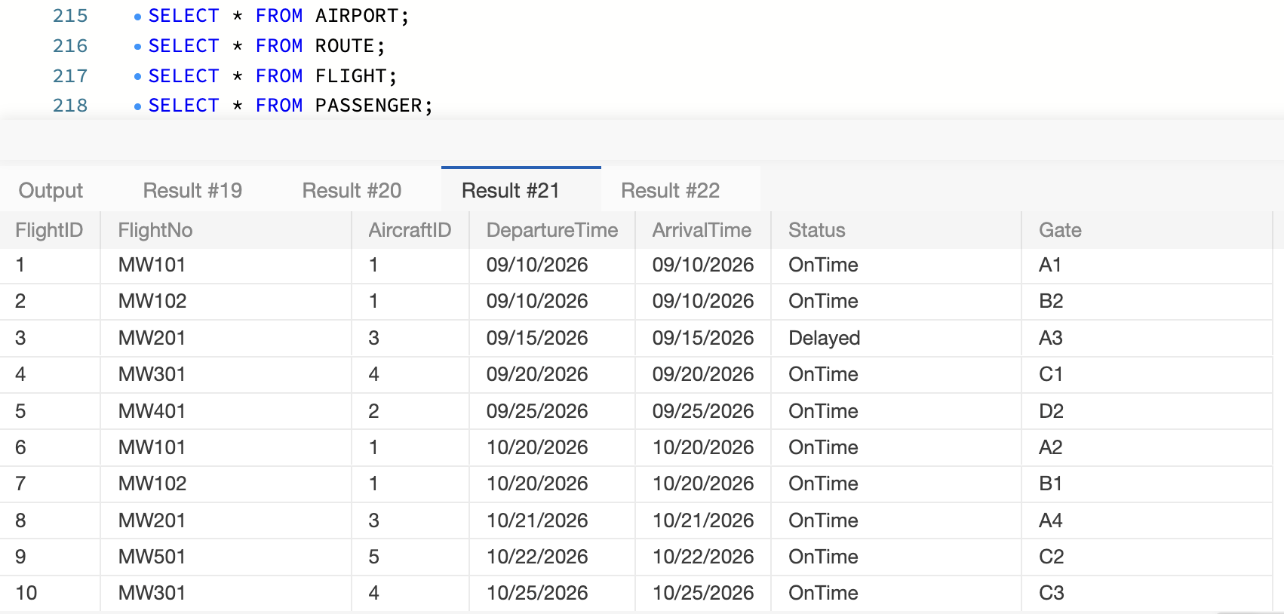
SELECT * FROM FLIGHT
PASSENGER: 100 rows (the 8 core passengers used by the queries are shown; IDs 9–100 are 92 extra made-up passengers: 72 Thai, 10 Lao, 10 Singaporean. Mint, a child, has no phone or email, so both are NULL)
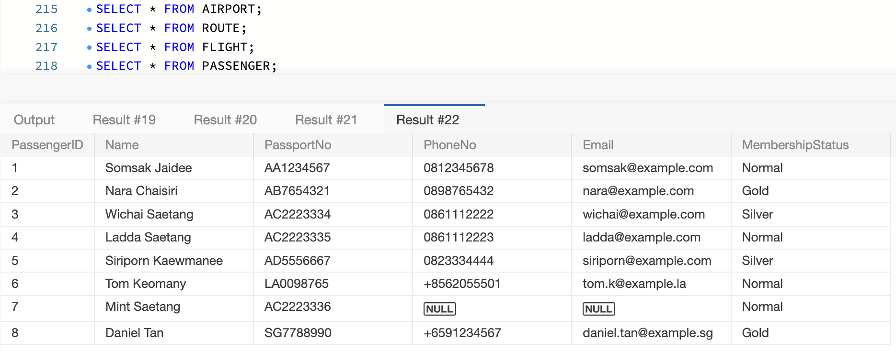
SELECT * FROM PASSENGER

7.4 DML: the 20 queries
db/queries.sql answers the airline’s 3 business questions (the 3 report pages), then exercises every SQL feature from Lectures 8–10. The UPDATE and DELETE examples run inside START TRANSACTION … ROLLBACK, so the sample data stays the same for everyone.
# | Question | SQL used
Q1 | How many seats are free on MW101 on 20 Oct, in each class? (O4) | JOIN, LEFT JOIN, GROUP BY
Q2 | Which bookings has a passenger made, and which are unpaid? | 5-table JOIN; LEFT JOIN on PAYMENT
Q3 | Income per route last month, and the route that sold the fewest seats (O3) | GROUP BY, SUM, a WITH CTE that keeps ties
Q4 | Flights departing in October 2026, earliest first | BETWEEN, ORDER BY
Q5 | The Saetang family; passengers with no email | LIKE, IS NULL
Q6 | Passengers per membership level, levels with 15 or more only | GROUP BY, HAVING
Q7 | Boarding list for MW101: who sits where, and who booked it | PASSENGER joined twice with aliases
Q8 | Double-booking check: must return 0 rows (O1); Q8b checks BR14 | GROUP BY, HAVING COUNT(*) > 1
Q9 | Reservations per booking staff member | LEFT JOIN keeps staff with 0
Q10 | Issued tickets on MW101 not checked in yet (BR13) | LEFT JOIN + IS NULL
Q11 | Bag weight per ticket against its class limit (BR12) | SUM, CASE
Q12 | Aircraft with no flights | LEFT JOIN + IS NULL
Q13 | What Gold and Silver members paid in 2026, refunds subtracted | IN, SUM
Q14 | v_flight_load: seats total, sold and free per flight and class | CREATE VIEW
Q15 | MW301 on 25 Oct is delayed | UPDATE with the PK in WHERE
Q16 | Delete a passenger who has bookings | DELETE refused by RESTRICT (error 1451)
Q17 | Delete a held, unpaid reservation | DELETE that CASCADEs to its tickets
Q18 | Six rule-breaking inserts and deletes (a–f) | Refused by CHECK (3819), UNIQUE (1062), RESTRICT (1451) and the triggers (1644)
Q19 | What each fare on MW101 includes, and what each condition costs | 3 tables through the FARE_RULE bridge
Q20 | Upcoming fares that are not refundable | LEFT JOIN + IS NULL

Query results
Each result below was run on seed.sql (MySQL 8.4) and re-checked on a fresh copy of the database on Thu 8 Oct.
Q1. Free seats on MW101, 20 Oct, by class (O4). 5 of 8 Economy seats and all 4 Business seats are free.
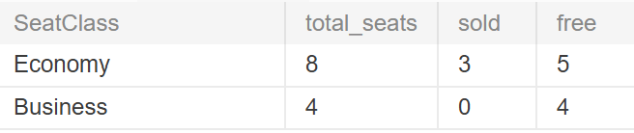
Q1 result: Economy 8 total, 3 sold, 5 free; Business 4 total, 0 sold, 4 free
Q2a. Somsak’s bookings and flights (5-table join). 3 flight legs across reservations 1 and 8.
Q2a result: reservations 1 and 8 with flights MW101, MW102 and MW301
Q2b. Payment status of each booking (LEFT JOIN). Reservation 1 is paid (3,000 THB); reservation 8 is held and not paid.
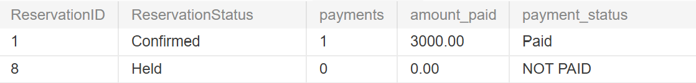
Q2b result: reservation 1 Paid 3000.00, reservation 8 NOT PAID
Q3a. Income per route last month (O3). BKK → SIN earned the most (52,800 THB from 9 seats).
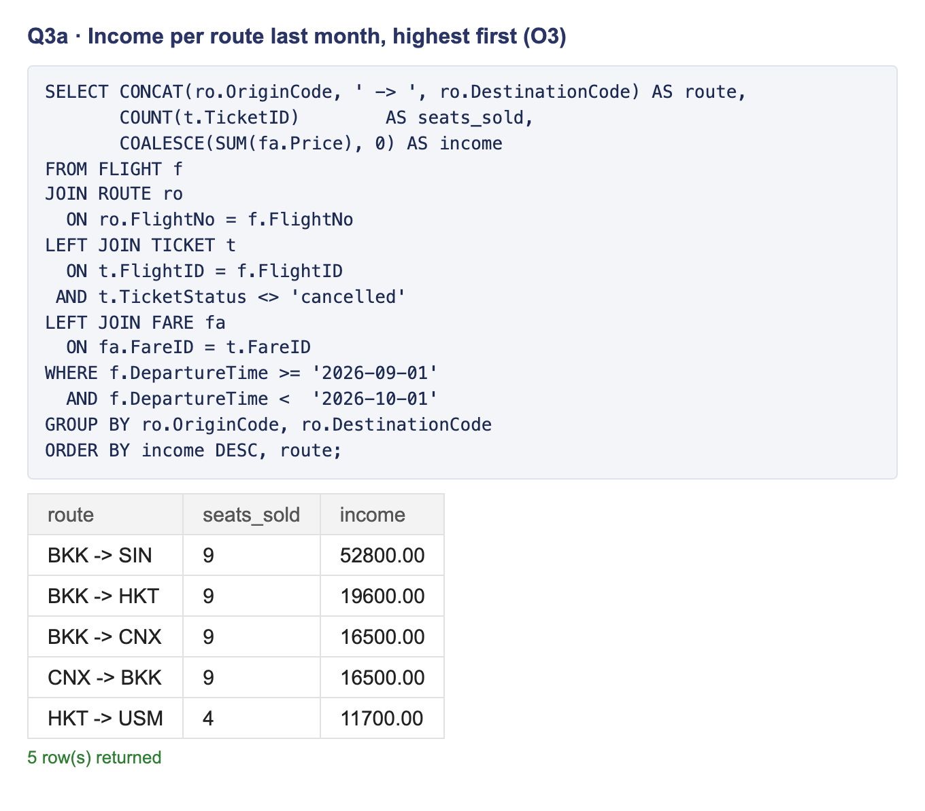
Q3a: SQL and result, income per route for September, BKK to SIN highest
Q3b. The route that sold the fewest seats (WITH, keeps ties). HKT → USM sold only 4 seats.
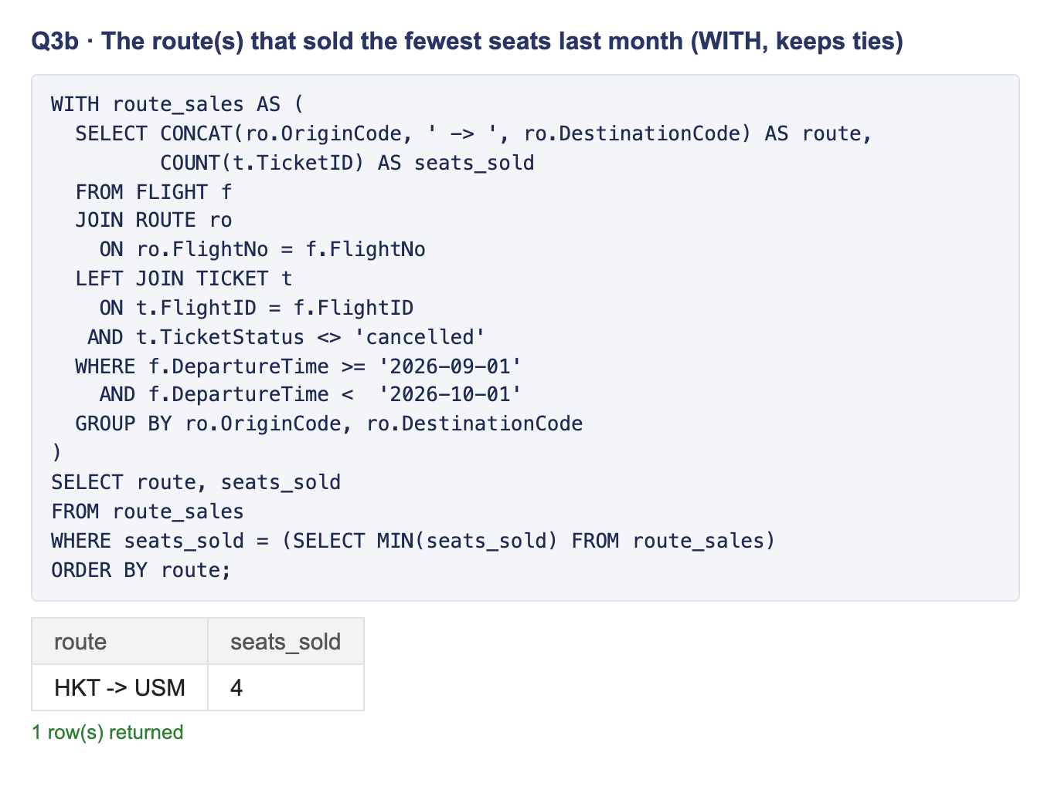
Q3b: SQL and result, HKT to USM with 4 seats sold
Q4. Flights departing in October 2026 (BETWEEN, ORDER BY). 5 flights, earliest first.
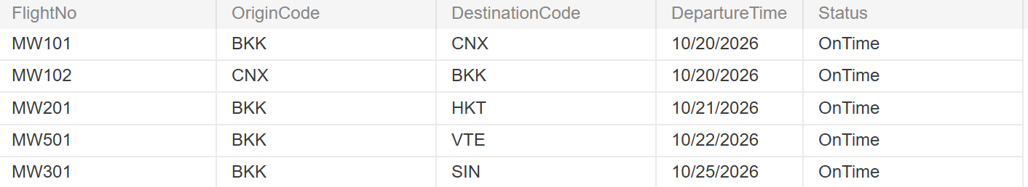
Q4 result: five October flights in departure order
Q5a. The Saetang family (LIKE). 3 passengers.
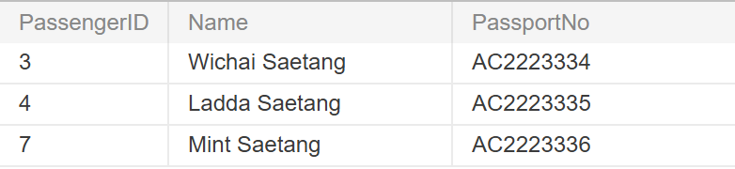
Q5a result: Wichai, Ladda and Mint Saetang
Q5b. Passengers with no email (IS NULL). Mint Saetang.
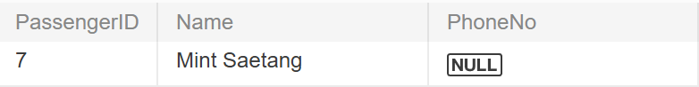
Q5b result: Mint Saetang with no email
Q6. Membership levels with 15 or more passengers (GROUP BY, HAVING). Normal (68) and Silver (20) are kept; Gold (12) is dropped by HAVING.
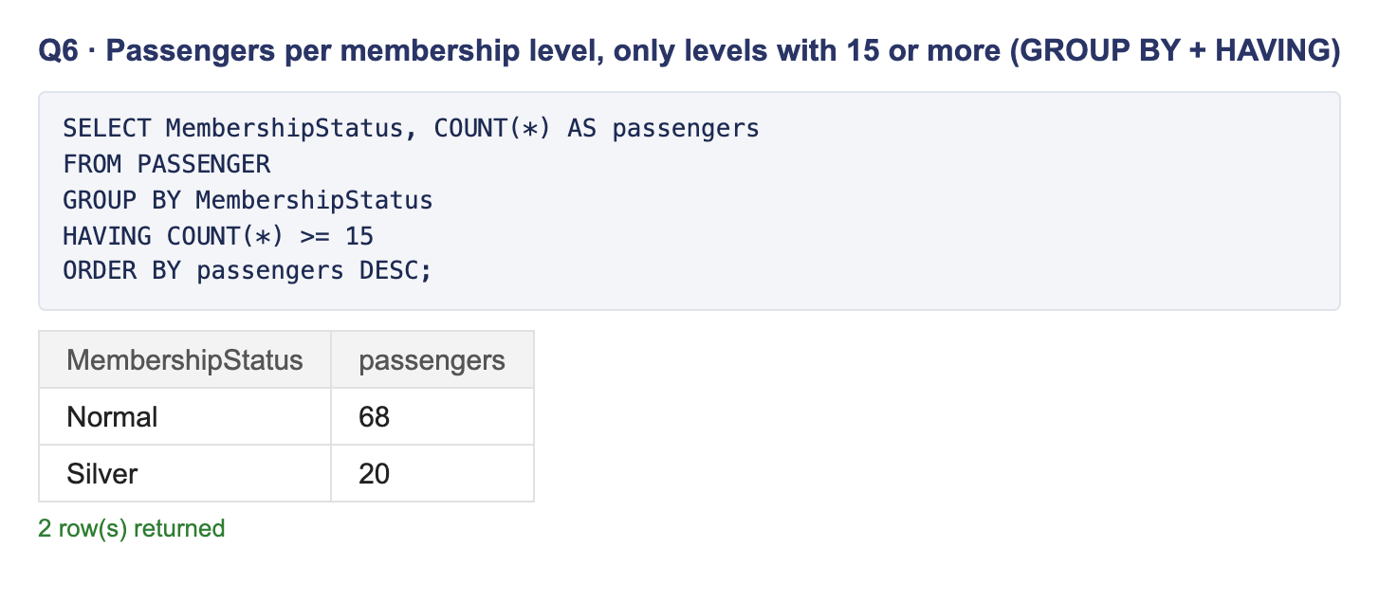
Q6: SQL and result, Normal 68 and Silver 20
Q7. Boarding list for MW101 (PASSENGER joined twice). Who sits where and who booked it.
Q7 result: boarding list for MW101 with seats and bookers
Q8. Double-booking check (O1, BR10) and Q8b. Staff in exactly one subtype (BR14). Both return 0 rows, which is the expected result: no seat is on two live tickets, and no staff member is missing or doubled in a subtype table.
Q9. Reservations per booking staff member (LEFT JOIN). Ploy Srisuk created 17 reservations and Anan Wongsa 15; the rest were booked online.
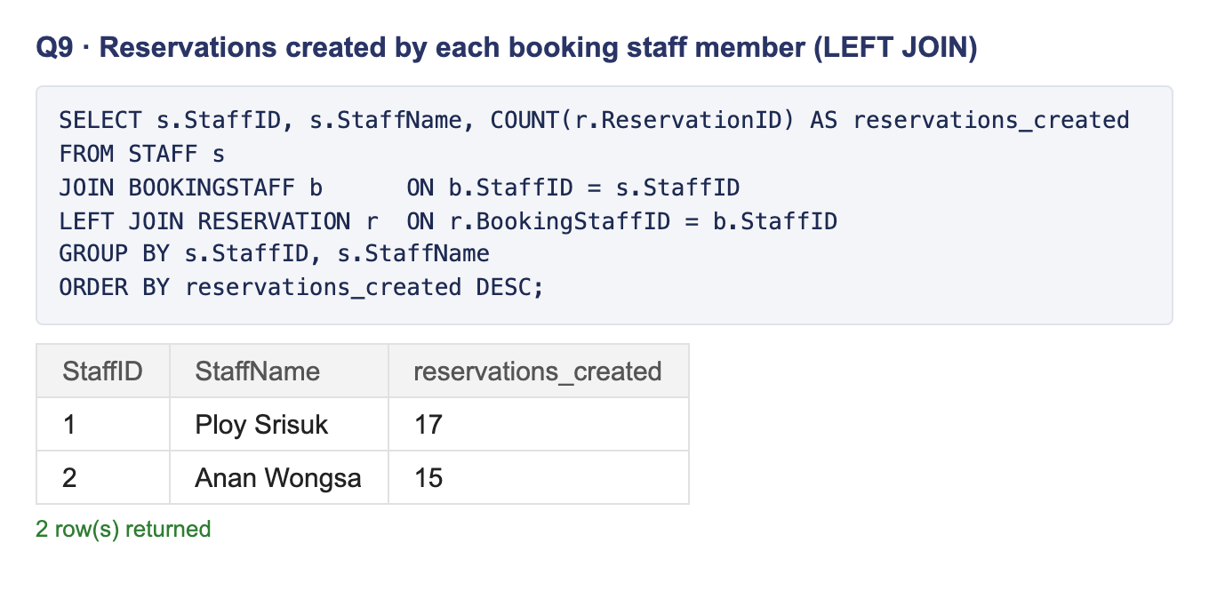
Q9: SQL and result, Ploy Srisuk 17 and Anan Wongsa 15 reservations
Q10. Issued tickets on MW101 (20 Oct) not checked in yet (LEFT JOIN + IS NULL, BR13). 3 travellers in seats 2A–2C still need to check in.
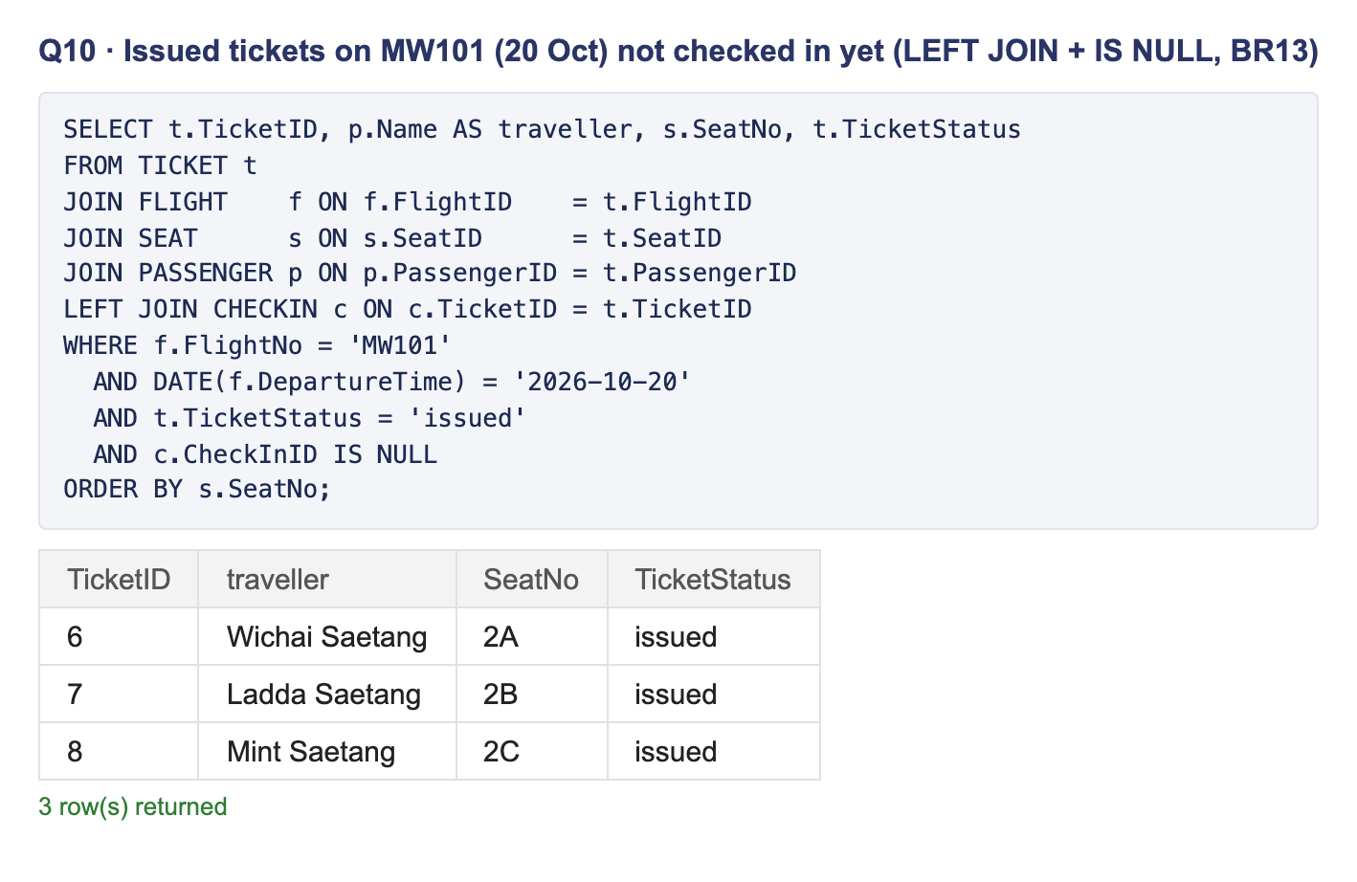
Q10: SQL and result, 3 issued tickets not checked in
Q11. Baggage weight per ticket against its class limit (CASE, BR12). All 24 tickets with bags are under their limit; tickets 46 (Business) and 4 (Economy) have only 0.5 kg left.
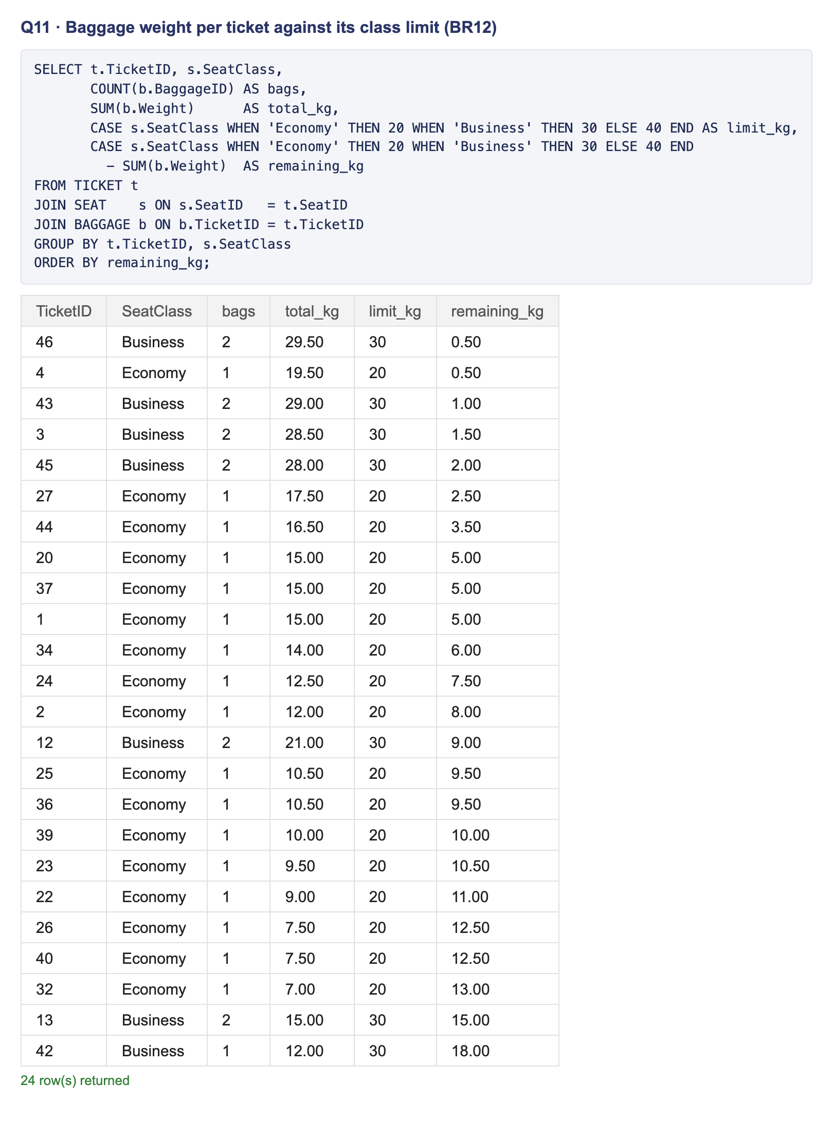
Q11: SQL and result, 24 tickets with bags, all under the class limit
Q12. Aircraft with no flights (LEFT JOIN + IS NULL). The Airbus A321 (aircraft 6) is not scheduled yet.
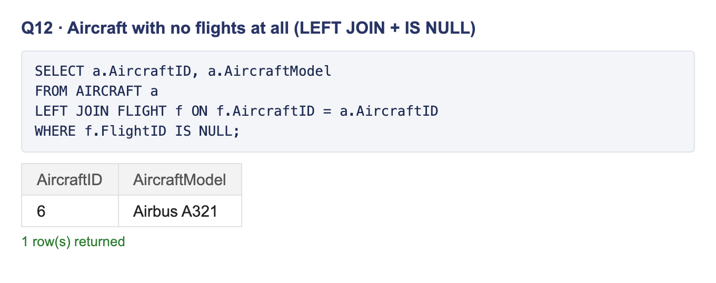
Q12: SQL and result, aircraft 6 Airbus A321
Q13. What Gold and Silver members paid in 2026 (IN, refunds subtracted). 10 members; Dao Jantarawong paid the most, 19,500 THB.
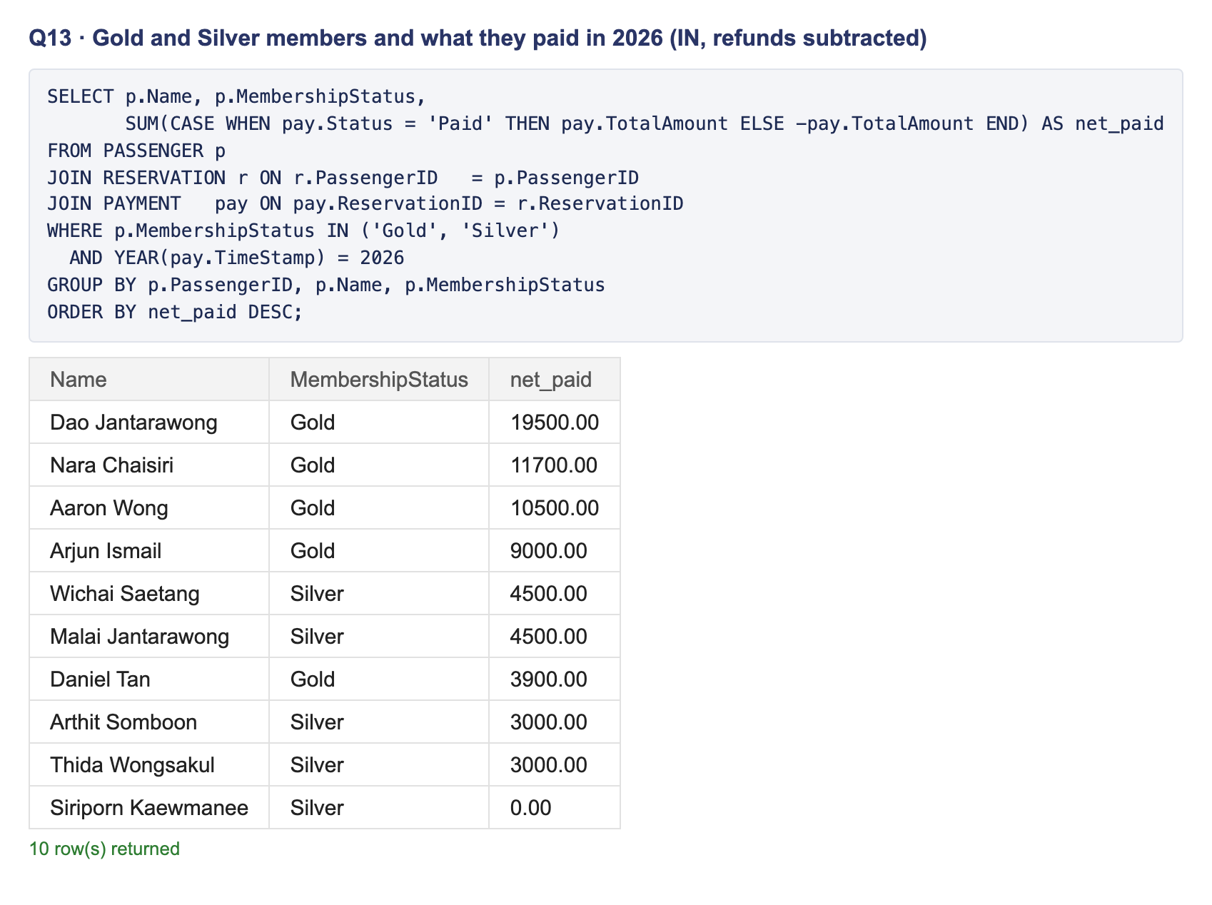
Q13: SQL and result, 10 Gold and Silver members with net paid
Q14. The view v_flight_load (CREATE VIEW). Total, sold and free Economy seats on each upcoming flight, from one simple SELECT on the view. MW201 and MW301 have no Economy seats left.
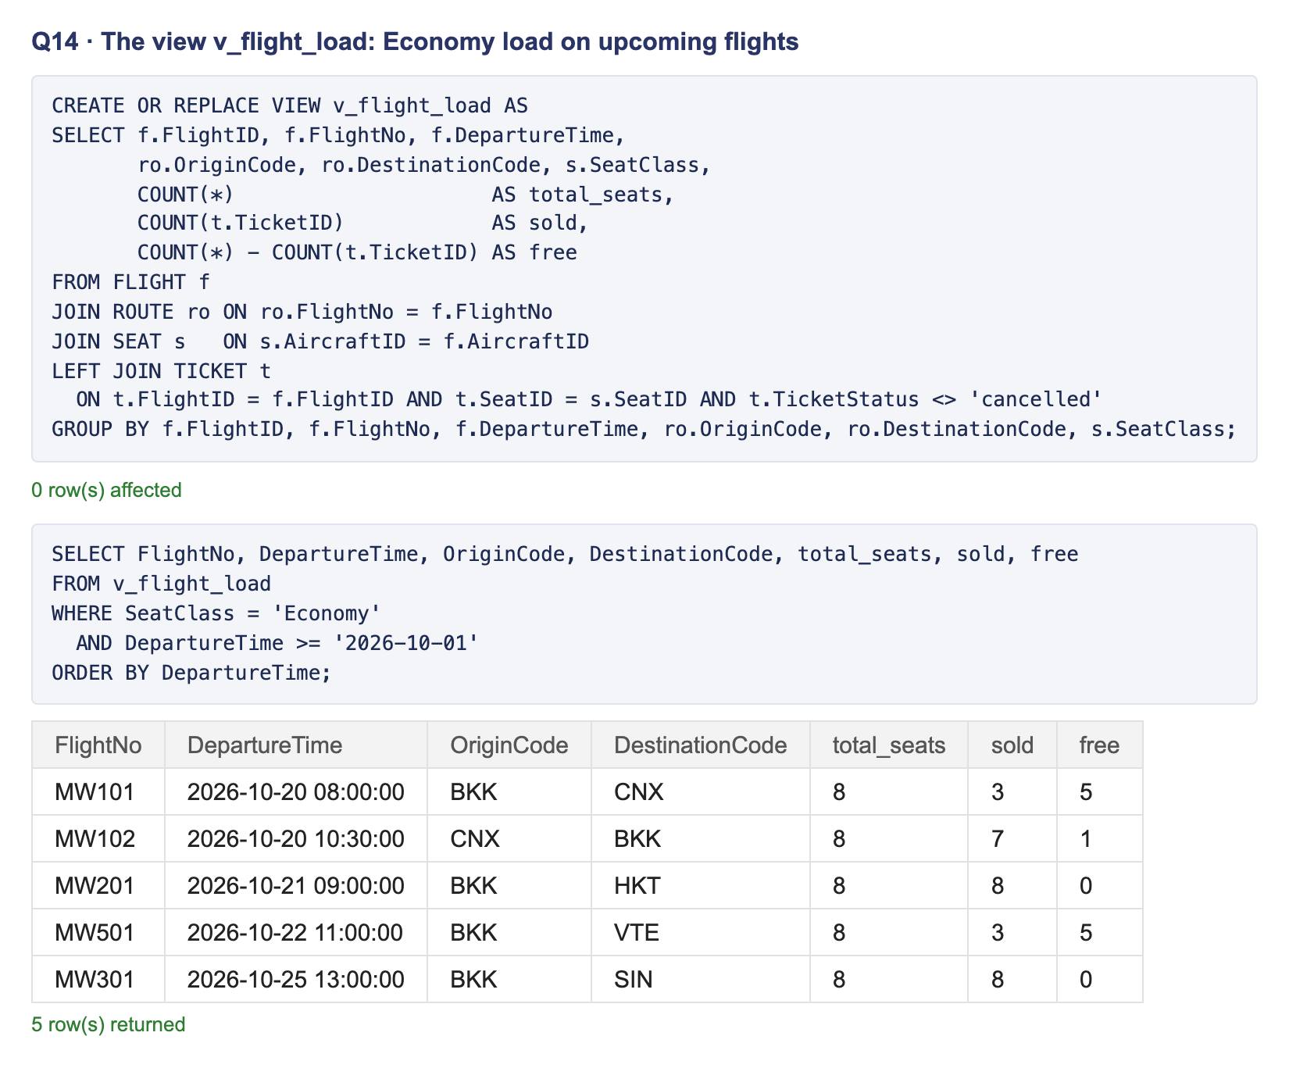
Q14: CREATE VIEW, then the Economy load of 5 upcoming flights
Q15–Q18 show the constraints at work (Lecture 8.2). Q15 and Q17 run inside START TRANSACTION … ROLLBACK, so the sample data does not change.
Q15. UPDATE with the primary key in WHERE. MW301 changes from OnTime to Delayed: 1 row changed.
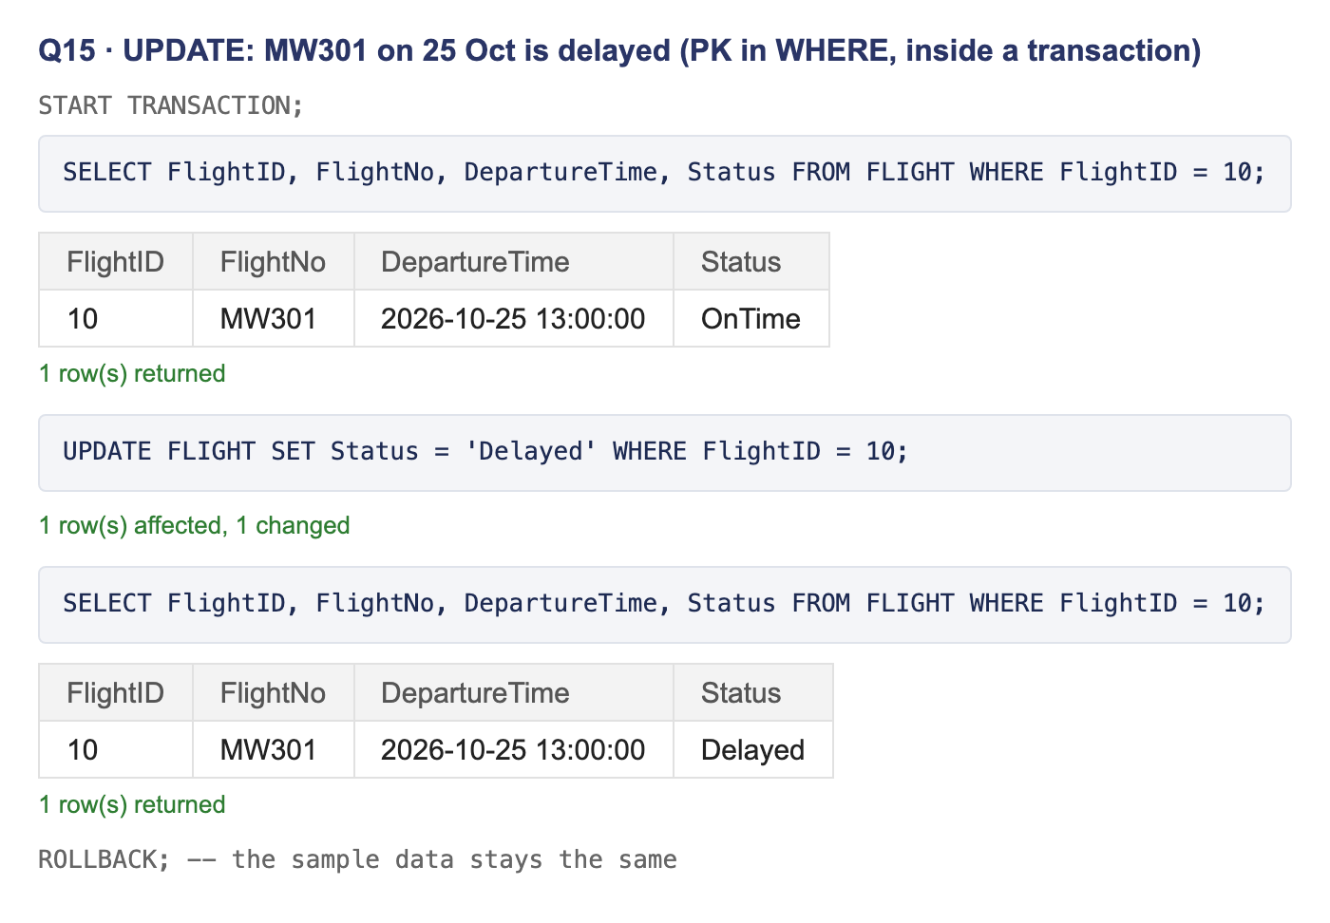
Q15: SELECT before, UPDATE, SELECT after showing Delayed
Q16. DELETE a passenger who has reservations: refused by RESTRICT. Error 1451 on RESERVATION_PASSENGER_FK, so the booking history is kept.
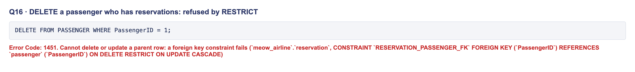
Q16: DELETE refused with error 1451
Q17. DELETE a held, unpaid reservation: CASCADE. Its ticket (ticket 9) is deleted with it: 1 row before, 0 rows after.
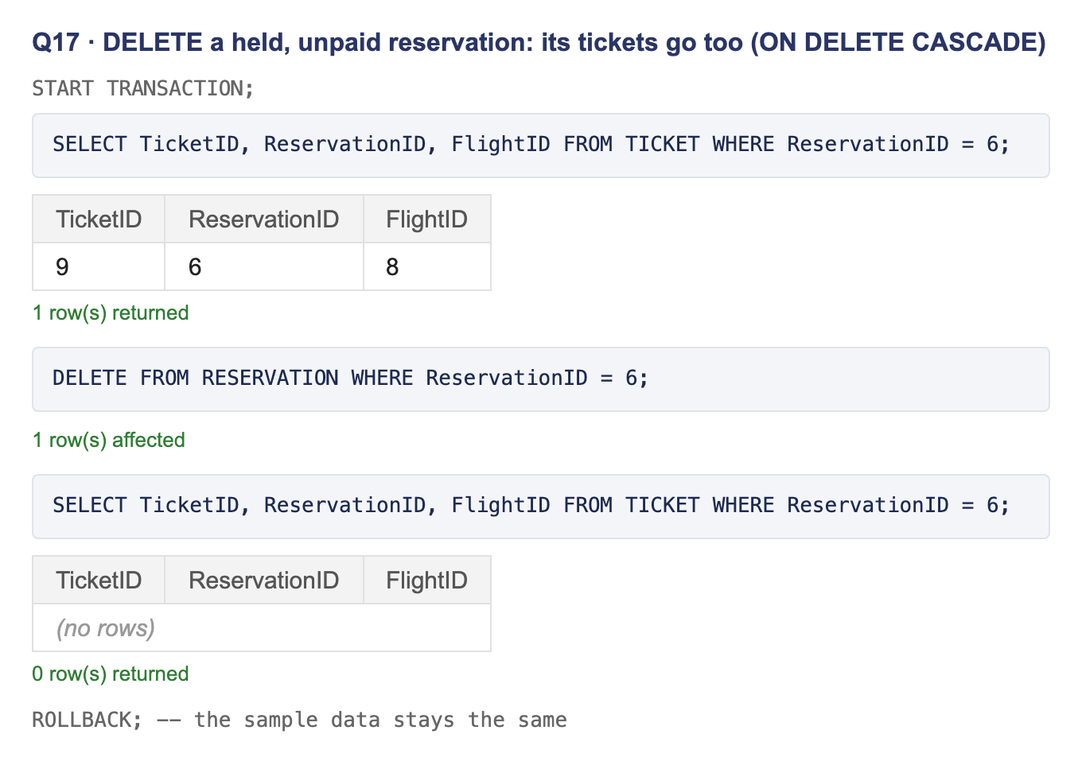
Q17: ticket 9 before, DELETE, no rows after
Q18. The database refuses rule-breaking data. Each statement fails with MySQL’s own error:
Query | Attempt | Refused by | Error
Q18a | A route from BKK to BKK | CHECK ROUTE_Airports_CK (BR7) | 3819
Q18b | Sell seat 2A on MW101 a second time | UNIQUE TICKET_Seat_On_Flight_UQ (O1, BR10) | 1062
Q18c | A second seat for Ladda on the same flight | UNIQUE TICKET_Passenger_On_Flight_UQ (BR18) | 1062
Q18d | Delete the ‘Refundable’ condition still in use | FK FARE_RULE_CONDITION_FK, RESTRICT (BR19) | 1451
Q18e | A seat from another aircraft | Trigger TICKET_Seat_Fare_BI | 1644
Q18f | A Business seat on an Economy fare | Trigger TICKET_Seat_Fare_BI (BR15) | 1644
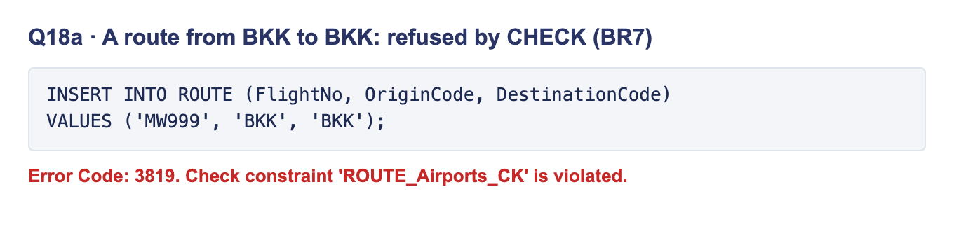
Q18a: error 3819, check constraint violated
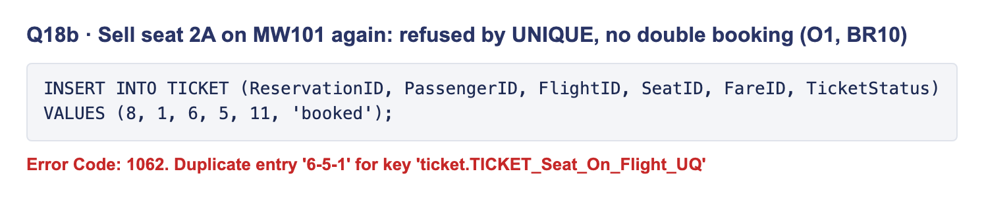
Q18b: error 1062, duplicate seat on the flight
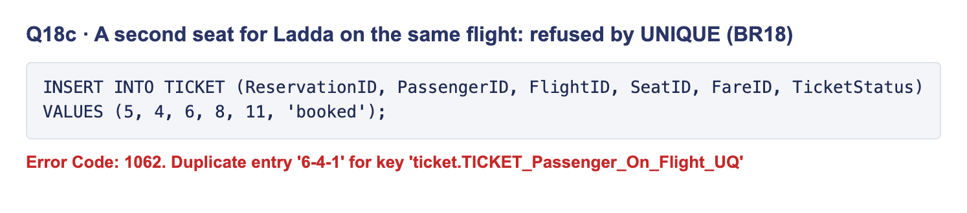
Q18c: error 1062, duplicate traveller on the flight
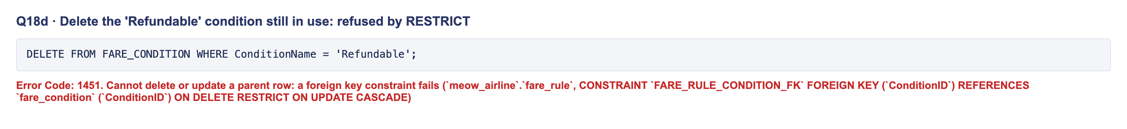
Q18d: error 1451, condition still used by fares
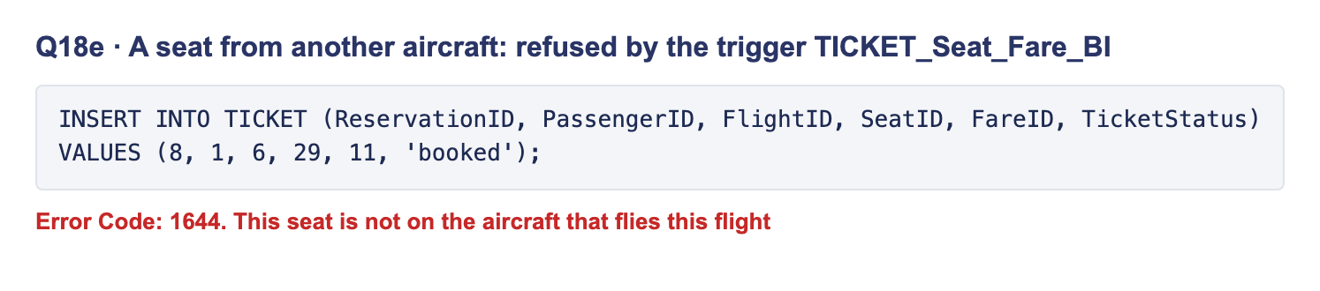
Q18e: error 1644, seat not on the flight’s aircraft
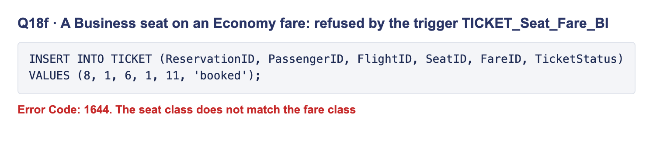
Q18f: error 1644, seat class does not match the fare class
Q19. What each MW101 fare includes (through the FARE_RULE bridge). 5 fare-condition rows across Economy and Business.
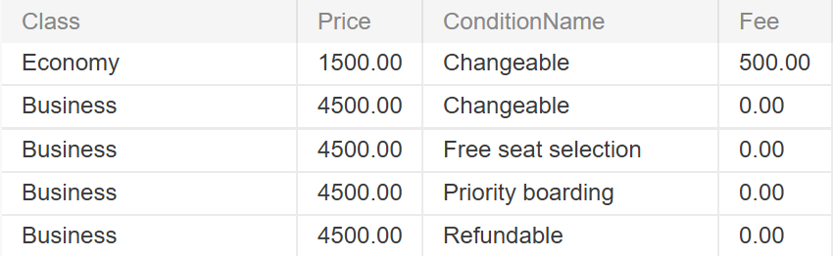
Q19 result: fare conditions and fees for MW101
Q20. Upcoming fares that are not refundable (LEFT JOIN + IS NULL, the condition inside ON). All 5 upcoming Economy fares: a passenger who cancels gets no money back.
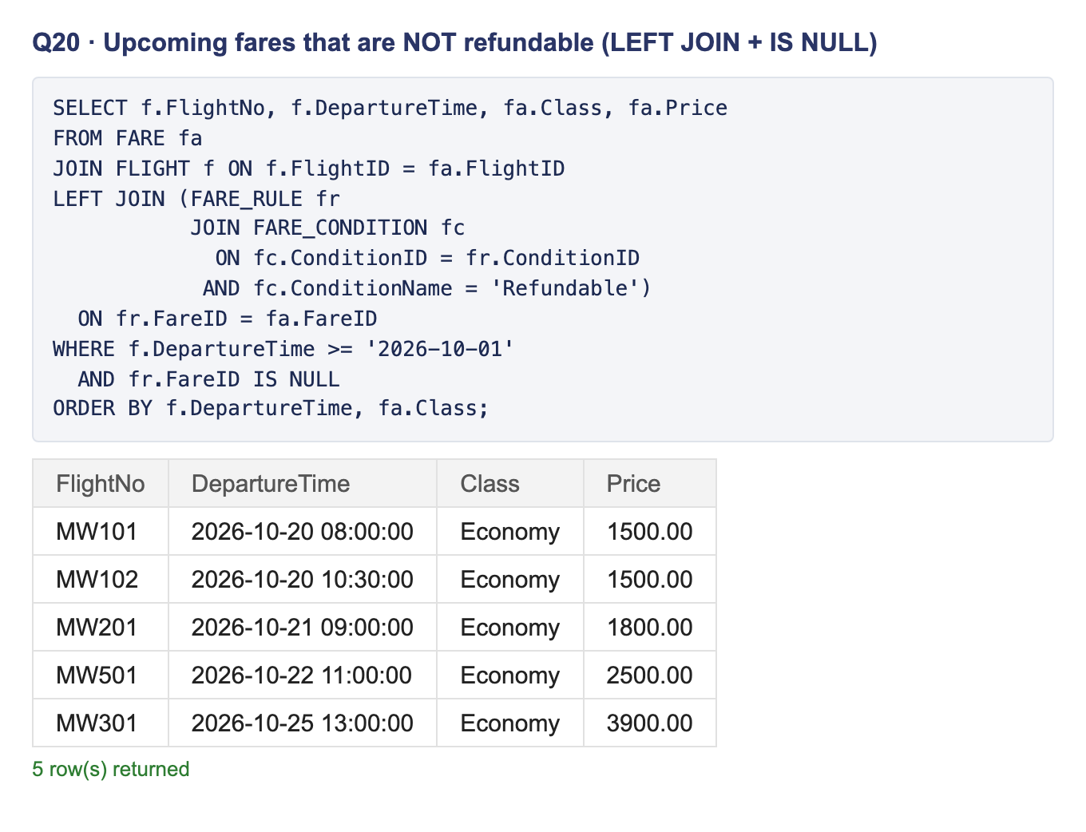
Q20: SQL and result, 5 non-refundable Economy fares
All 20 queries ran on a fresh schema.sql + seed.sql with the expected results. Q1–Q9 and Q19 were captured by Kawinthida; Q10–Q18 and Q20 show the SQL above each result.

8. Database system architecture
The system has three tiers: the browser shows EJS pages, an Express server runs the business logic, and MySQL stores the data and enforces the rules. The browser never talks to MySQL directly.
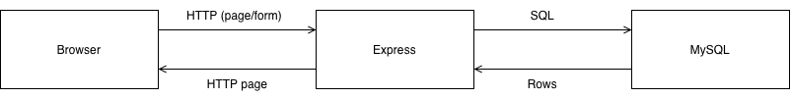
Browser sends HTTP to Express, Express sends SQL to MySQL; rows come back and Express returns an HTML page
One request, step by step (an agent books a ticket):
- The agent submits the booking form. The browser sends an HTTP POST to Express.
- Express matches the URL to a route in routes/, which calls its controller in controllers/.
- The controller checks the input, takes a connection from the shared pool in config/db.js and sends SQL with ? placeholders.
- MySQL runs the SQL inside one transaction and checks every constraint and trigger. It either commits the reservation and all its tickets, or rolls everything back.
- Express renders an EJS page from views/ with the result (or MySQL’s error as a friendly message) and sends the HTML back.
Part | Where | What it does
Connection pool | config/db.js (mysql2) | One shared pool of MySQL connections for every controller
Credentials | .env file, not in Git | Host, user, password and database name
Routes | routes/ (14 files, one per table group, plus reports) | Map each URL to a controller function
Controllers | controllers/ | Validate input, run SQL, handle errors
Views | views/ (EJS) | HTML pages and forms, including the 3 report pages
Three safety choices. Every query uses ? placeholders, so typed input can never run as SQL (no SQL injection). A booking runs in one transaction, so it is all or nothing. The rules live in MySQL, so even a bug in the backend cannot double-book a seat.

9. Tech stack
We built Meow Airline with free, widely used tools taught in the course: MySQL for the data, Node.js with Express for the server, and EJS for the pages.
Layer | Tool | Used for
Database | MySQL 8.4 | Tables, constraints, triggers, the view
Database tools | MySQL Workbench, DBeaver | Running the SQL files, screenshots
Backend | Node.js, Express | Routes and controllers
Database driver | mysql2 | Connection pool, ? placeholders, transactions
Frontend | EJS templates, HTML, CSS, JavaScript | Booking, check-in and report pages
Design | draw.io (diagrams.net) | The EER diagram
Teamwork | Git, GitHub | One shared main branch; each person confirms before pushing
Hosting | Local laptop (MySQL 8.4 + Node.js) | The live demo runs on one team member’s laptop; no cloud hosting

10. Milestones
The project ran in 10 days, from Mon 5 to Thu 15 Oct 2026, split into phases with one owner and one reviewer each. Until Wed 7 Oct changes reached main through GitHub pull requests; from Thu 8 Oct everyone pushes straight to main after confirming the push (RULES.md 1.4–1.5).
Phase | What | Dates | Owner | Reviewer | Status
1 | Proposal and pitch | Before 5 Oct | All | — | Done
0 | Setup, learn MySQL, practice Passenger CRUD | Mon 5 – Tue 6 | All | — | Done
2 | Fix the ERD, relational model, FDs and 3NF | Mon 5 – Tue 6 | Patarawadee | Kawinthida, Kornnaphat | Done
3 | schema.sql and seed.sql running in MySQL; schema frozen | Wed 7 – Thu 8 | Patarawadee | Kawinthida | Done (frozen Wed 7)
4 | Backend routes and controllers | Fri 9 – Mon 12 | Kawinthida | Patarawadee | Done (EJS pages connected Thu 8 Oct)
5a | queries.sql (section 7.4) | Fri 9 – Sun 11 | Kawinthida, Kornnaphat | Patarawadee | Done (all 20 results in section 7.4)
5b | Frontend pages and the 3 report pages | Sat 10 – Mon 12 | Kornnaphat | Patarawadee | Done (demo flow works in the browser Thu 8 Oct)
6 | Report, slides, rehearsal, Mango upload | Tue 13 – Wed 14 | All | — | Not started
— | Presentation | Thu 15 Oct | All | — | —
Update the Status column before submitting.

11. The UI
The web app lets an agent run the whole booking flow on one shared database: book a family of 3, take payment, check them in, and read the 3 reports. This is also our live demo.
The screenshots below follow that demo on the real app, in order: the Jaidee family (Somsak, Somchai and Malee) books seats 3B, 3C and 3D on MW101 BKK → CNX on 20 Oct 2026.
Home. The operations desk: live counts of passengers, upcoming flights and reservations, and shortcuts to each task.
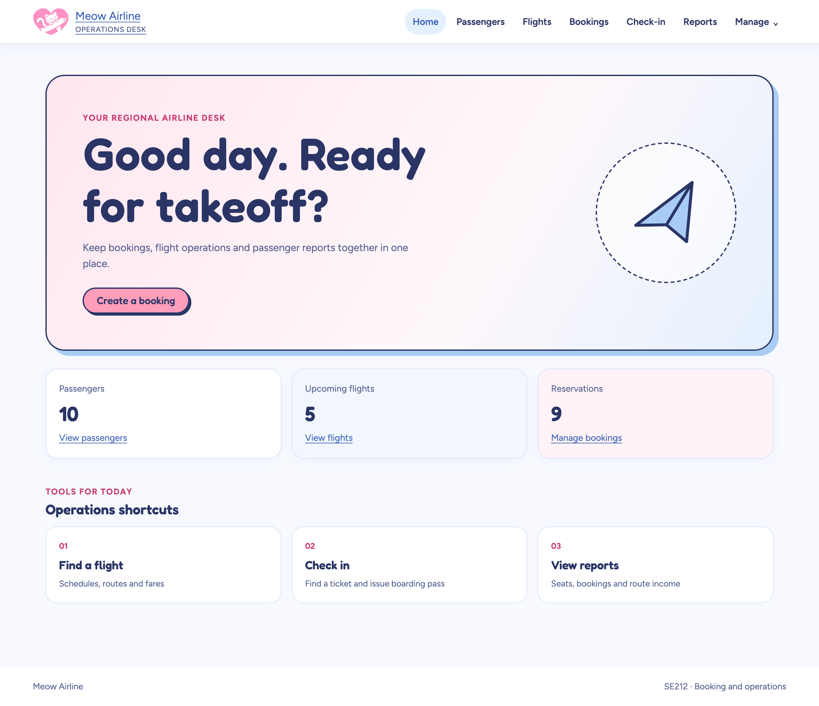
Home page: welcome panel, record counts and shortcuts
1. Booking a family of 3. One reservation, one row per traveller. Picking a flight fills its fares; picking a fare lists only the free seats of that class (BR10, BR15). The whole booking is saved in one transaction.
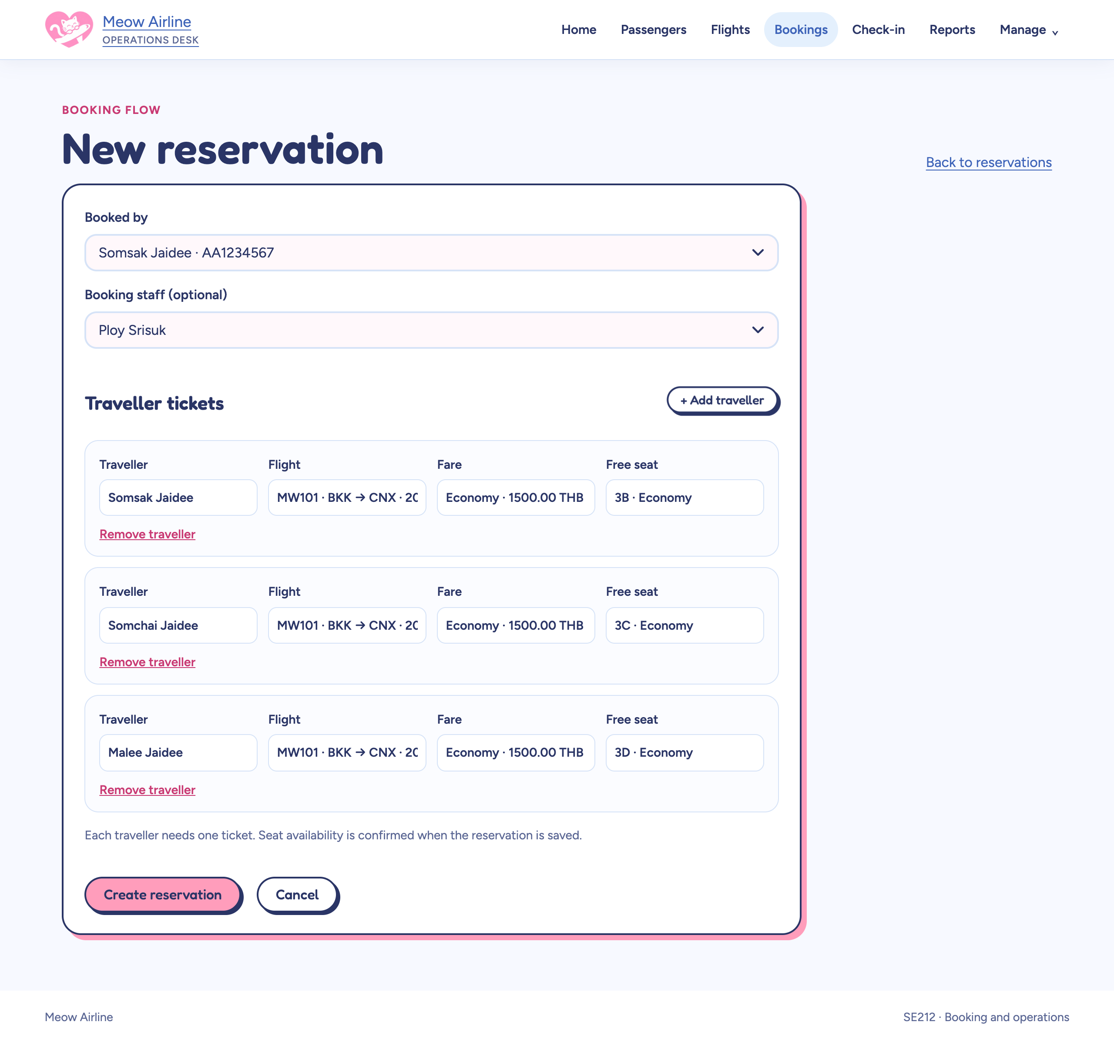
New reservation form with three travellers on MW101, Economy, seats 3B, 3C, 3D
2. Payment and ticket issue. After the 4,500 THB payment the reservation is Confirmed, and each ticket can be issued (BR8: no ticket before full payment).
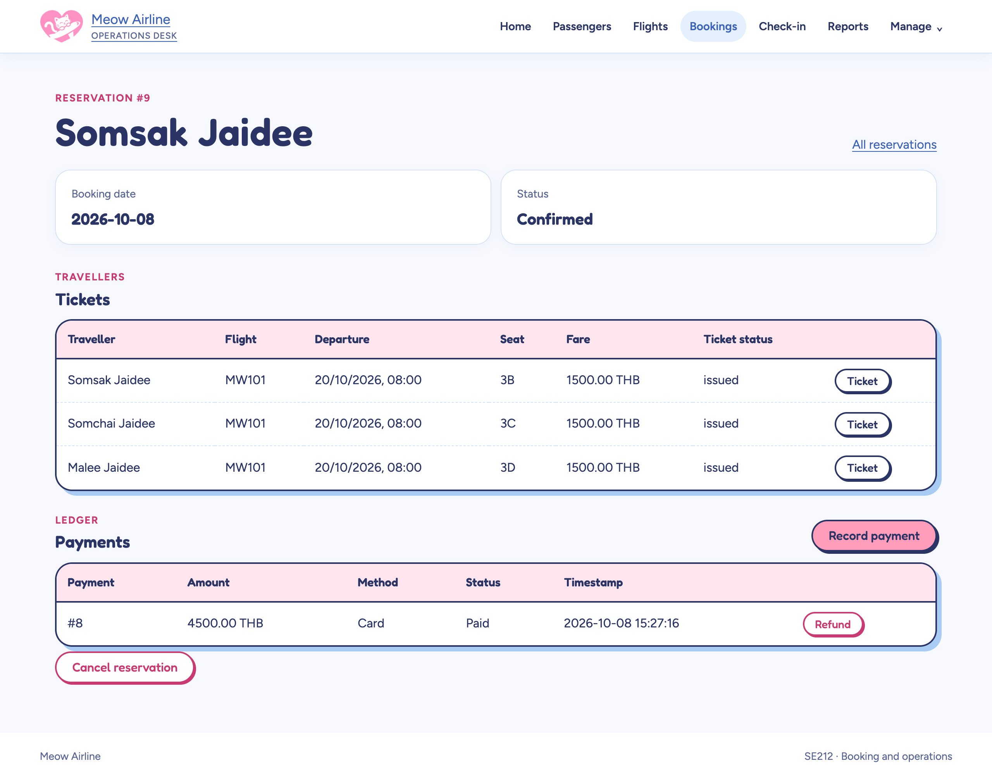
Reservation 9: Confirmed, three issued tickets, one paid payment
3. Check-in. The desk finds the tickets by reservation or passport. Only issued tickets for flights that have not left can check in (BR13); Somsak is already checked in.
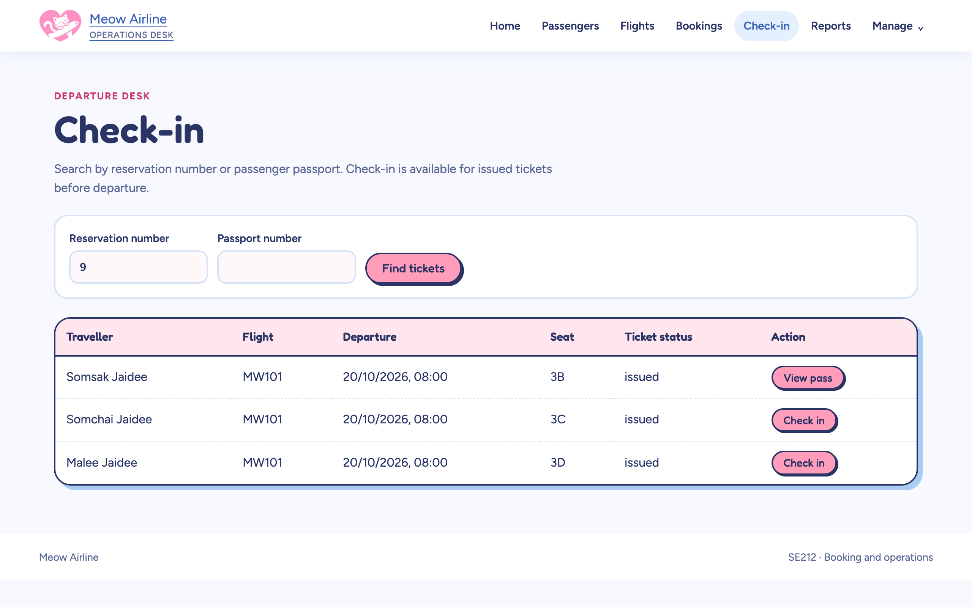
Check-in search for reservation 9: one View pass, two Check in buttons
Boarding pass for the checked-in ticket.
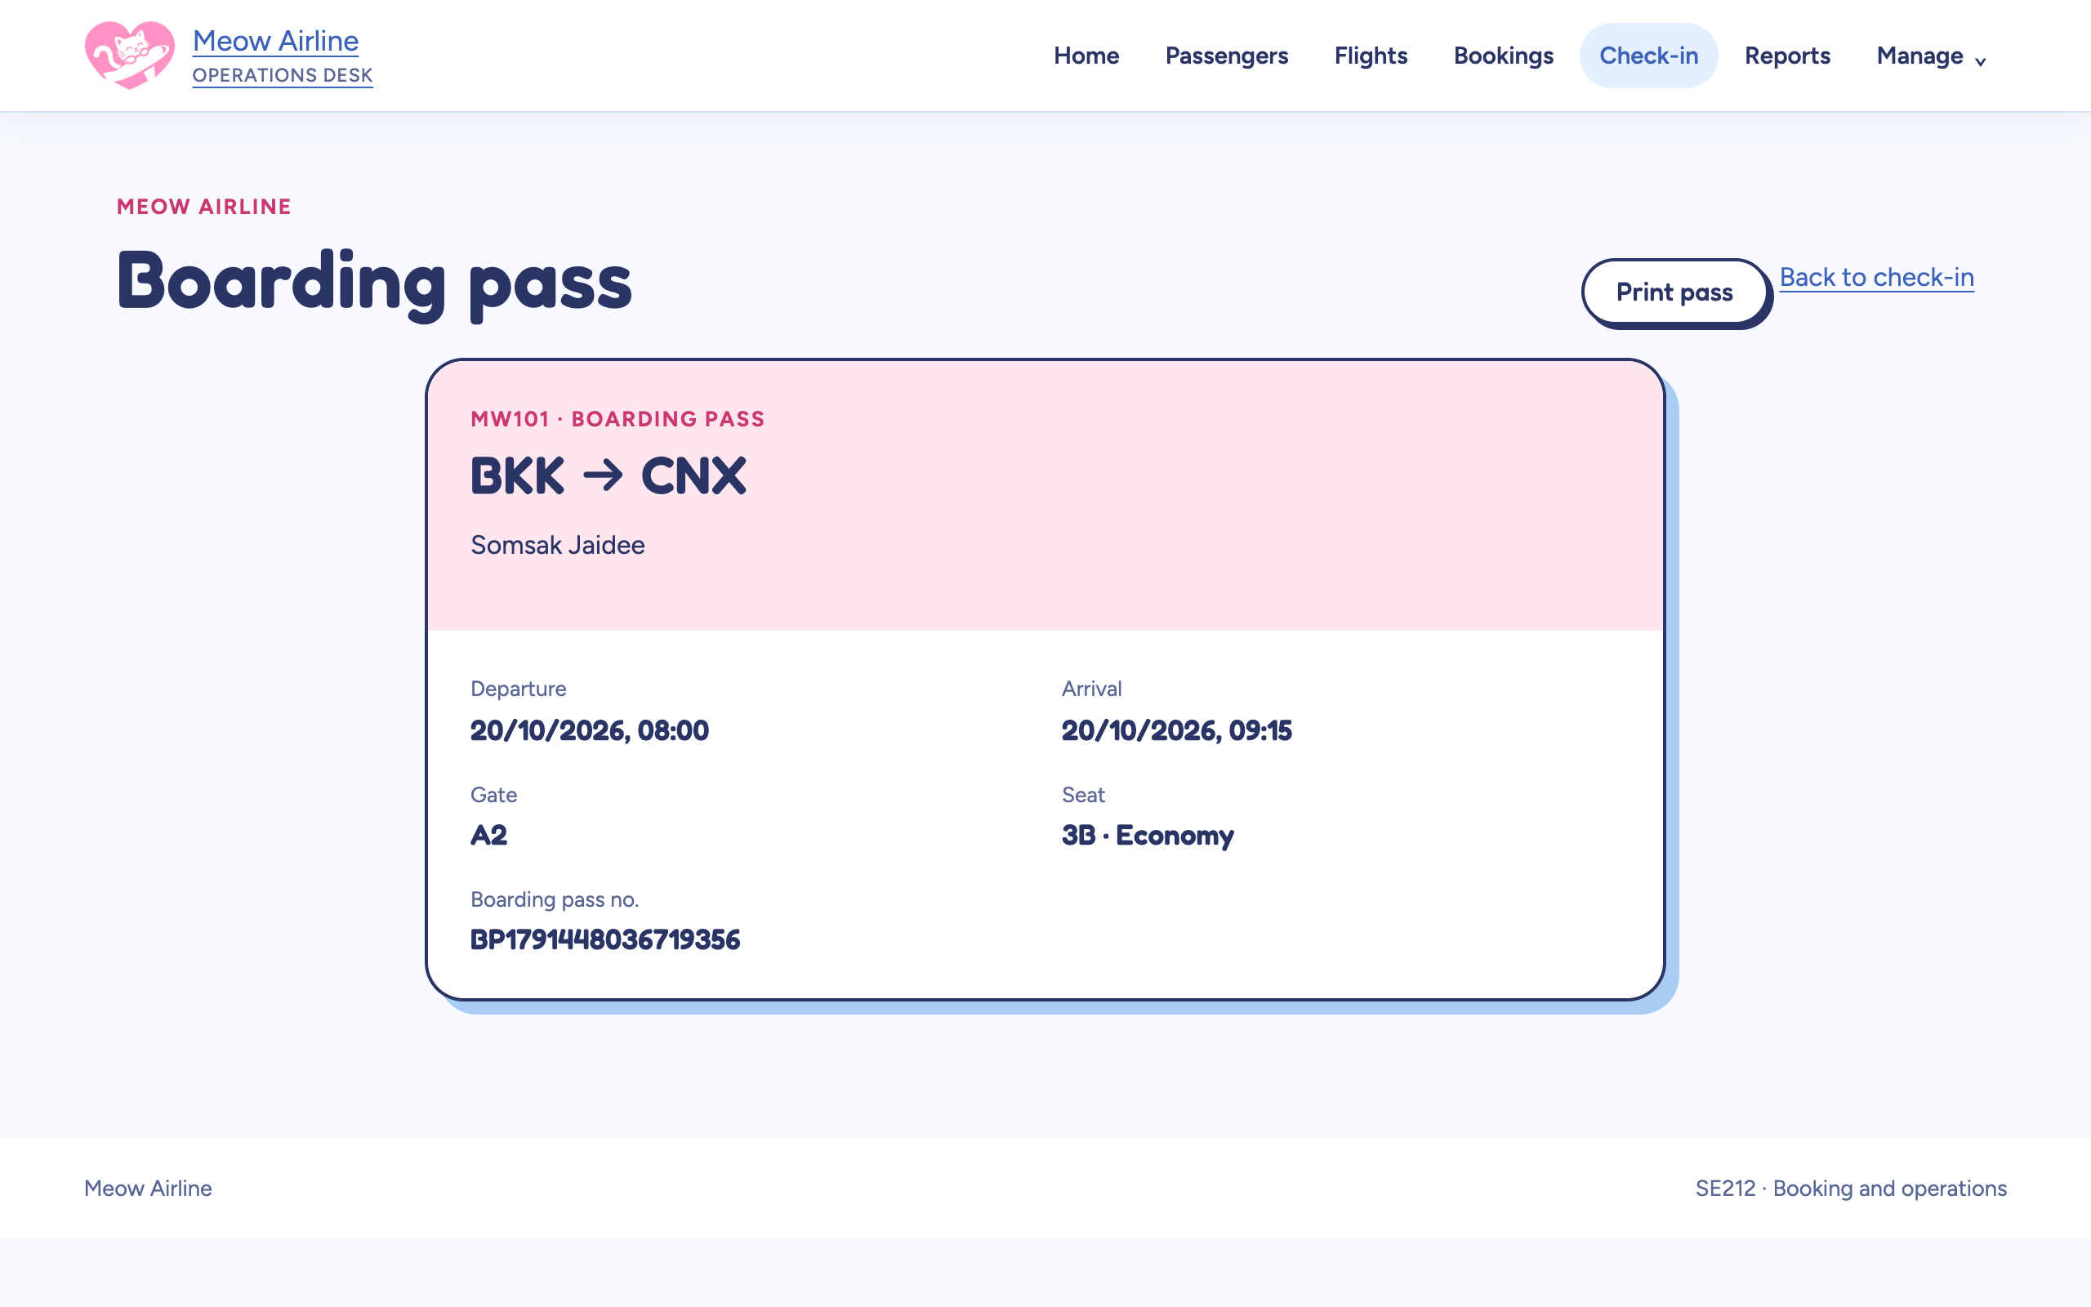
Boarding pass: MW101 BKK to CNX, Somsak Jaidee, seat 3B Economy, gate A2
Report 1: free seats per flight and class (Q1, O4). MW101 now has 2 of 8 Economy seats left.
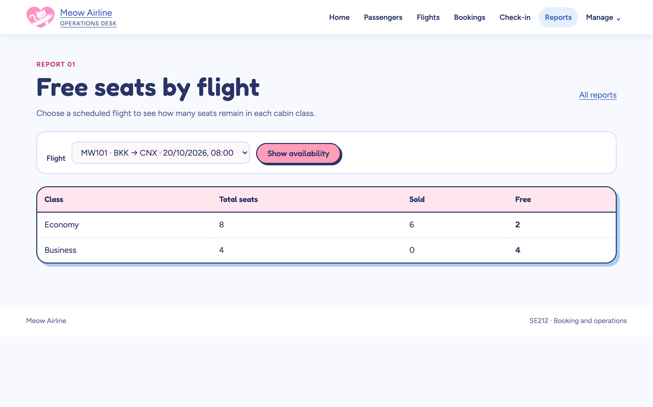
Free seats report for MW101 on 20 Oct: Economy 8 total, 6 sold, 2 free; Business 4 free
Report 2: a passenger’s bookings and payments (Q2). Every ticket Somsak booked, with what is paid and what is still due.
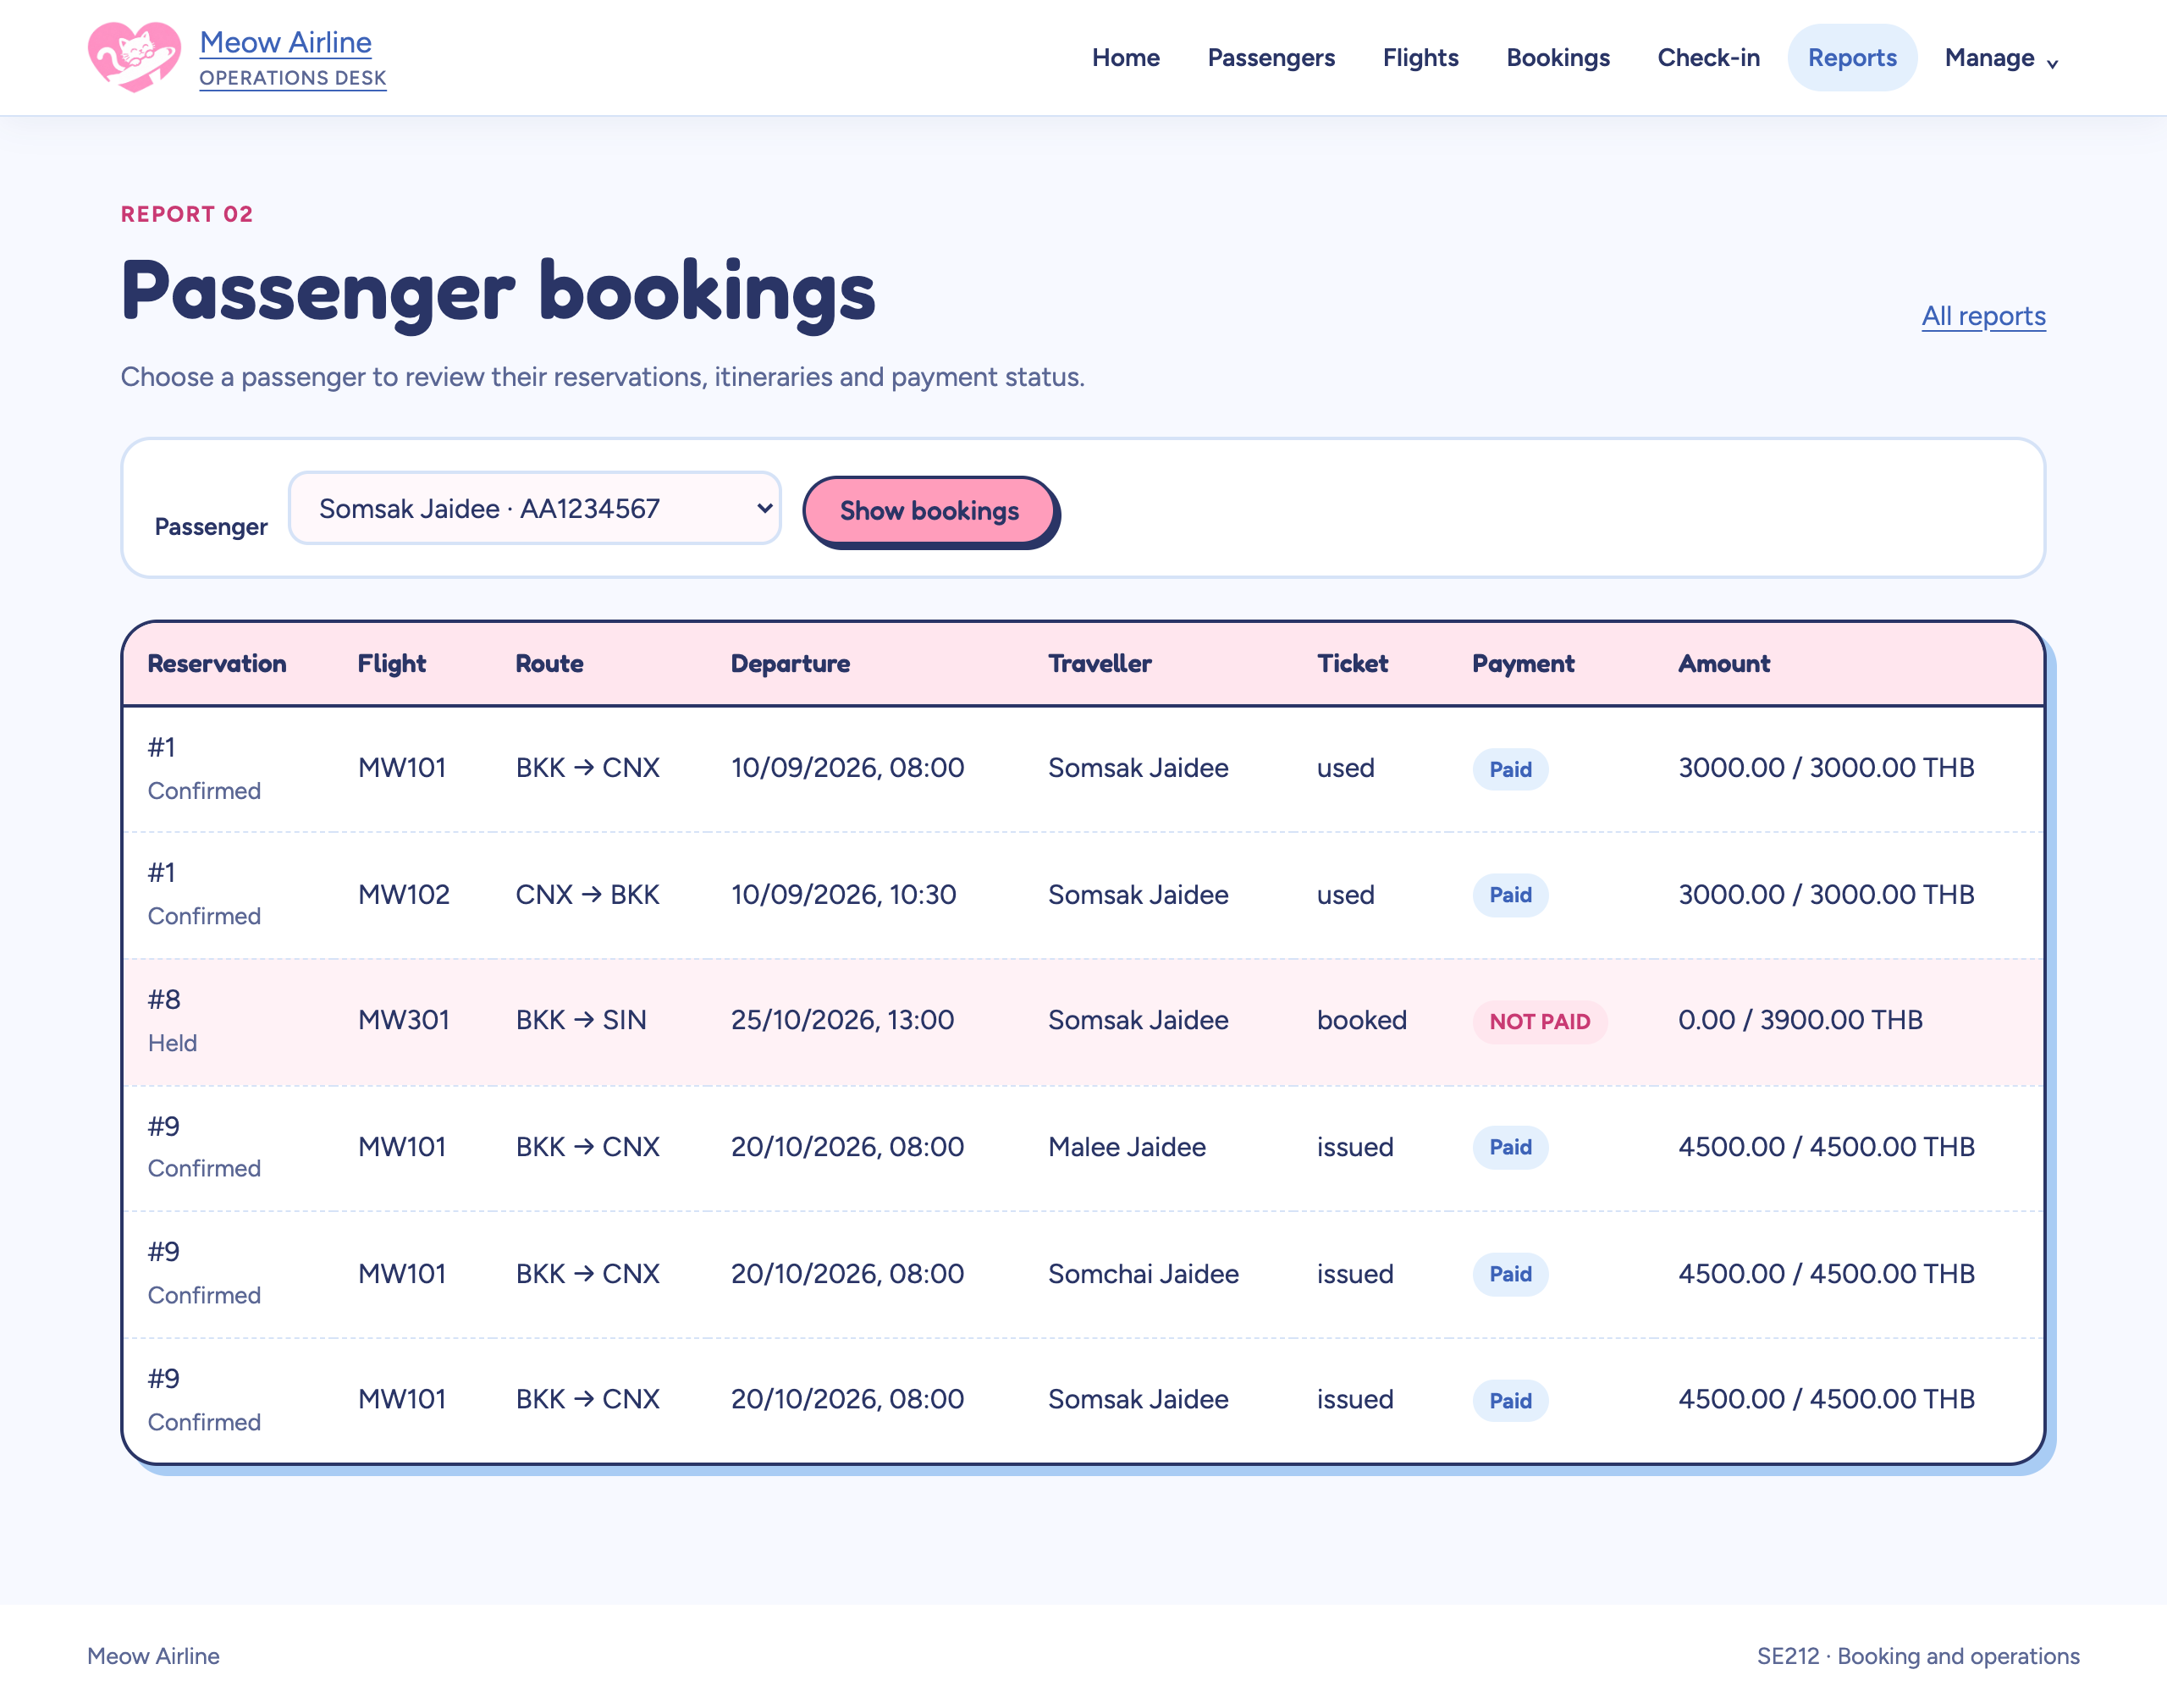
Passenger bookings report for Somsak Jaidee, including reservation 9 paid and reservation 8 not paid
Report 3: income per route last month (Q3, O3), with the route that sold the fewest seats.
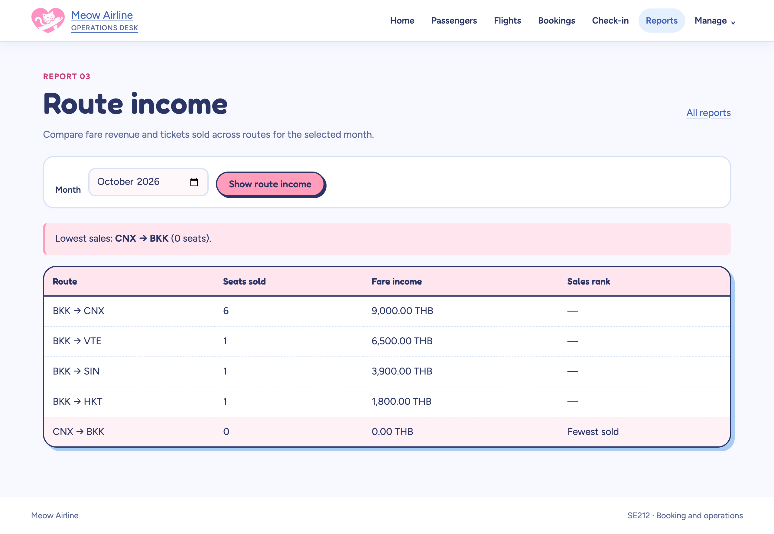
Route income report for October 2026, BKK to CNX first with 9,000 THB, CNX to BKK fewest sold
On a phone. Every page fits a 390 px screen; the navigation folds behind the Menu button.
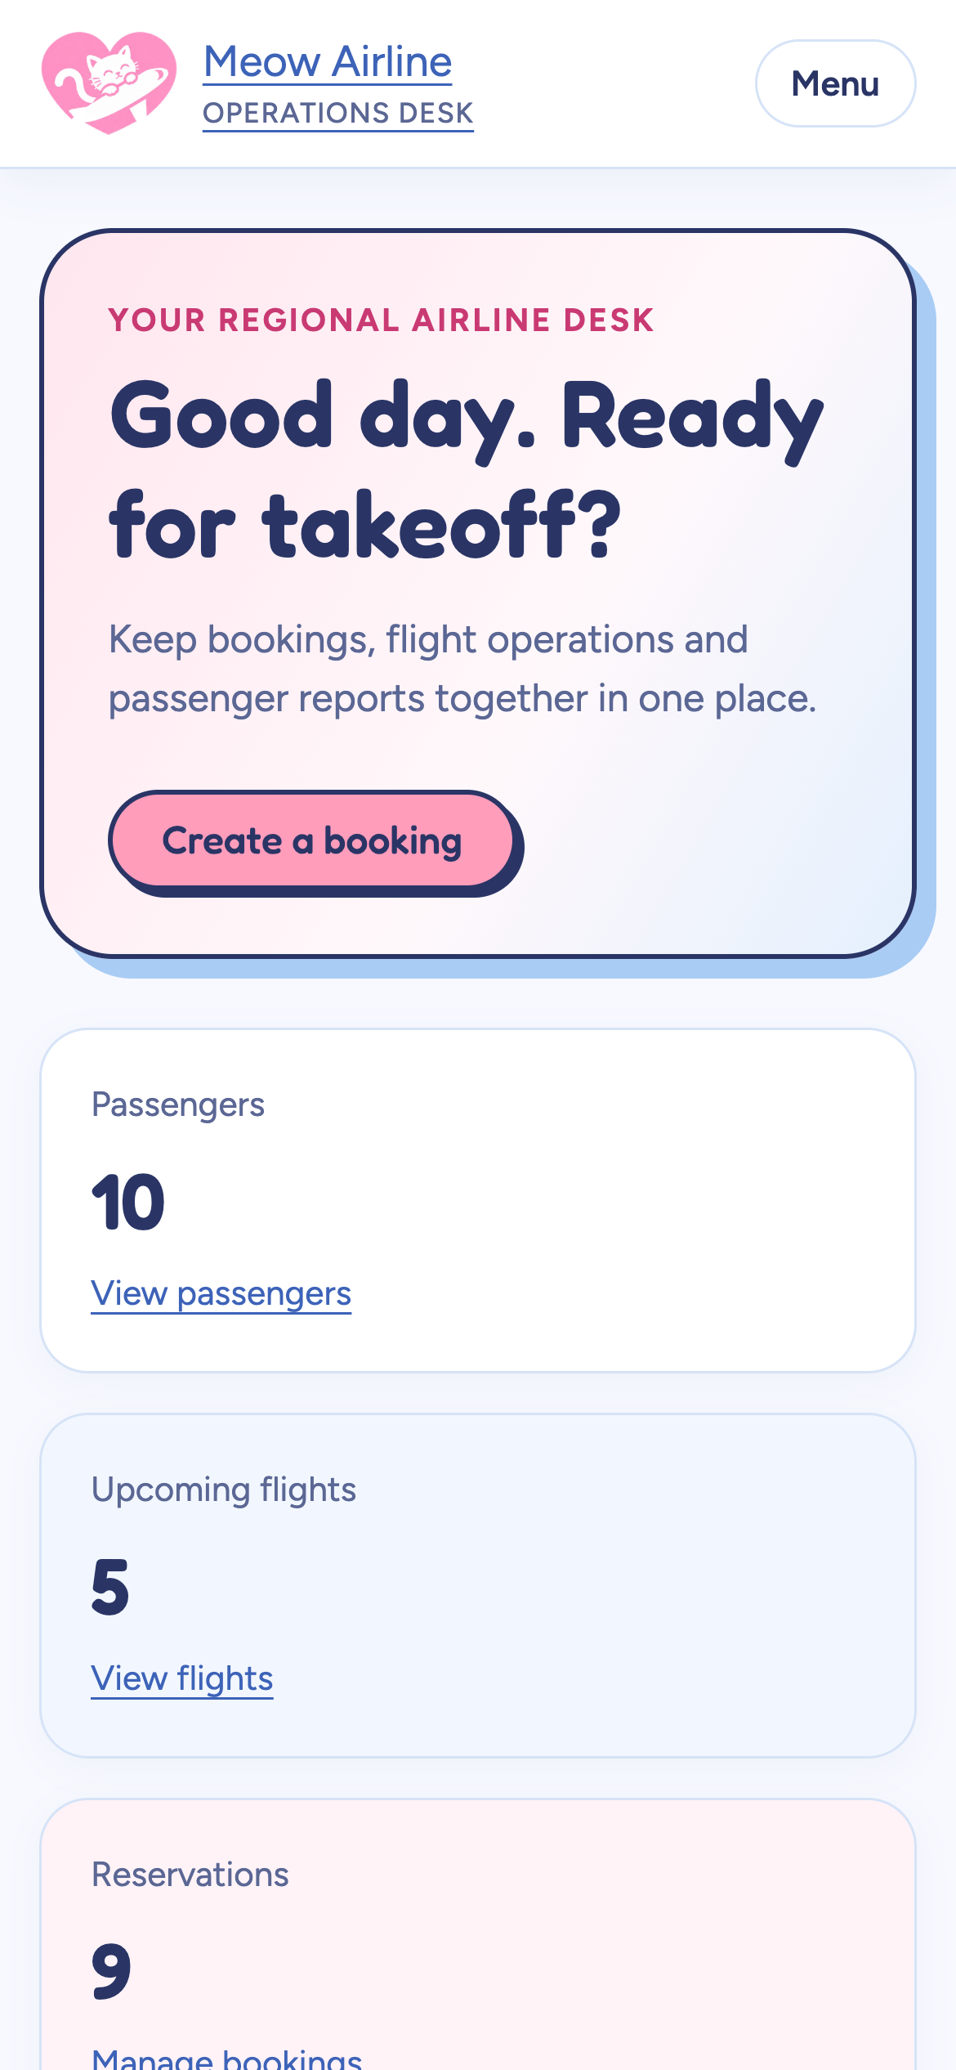
Home page on a phone

