Промежуточная аттестация SQL

Задание 1.

select tf.ticket_no, tf.flight_id, tf.fare_conditions, tf."amount", t.passenger_id, t.passenger_name

from bookings.ticket_flights tf

join bookings.tickets t on t.ticket_no = tf.ticket_no

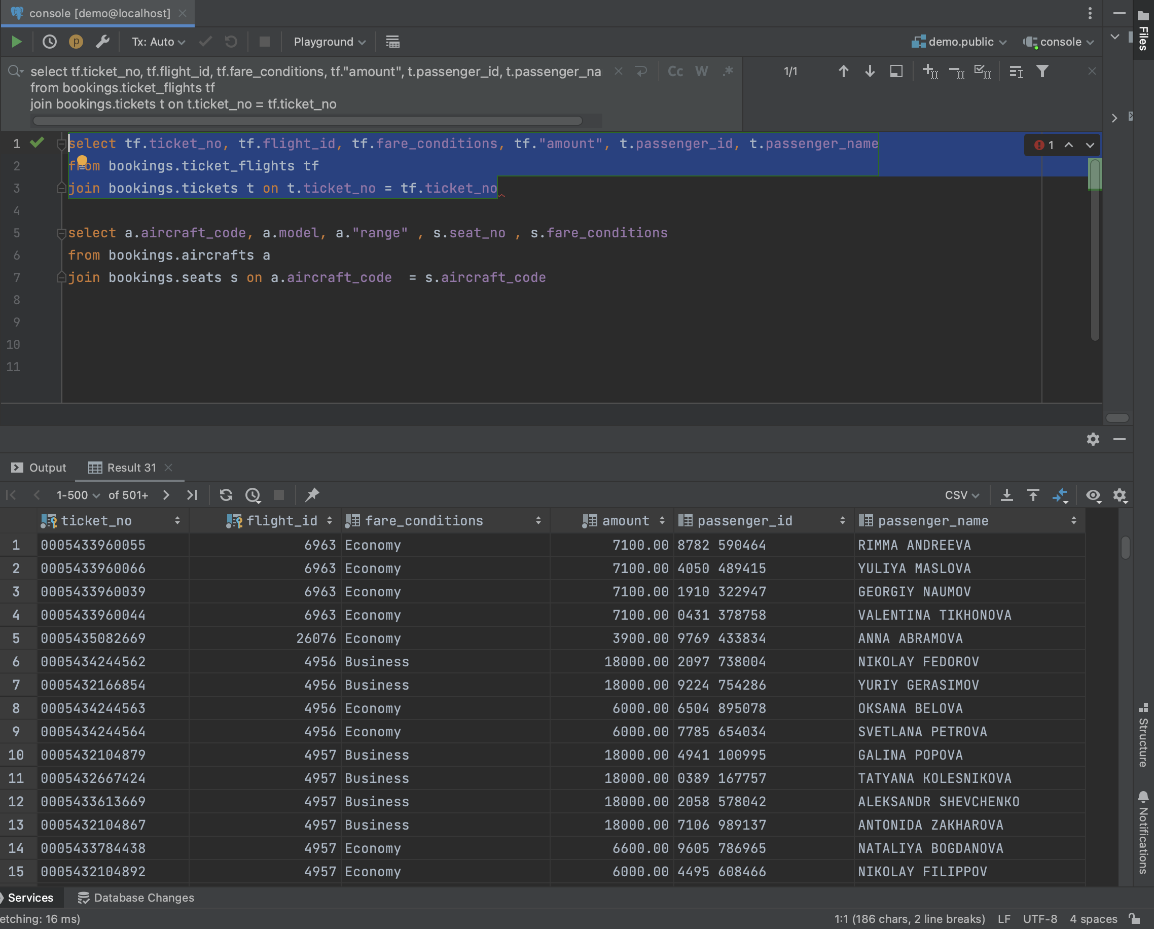

select a.aircraft_code, a.model, a."range" , s.seat_no , s.fare_conditions

from bookings.aircrafts a

join bookings.seats s on a.aircraft_code = s.aircraft_code

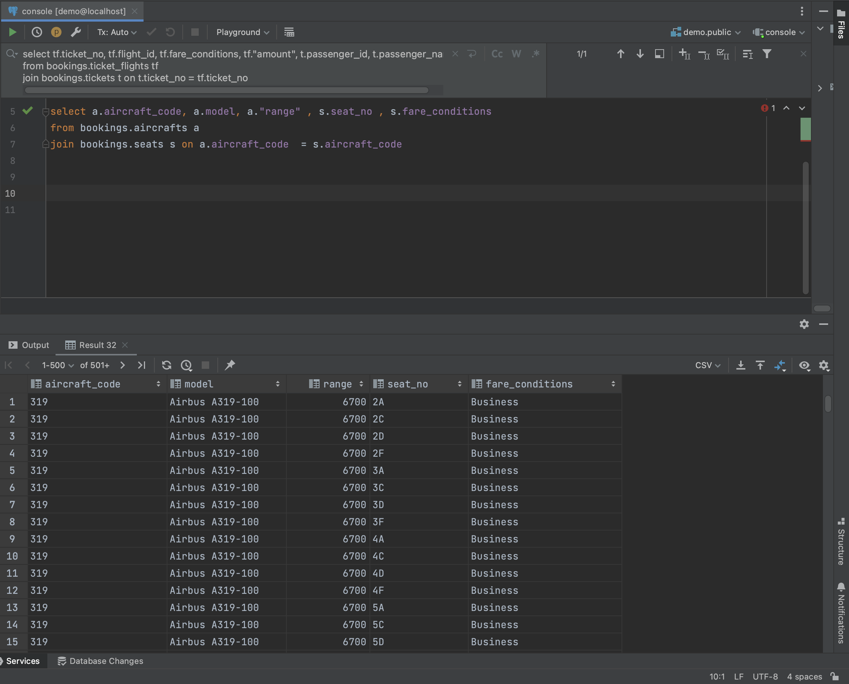

select model as name, 'самолет' as object_type

from bookings.aircrafts

union all

select airport_name, 'аэропорт'

from bookings.airports

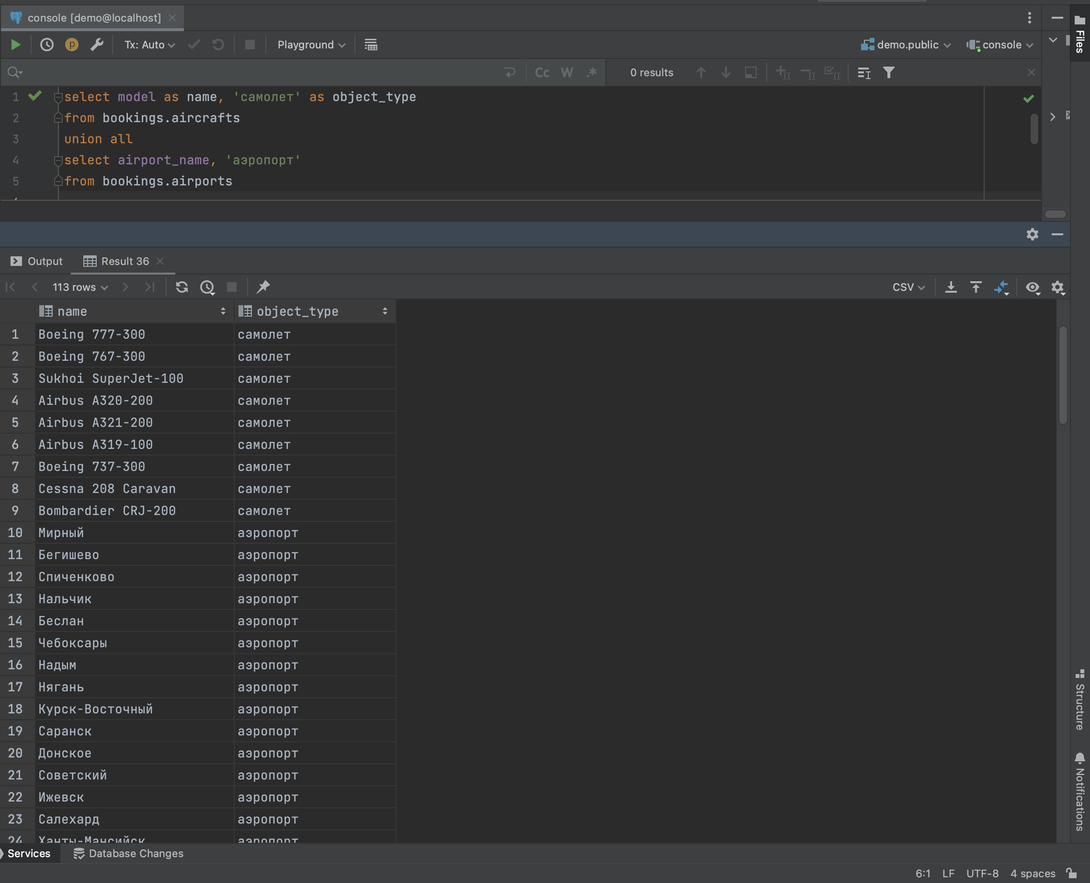

Задание 2.

select ticket_no, fare_conditions, amount

from bookings.ticket_flights

where "amount" < 10500

order by "amount" desc

limit 7;

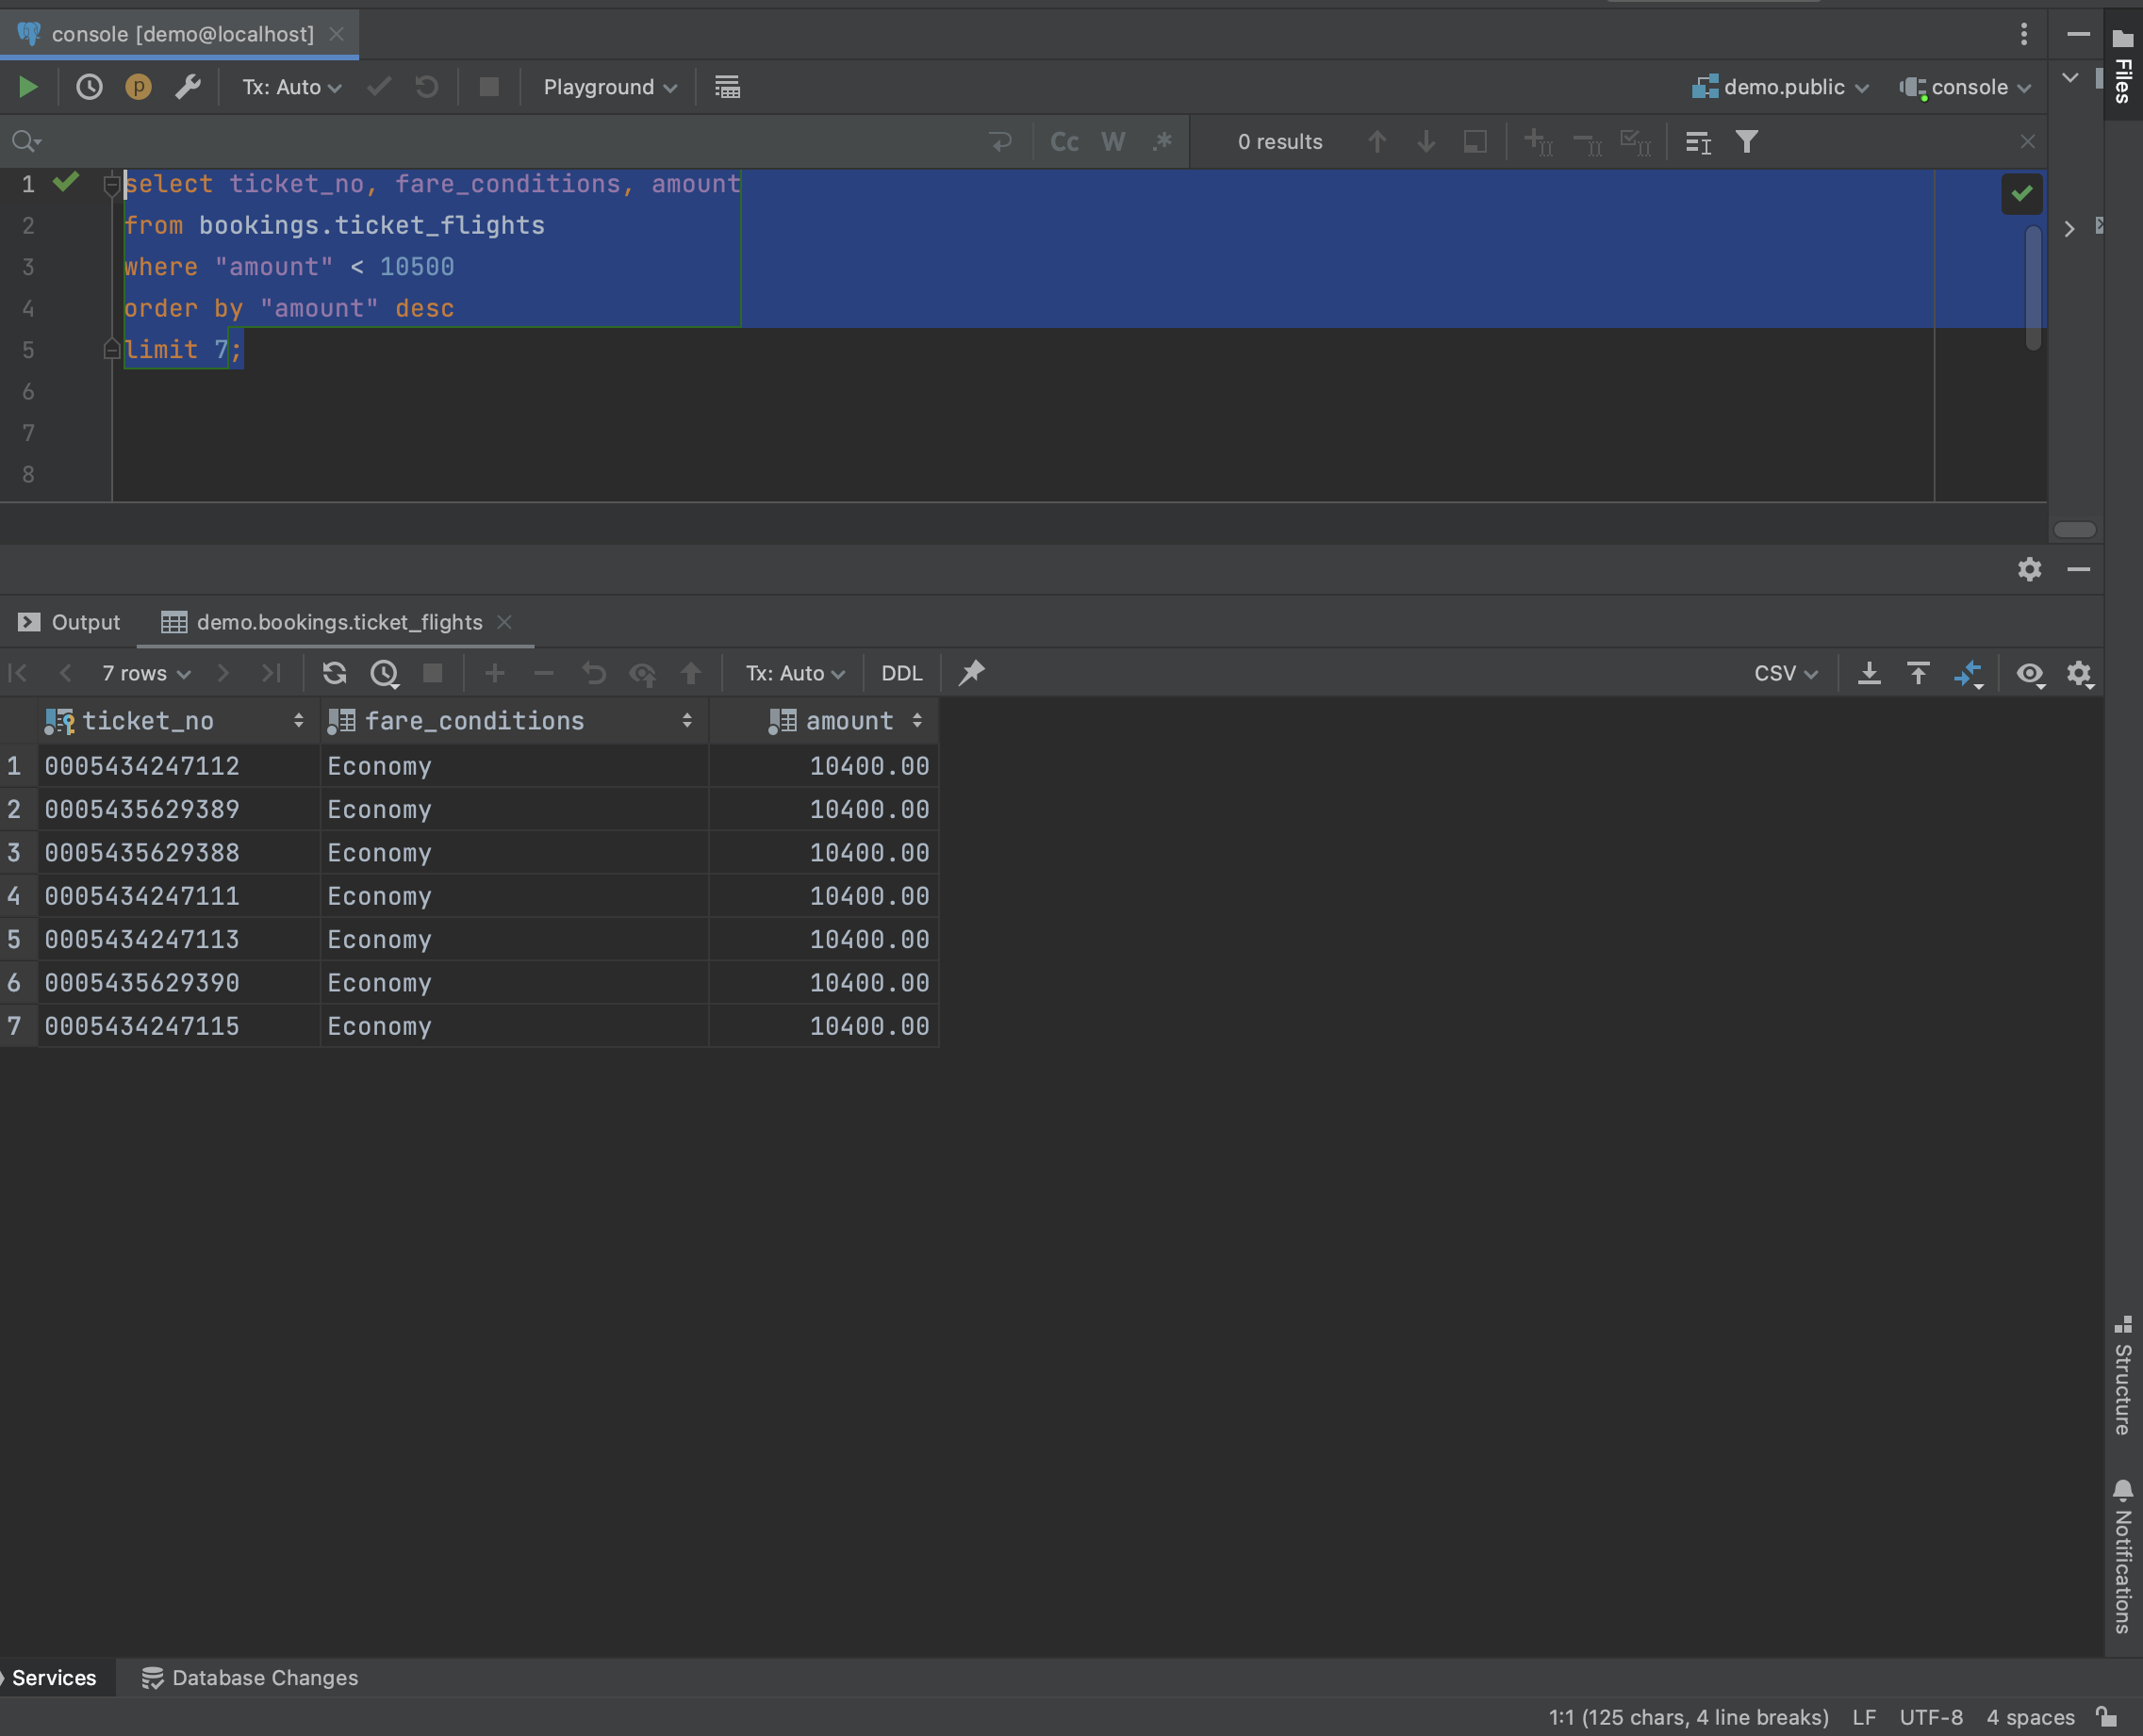

Задание 3.

select model as plane, fare_conditions as class, count(*) as seats_count

from bookings.aircrafts a

join bookings.seats s on a.aircraft_code = s.aircraft_code

group by plane, class

order by plane, seats_count;

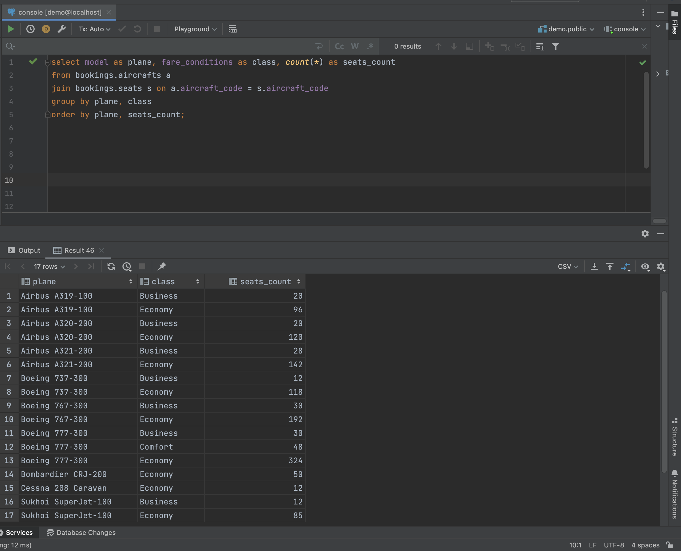

Задание 4.

select t.passenger_name, t.ticket_no, f.departure_airport , f.arrival_airport , t.book_ref,

f.status , tf.fare_conditions, tf.amount, b.total_amount

from bookings.flights f

join bookings.ticket_flights tf on f.flight_id = tf.flight_id

right join bookings.tickets t on tf.ticket_no = t.ticket_no

left join bookings.bookings b on t.book_ref = b.book_ref;

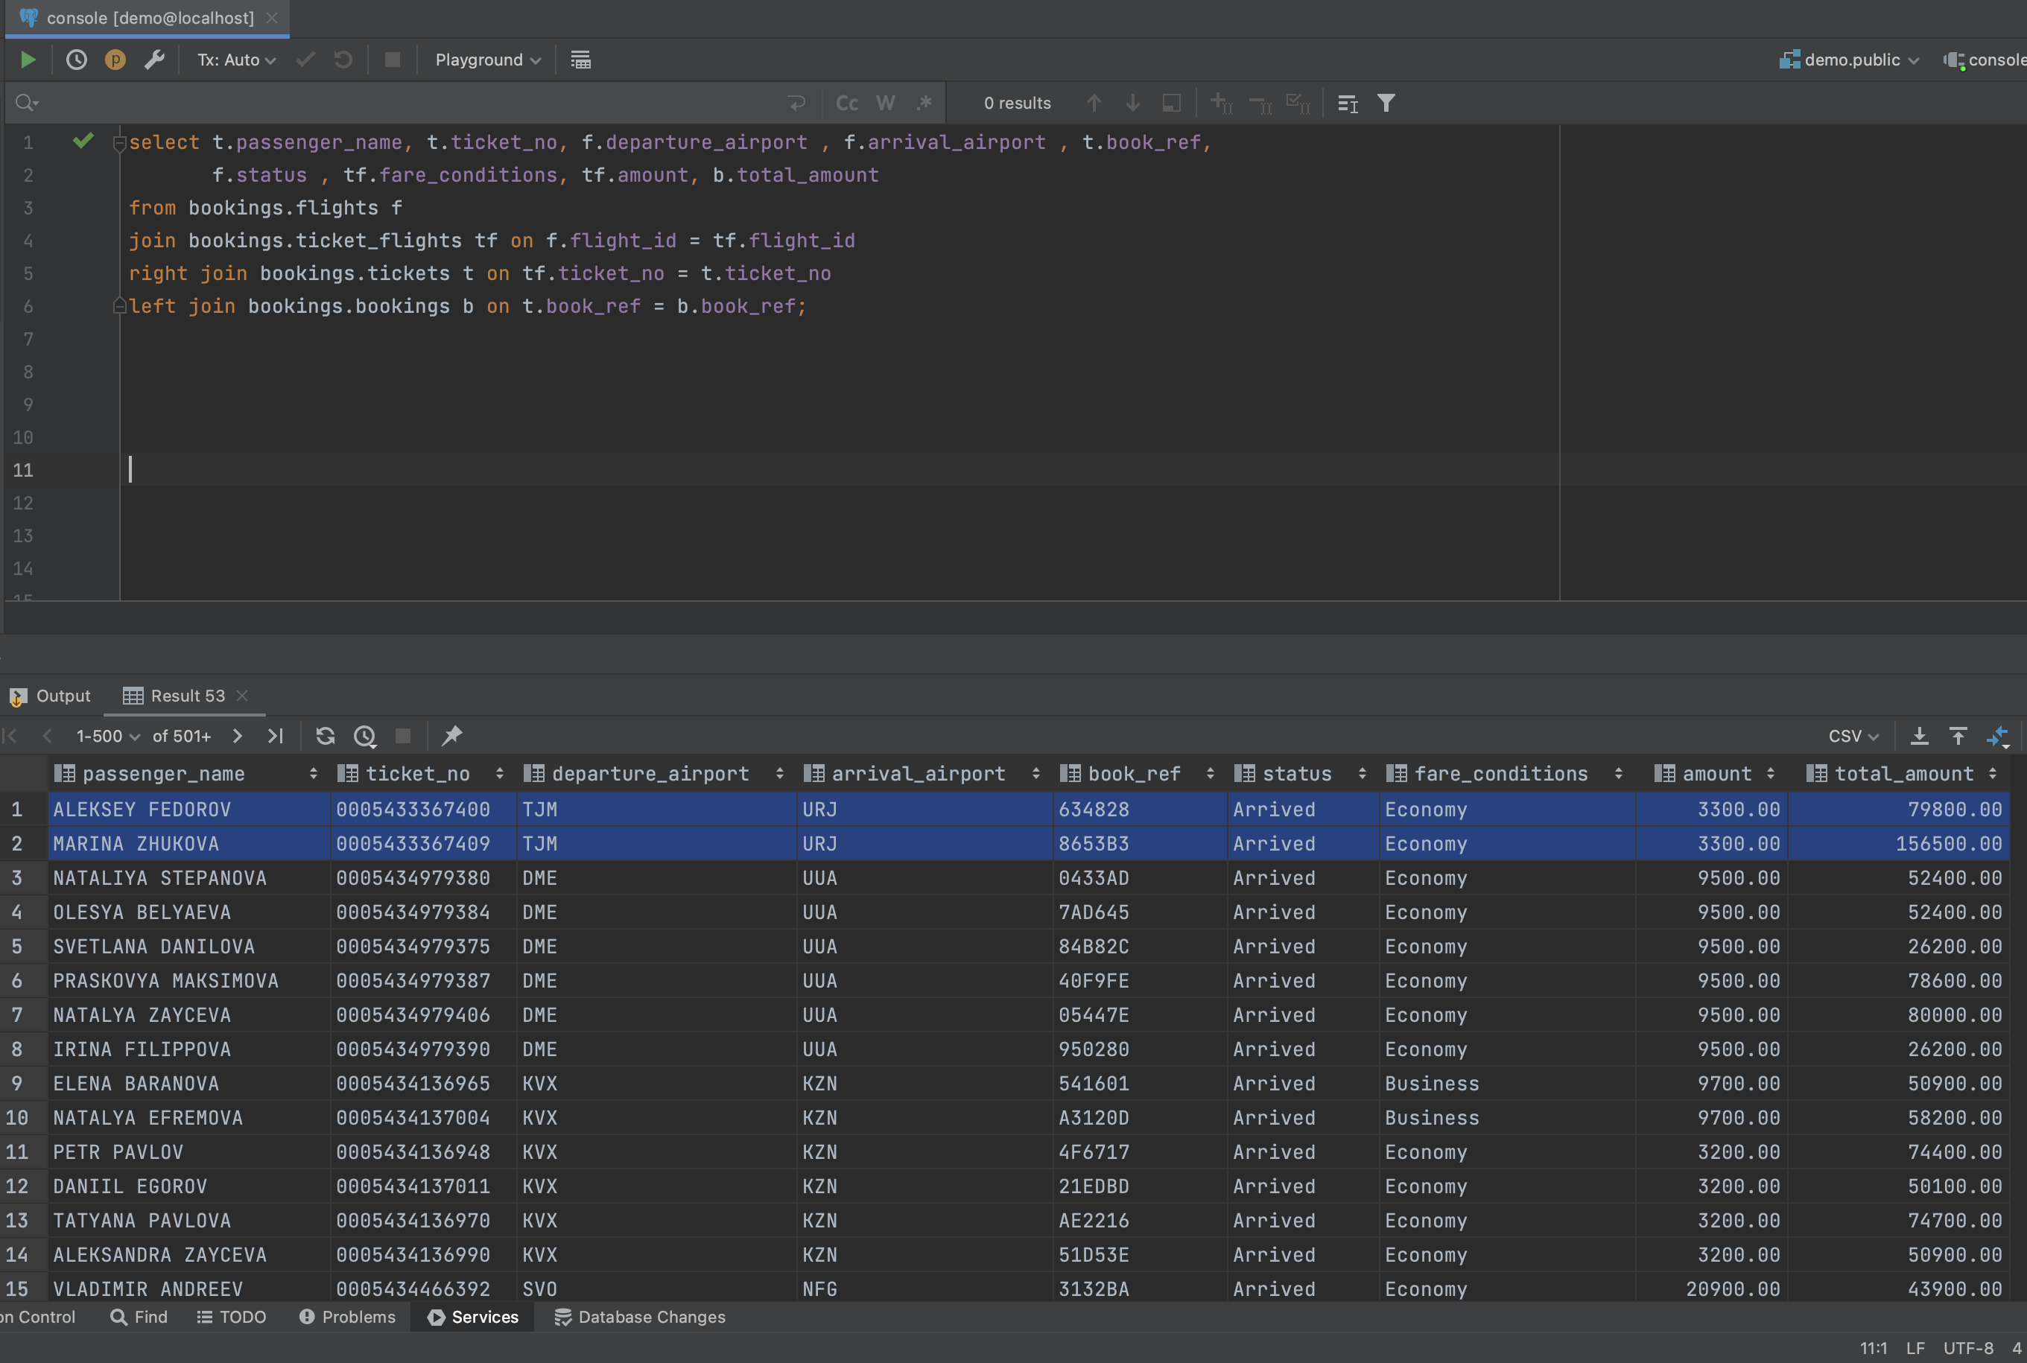

Задание 5.

create or replace view tickets_less_10500 as

select ticket_no, fare_conditions, amount

from bookings.ticket_flights

where "amount" < 10500

order by "amount" desc

limit 7;

select * from tickets_less_10500;

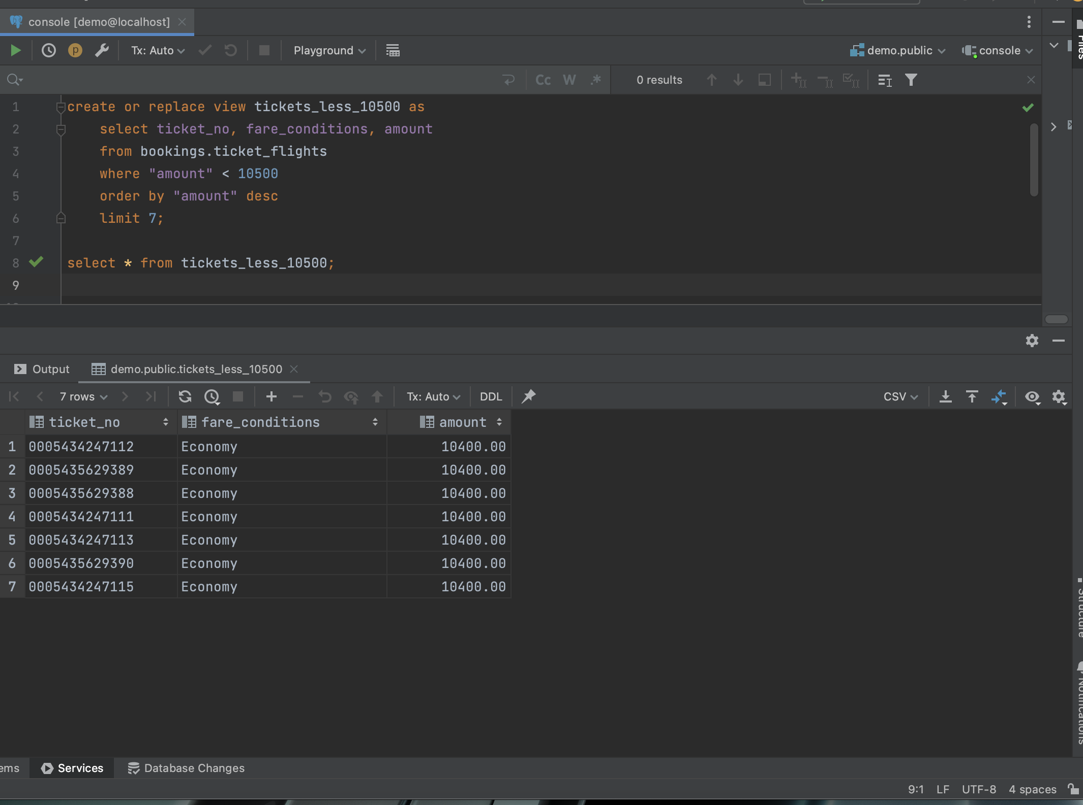

Задание 6.

