Project Title
By
William Taplett

CS 4395 – Senior Project Report
In partial Fulfillment of a Bachelor of Science in Computer Science Department of Computer Science and Engineering Technology University of Houston – Downtown

Semester: Spring 2025

Faculty Mentor : ______________________________

SQL vs NoSQL
Which one ?

Abstract

Database research has had a deep impact on the economy and society. Its technology has been the stimulus for many major developments in software engineering and therefore is the most important development in the field of software engineering. Today’s large enterprise databases often support overly complex queries and are expected to deliver instant responses to those queries. As a result, database administrators are constantly called upon to apply a wide variety of methods to help improve performance. There are many diverse types of databases. In this paper, I will be focusing on SQL and NoSQL databases. One of the most important considerations when selecting a database is how relational ( SQL ) and non-relational ( NoSQL ) data structures interact. To determine which model to utilize, consider your data model , schema requirements , scaling needs and querying patterns. For a higher performance , consider using a combination. All software products have one thing in common; eventually they must store or retrieve data either from a file or a database.

Introduction

During the 1960s, the file-based system was an attempt to computerize the manual filing system. It was the forerunner to the database system. The file-based system was a significant improvement over the manual system, but it had performance issues. File-based systems contain uncontrolled duplication of data and write fixed queries. To become more effective, an innovative approach was taken and the database system developed. A database is an organized collection of related data. A database management system (DBMS) is the software that manages and controls access to the database. A database application is a program that interacts with the database. A database system is the data , DBMS and the application programs that interact with the database.
From the hierarchical database (which relied on a tree-like model and allowed only a one-to-many relationship) and the network database (a more flexible model that allowed multiple relationships) in the mid-1960’s to cloud and self-driving databases today, databases have shaped the economy across the globe. The business world of today is getting more competitive, requiring organizations to adapt quickly to changes and stay competitive. Furthermore, as the applications of database systems become even more complex software engineers need new algorithms for file storage, file access and query optimization. Choosing the right is not a matter of preference, but is which one will fulfill the needs of our application in the best feasible way. Analyze three main criteria of your database: data availability vs consistency, scalability, and performance. In general, because both relational (SQL) and non-relational (NoSQL) data structures are practical possibilities, it is desirable to combine them for higher flexibility and scalability.

What is SQL
SQL or Structured Query Language is a programming language that allows both technical and non-technically minded users to query, manipulate, and change data in a relational database. Organized into columns and rows within a table, SQL databases use a relational model that work best with well-defined structured data, such as names and quantities, in which relations exist between different entities. Within a SQL database, tables are linked through "foreign keys" that form relations between different tables and fields, such as customers and orders or employees and departments.
SQL databases are vertically scalable, meaning that you can increase the maximum load by adding further storage components like RAM or SSD. While in some cases this may mean that SQL databases are limited by the resources available on the server, cloud-based storage and other technologies can provide more scalability with SQL.

What is NoSQL
NoSQL databases are non-relational databases that store data in a manner other than the tabular relations used within SQL databases. While SQL databases are best used for structured data, NoSQL databases are suitable for structured, semi-structured, and unstructured data. As a result, NoSQL databases do not follow a rigid schema but instead have more flexible structures to accommodate their data types. Furthermore, instead of using SQL to query the database, NoSQL databases use varying query languages (some do not even have a query language).
NoSQL databases are scalable horizontally, meaning that they use multiple nodes in a cluster to manage increased workloads. This allows data architects to simply scale them by supplementing clusters with additional servers. Data architects design the blueprints that organizations use for their data management systems.
NoSQL non-relational databases work well with unstructured data and typically possess the following properties:
- NoSQL is schema-less (no fixed data model).
- NoSQL databases have a dynamic schema for unstructured data, making integrating data into certain types of applications easier and faster.
- NoSQL uses non-tabular data models, which can be document-oriented, key-value, or graph-based. The most common NoSQL databases include MongoDB, Cassandra, HBase, Redis, Neo4j, and CouchDB.
NoSQL manages the scale and agility challenges you may face in modern applications, especially ones that manage large volumes of rapidly changing data. These demands exist across every industry vertical and application domain, including IoT, user analytics, personalization, ad tech, eCommerce, gaming, and social networks.

SQL and NoSQL Difference
SQL or Structured Query Language is the most widely used expression in the world for executing commands in relational databases, based on tables. Through SQL, one creates databases, tables, columns, and indexes where it guarantees and revokes user distinctions by querying and storing data.
Therefore, SQL is a robust language divided into the command sets of Data Definition Language (DDL), Data Manipulation Language (DML), Data Control Language (DCL), Transactional Control Language (TCL), and Data Query Language (DQL). SQL is one of the most widely employed choices, making it a safe and beneficial option for complex services. However, it can be limited.
All your data must follow the same structure. It can require a great deal of initial preparation, and one error can bring the entire system to a halt. Today, an SQL database is designed for unproductive data and provided as organized data. Its flexibility allows each document to have its structure by allowing various database syntaxes for other databases. As dataset sizes grow, big data architectures become necessary for efficient and timely processing of it. In turn, it entails the use of efficient algorithms for cluster-size and cost optimization as well as for scalable feature selection and dimensionality reduction.
On the other hand, NoSQL databases are scalable. This base object supports more traffic by adding more servers to its database. This absolution makes NoSQL more powerful and the most chosen for projecting larger sets by allowing constant changes.
The dynamic schema of NoSQL databases easily supports agile development, which requires extensive and fast iterations. However, the term NoSQL has two definitions of different origins, where one refers to relational databases that do not use the SQL language for querying, created by Carlo Strozzi. The other is related to the NoSQL movement, which defines a tool structure that does not use a relation body.
The NoSQL database consists of files organized in a hierarchical database format and uses the UNIX Shell as an interaction tool. The NoSQL database models have a completely different structure, each using an incompatible query form. NoSQL databases define four types of structured data, such as documents, graphs, key-value pairs, and vast column stores. One of the most general types we have in the NoSQL world, with schemas defined as flexible, allows records and documents to have distinct types and numbers of fields without needing a fixed schema.
Such documents are defined in JSON format through concepts contiguous to the object-oriented model, where it is equivalent to documents. In addition, new fields can be added, allowing for rapid application development, as in the case of MongoDB and CouchDB.

Querying Patterns
Querying patterns also play a significant role in database selection. SQL databases excel at complex queries that involve joining data from multiple tables. SQL provides an informative query language that allows developers to specify what data they want to retrieve, without specifying how to retrieve it. The database system optimizes the query execution plan, ensuring efficient data retrieval.
NoSQL databases often rely on different querying mechanisms, such as MapReduce or specialized query languages. MapReduce is a programming model for processing large datasets in parallel, by dividing the data into smaller chunks and processing them independently. While MapReduce can manage large volumes of data, it can be more complex to implement than SQL queries.
The choice of querying pattern depends on the complexity of the queries and the volume of data. If the queries are complex and involve joining data from multiple tables, SQL databases are a suitable choice. If the queries are simple and involve retrieving data based on a key, NoSQL databases may be more efficient. For large-scale data processing, MapReduce can be a viable option, but it requires specialized expertise.
Indexing is an especially important concept in databases. Indexes are used to quickly locate data without searching every data record. In other words, indexing helps to locate the exact position of a specific data item in a shorter period of time. Examples of indexes include Primary, Secondary, Clustering, Multi-level and BTree indexes. SQL databases implement indexing mechanisms differently compared to NoSQL databases. In SQL databases, an index is created on one or more columns of a table whereas in NoSQL databases, indexing can be done by associating a key with the location of a corresponding data record.
Scaling
Scaling is a critical consideration when choosing a database, as it determines the ability of the system to manage increasing workloads and data volumes. SQL databases typically rely on vertical scaling, where the resources of a single server are increased (e.g., adding more CPU, memory, or storage). Vertical scaling has inherent limitations, as there is a maximum capacity for a single server, and it can be expensive and disruptive to upgrade hardware.
NoSQL databases, on the other hand, are designed for horizontal scaling, where more servers are added to a distributed system. Horizontal scaling allows for near-linear scalability, as the workload is distributed across multiple servers. This approach is more cost-effective and resilient than vertical scaling, as the system can continue to operate even if some servers fail.
The choice between vertical and horizontal scaling depends on the specific needs of the application. If the workload is constant and predictable, vertical scaling may be sufficient. If the workload is highly variable or expected to grow rapidly, horizontal scaling is a more scalable and cost-effective solution. NoSQL databases are better suited for applications requiring horizontal scaling, while SQL databases may be more appropriate for applications with moderate scaling needs.

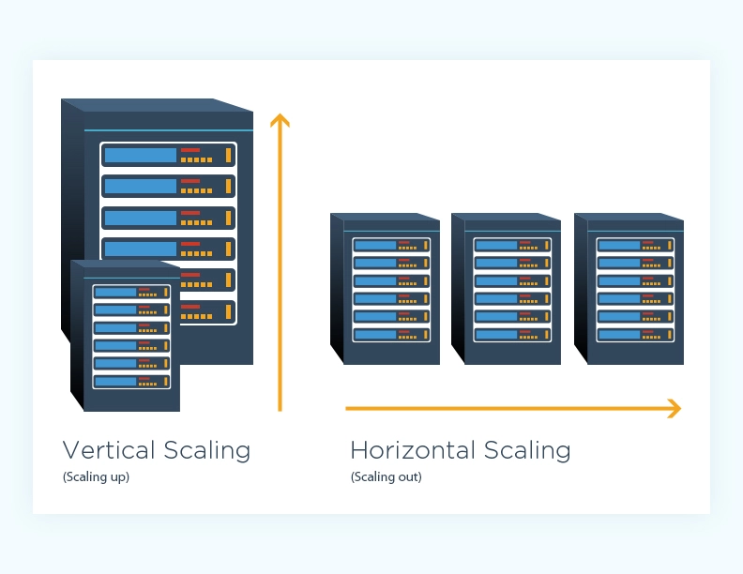
Vertical Scaling: adds more RAM, CPU and Memory to the one existing machine
Horizontal Scaling: adds more machines to the group of distributed system
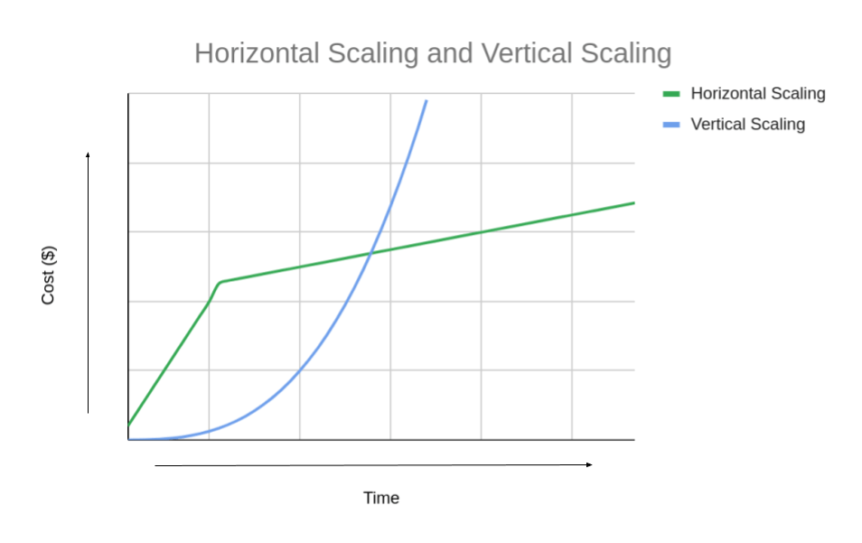
Horizontal Scaling: higher initial costs
Vertical Scaling: more cost-effective initially
CAP , ACID & BASE
In any distributed system, it is important to understand the CAP theorem. Also known as Brewer’s theorem, it was first presented by Eric Brewer, a computer scientist at the University of California, Berkeley in 1998. It helps describe the behavior of distributed data systems. CAP stands for Consistency Availability and Partition Tolerance.
- Consistency: Guarantees all queries receive the most recent data written to the data store.
- Availability: Guarantees all requests receive a valid response without error.
- Partition Tolerance: Guarantees all requests are processed and managed without error regardless of network issues or failed nodes.
The CAP Theorem states that it is impossible for a distributed data store to simultaneously provide more than 2 of the 3 properties. Therefore, a database can only have consistency and availability , consistency and partitional tolerance or availability & partitional tolerance.
In database design SQL and NoSQL databases fall into two models for handling transactions , ACID and BASE. ACID is a set of four fundamental properties that ensure database transactions are dependable and powerful. ACID stands for Atomicity Consistency Isolation Durability.
- Atomicity: ensures that every part of a transaction is executed completely, otherwise the entire transaction is rolled back
- Consistent: ensures that every transaction transforms your database from one valid state to another, never breaking the rules you have set
- Isolated: ensures that multiple concurrent transactions do not interfere with each other
- Durability: guarantees that once a transaction is committed, the changes are permanent, even if there is a power loss or system crash.
In contrast to ACID databases, BASE databases show importance on availability over absolute consistency of data. BASE stands for Basically Available Soft State Eventual consistency.
The CAP theorem connects with ACID and BASE properties in database design.
- Basically Available: should be available to respond with some acknowledgment — even if it is a failure message, to any incoming request.
- Soft State: The state of the system might change over time, even without input.
- Eventual Consistency: the system assumes some delayed consistency. If no current updates are made for a certain period of time, eventually all nodes in the distributed system will converge to a consistent state. 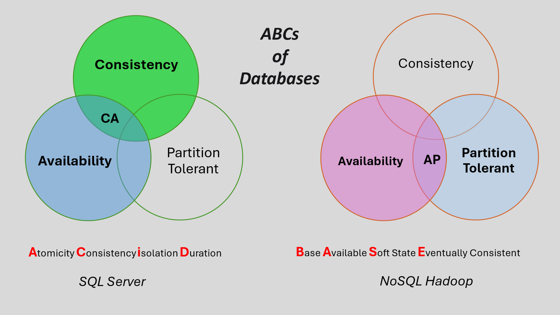

- Methods and Materials

Materials
SQL Databases Used:
- MySQL (version 8.0): Widely used open-source RDBMS known for its ACID compliance and transactional support.
NoSQL Databases Used:
- MongoDB (version 6.0): Document-oriented database, popular for flexible JSON-style documents.
- Apache Cassandra (version 4.1): A distributed column-family database suitable for high write-throughput scenarios.
- Redis (version 2.6) In memory data store that uses key value structures
- Neo4j (version 1.6.) graph database management system
Tools:
- Python scripts for test data generation
- Jupyter Notebook
- Visual Studio Code
- Visual Studio 2022

To view how data is stored in different databases, I created a database for the GameStop company in MySQL, Neo4j and Cassandra. It contains information on the employees of the company, customers who have membership, sales transactions and store locations. For MySQL, I created six tables for my data using a process called normalization. Normalization is a technique for providing a set of relations with desirable properties that support the data requirements of an enterprise. This set includes a minimal number of attributes (columns), attributes with a close logical relationship and minimal redundancy. For Neo4j and Cassandra, I denormalized my 6 normalized (MySQL) tables and created 4 tables. Denormalization is the opposite of normalization. In this technique, we combine tables or add redundant data to improve query performance.
In Cassandra, I used a function called TTL (Time To Live ). This function expires data for a specified period of time. It is a value that indicates how long to keep the value. In my demo, I used it to change the price of the game consoles for thirty-five seconds. I find this function useful for businesses to set on sale items, since sales are usually for a few days or a week. After the TTL value has expired, the value becomes null. Despite the value not reverting to its original value, the Time To Live function is a convenient feature for data that is no longer needed.
Product NO | Name | category | pRiCe | quantity | Store no
54321 | niNtenDO sWitcH 2 | consoles | 449.99 | 50 | 3
98765 | street fighter 2 | games | 29.99 | 20 | 8
33456 | Black Wireless | accessories | 179.99 | 30 | 5
13579 | Yu-Gi-Oh! | collectibles | 24.99 | 500 | 3
24680 | Batman | collectibles | 24.99 | 1 | 6
Products

For both SQL and NoSQL models, different workloads were taken. These are:
- Workload A, 50% read, 50% write
- Workload B, 100% write
- Workload C, 100% read
- Time and throughput
Results
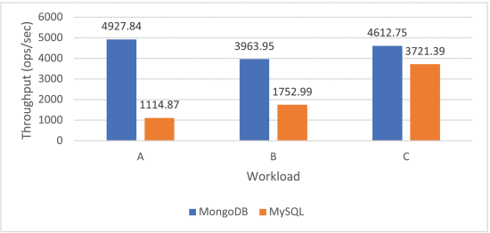

A. Workload A
• Workload A consists of 50% reads and 50% writes, plus ten million records.
The MySQL and MongoDB databases are evaluated, and MongoDB performs 55.77% better. However, MySQL exhibits slower performance with 95 minutes and 8 seconds, while MongoDB performs better with 42 minutes and 5 seconds.
Normalized table [ MySQL ]
The denormalized version includes all columns plus street, zip code and city columns.
B. Workload B
• Workload B consists of 100% writes plus ten million records.
The MySQL and MongoDB databases are assessed, and MongoDB performs 77.37% better. However, MySQL exhibits slower performance with 149 minutes and 49 seconds, while MongoDB performs better with 33 minutes and 82 seconds.
C. Workload C
• Workload C consists of 100% reads plus ten million records.
The MySQL and MongoDB databases are evaluated, and MongoDB performs 19.33% better. However, MySQL exhibits slower performance with 44 minutes and 79 seconds, while MongoDB performs better with 36 minutes and 13 seconds.

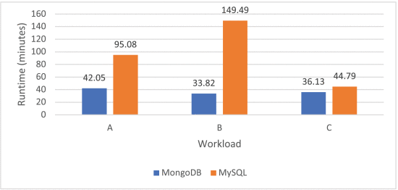
In the case of runtime for the three workloads, MongoDB takes less time than MySQL to perform all three.

Discussion

The results suggest that MongoDB (NoSQL database) outperforms MySQL (SQL database) in both read and write operations. Even though my data was originally implemented in a SQL database, I found it more convenient, flexible, and agile to implement the data in Neo4j , a NoSQL graph database. With the graph database, I can explicitly create relationships among data tables with edges that I can easily identify. Unlike SQL , graph databases do not need primary keys, foreign keys, and the Join operations to create relationships.
The nature of NoSQL databases is highly suitable for Big Dats applications given their built-in flexibility and scalability. While compared with SQL systems that have only vertical scaling strategies which means that each node in a system must be upgraded and costs a lot, NoSQL systems utilize horizontal scaling, meaning that more servers can be added to the system. This is preferred in big data management because it is cheaper and more resourceful in terms of time.
In Neo4j, I created relationships with data tables I thought would be important to have. They are Works_aT_Preferred_Store , Carried_oUT and Member_Purchased. Since MySQL is unable to create relationships explicitly, I would have to query the Join operator on multiple tables which is more time consuming. Implementing the database in Neo4j is more flexible and visual of data and less time consuming in querying relationships.
In Cassandra, a NoSQL column-oriented database, I used a special function called TTL that lets you expire data that is no longer needed. Unfortunately, MySQL is unable to perform this. I found this function especially useful for data that is needed temporarily like sale prices.
There are also many other databases including cloud and self-driving databases. Cloud databases operate on a cloud computing platform. Self-driving databases are the newest type, also known as “autonomous” database, and are cloud based and use machine learning to operate.

Conclusion

SQL and NoSQL databases serve distinct yet similar roles in modern data management. SQL databases offer growth, consistency, and powerful query capabilities, making them ideal for structured data and transactional applications. NoSQL databases provide scalability, flexibility, and performance for large-scale, unstructured, and real-time applications.
Future research should explore hybrid databases, edge computing integration, and the impact of AI workloads on database design. As data continues to grow in complexity and volume, adaptive, scalable, and intelligent database systems will be essential to powering the next generation of applications.
The choice between SQL and NoSQL databases should be driven by specific application requirements rather than personal preference. For applications requiring complex queries, transaction integrity, and consistent data structures, SQL databases provide robust solutions. For applications dealing with large volumes of unstructured data, requiring high scalability, or needing flexible schemas, NoSQL databases offer significant advantages.
However, as noted in the research, "because both relational (SQL) and non-relational (NoSQL) data structures are practical possibilities, it is desirable to combine them for higher flexibility and scalability." Many modern applications benefit from a polyglot persistence approach, using different database types for different components of the system.

Key Recommendations:
- Analyze your data model, schema requirements, scaling needs, and querying patterns
- Consider a hybrid approach for complex applications with diverse data requirements
- Evaluate the trade-offs between consistency (SQL) and availability (NoSQL)
- Plan for future growth and changing requirements when making your selection
As database technologies continue to evolve, the lines between SQL and NoSQL are becoming faded, with SQL databases adopting NoSQL features and vice versa. The future of database management lies in systems that can provide the best of both worlds, offering the consistency and query capabilities of SQL alongside the flexibility and scalability of NoSQL.

Acknowledgment

I would like to thank my database professor Dr. Ling Xu for teaching this course in a method I was able to follow and learn. She was the motivation for me to do a project on databases. I thank AmpCode (Neo4j) , Net Ninja (Redis) , Bro Code (MongoDB) and jumpstartCS (Cassandra) for their inspiring YouTube tutorials. I would also like to thank BigQuery , Google Cloud’s data warehouse for access to their massive data sets. Because of these great teachers, I have become better skilled with databases.

References

1) Connolly, Thomas M, and Carolyn E Begg. Database Systems: A Practical Approach to Design, Implementation, and Management. 6th ed., Harlow, Essex, England, Pearson Education Limited, 2015, dl.ebooksworld.ir/motoman/Pearson.Database.Systems.A.Practical.Approach.to.Design.Implementation.and.Management.6th.Global.Edition.www.EBooksWorld.ir.pdf.
2) Oracle. “What Is a Database?” Www.oracle.com, 24 Nov. 2020, www.oracle.com/database/what-is-database/.
3) ByteByteGo. “CAP, PACELC, ACID, BASE - Essential Concepts for an Architect’s Toolkit.” Bytebytego.com, ByteByteGo Newsletter, 10 Oct. 2024, blog.bytebytego.com/p/cap-pacelc-acid-base-essential-concepts. Accessed 24 Mar. 2025.
4) “Basically Available, Soft State, Eventual Consistency.” DevX, Oct. 2023, www.devx.com/terms/basically-available-soft-state-eventual-consistency/.
5) Ramirez, Misael. “Horizontal vs Vertical Scaling for Application Hosting: Which One Is Best for You?” Liquid Web, 4 Mar. 2021, www.liquidweb.com/blog/horizontal-vs-vertical-scaling/. “A Complete Guide to ACID Properties in DBMS with Examples | Relia Software.” Reliasoftware.com, 17 Oct. 2024, reliasoftware.com/blog/acid-properties-in-dbms.
6) Slingerland, Cody. “Horizontal vs. Vertical Scaling: How Do They Compare?” CloudZero, 5 May 2023, www.cloudzero.com/blog/horizontal-vs-vertical-scaling/.
7) “How Horizontal vs Vertical Scaling Affects Your Operations.” Www.redswitches.com, 13 Mar. 2023, www.redswitches.com/blog/horizontal-vs-vertical-scaling/
8) Awesome. “The Fascinating History of Databases.” YouTube, 17 Jan. 2025, www.youtube.com/watch?v=6szdySvorzA. Accessed 11 Mar. 2025.
9) Custer, Charlie. “Vertical vs. Horizontal Scaling: What’s the Difference and Which Is Better?” Cockroach Labs, 10 Apr. 2023, www.cockroachlabs.com/blog/vertical-scaling-vs-horizontal-scaling/.
10) “What Does a Data Architect Do? A Career Guide.” Coursera, www.coursera.org/articles/data-architect.
11) Reetishwaree, Seenauth, and Visham Hurbungs. “Evaluating the Performance of SQL and NoSQL Databases in an IoT Environment.” 2020 3rd International Conference on Emerging Trends in Electrical, Electronic and Communications Engineering (ELECOM), 25 Nov. 2020, https://doi.org/10.1109/elecom49001.2020.9297028
12 ) Almoqhem, Waleed. الضخمة‬ البيانات‬ مع‬ التعامل‬ في‬ المهيكلة‬ االستعالم‬ بلغة‬ مقارنة‬ مهيكلة‬ الغير‬ االستعالم‬ لغة‬ أداء‬ تحليل‬ إعداد‬ الباحث‬ / المقحم‬ مقحم‬ وليد‬ اإللكترونية‬ السعودية‬ الجامعة‬ - المعلومات‬ تقنية‬ كلية:‬ Performance Analysis of NoSQL and New SQL Databases in Handling Big Data Name of Researcher.‬‬‬‬‬‬‬‬‬‬‬‬‬‬‬‬‬‬‬‬‬‬‬‬‬‬‬‬‬‬‬‬‬‬‬‬‬‬‬‬‬‬‬‬‬‬‬‬‬‬‬‬
‌

‌

‌

‌

‌

