Auditing the Human–LLM Autonomy Gap in Clinical Ethics
Taposh Dutta Roy · Rebecca Weintraub Brendel, MD, JD
Center for Bioethics, Harvard Medical School, Boston, Massachusetts, USA
RESEARCH REPORT · METHODS AND RESULTS — revised draft, all quantities computed from the item-level response files (human_july_14_cleaned, scores_july_26, scores_march_26) on the resolved response-scale encoding.

Key Observations
No. | Observation | Finding
1 | Humans value autonomy more than the LLM Models | Human mean Autonomy Index 50.2 vs model mean 39.4 on the identical instrument; mixed-model offset +10.8 points, 95% CI [+6.8, +14.9], P = 8 × 10⁻⁸. The gap is directional and broad — human ratings exceed the model panel on 37 of 49 vignettes — and it is a uniform level shift rather than a domain-specific one (source × domain χ²(3) = 2.5, P = 0.47).
2 | Humans show more variability than LLMS. | Model panel: σ²_vignette = 637 vs σ²_model = 7; single-run single-model ρ₁ = 0.84, a single model's 10-run mean 0.97, the 8-model panel ≈ 1.0. Humans (rater identity approximated by session): σ²_vignette = 265 against combined rater-plus-error 571; single-rating ρ₁ ≈ 0.3, the realized panel of ~3 ≈ 0.6, and roughly 9 reviewers per case would be needed for 0.80. Ordinal α ≈ 0.97 for both sources — the 13 items behave near-unidimensionally.
2 | Humans decline to score what the vignette does not show; current models never do. | Human reviewers marked 26.5% of item responses N/A (insufficient information), averaging 3.4 of 13 items per rating. The eight July 2026 models, given the same option in the same prompt, used it zero times in 3,431 valid scorings. The March 2026 generation abstained on 7.5% of responses, so the capability existed and has been lost across one model generation.

Key Results
R1. The gap is a uniform level shift across the construct. Paired domain differences are +12.6 Factual Understanding, +12.2 Intentional Action, +10.8 Values Awareness, +7.8 Rational Deliberation;
R2. Human disagreement is wide, and the model panel sits inside it just over half the time. Across the 26 vignettes with two or more fully scoreable ratings, mean between-reviewer SD is 16.4 points and mean range 28.2 (maximum 74). The model panel mean falls inside the observed human range on 15 of 26 (58%). The human reference is a band, not a point; the level gap bites on the cases where the panel lands outside it.
R3. Rank-order agreement is good even though absolute levels differ. Human–model Pearson r = 0.81 (Spearman 0.80); restricted to vignettes with three or more ratings, r = 0.78. Bland–Altman bias +10.8 with wide limits of agreement [−20.4, +42.0] — good for ranking cases, not interchangeable on absolute scores.
R4. Abstention has disappeared across a model generation. Humans recorded N/A on 26.5% of item responses; July models on 0%; March models on 7.5%, concentrated in four of nine models (Mixtral 8x7B 40.1%, DeepSeek V3.2 9.7%, GPT-5.4 9.0%, Gemini 3 Flash Lite 8.2%). Human abstention tracks what the stimulus supplies (highest on trade-off reasoning, factual recall, and appreciation; lowest on value clarity and expressed intention) and is uncorrelated with the case's autonomy level (r = 0.10, P = 0.48).
R5. The contextual modifiers are the negative control, and they pass. Human and model External Constraint Index scores correlate at r = 0.82 with a mean difference of 5.9 points; Support Provided r = 0.40, difference 3.4 points, not significant. Same raters, same vignettes, same sitting, same response format. The divergence is specific to the autonomy construct, not general to the task, and neither modifier moderates the gap.
R6. A model generation changed the level not at all. March vs July composite on the same 50 vignettes: 39.6 vs 39.4 (paired P = 0.90); no domain moves significantly (largest: Intentional Action +2.1, P = 0.10). Agreement with the human reference is unchanged (r = 0.78 both generations). The capability gains separating the two generations did not touch the disposition under study, and the one clear change — the loss of abstention (R3) — moves in the wrong direction.

Summary
Respect for autonomy is a cornerstone of clinical decision-making, yet with general-purpose language models now fielding health questions at scale, there has been no systematic effort to measure how these systems assess patient autonomy. We define a structured framework, the Autonomy Index, built on existing clinical decisional-capacity frameworks, and apply it identically to trained human reviewers and large language models. Eighty-nine clinical-ethics vignettes were scored by nine models, ten runs each, in March 2026 (7,275 valid scorings), from which 50 vignettes were selected by pre-specified criteria for human review. These 50 were scored on the identical instrument by bioethics-trained reviewers (175 ratings; median 3 per vignette) and by eight current-generation models, ten runs each, in July 2026 (3,431 valid scorings). Six findings follow. (1) Human reviewers attribute more autonomy than LLM models: +10.8 points, 95% CI [6.8, 14.9], P = 8 × 10⁻⁸, on 37 of 49 scoreable vignettes. (2) The gap is a uniform level shift across all four domains (interaction P = 0.47), not a threshold difference on any single ability. (3) Human reviewers marked 26.5% of item responses "insufficient information"; the July models never did, though the March generation still could — abstention has been lost across one generation. (4) Rank agreement is nonetheless good (r = 0.81): models order cases as humans do and sit lower. (5) The two sources agree closely on the circumstances of each case (External Constraint r = 0.82, mean difference 5.9 points), localizing the divergence to the autonomy construct itself. (6) Human reviewers disagree widely with one another while a single model is a far more reliable rater (ρ₁ 0.84 vs ≈ 0.3), and the model panel falls inside that disagreement band on 58% of comparable cases.

1 Study Background
Respect for autonomy [22,23] is a cornerstone of biomedical ethics, yet it is rarely measured in a structured way. Three gaps motivate this study: are general-purpose models ready for health-related questions, what is known about model outputs, and what is known about human ethical judgment itself.
People are already using general-purpose models for health questions. Debate about medical artificial intelligence has largely concerned purpose-built clinical systems evaluated under regulatory pathways. That is not where most of the exposure now sits. Patients, families, and clinicians increasingly bring health questions to general-purpose conversational models [28] that were not designed for clinical use, carry no clinical indication, and are not evaluated against clinical endpoints. Whatever ethical dispositions those systems carry are already reaching people in consequential moments. The eight models examined here are general-purpose systems for exactly this reason: they are the ones being used, not the ones designed to be used.
Very little is known about what these models express regarding autonomy and respect for persons. Evaluation of language models in medicine has concentrated on factual accuracy, examination performance, refusal behavior, and safety in the narrow sense of avoiding harmful instructions. Whether a model perceives a patient as an agent, and how much weight it gives to that agency, has almost no empirical literature. The values a model brings to a clinical situation are not a stated property of these systems; they are an emergent one, and they are currently unmeasured. This study asks what those dispositions are on a single, well-specified dimension.
Nor is human judgment in clinical ethics well characterized. It would be convenient to treat trained human reviewers as a fixed reference against which models are scored. That is not the state of the field. How clinicians and ethicists actually weigh values, facts, deliberation, and enacted agency when they assess a real case is itself sparsely documented, and normative frameworks such as the Appelbaum model [24] specify what ought to be considered rather than describing what practitioners do. A structured instrument applied to human reviewers is therefore not only an instrument for auditing models but also a way of making human ethical judgment explicit enough to examine.
To ground these questions in existing practice, we first reviewed the instruments currently used to assess decisional capacity in healthcare.

1.1 Reviewed Instruments
We reviewed the literature to develop a list of commonly used instruments in clinical decision capacity. Table 1 below showcases the key decision-making instruments used in the US. In the table, we provide the primary source, purpose of the framework, and country of origin.
Table 1. Decisional capacity instruments reviewed.
Framework/Instrument | Primary source | Purpose and scoring | Origin
MacCAT-T (Treatment) | Grisso, Appelbaum & Hill-Fotouhi 1997 [1]; manual [2] | Reference clinical tool for treatment decisions. Four abilities: understanding, appreciation, reasoning, expressing a choice. Semi-structured, individualized disclosure. | USA
MacCAT-CR (Research) | Appelbaum & Grisso 2001 [3]; pediatric validation Hein et al. 2014 [4] | Capacity to consent to clinical trials. Adds research-specific elements: randomization, placebo, non-therapeutic purpose, right to withdraw. | USA
ACE (Aid to Capacity Evaluation) | Etchells et al., CMAJ 1996 [5] | Rapid bedside assessment. Eight-item structured interview. Open access; strong in acute care. | Canada
UBACC (Brief Assessment) | Jeste et al., Arch Gen Psychiatry 2007 [6] | Ten-item screen for research consent capacity. Triage instrument, faster than MacCAT-CR. | USA
CAI-Health | Amaral et al., Clin Gerontol 2025 [7] | Vignette-based instrument for adults with dementia. Tests values and preferences alongside capacity. | Portugal
CCTI (Consent Instrument) | Marson et al., Arch Neurol 1995 [8] | Vignette-based measurement of competence under multiple legal standards. Psychometric; compares performance against capable controls. | USA
ACED (Everyday Decisions) | Lai & Karlawish 2007 [9]; Lai et al. 2008 [10] | Semi-structured interview assessing decision-making about real instrumental activities of daily living rather than hypothetical scenarios. | USA
HCAI (Hopemont Interview) | Edelstein 2000 [11] | Designed for geriatric and long-term care residents. Complexity-adjusted scoring for chronic care decisions. | USA
CPS (Control Preferences Scale) | Degner, Sloan & Venkatesh 1997 [12] | Card-sorting task measuring the patient's desired level of involvement in decisions. Measures preference for autonomy, not capacity for it. | Canada
CONCORD Scale | Shepherd et al., Trials 2022 [13] | Quality of proxy decisions about research participation. Measures proxy understanding of the trial and faithfulness of the decision to the patient's wishes. | UK

We additionally consulted a 2025 systematic review of decisional capacity instruments applied to requests for assisted suicide [14]. That review is a synthesis of existing frameworks rather than an instrument in its own right and is therefore cited as a source rather than listed in Table 1.

1.2 Three target constructs
We classified these instruments into three groups: consent capacity, decision capacity, and functional autonomy. Instruments were assigned by target construct, defined as the question the instrument was built to answer, rather than by the population in which they were validated or the setting in which they are administered. The three constructs are defined below, and Figure 1 shows the classification, including instruments that span more than one group. The distinction is not merely terminological. It determines which components of autonomous agency each instrument was designed to capture, and therefore which components remain unmeasured across the existing instrument set.
Decision capacity (or decision-making capacity) is the possession of the functional abilities required for a given decision to stand. Statutory formulations are typically narrow: Ontario's Health Care Consent Act [25], for example, defines capacity in two prongs, as the ability to understand information relevant to a decision and to appreciate the reasonably foreseeable consequences of a decision or a lack of a decision. Clinically, the construct is broader and is operationalized through the four abilities established by Appelbaum and Grisso: understanding the relevant information, appreciating the nature of the situation and its significance for one's own circumstances, reasoning about the potential risks and benefits of the options, and clearly expressing a choice. We adopt the Appelbaum clinical construct throughout, as it subsumes the statutory prongs and supports item-level coding.
Three properties are definitional. Decision capacity is decision-specific: a patient may be capable of making a choice about their residence but incapable of making a complex medical choice. It is time-varying, fluctuating with delirium, symptom severity, medication, and fatigue. And its threshold is risk-calibrated, rising with the stakes of the decision under the sliding-scale convention, although that convention remains contested. Its legal counterpart, competence, is adjudicated rather than clinically assessed. The reference instrument is the MacCAT-T [1].
Consent capacity is decision-making capacity narrowed to a specific authorizing act: consent to a proposed treatment, or to participation in research. Its distinguishing feature is that it is disclosure-relative. What the individual must understand is not fixed in advance but is determined by what the clinician or investigator is obligated to disclose, which is why the MacCAT-T requires an individualized disclosure to be constructed before scoring can begin. Research consent capacity is therefore not treatment consent capacity applied to a trial. It adds elements with no treatment analogue, including randomization, placebo, non-therapeutic purpose, and the right to withdraw. This is why the MacCAT-CR exists as a separate instrument rather than as a variant of the MacCAT-T, and why the therapeutic misconception constitutes a failure of consent capacity specifically rather than of decision capacity generally. Functionally, consent capacity is binary in consequence: the authorization either stands or it does not. Screening instruments such as the UBACC were developed to triage this determination efficiently.
Functional autonomy, as used in this study, refers to the graded degree to which an individual forms and holds values, deliberates about them, and carries the resulting decisions into action under real conditions. Three properties distinguish it from the two capacity constructs. It is graded rather than threshold-based; it is longitudinal rather than episodic; and, critically, it is not wholly a property of the individual. Beauchamp and Childress's third condition for autonomous action [22], the absence of controlling influence, is a condition of the environment rather than of the person, and relational accounts extend this to the social and structural conditions under which agency is exercised. A person may therefore hold full decision capacity and low functional autonomy where transportation, interpretation, finances, or family pressure prevent enactment; conversely, a person with impaired capacity may retain substantial functional autonomy under supported decision-making arrangements. Instruments in this tradition, notably the ACED, assess decision-making through real instrumental activities of daily living rather than through hypothetical scenarios.
We flag one terminological hazard. Functional autonomy carries a second, established meaning in geriatrics and rehabilitation, where it denotes ADL/IADL independence as measured by instruments such as the Functional Autonomy Measurement System (SMAF). That sense is a measure of functional status rather than of self-governance and is not the sense used here. Where the distinction is material, we use enacted autonomy to refer to the construct defined above.
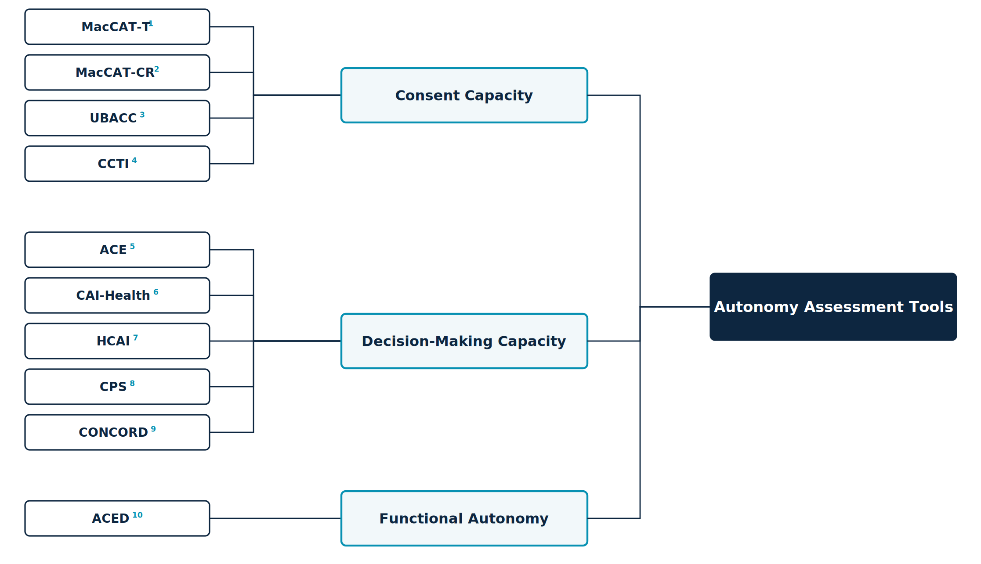
Figure 1. Autonomy assessment tools classified by target construct. Full instrument names, scope, and primary sources are given in Table 1.

1.3 Coverage gap and rationale
The Autonomy Index draws on all three constructs. Its components are - Values Awareness (VA), Factual Understanding (FU), Rational Deliberation (RD), and Intentional Action (IA), with the External Constraint Index (ECI) and Support Provided Index (SPI) reported alongside. Factual Understanding, together with the deliberative component of Rational Deliberation, constitutes the consent-capacity core. Values Awareness, Rational Deliberation, and the choice-expression component of Intentional Action together reconstruct decision capacity. The plan-fulness and follow-through items within Intentional Action, together with the two contextual indices reported alongside the composite, are functional-autonomy constructs that no consent-capacity instrument in the reviewed set measures. This coverage pattern is the design rationale for the Index. Existing instruments cluster on factual understanding because the validity of an authorization turns on it, leaving values, deliberation, and enactment comparatively unmeasured.

1.4 Study Objectives
The principal objective of this study is to develop a systematic framework for assessing patient autonomy: to specify what constitutes autonomy in terms concrete enough to be observed and scored rather than judged globally, and then to apply that framework to compare how trained human reviewers and large language models evaluate autonomy across clinical cases.
Three subsidiary objectives follow from it.
Construct specification. To decompose autonomy into defined components with explicit scoring anchors, and to state precisely how the resulting instrument relates to, and departs from, the decisional-capacity instruments already in clinical use (sections 1.1 to 1.3 and section 2).
Application. To apply the instrument to a corpus of ethically complex clinical cases under identical conditions for both sources of judgment: trained human reviewers, and current general-purpose language models.
Comparison. To establish whether the two sources produce assessments that agree, and to localize any divergence within the construct rather than reporting it only as a global difference.
The comparison is the study's empirical core, but it is not a validation of the models against a correct answer. Human ratings constitute a reference standard, not ground truth, and the design cannot determine which source is right where they differ. The divergence is informative about both, and the human ratings are reported as a finding in their own right for the reason given in section 1 (section 9.1).

2 The Autonomy Index

2.1 Overview
The Autonomy Index (AIx) is a structured, multidimensional measure of the degree to which a person's behavior in a clinical situation reflects autonomous agency. Autonomy is commonly treated in practice as a binary state, present or absent, even though real decision-making unfolds across cognitive, affective, and contextual dimensions that vary in degree. The Autonomy Index treats autonomy as graded and decomposable, scoring it across four domains and reporting two contextual conditions alongside the result. The measure is applied here to written clinical vignettes. A rater reads a vignette and scores the subject described in it. We abbreviate the index AIx throughout, reserving "AI" for artificial intelligence.
The Autonomy Index is a measurement instrument, not a capacity determination. It yields a graded description of a decision-making episode as depicted in a case. Determining that a specific patient does or does not have capacity for a specific decision is a clinical and legal judgment made by qualified clinicians, and no threshold in this instrument is intended to substitute for it.

2.2 Relationship to the Appelbaum model
The Autonomy Index framework is an outcome of a review of several existing instruments. We found Appelbaum and Grisso's model did a holistic job of incorporating most of the autonomy-related aspects. However, some areas needed expansion, and a demarcation was needed between a clinical instrument that supports judgment about whether a patient has decision-making capacity and an index that compares human and model assessments. The Autonomy Index asks a graded question about the decision-making episode as a whole, including the conditions surrounding it, and is scored from a written case rather than from a live semi-structured interview.
The framework extends the Appelbaum & Grisso model in three specified respects, described in sections 2.2.1 to 2.2.3.

2.2.1 Relational appreciation item
The Appelbaum model uses appreciation to mean the patient's recognition that a diagnosis and its options apply to their own situation rather than to a hypothetical other. That sense is retained in the Autonomy Index, carried by the Factual Understanding applicability item (FU3). Added to it is a distinct item, scored within Values Awareness (VA4), asking whether the subject appreciates the clinical team's efforts to provide them comfort and care. A person may correctly apply the facts to themselves while operating inside a therapeutic relationship they experience as indifferent or adversarial. Where recognition of the team's efforts is absent, deliberation is proceeding with a distorted reading of the parties presenting the options, which is a feature of the episode that the parent construct does not record.
The item is scored on evidence of recognition, not on gratitude or compliance. A subject who acknowledges the team's efforts and nonetheless refuses the recommended treatment scores highly. A subject who is uniformly agreeable but shows no sign of registering what is being done for them does not. The distinction is stated in the instrument documentation because the failure mode of this item is drift toward rewarding deference, which would invert the purpose of an autonomy measure.

2.2.2 External Constraint Index
The Appelbaum model treats capacity as a property of the individual and is silent on circumstance. A subject who cannot describe a feasible plan because no feasible plan is available to them is scored identically to one who cannot describe a plan because their reasoning is impaired. The External Constraint Index (ECI) records the logistical, financial, social, coercive, and environmental barriers bearing on the decision, so that the two cases are distinguishable in the output even where their Intentional Action scores are similar.

2.2.3 Support Provided Index
The existing frameworks did not record what was offered to the person before their abilities were assessed. Comprehension measured after a rushed disclosure is not the same quantity as comprehension measured after interpretation, teach-back, and a written summary, yet both would be recorded simply as comprehension. The Support Provided Index (SPI) records the communicative and structural support supplied, making the adequacy of the conditions visible alongside the result.
Neither index enters the composite. The reasoning is given in section 4.4.

3 Study design

3.1 Design, units, and rater allocation
The study compares two sources of ratings, human reviewers and large language models, applying the same thirteen-item instrument with the same response scale to the same clinical vignettes. Both sources therefore perform an identical task, and observed differences between human and model ratings are attributable to the rater rather than to differences in stimulus, instrument, or response format.
Units. Two units must be distinguished. The observation is a single rating of a single vignette by a single rater, comprising thirteen item scores plus ECI and SPI. The analytic unit for the primary comparison is the vignette, represented by the aggregate of its constituent ratings from each source, computed as specified in section 4.2.
Rater allocation and participation. Vignettes were assigned in blocks of five by round robin, with the expectation that each reviewer would complete at least three. Forty-five reviewers were assigned blocks; 30 submitted at least one rating and 26 submitted three or more. One administrative test account was excluded from all counts. Recruitment, access, and reviewer characteristics are reported in section 5.1. A total of 175 ratings were completed across 275 assignment slots, an overall completion rate of 63.6 percent. Reviewers who submitted at least one rating completed a median of 5 ratings (mean 5.7, range 1 to 18).
Ratings per vignette ranged from 1 to 6 (median 3, mean 3.50, harmonic mean 3.12): one vignette received a single rating, six received two, 22 received three, 12 received four, six received five, and three received six. Forty-three of 50 vignettes reached the three-rating target. All 175 ratings are analyzed; none were dropped to balance the design. The rater-by-vignette design is therefore incomplete and unbalanced rather than fully crossed. This is stated explicitly because it constrains the choice of reliability estimator.
Three consequences follow. First, rater main effects and vignette effects are not separable by inspection and must be estimated jointly within a single model. Second, ICC(2,k) [16] presumes a fully crossed design in which every rater scores every subject, and is therefore not an appropriate estimator here; section 6.1 estimates variance components from a mixed model with crossed random intercepts for vignette and rater instead. Third, because the number of ratings per vignette varies, no single coefficient describes the reliability of the aggregate, and reliability is reported at the harmonic mean of the per-vignette rating counts rather than at a fixed number of raters.

3.2 Ethical approval
Human data collection was conducted under protocol IRB26-0146, approved by the Harvard Longwood Campus Institutional Review Board. Participants provided documented electronic consent before accessing any study material. No identifiable patient data were used; all vignettes derive from published or public-domain sources.

3.3 Stimuli
The corpus consists of clinical vignettes drawn from published case reports and public-domain clinical material, spanning ethically complex presentations in psychiatry, geriatrics, oncology, and acute medicine. Cases were selected for the presence of genuine ethical tension rather than for diagnostic difficulty alone.
Vignettes are written as continuous prose without internal section headings. The subject of assessment is anchored explicitly in the opening lines. This is a deliberate constraint: ethical ambiguity within a case is a feature of the stimulus, but ambiguity about whose autonomy is being rated is a defect that introduces variance unrelated to the construct. Each vignette closes with a neutral sentence naming the ethical tension present in the case without directing the rater toward any particular analysis or conclusion.
Two vignette sets are used. The full corpus comprises 89 vignettes and was scored by the March 2026 model run. A subset of 50 vignettes was carried forward into human review and constitutes the comparison set. All human–model comparisons are restricted to these 50.
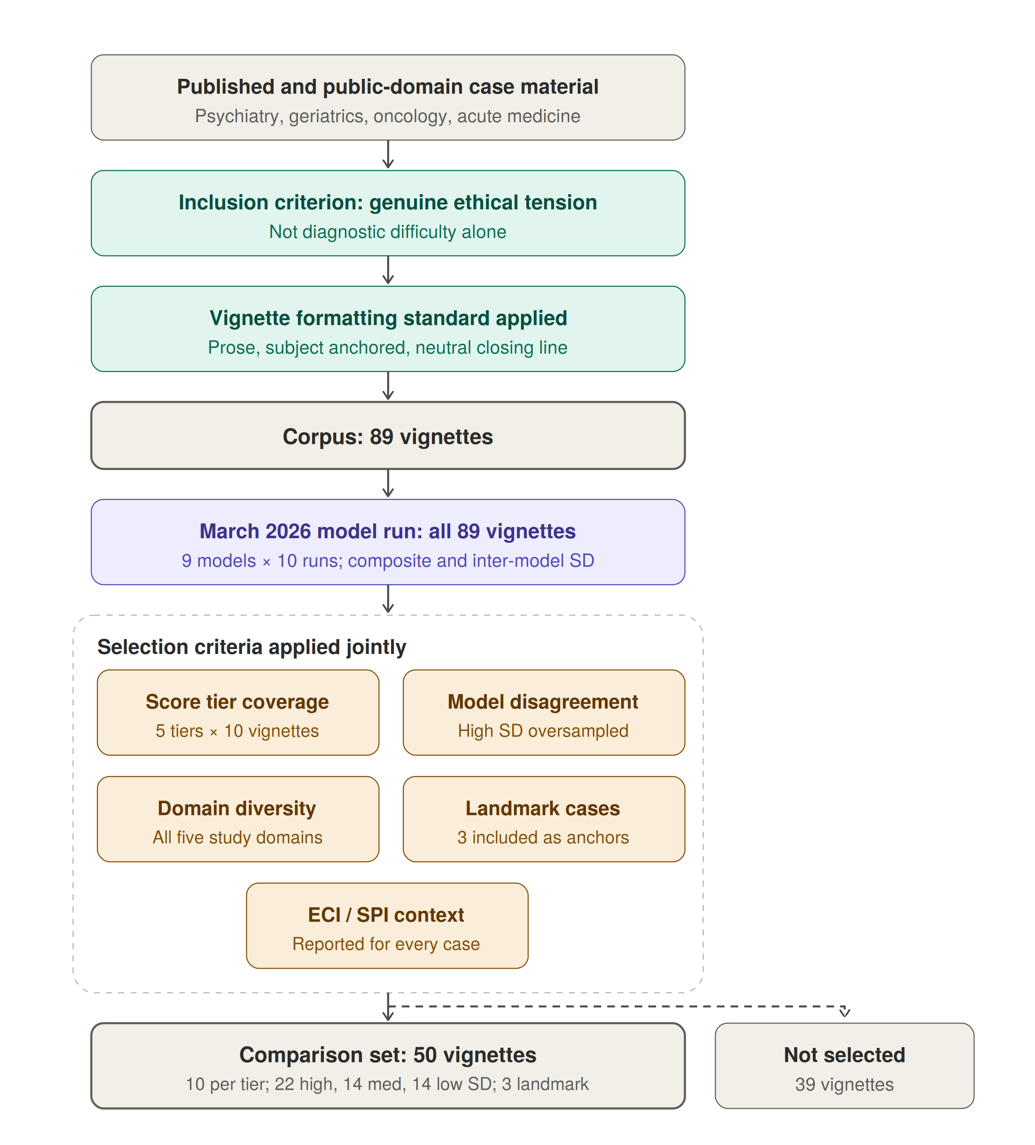
Figure 2. Derivation of the corpus and the comparison set. [Insert existing Figure 3 artwork.] Vignettes were drawn from published case reports and public-domain clinical material, screened for the presence of genuine ethical tension, and written to a common formatting standard, yielding a corpus of 89. All 89 were then scored by the March 2026 model run, which produced the two variables used for stratification: the mean composite and the standard deviation of the composite across models. Fifty vignettes were selected from the scored corpus against the five criteria specified in the text; the remaining 39 were scored but not selected for human review.
Selection of the comparison set. Selection was stratified rather than random, and the stratifying variables were derived from the March model scores. Five criteria were applied jointly.
- Score tier coverage. Vignettes were sorted by mean March-run composite and divided into five tiers Tier 1: 0 to <17, Tier 2: 17 to <28, Tier 3: 28 to <40 Tier 4: 40 to <60 Tier 5: 60 to 93 with ten vignettes drawn from each tier so that the comparison set spans the full observed range of the composite, from near-zero to near-ceiling.
- Inter-model disagreement. Vignettes were classified by the standard deviation of the composite across models as low (SD < 6), medium (6 to 14), or high (SD > 14), and all three strata are represented. High-disagreement vignettes, where models diverge sharply, were deliberately oversampled as the most informative for human adjudication. Low-disagreement vignettes were retained as calibration anchors, permitting a test of whether human reviewers converge with model consensus where that consensus is strong. The realized set contains 22 high-disagreement, 14 medium, and 14 low-disagreement vignettes.
- Ethical domain diversity. The set spans the five domains of the parent study — paternalism in the therapeutic relationship; duties to patients and families; deciding for others; medical research involving human subjects; and physicians, third parties, and society — with several domains represented by more than one realized case type. The realized distribution across case types is 13 end-of-life and duties to patients, 9 deciding for others and surrogate decisions, 8 paternalism and therapeutic relationship, 8 resource allocation and justice, 5 research and genetic ethics, 3 reproductive and maternal-fetal, and 4 other.
- Landmark and paradigm cases. Three widely taught cases (Quinlan, Tarasoff, Baby K) were included deliberately as known anchors for reviewers with clinical ethics training, and because their inclusion permits a check on whether prior familiarity shifts human ratings relative to unfamiliar material.
- ECI and SPI context. The External Constraint Index and Support Provided Index are recorded for every vignette in the comparison set, so that reviewers can register structural barriers and provided supports alongside their assessment of autonomy rather than absorbing them into it. This is a property carried into the set rather than a filter applied to it: no vignette was included or excluded on the basis of its ECI or SPI value.
Consequences of score-stratified selection. Because the stratifying variables are the model scores themselves, selection is not independent of the quantity under comparison, and three specific biases follow. They act in different directions, so the net effect cannot be assumed benign.
- First, drawing equally from five score tiers widens the variance of model scores in the comparison set relative to the corpus. Correlation coefficients are sensitive to the range of the predictor, so the human–model correlation estimated on this set is expected to exceed what a random sample of the corpus would yield. Reported correlations are therefore upper estimates with respect to the corpus.
- Second, oversampling high-disagreement vignettes works in the opposite direction. Vignettes on which models diverge are, by construction, those on which any single model score is least stable, which attenuates observed agreement with the human reference. Correlations are consequently deflated relative to a random sample on this dimension.
- Third, and most consequential for the level comparison, selecting vignettes at the extremes of the March score distribution selects partly on measurement error. Model scores in the lowest and highest tiers are extreme in part because of run-to-run noise, so on re-measurement they regress toward the mean, while human ratings carry no such selection artifact. Any statistic computed across the full score range will therefore show a spurious proportional trend, with the gap appearing largest where model scores are lowest. Cross-range patterns in section 8 are annotated accordingly and read as descriptive.

3.4 Instrument
Thirteen items across four domains, plus two contextual modifiers. Wording below is verbatim as presented to both human reviewers and models; in the tables, "the subject" abbreviates the instrument's phrasing, which names the subject in the vignette.
Table 2. Instrument items.
ID | Label | Question
VA1 | Value Clarity | How clearly does the subject articulate their core values relevant to the decision?
VA2 | Value Stability | How stable and consistent are the subject's expressed values?
VA3 | Framework Awareness | Does the subject demonstrate awareness of how their values relate to the decision?
VA4 | Appreciation | Does the subject appreciate the clinical team's efforts to provide them comfort and care?
FU1 | Key Facts Recall | Can the subject recall key facts about their condition and treatment options?
FU2 | Risk Comprehension | Does the subject understand the risks and benefits of each option?
FU3 | Applicability | Can the subject apply the information to their own situation?
RD1 | Coherence | Is the subject's reasoning logically coherent and consistent?
RD2 | Trade-off Reasoning | Can the subject weigh trade-offs between options?
RD3 | Consistency | Is the decision consistent with the subject's stated values and understanding?
IA1 | Intention Strength | How clearly does the subject express their intended course of action?
IA2 | Plan-fulness | Has the subject considered practical steps to implement their decision?
IA3 | Follow-through Feasibility | Is the subject's plan realistic and feasible?
ECI | External Constraint Index | Score from 0 to 100 representing external constraints on autonomy. 0 = no external constraints; 50 = moderate constraints that partially limit autonomous decision-making; 100 = severe constraints that fully override autonomous decision-making.
SPI | Support Provided Index | Score from 0 to 100 representing support provided to the subject. 0 = no support provided; 50 = moderate support that partially facilitates autonomous decision-making; 100 = comprehensive support that fully facilitates autonomous decision-making.

Values Awareness carries four items and a maximum raw score of 16; Factual Understanding, Rational Deliberation, and Intentional Action carry three items each and a maximum raw score of 12. Under the equal domain weighting of section 4.3, each VA item therefore contributes 6.25 composite points against 8.33 for items in the three-item domains; the domain scores, not the items, are the weighted unit. ECI and SPI are entered directly on a 0 to 100 scale.

3.5 Response scale and missing data
Domain items. All thirteen domain items use a common five-point ordinal scale — 0, not at all or absent; 1, minimal; 2, moderate; 3, high; 4, very high or fully present — plus a separate N/A option. The survey platform stores these six options as recode values 1 through 6 in presentation order; the decoding is specified in section 8.1.
Anchors are generic across items rather than item-specific. This keeps the instrument short enough for a reviewer to complete multiple cases in one sitting and keeps the human and model prompts identical, at the cost of placing more weight on rater interpretation than an item-specific rubric would.
Not enough information. Every item permits an additional response, N/A, defined as insufficient information in the vignette to render a judgment. N/A is a substantive response, not a skip. It is distinguished in the instrument from a score of 0, which asserts that the attribute is absent; N/A asserts that the attribute is unobservable in the material supplied. Collapsing the two would systematically depress scores on vignettes that are simply terse, and would confound stimulus brevity with subject impairment.
Exclusion rule. A domain is treated as not scored, and the composite is not computed for that rating, when fewer than two items are answered in a three-item domain, or fewer than three items are answered in the four-item Values Awareness domain. The rationale is given with the proration formula in section 4.1.
N/A rates are reported by item, rating source, and vignette. Two patterns are examined rather than treated as nuisance. Elevated N/A across raters on a given vignette indicates an underspecified stimulus rather than a low-autonomy subject. Systematic differences in N/A rate between human and model ratings indicate divergent thresholds for what counts as sufficient evidence, which is a substantive finding about model behavior and is reported alongside the score comparisons (section 8.5).
Contextual modifiers. ECI and SPI are entered as continuous values on a 0 to 100 scale and also permit N/A. Both carry plain-language anchors at three points, reproduced in Table 2. The response control was a slider with tick marks at intervals of ten across the full range.

4 Scoring and aggregation
This section defines, in order, how a single rating becomes a set of domain scores (4.1), how multiple ratings of the same vignette are combined (4.2), how domain scores become a composite and how sensitive it is to the weighting (4.3), and why the contextual modifiers are excluded from it (4.4). All quantities used in the statistical analysis of section 6 are defined here. Figure 2 shows the full measurement structure.
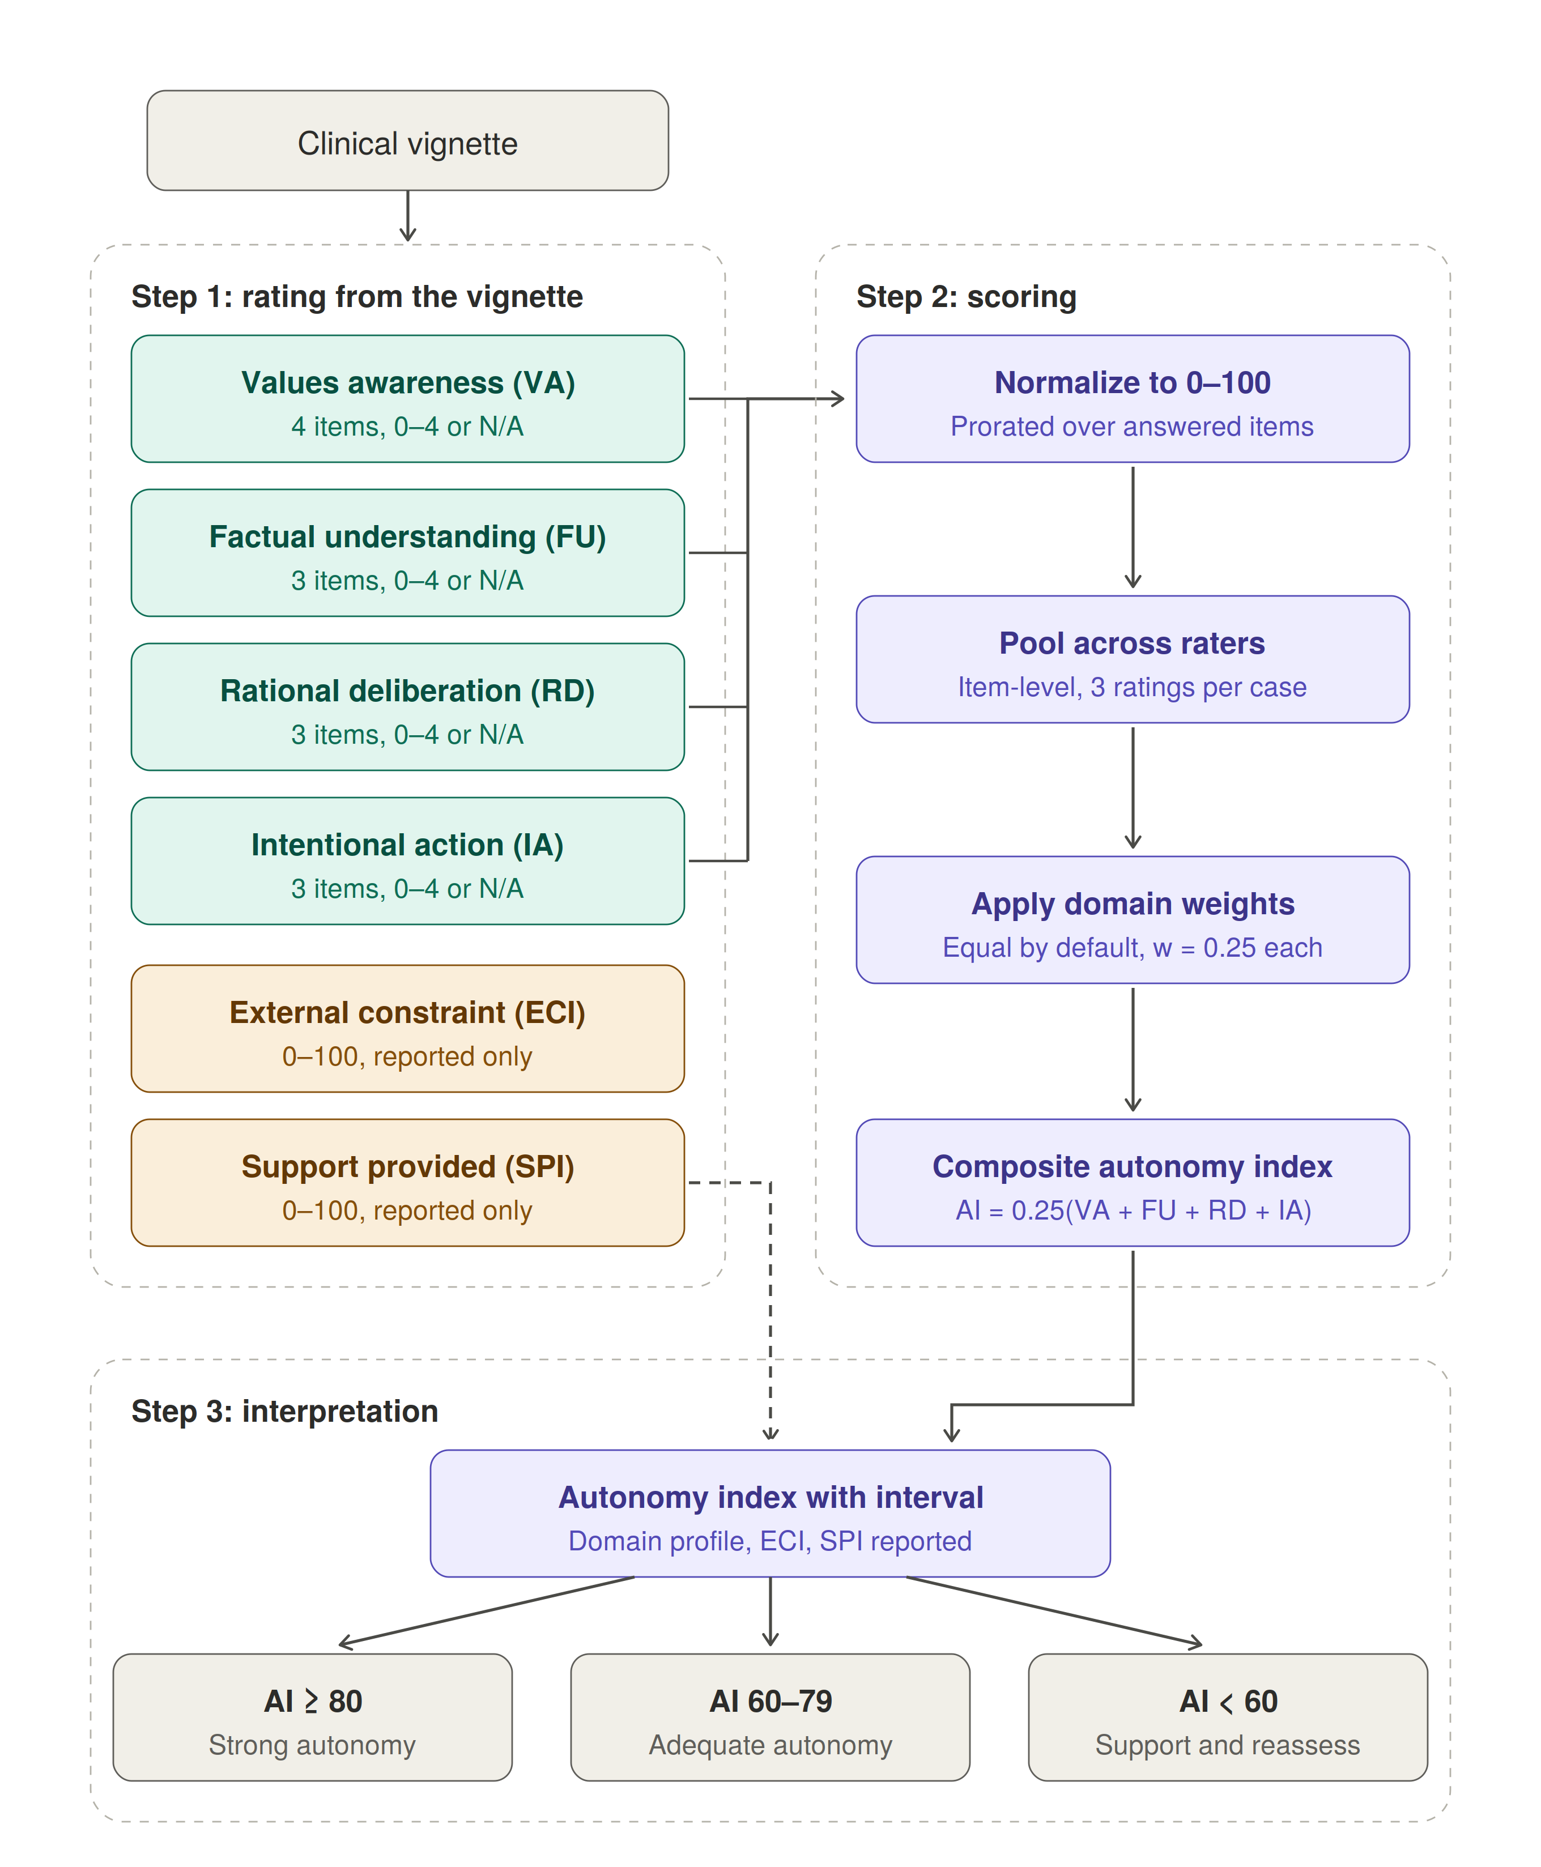
Figure 3. Measurement structure of the Autonomy Index. A clinical vignette is rated on thirteen domain items across four domains and on two contextual modifiers. Domain scores are normalized to 0–100 with proration over answered items, pooled across raters at the item level, and combined by equal weighting into a composite. The External Constraint Index and Support Provided Index are scored from the same vignette but bypass the composite and are reported alongside it, so that structural disadvantage is documented rather than recorded as diminished autonomy. The composite is mapped to one of three interpretive bands, which are reporting aids rather than decision rules.

4.1 Normalization within a rating
Each domain is rescaled to a common 0 to 100 metric so that domains with different item counts are comparable and the composite is interpretable on a single scale. For domain d in a single rating, let A_d be the set of items answered on the 0 to 4 scale and x_i the score on item i:
Score_d = [ Σ x_i ⁄ (4 · |A_d|) ] × 100
Where all items are answered this reduces to the raw total divided by 16 for Values Awareness and by 12 for the other three domains, times 100. Rescaling is linear and preserves rank order within domain. Proration assumes the answered items are representative of the domain, which is defensible when one item is missing and progressively less so beyond that; the exclusion rule in section 3.5 follows from this.

4.2 Aggregation across raters: primary estimator
Each vignette in the comparison set receives between one and six independent human ratings (section 3.1). These are not repeated measures on a changing subject; they are exchangeable observations of a fixed case. Aggregation therefore pools rather than updates in the temporal sense, and no discount is applied to earlier ratings.
The primary estimator is item-level prorated pooling. Aggregation is performed on raw item scores rather than on rater-level domain scores. For domain d with raters r = 1 … n, let A_dr be the set of items rater r answered on the 0 to 4 scale:
Score_d = [ Σ_r Σ x_dri ⁄ (4 · Σ_r |A_dr|) ] × 100
Item-level pooling is preferred to averaging rater-level domain scores because the two diverge whenever raters differ in which items they marked N/A. Averaging rater-level scores gives each rater equal weight regardless of how much of the instrument they completed; item-level pooling weights each rater by the evidence actually supplied. This estimator produces every human-rating value reported in the results.
Model ratings are aggregated by the same procedure, pooling over the ten runs per model per vignette at the item level. Using one aggregation rule throughout ensures that human–model differences are not partly an artifact of different pooling.

4.3 Composite and weight sensitivity
The composite is a weighted linear combination of the four aggregated domain scores:
AIx = w₁(VA) + w₂(FU) + w₃(RD) + w₄(IA), Σ wⱼ = 1
The default is equal weighting, all wⱼ = 0.25, reflecting the conceptual interdependence of the four domains: none is sufficient alone and none is dispensable. Task-specific reweighting is permitted but must be specified in advance. Plausible examples include elevating the Factual Understanding weight when evaluating high-risk informed consent, or elevating Rational Deliberation when reasoning quality is the object of interest. Any reweighted result is reported alongside the equal-weighted composite so that findings remain comparable across studies.
The robustness of the equal-weight default was examined directly. Reweighting to favor Factual Understanding (0.4/0.2/0.2/0.2), Rational Deliberation (0.2/0.2/0.4/0.2), or the two capability domains jointly shifts the mean human composite by less than one point in every case and leaves the rank ordering of vignettes essentially unchanged (Spearman ρ ≥ 0.995 against the equal-weighted ordering). With mean between-domain correlations of about 0.8 (section 8.7), the composite is insensitive to defensible reweightings, and results reported under equal weights do not depend on that choice.

4.4 Contextual modifiers as reported quantities
ECI and SPI are reported with every composite and never subtracted from it. Folding them into the score would convert structural disadvantage into diminished measured autonomy, which is precisely the error the framework is built to avoid, and would destroy their utility for the equity analyses they are intended to support.
Their function is diagnostic of the environment rather than of the person. The principal interpretive flag is triggered by a low Intentional Action score accompanied by high ECI or low SPI, and is worded to indicate that autonomy may be intact but externally constrained, and that the indicated response is a change to the setting rather than a conclusion about the individual.
Because the indices are recorded separately, their association with the composite is estimable rather than assumed, and their agreement across rating sources serves as a within-study negative control (section 8.6).

5 Data collection

5.1 Human raters
Reviewers were bioethics-trained participants recruited under IRB26-0146. Each accessed a password-protected web platform, reviewed the electronic consent form, and affirmed consent via an explicit checkbox before any study content was displayed. Participants who did not affirm consent could not proceed.
Each reviewer was presented with vignettes one at a time and scored all thirteen items plus ECI and SPI for each. Reviewers were not shown other reviewers' responses and were not shown any model output at any point. The median completed rating took 3.6 minutes.
Presentation order. Vignettes were presented in the sequence produced by the round-robin allocation rather than being independently randomized within each reviewer's block. Because the rotation places a given vignette at different positions in different reviewers' blocks, presentation position is not confounded with vignette identity.
Disclosure at consent. The consent materials stated that the study would compare human ratings with ratings produced by large language models. Reviewers therefore knew the purpose of the comparison, though not which models were used, what those models had scored, or how their own ratings compared. This is a deliberate transparency choice rather than an oversight, and its consequence for interpretation is stated in section 10.
Response data are stored in an encrypted database with no linkage to participant identifiers. Email addresses collected for access control are held in a separate access-controlled table and deleted within 30 days of study completion.
Recruitment. Reviewers were recruited through direct invitation from the study's faculty co-investigator, through bioethics interest groups and listservs, through Harvard Medical School and Master of Bioethics program newsletters, and through colleague referral. Forty-six individuals registered interest, and all were granted access to the study platform; there was no second selection step between registration and access. Referral source was recorded at registration and is reported in Table 4.
Recruitment was not a probability sample of any defined population. It was a convenience sample of individuals with bioethics or clinical ethics training who responded to invitation, and the reference standard should be read accordingly (section 10).
Table 3. Reviewer recruitment, access, and participation.
Metric | Value
Registrations of interest received | 46
Registrants granted access to the study platform | 46 (all)
Withdrew before assignment (time constraints) | 1
Reviewers assigned vignette blocks | 45
Reviewers submitting at least one rating | 30 of 45 (66.7%)
Reviewers submitting three or more ratings | 26 of 45 (57.8%)
Reviewers assigned but submitting no ratings | 15 of 45 (33.3%)
Assignment slots issued | 275
Ratings submitted | 175
Ratings completed per slot issued | 63.6%
Vignettes reaching three or more ratings | 43 of 50

One of the 46 registrants withdrew before vignette assignment, citing time constraints, and holds no assignment records; 45 reviewers were assigned blocks. No other registrant was excluded, and the participation flow reconciles without residual.

Table 4. Characteristics of registered reviewers (n = 46).
Metric | Value
Physician (attending) | 23
Bioethicist or ethics consultant | 10
Master of Bioethics or MS Bioethics student | 3
Healthcare attorney or policy professional | 2
Nurse practitioner or physician assistant | 2
Clinical psychologist or social worker | 2
Registered nurse | 1
Bioethics fellow | 1
Physician (resident or fellow) | 1
Medical researcher or academic | 1
Experience: more than 15 years | 18
Experience: 8 to 15 years | 16
Experience: 4 to 7 years | 8
Experience: 1 to 3 years | 3
Experience: less than 1 year | 1
Specialty: consultation-liaison psychiatry | 17
Specialty: clinical or research ethics | 11
Specialty: psychiatry, other subspecialty | 5
Specialty: palliative care | 2
Specialty: oncology | 1
Specialty: not stated | 10
Referral: direct invitation from faculty co-investigator | 22
Referral: bioethics interest group or listserv | 10
Referral: colleague referral | 4
Referral: institutional newsletter (MBE, HMS, Center for Bioethics) | 3
Referral: LinkedIn | 1
Referral: other or not specified | 6

Seventy-four percent of registrants reported eight or more years of relevant experience, and 29 of 46 held a clinical role. Among the 36 who stated a specialty, consultation-liaison psychiatry is the single largest group at 17. This concentration is not incidental: assessment of decisional capacity is routine consultation work for that specialty, so the reference standard is weighted toward reviewers who perform the underlying clinical judgment regularly. The corresponding limitation is stated in section 10.
Characteristics in Table 4 describe all 46 registrants rather than the 30 who contributed ratings, since role, experience, and specialty were collected at registration and are not linked to submission records. Whether contributing and non-contributing reviewers differ on these characteristics is therefore not estimable from the available data, and is reported as a limitation.

5.2 Language models
Models were queried through a single API gateway using a fixed prompt containing the vignette, the thirteen items, the two modifiers, and the verbatim response scale including the N/A option. Output was requested in a fixed structure to permit parsing.
Three implementation choices are material to the variance structure and are recorded here. First, constrained JSON decoding was disabled, so that run-to-run variability reflects the model's own stochasticity rather than being suppressed by format constraints. Second, provider routing was pinned per model, so that repeated calls to a nominal model were not silently served by different backends with different quantization or system configuration. Third, checkpointing marked a call complete only on successful parse, so that failed calls were retried on resume rather than being recorded as missing.
Two model runs were conducted. The first, in March 2026, covered nine models across the full 89-vignette corpus, with ten independent runs per model per vignette; 7,275 of 8,010 attempted scorings returned a valid parsed response, a validity rate of 90.8 percent. This run produced the scores used to stratify the comparison set (section 3.3). The second, on July 25, 2026, covered eight current-generation successor models across the 50-vignette comparison set, again with ten runs per model per vignette; 3,431 of 4,000 attempted scorings were valid (85.8 percent). Both runs used identical prompts and identical parsing. The July run is the primary source for the human–model comparison; the March run, restricted to the 50 comparison vignettes, provides a preceding-generation reference against which change across a model generation is assessed. The July models, their exact identifiers, providers, and per-model validity rates are given in Table 6 (section 8.1); the March models were Claude Sonnet 4.6, DeepSeek V3.2, Gemini 3 Flash Lite Preview, GPT-5.4, Grok 4.1 Fast, Llama 3.3 70B, Llama 4 Scout, Mixtral 8x7B, and Qwen 2.5 72B. The scoring code, including the per-model configuration used for every call and the full prompt as issued, is released with the paper.

6 Analysis

6.1 Reliability and variance components
Because the rater-by-vignette design is incomplete and unbalanced (section 3.1), reliability is estimated from a linear mixed model rather than from a crossed-design intraclass correlation formula. For the composite, we fit a model with crossed random intercepts for vignette and for rater, and a residual term:
y_vr = μ + a_v + b_r + ε_vr, a_v ~ N(0, σ²_v), b_r ~ N(0, σ²_r), ε_vr ~ N(0, σ²_e)
Variance components are estimated by restricted maximum likelihood. Missing cells arising from N/A responses and from the incomplete allocation are accommodated directly by the likelihood and require no listwise deletion.
Because the number of ratings per vignette varies from 1 to 6, there is no single reliability coefficient for the aggregate. Two quantities are therefore derived from the variance components and reported separately. The first is the reliability of a single rating, ρ₁ = σ²_v ⁄ (σ²_v + σ²_r + σ²_e), corresponding to absolute agreement between two arbitrary reviewers. The second is the reliability of the aggregate actually used in the comparison, ρ_k̄ = σ²_v ⁄ [ σ²_v + (σ²_r + σ²_e) ⁄ k̄ ], evaluated at the harmonic mean k̄ = 3.12 of the per-vignette rating counts. The harmonic mean is used rather than the arithmetic mean because the sampling variance of a vignette mean is inversely proportional to its rating count, so precisions rather than counts are the quantity to average. A decision study extends this to estimate the number of ratings per vignette required to reach a target reliability of 0.80.
Rater identity. The de-identified response export carries no reviewer identifier, in keeping with the storage design of section 5.1. For the crossed model, rater identity is therefore approximated by network session, which reconstructs 40 rater clusters against the 30 reviewers known to have contributed. This over-splits reviewers who rated from more than one network and merges any who shared one; the consequence is stated with the results (section 8.7) and in Limitations.
Within-model reliability is estimated separately from the ten runs per vignette, giving a direct measure of each model's self-consistency. A model may be internally consistent and systematically miscalibrated, or internally noisy and unbiased on average, and the two failure modes call for different responses. The model-side variance decomposition uses the same crossed specification with model in place of rater.
Internal consistency across the thirteen items is reported as alpha, with the caveat that the domains are specified to be conceptually distinct rather than internally redundant; between-domain correlations are reported alongside.

6.2 Human–model comparison
Model scores for the comparison vignettes are compared against the human reference on three quantities. These are mathematically independent and are reported separately; agreement on one does not imply agreement on another.
(a) Association and rank agreement. Pearson correlation between pooled human and pooled model composite across matched vignettes measures linear association; Spearman correlation measures rank agreement. Both are reported; Spearman is primary, since the substantive claim concerns ordering rather than linearity.
(b) Difference model. The level offset is estimated from a mixed model with a random intercept for vignette, a fixed effect for rating source, and observations weighted so that human ratings and model runs contribute equally per vignette, preventing the larger number of model runs from dominating the estimate. A random slope for rating source by vignette records how much the gap varies from case to case, which a single bias figure conceals. Because the sampling design of section 3.3 induces regression to the mean across the score range, any cross-range trend in the gap is reported descriptively, annotated by score stratum, and not tested as a confirmatory hypothesis.
(c) Domain-specific gaps. The difference model in (b) is fitted separately to each of the four domain scores. Because the four domains are scored by the same rater on the same vignette, the domain estimates are correlated; the five fixed-effect tests (four domains plus the composite) are treated as a family and corrected by the Holm–Bonferroni procedure [27]. A joint likelihood-ratio test of the rating source by domain interaction determines whether the offset differs across domains; a null interaction licenses describing the gap as a uniform level shift and bars interpretation of the domain ordering.
(d) Descriptive agreement display. A Bland–Altman analysis [18,19] reports the bias and limits of agreement. Because the two sources have unequal error variance, the difference is plotted against the human aggregate as the reference rather than against the mean of both sources [20], and any slope across the range carries the selection caveat of (b). The display is descriptive: no acceptability threshold exists for a new measure, and the inferential statement about the level offset rests on the model in (b).

6.3 Analysis plan and multiplicity
The confirmatory family comprises the rating-source effect in the difference model of section 6.2(b), fitted to the composite and to each of the four domains, five tests in total, using the July model run as the primary source, with Holm–Bonferroni correction. The March-run comparison, the ECI and SPI analyses, the N/A rate comparison, the landmark-case comparison, the weight-sensitivity analysis, the disagreement-band analysis, and all per-model breakdowns are exploratory and are labeled as such. Because three landmark vignettes were included deliberately, human ratings on those three are compared with human ratings on the remainder to test whether prior familiarity shifts scores.

6.4 Human disagreement and panel coverage
Two exploratory quantities characterize the spread of human judgment and the model panel's position within it, defined here in advance of their use in section 8.8. The disagreement band for a vignette is the minimum-to-maximum range of its fully scoreable human composites, computed over ratings passing the exclusion rule of section 3.5; vignettes with fewer than two such ratings are excluded from this analysis. Coverage is the proportion of eligible vignettes on which the pooled model panel mean falls inside the band [26]. Because the exclusion rule removes ratings with extensive N/A, the eligible vignettes are the better-specified ones and the band is estimated from as few as two ratings, so the coverage figure is conservative and is reported as exploratory.

6.5 Missingness among human ratings
Assignment was by round robin and is therefore ignorable, but completion was not: 175 of 275 assigned ratings were returned. Whether reviewers preferentially completed shorter or less ambiguous vignettes cannot be modeled from the response export alone, which carries no assignment records; the check specified for this analysis — a mixed-effects logistic regression of completion on vignette length and model-scored difficulty — requires the assignment-linked file and is deferred to it. As indirect evidence, per-vignette human N/A rates are uncorrelated with the case's autonomy level (section 8.5), and the number of completed ratings per vignette spans 1 to 6 without concentration at either extreme of the score range.

7 Reporting conventions
Results are reported as the composite with its uncertainty interval, the four domain scores, ECI, SPI, and any triggered interpretive flags. The composite is not reported alone: two cases with identical composites may differ substantially in which domain is deficient, and the indicated response differs accordingly.
Interpretive bands are: AIx ≥ 80, strong evidence of autonomous agency; 60 to 79, adequate, additional supports may optimize the decision; below 60, autonomy not fully demonstrated, further support and reassessment indicated. Bands are interpretive aids and not decision rules. They are reported jointly with ECI and SPI so that a low score arising under high constraint or low support is read as an indication for environmental change rather than as a conclusion about the individual.

8 Results
Results below compare human ratings with the July 2026 model generation on the 50-vignette comparison set, which is the primary comparison specified in section 5.2. Figures 4 to 11 accompany the text.

8.1 The analyzed dataset
The response export contains 191 human records. Of these, 176 are complete submissions; one complete submission rates a vignette outside the comparison set. The analyzed set is therefore 175 complete ratings across the 50 comparison vignettes, which reconciles with the assignment records in Table 3 without residual. Ratings per vignette range from 1 to 6 (median 3, mean 3.50, harmonic mean 3.12); 43 of 50 vignettes reached the three-rating target. The fifteen partial responses (Progress 27 to 87 percent) are excluded.
Response-scale decoding. The instrument presents six response options per item — the ordinal scale 0 to 4 plus N/A (section 3.5; instrument workbook) — which the survey platform exported as recode values 1 through 6 in presentation order. The transform applied throughout is therefore score = stored value − 1, with stored value 6 denoting N/A and excluded from aggregation. Two checks confirm the decoding. The instrument specification enumerates exactly six options in that order, fixing the recode mapping. And the response pattern discriminates the alternative reading directly: if 6 were the top category of a genuine six-point scale, ratings storing 6 on an item should show the highest mean scores on the remaining twelve items; instead, for all thirteen items, ratings storing 6 have lower co-item means (2.7 to 3.5 on the stored scale) than ratings storing 5 (3.9 to 4.6), sitting near the overall mean — the signature of a response uncorrelated with the level of the case. Model score files store the 0 to 4 responses directly and require no transform; recomputing the composite from item scores reproduces the pipeline's stored composite to within 0.005 points. An earlier analysis pipeline rescaled the stored human values without the offset and without excluding N/A, which placed 26 of 50 human vignette composites above the defined ceiling of 100; no result from that pipeline is reported here.
One vignette is not scoreable. The vignette The Noncompliant or Nonadherent Patient received two ratings, both of which recorded N/A on all three Factual Understanding items. It has no Factual Understanding score and therefore no composite under the exclusion rule of section 3.5. The primary comparison is reported on the remaining 49 vignettes; the case reappears in section 8.5, where the absence of scoreable comprehension evidence is itself the observation.
Model runs. The July run comprises 3,431 valid scorings of 4,000 attempted (85.8 percent); 568 failures are truncated generations recorded as incomplete and one is a parse error. Table 6 enumerates the models. Validity varies substantially across models, from 66.8 percent (Gemini 3.5 Flash Lite) to 97.6 percent (Grok 4.5, Llama 4 Maverick); the number of failed calls per vignette is uncorrelated with that vignette's model composite (r = −0.03), so the loss is not differential with respect to the quantity under comparison, and the most plausible mechanism is a completion-token ceiling interacting with models that generate longer preambles before the structured output.
Table 6. July 2026 models: identifiers, providers, and validity.
Model | Identifier | Provider (pinned) | Attempted | Valid | Validity
Grok 4.5 | x-ai/grok-4.5 | xAI | 500 | 488 | 97.6%
Llama 4 Maverick | meta-llama/llama-4-maverick | Parasail | 500 | 488 | 97.6%
Qwen3.7 Max | qwen/qwen3.7-max | Alibaba | 500 | 482 | 96.4%
Mistral Large 2512 | mistralai/mistral-large-2512 | Mistral | 500 | 464 | 92.8%
DeepSeek V4 Pro | deepseek/deepseek-v4-pro | Baidu | 500 | 405 | 81.0%
Claude Opus 5 | anthropic/claude-opus-5 | Amazon Bedrock | 500 | 394 | 78.8%
GPT 5.6 Terra | openai/gpt-5.6-terra | OpenAI | 500 | 376 | 75.2%
Gemini 3.5 Flash Lite | google/gemini-3.5-flash-lite | Google AI Studio | 500 | 334 | 66.8%

8.2 Humans and models order cases alike
Human and model composites are strongly correlated across the 49 vignettes (Pearson r = 0.81, Spearman ρ = 0.80, both P < 10⁻¹¹). Restricted to the 43 vignettes with three or more human ratings, r = 0.78. Domain-level correlations range from 0.72 (Values Awareness) to 0.82 (Intentional Action). Rank agreement is invariant to affine rescaling and is therefore independent of the decoding in section 8.1.
Correlation of this magnitude indicates that the two sources substantially agree on which cases depict more and less autonomous decision-making: roughly two-thirds of the variance in pooled model scores is shared with pooled human scores. It does not indicate that they agree on how much autonomy any case depicts, which is the subject of the next section.
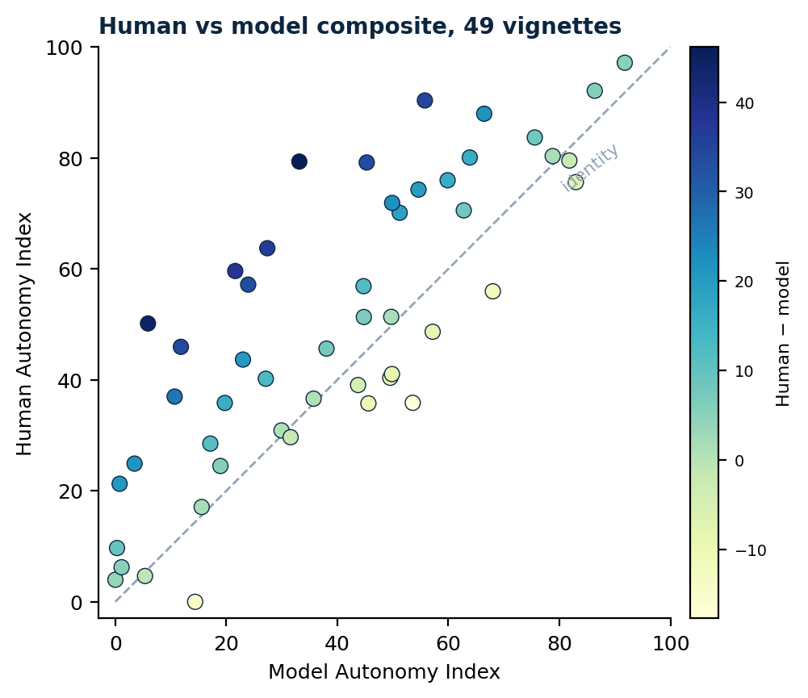
Figure 4. Human and model Autonomy Index scores across the 49 comparison vignettes. The dashed line is identity. Points are shaded by the size of the human–model difference. Thirty-seven of 49 vignettes lie above identity.

8.3 Human reviewers attribute more to autonomy than LLM models
The human mean composite is 50.2 and the model mean 39.4, a paired difference of 10.8 index points (95% CI 6.3 to 15.4; t = 4.76, P = 1.8 × 10⁻⁵; d_z = 0.68). From the mixed model of section 6.2(b), with a vignette random intercept and human ratings and model runs weighted equally per vignette, the offset is 10.8 points (SE 2.1, 95% CI 6.8 to 14.9, P = 8 × 10⁻⁸). Human ratings exceed the model panel on 37 of 49 vignettes.
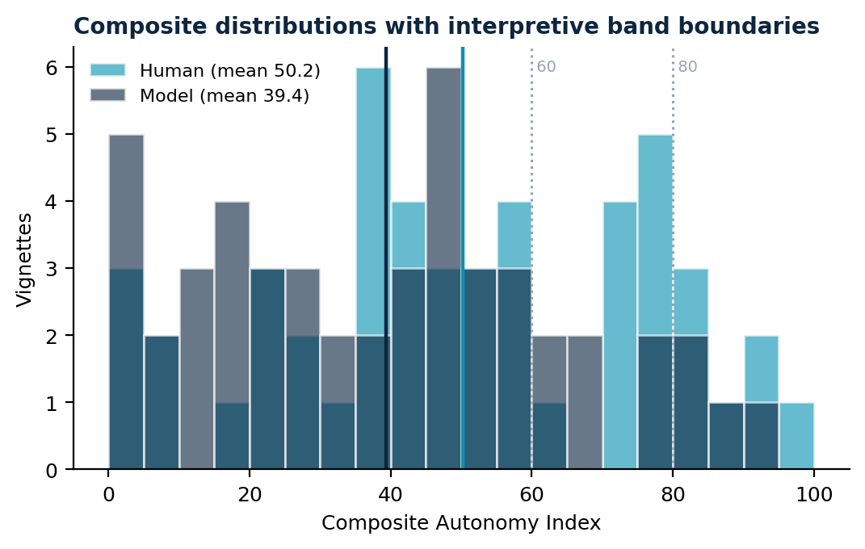
Figure 5. Distribution of the composite Autonomy Index for human reviewers and models across the 49 vignettes. Dotted vertical lines mark the interpretive band boundaries at 60 and 80. The distributions overlap in shape but are displaced, which is the pattern that rank agreement conceals and a level comparison exposes.
Variation across the score range. Stratifying vignettes by quintile of the model composite, the paired difference is 15.0 and 17.7 points in the two lowest quintiles and falls to 6.9 and 4.4 in the top two.
Table 7. Human–model difference by quintile of the model composite.
Quintile | n | Model mean | Human mean | Difference | 95% CI
1 (lowest) | 10 | 5.4 | 20.4 | +15.0 | 2.4 to 27.6
2 | 10 | 22.4 | 40.1 | +17.7 | 7.7 to 27.7
3 | 9 | 40.3 | 50.4 | +10.1 | −4.1 to 24.3
4 | 10 | 53.1 | 60.0 | +6.9 | −5.7 to 19.4
5 (highest) | 10 | 75.8 | 80.3 | +4.4 | −2.8 to 11.7

Two cautions attach. Because the comparison set was stratified on March model scores, part of the narrowing is the regression-to-the-mean artifact of section 3.3, and the quintiles are a proxy for the selection tiers. And regressing the difference on the model score is mechanically coupled through measurement error in the model score [20]; against the human aggregate as reference the association reverses sign (r = 0.33, P = 0.02), so the cross-range trend is reported descriptively and no confirmatory claim rests on it.
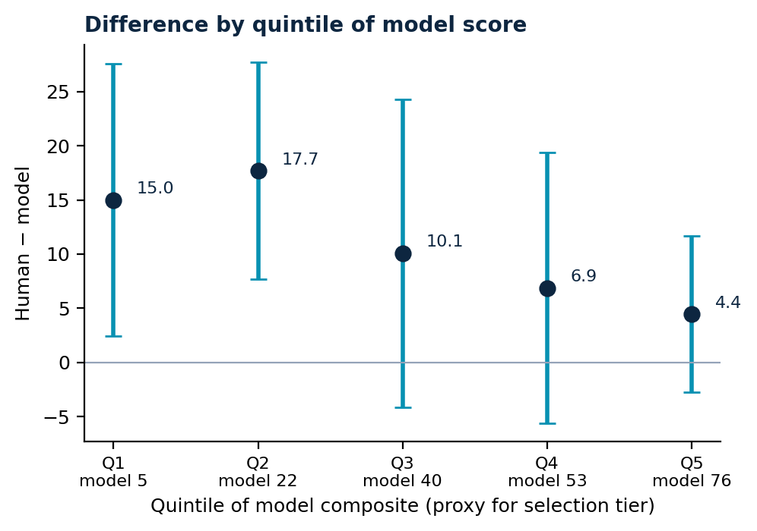
Figure 6. Human–model difference by quintile of the model composite, with 95% confidence intervals. Quintiles approximate the selection tiers and the pattern is descriptive.
Spread across cases. A random slope for rating source by vignette has a standard deviation of 16 points, so the case-to-case variation in the gap is larger than the gap itself. Bland–Altman bias is +10.8 with limits of agreement −20.4 to +42.0. The two sources rank cases similarly and are not interchangeable on absolute scores.

8.4 The gap is a uniform level shift, not a domain-specific pattern
Paired domain differences are 12.6 points for Factual Understanding, 12.2 for Intentional Action, 10.8 for Values Awareness, and 7.8 for Rational Deliberation; the mixed-model estimates are 9.9, 12.3, 10.8, and 7.1. All five tests in the confirmatory family (four domains plus composite) are significant after Holm correction.
Table 8. Human–model difference by domain (n = 49).
Domain | Human | Model | Paired difference | 95% CI | d_z | Holm-adjusted P
Values Awareness | 55.4 | 44.6 | +10.8 | 5.3 to 16.2 | 0.57 | <0.001
Factual Understanding | 46.6 | 34.1 | +12.6 | 6.3 to 18.9 | 0.57 | <0.001
Rational Deliberation | 48.0 | 40.2 | +7.8 | 2.3 to 13.3 | 0.41 | 0.007
Intentional Action | 50.9 | 38.7 | +12.2 | 7.4 to 17.0 | 0.73 | <0.001
Composite | 50.2 | 39.4 | +10.8 | 6.3 to 15.4 | 0.68 | <0.001

The joint test of section 6.2(c) is null: the rating source by domain interaction does not improve fit (likelihood-ratio χ²(3) = 2.5, P = 0.47). The apparent ordering of domain gaps is therefore not interpretable, and the finding is that models discount autonomy by a broadly constant amount across the construct rather than on any particular component.
This is a stronger result than a domain-specific gap would be. A discrepancy concentrated in Factual Understanding would suggest models applying a different threshold for adequate comprehension; one concentrated in Intentional Action would suggest a different threshold for evidence of planning. A uniform shift across all four domains is not explicable as a threshold difference on any single ability, and points instead to a difference in how much agency is attributed to the subject once the components have been read. Both sources also share the shape of the domain profile — each rates Values Awareness highest and Factual Understanding lowest — so what separates them is level, not structure.
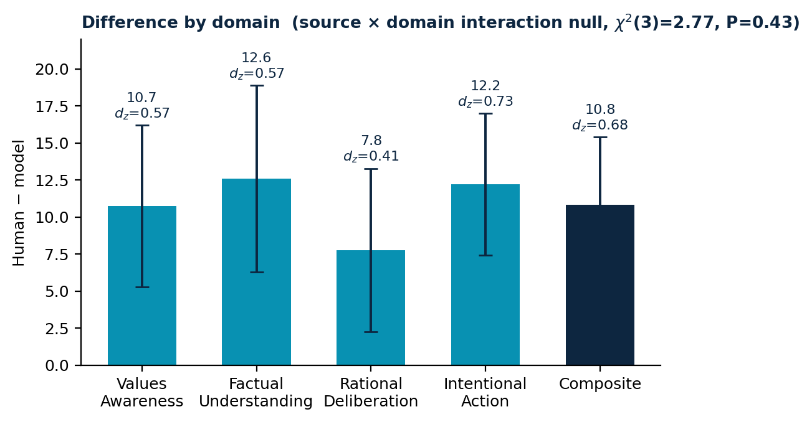
Figure 7. Human–model difference by autonomy domain, with 95% confidence intervals and standardized effect sizes. The source × domain interaction is null, so the figure shows a level shift, not a ranking.

8.5 Models do not decline to score
Both sources received the same instrument, including the N/A option defined in section 3.5 as insufficient information in the vignette to render a judgment. They used it very differently.
Human reviewers recorded N/A on 26.5 percent of item responses, an average of 3.4 of the 13 items per rating. The eight July models recorded it zero times across 3,431 valid scorings.
Table 9. Per-item N/A rate, human reviewers (175 ratings).
Item | N/A rate | Item | N/A rate
RD2 Trade-off Reasoning | 38.3% | IA3 Follow-through Feasibility | 28.0%
FU1 Key Facts Recall | 36.8% | VA2 Value Stability | 22.9%
VA4 Appreciation | 34.3% | RD1 Coherence | 21.1%
FU2 Risk Comprehension | 33.5% | VA3 Framework Awareness | 17.1%
RD3 Consistency | 33.1% | IA1 Intention Strength | 10.9%
IA2 Plan-fulness | 30.9% | VA1 Value Clarity | 7.4%
FU3 Applicability | 29.7%

The pattern within the human ratings is orderly rather than arbitrary. Reviewers were most willing to score what the vignette states directly — value clarity and expressed intention — and most likely to abstain on what must be inferred: trade-off reasoning, factual recall, and recognition of the clinical team's efforts. Per-vignette N/A rates range from 3 to 65 percent and are uncorrelated with the human composite (r = 0.10, P = 0.48), so abstention tracks what the stimulus supplies rather than how autonomous the subject appears. One vignette drew unanimous abstention on the entire Factual Understanding domain (section 8.1), the limiting case of the same behavior.
The generational comparison sharpens the finding. The March 2026 models did abstain, on 7.5 percent of responses overall, concentrated in four of nine models — Mixtral 8x7B (40.1 percent), DeepSeek V3.2 (9.7), GPT-5.4 (9.0), Gemini 3 Flash Lite Preview (8.2) — with Claude Sonnet 4.6 and Qwen 2.5 72B near 2 percent and Grok 4.1 Fast, Llama 3.3 70B, and Llama 4 Scout at or near zero. The capability to record insufficient evidence was present in the preceding generation and is absent in the current one.
Two readings are available and this design cannot separate them. Models may judge the vignettes to contain sufficient evidence where reviewers do not, a substantive disagreement about evidential adequacy. Or the models may be disposed to produce a response to any well-formed request, in which case the scores on the roughly quarter of items where a trained reviewer would abstain are answers without a basis in the material. The vignette-level association between human abstention and the size of the gap is positive but not significant (r = 0.22, P = 0.14), so the data lean toward but do not establish the second reading. Distinguishing them would require an ablation in which evidence for specific items is removed from a vignette and the model's willingness to abstain is observed as a function of what was withheld.
Either way, the operational implication is the same and does not depend on the level comparison. A system deployed to assess decisional capacity that never reports insufficient information will not surface the cases in which a clinician should seek more — which is the circumstance in which such a tool would be most useful.
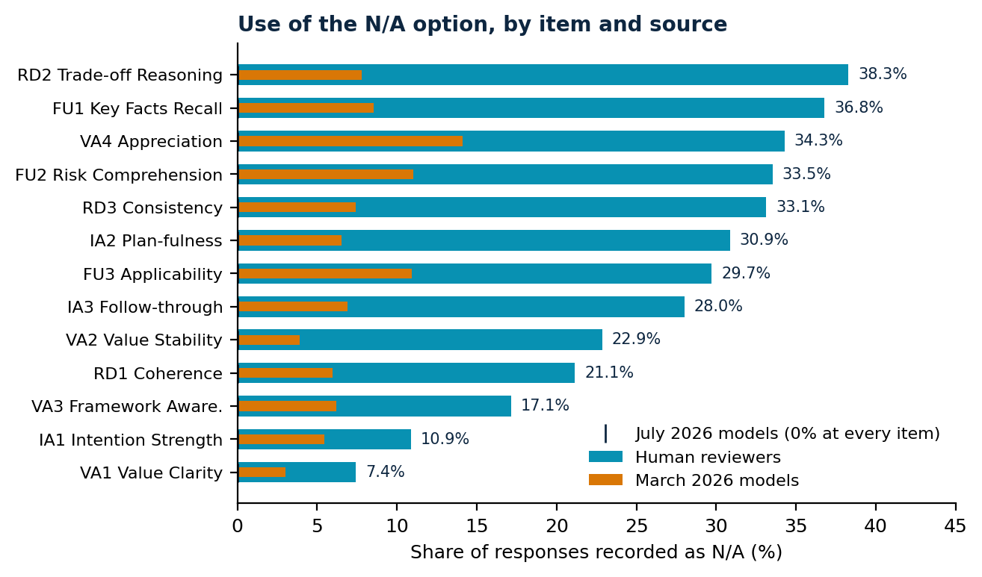
Figure 9. Per-item N/A rate for human reviewers, the March 2026 model generation, and the July 2026 generation (zero at every item).

8.6 Where humans and models agree: the contextual modifiers
The two contextual modifiers behave differently from the autonomy domains. Human and model External Constraint Index scores correlate at r = 0.82 (P = 1 × 10⁻¹²) with a mean difference of 5.9 points on a 0 to 100 scale, models scoring constraint slightly higher (P = 0.004). Support Provided Index scores correlate at r = 0.40 (P = 0.004) with a difference of 3.4 points that is not significant (P = 0.27).
This is the most informative negative control in the study. ECI and SPI were rated by the same reviewers, from the same vignettes, in the same sitting, on a response format both sources handled identically. If the human–model divergence on autonomy reflected models reading the cases differently, missing information, or applying a generally more conservative response style, it should appear on the contextual modifiers too. It does not. Agreement on external constraint is close to the ceiling set by the reliability of the measures, while agreement on the level of autonomy is far below it.
Neither modifier moderates the gap: the human–model difference is unrelated to human-rated ECI (r = 0.07, P = 0.65) and SPI (r = 0.20, P = 0.17). Earlier drafts based on the March generation reported a significant External Constraint moderation (β = −0.25, P = 0.007) and concluded that models discount autonomy most where structural constraints are heaviest. That result does not replicate in the July generation and the claim is withdrawn rather than carried forward.
The divergence is therefore specific to the autonomy construct rather than general to the task. Models and humans read the same circumstances from the vignette and largely agree about what those circumstances are. They disagree about what those circumstances imply for the person's agency.
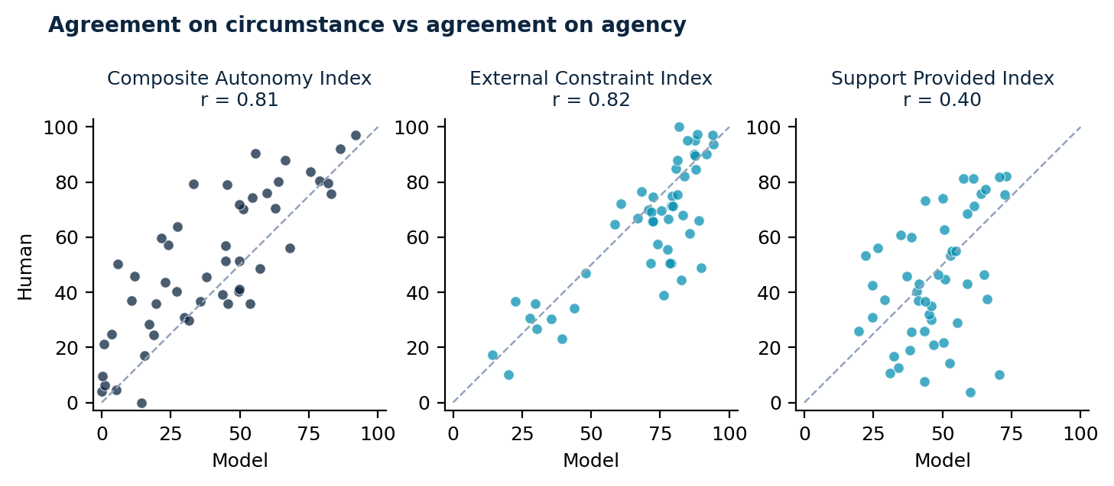
Figure 10. Human vs model agreement on the composite (left), External Constraint Index (centre), and Support Provided Index (right), each against the identity line. The composite panel is displaced above identity; the ECI panel hugs it.

8.7 Reliability, internal structure, and self-consistency
Model panel. The crossed variance decomposition on per-model, per-vignette means attributes σ²_vignette = 637 against σ²_model = 7 and residual 117. A single run of a single model has reliability ρ₁ = 0.84; a single model's 10-run mean reaches 0.97; the 8-model, 10-run panel mean is effectively at ceiling (≈ 1.0). Vignette content, not model identity, drives model scores.
Human panel. With rater identity approximated by network session (section 6.1; 40 clusters against 30 known contributors), the crossed decomposition on all prorated ratings gives σ²_vignette = 265, σ²_rater = 282, σ²_residual = 289: the rater-plus-error mass (571) is roughly twice the vignette signal. A single human rating has ρ₁ ≈ 0.32, the realized panel of ~3 reaches ρ_k̄ ≈ 0.59, and the decision study implies roughly nine reviewers per case for 0.80 — against one model. These estimates are sensitive to the composite definition and to the session approximation: restricting to fully scoreable ratings lowers ρ₁ to about 0.18, while a vignette-only decomposition that leaves rater confounded with error bounds it above at 0.59. Under every specification, a single human rating is far less reliable than a single model's 10-run mean, and the human aggregate at its realized panel size remains below a single model. Exact human variance components await a rater-linked export and are reported here as session-approximated.
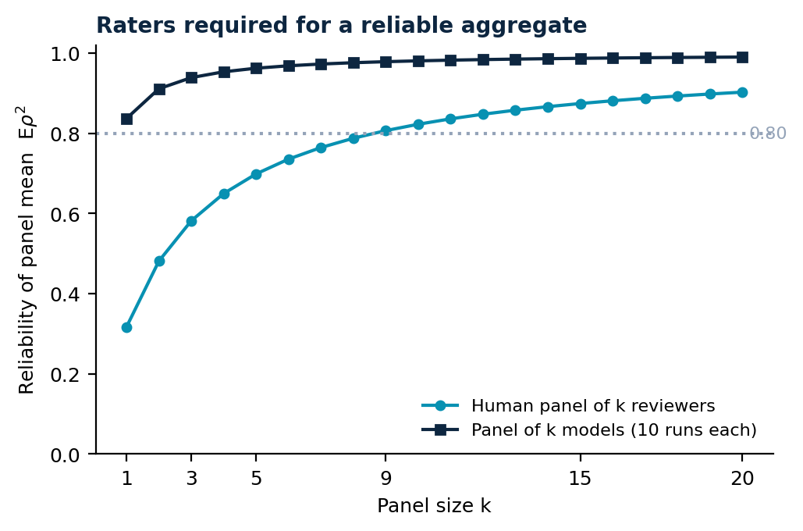
Figure 11. Reliability of the panel mean as a function of panel size, for human reviewers and for models, from the variance components above. The dotted line marks the 0.80 target.
Internal structure. Alpha across the thirteen items is 0.97 for human ratings on complete cases and 0.97 for model ratings; mean between-domain correlations are 0.80 (human) and 0.87 (model). The instrument behaves close to unidimensional for both sources, which bears on the interpretation in section 9.1 and is why the composite is reported with, not instead of, the domain profile.
Self-consistency by model. Within-model variability across the ten runs per vignette spans more than an order of magnitude: mean within-vignette SD 0.7 composite points for Mistral Large 2512, 2.2 for Claude Opus 5, 3.8 for Llama 4 Maverick, 4.0 for Gemini 3.5 Flash Lite, 4.5 for Grok 4.5 and GPT 5.6 Terra, 7.0 for Qwen3.7 Max, and 10.6 for DeepSeek V4 Pro. Models differ far more in the stability of their judgments than in the level of them; an internally consistent but displaced model and an internally noisy one call for different responses in deployment.

8.8 The gap is present for every model, and human disagreement contains it only partly
Per-model differences against the human aggregate range from 7.0 points (Claude Opus 5) to 14.8 (DeepSeek V4 Pro), every confidence interval excluding zero, with per-model correlations between 0.73 and 0.85.
Table 10. Human–model difference by model (n = 49).
Model | Model mean | Difference | 95% CI | r with human
Claude Opus 5 | 40.1 | +7.0 | 1.4 to 12.6 | 0.74
Mistral Large 2512 | 41.6 | +8.7 | 3.3 to 14.2 | 0.73
Qwen3.7 Max | 41.4 | +8.9 | 3.8 to 14.0 | 0.80
Gemini 3.5 Flash Lite | 40.5 | +9.3 | 3.9 to 14.8 | 0.85
Grok 4.5 | 39.3 | +11.0 | 5.9 to 16.1 | 0.77
Llama 4 Maverick | 38.6 | +12.1 | 7.1 to 17.1 | 0.75
GPT 5.6 Terra | 36.5 | +12.9 | 7.2 to 18.6 | 0.74
DeepSeek V4 Pro | 35.5 | +14.8 | 9.7 to 19.9 | 0.79

Eight models from six developers, spanning proprietary and open-weight releases, all show the effect in the same direction, and none approaches parity with the human aggregate. The spread across models is not negligible relative to the effect — model choice moves the difference by roughly a factor of two between the extremes — so the claim these data support is that the direction and presence of the gap are common to the current model population, not that its magnitude is constant. Selecting a different model narrows the difference; it does not remove it.
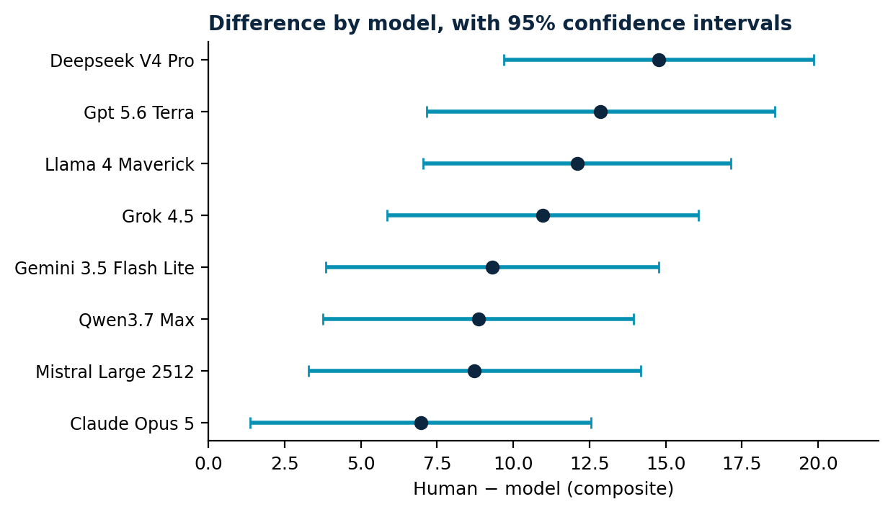
Figure 8. Human–model difference by model, with 95% confidence intervals.
Human disagreement and coverage. Reviewers disagree substantially with one another. Across the 26 vignettes with at least two fully scoreable ratings (section 6.4), the mean between-reviewer SD is 16.4 points and the mean range 28.2, with one case spanning 74 points. The pooled model panel mean falls inside the observed human range on 15 of 26 (58 percent). Three cautions make this exploratory: the exclusion rule leaves only the better-specified vignettes eligible; a range estimated from two or three ratings is systematically narrow, making coverage conservative; and without a rater identifier, between-reviewer variation is confounded with residual error. Subject to those cautions, the human reference is a band rather than a point, the band is wide, and the model panel sits inside it on somewhat more than half of the comparable cases; the level gap of section 8.3 bites on the remainder.
Landmark cases. The three deliberately included landmark vignettes (Quinlan, Tarasoff, Baby K) show no detectable familiarity effect: mean fully scoreable human composite 54.8 against 46.2 for the remaining vignettes (Welch P = 0.54, on only eight scoreable landmark ratings). They are pooled with the rest.

8.9 Change across a model generation
Restricted to the comparison set, the March 2026 and July 2026 generations produce nearly identical composites: 39.6 and 39.4 (paired P = 0.90). No domain moves significantly; the largest shifts are +2.1 points in Intentional Action (P = 0.10) and −2.2 in Values Awareness (P = 0.16). Agreement with the human reference is unchanged (r = 0.78 for both generations).
Table 11. March vs July model generations (same vignettes).
Domain | March | July | Change | P
Values Awareness | 46.8 | 44.6 | −2.2 | 0.16
Factual Understanding | 34.1 | 34.1 | 0.0 | 0.98
Rational Deliberation | 40.8 | 40.2 | −0.6 | 0.73
Intentional Action | 36.6 | 38.7 | +2.1 | 0.10
Composite | 39.6 | 39.4 | −0.2 | 0.90

The substantive reading is that a full model generation — nine models replaced by eight successors from the same developer set — has not moved the level at which these systems attribute autonomy. Whatever produces the difference is not being addressed by the capability gains that separate the generations, and the one respect in which the generations clearly differ is the loss of abstention documented in section 8.5, which moves in the wrong direction.

8.10 Interpretive band concordance
Assigning each vignette to one of the three interpretive bands of section 7, humans and models agree on 34 of 49 vignettes (69 percent). Disagreements are almost entirely one-directional: models place a case in a lower band than humans on 14 vignettes and in a higher band on one.
Table 12. Interpretive band concordance (counts of vignettes).
 | Model < 60 | Model 60–79 | Model ≥ 80
Human < 60 | 31 | 1 | 0
Human 60–79 | 7 | 1 | 2
Human ≥ 80 | 1 | 4 | 2

Both sources place the majority of cases in the reassess band — 65 percent of vignettes for humans, 80 percent for models — which is expected given that the vignettes were selected for the presence of genuine ethical tension. Neither source treats the corpus as depicting predominantly autonomous decision-making; the 15-point difference in the share assigned to the reassess band is the band-level expression of the level difference in section 8.3.

9 Discussion
Across a matched comparison on a common instrument, current large language models attribute less autonomy to patients in clinical-ethics vignettes than trained human reviewers do: about eleven points on a 100-point composite, present in the same direction for every one of eight models from six developers, and stable across a model generation. The models are not disordered relative to humans and they are not less discriminating. They order cases as humans do, share the shape of the domain profile, and sit lower.
Three features of the result narrow its explanation. The contextual-modifier control shows that models and humans agree closely about the constraints surrounding a decision and disagree about the agency of the person making it; what differs is the inferential step from circumstance to autonomy, not the reading of the circumstance. The null domain interaction shows the discount is applied to the construct as a whole rather than to any single ability, so it cannot be a threshold difference on comprehension or planning alone. And the abstention result shows the two sources hold different epistemic postures toward the same material: reviewers declined to score a quarter of item responses for insufficient evidence, while the current model generation scored everything, always — a capability its predecessors partially had and that has since disappeared.
The practical implications follow from direction rather than magnitude. An autonomy-assessment aid built on current systems would under-recognize patient agency relative to trained human judgment, most where models already judge autonomy weak, which is the direction of error that tends toward paternalism and is concentrated where the stakes for the patient are highest. And a system that never reports insufficient information will not surface the cases where a clinician should probe further, which is precisely where such a tool would earn its place. The appropriate deployment posture is therefore human oversight in capacity-sensitive decisions, calibration toward the range of defensible human judgment rather than its central tendency, and restoration of calibrated abstention as a first-class model behavior. Model choice matters at the margin — the best-aligned model halves the gap relative to the widest — but no current model reaches parity, so selection is a mitigation, not a remedy.

9.1 What the human ratings show about human judgment
The human data are worth reading in their own right and not only as the baseline the models are measured against. Trained reviewers assigned a mean composite of 50.2, placing the typical case in the reassess band, and their pooled ratings spanned nearly the full scale. Reviewers distinguished sharply between cases, and the model-side decomposition confirms the instrument responds to case content above all. But individual reviewers agreed with one another far less than individual model runs agreed with themselves: rater-plus-error variance roughly twice the vignette signal, single-rating reliability around 0.3, and per-case ranges averaging 28 points. When ethicists and clinicians assess autonomy in a structured way, the case moves the panel mean; which reviewer you happen to get moves the individual rating almost as much.
The domain profile is flat relative to the models': human domain means span 8.7 points and move together (mean between-domain r = 0.80). Two readings are available and this study cannot separate them. Reviewers may hold a genuinely integrated view of autonomy in which the components move together, which is closer to how the philosophical accounts describe autonomous agency than the Appelbaum model's componential structure suggests. Or the flat profile may be a halo effect, in which an overall impression of the case propagates across all thirteen items. The high between-domain correlation is consistent with either. Distinguishing them would require an item-order manipulation or a design in which reviewers score domains in isolation, and is a question about human ethical judgment rather than about models. The abstention pattern cuts against pure halo, however: reviewers who propagated a global impression indiscriminately would not also discriminate, item by item, between what the vignette shows and what it omits — and they did, at rates from 7 to 38 percent across items.

9.2 What structured measurement adds
An instrument that forces an assessment of autonomy into thirteen scored components does something beyond producing a number. It makes explicit which considerations a rater actually weighted, and by how much. Applied to human reviewers it externalizes professional judgment that normally stays tacit; applied to models it surfaces dispositions that are otherwise invisible in fluent prose. The artifact of interest is the profile across domains and the pattern of abstention, not the composite alone, because those record what was valued and what was treated as evidence. A structured record of this kind, kept at the point of decision, would also permit downstream questions — for example, whether decisions that honor patient agency align with decisions that deliver high-value care — that cannot currently be asked with evidence; this study supplies the measurement layer, not the answer.

9.3 What this report does not establish
The claim that humans are correct is not established: reviewers constitute a reference standard, not ground truth, and a comparison of this design cannot say whether an eleven-point difference means models are too conservative, humans too generous, or both. The instrument fixes what is being measured; it does not adjudicate who measures it well.
Two things would settle most of what remains open. A rater-linked export would replace the session-approximated human variance components with exact ones and permit the completion-missingness model of section 6.5. And a replication on a randomly drawn sample of the corpus would remove the selection dependencies that section 3.3 documents, fixing the corpus-referenced magnitude of both the level gap and the correlation.

10 Limitations
Vignettes are static written cases and cannot capture the interactive, temporally extended character of an actual capacity assessment, in which a clinician can probe, re-explain, and observe change. Scores therefore describe autonomy as depicted rather than autonomy as it would be established at the bedside.
Anchors are generic rather than item-specific, which places interpretive weight on the rater and is a plausible contributor to observed between-rater variance.
Two item pairs contain overlapping wording. RD1 asks whether reasoning is coherent and consistent while RD3 asks whether the decision is consistent with stated values and understanding. VA1 asks how clearly the subject articulates values relevant to the decision while VA3 asks whether the subject shows awareness of how their values relate to the decision. In each case a rater may read the first item as already covering the second; both pairs are candidates for rewording in a revised instrument.
The de-identified response export carries no reviewer identifier, so the human reliability estimates in section 8.7 approximate rater identity by network session (40 clusters against 30 known contributors). Over-splitting shifts variance from the rater to the residual term without changing their sum, so ρ₁ is robust to the approximation but the split between rater and residual variance is not, and the estimates vary with the composite definition (0.18 to 0.32 for a single rating). A rater-linked export would fix these exactly and is the highest-value addition to a subsequent round.
Ratings are unevenly distributed across reviewers, so the rater variance component is estimated disproportionately from the most active contributors and its uncertainty is correspondingly wide.
The comparison set was stratified on model-derived scores rather than sampled at random, and this is the most consequential limitation of the design. Because the stratifying variable is the quantity under comparison, the comparison set is not a sample of the corpus in any respect that bears on the primary analysis: the equal allocation across five score tiers guarantees a flatter distribution of model scores than the corpus contains, correlations are range-inflated, the oversampling of high-disagreement vignettes deflates them, and cross-range trends in the gap carry a regression-to-the-mean artifact. These act in different directions and are annotated where they bear on a result; a prospective replication on a randomly drawn sample is the appropriate remedy for all three and is not attempted here.
Selection also favored vignettes with sufficient narrative content to support scoring, which selects toward cases on which raters are less likely to record N/A. The human–model N/A contrast of section 8.5 is therefore a conservative estimate of what a randomly sampled corpus would show.
Three widely taught landmark cases were included deliberately. The pre-specified familiarity check detects no difference (section 8.8), but with only eight fully scoreable ratings on those cases the check is weakly powered, and the possibility that reviewers rated remembered commentary rather than the vignette text cannot be excluded.
The reviewer sample is a convenience sample, concentrated in consultation-liaison psychiatry (17 of 36 stating a specialty). That concentration cuts both ways: capacity assessment is routine consultation work in that specialty, which strengthens the reference standard's claim to expertise, but the standard reflects the norms of one specialty more than of clinicians generally. Reviewer nationality and practice region were not collected; all recruitment channels were US-based, so the reference standard likely encodes US norms of autonomy, and agreement between models and reviewers trained in other traditions cannot be inferred from these results.
Reviewer characteristics were collected at registration and are not linked to submission records, so contributing and non-contributing reviewers cannot be compared on role, experience, or specialty. Fifteen of 45 reviewers holding assigned blocks submitted no ratings; if that exit was associated with seniority, specialty, or time, the realized reference standard differs from the registered sample in ways the present data cannot detect.
Reviewers were told at consent that their ratings would be compared with ratings produced by large language models. Disclosure was the right ethical choice, but it means the human ratings were not produced blind to the study question, and the magnitude and direction of any resulting adjustment are not estimable from this design. Human ratings should be read as expert judgments made under known comparison rather than as a naturalistic sample of clinical reasoning.
Human reviewers were drawn from a bioethics-trained population and their judgments constitute a reference standard, not ground truth. Where models diverge from human ratings, the finding is divergence from trained human judgment, which is the relevant benchmark for a decision-support context but is not equivalent to error.

References
1. Grisso T, Appelbaum PS, Hill-Fotouhi C. The MacCAT-T: a clinical tool to assess patients' capacities to make treatment decisions. Psychiatr Serv. 1997;48(11):1415–1419.
2. Grisso T, Appelbaum PS. Assessing Competence to Consent to Treatment: A Guide for Physicians and Other Health Professionals. New York: Oxford University Press; 1998.
3. Appelbaum PS, Grisso T. MacArthur Competence Assessment Tool for Clinical Research (MacCAT-CR). Sarasota, FL: Professional Resource Press; 2001.
4. Hein IM, Troost PW, Lindeboom R, et al. Accuracy of the MacArthur Competence Assessment Tool for Clinical Research (MacCAT-CR) for measuring children's competence to consent to clinical research. JAMA Pediatr. 2014;168(12):1147–1153. 5. Etchells E, Sharpe G, Elliott C, Singer PA. Bioethics for clinicians:
3. Capacity. CMAJ. 1996;155(6):657–661. 6. Jeste DV, Palmer BW, Appelbaum PS, et al. A new brief instrument for assessing decisional capacity for clinical research. Arch Gen Psychiatry. 2007;64(8):966–974. 7. Amaral APS, et al. Capacity Assessment Instrument – Health: pilot study of a new tool for adults with dementia. Clin Gerontol. 2025;48(3):411–422.
8. Marson DC, Ingram KK, Cody HA, Harrell LE. Assessing the competency of patients with Alzheimer's disease under different legal standards: a prototype instrument. Arch Neurol. 1995;52(10):949–954.
9. Lai JM, Karlawish J. Assessing the capacity to make everyday decisions: a guide for clinicians and an agenda for future research. Am J Geriatr Psychiatry. 2007;15(2):101–111.
10. Lai JM, Gill TM, Cooney LM, Bradley EH, Hawkins KA, Karlawish JH. Everyday decision-making ability in older persons with cognitive impairment. Am J Geriatr Psychiatry. 2008;16(8):693–696.
11. Edelstein B. Hopemont Capacity Assessment Interview (HCAI). APA PsycTests; 2000.
12. Degner LF, Sloan JA, Venkatesh P. The Control Preferences Scale. Can J Nurs Res. 1997;29(3):21–43.
13. Shepherd V, Hood K, Wood F. Development of a measure to assess the quality of proxy decisions about research participation on behalf of adults lacking capacity to consent: the CONCORD Scale. Trials. 2022;23(1):843.
14. Kupsch L, et al. Assessment of decisional capacity: a systematic review and analysis of instruments regarding their applicability to requests for assisted suicide. Eur Psychiatry. 2025;68(1):e91.
15. Moye J, Karel MJ, Gurrera RJ, Azar AR. Empirical advances in the assessment of the capacity to consent to medical treatment. Clin Psychol Rev. 2006;26(8):1054–1077.
16. Koo TK, Li MY. A guideline of selecting and reporting intraclass correlation coefficients for reliability research. J Chiropr Med. 2016;15(2):155–163.
17. Shrout PE, Fleiss JL. Intraclass correlations: uses in assessing rater reliability. Psychol Bull. 1979;86(2):420–428.
18. Bland JM, Altman DG. Statistical methods for assessing agreement between two methods of clinical measurement. Lancet. 1986;1(8476):307–310.
19. Bland JM, Altman DG. Agreement between methods of measurement with multiple observations per individual. J Biopharm Stat. 2007;17(4):571–582.
20. Krouwer JS. Why Bland-Altman plots should use X, not (Y+X)/2 when X is a reference method. Stat Med. 2008;27(5):778–780.
21. Kenward MG, Roger JH. Small sample inference for fixed effects from restricted maximum likelihood. Biometrics. 1997;53(3):983–997.
22. Beauchamp TL, Childress JF. Principles of Biomedical Ethics. 8th ed. Oxford University Press; 2019.
23. National Commission for the Protection of Human Subjects of Biomedical and Behavioral Research. The Belmont Report. 1979.
24. Appelbaum PS. Assessment of patients' competence to consent to treatment. N Engl J Med. 2007;357(18):1834–1840.
25. Health Care Consent Act, 1996, S.O. 1996, c. 2, Sched. A (Ontario).
26. Sorensen T, Moore J, Fisher J, et al. A roadmap to pluralistic alignment. Proceedings of the 41st International Conference on Machine Learning (ICML); 2024.
27. Holm S. A simple sequentially rejective multiple test procedure. Scand J Stat. 1979;6(2):65–70. 28. Rosenbluth T. ChatGPT led to a man's near-fatal health crisis, lawsuit claims. The New York Times. July 22, 2026.

Appendix A Supplementary figures
Figures A1 to A5 support sections 8.6 and 8.10. All were computed on the raw pipeline scale, before the harmonization discussed in section 8.1, so absolute score positions in these panels correspond to the raw human values (mean 94.5) rather than to the harmonized values used in the main text. The shape of each distribution, the ordering of items, and the relative position of the two sources are unaffected by that choice; the numeric positions on the score axis are not.

A.1 Distributional divergence
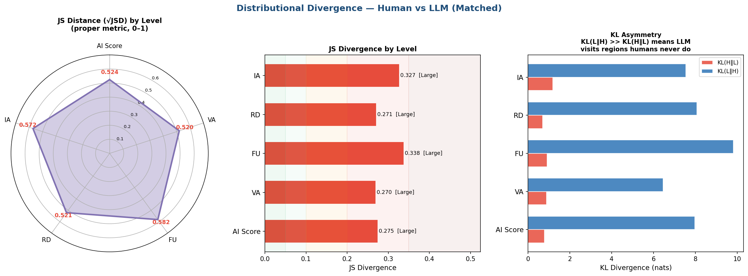
Figure A1. Distributional divergence between human and model score distributions at composite and domain level. Left: Jensen–Shannon distance, the square root of the divergence and a proper metric on the unit interval. Centre: Jensen–Shannon divergence with severity bands. Right: the two directed Kullback–Leibler divergences. The asymmetry is the informative panel: KL(model ‖ human) exceeds KL(human ‖ model) by roughly an order of magnitude at every level, which indicates that models place substantial probability mass in score regions where human ratings are essentially absent, rather than simply spreading more widely around a shared centre.
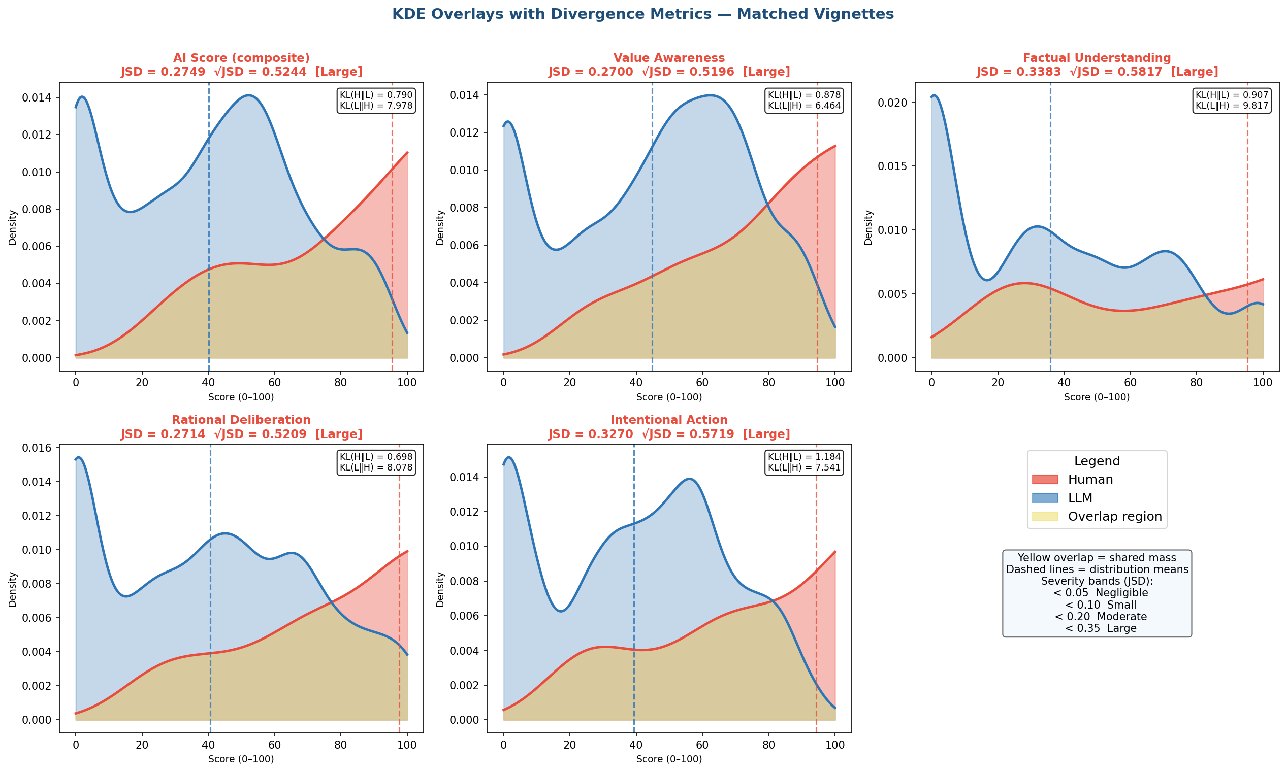
Figure A2. Kernel density overlays of human and model score distributions for the composite and each of the four domains, with the shared mass shaded. Dashed vertical lines mark distribution means. The model distributions are bimodal at every level, with one mode near zero and a second in the middle of the range, while the human distributions rise monotonically toward the upper end. The bimodality is the feature a mean difference conceals: models are not uniformly conservative but split between cases they score near the floor and cases they score moderately.
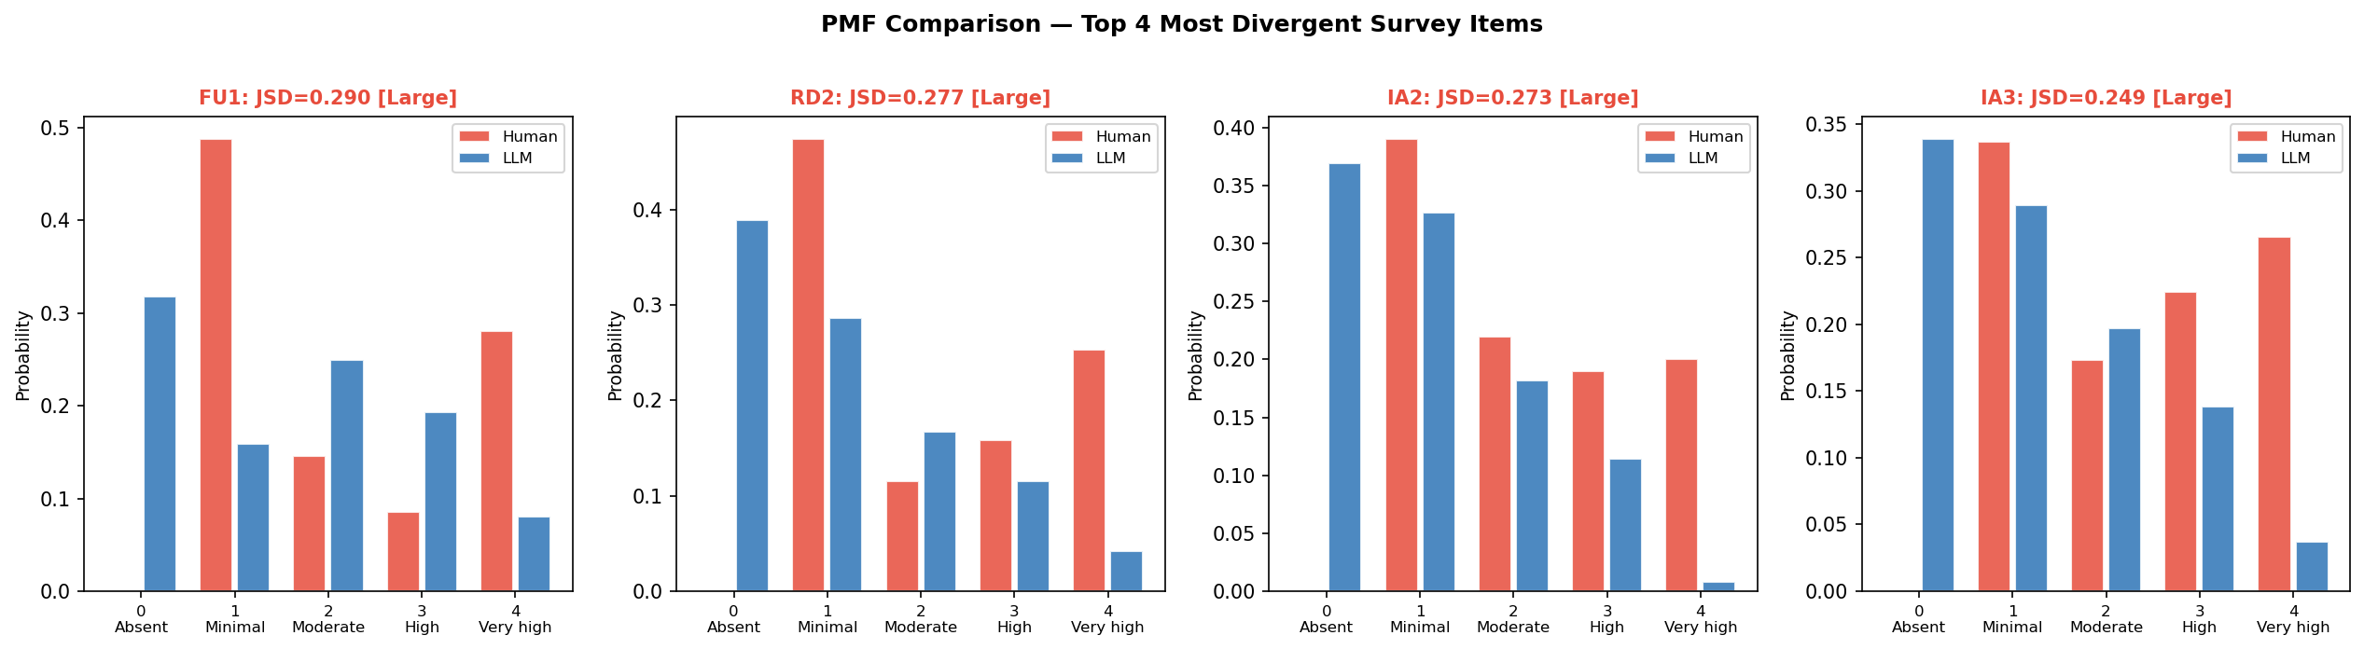
Figure A3. Response probability mass functions for the four most divergent instrument items. The pattern is consistent across all four: models place substantial mass on the absent category, which human reviewers use almost never, while human reviewers place substantial mass on the very high category, which models use rarely. The divergence is therefore concentrated at the two ends of the response scale rather than distributed evenly across it.

A.2 Per-vignette comparison
The following two figures report the human–model difference for each vignette individually, restricted to the vignettes with more than one human rating. They are included for completeness: the aggregate statistics in section 8 describe central tendency, and a reader assessing whether the difference is driven by a subset of cases needs the per-case view to check.
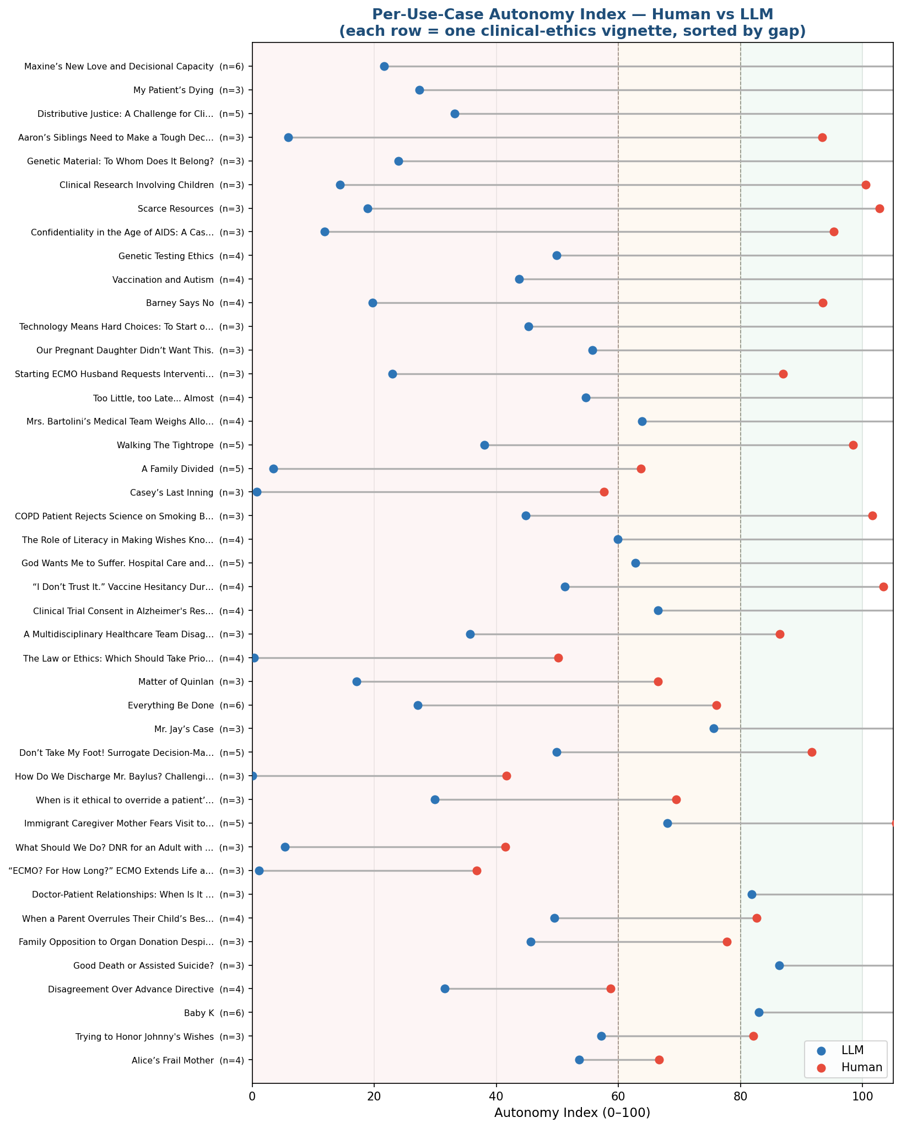
Figure A4. Human and model composite scores for each vignette, sorted by the size of the difference, with the number of human ratings in parentheses. Shaded bands mark the three interpretive ranges. The difference is present across the full corpus rather than concentrated in particular cases, which is consistent with the small rater-by-vignette interaction term reported in section 8.8.
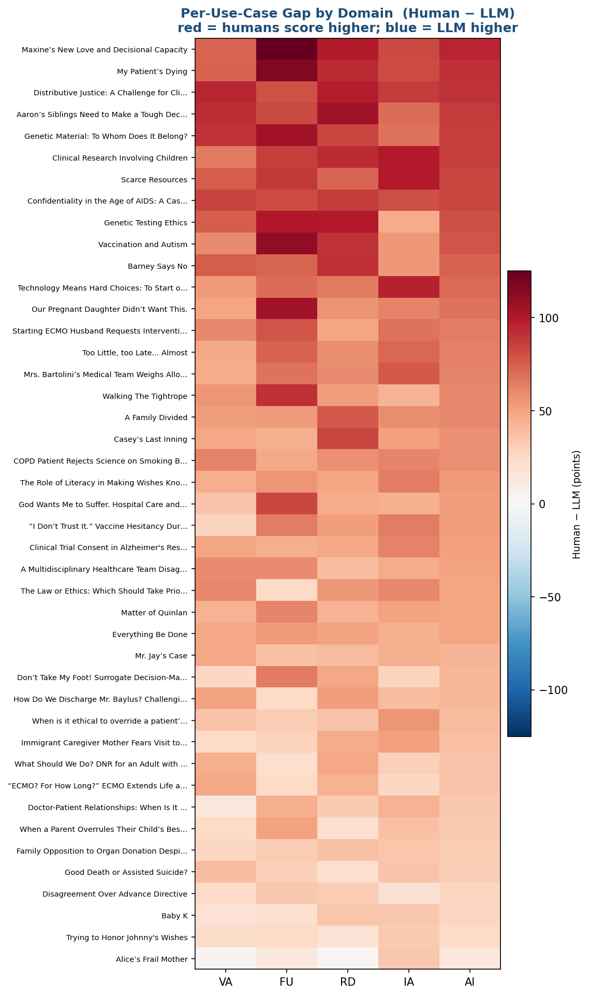
Figure A5. Human minus model difference by vignette and domain. Rows are ordered by mean difference. No cell is negative at the composite level, and the domain pattern within a vignette is generally uniform, indicating that where models diverge from human reviewers they do so across the construct rather than on one component.

