1996: Text-only MOO

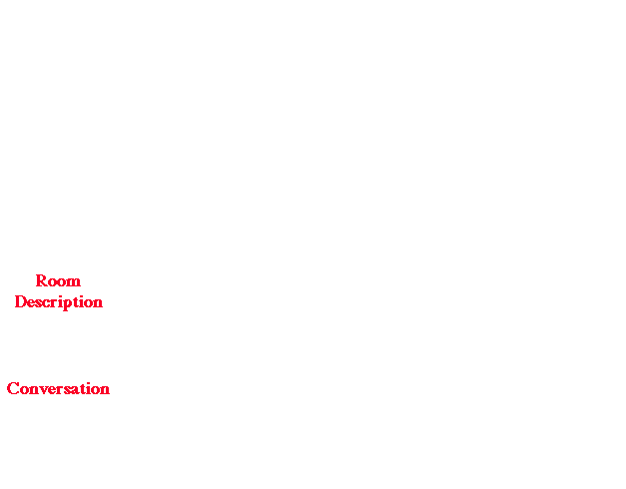

You walk out into the center of the campus. You see some construction going on
at the Student Activities Center and the Pepperdine Center, and here more
construction off to the west. A trail heads off to the south...
______________ __________________________
/__//_____\\___\ \_____\\__________//_____/ ______________
| Student | | Teacher Professional | /__//_____\\___\
| Activities | | Development Institute | | Pepperdine |
| Center | | | | Center |
| ._. ._. | ** | ---- ===__=== ---- | | ._____. |
| | | | | | **** | |__| | | | | |__| | | | | | |
|___| |___| || |_______| | | |________| |___| | |____|

WEST SAC TI PC
_____________________________\\_____________________________________
~~ ~ ~ ~ ~ ~ ~ ~ \\~ ~ ~~~ 3 R's River ~ ~ ~ ~ ~
~ ~ ~ ~ ~~~ ~ ~ ~~ ~~ ~~\\~~ ~ ~ ~ ~ ~ ~ ~ ~ ~~ ~ ~~ ~~~~~~
--------------------------------\\----------------------------------
\\
\\ SOUTH

Trail into the Woods

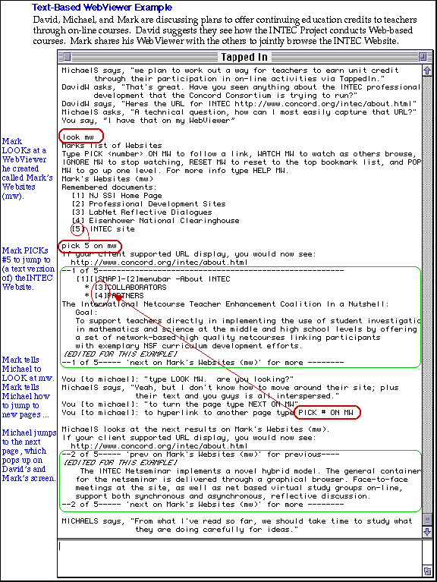
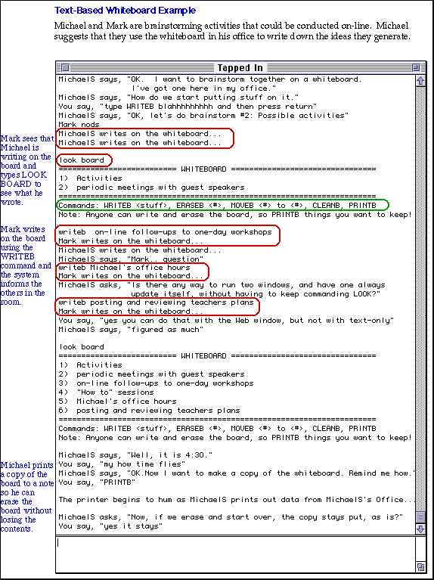

1997-1998: Adding a Web-interface to the MOO

TAPPED IN Floorplan

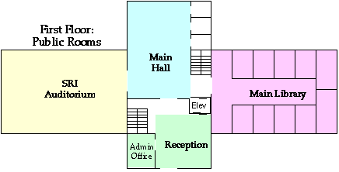

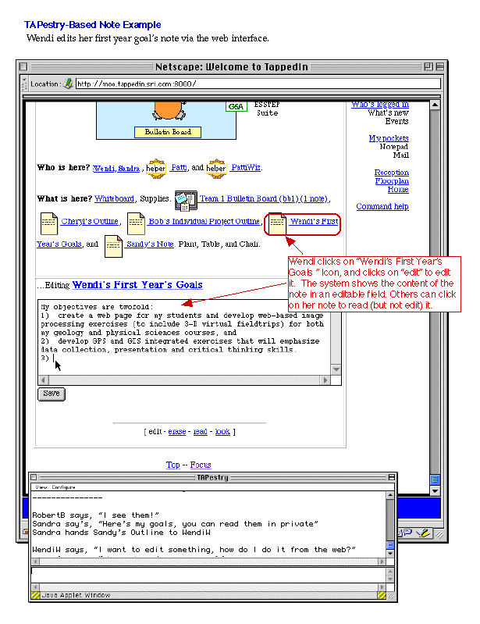
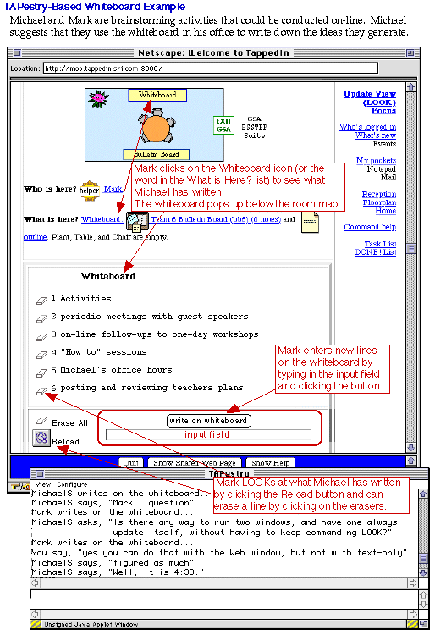


1998-2000: Redesigned to reduce windows, improve look, focus attention



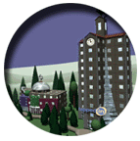

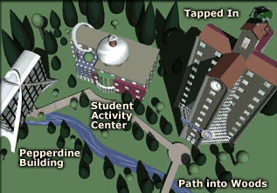





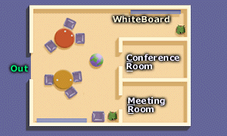
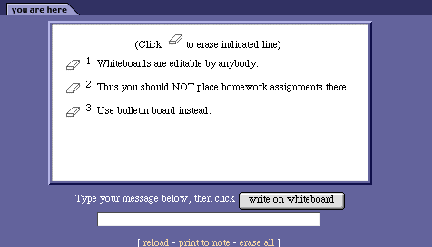

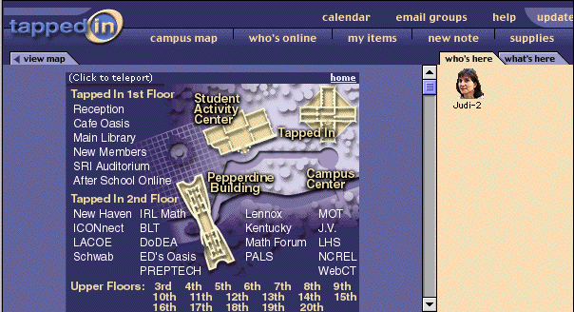
2001-present: Complete redesign of underlying technology and interface (moving off of MOO platform to Java-based web application) and addition of many new tools and services

