The online workplace of an international community of education professionals

What Do Educators Do in Tapped In?
Tapped In brings educators together both locally and worldwide to cultivate a community that supports each teacher as a professional. K-12 teachers, librarians, administrators, and professional development staff, as well as university faculty, students, and researchers gather here to learn, collaborate, share, and support one another. In Tapped In, educators:
- Plan and conduct learning projects with colleagues and K-12 students.
- Participate in or lead topical discussion and groups.
- Attend online courses offered by TPD providers.
- Mentor other educators or find a mentor.
- Try out new ideas in a safe, supportive environment.
- Find a career-long home.
To learn more about Tapped In, visit tappedin.org and log in as a guest or get free membership and join the community. Click on the Calendar to see our After School Online (ASO) activities for a great way to meet others in the community.

Tapped In is owned and operated by SRI International’s Center for Technology in Learning (ctl.sri.com). CTL's mission is improving learning and teaching through innovation and inquiry in computing and communications. Tapped In has been in operation since 1997 with funding from the National Science Foundation, SRI, and tenant organizations.



For more information, email:
tappedin-contact@tappedin.org

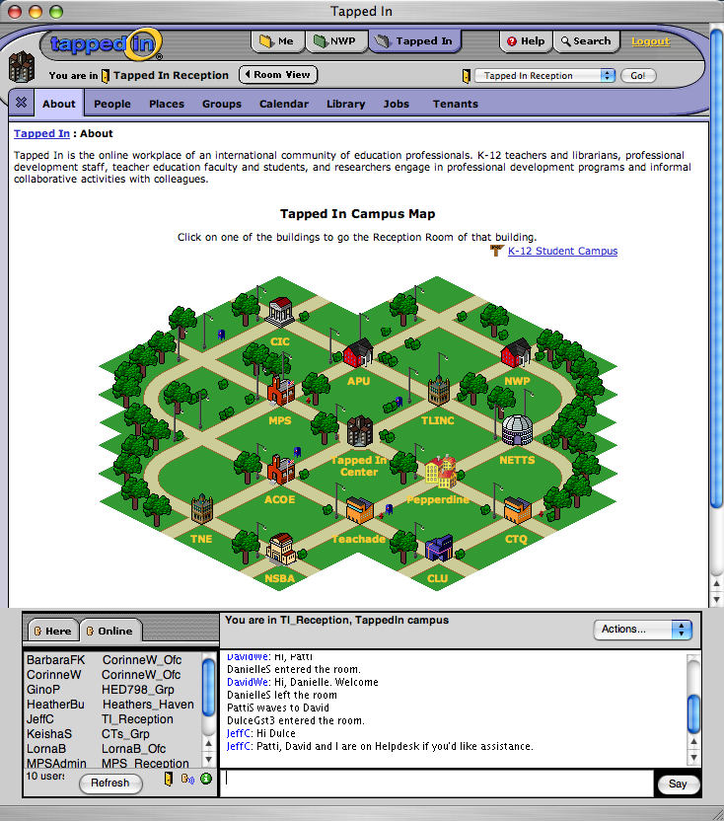 | 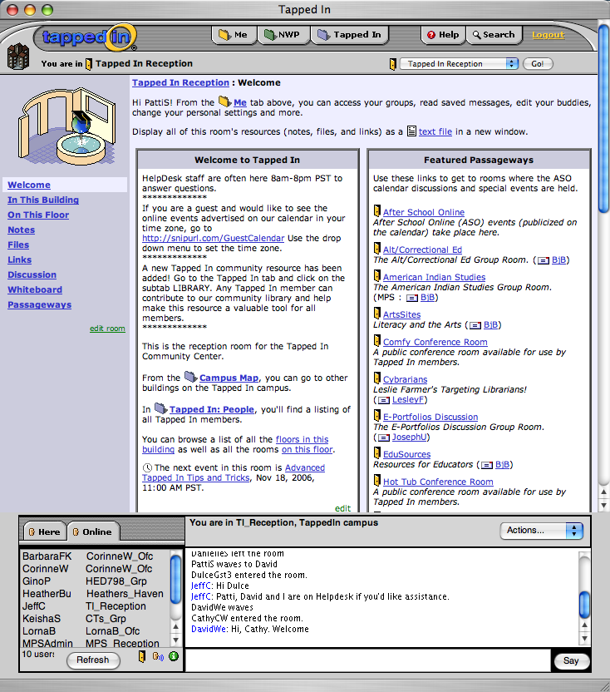
The Tapped In campus (left) and Reception room (right), illustrating the main features of the Tapped In user interface (e.g., notes, files, links, discussion boards, chat, private messaging, member directories, resource library, job bank, groups, events, search help.)
To learn more about the features of the Tapped In web interface, see the Interface Guide at http://tappedin.org/tappedin/web/help/ui.jsp

