學號：R05546022系級： 工工所碩二 姓名：謝立成

1. 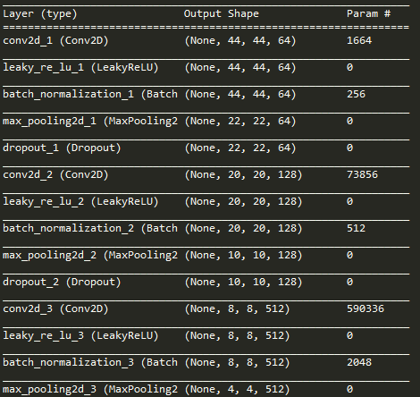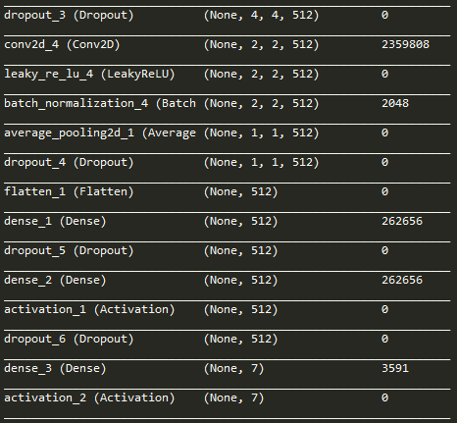(1%) 請說明你實作的 CNN model，其模型架構、訓練過程和準確率為何？

- Total params: 3,559,431

- Trainable params: 3,556,999

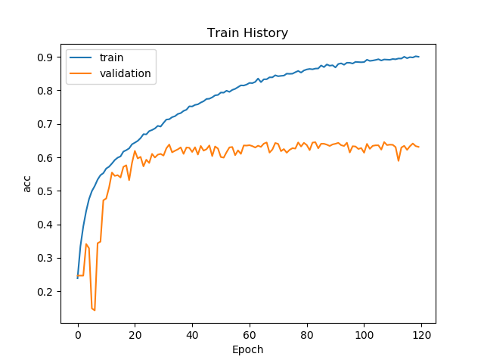- Non-trainable params: 2,432

Final Valid ACC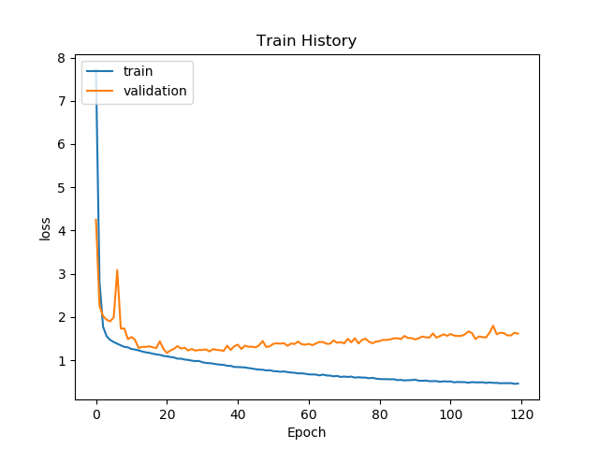 are around 65%

1. (1%) 承上題，請用與上述 CNN 接近的參數量，實做簡單的 DNN model。其模型架構、訓練過程和準確率為何？試與上題結果做比較，並說明你觀察到了什麼？  
   (Collaborators: )

Epoch 180/180

25838/25838 [==============================] - 0s 16us/step

- loss: 2.1008 - acc: 0.2516 - val_loss: 2.0967 - val_acc: 0.2483

DNN sucks, it the model will be in local optimal 0.2483 even more often than CNN for image processing.

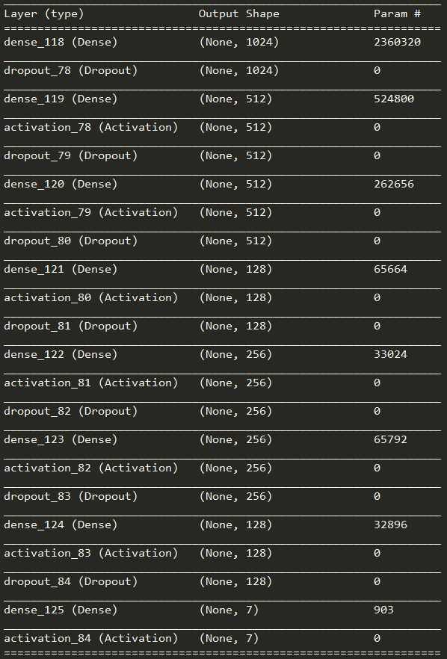

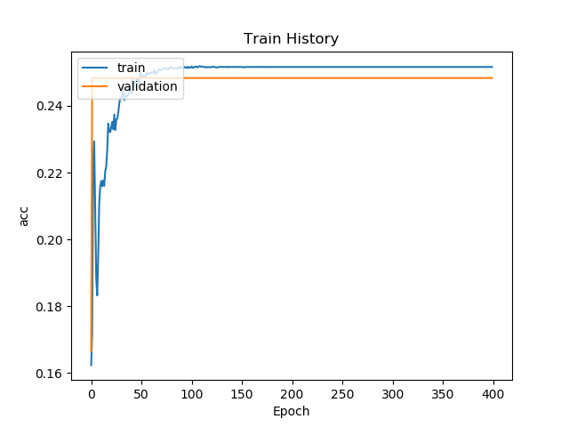

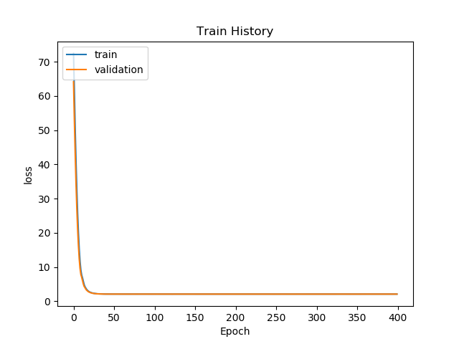

1. 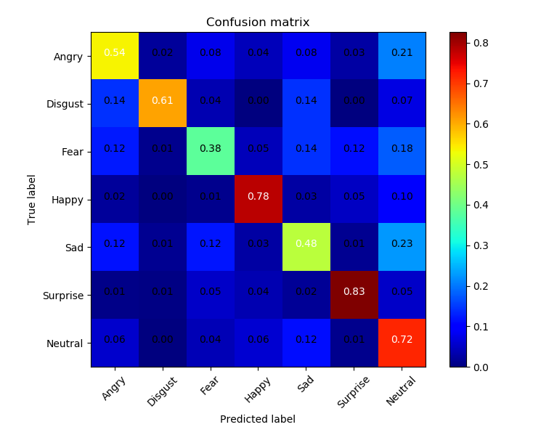 (1%) 觀察答錯的圖片中，哪些 class 彼此間容易用混？[繪出 confusion matrix 分析]  
   (Collaborators: )

It appears that class “Neutral” are a bit easy to be classified as incorrect ; but are good

Overall.

1. (1%) 從(1)(2)可以發現，使用 CNN 的確有些好處，試繪出其 saliency maps，觀察模型在做 classification 時，是 focus 在圖片的哪些部份？  
   (Collaborators: r05546003 r05546024 r05546026)

If mostly focus on the central facial area, or the nose area.

答：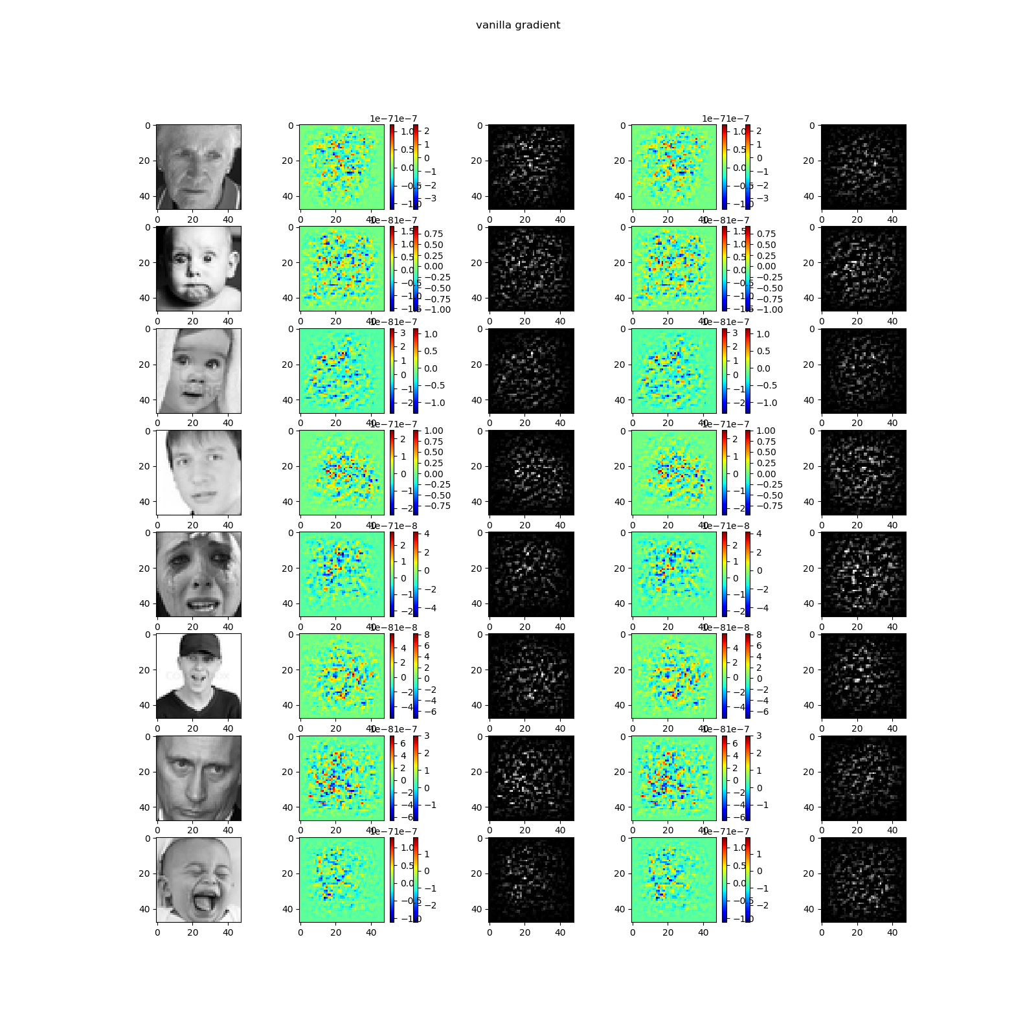

1. (1%) 承(1)(2)，利用上課所提到的 gradient ascent 方法，觀察特定層的filter最容易被哪種圖片 activate。  
   (Collaborators: r05546003 r05546024 r05546026 )

答：It appears filter 9, 21, 29 are activated.

