Easy-Launch
Intro
The Polaris Project is provided by Taprootagro Technology Limited and is open-sourced under the MIT License. It is positioned as an open-source technical tool and industry infrastructure, aiming to drive agricultural digitalization and bring advanced technology directly to the fields.

This document helps users quickly perform private customization of front-end content, including code downloading, visual content editing, uploading to GitHub, deploying PWA, and generating apps for rapid distribution. For back-end deployment, please read the documents in the developer directory in detail.

Enterprises can immediately assign corresponding domain links, create QR codes, and conduct marketing promotion. Content configuration or back-end deployment can be carried out subsequently.
Domain name assignment examples:
- farmer-china.taprootagro.com
- distributor-china.taprootagro.com

open add： | https://github.com/taprootagro
website： | https://topagro.com https://taprootagro.com

Note: The MIT License is an extremely permissive open-source software license. It allows anyone to use, modify, distribute, and sell the software for free without restriction, and derivative code can be closed-sourced for commercial use. The core obligation is simply to include the original author's copyright notice and the license agreement in copies of the software.
- Preparation
- Download and install the development tool Cursor.
Follow the instructions to download the version for Mac or Windows: https://cursor.com/
- Download and install the configuration file/environment Node.js.
Follow the instructions to download the version for Mac or Windows: https://nodejs.org
(3) Download the source code and extract it to the Desktop:
Example farmercode-public: Open the taprootagro homepage, click on farmercode-public, click the green "Code" button, select "Download ZIP", then download and extract it to the Desktop.
demo：
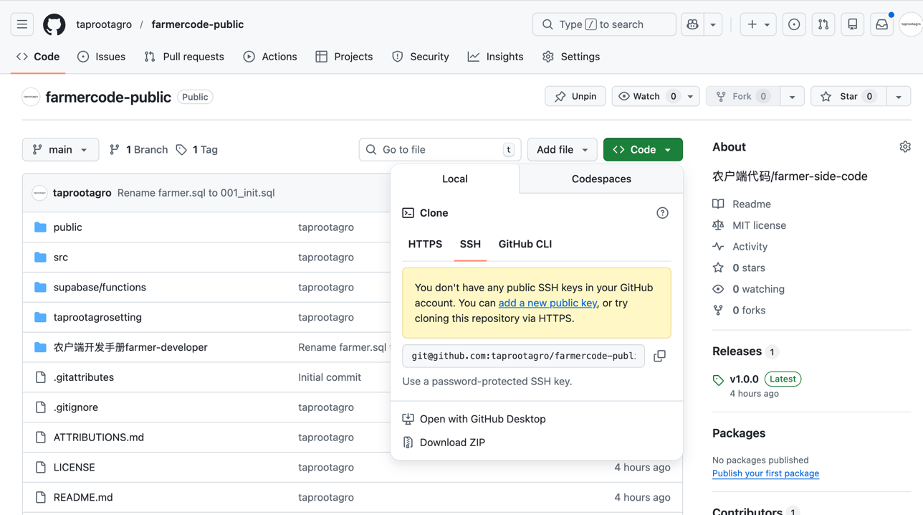

2. Launch Editor & Modify Content
- Open the Project
a) Open the Cursor，b) open project. c) Select the project folder.
- Configure Running Environment
- In the New Chat dialog, copy the following content, run it, and click run:“I want to open this project, execute npm install and npm run dev -- --host 127.0.0.1”
- The New Chat dialog will generate an editing address for you. Open it in a browser, for example: (http://127.0.0.1:5173/)
- Visual Content Modification
In the opened webpage, click "Profile → Settings → Content Configuration Management" to start modifying content. The password is "taprootagro". Click save after modifying, and the code will automatically save the changes.

Note：
- For subsequent modifications, repeat this process. Auto-save will only work under the npm run dev -- --host 127.0.0.1 mode.
- Please ensure your OSS/CDN has CORS enabled so that this PWA/APP can successfully fetch resources.
- Refresh the page three times consecutively, and the app will automatically clear all cache and re-fetch content. This can be used to force-view the latest change details.
demo：
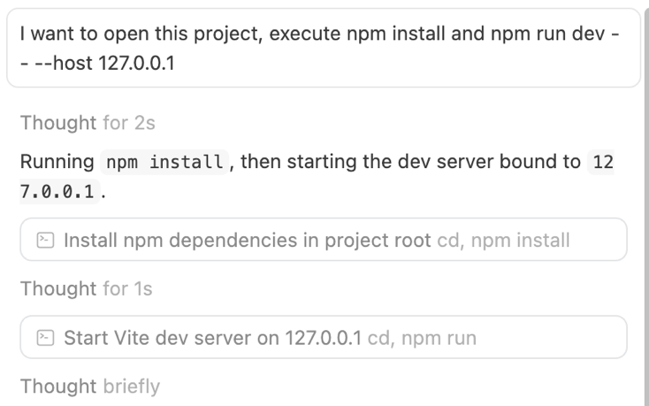
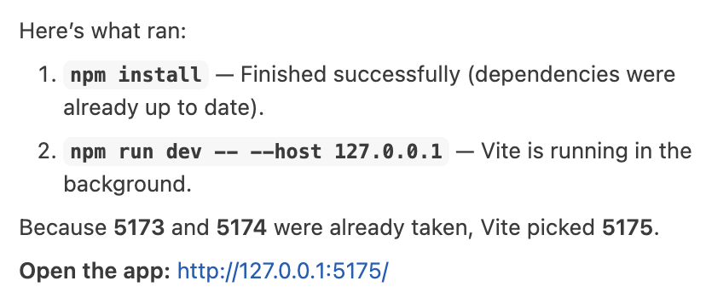
Open the HTTP address: Go to "Profile → Settings → Content Configuration Management" to start modifying content. The password is "taprootagro". Click save, and the code will be saved automatically;
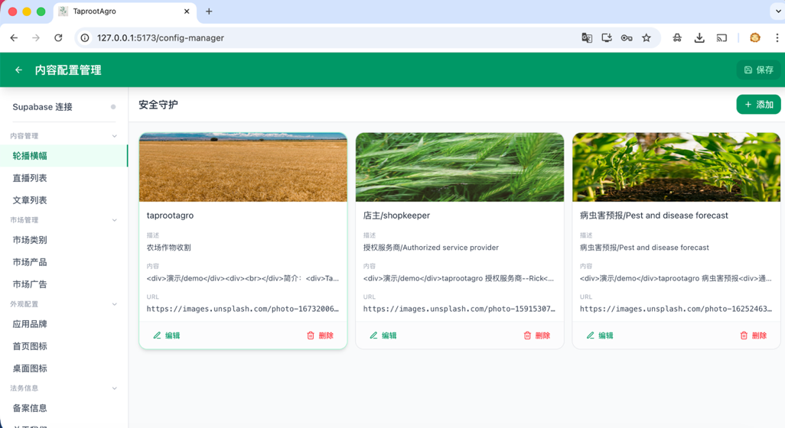
3. Uploading Code to Github
- Download GitHub Desktop:
https://desktop.github.com/download/
- Click on File, create a New Repository, fill in a name (e.g., taprootagrofarmer), and set the local folder path.
- Copy the code into this folder (the one with the same name as your repository).
- GitHub Desktop will automatically refresh the content. After filling out the Commit message, click Fetch Origin (Note: should be Push Origin for first upload) to push the code to GitHub.
Note：
- Cursor supports binding with GitHub for one-click pushing; please explore this on your own. This step-by-step process is provided here to prevent accidental errors by small to medium-scale users and to maintain a clear workflow separation.

Demo:Click File / New Repository / Fill in the relevant information; or click "Create a New Repository..." on this page / Set the local folder path.
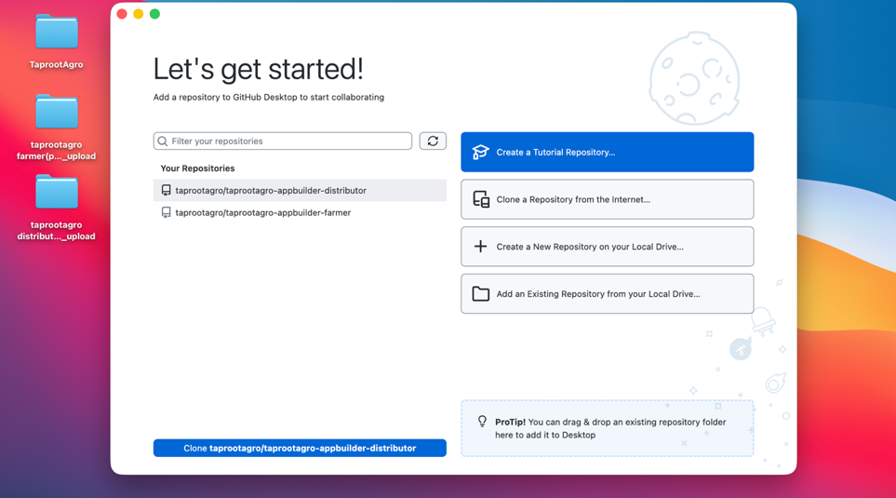
In the directory you set, a folder with the same name will be generated. Copy the modified code into its root directory.
!!!! Note: Enable the "Show Hidden Files/Folders" option. The directory should only contain the following files (the total size should be around 3 MB).
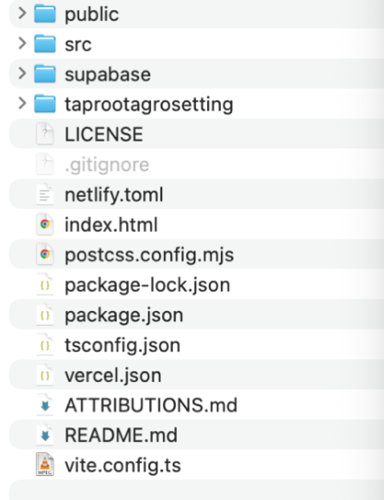
Return to GitHub Desktop. The application will automatically refresh the content. Fill in the "commit" message, then click "Fetch Origin" ("Push Origin" for first upload) in the top-right corner to push your code to GitHub.
4. Deploying PWA and App Applications
//
Large/multinational corporations rarely have "lightweight architecture and fast response" capabilities. Rapidly promoting your application before they can react is a golden window of opportunity to capture users.
//
4.1 Deploying PWA, Applicable to enterprises outside Mainland China; scan to add to the home screen. The /app experience is better, and the app can also be promoted simultaneously.
- Register with Tencent Cloud EO / Vercel / Netlify.
- Follow the web instructions, link your GitHub project, and click to automate deployment.
- Bind your domain name according to the instructions.
- Generate a QR code from your domain name to promote it to farmers
- If you need to update content, the easiest way is to repeat steps 2-3. Upload the code to the same-named folder, and Tencent Cloud EO / Vercel / Netlify will update automatically. In about 1 minute, users will receive the updated content.
Enterprise professional users can edit and update content via the Supabase backend with real-time push.

Note:
- Cloudflare offers this service. Let Cursor AI update your local dist files, then upload the dist files to cloudflare/worker and pages/new/pages. This is the simplest path.
- Thanks to the market strategies of internet service providers, there is almost no cost to deploy applications of this type. 100GB of bandwidth, costing between 0-10 USD, can support approximately 50,000 to 100,000 visits or downloads.

4. Deploying PWA and App Applications
4.2 Deploying the App, PWA support is limited in Mainland China; please promote the app for a better user experience.
- On the taprootagro GitHub homepage, open taprootagro-appbuilder-farmer or taprootagro-appbuilder-distributor.
- Click Fork in the top-right corner, select your personal account as the destination, and click Create fork.
- On your personal GitHub page, open the forked content. Click Actions -> Build Android App -> run workflow -> fill in the app information -> wait for about 6 minutes -> open Summary, and download the ZIP file at the very bottom of the information section.
- This ZIP file contains your exclusive .aab and app files,
keystore-info.txt，release.keystore
Please back up these two files. They are core company assets and your only proof of ownership for future app updates. If leaked or lost, you will lose the authority to update all previously promoted apps and will be forced to re-promote and install a completely different app.
（5）If you need to continue using this "Build Android App" online packaging tool in the future, to maintain the same signature for subsequent builds, please refer to the information in keystore-info.txt and set up secrets in Settings → Secrets and variables → Actions → New secret.
Demo:
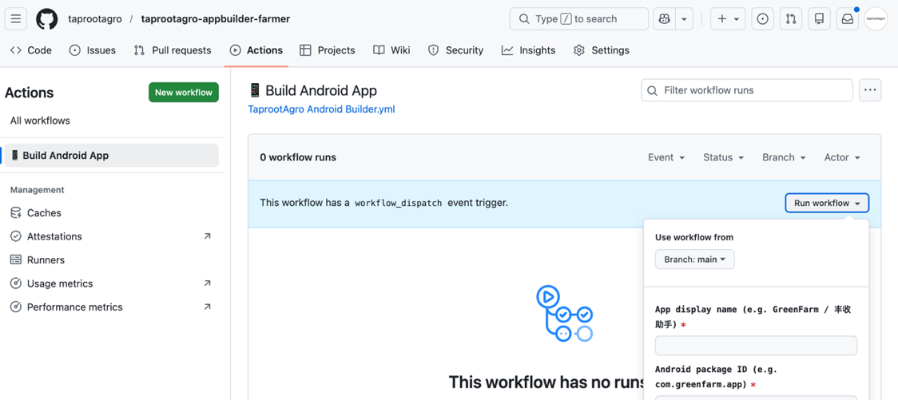
After the run is complete, click "build xxx app", click "Run Workflow", and download the file at the very bottom of the "Summary" section. The initial version should be around 8 MB in size, making it easy to share quickly.
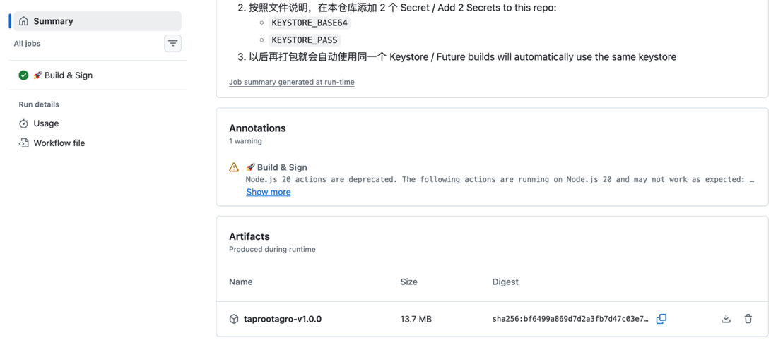
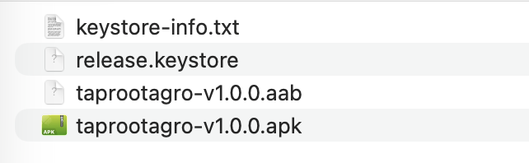
At this point, you have successfully prepared the front-end application for promotion.
This is Polaris Project v1.0.0, an initial release, and not all features have been implemented. You can continue to follow project updates, including bug fixes, functional maintenance, and private enterprise data analysis. This will help your company transform business data into precise credit models and core digital assets, building a brand moat.

If you encounter any bugs during use, please email support@taprootagro.com, and we will resolve them as soon as possible.
Notes:
a）The technical team only accepts bug reports for the Polaris Project to be included in the version optimization plan. If necessary, we will discuss bug reproduction conditions with you. The team do not provide general Q&A or handle other matters.
B）Based on current features, our company is gradually adapting marketing functions, online sales, and product traceability. We do not provide any enterprise customization services.

