Approach 3 – Shared Variable with Synchronization: Analysis
Nov 2, 2026 · @Rico

1. Overview and experimental setup
Approach 3 is correct but slow: with a mutex taken on every update, 5 threads need 0.309 s, 4.2× longer than the 0.074 s single-thread baseline, while the same work with thread-local counters needs 0.025 s.
This report covers the Approach 3 part of the lab (a shared counter protected by a mutex). It compares Approach 3 with a single-thread baseline and with local accumulation (equivalent to Approach 2), and it answers the required explanations (A to E) and the trade-off experiments 6.1 and 6.3 of the assignment.
- Machine: Ubuntu in Oracle VirtualBox with 5 virtual cores (the host laptop has 12 cores); gcc with -O2 -pthread.
- Workload: N = 20,000,000 random points, identical for every configuration. The base seed is fixed at 12345 and each thread derives its own independent seed from it.
- Timing: from the first pthread_create to the last pthread_join, measured with CLOCK_MONOTONIC. Nothing is printed and no I/O happens inside the timed region.
- Repetitions: 5 runs per configuration, mean reported. The 5-thread, k = 1 configuration has 10 runs because it appears in both the thread sweep and the k sweep.
- Thread counts: 1, 2, 4, 5, 10, 16, 32, 64 and 100, so there are values below, equal to and above the 5 virtual cores.
- Metrics: speedup = T_single / T_parallel with T_single = 0.0742 s (± 0.0029 s over 5 runs, single thread without mutex); efficiency = speedup / number of threads.

2. Implementation
Approach 3 keeps one global counter, global_count, guarded by one pthread_mutex_t; the synchronization interval k decides how often a thread enters the critical section.
k | Behaviour | Role in this report
1 | Lock, add the 0/1 result of the point, unlock, on every iteration | Approach 3 as specified (maximum contention)
10 to 100000 | Count in a local variable; lock and add it to the shared counter every k iterations | Experiment 6.1
0 | Count locally; one locked update when the thread finishes | Reference equal to Approach 2
The critical section of the worker thread:
if (k == 1) {
pthread_mutex_lock(&count_lock);
global_count += hit; /* hit is 0 or 1 */
pthread_mutex_unlock(&count_lock);
} else {
local += hit;
if (k > 1 && ++since == k) { /* flush every k iterations */
pthread_mutex_lock(&count_lock);
global_count += local;
pthread_mutex_unlock(&count_lock);
local = 0; since = 0;
}
}
Three design choices keep the measurement fair:
- Each thread processes N / T points (the remainder is spread over the first threads), so the total work is the same for every thread count.
- Each thread has its own xorshift64* generator, seeded with splitmix64 from the base seed and the thread index. rand() is avoided because its shared state would add a second, hidden source of contention.
- The single-thread baseline is the same loop without threads or mutex, so T_single contains no synchronization cost.

3. Results
With local counters (k = 0) the best result is 4 threads at 0.0179 s (4.14× speedup); with a mutex on every update (k = 1) no thread count beats the 0.0742 s single-thread baseline, and the best case is 1 thread at 0.1076 s.
Mean execution time of 5 runs, N = 20,000,000, 5 virtual cores. Speedup is relative to T_single = 0.0742 s; efficiency = speedup / threads.
Threads | Time, k = 1 (s) | Speedup, k = 1 | Time, k = 0 (s) | Speedup, k = 0 | Efficiency, k = 0
1 | 0.1076 | 0.69 | 0.0672 | 1.10 | 1.10
2 | 0.4443 | 0.17 | 0.0367 | 2.03 | 1.01
4 | 0.2462 | 0.30 | 0.0179 | 4.14 | 1.04
5 | 0.3085 | 0.24 | 0.0253 | 2.94 | 0.59
10 | 0.5014 | 0.15 | 0.0194 | 3.84 | 0.38
16 | 0.5129 | 0.15 | 0.0205 | 3.62 | 0.23
32 | 0.5240 | 0.14 | 0.0220 | 3.38 | 0.11
64 | 0.5287 | 0.14 | 0.0239 | 3.10 | 0.05
100 | 0.5286 | 0.14 | 0.0248 | 3.00 | 0.03
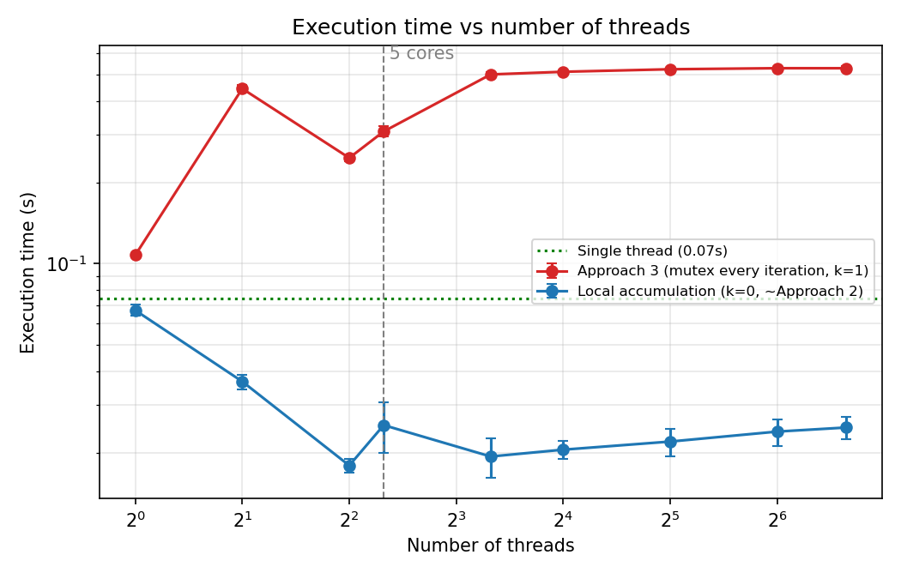
Figure 1. Execution time vs number of threads (log axes). Red: Approach 3, mutex on every iteration (k = 1). Blue: local accumulation (k = 0). The dotted line is the single-thread baseline; the dashed line marks the 5 virtual cores.
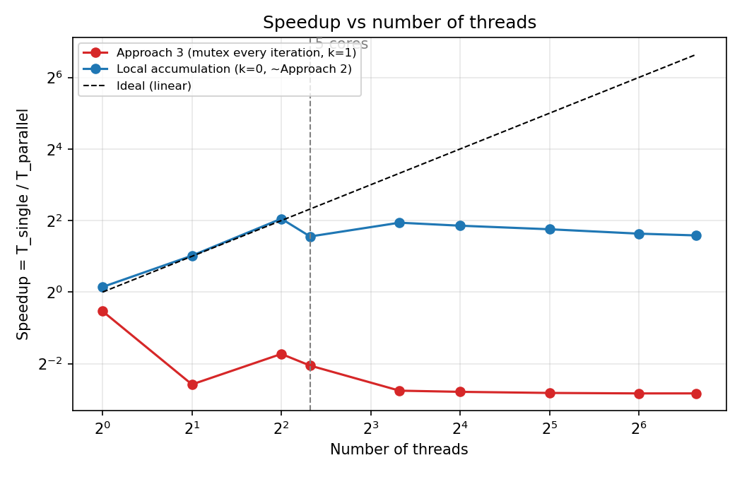
Figure 2. Speedup vs number of threads against the ideal linear speedup.
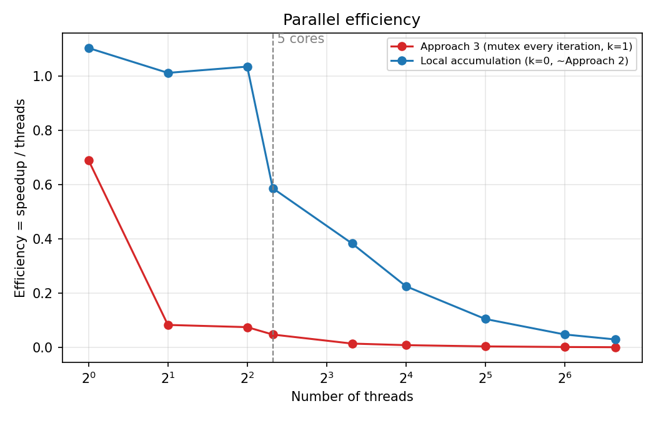
Figure 3. Parallel efficiency (speedup divided by number of threads).
Correctness. For a given number of threads, π is identical for every value of k (for example 3.141648 with 5 threads for k = 0, 1, 10, …, 100000), so the mutex never loses an update; it only costs time. Across thread counts π varies between 3.140740 and 3.141678, because each thread count splits the points and seeds differently. The standard error for N = 2×10⁷ is about 3.7×10⁻⁴, and all values lie within about two and a half standard errors of the true value.

4. Required explanations (A to E)
Speedup stops growing at about 4 threads, and Approach 3 is slower than one thread at every thread count, because the shared mutex serializes the work that the threads were meant to share.
A. Non-linear speedup and diminishing returns. With local counters (k = 0) the speedup follows the ideal line up to 4 threads (2.03 with 2 threads, 4.14 with 4), then drops to 2.94 with 5 threads, recovers to 3.84 with 10 and slowly falls to 3.00 with 100. Doubling the threads therefore stops doubling the speed as soon as the cores are used up. Three factors probably add to this: only about 4 of the 5 virtual cores are really free; thread creation and join are inside the timed region, and a total runtime of about 20 ms makes a few milliseconds of overhead a 10 to 20 % effect; and the measurements are noisy (5 threads: 0.0253 s ± 0.0054 s). The baseline is also noisy: the same loop took 0.0742 s as single and 0.0672 s as 1 thread with k = 0, which is why the speedup at 1 thread is 1.10 and why the efficiency is slightly above 1 at 2 and 4 threads. These values are measurement noise, not superlinear speedup.
B. Saturation point. The k = 0 curve reaches its minimum at 4 threads (0.0179 s) and then stays between 0.019 s and 0.025 s up to 100 threads. The VM has 5 virtual cores, but the guest system and the host also need CPU time, so the effective number of free cores is probably about 4; this is a hypothesis that a finer sweep (3, 4, 5, 6 threads with a larger N) would test. For k = 1 the saturation comes from the lock, not from the cores: the time rises from 0.31 s (5 threads) to 0.50 s (10 threads) and then stays flat at 0.53 s up to 100 threads.
C. Oversubscription. Above 5 threads there are more runnable threads than cores, so the scheduler time-slices them and every switch costs a context switch and a partly cold cache. For k = 0 this is cheap because the threads are CPU-bound and never wait: the time grows only from 0.0194 s (10 threads) to 0.0248 s (100 threads), +28 %. The cores stay busy and the extra threads add overhead, not throughput. For k = 1 it is worse (0.31 s with 5 threads against 0.50 s with 10), most likely because a thread that is descheduled while it holds the mutex makes all the others wait for it.
D. Synchronization cost: why Approach 3 is worse than Approach 2. Each point costs about 3.4 ns of computation (0.0672 s / 2×10⁷ with 1 thread, k = 0). A lock and unlock without contention already costs about 2.0 ns more per iteration (0.1076 s for 1 thread, k = 1). With contention, a update costs about 25 ns (0.50 s / 2×10⁷ at 10 or more threads), roughly 7 times the computation itself, which is why the speedup is about 0.14 (7 times slower than one thread). Three effects add up: the critical section lets only one thread update at a time (serialization); the cache line holding the mutex and the counter moves between cores at every update (coherence traffic); and a thread that fails to get the lock sleeps in the kernel and must be woken (system calls and context switches). When the serialized part is several times larger than the parallel part, Amdahl's law limits the speedup to about 1 regardless of the number of threads. One result is not explained by this argument: 2 threads (0.444 s) are slower than 4 threads (0.246 s) with k = 1. We observed it but did not test a cause; a possible cause is how the mutex hands the lock over between sleeping and running threads.
E. Parallel efficiency. Efficiency is the speedup divided by the number of threads. For k = 0 it is about 1 up to 4 threads, 0.59 with 5 threads, 0.38 with 10, 0.11 with 32 and 0.03 with 100. Since the speedup is flat at 3 to 4 while the thread count grows, the efficiency falls roughly as 1 divided by the number of threads. For k = 1 the efficiency is below 0.1 from 2 threads on and reaches 0.001 with 100 threads.

5. Trade-off experiments (6.1 and 6.3)
Updating the shared counter every 100 iterations instead of every iteration makes the 5-thread run 15 times faster (0.309 s to 0.020 s), and larger intervals give no further measurable gain.

6.1 Synchronization frequency
5 threads, N = 20,000,000, 5 runs per value of k (10 for k = 1).
k | Mean time (s) | Std. dev. (s) | Speedup
1 | 0.3085 | 0.0136 | 0.24
10 | 0.0817 | 0.0026 | 0.91
100 | 0.0204 | 0.0032 | 3.64
1000 | 0.0219 | 0.0066 | 3.39
10000 | 0.0252 | 0.0057 | 2.94
100000 | 0.0224 | 0.0064 | 3.32
0 (one update at the end) | 0.0253 | 0.0054 | 2.94
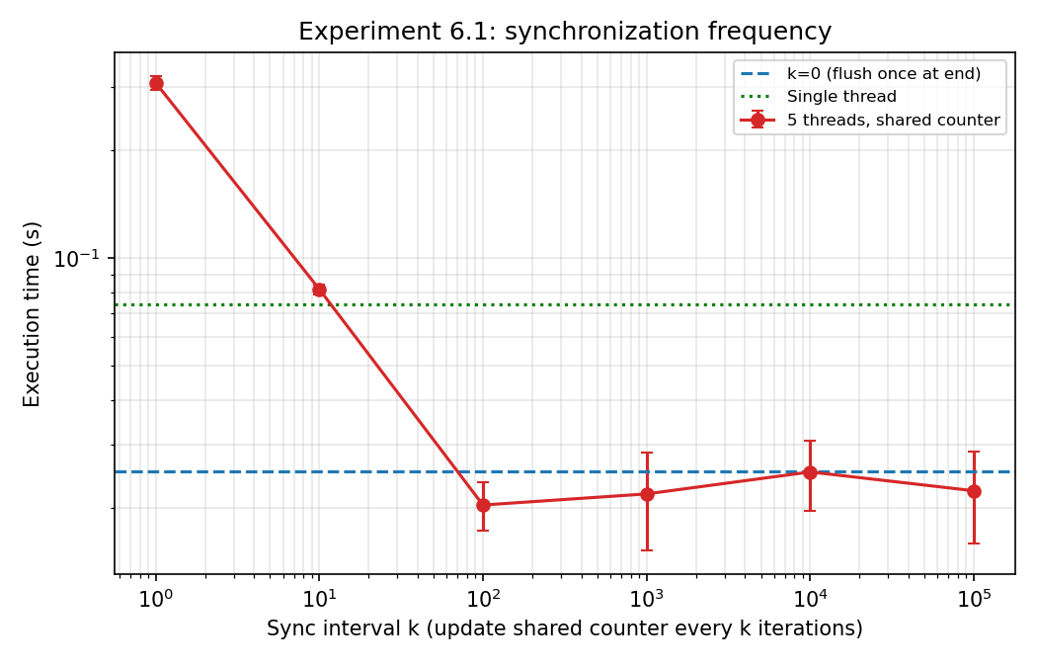
Figure 4. Execution time of 5 threads vs synchronization interval k (log axes). The dashed line is k = 0, the dotted line the single-thread baseline.
The time falls by 3.8× when k goes from 1 to 10 and by 15× when it goes from 1 to 100, so the cost of synchronization is paid per lock operation and shrinks in proportion to how rarely it happens. From k = 100 on, the differences between the values (0.020 s to 0.025 s) are smaller than the run-to-run spread of 3 to 7 ms, and the results are statistically indistinguishable from k = 0. We therefore do not rank them. Practically, flushing the local counter every 100 iterations or more already gives Approach 2 performance, and the result is the same π.

6.3 Local vs shared computation
 | Local accumulation (Approach 2, k = 0) | Shared accumulation (Approach 3, k = 1)
Critical section | None inside the loop; one locked update per thread at the end (T updates in total) | Inside the loop; 2×10⁷ locked updates in total
Contention | None while counting; the threads touch only their own variables | All threads compete for the same mutex and the same cache line
Serialization | Only the final sum of T partial counts | The whole counting phase: one update at a time
Time, 5 threads | 0.0253 s | 0.3085 s (12× slower)
Time, 100 threads | 0.0248 s | 0.5286 s (21× slower)
The two versions do the same arithmetic. The only difference is where the counter lives: a private variable lets every core work without waiting, while a shared one turns the loop into a queue at the mutex. The gap also widens with the number of threads, because more threads mean a longer queue but no more critical sections executed per second.

6. Best practices and limitations
Keep the hot loop free of locks: accumulate in a private variable and merge rarely, and the program matches Approach 2 without any lock tuning.
Best practices supported by these results
- Accumulate locally, merge once per thread (map–reduce). With 5 threads, k = 0 is 12× faster than k = 1.
- If a shared update cannot be avoided, batch it. Flushing every 100 iterations removed almost all of the cost (15× faster than k = 1).
- Match the number of threads to the free cores (about 4 to 5 here). Beyond that the speedup did not grow, the time rose by 28 % from 10 to 100 threads, and with a mutex extra threads only lengthen the queue.
- Give each thread its own random generator and seed, share nothing except the final merge, and fix the base seed so that runs can be reproduced.
- Measure carefully: time only the compute region, no I/O inside loops, the same N for all configurations, at least 5 runs, and document every parameter.
Limitations
- The measurements come from a virtual machine with 5 virtual cores shared with the host; a physical machine, or the 12-core host, may give a different curve and a different saturation point.
- Runs with k = 0 last only about 20 ms, so the spread is 10 to 20 %. A larger N (for example 10⁸) would make the curves smoother.
- The baseline is noisy: the same loop took 0.0742 s as single and 0.0672 s with 1 thread and k = 0, so speedup and efficiency values above 1 at small thread counts are not meaningful.
- The explanation that only about 4 cores are really free, and the explanation of the 2-thread against 4-thread result with k = 1, are hypotheses we did not test.
- Thread creation and join are included in the measured time by design (from the first pthread_create to the last pthread_join).
- With k = 1 the lock is taken on every iteration, including points outside the circle. Locking only on hits (about 78.5 % of iterations) would remove the rest of the lock operations; we did not measure that variant.

