On the following pages, you will be presented with a list of concepts in the computer science domain. One of the concepts is designated as the “root” concept and is drawn as a node at the top of the page. The remaining concepts are listed in alphabetical order.
Your task is to draw these concepts below the root concept as nodes, positioned so that relationships (edges) can be drawn between them – achieving a graph. Your graph need not be a tree, nor be connected, nor reflect a concept hierarchy in its layout.
This experiment is not concerned with the aesthetics of the graph, but rather with the relationships between concepts. It is not necessary to attempt to minimise edge crossings or lengths, but nodes should be placed so that relationships are clear. You should only model relationships in the computer science domain.
The relationships you have to choose from are parent-child, sibling, synonym, and antonym. Sibling is not meant as a relationship between nodes with a common parent if this can otherwise be shown. Rather, it is meant as an indicator that two concepts are directly related, but not in an obvious parent-child way, nor as synonyms or antonyms.
You can use the following edge types to represent these relationships (you need not label your edges, nor circle your nodes):

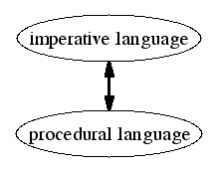
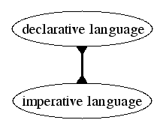
antonym
synonym

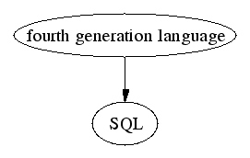
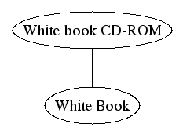
parent-child
sibling

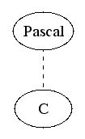

If you wish, you can also use
a broken line style to indicate weak
relationships, for example:
click
context-sensitive menu
double-click
Douglas Engelbart
drag
Graphical User
Interface

GUI
hamster
HID
Human Interface Device
icon
input device
keyboard
laptop
menu
mouse mat
mouse pad
notebook
optical mouse
point
pointer
pointing device
reference
right-click
tailless mouse
touchpad
trackball
trackpad
Trackpoint
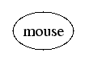
address bus
address resolution
Address Resolution
Protocol

ARP
cache
CPU
dot address
dot notation
e-mail address
Internet address
IP address
ISP
main memory
memory location
Memory Management
Unit

MMU
object identifier
OID
pointer
program counter
register
type
word
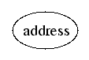
abstract class
class
concrete class
dynamic binding
dynamic programming
inheritance
instance variable
instantiation
Java
multiple inheritance
object
object-oriented programming
polymorphism
programming fluid
reuse
Smalltalk
subtype
type
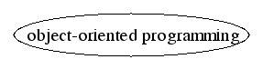
Accelerated Graphics Port
bus
cache
cathode ray tube
Compact Disc
CPU
CRT
data
disc
floppy
floppy disk
hamstar
high density
Human Interface Device
input
joystick
jump
keyboard
liquid crystal display
mice
monitor
motherboard
mouse
output
PCI
Peripheral Component
Interconnect
pointing device
process
RAM
Read-Only Memory
register
ROM
storage
touchpad
trackpad
