MECUREO Ontology and Modelling Tools

Trent Apted Judy Kay
Research Assistant Associate Professor
School of Information Technologies,
University of Sydney, Australia, 2006.
{tapted, judy}@it.usyd.edu.au

Abstract
This paper describes MECUREO, a system able to automatically construct an extensive ontology from a dictionary source, currently using a lightweight approach. During construction, the ontology is given particular attributes derived from the text with an aim to make it most suitable for the automatic generation of models for computer science entities from limited information. Such entities might include people, exam papers, subjects, courses, emails or a single concept. The model is derived from existing textual data that represents or describes the entity. The models generated in this way can then be compared with each other to generate an evaluation of their similarity on a canonical scale, e.g. the reals in [0,1], or shown graphically. We will present the architecture, algorithms and current, evaluated results for MECUREO. This will be followed by a discussion of related work.

Keywords information retrieval, ontologies, acquisition, sharing and reuse of conceptual structures, [[~6 more]]

Introduction
A software representation of an extensive computer science ontology may be used in a variety of roles in a teaching system. It enables a system to infer from a minimal knowledge base about a student to a quite extensive model of their knowledge. Teaching goals can then be inferred by studying this model and expanding concepts the student is modelled as knowing – working with those that are closely related. It is also possible for a learning goal to be established, with the ontology identifying aspects that need to be taught as a foundation for this goal; for example, if they are prerequisites.
The size and scope of such an ontology means that it becomes necessary to effectively query the information it represents. This also allows a model within the scope of the ontology to be constructed efficiently using minimal knowledge. Models can be compared, looking for similarities, and a result given that reflects their relative structure and position in the ontology. This result can then be used as additional information to learn from the models.
Rather than creating the ontology by hand, MECUREO (originally, Model Expansion and Comparison Using Reverse Engineered Ontologies) is able to automatically construct an ontology. It uses an existing, reliable resource to ensure appropriate coverage of computer science terms. This saves a considerable amount of effort and helps minimise errors while maximising breadth of coverage. The generated ontology may also serve as a basis for refinement by hand. For example, it is often easier to categorise an unknown relationship (that is, a relationship known to exist for which there is not enough information to categorise it) by examining the automatic construction than it is to identify a relationship independently.
Our approach to the ontology construction overcomes some of the limitations of existing ontology tools and representation formats such as OilEd [] and DAML []. Specifically, an incorporation of weighted relationships between concepts allows more information to be extracted from the ontology towards learning goals. In addition, the representation format is customised to improve the handling of such a large ontology efficiently and effectively, particularly when using a web-based interface.
While ontologies are most often used to facilitate the exchange of data [], the rich semantic information contained in an ontology can be used for a variety of other roles in the learning domain. We will discuss the ability to automatically construct a model from limited, arbitrary textual input and then use this model with others to learn from the input in the context of a specific problem.
Given a personal biography, a list of publications, or a person's self-description of interests, we would like to identify people who have similar interests. There are several ways that this information might be used. For example, the documents that are interesting to one person are more likely to be interesting for a person with similar interests. If we have access to the rated documents from one person, we can then use this information to make recommendations to other, similar people.
For instance, a computer science researcher describes their interests as knowledge representation, genetic programming and data mining. Another researcher describes their interests as neural networks, data marts and STRATEGY. We would like to be able to recognise that these two people are actually interested in quite similar things. Since they have chosen to express their interests with different terms, we can only recognise the similarity between the two self-descriptions if we can recognise the similarity of the terms used by each user. The term-level similarities can then be reconstructed to form a measure of similarity between the models of the two users themselves.
One way to tackle this problem is to make use of knowledge about the relationships between terms to grow the set of terms supplied by each user. With this knowledge we can describe the users' interests as the set of terms they explicitly supply, plus the set of terms that we infer are similar. There are two elements in MECUREO's approach to matching people's interests: growing the set of user-supplied terms and the matching process for the enlarged sets of interests.
In Section 2, we give a description of the way that we have constructed a computer science ontology. Then Section 3 outlines the querying process we use to grow ontology graphs from an initial small set of concepts, as well as the process used to match and compare graphs. In Sections 4 and 5 we will describe our evaluation process and the results, respectively, and in Section 6 we give an outline of a supplementary model visualisation used during evaluations. We conclude by outlining related work in Section 7 and giving conclusions in Section 8.

Ontology Construction
ontology
1. <philosophy> A systematic account of Existence.
2. <artificial intelligence> (From philosophy) An explicit formal specification of how to represent the objects, concepts and other entities that are assumed to exist in some area of interest and the relationships that hold among them.
For {AI} systems, what "exists" is that which can be represented. When the {knowledge} about a {domain} is represented in a {declarative language}, the set of objects that can be represented is called the {universe of discourse}. We can describe the ontology of a program by defining a set of representational terms. Definitions associate the names of entities in the {universe of discourse} (e.g. classes, relations, functions or other objects) with human-readable text describing what the names mean, and formal {axioms} that constrain the interpretation and well-formed use of these terms. Formally, an ontology is the statement of a {logical theory}.
A set of {agents} that share the same ontology will be able to communicate about a domain of discourse without necessarily operating on a globally shared theory. We say that an agent commits to an ontology if its observable actions are consistent with the definitions in the ontology. The idea of ontological commitment is based on the {Knowledge-Level} perspective.
3. <information science> The hierarchical structuring of knowledge about things by subcategorising them according to their essential (or at least relevant and/or cognitive) qualities. See {subject index}. This is an extension of the previous senses of "ontology" (above) which has become common in discussions about the difficulty of maintaining {subject indices}.
(1997-04-09)

Dictionary Source
In order to construct the ontology, the resource chosen was the Free On-Line Dictionary of Computing (FOLDOC) []. This is a free Internet resource that currently contains definitions for 13,590 computer science terms in over 4.8 megabytes of text; it is quite extensive. The off-line version encloses significant words (eg words defined elsewhere) in braces and uses standard conventions in the layout and grammar of each definition. An example is given in Figure 1 for the word ontology. This makes it feasible to perform automatic analysis of the definitions without the need for more sophisticated NLP.
Figure 1 – An extract from FOLDOC showing the entry for ontology. Key portions discussed are highlighted with bold
FOLDOC was chosen because of its breadth and up-to-date coverage within the computer science domain, as well as its machine readability and licensing arrangement. In the entry in the dictionary under Free On-Line Dictionary of Computing, the dictionary describes itself as "a searchable dictionary of acronyms, jargon, programming languages, tools, architecture, operating systems, networking, theory, conventions, standards, mathematics, telecoms, electronics, institutions, companies, projects, products, history, in fact anything to do with computing". Its focus is providing a one-stop source of information about all computing terms. It includes many cross- and bibliographical references and is kept up-to-date with emerging technologies and institutions.
The ontology itself is generated by processing an off-line image of the FOLDOC computer science dictionary. Individual definitions are parsed, looking for a categorisation for each word and to identify words that are related to it. Grammatical conventions in the dictionary are also used to provide additional information to the relationships wherever possible. That is, how the words are related.
analogous: very sibling
any of: strong child
archetypal: very child
as in: normal parent
compare: very dissim
compatible: strong sibling
developed: strong parent
e.g.: very parent
eg: very parent
extension: strong child
manufacturer: strong parent
opposed: very dissim
opposite: strong dissim
replaced: very sibling
see: very sibling
variant: strong child
version: strong child

Concept Relationships
The consistent grammatical conventions mean that synonym, antonym, child and parent relationships can be extracted if certain keywords are present; otherwise an unknown relationship is created. For example, acronyms usually become modelled as synonyms of their expansions, relationships identified such as between call-by-value and call-by-name are able to modelled as antonyms and patterns such as developed at X or a type of X represent child relationships. A list of cross-references after an 'e.g.' in the dictionary usually represent instances of the concept being defined and so that concept is modelled as the parent of the cross-references.
The keyword-relationship mapping is read from a text (configuration) file in the form:
<Keywords> ::= { <item> \n }
<item> ::= <keyword>: invalid | <defn>
<defn> ::= <strength> <type>
<strength> ::= weak | normal | strong | very
<type> ::= child | parent | dissim | sibling
An example is shown in Figure 2. This strategy makes the mapping easily customisable, so it possible to process a similarly formatted dictionary in a different, or more specific domain (eg a description of courses and subjects offered at a university). The other dictionary may then be used to perform similar queries, or it may be merged with the generated ontology for amalgamation or comparison.
Figure 2 – a portion of the (much larger) keywords file used to process FOLDOC
The final output of the parsing process is backed by a weighted digraph. Further properties are recorded with the nodes and edges to facilitate querying. The procedure to obtain this output, given FOLDOC and the keyword-relationship mapping as input, will be discussed in the context of the entry for ontology in Figure 1. A visual representation of the output corresponding to this context is shown in Figure 3. This context was chosen to try and demonstrate a typical entry – random in the sense that the decision to use it is not based on how MECUREO performs with it – and one not used to calibrate the system. In the discussion that follows concept is used to describe an entity at the ontology (conceptual) level, word at the dictionary level and node at the representation level; similarly for relationship, link and edge with respect to entity associations.

Determining the Nodes
Consider the entry in the dictionary for ontology shown in Figure 1; parsing this entry initially results in the node ontology being generated. It becomes linked with the category nodes for philosophy, artificial intelligence and information science, such that a query on any of these categories will result in the ontology node being returned. All phrases in braces ({AI}, {knowledge}, {domain}, etc.) also become nodes and an edge is formed between each and ontology.
It should also be noted that, despite an inherent direction (with the node whose definition's body the link was extracted from designated the head), the edges are traversed in either direction for the purpose of querying. This means that the node for any dictionary entry that referred to ontology will be considered in a query that visits the ontology node.
In addition, it is sometimes the case that a link in an entry is not itself defined. Initially there was only the option of whether to create a separate node or ignore it. With the introduction of a more sophisticated (yet not computationally expensive) matching process for model expansion, undefined references now undergo the same matching process. The sensitivity (i.e. whether a match thought too unlikely by the system is rejected or not) is adjustable. For example, in a previous implementation, Knowledge-Level was unmatched and hence stood alone, whereas now it is matched to a definition. However, our choice of the Porters stemming algorithm [] does not generate the same stem for index and indices, hence the node subject indices remains unmatched without intervention (see Figure 3). Details of the matching process can be found in Section 3.2.2 Concept Matching.

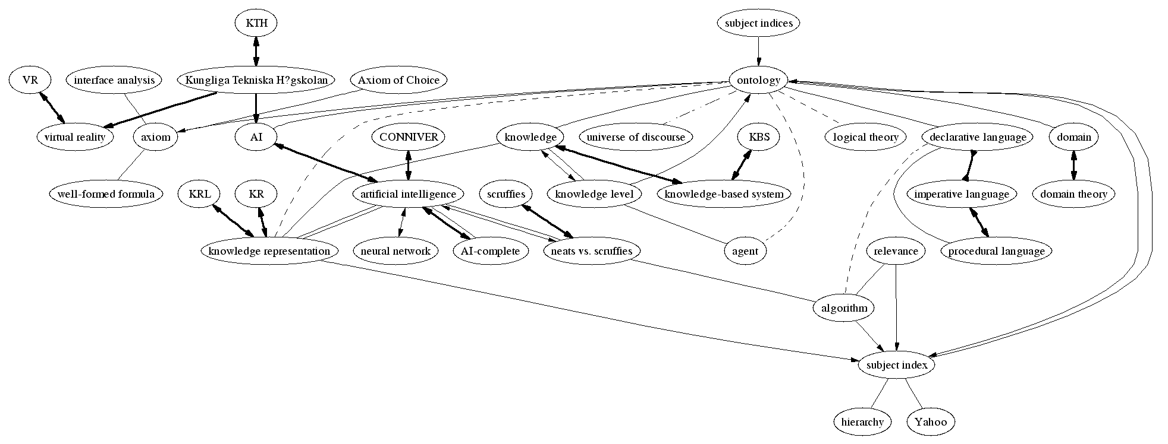
Determining the Relationship
Figure 3 - Point query from ontology with a depth limit of 0.85
Bidirectional edges indicate synonym (or strong sibling) relationships, reversed arrowheads indicate antonym (or other opposing) relationships, directed edges indicate strict parent/child relationships and undirected edges indicate undetermined relationships (or weak siblings). Bold, normal, dashed and dotted line styles indicate progressively weaker relationships for all types. These are discussed further in Section 3.1
For successful querying of such a large ontology, it was found that, in general, it was unproductive to treat all relationships between concepts in the same way. It was decided that each relationship should be given a weight that reflects the amount of work required to 'travel' from one concept to the next. The first step towards this is determining that a relationship exists and its type, after which a weight can be inferred.
The type for each edge is determined from keywords around the phrase and the currently loaded relationship mapping. When a link can be designated a type in this way, it becomes a property of the edge so that it can also be used in subsequent processing and output (e.g. graphically). The keyword also determines an associated direction of the edge, based on the type.
It is often possible to identify a link as being an antonym, or strictly a child or parent, and this information is preserved in the graph. For our experiments, these mappings were determined by manually analysing the grammar used in a selection of definitions in the dictionary. Any patterns recognised were recorded so they could then be used to classify the links in all the definitions of the dictionary (see Section 4.1).
For example, keywords identified in the extract in Figure 1 include formal, see, e.g. and about. See gives a type to the edge with subject index and about with (all three of) domain, declarative language and universe of discourse. Here axiom(s) is an unfortunate anomalous classification; e.g. and formal both appear near axioms and because e.g. was configured to have a stronger base weight it is used for this edge rather than formal, giving a 'child' edge rather than the 'parent' type associated with formal. This is all partly reflected in Figure 3: subject index has a bidirectional (sibling) edge and axioms has a directed 'child' edge. About was not configured with a strong enough base weight to have a distinctive edge in this output configuration.
Examples from other parts of the dictionary include: laziness modelled as a 'synonym' for lazy evaluation, declarative language modelled as an 'antonym' for imperative language, TABLOG modelled as a 'child' of both relational programming and functional programming; curried function has Haskell modelled as a 'parent' and other relations have 'sibling' or 'unknown' relationship types. Synonym and antonym relationships are bi-directional. Parent and child relationships are directed from the parent to the child (whether it is called a parent or child depends on the context of the location where the relationship was discovered). Sibling and unknown relationships are undirected.

Determining the Weight
We have defined a base weight for each link type. This is a constant between 0 and 1. The actual weights are specified in a configuration set. We have chosen values that are both intuitive and which appear to produce sensible results on our training and evaluation sets. This approach seemed to provide better results than the more common practice of a common weight for all link types in such ontological structures. The need for our differentiated link weight values may be due to the fact that our ontology was constructed automatically from an online dictionary, rather than being handcrafted.
This type-link is then adjusted according to the position of the phrase in the definition: later terms have a higher weight, indicating that the term is less closely related to the term being defined. The formula for the weight adjustment factor, p_{i}, is calculated as:
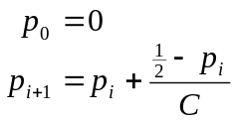
Here C is an adjustable positive constant, greater than one, with 10 currently being used as a default until other parameters have been fine-tuned. Small C values penalise later links in highly branching nodes while a large C distributes weights for successive links more gradually. Rearranging with the default of 10 yields p_{i+1} = 0.05 + 0.9p_{i}. Otherwise, the general closed form is:
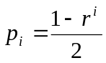 with 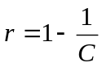
Essentially it gives a gradually increasing penalty smoothly tapered at 0.5.
Ideally, in choosing a value for C, we would want the average weight of all relationships (taken individually across all concepts) to equal the average of all concepts' average peer weight. This would reflect a consistent distribution of link weights for both highly branching nodes and nodes with few peers. Knowing that this is the case helps choose a distance when formulating queries so that growth of models with varying distance is roughly consistent (see Section 3). Experiments showed that the discrepancy between these values was only significant for very small values of C (less than four). However, if C is large there is less spread in the weights chosen, making it more difficult to distinguish nodes that should be filtered when choosing the distance in a query.
This formula is a compromise designed to give 'fair' weights to all links, be they in definitions with many links or not. Informal evaluations indicated that this strategy was more effective. Earlier experiments with more discrete weights gave poorer results for highly branching nodes.
There is also the option of using the position of the link in the entire definition (e.g. penalise by the proportion of text in the definition that has so far been processed). However, this would unfairly weight longer definitions. That is, the first links found in a long and detailed definition would be penalised significantly less than those of a brief definition. An alternative would be to normalise the penalties (e.g. by giving each definition an inverse weight 'quota'), but this would unfairly weight shorter definitions. In any case, the concepts in the dictionary were not all given the same attention when they were defined – even if the concepts are, in a sense, equally 'significant' in the domain. Hence the compromise is used.
The formula spreads the distribution of weights so that links mentioned early in a definition are treated as more closely related to the word being defined. This may seem a rather bold generalisation. However, it is reflected in the nature of many definitions in the dictionary. For example, from the ontology extract in Figure 1, AI, knowledge and domain occur before universe of discourse, axioms, agents and Knowledge-Level and so the edges to the former are given less weight. In these cases it is intuitively the right thing to do and while there are many exceptions (eg logical theory in Figure 1), the generalisation was found to work well in our initial precision evaluations.
The final weight assigned to an edge is the sum of the base weight and the adjustment. It is possible for the weights of links whose type is explicitly weak to exceed 1.0, so this value is capped at 1.0. This allows a query to deliberately visit (at least) every node at a particular depth (as opposed to distance) without additional computation being required. Thus every weight is in the interval (0, 1].
There was initial concern that this might be counter-productive. Having a large number of edges with a weight of 1.0 ignores the arguments for having a smooth penalty function (above), but it was found not to be the case in practice. Explicitly weak relationships are a minority as it is rare for a keyword (when one is actually found) to indicate a conceptually weaker relationship. The words in the context of truly weak relationships are usually too obscure to improve the overall performance, as we discuss below. However, the penalty adjustment was often found to weight these relationships appropriately.
On top of this, there are some special cases. In the extract for ontology in Figure 1, AI, for example, was not adjusted because it is the first relationship identified (p_{i} = 0). So this edge retains the default base weight, but if we then look to the definition of AI in Figure 4 then another pattern is identified – a synonym. So an edge with negligible weight is formed between AI and artificial intelligence to reflect this property. In this way anything that is close to AI is also close to artificial intelligence and vice versa.
Links occurring in the body of a definition whose type is determined to be very strong are similarly modelled (i.e. their base weight is near-zero). However, these are adjusted depending on their position in the same fashion as normal links.
The final result of this example is shown in Figure 3, as a point query, and is further discussed in Section 3.1.
AI
{artificial intelligence}

Figure 4 - The definition for AI

Ontology Queries
The ontology generated is very large – in excess of 21,000 nodes (after matching). Tools have been written to query the ontology from a specific concept, or a set of concepts (for example in a user model). This results in a subgraph of the original ontology graph being generated. As a useful side-effect, nodes (as well as edges) are assigned a weight that reflects how closely each node matches the original query. [[The merge queries (for combining and comparing models) are still in evaluation and (re)development stages and will be discussed in a later paper.]]

Point Queries
A query can be executed from a single node (which may be word, phrase or category) in the original graph, or in any graph generated as the result of a previous query. This query results in a concept map style representation of all things related to the query node within a certain distance. This is useful for browsing the ontology and for general information retrieval, and was the primary method used to evaluate the ontology construction.
The distance is specified as part of the query and its reach is determined by the edge weights corresponding to the relationships between nodes. All nodes whose shortest path to the query node is less than or equal to the specified distance are included in the output graph. This is determined in increasing order of path cost, so it is also possible to specify a node limit to restrict the size of the graph. The shortest path cost becomes a property of each node, which can then be used towards a visualisation heuristic.
Once the nodes are determined, any edges that exist between them (not only those along the shortest paths) are duplicated. This preserves the structure of the ontology to facilitate further querying on the output graph, to perform structure analysis (e.g. for comparisons), and in order to represent all the information available when the graph is displayed.
An example of a point query is shown in Figure 3 from the node ontology. This also shows the result of parsing the dictionary extract given in Section 2. Bold, bidirectional edges indicate relationships identified as being synonyms (or other immediate cross references in the dictionary). For example the relationships between KR and knowledge representation, and between neural network and artificial neural network, are identified as synonyms. Bold edges with reversed arrows (e.g. between declarative language and imperative language) represent antonym relationships. Other bold edges indicate very strong relationships, as determined by the keyword-relationship mapping.
Directed edges attempt to identify strict parent-child relationships. However, they are also used for strong links where an explicit type could not be determined (the definition that contained the original link becomes the child). Edges with no arrows represent relationships for which a type could not be determined, with dashed and then dotted line styles representing progressively weaker relationships (see Figure 5 for an example with dotted line styles), as determined by the assigned edge weight. When there is more than one edge between two nodes, this indicates more strength, because the definitions for each of the nodes will have referred to each other.
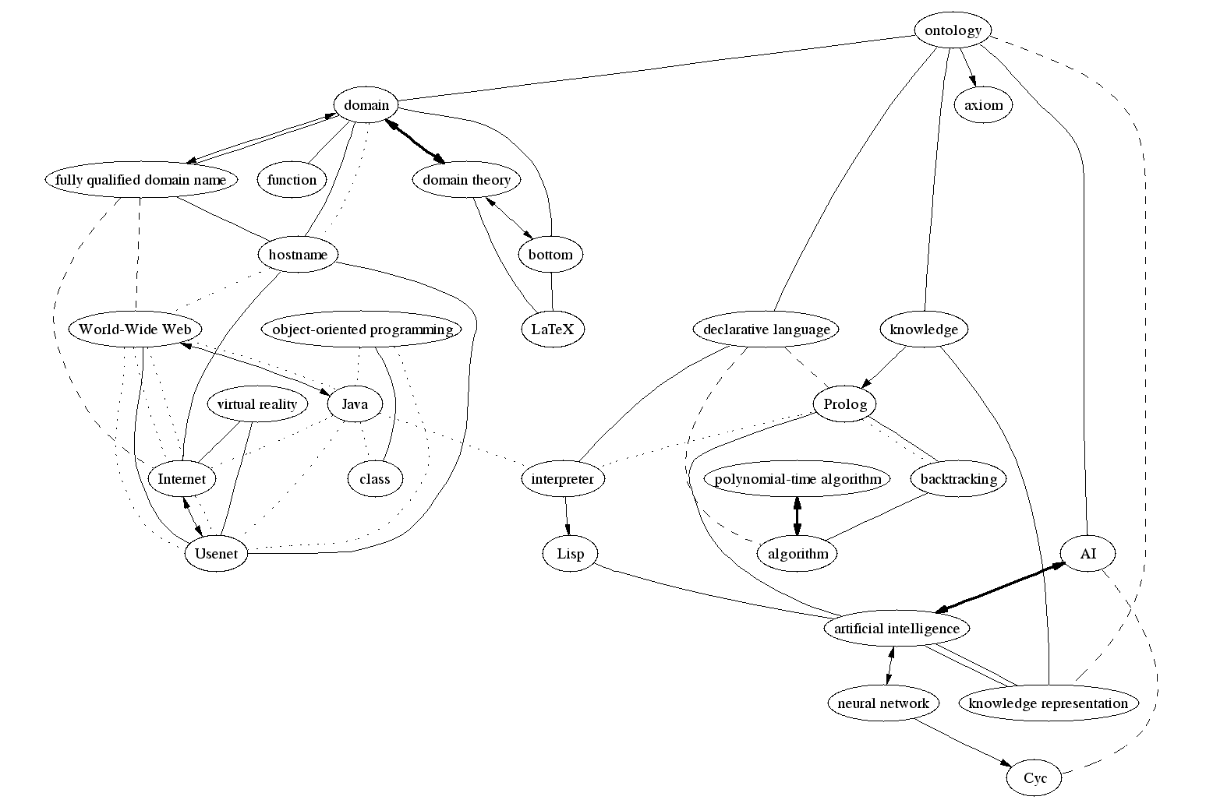
In Figure 3, the depth limit of 0.85 is restricting the range of the nodes included. All the nodes related to ontology are included because there are no weak relationships with ontology and 1.0 is the weight limit for a single edge. However, for the nodes related to ontology, only synonyms or other strongly related peers are included, such that there is always a path from any node to ontology with a cost less than or equal to 0.85.
Figure 5 - Point query from ontology with a depth limit of 1.35 an a minimum peerage of 12
A deeper query, also from ontology, is shown in Figure 5. As you would expect, the number of nodes is exponentially proportional to the depth of a query due to branching. In order to restrict the output so that it remains relatively small and uncluttered in the visualisation, a minimum peerage of twelve is enforced for this figure. Note that the peers themselves are not shown unless they also have a minimum of twelve peers. Highly connected nodes generally represent less obscure concepts, so are of more interest to someone viewing the model, which is why this filtering method is effective. Note that the values 0.85, 1.35 and 12 chosen for depth and minimum peerage were chosen simply to produce manageable image sizes.
Viewing the ontology in this way allows the 'bigger picture' to be seen. From here, further detail may be sought, and this can be accomplished with a follow-up query on any node, using smaller values for the depth limit and minimum peerage. These queries can also show interesting chains of relationships, along the lines of the 'degrees of separation'. In fact, over 90% of the ontology is within a distance of 3.0 from some highly branching nodes such as SQL. This means that at least 90% of the nodes in the ontology are within a maximum distance of 6.0 from each other. See also Section 5 and Figure 8.

Multipoint Queries (Model Expansion)
Model generation proceeds in three stages. First, key concepts are extracted from a data source. These are then matched (where possible) to concepts in the ontology. These concepts have a corresponding subgraph, which is then grown within the ontology to produce a rich model. Our work has concentrated on the second and third stages of the process. We start with a simple list of terms needed from the first stage, for example, the keywords of a document.

Subgraph Growing
By indicating simply a subset of nodes in the ontology, it is possible to grow the corresponding subgraph a specified distance. For example given a set of concepts in the ontology, it is possible to construct a subgraph consisting of the nodes corresponding to these concepts. This graph may then be grown to include nodes nearby any of the existing nodes. The procedure takes the form of a query on the ontology to produce a model, given a set of concepts and a distance (or alternatively, a maximum output size) as input.
Figure 6 and Figure 7 are graph representations of models constructed using the MECUREO system. Figure 6 is the result of expanding the terms knowledge representation, genetic programming and data mining a distance of 0.8 in the ontology. For a smaller and clearer image, nodes in the graph with fewer than 3 peers (and their incident edges) were removed. Figure 7 is the result of similarly expanding the terms neural networks, data marts and STRATEGY after going through an intermediate concept matching step (see Section 3.2.2). Both graphs are generated using knowledge from the unmodified, automatically constructed ontology.
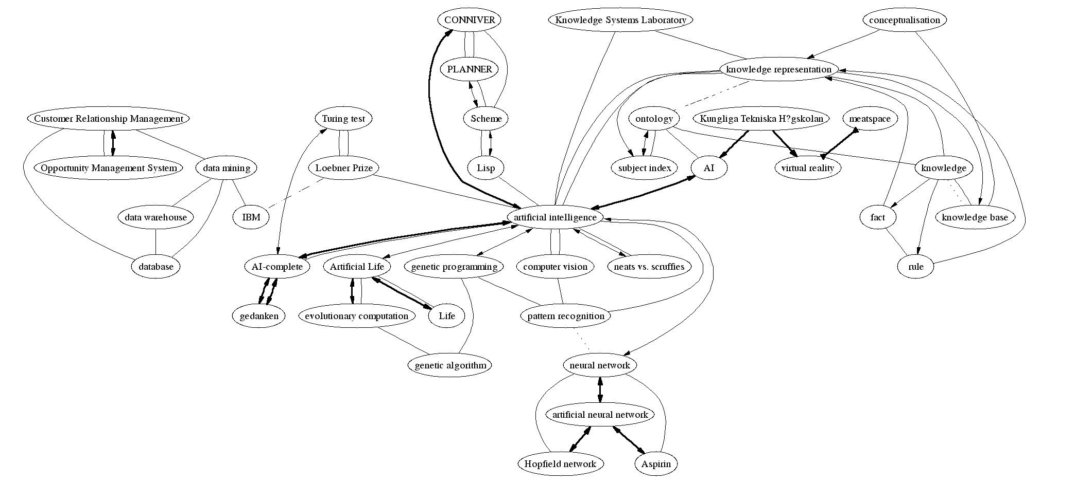
Each node in the subgraph to be grown is given an initial weight to begin the query, which defaults zero (as in the examples). This can be specified along with the set of words from which the model is generated, or it can simply be the node weight assigned to a node from a previous query. The graph that results from the query will include all nodes visited along any path originating from any node in the input graph, whose path length is not more than the specified query distance, minus the weight of the originating node. This is essentially the generalisation of a point query to handle multiple input nodes.
Figure 6 - Model expanded from the concepts knowledge representation, genetic programming and data mining with a depth of 0.73 and minimum peerage of 3
However, in order to give greater emphasis to output nodes that are close to more than one node in the input subgraph, the weight assigned to any node adjacent to more than one input node is reduced. The reduction is calculated by treating the edges as if they were parallel resistors. That is, each node will be given a final weight equal to the reciprocal of the sum of the reciprocals of weights assigned to this node from each of the input nodes. This adjustment propagates outwards, such that any path from this node may be slightly longer. In this way, inputs (especially word lists) that tend to focus on groups of related concepts in the ontology will have these groups emphasised, while isolated concepts will have less growth. It also makes it possible to specify relatively small distances to grow (perhaps smaller than any edge weight) and yet still yield some growth if the input graph has one or more conceptual focal points.
This type of query allows any computer science entity to be modelled, provided it can be translated into a set of key concepts. The ontology determines the relationships between those concepts and allows the model to be extended to include related concepts. As a side effect, the nodes are each given a weight that reflects their closeness to the query input. This model may then be output (e.g. graphically), stored or used in further queries.
These calculations rely upon the weights associated with the links within the ontology generated from the online dictionary of computer terms. The way in which these weights were determined is discussed in Section 2.5.

Concept Matching
Our current work has assumed that we have been provided with a list of terms that describe each entity being compared. Our longer-term goal is to integrate into the system tools that can extract the terms from documents such as email, an on-line biography or a call for papers. The aim will be to find near matches between terms from the entity with nodes in the ontology and to calculate their relevance. This can then be used as a basis to model (and grow) the entity. To accomplish this, we have been evaluating the potential value of techniques such as stemming [Error: Reference source not found] and edit distance [].
There are significant obstacles in developing a good matching procedure for concepts in the computer science domain. There is detail that would be lost if a simple stemmer, edit distance or even case-insensitivity is used to match terms. For example, there is COM (Component Object Model or Computer On Microfilm) and there is com (www...com) for which two, distinct and distant nodes exist. Furthermore, the vast number of acronyms and proper nouns in our ontology are not easily suited to a stemmer for the English language. There is also an obstacle in the form of the size of our ontology, which makes a full scan of concepts time consuming if a match is to be searched for.
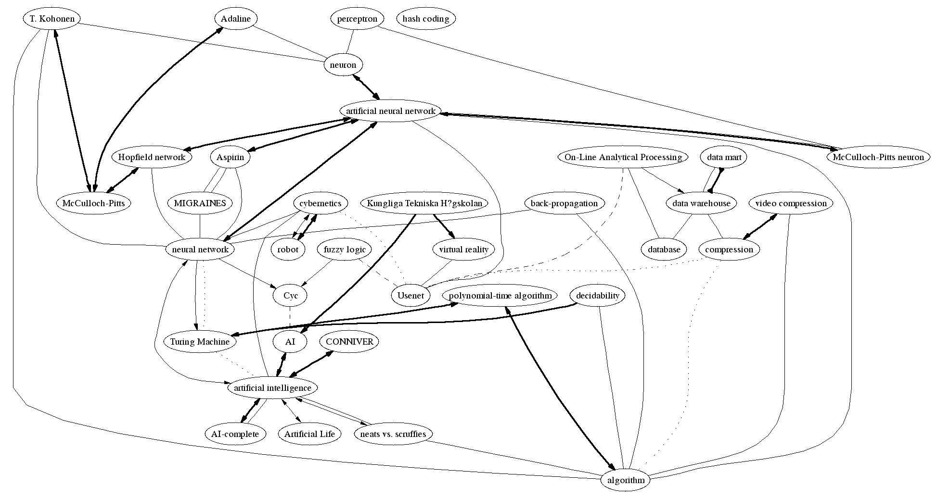
The procedure used to find the nodes in Figure 7 matches concepts on the case-insensitive stems of their component words. This takes constant time for each concept to be matched, as string hashing is performed. However, if no stem match was found, a substring search is performed that takes linear time (on the size of the ontology ~104) for each concept to be matched. A cut off edit distance [Error: Reference source not found] is then used to help mitigate incorrect matches unless human interaction is involved (whereby the user can select terms ranked by edit distance). The stemmer used is a version of the Porters stemmer [Error: Reference source not found], slightly modified to perform on the UK-English used in the FOLDOC resource [Error: Reference source not found].
Figure 7 - Model expanded from the concepts STRATEGY, neural networks and data marts with a depth of 0.9 and minimum peerage of 3.
Note that in both Figure 6 and Figure 2, the node whose label is 'ShowCase STRATEGY (www://www.showcasecorp.com)' has been culled because its only peer is 'data mining' and so the node does not meet the minimum peerage requirement for image output of 3, although it is still part of the model from which the image is derived. The label is such simply because the dictionary from which the ontology is derived references the relationship in this way (that is, with the ShowCase URL).
For the query '"STRATEGY" "neural networks" "data marts"', the nodes ShowCase STRATEGY (www://www.showcasecorp.com), neural network and data mart are matched. These nodes were then grown as described in Section 3.2.2 with a distance of 0.8 to produce Figure 7, after enforcing a minimum peerage filter of 3 peers.

Matching Models
The purpose of a matching query is to return a value, or set of values, reflecting the similarity of the two input graphs that model the two entities we want to compare. In the case of Figure 6 and Figure 7, there is considerable overlap: for example, artificial intelligence and its immediate peers. Ideally, we would like to quantify this in terms such as: these models are, say, approximately 70% similar.
We have explored approaches to this task. We currently calculate the following measures:
- the node weight, as assigned by a previous query, and we do so both for nodes that are common to both graphs and those appearing in only one graph;
- the numbers of nodes present and common;
- the relative sizes of the graphs, so that, for example, we can bias a subset comparison for model classification;
- the distance in the ontology between a node in only one graph and any node of the graph in which it is not;
- minimum weights of spanning trees; and
- characteristics of the graph that would result from a merging of the input models.
We envisage that the heuristic for combining these measures may need to depend upon the application. Some applications may weight some of these elements more highly. Other uses may simply preserve them as separate measures. Techniques in related work [, , ] may also show promise if they can be applied to our ontology without losing detail.

Evaluation of the Ontology

Tuning the Construction
In order to tune the construction procedure, a collection of randomly and deliberately chosen definitions were selected to intuitively evaluate the output and adjust the parameters. This began with selection of representative definitions, which were manually processed to determine the keywords and relationships to derive from them. The base weights and weight function were also adjusted to achieve an intuitively correct result.
Once the initial set of parameters were established, random definitions were queried and the results were compared with the definitions. Adjustments and additions were made to improve the correspondence between the logical structure of the definition and the resulting graph. The ontology was then rebuilt and changes were checked against previously examined definitions. An error rate was established based on the number of incorrectly classified relationships.
A compromise had to be reached between the error rate and the number of classified relationships. Each addition decreased the number of unknown relationships. However, when a change was made that resulted in the number of incorrectly classified relationships increasing more than the number correctly classified relationships, it was reversed. The test set was gradually increased in this way, with randomly selected definitions, until no more changes could be made that satisfied this requirement.
The final size of the test set, not including synonyms, was 193 definitions. This is roughly one percent of the entire dictionary. Further examination may improve the success slightly by adapting to patterns specific to small sets of definitions. However, this is essentially refinement by hand and should be performed on the ontology directly (rather than the automatic construction parameters) so that fewer errors are introduced.
Once the construction parameters were thus tuned, empirical evaluation was performed on the resulting ontology. These were conducted using only concepts not in the final test set.
A more sophisticated keyword identification technique using NLP is currently being trialled. This makes it possible to identify a more detailed correspondence between a relationship and the keyword(s) classifying it. In this way inappropriate keywords can be ignored and suspicious ones can be weighted accordingly (i.e. penalised). This decreases the error rate dramatically. It also allows more relationships to be determined by examining parts of the definition that are not explicitly cross-referenced for possible links and looking for matches for concepts that are known to be definitions in certain parts of each sentence. These too are penalised appropriately to reflect the use of an implicit rule.

Concept Mapping Experiments
The behaviour of the point queries lends itself nicely to comparison with manually constructed concept maps. A small set of volunteers from undergraduate computer science were given a number of topics (concepts in the ontology) closely related to subjects they had previously studied. They were then asked to draw a concept map around this concept, after being shown a mundane example of a concept map based around farm. There was no intervention with the volunteer until the exercise was complete.
The starting concepts were chosen to reflect the students' area of expertise and encourage uninhibited expansion, as well as represent some key concepts in the ontology. The final choices were declarative language, SQL and device. This resulted in a collection of hand-drawn concept maps for each concept, which were compared against point queries in the ontology from the same starting concepts. The volunteers were then asked to comment qualitatively on the concept maps generated by the ontology.

Comparison with Trusted Sources
To perform a quantitative analysis, trusted knowledge bases were consulted. Most often these were significantly smaller, or had a different focus that was not appropriate for comparison with a computer science ontology. The main resource used to perform this analysis was the ASIS Thesaurus of Information Science []. This contains 1615 concepts from the information science domain arranged, hierarchically, in a tree. However, it touches upon many corporate concepts that the FOLDOC ontology does not cover (e.g. one of the top-level nodes is business and management operations).
The flexibility of the construction tools was also put to the test in the evaluation method. Some simple pre-processing on the thesaurus was performed to convert it to a format similar to the dictionary. It was then parsed by the same tool used to construct the ontology. In this way all the existing querying and visualisation tools could be used to aid the evaluation procedure.
However, the structural elements of the thesaurus and dictionary are not the same. The thesaurus is a tree, and there is only one edge type (although the ordering of children in the thesaurus could be used to give weight to the edges). Evaluation was conducted by examining the distance in the ontology between a concept and its parents in the thesaurus. Stemming was used to assist matching of concept names.

Matching Evaluation
For the model matching procedure, informal evaluation has been conducted by comparing graphs derived by strategic modifications to a collection of mock models. This allowed algorithms to be analysed and early refinement of the algorithms to be performed.
We note that accuracy is hard to define for this problem. Being able to definitively state that two models are, say, seventy percent similar is not feasible – neither for a computer nor a human. The problem is not to construct an isomorphism, but to determine how disparate two models are within the context of the ontology. Furthermore, we wish to make use of the additional meta-data in our ontology in the form of relationship weights to give an accurate comparison using all the available information.

Results

Ontology Properties
Presently, only partial results can be presented as work is still continuing. Also, it should be noted that all of the examples given in this paper, and those used to evaluate the ontology, were the direct result of the automatic construction. At no point were the structures of the graphs modified in any way from the generated result. Furthermore, the definitions corresponding to the nodes in these graphs were not used to tune the construction process (e.g. in determining the keywords to use that decide relationship types). The obtained ontology can be used as a foundation for further refinement by hand, in order to improve the performance of the ontology in specific applications.
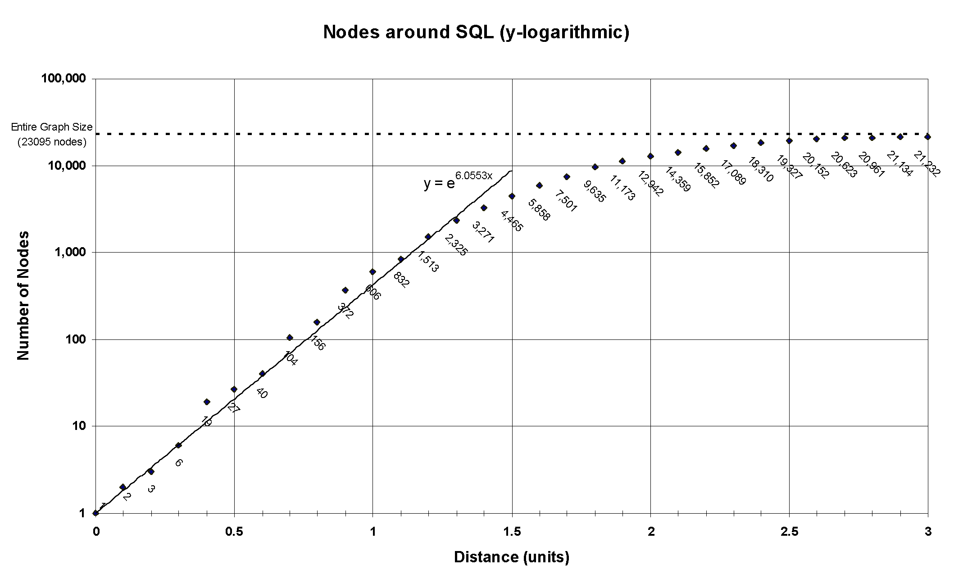
The most recent ontology generated contains 21,029 concepts and 57,407 directed relationships of which 55,181 are between distinct concepts. The queries used for generation and comparison traverse relationships in either direction, so there is an effective average of 5.25 distinct peers per node for the purposes of these queries. However, often a node has only a single relationship that is an explicit synonym with negligible weight. When this occurs the related nodes behave semantically a single node when encountered in a query. This effectively increases the perceivable peerage.
Figure 8 - Chart showing the size of prgressively larger point queries from SQL
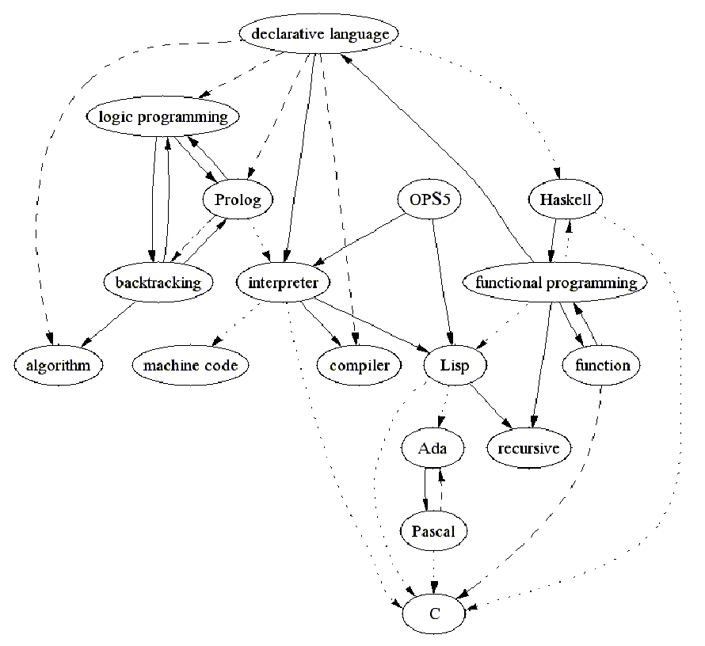
The performance of the queries with respect to the breadth achieved is indicated in Figure 3 and Figure 8. The exponential increase in query size with respect to distance is seen clearly in Figure 8. As the size of the query approaches the total number of nodes available, this relationship is tapered, as expected, due to the limited scope of the ontology. Note that in this example, a particularly dense region of the ontology (SQL) was chosen as a starting point to achieve consistency at small distances. Most queries yield a distribution that starts slower and don't achieve exponential growth until a distance of approximately 0.7, showing the same decay at a greater distance.
Figure 9 - Concepts near declarative language with a minimum of 10 peers
Figure 5 and Figure 9 show the depth and far-reaching relationships that can be extracted from the ontology. These were constructed by filtering out nodes that did not have a minimum number of peers when the graph definition was output.

Concept Mapping Results
The results of the concept mapping experiment are largely qualitative. Overall findings are summarised in Figure 10. Of the 122 total nodes drawn, 105 were exact or near matches to concepts in the ontology – around 86%. The remaining nodes were most often too specific instances of a concept, or were parts of the syntax used by a particular concept. Specifically, the following hand-drawn nodes were unable to be matched: screwdriver, spanner, mallet, flat head, Phillips head, rule, constraint satisfaction problem, iProlog, FROM, WHERE, SELECT, UPDATE, INSERT, 1:1, 1:M, M:1, M:M.
Volunteer | Root Concept | Nodes drawn (excluding root) | Edges drawn | Nodes matched | Edges matched (depth ≤ 1.5)
A | SQL | 25 | 25 | 17 | 17
A | device | 28 | 28 | 23 | 22
B | declarative language | 16 | 16 | 15 | 14
C | declarative language | 19 | 22 | 18 | 20
D | declarative language | 16 | 16 | 15 | 15
E | SQL | 18 | 18 | 17 | 16
TOTAL |  | 122 | 125 | 105 | 104
There was some discrepancy in the placement of edges. All but one participant's concept maps had a tree structure, despite encouragement beforehand to draw a graph. This contributed a little to the observation that often concepts drawn as being connected via an intervening node in the concept map (perhaps intended as a common parent) corresponded to explicit sibling relationships in the ontology (for example, Prolog and logic programming being connected to declarative language in Figure 9). Otherwise, of the 108 edges between matched concepts, only 4 needed more than two edges from the ontology to form a path between them. Specifically, these were the ones (drawn) between fact and Prolog; thunk and lazy evaluation; cluster and index; and tools and device.

ASIS Thesaurus Comparison
Figure 10 - Concept mapping results
In the thesaurus, only 270 of the 1345 concepts were exact matches. With stemming, this was increased to 519 near matches. We then attempted to estimate where ontology was failing to match the thesaurus. We knew that part of the difference was due to the different orientation of the Thesaurus and the on-line dictionary which is the foundation for our ontology. The former has a strong business orientation where the latter is for computer science terms. Manual analysis of some portions of the thesaurus that are directly related to computer science, rather than business, suggests that approximately 60% of nodes could be directly mapped to concepts in the ontology, for the purpose of comparing relationships.
We then explored the role of near matches of terms across the two sources. For each parent node in the thesaurus that matched a node in the ontology, a point query was performed. The cost assigned to each matched child (as a result of the query) was used to evaluate the precision. This cost is simply the shortest path, so this value was recorded for each node that matched. The analysis of these values was then conducted by hand. Ideally the nodes would be adjacent and the path cost between them would be between 0.5 and 1.0. For synonyms and other strong relationships, 90% of costs ranged between 0.2 and 1.9 units. The mean cost was approximately 1.4 units, translating to an average of around two edges on each path. The remaining 10% of costs were too large to have the nodes considered as being directly related due to branching effects.
Again, these results reflect how the focus of the thesaurus does not correspond directly to that of the dictionary. For example, parent concepts in the thesaurus such as artificial intelligence generally perform well due to their correspondence to a specific concept in the ontology. On the other hand concepts such as data processing are somewhat ambiguous in a computer science domain, and so did not perform as well.

Supplementary Visualisation
For small models (less than about one hundred concepts) a traditional graph output is able to provide useful information to the user. To facilitate this, automatic output to the dot language [] is provided. This output, along with the dot graph visualisation tool [], was used to generate all the examples in this paper. It includes information regarding the relationship strengths and types, as well as meta-data to position nodes vertically according to how closely they match the query used to generate the initial graph.

Related Work
The automatic construction of ontologies and extraction of semantic information from machine readable dictionaries and text is broadly interesting. Some important work in this area can be found in Moldovan [] and Kietz [] where the focus is deriving knowledge from a specific domain (such as within a corporation), and in Richardson [] and Miller [] where the focus is to determine semantics from knowledge in general, with little emphasis on proper nouns. Our work on automatic ontology construction has focussed on generating an ontology that can be used to assist in modelling computer science entities. For this reason, we took a different approach, building a detailed ontology of computer science backed by a weighted digraph to facilitate automatic querying.
The task of matching terms with a similar meaning has been tackled by a quite diverse set of approaches. For example, Becker [] explores the use of formal concept analysis in the context of document retrieval rather than modelling user interests as a first stage in matching users. Another similar project in Suryanto [] also uses lattices for inferring user interests. However, it uses the lattices as a basis for interacting with the user to elicit an expanded self-description. Similarly, Moldovan [Error: Reference source not found] addresses the problem of building richer models of people's interests by relying on knowledge elicitation from the user, but it uses taxonomic representation of computer terms.
MECUREO's term growing algorithms are based on the intuitive notion that a pair of terms that are more similar should be closer in the ontological graph. This idea is not novel and was recognised in the earliest work on semantic networks reviewed in Sutcliffe [] and Resnik [].

Conclusion
This paper has described our approach to the automatic construction of a reasonably accurate and complete computer science ontology from a dictionary. The dictionary is parsed and a graph is generated with nodes representing concepts and weighted, directed edges representing the relationships in the ontology. The querying tools provide an effective way to focus on individual concepts or on a collection of concepts to represent a model, or models, to perform comparisons. Early evaluation has determined that the results are sensible, but further work needs to be conducted to determine the effectiveness of the ontology in its applications, such as for machine learning.

References and Notes

[?] S. Bechhofer, I. Horrocks, C. Goble and R. Stevens. OilEd: a Reason-able Ontology Editor for the Semantic Web. Lecture Notes in Computer Science Vol.2174, 2001. pp.396. Or OilEd – Ontology Interface Layer Editor, at http://oiled.man.ac.uk/
[?] James Hendler and Deborah L. McGuinness. The DARPA Agent Markup Language. IEEE Intelligent Systems, Vol. 15, No. 6, November/December 2000, pp 67-73, or at http://www.daml.org
[?] T.R. Gruber. Towards Principles for the Design of Ontologies Used for Knowledge Sharing. Formal Conceptual Analysis and Knowledge Representation. Kluwer Academic Publishers, 1993.
[?] S. Bechhofer, C. Goble, and I. Horrocks. DAML+OIL is not enough. 2001.
[?] FOLDOC – the Free On-Line Dictionary Of Computing. © 1993 by Denis Howe, updated regularly, at http://www.foldoc.org/
[?] M. F. Porter. An algorithm for suffix stripping. Program July 1980, 14(3):130-137.
[?] I. V. Levenshtein. Binary Codes capable of correcting deletions, insertions, and reversals. Soviet Physics Doklady, Feb. 1966, 10(8):707-710.
[?] A. Maedche, S. Staab. Measuring Similarity between Ontologies. EKAW, 2002.
[?] A. Maedche, S. Staab. Making Results Comparable – Cross-Evaluating Ontologies.
[?] D. B. Leake, A. Maguitman, A. Cañas. Assessing Conceptual Similarity to Support Concept Mapping. Proceedings of the Fifteenth International Florida Artificial Intelligence Research Society Conference, 2001.
[?] ASIS [American Society for Information Science] Thesaurus of Information Science; (published 2002-02-07), http://www.asis.org/Publications/Thesaurus/isframe.htm
[?] The DOT Language, by AT&T Labs; at http://www.research.att.com/~erg/graphviz/info/lang.html
[?] E.R. Gasner, E. Koutsifios, S.C. North and K.P. Vo. A Technique for Drawing Directed Graphs. IEEE Trans. Software Eng., 1993, 19:214-230. Software at http://www.research.att.com/sw/tools/graphviz/.
[?] D. Moldovan, R. Girju, V. Rus. Domain-Specific Knowledge Acquisition from Text. ANLP, 2000.
[?] J. Kietz, R. Volz. Extracting a Domain-Specific Ontology from a Corporate Intranet. Proceedings of CoNLL-2000 and LLL-2000, Lisbon, Portugal, 2000, pp 167-175.
[?] S. D. Richardson, W. B. Dolan, L. Vanderwende. MindNet: acquiring and structuring semantic information from text. ACL, 1998, Vol. 2, pp 1098-1102.
[?] G. A. Miller, R. Beckwith, C. Fellbaum, D. Gross, K. Miller. Introduction to WordNet: An On-line Lexical Database. International Journal of Lexicography (special issue), 1990, 3(4):235-312. (Revised 1993).
[?] P. Becker, P.Eklund. Using formal concept analysis for document retrieval. ADCS, 2001.
[?] H. Suryanto, P. Compton. Discovery of Ontologies from Knowledge Bases. First International Conference on Knowledge Capture, 2001.
[?] R. F. E. Sutcliffe, D. O'Sullivan, A. McElligot, L. Sheahan. Creation of a Semantic Lexicon by Traversal of a Machine Tractable Concept Taxonomy. Journal of Quantitative Linguistics, 1995, pp 33-42.
[?] P. Resnik. Semantic Similarity in a Taxonomy: An Information-Based Measure and its Application to Problems of Ambiguity in Natural Language. Journal of Artificial Intelligence Research, 1999, pp 95-130.

