7

Trent Apted / tapted / 0010433

July Semester 2002
TSP Project

Final Report

Abstract
This report gives a detailed account of the modifications made to my COMP3809 Advanced Software Project for the February semester of 2002. It describes the work done towards my TSP Project for the July semester of 2002 consisting, in part, of these changes. It builds on, and describes enhancements to, information in the Final Report for the COMP3809 project.

Executive Summary
The continuing development of this project has been centred on the automatic generation and applications of ontologies. More specifically, the construction of ontologies relating to the field computer science with features that make them suitable for the expansion of entity models using limited information. For example, given a personal biography, a list of publications, or a person's self-description of interests, we would like to identify people who have similar interests, even if they have chosen to express their interests with different terms. The project also addresses related problems that may be solved by the application of an ontology, such as information retrieval and the visualisation of entity models.
Current work in the area has focussed mainly on generating ontologies to represent 'the world' or to model linguistics, without concentrating on how the ontology might be queried. In other work, ontologies have been used as a basis for the determination of semantic information, such as for NLP, by examining relationships in isolated parts of the ontology. Furthermore, much of the work has involved human interaction in order to provide hints towards construction of the ontology and its refinement.
The goal of this work has been to develop and evaluate a fully automated approach to ontology construction and querying. The queries that have been developed allow models to be generated from a list of arbitrary keywords, which goes through a process to match the words to concepts present in the ontology. After concepts are matched, the model is grown using information about the relationships between concepts contained in the ontology. Once models have been generated in this way, they may then be represented visually or used in further queries. One type of query compares two models to detect their similarities with an aim to return a single result in the canonical scale comprising of the reals in [0, 1]. Another type of query allows two models to be compared visually. For the construction of the ontology, there was a refocus on the provision of features within the ontology that would make such queries fruitful.
In earlier work, the following had been accomplished (stated briefly):
- framework and implementation of the initial parser to automatically construct an ontology, backed by a weighted digraph, from the FOLDOC resource
- functionality to generate a subgraph of the ontology containing concepts within a specified distance of a query node
- functionality to merge two subgraphs
- implementation of the initial serialisation of the ontology and subgraphs
- searching (by scanning) and filtering (by categories) of concepts in the ontology
- generation of models using multiple query nodes (by repeated subgraphing and merging)
- initial output formats for the DOT language and RDF for VLUM
- development the initial graphical user interface

The current work builds upon this in the following ways:
- improvements to the RDF output format
- inclusion of a URL pointing to the definition of a concept so that it may be loaded while browsing the ontology or a model
- inclusion of link types so that relationships may be filtered in VLUM
- improvements to the DOT output format
- inclusion of hints for dot to position nodes vertically to reflect their 'closeness' in a query
- clustering of nodes, eg for visual comparison
- improvements to the weighted digraph representation of the ontology/models
- optimisation of the serialised format for space and loading time efficiency
- true growing of a model, more efficient and accurate than the old generation
- slight modifications to merging to support clustering
- improvements to the interfaces
- the implementation of a clean API to encapsulate and combine functionality
- the implementation of a range of CGI accessibility providing a simple and easy, yet powerful, interface for generating models dynamically
- minor GUI improvements, as well as incorporation of the new functions
- introduction of matching
- implementation of an efficient, versatile string matcher built around the Porters stemmer
- incorporation of concept matching applied to a query for model expansion
- incorporation of matching in the parser the construct a denser and cleaner ontology
- implementation of model comparisons using heuristic detection and quantification of similarities between models, and their initial evaluation
- formal development of the information in the configuration files to improve classification of relationship types
- formal evaluation of the accuracy and coverage of the generated ontology using a combination of comparison to trusted sources and empirical evaluation
- collection of various statistics of interest relating to the generated ontology
- adaptation to another dictionary-like resource – an HCI glossary
- a more thorough investigation into the context area

Part of the work towards the TSP project also included the co-authoring of two research papers:
- T. Apted and J. Kay. Visualisation of Learning Ontologies. Accepted as a full paper in the ICCE workshop on ontologies, 2002.
- T. Apted and J. Kay. Generating and Comparing Models within an Ontology. Accepted as a full paper to the ADCS conference, 2002.
Contents

7 1
Abstract 1
Executive Summary 2
Introduction 5
Extension Proposals 5
Modifications to package foldocparser 7
RDF Output Format 7
Vertical Positioning in DOT 8
Clustering in DOT 8
Extending the Configuration 10
Modifications to package hashgraph 12
Serialised Format 12
Model 'Growing' 12
Merging Models for Clustering 14
Matching – package porterstemmer 15
The Matching Algorithms 15
Matching for Model Expansion 15
Matching in the Parser 16
Comparing Models – package foldocml 18
Global Similarity 18
Base Nested Similarity 19
Basic Search Similarity 19
Averaged Search Similarity 20
Normalised Search Similarity 20
Averaged Normalised Search Similarity 20
Minimum Spanning Tree Similarity 20
Summary 21
Interfaces 23
The MECUREO API 23
CGI Interfaces – package foldoccmd 24
Modifications to the GUI – package foldocui 25
Evaluation of the MECUREO system 25
Concept Map Experiments 25
Comparison with Trusted Sources 27
ASIS Thesaurus 27
Initial Comparison Evaluations 28
Inverse Power Law Applied to Ontologies 28
Adapting to Other Dictionaries 30
Generating the Usability Ontology 30
Related Research 31
Ontology Construction 31
Ontology Queries 32
Matching 32
Edit Distance – agrep 32
Stemming 33
Similarity Measurement 33
Bibliography 36

Introduction
The project, dubbed MECUREO, relates to ways of automatically generating and using detailed and accurate ontologies from dictionary-like resources with an aim to use them for queries relating to learning. The queries, also forming part of the project, provide ways of using the knowledge contained in the ontology to:
- construct a concept map around a related concept
- 'grow' a model consisting of a number of concepts
- select an initial set of concepts for a model (through matching of arbitrary keywords)
- compare two models quantitatively; and
- merge models (eg for a qualitative, visual comparison)
Other tools associated with the project provide:
- serialisation and deserialisation of models
- output to the DOT graph visualisation language
- output to RDF for the VLUM visualisation tool
- a graphical user interface to access the tools
- command line interfaces for CGI programs
- CGI scripts and web forms using the command line interfaces; and
- a clean API to access all the functionality (eg for machine learning).
To provide these tools, other components – useful by themselves – were developed, which include:
- an interface to the Porters stemmer (providing component stem matching to a set of words along with an heuristically determined match 'cost'); and
- an efficient 'HashGraph' data structure for representing weighted digraphs

Extension Proposals
The following extensions were proposed early on in the semester to provide the initial direction for development. These are referred to by number later in this document. At the time of writing, all extensions except {2} and {8} were developed. However, {4} and {6} are still in development and {5} is extended whenever new functionality is added to the system. The remaining extensions are complete. Further description and implementation details are described later in the report.

{1} clicking a link to open up a definition within VLUM

{2} edge labels in DOT for keywords
→ a change serialised format to support it

{3} extending RDF output to adapt to the new VLUM
→ VLUM now includes support for link types (sibling/parent/child/etc) to which a filter can be applied
→ these are already in the serialised format, but are ignored when converting to RDF for VLUM
{4} compare two graphs to give a quantified "% similar" type result

{5} an API, eg for machine learning [interface omitted, see Javadocs]

{6} more intelligent 'arbitrary input' parsing
→ some NLP expertise would be required to accomplish this most desirably
→ this would allow model generation an InputStream / Reader for a text file instead of an iterator over node names

{7} a different way to do generate, which would give similar output, but it wouldn't need the 'infinity' parameter; more along the lines of a 'grow'. This should give the weights assigned to nodes a better spread without having to guess a good value to use for infinity, although the set of nodes themselves would be the same as the old generate. Whether the relative weights are preserved or not would depend on the formula used to adjust weights of nodes linked to more than one of the query nodes – perhaps something along the lines of the 'parallel resistors' formula to combine the node weights. However, it would be harder this way to differentiate weights of nodes actually in the query like the old generate does (their weights would probably start off zero, and have to stay zero, unless you use some kind of bias, or use Laplace estimators maybe...). This new version of generate would probably also be more efficient, especially when the number of query nodes is high.

{8} clustering in VLUM for visually comparing two models
→ bias node weights depending on whether they appeared in the left graph, the right graph or both graphs of a 'merge' operation
→ either bias only mark, only reliability or both
→ biasing only one would preserve the 'strength' of a node in a resulting merge of the two users, in the other axis
→ there may have been an enhancement to the input specification of VLUM to allow a better way to do this (specific colours perhaps)

{9} using node weights in DOT
→ it is possible in DOT to partition the graph with vertical precedence.
→ you could ask the layout engine to try and position the edges (can't specify nodes, unfortunately) of the nodes with a low weight (close match) higher up in the graph.
→ this should make the output more tree-like, however it would be necessary to do a subgraph query first to organise it.
→ partitioning may be an issue - putting each node with a different precedence might cause a graph that is too vertically spaced ⇒ maybe use binning to partition it.
→ the vertical precedence would reflect the horizontal axis in VLUM

{10} Clustering in DOT for visually comparing two models
→ It's possible to ask the layout engine to cluster nodes.
→ can do it similar to {8} above
→ labels can also be specified for the clusters.
{11} smoothing the transition from query ⇒ graph ⇒ RDF ⇒ html ⇒ browser
→ as well as from query ⇒ graph ⇒ DOT ⇒ gif ⇒ viewer
→ i.e. be able to click a button in the interface to immediately open up a browser showing VLUM with the current graph, or an image viewer showing the DOT graph (or a separate frame in the interface that loads it).
→ this would most likely be platform-dependent though; it would need shell executes to run the layout engine and browser windows ⇒ a configuration file ~/.foldocquerierrc or something like that, plus a way to specify the command.

Modifications to package foldocparser

RDF Output Format
The first modification to the project – extension {1} – involved changing the way nodes were identified in the RDF output. Changing the identifiers to an URL provides the information that VLUM needs to enable it to open up the definition in a side HTML frame. This was a relatively simple change to an isolated part of the Outputter. However, when testing in VLUM was unsuccessful, it was found that VLUM was hard-coded to only process URLs beginning with "http://imdb.". Andrew Lum graciously tweaked VLUM to remove this restriction and it all worked. See Error: Reference source not found for an example.
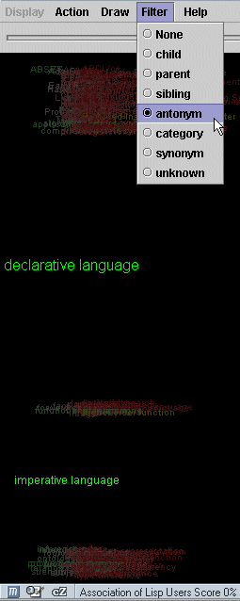
To ease testing, part of extension {11} was developed in parallel. HTML templates are used to automatically generate a frameset and corresponding frames for providing VLUM with the environment it needs to load the newly created RDF file and enable the Action → View Selected functionality.
Figure 1 - Antonym filter enabled ('declarative language' subgraph)
Soon after, relationship filtering was written into VLUM by Andrew (extension {3}). Another change was made to the RDF output to include the type recorded by the parser for each link. This information was already kept in the serialised format, so the only change that had to be made was to the format of a peer tag in the RDF output. However, this focus on the link categories highlighted some of the deficiencies in the current parser configuration. The keywords file was subsequently extended in a formal manner to improve the number of successfully categorised links (discussed below in Parser changes).
More recently, when the usability ontology was created from the HCI glossary, further changes were made to enable URLs to be similarly generated to point to the definitions at usabilityfirst.com. The style of URL used at this site meant that additional information (the term's id number) had to be serialised, so changes were made to the serialised format to accommodate this. In addition, prompts in the GUI and flags for the CGI interfaces were added for the creation of the RDF files so that either FOLDOC URLs or HCI URLs could be output in the RDF document.
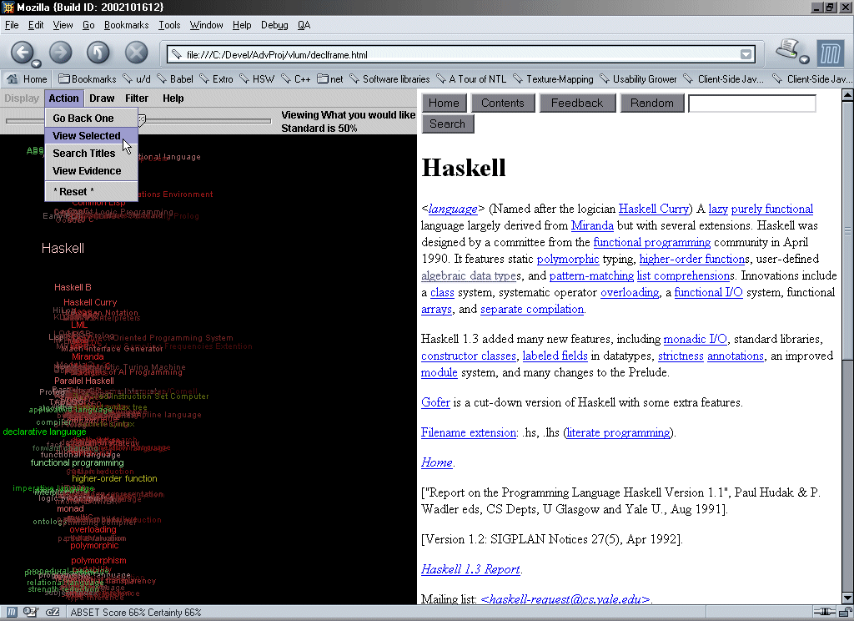
Figure 2 - VLUM and view frame for Haskell (from 'declarative language' subgraph)

Vertical Positioning in DOT
The output to the dot language for the AT&T graph visualisation tool of the same name was modified to give layout hints based on the node weight. The node weight is assigned when a query is performed and reflects the 'closeness' of the node output to the query input. Nodes are first ordered by their assigned node weight and output in a way to tell dot to place nodes with equal weight at the same layer in the graph drawing. The ordering of layers is determined by relative weights – with the lowest weight level at the top. This helps to show the logical flow of concepts from top to bottom, improving the clarity of the query output. Note that unequal node weights do not guarantee that two nodes will be on different layers; nor does a weight of zero guarantee that the node will be at the top. This is mainly due to conflict resolution in the layout algorithm used by dot.

Clustering in DOT
Further changes were made to the dot output to support clustering of models after a merge query. This special kind of query combines two graphs into a single graph, treating node weights appropriately. Slight changes were made to the procedure to include additional information in the result indicating the source of the nodes. This allows clusters of nodes to be formed, based on whether they came either from both graphs or from only a single graph. Nodes within each cluster are also ordered, based on their node weight. Dot will first form the subgraphs within the clusters, and then treat each cluster as a single node to layout the entire graph. This gives a special kind of output that is especially useful for comparing two models. See and the more detailed version in Figure 2 for an example.
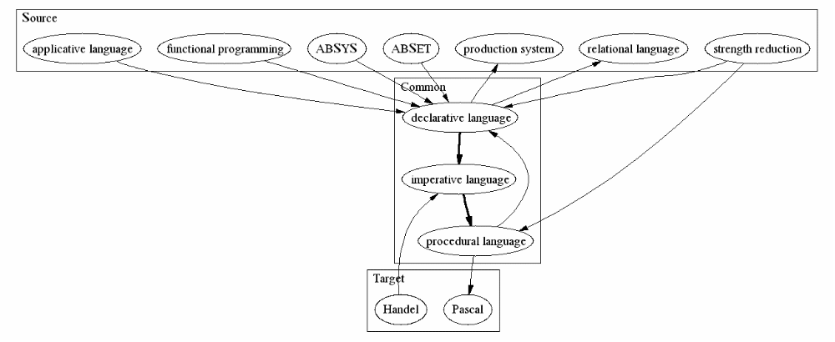
Figure 1 - Clustered merge of point queries from declarative language and imperative language; each with a depth of 0.6 ('Target' and 'Source' identify each of the source graphs – determined by the order in which the merge operation is applied; ie, order of parameters))

Extending the Configuration
Once the initial set of parameters was established, random definitions were queried and the results were compared with the definitions. Adjustments and additions were made to improve the correspondence between the logical structure of the definition and the resulting graph. The ontology was then rebuilt and changes were checked against all previously examined definitions. An error rate was established based on the number of incorrectly classified relationships.
A compromise had to be reached between the error rate and the number of classified relationships. Each addition decreased the number of unknown relationships. However, when a change was made that resulted in the number of incorrectly classified relationships increasing more than the number correctly classified relationships, it was reversed. The test set was gradually increased in this way, with randomly selected definitions, until no more changes could be made that satisfied this requirement.
The final size of the test set, not including synonyms, was 193 definitions. This is roughly one percent of the entire dictionary. Further examination may improve the success slightly by adapting to patterns specific to small sets of definitions. However, this is essentially refinement by hand and should be performed on the ontology directly (rather than the automatic construction parameters) so that fewer errors are introduced.
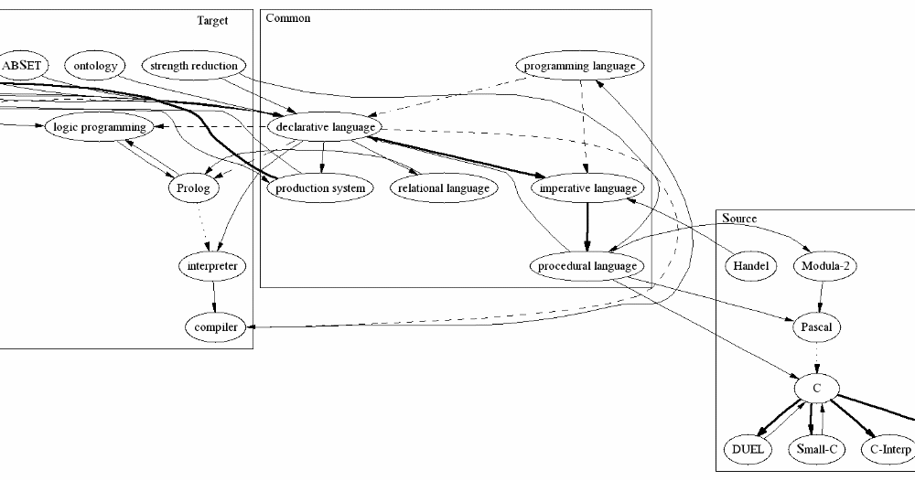
Figure 2 - Clustered merge of point queries from declarative language and imperative language; each with a depth of 0.8 (cropped to fit)

Modifications to package hashgraph

Serialised Format
Apart from the recent changes to adapt to the HCI URLs, some optimisations were applied to the serialised form of a graph (i.e. an ontology or model). All strings in the graph were moved to a table of unique strings at the beginning of the file to avoid duplication. This also allows Java to reuse the memory occupied by the string by having multiple pointers to each (heap size and garbage collection during loading were becoming an issue for large graphs). Subsequent references to the string were by index into the table.
This then meant there were many relatively small integers being used. To provide further optimisation, two bits were sacrificed as overhead to progressively encode the integers to use as few bytes as possible. The encoding is localised and uses only a few masks and bit shifts, so does not add significantly to the load time, while the fact that there is less total file to read from disk generally reduces the overall load time.
A final optimisation was to change the data type for node and relationship weights to a float - the extra precision provided by a double is not perceivable in any of the visualisations. The improved files were about 40% of the size of the old files. As an example, the main FOLDOC ontology (21,029 nodes and 114,815 links) went from 4,874kB to 1,688kB and now loads in around five seconds with the JIT compiler.

Model 'Growing'
The old HashGraph created models by repeated subgraphing and merging operations. Extension {7} in Extension Proposal outlines some of the shortcomings of this method. The main problems were the requirement to provide asymmetric values of infinity in order to give equal weighting to all the subgraphs and the poor scalability for large input models. The new method is also able to give emphasis to areas of the input model that are focussed in a close region of the ontology, which the old method was unable to do. Model growing forms the third and final stage in the 'Model generation' procedure used to create models in the MECUREO toolset described in [18]:
Model generation proceeds in three stages. First, key concepts are extracted from a data source. These are then matched (where possible) to concepts in the ontology. These concepts have a corresponding subgraph, which is then grown within the ontology to produce a rich model.
By indicating simply a subset of nodes in the ontology, it is possible to grow the corresponding subgraph a specified distance. For example given a set of concepts in the ontology, it is possible to construct a subgraph consisting of the nodes corresponding to these concepts. This graph may then be grown to include nodes nearby any of the existing nodes. The procedure takes the form of a query on the ontology for a model, given a set of concepts and a distance (or alternatively, a maximum output size) as input.
Error: Reference source not found and Figure 2 are graph representations of models constructed using the MECUREO system. Figure 1 is the result of expanding the terms knowledge representation, genetic programming and data mining a distance of 0.8 in the ontology. For a smaller and clearer image, nodes in the graph with fewer than 3 peers (and their incident edges) were removed. Figure 2 is the result of similarly expanding the terms neural networks, data marts and STRATEGY after going through an intermediate concept matching step (see §3.2). Both graphs are generated using knowledge from the unmodified, automatically constructed ontology.
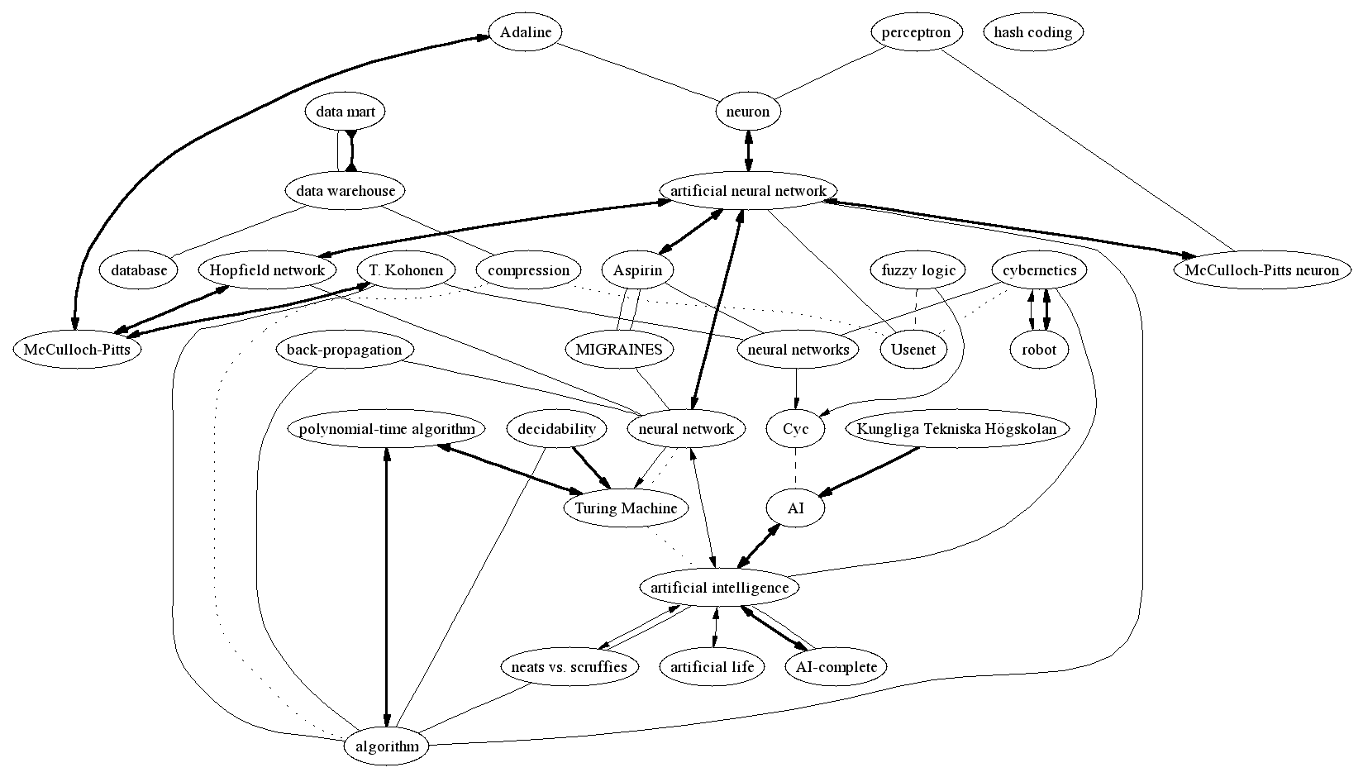
Each node in the subgraph to be grown is given an initial weight to begin the query, which defaults zero. This can be specified along with the set of words from which the model is generated, or it can simply be the node weight assigned to a node in a previous query. The graph that results from the query will include all nodes visited along any path originating from any node in the input graph, whose path length is not more than the specified query distance, minus the weight of the originating node.
Figure 5 – Model expanded from the concepts STRATEGY, neural networks and data marts with a depth of 0.8 and minimum peerage of 3.
Note that in both Figure 1 and Figure 2, the node whose label is 'ShowCase STRATEGY (www://www.showcasecorp.com)' has been culled because its only peer is 'data mining' and so the node does not meet the minimum peerage requirement for image output of 3, although it is still part of the model from which the image is derived. The label is such simply because the dictionary from which the ontology is derived references the relationship in this way.)
The image was constructed by inputting the above query into the web form for the MECUREO demonstration cgi accessed via http://www.ug.it.usyd.edu.au/~tapted/modelgrow.html

However, in order to give greater emphasis to output nodes that are close to more than one node in the input subgraph, the weight assigned to any node adjacent to more than one input node is reduced. The reduction is calculated by treating the edges as if they were parallel resistors. This adjustment propagates outwards, such that any path from this node may be slightly longer. In this way, inputs (especially word lists) that tend to focus on groups of related concepts in the ontology will have these groups emphasised, while isolated concepts will have less growth. It also makes it possible to specify relatively small distances to grow (perhaps smaller than any edge weight) and yet still yield some growth if the input graph has one or more conceptual focal points.
This type of query allows any computer science entity to be modelled, provided it can be translated into a set of key concepts. The ontology determines the relationships between those concepts and allows the model to be extended to include related concepts. As a side-effect, the nodes are each given a weight that reflects their closeness to the query input. This model may then be output, stored or used in further queries.
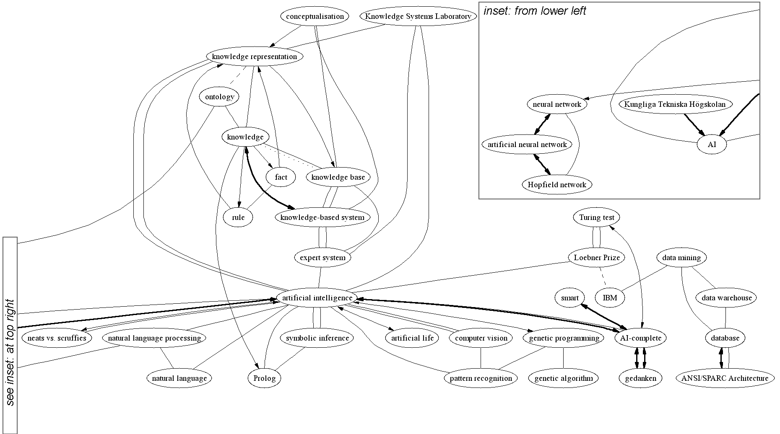
The runtime improvement comes from the fact that only one application of (an adapted) Dijkstra's algorithm is applied to the model to be grown. Previously, one application was required for each subgraph operation. There is additional computation required to detect and process the parallel links, however this only contributes constant time for each node encountered. The ontology graphs we are interested in are generally relatively sparse (the number of edges is generally below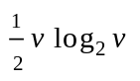). The current implementation uses a pairing heap for the priority queue resulting in approximately 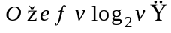 average runtime, where v is the number of concepts in the full ontology. However, the maximum depth (or maximum size) of the output graph specified in the query provides an early exit; the worst case runtime is the same, but it is rarely approached.
Figure 6 – Model expanded from the concepts knowledge representation, genetic programming and data mining with a depth of 0.8 and minimum peerage of 3.
Bidirectional edges indicate synonym (or strong sibling) relationships, reversed arrowheads indicate antonym (or other opposing) relationships, directed edges indicate strict parent/child relationships and undirected edges indicate undetermined relationships (or weak siblings). Bold, normal, dashed and dotted line styles indicate progressively weaker relationships for all types.

Merging Models for Clustering
To enable clustering in DOT, additional information had to be recorded in the nodes during a merge operation. The source of each node – whether it is from the left or right graph, or from both – is saved in a temporary variable for each node. The way node weights are combined for nodes in both graphs was also changed slightly. Input graphs are now normalised before being merged so that simply adding the costs is reasonable. The infinity value can be manually specified but, because the graphs are now normalised between 0 and 1, it makes sense to use a default of 2 to give an even spread of weights in the output graph. However, when clustering is used, the positioning heuristic for the clustering overrides that used for the node weight when there is a conflict.

Matching – package porterstemmer

The Matching Algorithms
In order to facilitate the successful generation of detailed models from arbitrary input it is necessary to match key words and phrases found in the input to concepts in the ontology. The concepts thus matched can then be grown within the ontology as discussed in to provide more detail and find related concepts. This stage of the model generation procedure assumes the arbitrary input has been tokenised in some way (eg by NLP such as that used in the STI profiler) to identify key components of the input. These need not be concepts in the ontology. A weight can also be attached to each token to form part of the initial node weight for the matched concept during expansion (eg the inverse of the frequency such as that reported by the STI profiler).
The matching algorithms begin by processing a list of strings that constitute possible matches. The implementation constructs an Indexer instance simply by using the toString() method of the Objects returned by a Java Iterator. This makes the Porter stemmer wrapper easy to incorporate into other applications. The pre-processing involves stemming the components of each phrase (i.e. each word) and using the result as a key for an entry inserted into a hash table for fast lookup. Inevitably there will be conflicts (i.e. when multiple words have the same stem), so the keys map to a collection of matches.
Once the instance is created, a string can be match()ed to an entry in the table. The same component stemming is applied as in the pre-processing. If the result maps to a collection of matches, a heuristic is applied and attached to each match. The set is sorted by this heuristic and returned as an array – the first item is the best match, according to the heuristic. The original heuristic was simply the difference of string lengths. Recently, this was changed to be the edit distance (or Levenshtein distance) as discussed in [4] – using a dynamic programming implementation – with only a small sacrifice to efficiency. However, the scalability essentially remains the same if m is the number matches and s is length of the string to match, each match takes approximately O(ms²). That is, it is not dependent on the number of possible matches – if m is constant (eg if a maximum of five phrases match to the same key) and s is constant (eg no string is longer than thirty characters) this is O(1).
If there is no match, there is an option to 'look harder'. This will search through the keys looking to see if any component of the key is a substring of the query. Unfortunately, this is slow as it is linear on the number of possible matches. For this reason, the simplistic heuristic is used by default, which is modified slightly to be the length of the query minus the combined lengths of substrings found.

Matching for Model Expansion
When used as part of the CGI interface, words are loaded from a text file consisting only of the names of concepts in the ontology. This is to save time – it is not necessary in the first step of the CGI interface to construct the ontology graph so a smaller data file can be read that does not include structural information. When the ontology is already loaded (as in the Connection API) an iterator over ontology Nodes is used.
When fully automated, the best match is used as one of the initial nodes in the model that is grown, as determined above using stem matching. The initial node weight will later be determined heuristically, based on the edit distance and the weight contained in the query (if specified). Currently it is based only on the distance, and the normalisation means that a single distant match will skew the results. The look harder is not used by default.
For the interactive CGI interface, matches are listed in a table with their associated distance, allowing the matches to be selected for the model generated in the next stage (the best match is selected by default). The look harder option is used if there is no match as the runtime is dominated by the time it takes to load the word list. Furthermore, if there are many keywords in the query, the table can be displayed progressively (that is, progressive feedback is provided) if the browser supports it.

Matching in the Parser
In the parser, matching is used to decrease the number of leaves created – i.e. concepts that do not occur as definitions in FOLDOC. If a concept that would otherwise become a leaf is matched in the parsing process to a concept known to be a definition, a relationship is created to the matched concept instead. This improves the density of the ontology and allows grammar that is sometimes incorporated in the relationship (eg plurals and capitalisation) to be ignored. In the original [COMP3908] parser, leaves were simply created (if leaves were enabled).
The matching is done progressively (i.e. in stages), with the last stage optional. The last stage is optional because it uses the significantly slower substring match and sometimes makes obscure or incorrect matches. However, often the matches are incorrect only in that they should be separate concepts, rather than combined. That is, detail would be lost by merging them, which is why the alternative is to create a leaf.
The stages are:
- Exact match
- White-space trimmed
- Replacement of any non-alpha-numeric sequence of characters with a single space
- Case insensitive match
- Component stem matching
- Substring matching
Changes made to the query string at each stage are used as the query input to the next stage. For example, stage 5 matches using case insensitive stems of trimmed alpha-numeric sequences. Stages 2 and 3 usually only match when there are structural inconsistencies in the layout of the input. However, the changes they make are useful for the stemming stage. Hashtables similar to that used in the Indexer for component stem matching are created for stages 2, 3 and 4 to that they, too, occur in constant time.
Using stages to match in this way seems to work well in practice. After incorporating matching into the parser, another 'warning' was put in to report any match that wasn't exact. While I've only manually checked about 200 of the 15,000 relationships newly affected by matching, only some of the substring matches have been unreasonable – in most cases a new node (a leaf) is the solution.
The overall result is a more dense ontology. Furthermore, matches during generation that turned up leaves that should have turned up a central concept will now match the central concept. This means that the effectiveness of model generation should not be adversely affected by the way the query is formatted. For example Artificial Intelligence was a closest match to Artificial intelligence which, being a leaf, was not directly connected to the central concept artificial intelligence. This is a simplistic example, matching by case insensitivity – stem matches are a little more obscure.
A summary of the results for the various matching methods is shown in Figure 3, with respect to the ontology generated for computer science using FOLDOC.

Parse Method | Nodes | Edges | Average Peerage
no leaves, no matching | 13,690 | 42,814 | 6.255
leaves, no matching | 23,095 | 57,550 | 4.984
no leaves, regular matching | 13,690 | 50,061 | 7.314
leaves, regular matching | 21,029 | 57,407 | 5.460
No leaves, substring matching | 13,690 | 55,581 | 8.120
leaves, substring matching | 14,552 | 56,446 | 7.758
Figure 3 - Statistics of matched and unmatched ontologies generated using FOLDOC

Comparing Models – package foldocml
A number of comparison heuristics have been developed and implemented. Another is in development. Their use is documented in foldocml.Connection in the Javadocs. The important characteristics are summarised here. In each summary, g1 and g2 refer to the two models being compared (the operands of the comparison function); |g1| and |g2| are their respective sizes. In each case the goal is to return a real number describing how similar g1 and g2 are – with 0 representing no similarity. Some of the functions are able to return a values evenly distributed over the reals in [0, 1], with 1 being a perfect match. Others return a set of values representing similarity of various graph features to be used independently (or as inputs to a classifier).

Global Similarity
This applies a heuristic using the number of nodes common and not common between g1 and g2, as well as the difference in node weights for nodes that are common and a biased penalty function for nodes that are not common.
It runs in O(|g1| + |g2|).
The value returned is achieved by first forming
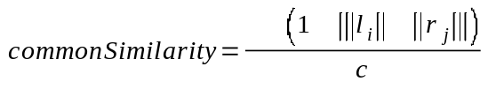
where c is the number of nodes common between the graph, l_{i} is the i^{th} concept in g1, r_{j} is the j^{th} concept in g2 and ||x|| denotes the node weight of x; the sum is over any nodes for which the concepts l_{i} and r_{j} match exactly (because models to compare are generated within the same ontology, near matching is not considered).
This is then penalised and combined into a single real number, finalSimilarity ∈[0, 1], by forming
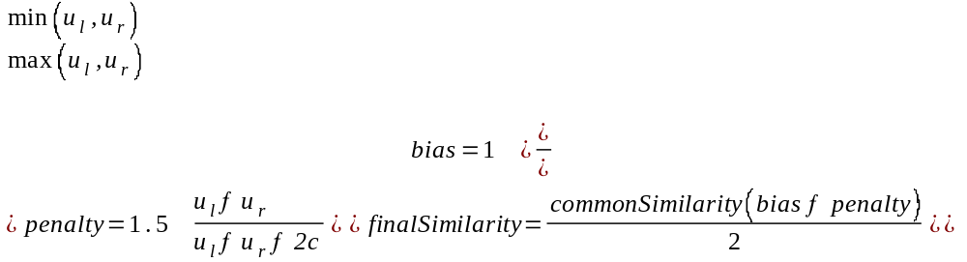
where u_{l} is the number of nodes in g1 not in g2 and u_{r} is the number of nodes in g2 not in g1.
Notes:
- this is with the current final contribution constants
- the contributions of bias and penalty (both separately and together) can be adjusted, but if all comparisons are done with the same constants the relative similarities returned should be consistent
- bias gives a beneficial bias when it is found that one graph is clearly a subset of another - this is helpful for classification comparisons
- penalty penalises the similarity of nodes common by determining the ratio of numbers of nodes not common to those common. In the implementation small offsets are used to simulate Laplace estimators in case any part is zero.
- the finalSimilarity returned combines the values heuristically using adjustable contribution constants. The Similarity class used to make the comparison holds the intermediate values (as for all comparison functions).

Base Nested Similarity
This returns a ratio to represent how similar g2 is with the current Connection using the same function as Global Similarity. That is g1 is the ontology used to create the ontology. This is used, in part, to show coverage of the model within the ontology – it can also be used to compare two models (i.e. by comparing the base nested similarities of each)

Basic Search Similarity
This uses the same commonSimilarity value as for Global Similarity, but calculates the penalty differently. It is not designed to return a value in [0, 1] - the separate values for commonSimilarity and penalty are to be used to evaluate the similarity as there is not yet a clear way to combine them using this method alone. For each node in g1 not in g2, the shortest path in the ontology (i.e. for the current connection) between that node and any node in g2 is found. A maximum distance is specified and if the path exceeds that distance, or there is no path, the maximum distance is substituted (the default used here is a distance of 5).
This and the other Search Similarity algorithms run in worst case that is essentially
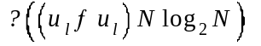
where N is the size of the ontology. However, the reality is not really this bad because the maximum distance is able to provide early exits for most searches. The value calculations for Basic Search Similarity are the same as for Global Similarity except
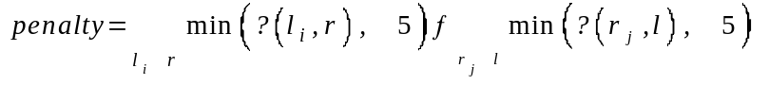
where δ(x_{i}, y) denotes the weight of the shortest path from the i^{th} concept in x to any concept in y using the weights of the relationships in the ontology.

Averaged Search Similarity
Similar to Basic Search Similarity, except
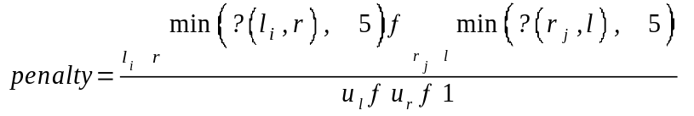

Normalised Search Similarity
Similar to Basic Search Similarity, except
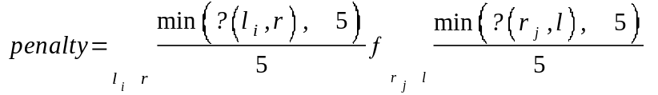

Averaged Normalised Search Similarity
This is essentially the combination of Averaged Search Similarity and Normalised Search Similarity. Again, it works similarly to Basic Search Similarity, except
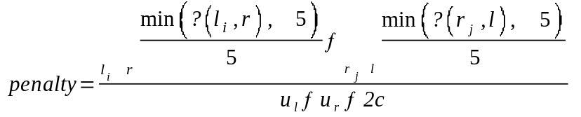
Unlike the other search methods, this is able to give a final 'ratio similar' that is in [0, 1], and realistically representative of the actual "% similar" of the graphs.

Minimum Spanning Tree Similarity
This turned out to be surprisingly effective, despite its seeming simplicity. However, its simplicity is mainly due to the work done by the merging and MST algorithms, which cannot be put into a formula. The first stage of this method merges g1 and g2, to form g3, say. Then computes minimum spanning trees for all three models and sums the edge weights of each tree to produce w_{l}, w_{e}, and w_{c.} Then
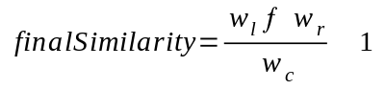
The logic behind this formula is because, apart from exceptional circumstances, the weight of the combined MST cannot be more than the sum of the MSTs of its parts (as it consists only of edges from its parts); and it cannot be less than the maximum of one of its parts (as it consists of at least the edges of it parts). The average is used rather than the maximum to give a slight advantageous bias to models that may show indication that one is a subset of the other (as was done for Global Similarity). The final result is capped to the range [0, 1] – that is, if it is negative, 0 is returned and if it is greater than 1, 1 is returned.
The formula for finalSimilarity is derived from the following:
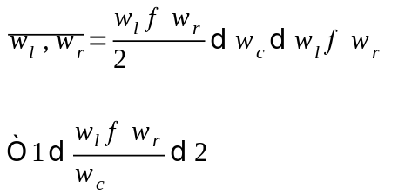
It's hoped that the MSTs will provide an even spread over the range, and that the result reflects, at least conceptually, the true similarity of the two models. Note that this simplification can only be made because the models are generated within the same ontology; with the same relationship weights.
The running time of the current implementation is bounded by the time it takes to find an MST of the merged graph as the merging itself occurs in linear time. The values in Figure 3 show that the graph is truly sparse so, with Prim's and Pairing Heaps this is approximately
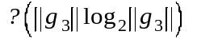

Summary
Initially, there were a number of issues with the similarity measure. The currently implemented framework has hooks (functors) to perform a more reasonable similarity comparison. This was the manner in which the various Search Similarity functions were implemented. The comparison of models generated by MECUREO poses a bit of a unique problem because:
- the graphs being compared are subsets of the ontology (in general), the links set is the same for the same set of nodes and the links have the same weight; BUT
- the nodes themselves have a weight that is different and reflects how closely the node fits in the model; ALSO
- for nodes that are not common across the two graphs there is still a 'closeness' that can be derived by analysing the shortest path from that node to any node in the other graph (in which it is not contained) - using the original ontology
In order not to lose detail in the models and to make full use of the ontology, only ideas from all the graph comparison metrics could be implemented. There are still others I would like to explore that look as though they might be adaptable. There is also a weighted version of MST Similarity, which has already begun development. However, I as yet have not been able to balance the weights in order to produce a value in the range [0, 1] (nor figure out the limits in order to adjust it).
It should probably be said that all the implemented comparison algorithms are still in development, as they have not been properly evaluated. Informal evaluation was conducted by running the algorithms on a small set of sample models with strategic alterations to see if alterations are picked up. Also the "conceptual" similarity (i.e. how well it was placed in the range [0, 1]) has so far only been tested by [tentatively] using my own intuition. I plan to later conduct a more formal evaluation. See also .
An example of the comparison algorithms being applied is discussed in the context of comparison with the ASIS thesaurus in . This application is unique in that the models being compared are not derived from the same ontology, so most of the algorithms could not be applied. Later evaluation of the algorithms will also need to consider how well the comparison results perform in their application. For example, how well they perform for classification in a machine learning application.

Interfaces
The MECUREO interfaces encapsulate the functionality and draw together interconnected modules. In the original project, there was merely a command-line based interface to the parser and a Java GUI to access the functionality. This semester, further work was done to enable access to the functionality via an API or through web CGI scripts. In addition, the GUI was improved and modified to include access to the new functionality.

The MECUREO API
The goal with the API was to encapsulate all of the complexity and to provide a simplified layer to the flexibility of the system; without disabling any of the flexibility. The main culprit was the HashGraph data structure. This includes the shortest path algorithms, various ways to construct an ontology (eg a variety of merging, cloning and growing functions); the usual generic Container operations (iterators, get, add, etc); serialisation and the minimum spanning tree function.
The API is contained in the foldoccmd.Connection class, which is thoroughly documented in the generated MECUREO Javadocs. An instance is a connection to an ontology graph and it operates on HashGraphs so that flexibility is not lost. However, the client need not know any of the details of the HashGraph if they do not require the flexibility. The client need know simply that it constitutes the main parameter and return value used in the API.
The API provides a small set of methods for loading, saving, generating (growing), comparing and outputting (to DOT or XML) models, represented by HashGraphs. In this way, it brings together the functionality in the other packages (i.e. for output and comparison) to provide a single entry point to the system. Its intended eventual use is part of a larger interactive system or within machine learning applications.
The encapsulation provided by the API also proved useful for designing the other interfaces and testing classes. For example, a typical tester for comparing two saved models (arguments 1 and 2) within the serialised ontology (argument 0) is simply:
public static void main(String[] args) throws Exception {
Connection conn = Connection.connect(new File(args[0]));
HashGraph left = Connection.openGraph(new File(args[1]));
HashGraph right = Connection.openGraph(new File(args[2]));
System.out.println("Similar1 = " + conn.ratioSimilar1(left, right, System.err));
}
As another example, one of the CGI interfaces described below uses this code after processing its own arguments into ontology, words, depth and minKids:
Connection conn = Connection.connect(new File(ontology));
HashGraph query = conn.grow(words.iterator(), depth);
Connection.outputDOT(query, new PrintWriter(System.out), minKids);

The resulting output is simply piped to the dot program to produce the image shown in the browser.
For obvious reasons, the best description of the API, from a programmer's point of view at least, is given in the Javadocs.

CGI Interfaces – package foldoccmd
To ease the progression from
query → model → grown model → dot (text/plain) → gif image (image/gif)
RDF(text/xml)
used during testing, a set of CGI scripts were written. The convenience they provide also proved useful for demonstrating MECUREO's capabilities and allowed a model to be represented by a single (albeit lengthy) URL. For example
http://www.ug.cs.usyd.edu.au/~tapted/quickdot.cgi?w1.1=%22ShowCase+STRATEGY+%28http%3A%2F%2Fwww.showcasecorp.com%2F%29%22&w2.1=%22neural+networks%22&w2.2=%22neural+network%22&w3.1=%22data+mart%22&distance=0.8&peerage=3
was the URL that retrieved the image shown in Error: Reference source not found. Furthermore, a query via a URL allows an XML document to be generated on-the-fly for a particular query. This means that it is easy to incorporate dynamic datasets into XML-enabled applications that can load from a URL — most notably java applets, such as VLUM.
The main, interactive access point is currently http://www.ug.cs.usyd.edu.au/~tapted/modelgrow.html. Here the user is presented with a web form asking for a starting point for a grow query. The user has the option to produce an image, dot text, RDF as text or XML, after specifying a distance to grow. For graph output, there is also the option to cull nodes that do not have a specified minimum number of peers. If textual output is chosen, progressive output is shown as the ontology loads, if the browser supports it. A detailed guide, notes of peculiarities and a default query are provided.
The next step for the interactive model generation is the selection of concepts that matched the query. The closest matches (that is, those that would be used in a fully automated generation) are selected by default. Distance and peerage parameters may also be modified here if it looks as though the result may be too large or small. To provide this intermediate page, the entire ontology is not loaded – only the concept list – so that it may execute faster. Details of the process are provided in the section, .
The final stage is the generation and display of the model using the selected output format. For image/gif output, the CGI script pipes output of the textual dot data to the dot program that, in turn, produces a gif on standard output for the browser. For textual/progress output, standard error is redirected to standard output so that the (normally hidden) progress bars may be shown.
There were a number of obstacles that had to be overcome in order to use a Java program in a CGI script – particularly with the quirks on the ugrad machines. Details are accessible from the web form for interested parties. The main requirement was a command-line interface for each the various query types, which could then be invoked by a shell script.
More recently, an HCI and usability glossary was parsed by MECUREO in a similar fashion to FOLDOC. The resulting ontology was then linked to a set of CGI scripts accessible from http://www.ug.cs.usyd.edu.au/~tapted/usabilitygrow.html to provide the same functionality. This ontology is considerably smaller than the FOLDOC ontology and so results are obtained much quicker, but they are no less interesting. Details about the procedure to achieve the HCI ontology are discussed in the section, .

Modifications to the GUI – package foldocui
As well as incorporating all of the new functionality into the existing GUI, the following minor tweaks were performed:
- density is now more accurately reported (although slightly less efficient)
- clicking a graph in the UI shows its size/density in the status bar
- loading of a model is made slightly faster by specifying the initalCapacity for each map (although Java's garbage collector still causes pauses)
- graph loader dialogue has been revamped
- various interface fixes to avoid unsightly stack dumps when some operations fail (eg if they were cancelled)

Evaluation of the MECUREO system
Evaluation of the MECUREO system was performed in a formal manner. It was evaluated primarily with respect to how good the generated ontology is. That is, how accurate and complete it is for our purposes. The procedure and results were first documented in the two research papers and are reproduced here. A formal evaluation of the comparison functionality is still being conducted.

Concept Map Experiments
The behaviour of the point queries lends itself nicely to comparison with manually constructed concept maps. A small set of volunteers (undergraduate computer science students) were given a number of topics (concepts in the ontology) closely related to subjects they had previously studied. They were then asked to draw a concept map around this concept, after being shown a mundane example of a concept map based around farm. There was no intervention with the volunteer until the exercise was complete.
The starting concepts were chosen to reflect the students’ area of expertise and encourage uninhibited expansion, as well as represent some key concepts in the ontology. The final choices were declarative language, SQL and device. This resulted in a collection of hand-drawn concept maps for each concept, which were compared against point queries in the ontology from the same starting concepts. The volunteers were then asked to comment qualitatively on the concept maps generated by the ontology.
The results of the concept mapping experiment are largely qualitative. Overall findings are summarised in Figure 8. Of the 122 total nodes drawn, 105 were exact or near matches to concepts in the ontology – around 86%. The remaining nodes were most often too specific instances of a concept, or were parts of the syntax used by a particular concept. Specifically, the following hand-drawn nodes were unable to be matched: screwdriver, spanner, mallet, flat head, Phillips head, rule, constraint satisfaction problem, iProlog, FROM, WHERE, SELECT, UPDATE, INSERT, 1:1, 1:M, M:1, M:M.

There was some discrepancy in the placement of edges. All but one participant’s concept maps had a tree structure, despite encouragement beforehand to draw a graph. This contributed a little to the observation that often concepts drawn as being connected via an intervening node in the (perhaps intended as a common parent) corresponded to explicit sibling relationships in the ontology (for example, Prolog and logic programming in Figure 2). Otherwise, of the 108 edges between matched concepts, only 4 needed more than two edges from the ontology to form a path between them. Specifically, these were the ones (drawn) between fact and Prolog; thunk and lazy evaluation; cluster and index; and tools and device.
Volunteer | Root Concept | Nodes drawn (excluding root) | Edges drawn | Nodes matched | Edges matched (depth ≤ 1.5)
A | SQL | 25 | 25 | 17 | 17
A | device | 28 | 28 | 23 | 22
B | declarative language | 16 | 16 | 15 | 14
C | declarative language | 19 | 22 | 18 | 20
D | declarative language | 16 | 16 | 15 | 15
E | SQL | 18 | 18 | 17 | 16
TOTAL |  | 122 | 125 | 105 | 104
Figure 4 – Summarised results from ontology evaluations

Some further results of note not covered by the research papers include:
- Overall, there's less data to compare in the concept mapping experiments than for the ASIS thesaurus comparison, so evaluation could not be as rigorous.
- The node matching between the ontology and the concept maps is around 85%. The edges between matched nodes are nearly always evident, but in many cases they are connected to a child. For example:
ontology concept map
- Furthermore, due to the tree structure (i.e. e = v-1) of all but one of the concept maps, often there were additional links in the ontology – combining the cases above. For example:
ontology concept map

Comparison with Trusted Sources

ASIS Thesaurus
To perform a quantitative analysis, trusted knowledge bases were consulted. Most often these were significantly smaller, or had a different focus that was not appropriate for comparison with a computer science ontology. The main resource used to perform this analysis was the ASIS Thesaurus of Information Science [21]. This contains 1615 concepts from the information science domain arranged, hierarchically, in a tree. However, it touches upon many corporate concepts that the FOLDOC ontology does not cover (eg, one of the top-level nodes is business and management operations).
The flexibility of the construction tools was also put to the test in the evaluation method. Some simple pre-processing on the thesaurus was performed to convert it to a format similar to the dictionary. It was then parsed by the same tool used to construct the ontology. In this way all the existing querying and visualisation tools could be used to aid the evaluation procedure.
However, the structural elements of the thesaurus and dictionary are not the same. The thesaurus is a tree, and there is only one edge type, although the ordering of children in the thesaurus could be used to give weight to the edges. Evaluation was conducted by examining the distance in the ontology between a concept and its parents in the thesaurus. Stemming was used to assist matching of concept names.
In the thesaurus, only 270 of the 1345 concepts were exact matches. However, using stemming, this was increased to 519 near matches. In addition, manual analysis of some portions of the thesaurus directly related to computer science (i.e. not areas with a business focus) yielded approximately 60% of nodes that could be directly mapped to concepts in the ontology, for the purpose of comparing relationships.
The comparison of relationships was performed by looking at the cost of the shortest path between nodes in the ontology that have a parent-child relationship in the thesaurus. After pre-processing and parsing the thesaurus it was possible to use the same tools written for the ontology to aid our evaluation procedure. Ideally the nodes would be adjacent and the path cost between them would be between 0.5 and 1.0.
For each parent node in the thesaurus that matched a node in the ontology, a point query was performed. The cost assigned to each matched child (as a result of the query) was used to evaluate the precision. This cost is simply the shortest path, so this value was recorded for each node that matched. The analysis of these values was then conducted by hand.
Due to synonym and strong relationships, 90% of costs ranged between 0.2 and 1.9 units. The mean cost was approximately 1.4 units, translating to an average of around two edges on each path. The remaining 10% of costs were too large to have the nodes considered as being directly related due to branching effects, as described [in [18]].
Again, these results reflect how the focus of the thesaurus does not correspond directly to that of the dictionary. For example, parent concepts in the thesaurus such as artificial intelligence generally perform well due to their correspondence to a specific concept in the ontology. On the other hand concepts such as data processing are somewhat ambiguous in a computer science domain, and so did not perform as well.

Initial Comparison Evaluations
For the model matching procedure, informal evaluation has been conducted by comparing graphs derived by strategic modifications to a collection of mock models. This allowed algorithms to be analysed and for early refinement of the algorithms.
We note that accuracy is hard to define for this problem. Being able to state that two models are, say, eighty percent similar is not feasible – neither for a computer nor a human. The problem is not to construct an isomorphism, but to determine how disparate two models are within the context of the ontology. Furthermore, we wish to make use of the additional meta-data in our ontology in the form of relationship weights to give an accurate comparison using all the available information.

Inverse Power Law Applied to Ontologies
On a suggestion by Dr Aaron Quigley, some statistics of the automatically generated ontology were investigated. They were primarily concerned with whether node peerage in MECUREO's ontology obeyed the inverse power law. That is, does a plot of node peerage versus rank fits Zipf's law — the observation that frequency of occurrence of some event (P), as a function of the rank (i) when the rank is determined by the above frequency of occurrence, is a power-law function, 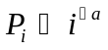; with the exponent a close to unity.
The plots were created for a number of ontologies – those created by enabling or disabling certain parsing flags. Most clearly showed signs of the inverse power law in action – a plot derived from the two most commonly used of our ontologies; that is, with and without leaves enabled is shown in Figure 5. The version with leaves enabled shows an extremely surprising correspondence to the inverse power law – an almost exact [R²-value is 0.99] fit to the function, 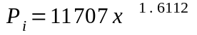 as shown in Figure 6. Clearly such precision is mostly fluke, but unfortunately 1.6 is comparatively distant from unity. The trend plot without leaves [not shown] yielded an R²-value of 0.93 and a closest fit to the function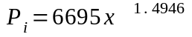.

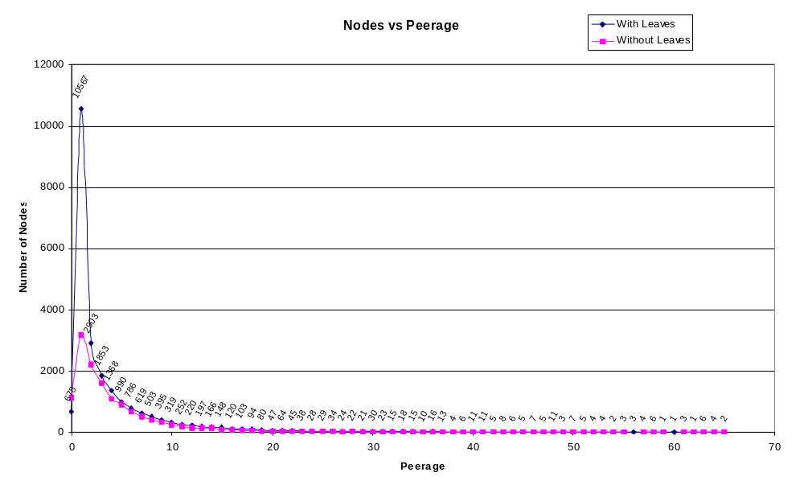
Figure 5 - Peerage vs. Rank for FOLDOC ontologies with and without leaves

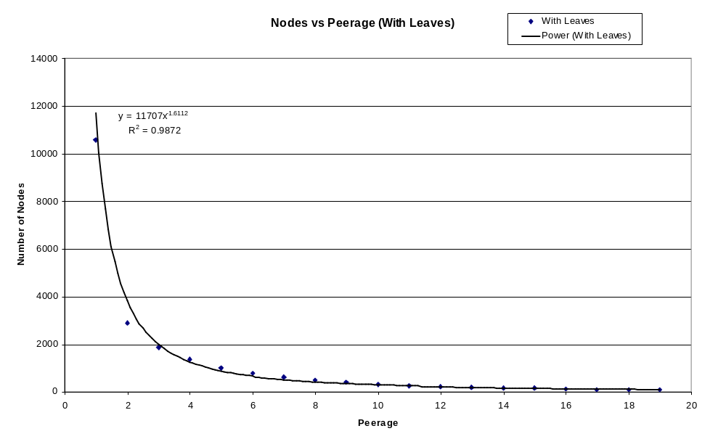
Figure 6 - Peerage vs. Rank for FOLDOC ontology with leaves (best fit)

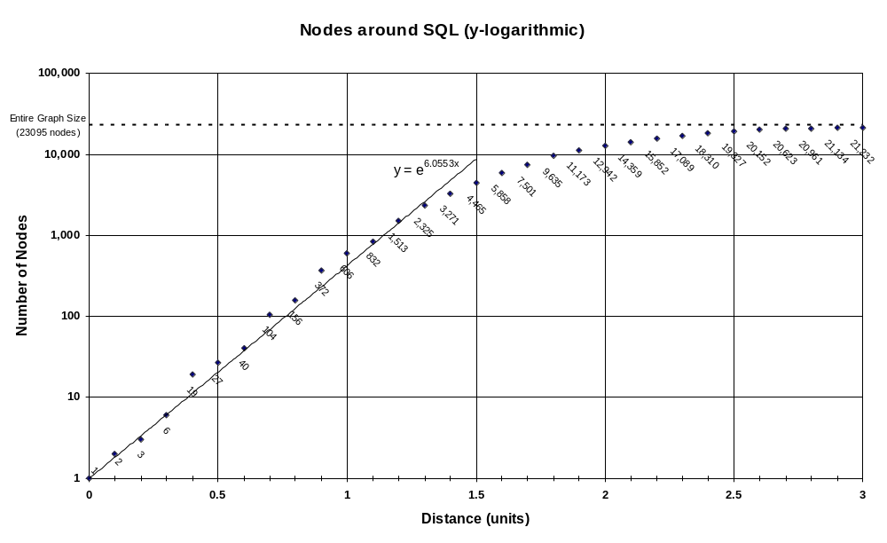
Another statistic was collected in order to determine the connectivity and breadth of coverage of the ontology. To show this, queries were performed from the (highly connected) concept, SQL. The resulting plot is shown in Figure 7. The findings were summarised in [18] with respect to the observed exponential increase due to branching factors (i.e. typical for a graph):
Figure 7 - Chart showing the size of progressively larger point queries from 'SQL'
The exponential increase in query size with respect to distance is seen in Figure 7. As the size of the query approaches the total number of nodes available, this relationship is clearly tapered, as expected, due to the limited scope of the ontology. Note that in this example, a particularly dense region of the ontology (SQL) was chosen as a starting point to achieve consistency at small distances. Most queries yield a distribution that starts slower and don’t achieve exponential growth until a distance of approximately 0.7, showing the same decay at a greater distance.

Adapting to Other Dictionaries
One of the features of the original project completed for COMP3809 was its speculated ability to easily adapt to other dictionary-like resources in order to automatically generate an ontology. This speculation proved to be quite true when the HCI glossary from www.usabilityfirst.com was processed into an ontology and hooked up to the same query tools.

Generating the Usability Ontology
The only real difficulty in generating an ontology from the usability glossary was the pre-processing involved in order to get it into a format similar to the FOLDOC dictionary for the parser. Each definition was on a separate html page, so after leeching the site and doing
$ tail –n+345 *.html > stage1.txt to combine them into one file, a few simple scripts were written to trim the html identify the source page and reformat each definition.
It was desired to identify the source page because this would allow Action→View Selected in VLUM to load the definition of the active concept in a side frame while navigating the ontology. The only change required to the parser and querying tools related to this functionality as it was now necessary to keep information with each node in addition to its name, which was all that was required to query FOLDOC via its CGI script. It was also necessary to make slight modifications to the xml output so that this information was used rather than the concept name. Once this was done, it was linked with the CGI scripts and made available online.
Testing using the CGI scripts showed some slight deficiencies. The usability glossary is not as well hyperlinked as FOLDOC and the links occur out of context, so much work towards the determination of link weight could not be applied. Future work may involve implementing a more sophisticated form of link detection to discover where the links occur in their context, as well as possibly detect more links to form a denser graph.
Another issue was the way in which terms were categorised in the glossary. In FOLDOC, there is only one level of categorisation, while terms in the glossary are categorised within a tree of categories – and not necessarily at a leaf. Currently, the category into which the concept is directly categorised is linked with each node. However, the relationships between categories are not established. In order to accomplish this it is a simple measure to manually append dictionary entries to the pre-processed dictionary to mimic the category relationships. There are few enough categories that this would not be impractical.
Now that we effectively have two ontologies, there is the possibility of merging them. Conceptually, HCI is a subset of computer science although, in this case, the glossary would provide more detail in this area. It can be accomplished simply by concatenating the two dictionaries and running the parser. However, there will need to be some form of conflict resolution if the View Selected functionality is to remain operational. This possibility has not yet been developed.
The usability ontology was only parsed recently, so full statistics have not yet been collected. The number of concepts in this ontology is 1124 concepts and there are 3412 relationships. However, the average peerage of approximately 6 that this would imply would be misleading, as a cursory examination has shown that there are frequently two edges between related concepts — one in each direction.

Related Research

Ontology Construction
Kietz et al [6] take a semi-automated approach to form a corporation-specific ontology by combining information from semi-structured information in a corporate intranet with information in core ontologies (specifically WordNet and GermaNet) and natural language documents. It is similar to MECUREO in that it analyses dictionary-like information in the form of domain-specific sources such as corporate glossaries. It uses a greater amount of NLP than MECUREO, but some of the methods are similar. For example, tokenisation occurs first and stemming is used to find word matches. However, their approach to stemming uses a lexicon of 700,000 word stems as opposed to an automated stemmer and concepts are created based on the stems, rather than using dictionary entries themselves to find known matches. There are further similarities in the use pattern matching, heuristics to determine relationships and a filtering stage. However, statistical methods are also used (this could later be incorporated into MECUREO, eg by giving a smaller weight to relationships that can be identified from more than one location in the dictionary). Furthermore, their (ongoing) work presented to date uses human interaction through visualisation tools to fine-tune the extracted ontology and a conflict resolution stage. They used empirical evaluation of the 518 concepts and 679 relationships produced in the final output and determined that 161 of the relations were wrong (i.e. 76% of all discovered relations were regarded correct by users). They do not give details of their evaluation technique, but do say that the evaluation is not yet complete. There was no specific mention of how the ontology created is to be used and how it might perform in its applications. I've been unable to find a follow-up paper.
Perhaps the canonical example of automatic acquisition of semantic information from text is MindNet, discussed by Richardson et al [7]. The techniques they present are a methodology for extracting information using a good deal of NLP. The specific example in this paper use a resource similar to the dictionary used by MECUREO (they use Microsoft Encarta) although there was no intent to use the resource as a dictionary (i.e. concepts are created by full detection rather than using dictionary headings). MindNet's focus is different from MECUREO's – concentrating on producing a general representation of semantic information, rather than a resource to use as the basis of more complex queries. They also evaluated the result using a thesaurus, although in their case it was a traditional [anti-] thesaurus of synonyms and antonyms rather than the hierarchical representation of the ASIS thesaurus. A similarity experiment with five humans compared MindNet's ability to detect synonyms and antonyms of words with that of the humans' – humans achieved 83% of synonyms and 93% of antonyms correct, while MindNet achieved 82% and 80% respectively.

Ontology Queries
Sutcliffe et al [14] focus on the creation of a lexicon for use in NLP, using a hierarchical concept ontology. There are similarities in their use of a heuristic approach and the use of weightings to represent relationships. They outline traversal algorithms applied to the ontology (WordNet in this case) that could be compared to the ontology queries in MECUREO. Indeed, they uncover many of the problems encountered in the first stages of MECUREO that were rectified by the use of heuristic weighting (as opposed to a more discrete approach). For example, their first algorithm traverses the graph by starting with a "centrality" of 1.0 and decreasing it by 0.1 at each level, which "suffers from a shortcoming which is that the number of possible features is very large". They do not give specific examples. They propose a second algorithm to overcome this with a similar theme (starting at 1.0 and decreasing by 0.1 at each level) but eliminate certain paths by tagging, disambiguation and elimination of certain types of words using information in WordNet. Their evaluation consisted of 'Similarity Tables' comparing the (normalised) result of the query with related lexical entries giving "interesting results but [without] 'proof' that the value shown for a particular match was correct". Therefore, they also carried out a psychometric evaluation to compare the tables with those created by human subjects. The technique is similar to that used for MECUREO, but it is matching of entries in a semantic lexicon that is being evaluated, rather than the ontology.

Matching

Edit Distance – agrep
Agrep uses the familiar edit distance algorithm first outlined in [4], but highly optimised to finding matches determined as "close" according to this edit distance in large volumes of text (it claims to be faster than many implementations of grep, in fact). Early experiments with agrep showed that edit distance was too inflexible for our applications. The need to specify a "distance" for a match to occur (i.e. in terms of the number of modifications to the string) did not suit the need to find a "nearest match" in order to match keywords to a small number of concepts in the ontology. Furthermore, the computer science context meant that edit distance made some obscure matches at many stages. For example, many acronyms were matched after a small change, but caused matches to completely unrelated concepts in the ontology.
To evaluate this, a word list was created consisting of all the concepts in the ontology and it was searched using some example queries. If there was no exact match, the edit distance was increased, but this usually resulted in a large number of matches – perhaps only one of which was related to the query – and no way to separate the 'closeness' of matches with the same edit distance.

Stemming
Stemming proved more fruitful, but there were still issues to be resolved, as discussed in [18]:
There are significant obstacles in developing a good matching procedure for concepts in the computer science domain. There is detail that would be lost if a simple stemmer, edit distance or even case-insensitivity is used to match terms. For example, there is COM (Component Object Model or Computer On Microfilm) and there is com (www...com) for which two, distinct and distant nodes exist. Furthermore, the vast number of acronyms and proper nouns in our ontology are not suited to a stemmer for the English language. There is also an obstacle in the form of the size of our ontology, which makes a full scan of concepts time consuming.
The procedure [currently] matches concepts simply on the case-insensitive stems of their component words. This takes constant time for each concept to be matched as string hashing is performed. However, if no stem match was found, a substring search is performed that takes linear time (on the size of the ontology ~10⁴) for each concept to be matched. The stemmer used is a version of the Porters stemmer [3], slightly modified to perform on the international-English used in the FOLDOC resource. For the query '"STRATEGY" "neural networks" "data marts"', the nodes ShowCase STRATEGY (www://www.showcasecorp.com), neural network, neural networks and data mart are matched.

Details about the manner in which this was overcome is discussed in the section of this report. It uses the Porter's stemming algorithm from [3], which proved very useful.

Similarity Measurement
Rahm et al [1] give a thorough survey of approaches to match schema. That is, their goal is to match (rather than compare using a canonical scale such as the reals in [0, 1]) components of data definitions (rather than data [models] themselves). They focus on matching related structures in SQL and conceptual data models to then show similarity on a canonical scale. It was difficult to find specific techniques that could be applied to MECUREO in this paper. However, there are good outlines of a range of specific approaches in 7 papers that address this task from which techniques may be gleaned, but these have not yet been followed up. Again, these papers focus on matching between data definitions for databases.
Visser et al [16] present some criteria for the comparison of two specific ontologies in the legal domain. However, their comparison techniques are completely manual – assessing epistemological adequacy, operationality and reusability of the ontologies. Their techniques for manually comparing metrics such as "Do all concepts and relations in the ontology gave a clear and unequivocal meaning?" are not outlined – rather they discuss qualitatively the properties of each of the ontologies with respect to the metrics, resulting on only qualitative conclusions that they apply to ontologies in general. While interesting, and a good background on what is 'good' about an ontology [eg as a means for evaluation], the techniques could not be applied to an automated approach to measuring similarity of models.
Leake et al [10] outline four different methods for comparing conceptual structures in the context of concept mapping. Some of the techniques formally presented here have been implemented more or less informally in MECUREO already. Their results are presented briefly, but show different methods achieving the "best results" depending on the application. An experiment with 10 graduate students yielded a "correlation factor" of 0.77 between their combined comparison methods and the evaluations made by their human subjects. In another paper [11] they present their ongoing research (results are not presented) directed towards case based reasoning within concept maps to support knowledge. Some of the techniques may be able to link MECUREO queries closer to AI classification applications, but this focuses on reasoning with a single model (the entire concept map) rather than comparison of two models within an ontology.
Eklund et al [2] address classification of Email models using an ontology. Rather than creating a model for each email, it assigns an email to a classifier and focuses on navigation through the set of emails organised in a lattice (rather than the traditional tree). It performs the navigation using concepts detected in each email using the assigned classifier. It discusses how the conceptual ontology thus formed can leverage traditional Information Retrieval systems. However, it relies on human interaction to form the conceptual ontology.

Other references mentioned in the papers above that I have not yet had time to go through, or have been unable to find, but may provide further insight to techniques that could be applied to MECUREO include:
G. Spanoudakis, P. Constantopoulos. Similarity for analogical software reuse: A computational model. In Proc. of ECAI-1994.
(Addresses measures for comparison of ontological structures in software engineering)
R. Rada, H. Mili, E. Bicknell, M. Blettner. Development and application of a metric on sematic nets. IEEE Transactions on Systems, Man and Cybernetics 1989.
E. Agirre, G. Rigau. Word sense disambiguation using conceptual density. In Proc. of COLING-1996.
E. Hovy. Combining and standardizing large-scale, practical ontologies for machine translation and other uses. In Proc of the First Int. Conf. on Language Resources and Evaluation, 1998.
R. Dieng, S. Hug. Comparison of personal ontologies represented through conceptual graphs. In Proc. of ECAI, 1998.
(The last four address comparison measures for AI)
G. Bisson. Learning in FOL with a similarity measure. In Proc. of AAAI-1992.
P. Weinstein, W. Birmingham. Comparing concepts in differentiated ontologies. In Proc. of KAW-1999.
(The last two address comparison between mostly disparate ontologies – rather than models within a single ontology)
B. Falkenhainer, K. Forbus, D. Gentner. The structure-mapping engine: Algorithm and examples. Artificial Intelligence 41, 1989.
(Addressing comparison of conceptual structures in general)

Bibliography
[1] E. Rahm, P. A. Bernstein. A survey of approaches to automatic schema matching. VLDB, 1001.
[2] P. Eklund, R. Cole. Structured Ontology and IR for Email Search & Discovery. ADCS, 2001.
[3] M. F. Porter. An algorithm for suffix stripping. Program, 1980.
[4] I. V. Levenshtein. Binary Codes capable of correcting deletions, insertions, and reversals. Cybernetics and Control Theory, 1966.
[5] D. Moldovan, R. Girju, V. Rus. Domain-Specific Knowledge Acquisition from Text. ANLP, 2000.
[6] J. Kietz, R. Volz. Extracting a Domain-Specific Ontology from a Corporate Intranet. Proceedings of CoNLL-2000 and LLL-2000, Lisbon, Portugal, 2000.
[7] S. D. Richardson, W. B. Dolan, L. Vanderwende. MindNet: acquiring and structuring semantic information from text. ACL, 1998.
[8] G. A. Miller, R. Beckwith, C. Fellbaum, D. Gross, K. Miller. Introduction to WordNet: An On-line Lexical Database. 1990 (revised 1993).
[9] A. Maedche, S. Staab. Measuring Similarity between Ontologies. EKAW, 2002.
[10] D. B. Leake, A. Maguitman, A. Cañas. Assessing Conceptual Similarity to Support Concept Mapping. Proceedings of the Fifteenth International Florida Artificial Intelligence Research Society Conference, 2001.
[11] D. B. Leake, A. Maguitman, A. Cañas. Towards Experience-Based Support for Knowledge Modelling. AAAI, 2001.
[12] P. Becker, P. Eklund. Using formal concept analysis for document retrieval. ADCS, 2001.
[13] H. Suryanto, P. Compton. Discovery of Ontologies from Knowledge Bases. First International Conference on Knowledge Capture, 2001.
[14] R. F. E. Sutcliffe, D. O'Sullivan, A. McElligot, L. Sheahan. Creation of a Semantic Lexicon by Traversal of a Machine Tractable Concept Taxonomy. Journal of Quantitative Linguistics, 1995.
[15] P. Resnik. Semantic Similarity in a Taxonomy: An Information-Based Measure and its Application to Problems of Ambiguity in Natural Language. Journal of Artificial Intelligence Research, 1999.
[16] P. R. S. Visser, T. J. M. Bench-Capon. A Comparison of Two Legal Ontologies. 1998.
[17] T. Apted and J. Kay. Automatic Construction of Learning Ontologies. ICCE, 2002 Workshop on Ontologies for Learning, to appear.
[18] T. Apted and J. Kay. Generating and Comparing Models within an Ontology. ADCS, 2002.
[19] J. T. Stasko, J. S. Vitter. Pairing Heaps: Experiments and Analysis. Communications of the ACM 32, 1987.
[20] B. M. E. Moret and H. D. Shapiro. An Empirical Analysis of Algorithms for Constructing a Minimum Spanning Tree. Proceedings of the Second Workshop on Algorithms and Data Structures, 1991.
[21] ASIS [American Society for Information Science] Thesaurus of Information Science; (first visited 2002-08-08), at http://www.asis.org/Publications/Thesaurus/isframe.htm. Published 2002-02-07.

Timeline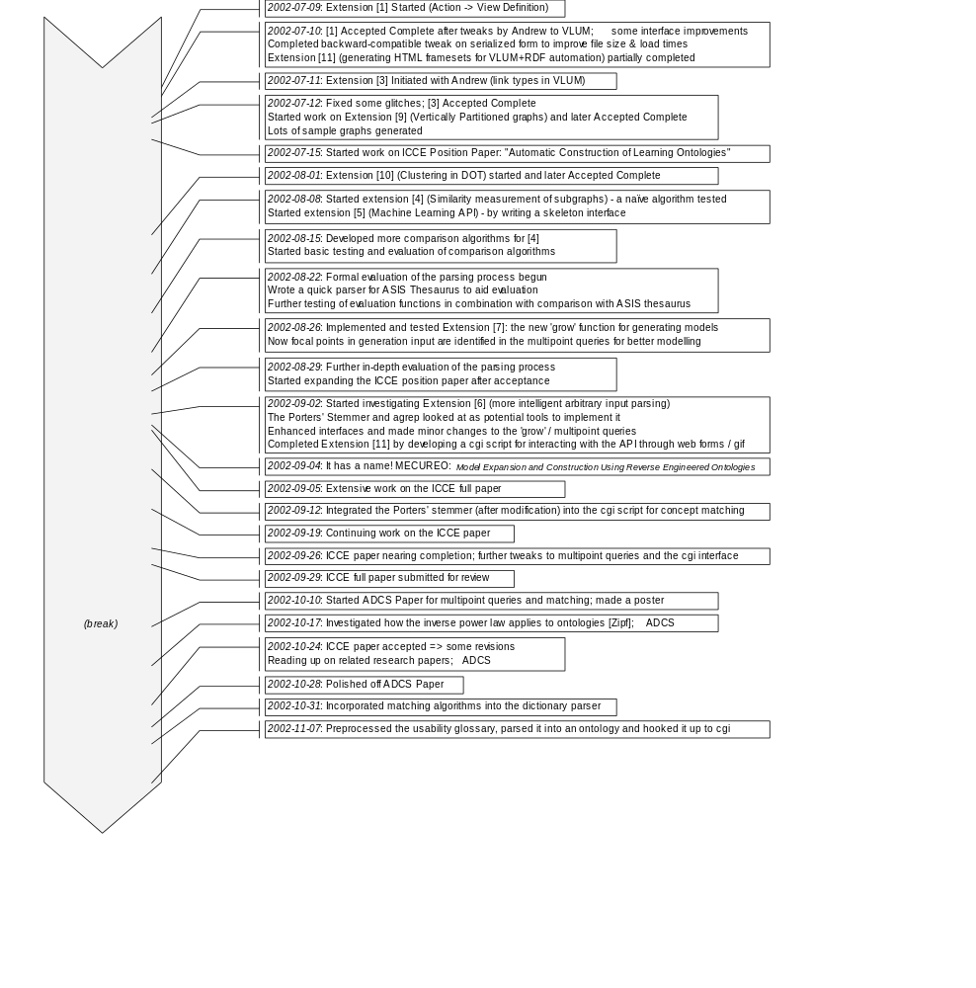
T
I
M
E
L
I
N
E

Originally, "Model Expansion and Comparison Using Reverse Engineered Ontologies"
http://www.ug.cs.usyd.edu.au/~tapted/mecureodoc/ is the current location of the Javadocs for the MECUREO system
The scalability of the Pairing Heap is still not completely determined. In practice, it generally performs better than the Fibonacci Heap on all operations [19], although recent research has shown that the amortized cost of a single decrease key operation is not O(1) as speculated ([20] has some empirical evidence; more recent research is working towards proving it).
Here, peerage is interpreted as the number of edges in or out of a node. Because subgraph and grow queries traverse edges in either direction (while they remain directed in the representation of the model), this is the number of concepts reachable via a single relationship edge in a query. Its calculation is simply given by 2*edges/nodes as the edges reported in the table are directed edges, and there is only rarely a situation in our ontology where there are two edges between the same two nodes.
The part of the algorithm for merging two graphs used in MST Similarity is unchanged from the COMP3809 implementation in first semester. However, there were changes relating to the implementation of clustering (see ).
Recently Prim's algorithm for finding the MST of a graph was implemented for a HashGraph, using a PairingHeap. This means the stated runtime remains speculative (see footnote 3)
Except where there is a direct relationship between a concept in one part and a concept in the other parts, and the parts are otherwise completely disjoint. This is very rare, so it is safe simply to cap finalSimilarity at 1.0.
The ontology generated using matching in the parser has since replaced the file used to generate the original Error: Reference source not found in the CGI scripts, so re-loading the URL now produces a slightly different image. Most notably, neural network and neural networks are the same node.
The entire FOLDOC ontology is quite large and Java remains relatively slow for some applications (particularly when the JIT compiler is disabled as it is on the undergraduate machines).

