Coding Challenge 4

Theresa Quintana

2025-02-27

Question 1. Explain the following

1. YAML (yet another markup language) header: a human-readable data format used for configuring R Markdown. It appears as a metadata block at the beginning of an R Markdown file that specifies the final file format, styling, and other settings.
2. Literate programming: combines code and documentation/explanation in a human-readable format. This helps make programs easier to understand because writing code is not just for machines!

You can find the corresponding documents to this assignement on my GitHub: [Theresa’s Coding Challenge 4 Github Access](https://github.com/taq-poly/CodingChallenge4.git)

The data used in this assignment was provided by: Noel, Z.A., Roze, L.V., Breunig, M., Trail, F. 2022. Endophytic fungi as promising biocontrol agent to protect wheat from Fusarium graminearum head blight. Plant Disease. [See the paper here](https://doi.org/10.1094/PDIS-06-21-1253-RE)

#install.packages('tinytex')  
#tinytex::install_tinytex()  
library(ggplot2)  
library(tidyverse)  
library(ggpubr)  
library(ggrepel)  
library(ggprism)  
library(knitr)  
  
#getwd()  
mycotoxin <- read.csv("MycotoxinData.csv", na.strings = "na")

#Question 2 - Change the factor order level so that the treatment “NTC” is first, followed by “Fg”, “Fg + 37”, “Fg + 40”, and “Fg + 70”.

mycotoxin$Treatment <- factor(mycotoxin$Treatment, levels = c("NTC", "Fg", "Fg + 37", "Fg + 40", "Fg + 70"), ordered = TRUE)

#Question 2 Boxplot

Question_2 <- ggplot(mycotoxin, aes(x = Treatment, y = DON, color = Cultivar)) +  
 geom_boxplot() +  
 geom_point(position = position_jitterdodge(jitter.width = 0.6)) +  
 scale_color_manual(values = c("#E69F00", "#0072B2")) +  
 xlab("") +  
 ylab("DON (ppm)") +  
 theme_classic() +  
 facet_wrap(~Cultivar)  
Question_2

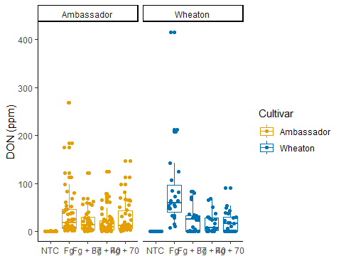

#Question 3a - Change the y-variable to plot X15ADON. The y-axis label should now be “15ADON”.

Question_3a <- ggplot(mycotoxin, aes(x = Treatment, y = X15ADON, color = Cultivar)) +  
 geom_boxplot() +  
 geom_point(position = position_jitterdodge(jitter.width = 0.6)) +  
 scale_color_manual(values = c("#E69F00", "#0072B2")) +  
 xlab("") +  
 ylab("15ADON") +  
 theme_classic() +  
 facet_wrap(~Cultivar)  
Question_3a

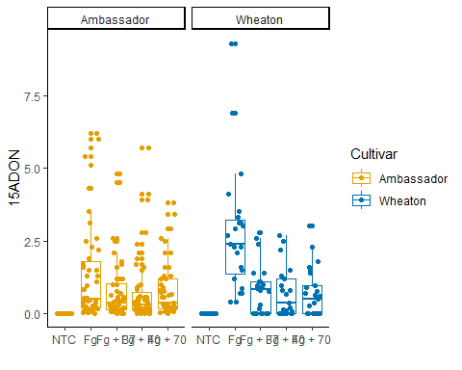

#Question 3b - Change the y-variable to plot MassperSeed_mg. The y-axis label should now be “Seed Mass (mg)”.

Question_3b <- ggplot(mycotoxin, aes(x = Treatment, y = MassperSeed_mg, color = Cultivar)) +  
 geom_boxplot() +  
 geom_point(position = position_jitterdodge(jitter.width = 0.6)) +  
 scale_color_manual(values = c("#E69F00", "#0072B2")) +  
 xlab("") +  
 ylab("Seed Mass (mg)") +  
 theme_classic() +  
 facet_wrap(~Cultivar)  
Question_3b

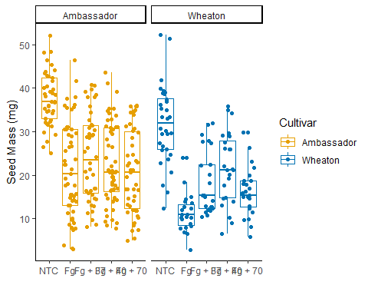

#Question 5 - Use geom_pwc() to add t.test pairwise comparisons to the three plots made above. Save each plot as a new R object, and combine them again with ggarange as you did in question 4.

Stats_Question_2 <- Question_2 +  
 geom_pwc(aes(group = Treatment), method = "t_test", label = "p.adj.signif")  
#Stats_Question_2  
  
Stats_Question3a <- Question_3a +  
 geom_pwc(aes(group = Treatment), method = "t_test", label = "p.adj.signif")  
#Stats_Question3a  
   
Stats_Question3b <- Question_3b +  
 geom_pwc(aes(group = Treatment), method = "t_test", label = "p.adj.signif")  
#Stats_Question3b  
  
#combination graph  
Question_5Combo <- ggarrange(Stats_Question_2, Stats_Question3a, Stats_Question3b, labels = "auto",  
 nrow = 1,  
 ncol = 3,   
 common.legend = T)  
Question_5Combo

