DATA ANALYTICS PROJECT REPORT

Customer Shopping Behavior Analysis
An end to end analysis using Python SQL and Power BI
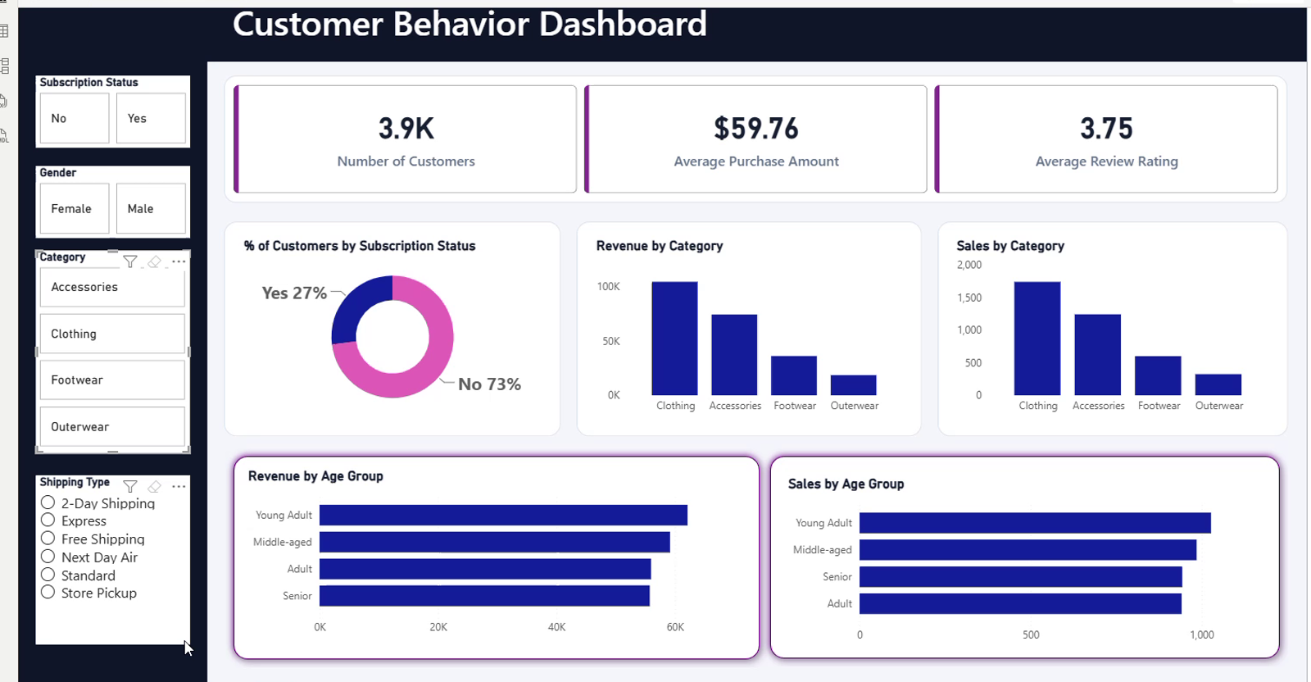
Final interactive dashboard developed in Power BI
Prepared by | Taki Abbas
Project type | Customer analytics and business intelligence
Tools | Python Pandas | MySQL | Power BI | DAX

Executive Summary
This project analyzes 3,900 customer shopping records to explain purchasing patterns, revenue concentration, customer engagement, subscription behavior, and product performance. The workflow combines Python for data preparation, MySQL for business analysis, and Power BI for interactive reporting.
The analysis shows that the business generated $233,081 in revenue with an average purchase value of $59.76 and an average review rating of 3.75. Clothing is the largest category by both sales and revenue, young adults contribute the most revenue, and 73% of customers are not subscribed. These findings point to clear opportunities in subscription conversion, targeted category promotions, and customer-experience improvement.

Project at a Glance
Measure | Result | Interpretation
Customer records | 3,900 | A broad customer-level dataset for segmentation
Total revenue | $233,081 | Overall purchase value represented in the data
Average purchase | $59.76 | Typical value of a customer purchase
Average rating | 3.75 / 5 | Generally positive, with room to improve
Subscribed customers | 27% | Most customers remain available for conversion

End to End Workflow
Step | Stage | Purpose
1 | Understand | Inspect structure, data types, completeness, and business meaning
2 | Clean | Treat missing ratings and standardize column names
3 | Engineer | Create age-group and purchase-frequency features
4 | Analyze | Answer ten business questions in MySQL
5 | Model | Create DAX measures and reporting fields in Power BI
6 | Visualize | Build the interactive dashboard and translate findings into actions

1 Project Definition

Business Objective
The objective was to convert transaction-level customer data into a clear view of shopping behavior. The project focuses on who buys, what they buy, how much they spend, how frequently they return, and which factors can support better marketing and retention decisions.

Questions Addressed
- How much revenue is generated by male and female customers?
- Which discount users spend at or above the overall average purchase amount?
- Which products receive the highest average ratings?
- How do key shipping options compare?
- Do subscribed customers spend more than non-subscribers?
- Which items have the highest discount usage rate?
- How can customers be grouped as New, Returning, or Loyal?
- Which three products lead sales within each category?
- How does repeat purchasing differ by subscription status?
- Which age group contributes the most revenue?

Technology Stack
Tool | Role in the Project
Python and Pandas | Exploration, missing-value treatment, renaming, and feature engineering
Jupyter Notebook | Documented and reproducible data-preparation workflow
MySQL | Business questions, aggregations, segmentation, CTEs, and window functions
Power BI | Data modeling, DAX measures, interactive filters, and final dashboard

2 Dataset Understanding
The dataset contains 3,900 rows and 18 original columns. Each row represents one customer shopping record and combines demographic, product, purchase, promotion, shipping, engagement, and payment information.
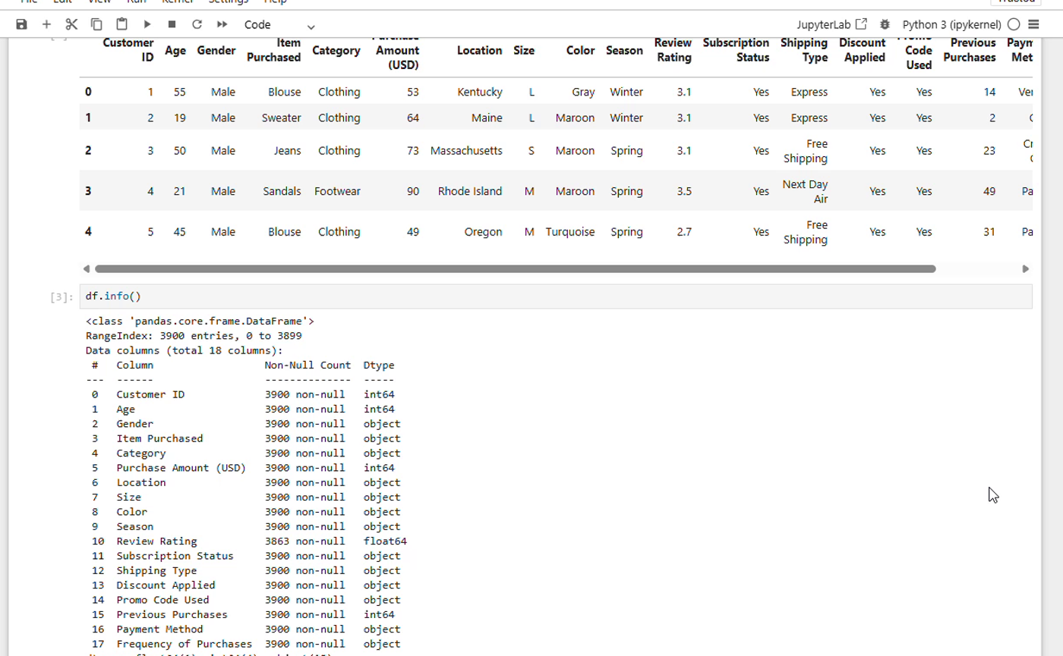
Initial data preview and structure inspection in Jupyter Notebook

Field Groups
Group | Fields | Analytical Use
Customer | Customer ID, Age, Gender, Location | Customer profiling and geographic or demographic segmentation
Product | Item Purchased, Category, Size, Color, Season | Product mix, category performance, and preference analysis
Purchase | Purchase Amount, Previous Purchases, Frequency of Purchases | Revenue, value, frequency, and loyalty analysis
Experience | Review Rating, Shipping Type, Payment Method | Service preference and satisfaction analysis
Promotion | Discount Applied, Promo Code Used, Subscription Status | Offer response and subscription analysis

3 Data Cleaning and Feature Engineering

Step 1 Data Profiling
The dataset was inspected with df.info(), descriptive statistics, and null counts. Seventeen columns were complete. Review Rating contained 3,863 non-null values, leaving 37 missing values to resolve.

Step 2 Missing Value Treatment
Missing review ratings were filled with the median rating of the corresponding product category. Category-level median imputation preserves differences between categories and is less sensitive to extreme ratings than a mean-based replacement.

Step 3 Column Standardization
Column names were converted to lowercase snake_case by trimming whitespace and replacing spaces with underscores. Purchase Amount (USD) was renamed to purchase_amount. This produced SQL-friendly, consistent field names such as customer_id, item_purchased, review_rating, and subscription_status.

Step 4 Feature Engineering
New Field | Logic | Why It Matters
age_group | Age ranges classified into Young Adult, Adult, Middle-aged, and Senior | Supports demographic comparison of revenue and sales
purchase_frequency_days | Frequency labels mapped to approximate days such as Weekly 7, Fortnightly 14, Monthly 30, Quarterly 90, and Annually 365 | Converts text frequency into an analysis-ready numeric interval
customer_segment | Previous purchases used to classify New, Returning, and Loyal customers | Creates an actionable loyalty view for SQL analysis

Step 5 Quality Verification
Null counts were checked again after imputation. The cleaned column list and derived fields were reviewed before the data was loaded into MySQL and Power BI.

4 SQL Business Analysis
Ten SQL questions were designed to move beyond descriptive totals and test revenue, customer value, discount behavior, product performance, subscription engagement, and loyalty. The work demonstrates filtering, grouping, conditional logic, subqueries, common table expressions, and window functions.
No | Business Question | SQL Technique
1 | Revenue generated by male versus female customers | SUM and GROUP BY
2 | Discount users spending at or above average | Subquery and filtering
3 | Top five products by average review rating | AVG, ROUND, ORDER BY, LIMIT
4 | Comparison of selected shipping methods | IN filter and GROUP BY
5 | Subscriber versus non-subscriber spend and revenue | COUNT, AVG, SUM
6 | Top items by discount usage rate | CASE expression and percentage calculation
7 | New, Returning, and Loyal customer segments | CASE expression
8 | Top three products inside each category | CTE and ROW_NUMBER window function
9 | Repeat buyers by subscription status | Conditional filter and aggregation
10 | Revenue contribution by age group | SUM, GROUP BY, descending rank

Representative Advanced Query
WITH item_counts AS (
SELECT category, item_purchased,
COUNT(customer_id) AS total_orders,
ROW_NUMBER() OVER (PARTITION BY category
ORDER BY COUNT(customer_id) DESC) AS item_rank
FROM customer
GROUP BY category, item_purchased
)
SELECT item_rank, category, item_purchased, total_orders
FROM item_counts WHERE item_rank <= 3;

5 Power BI Dashboard Development
The final dashboard brings the main indicators and comparisons into one interactive view. The design uses a compact KPI band, category and age-group comparisons, a subscription donut chart, and a left-side filter panel. Users can filter the complete report by subscription status, gender, category, and shipping type.
Customer Behavior Dashboard with KPI cards, charts, and interactive slicers

Dashboard Components
Component | Metric or Dimension | Purpose
KPI cards | Customers, average purchase, average rating | Immediate summary of scale, value, and satisfaction
Donut chart | Subscription status | Shows subscriber penetration
Column charts | Revenue and sales by category | Compares commercial performance across categories
Bar charts | Revenue and sales by age group | Highlights demographic contribution
Slicers | Subscription, gender, category, shipping | Supports interactive exploration

6 Key Findings

Category Performance
Category | Revenue | Revenue Share | Sales | Interpretation
Clothing | $104,264 | 44.73% | 1,737 | Largest category by revenue and volume
Accessories | $74,200 | 31.83% | 1,240 | Strong second category and cross-sell opportunity
Footwear | $36,093 | 15.49% | 599 | Mid-sized contribution
Outerwear | $18,524 | 7.95% | 324 | Smallest category in the current mix

Age Group Revenue
Age Group | Revenue | Share of Total | Rank
Young Adult | $62,143 | 26.66% | 1
Middle-aged | $59,197 | 25.40% | 2
Adult | $55,978 | 24.02% | 3
Senior | $55,763 | 23.92% | 4

Customer Engagement
- Approximately 1,053 customers are subscribed and 2,847 are not subscribed, producing a 27% versus 73% split.
- The large non-subscriber segment is the clearest conversion opportunity in the dashboard.
- The 3.75 average rating suggests broadly positive feedback, but it is not high enough to treat customer experience as fully optimized.
- Revenue is relatively balanced across age groups, although young adults lead the ranking.

7 Business Recommendations
Priority | Recommended Action | Reason
High | Create a targeted subscription conversion campaign for non-subscribers | Seventy-three percent of customers are currently outside the subscription base
High | Protect Clothing availability and use it to cross-sell Accessories | Together, the two categories generate more than three quarters of revenue
Medium | Develop age-specific creative and offers for young adults | Young adults lead revenue and sales in the dashboard
Medium | Review low-rated products and service touchpoints | An average rating of 3.75 leaves measurable room for improvement
Medium | Use loyalty segments for differentiated communication | New, Returning, and Loyal customers should not receive the same message
Low | Test seasonal bundles for Footwear and Outerwear | The smaller categories can be developed without weakening the core Clothing offer

8 Skills Demonstrated
- Data profiling, missing-value treatment, and feature engineering with Pandas
- Relational analysis using aggregations, subqueries, CASE logic, CTEs, and window functions
- Power BI modeling and DAX measure creation
- Dashboard layout, KPI design, chart selection, and interactive filtering
- Translation of technical analysis into business findings and recommendations

Conclusion
This project successfully converts a raw customer-shopping dataset into a complete analytical workflow and an interactive decision-support dashboard. It identifies the categories and customer groups that drive performance, makes the subscription gap visible, and provides practical actions for marketing, merchandising, and retention.
The strongest result is the integration of Python, SQL, and Power BI into one coherent case study. The project demonstrates not only technical execution, but also the ability to frame business questions, validate data, communicate findings, and recommend next steps.

Portfolio Summary
Analyzed 3,900 customer-shopping records using Python and MySQL, created customer and purchase-frequency features, answered ten business questions with advanced SQL, and built an interactive Power BI dashboard with DAX KPIs and dynamic filters. The analysis identified $233,081 in revenue, Clothing as the leading category, young adults as the highest-revenue age group, and a major subscription-conversion opportunity among the 73% non-subscriber segment.

