# Assignment 4

TOTAL: 50 + 10 pts.

You will need two databases, “world” and “om”, to complete the assignment. Scripts that create and populate databases are provided in Asg04_Databases.zip file in the Files section in Canvas.

What to submit:

1. ONE SQL script file with the query solutions of all 6 problems.
   1. Use SQL comments to mark the script with the question number it corresponds to.
   2. Make sure the file is signed, include your name in comments.
2. Word document with 8 screen shots of the results of execution of 8 queries. Please MARK THE SCREENSHOT with the QUESTION NUMBER.

Following are the questions related to the data stored in the “world” database. Write SQL queries that will provide the requested information.

1. How many countries are there on each continent? The query returns 7 rows. See screen shot below.

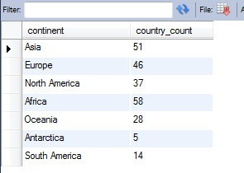

1. Find the number of cities and the total population of the cities in all the regions of the continent ‘Oceania’. The results should show the region, its city count, and total count of population living in those cities. Order results by region. See the screenshot below. Returns 4 rows.

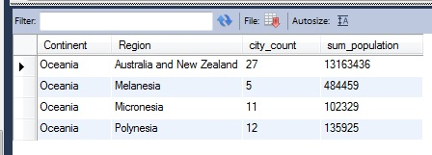

1. For each country find the city (in this country) with the largest population. Order results by population. Returns 232 rows. Format your results to look like the table below.

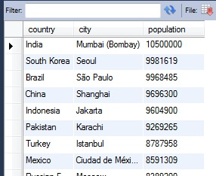

1. This one is a population analysis query. For each country in Europe (as continent) find countries’ population, sum of populations of all the cities in the database that are located in the country and percentage of country population that lives in the city (that is sum of all cities population divided by country population). Get all the countries that have more than 30% of population living in the cities. Please format your output like one in the screen shot. Returns 20 rows.

NOTE: We can see the data flaws of the database right away because Gibraltar has more than 100% of population living in the cities…

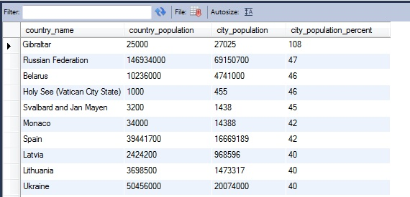

1. (10 pts.) Find countries which population is less than population of the country named Anguilla. Do not include countries with population 0. Retrieve country names, region and their population. Sort the results first by population, then by region, then by country name. You should get 11 rows. See screen shot below.

HINT: Use self-join.

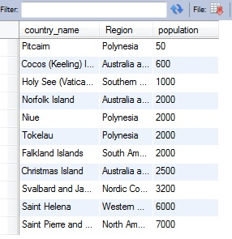

1. (10 pts.) Find title, artist name and unit price of all the items that are priced the same as the item named 'Umami In Concert'. Include 'Umami In Concert' into the resulting set. Order results by title. The result contains 3 rows.

HINT: Use self-join.

