# Assignment 5

TOTAL: 70 pts. (+10 pts)

You will need two databases, “world” and “om”, to complete the assignment. Scripts that create and populate databases are provided in Create_DB_Files folder in the files section in Canvas.

What to submit:

1. ONE SQL script file with the query solutions of all problems.
   1. Use SQL comments to mark the script with the question number it corresponds to.
   2. Make sure the file is signed, include your name in comments.
2. Word document with screen shots of the results of execution of the queries. Please MARK THE SCREENSHOT with the QUESTION NUMBER.

Following are the questions related to the data stored in the “world” database. Write SQL queries that will provide the requested information.

1. (10 pts.) Find names and populations of the countries that have Dutch as their official language. Order by country name. Returns 4 rows. See results below.

**REQUIREMENT**: Do not use JOIN, use subquery.

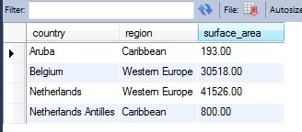

1. (10 pts.) Find city names and populations of the cities in 'Western Europe' region that have the city population larger than the average population of the cities in the country they are in. Include names of countries, city names, and city populations in the query results. Order results by country name and then by city name. This will be a ‘correlated subquery’.

Returns 41 rows. See screen shot below.

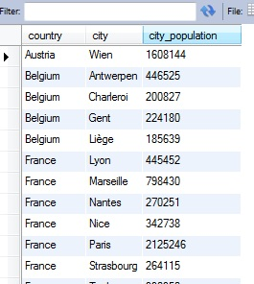

1. (10 pts.) Find the list of all the countries in the database that don’t have information about country language. Display region, country name and population. Returns 6 rows.

**REQUIREMENT:** Do NOT use JOIN, use subquery

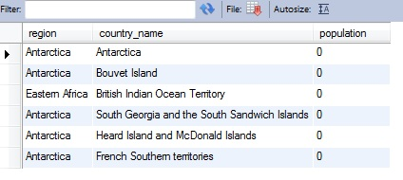

1. (10 pts.) Find all the countries that have surface area less than the surface area of Andorra. (**Requirement**: Do not find and then hard code the surface area number. Formulate your query so that it retrieves the number). Include country name, continent, and surface area into the result. Order by surface area in ascending order. Returns 43 rows.

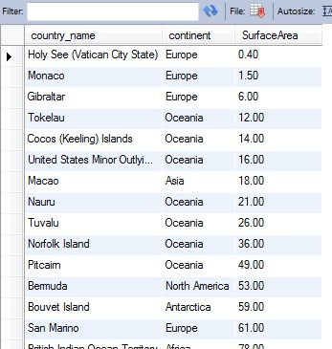

1. (10 pts.) Find all the countries that have the same official language as Belgium. Please note that Belgium has more than one official language. Order results first by language, then by country name. Returns 28 rows.

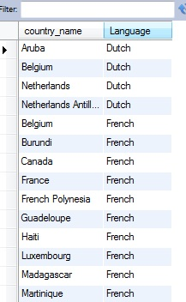

1. (10 pts.) Find all the countries on continent Africa that have French as official language. Order results by country name. Returns 5 rows.

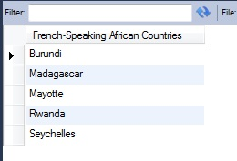

Following are the questions related to the data stored in the “om” database. Write the SQL queries that will provide the requested information.

1. (10 pts.) For each customer calculate the total number of items purchased. Keep in mind that each order may contain more than one purchased item. Find those that purchased more than 5 items. Returns 4 rows.

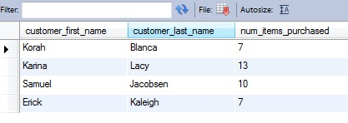

1. (10 pts.) For each customer get the most recent order date. Order by the order date from the most recent to the earlier ones. Returns 25 rows. Format the results same as they appear in the screenshot below.

REQUIREMENT: Use subquery, do not use JOIN

