# Assignment 6

TOTAL: 70 (+10) pts.

Now that we are approaching the end of the quarter and the end of the course, I am trying to get you “riding your bike” without my help.

For the following exercises you will need to do some digging into different resources along with figuring issues on your own.

You will need the database “ap” for this assignment. The scripts that create and populate databases are provided in the Create_DB_Files folder in the files section in Canvas.

What to submit:

1. **ONE SQL** script file with the query solutions of all queries.
   1. Use SQL comments to mark the script with the question number it corresponds to.
   2. Make sure the file is signed, include your name in comments.
   3. The script must run from start to finish with one call.

Word document with screen shots of the results of execution of the queries. Please MARK THE SCREENSHOT with the QUESTION NUMBER.

**Duplicate Table Exercise**

1. (10 pts) Figure out how to display the Table Information Tab in MySQL Workbench and place a screenshot of the **vendors** table in your Word document labeled a) (The example below shows the invoices_archive table- this is for demonstration and I don’t want you to submit my own screenshot!)

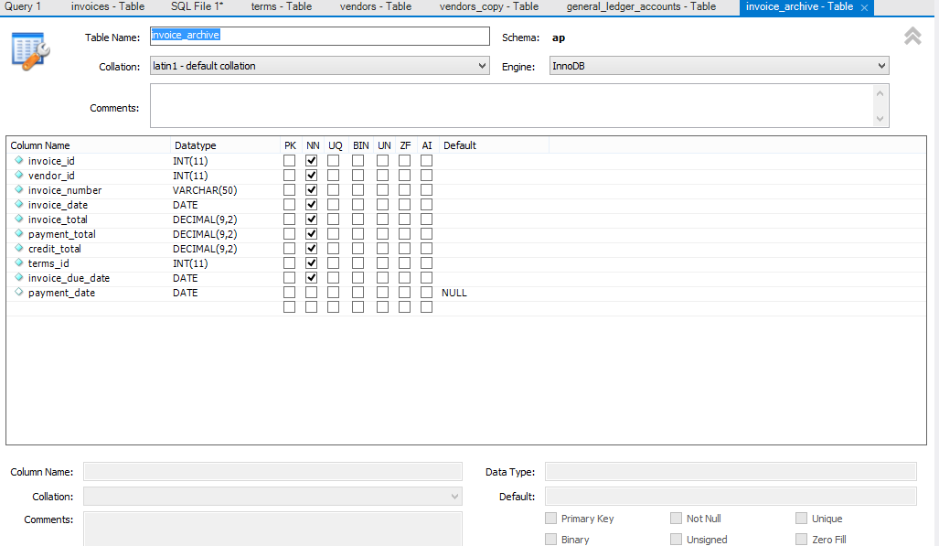

1. (10 pts) Create a duplicate of the vendors table named vendors_copy with the CREATE TABLE AS statement and put a screenshot of the table information in your Word document.
2. (5 pts) What are the differences in the tables between a) and b) and why are there differences? Your answer marked as c) in the Word document.
3. (10 pts) In order to create a duplicate table with the same behavior of the original table you must obviously do something else, one approach would be to create a new table, bring up the Table Information Tab and select the same boxes that are selected in the original table. After that you fill the new table with the records from the old table with the INSERT command. Do this for the general_ledger_accounts (general_ledger_accounts_table_copy) table, put the sql query in you sql file and the table information screenshot marked d) in the Word document.
4. (15 pts) Here comes a more professional way to duplicate a table with the same attributes. There is a way to find a query how the original table can be created. (Hint: Documentation in dev.mysql.com – Look up the description for the “DESCRIBE” statement and go from there to further information links. SHOW syntax related to creating tables. ) Put the query for the **invoices** table to your sql file and the screenshot of the result to the Word document.
5. (5+10pts)The result of e) leads to the following output line:

'invoices', 'CREATE TABLE `invoices` (\n `invoice_id` int(11) NOT NULL AUTO_INCREMENT,\n `vendor_id` int(11) NOT NULL,\n `invoice_number` varchar(50) NOT NULL,\n `invoice_date` date NOT NULL,\n `invoice_total` decimal(9,2) NOT NULL,\n `payment_total` decimal(9,2) NOT NULL DEFAULT \'0.00\',\n `credit_total` decimal(9,2) NOT NULL DEFAULT \'0.00\',\n `terms_id` int(11) NOT NULL,\n `invoice_due_date` date NOT NULL,\n `payment_date` date DEFAULT NULL,\n PRIMARY KEY (`invoice_id`),\n KEY `invoices_fk_vendors` (`vendor_id`),\n KEY `invoices_fk_terms` (`terms_id`),\n KEY `invoices_invoice_date_ix` (`invoice_date`),\n CONSTRAINT `invoices_fk_terms` FOREIGN KEY (`terms_id`) REFERENCES `terms` (`terms_id`),\n CONSTRAINT `invoices_fk_vendors` FOREIGN KEY (`vendor_id`) REFERENCES `vendors` (`vendor_id`)\n) ENGINE=InnoDB AUTO_INCREMENT=115 DEFAULT CHARSET=latin1’

What do you need to do in the MySQL workbench to get a usable MySQL query out of this information? (Hint there is an option to copy that line). (5 pts) Once you have a valid query and you want to create the table invoices_exactcopy with this you need some adaptions. Adapt the query above or the one that you get out of the workbench (without \n and quotes) for the creation of the table invoices_exactcopy, put the query to your sql file and the screenshot of the run to the Word document. (10 pts)

1. (5 pts) Create a query that inserts all records from invoices into invoices_exactcopy, put the query to your sql file and the screenshot of the run to the Word document.
2. (10 pts) Write a query that finds the invoice with the newest date and update all invoice_date entries of the vendor with vendor_id = 123 to the date that is 1 day younger than this one in invoices_exactcopy, put the query to your sql file and the screenshot of the run to the Word document.