# Assignment 7

TOTAL: 70 pts.

You will need several databases for this assignment. The scripts that create and populate databases are provided in the Create_DB_Files folder in the files section in Canvas.

What to submit:

1. **ONE SQL** script file with the query solutions of all queries.
   1. Use SQL comments to mark the script with the question number it corresponds to.
   2. Make sure the file is signed, include your name in comments.
   3. The script must run from start to finish with one call.

Word document with screen shots of the results of execution of the queries. Please MARK THE SCREENSHOT with the QUESTION NUMBER.

1. (10 pts) (Database “ap”) Create a view named “open_items” that shows the invoices that haven’t been paid. It should display four columns from the Vendors and Invoices Tables:

vendor_name, invoice_number, invoice_total, and balance_due (invoice_total-payment_total-credit_total). A row should only be created when the balance_due is > 0. Sort alphabetically by vendor_name. Write SELECT statement that shows the complete view. Returns 11 Rows:

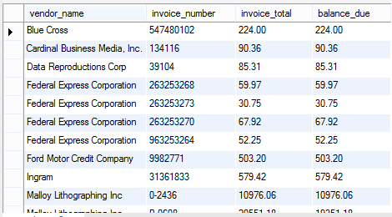

1. (10 pts) (Database “ap”) Create a view named “open_items_summary” that returns one summary row for each vendor that has invoices that haven’t been paid.

Each row should include vendor_name, open_item_count (the number of invoices with a balance due), and open_item_total (the total of the balance due amounts of this vendor). Write SELECT statement that shows the complete view. Returns 7 Rows:

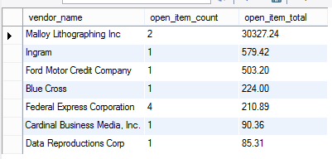

1. (10 pts) (Database “ap”) Write a SELECT statement that returns vendors firstname and lastname, balance due for all invoices with balance due >0. Sort by lastname. DO NOT USE the functions that you will create in 4.)!
2. (10 pts) (Database “ap”) Write a function that returns the firstname and another function that returns the lastname from the vendor_contacts table. Either of those functions will take invoice_id as (the only) input parameter.
3. (10 pts) Rewrite the SELECT statement in 3.) by using the functions created in 4.)
4. (10 pts) (Database “om”) Write a function that returns the most recent order date for a customer. Input parameters are customer_first_name and customer_last_name.
5. (10 pts) (Database “om”) Write a SELECT statement that returns for each customer the most recent order date. Use the function that you created in 6.) Order by the order date from the most recent to the earlier ones. Display the rows as shown in the screenshot below. Returns 25 rows.

