INTERNSHIP FINAL REPORT
DATA ANALYTICS
Beginner • Intermediate • Advanced

Field | Details
Student Name | Tara Bhramaramba
University | Srinivasa Institute of Engineering and Technology
Internship Duration | August 1st, 2026 – August 31st, 2026
Company | Shadow Fox
Role | Data Analytics Intern
Mentor | Mr. Aakash S

Executive Summary
This report consolidates the work completed across the Beginner, Intermediate, and Advanced levels of the Shadow Fox Data Analytics internship. The projects demonstrate a progression from foundational data cleaning and visualization to exploratory business analytics and executive HR analytics. The work includes cleaned datasets, KPI analysis, business visualizations, Tableau-style dashboards, interactive dashboard concepts, business insights, recommendations, reports, and presentation videos.

Report Structure
Level | Project Focus | Primary Outcome
Beginner | Superstore Sales Data Visualization | Basic KPIs, charts, dashboard and business insights
Intermediate | Customer & Revenue Analytics | Eight visualizations, deeper EDA, dashboard and recommendations
Advanced | IBM HR Attrition Analytics | HR KPIs, eight attrition visualizations, executive dashboard and decision-oriented storytelling

1. Objectives
The internship objectives, consolidated across all three levels, were:
- Understand the end-to-end data analytics workflow from dataset selection and preparation to visualization and reporting.
- Develop beginner-level skills in data cleaning, KPI creation, chart selection and dashboard design.
- Apply exploratory analysis to customers, products, revenue, regions, segments, profit and discount behavior.
- Apply advanced analytics to employee attrition and workforce characteristics.
- Create clear dashboards that communicate findings to technical and non-technical audiences.
- Translate analytical results into business insights and practical recommendations.
- Develop professional documentation, presentation and communication skills.

Level-wise Objectives
Level | Objectives
Beginner | Learn data preparation, basic KPIs, common business charts, dashboard layout and simple insights.
Intermediate | Perform deeper exploratory analysis and compare customer, product, regional, segment and profitability patterns.
Advanced | Develop HR-specific KPIs, analyze attrition risk, create an executive dashboard with filters/drill-down, and support management decisions.

2. Tasks and Responsibilities

2.1 Beginner Level – Sales Data Visualization
The Beginner level used a Superstore sales dataset to establish core data analytics skills.
- Inspected and prepared the dataset for analysis.
- Checked column names, data types, missing values, duplicates and consistency.
- Created KPI cards for key sales and profit measures.
- Created sales by region, monthly sales trend, profit by category, sales by category and top-product visualizations.
- Combined the visualizations into a Tableau-style dashboard.
- Prepared business insights, recommendations, report documentation and a 3-minute presentation video.
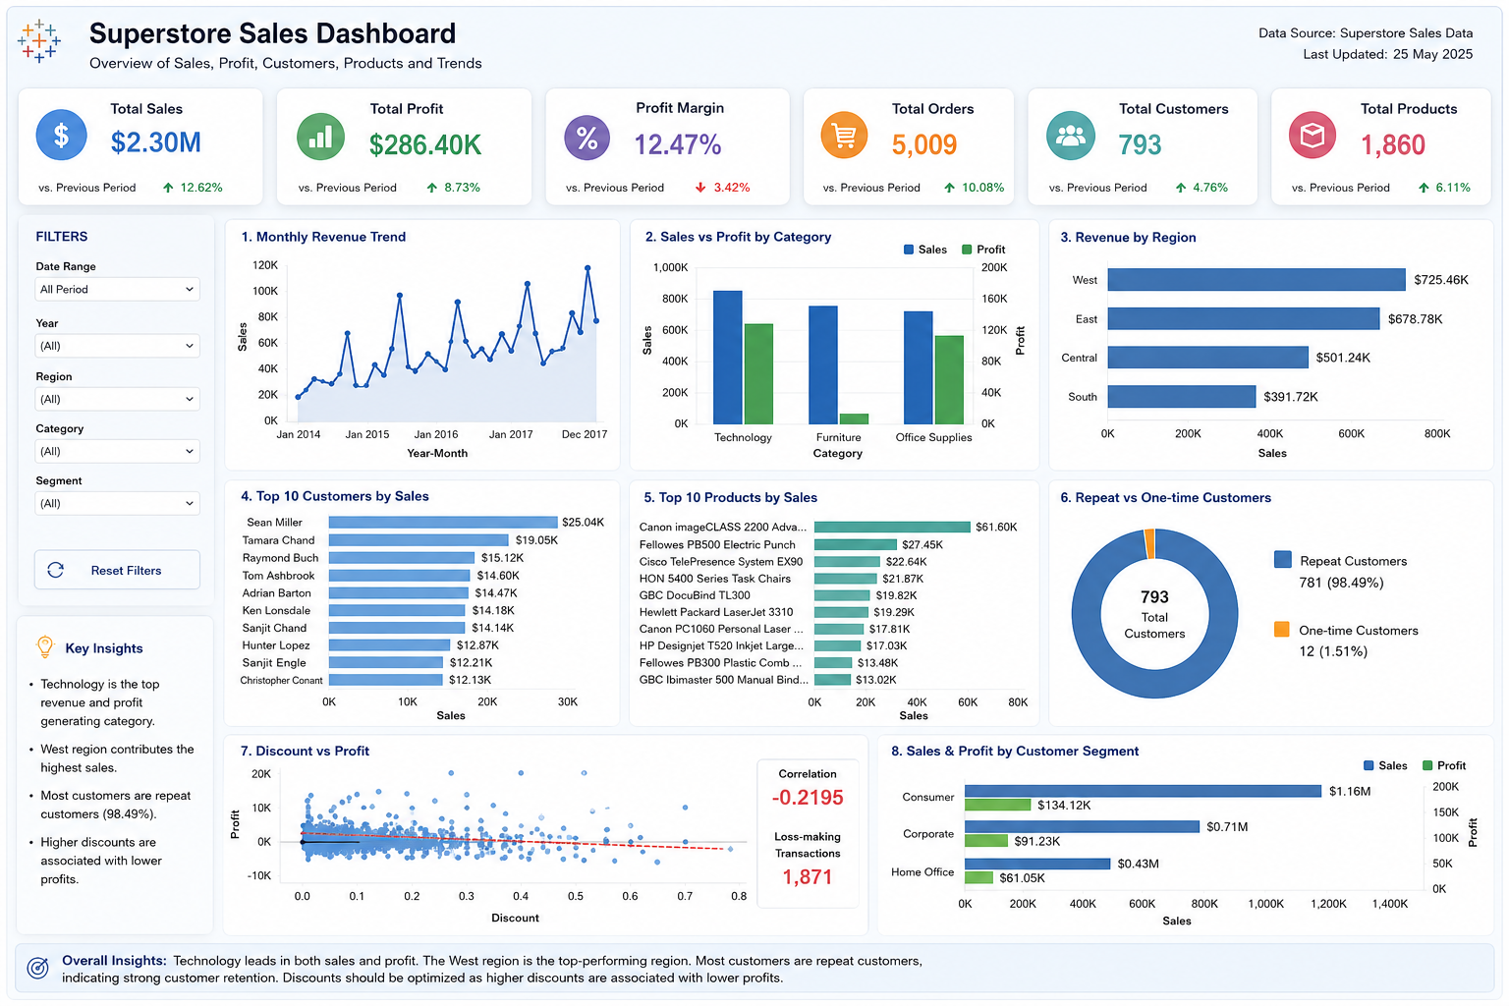
Figure 1. Beginner-level Tableau-style dashboard

2.2 Intermediate Level – Customer & Revenue Analytics
The Intermediate level extended the Superstore analysis from basic reporting into exploratory and comparative business analytics.
- Prepared the cleaned Superstore dataset for deeper analysis.
- Analyzed monthly revenue trends and regional performance.
- Compared sales and profit by category.
- Identified top customers and top products.
- Compared repeat and one-time customer behavior.
- Investigated discount versus profit patterns.
- Compared sales and profit across customer segments.
- Created eight visualizations, KPI cards, a dashboard, business insights and recommendations.
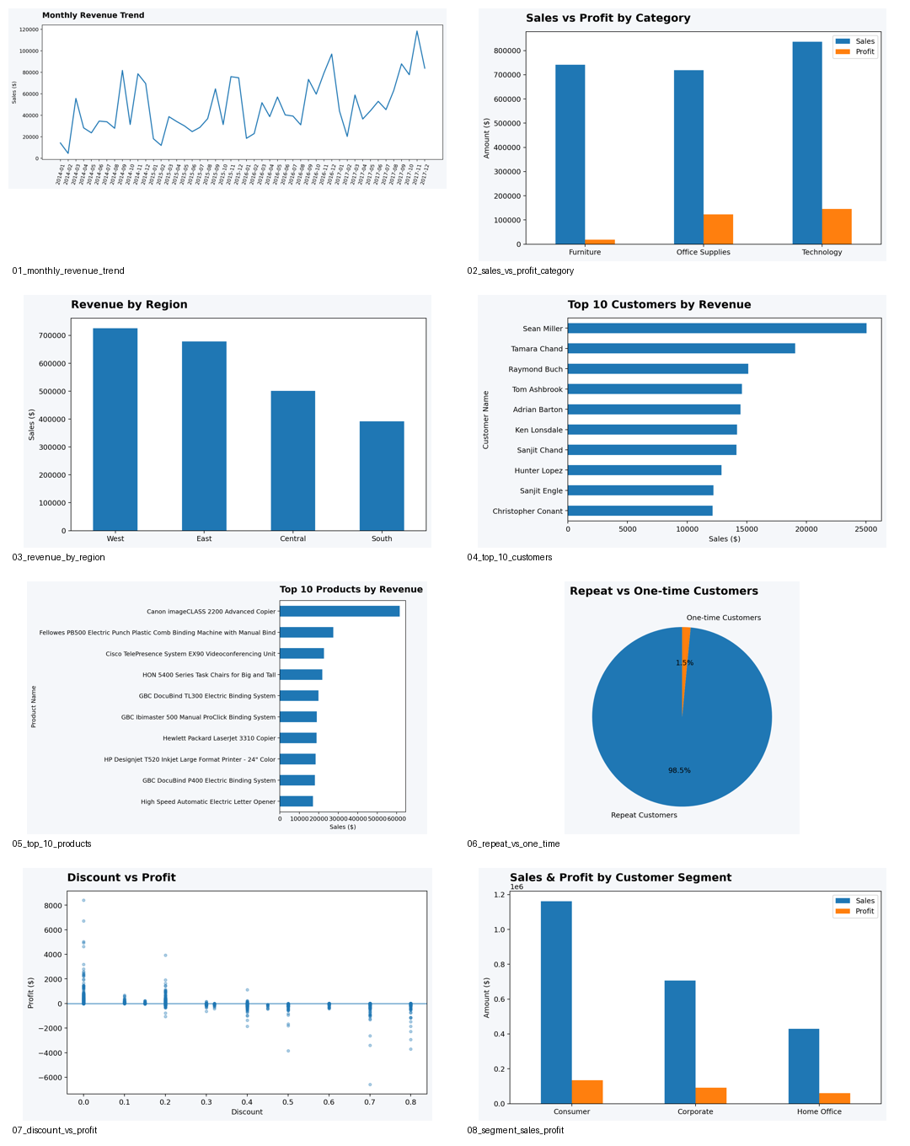
Figure 2. Intermediate-level visualization set

2.3 Advanced Level – IBM HR Attrition Analytics
The Advanced level focused on workforce analytics using the IBM HR Analytics Employee Attrition and Performance dataset.
- Used a dataset containing 1,470 employee records and 35 original fields.
- Cleaned and transformed HR data and created analytical fields such as Attrition Flag, OverTime Flag, Age Group, Income Band and Tenure Group.
- Developed executive HR KPIs including total employees, employees who left, active employees, attrition rate, average monthly income and overtime rate.
- Created eight attrition visualizations covering department, job role, age group, income band, job satisfaction, work-life balance, overtime and business travel.
- Developed an executive-style dashboard with KPI cards, filters and a department-to-job-role drill-down prototype.
- Prepared decision-oriented storytelling, business insights, recommendations, report and a 3-minute presentation video.
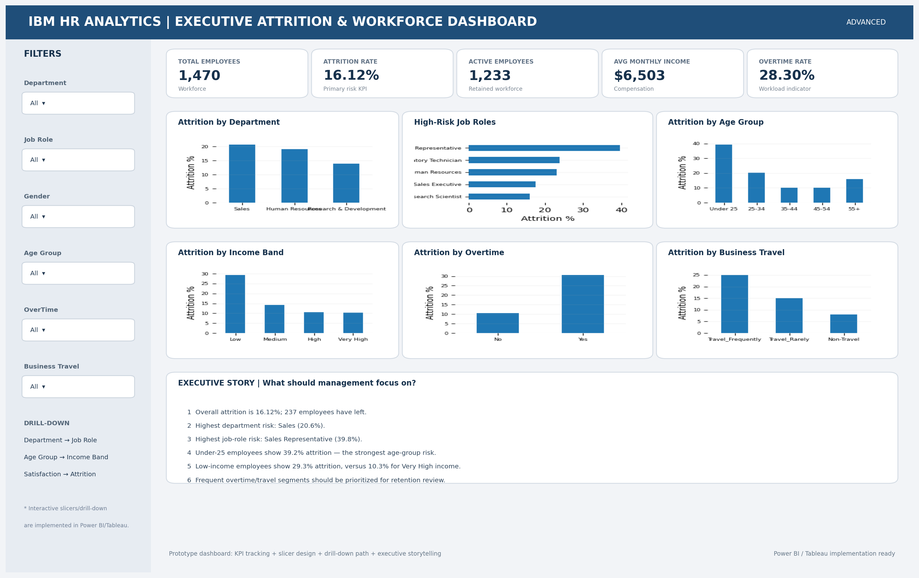
Figure 3. Advanced executive HR dashboard

2.4 Tools and Technologies
Area | Tools / Technologies
Data preparation | Microsoft Excel, Pandas/Python where applicable
Visualization | Tableau-style dashboards, Matplotlib/visualization outputs
Dashboarding | Tableau-style dashboard designs; interactive HTML dashboard prototype for Advanced
Documentation | Microsoft Word / report documentation
Presentation | Microsoft PowerPoint
Version control | GitHub planned for final repository organization
AI support | ChatGPT used for reference ideas, analysis support and documentation

2.5 Key Metrics Used
Level | Metrics / Measures
Beginner | Sales, Profit, Orders/records, regional sales, category sales/profit, product performance
Intermediate | Revenue, Profit, Customer value, Regional revenue, Category profitability, Discount, Segment performance
Advanced | Total Employees, Employees Who Left, Active Employees, Attrition Rate, Average Monthly Income, Average Age, Average Tenure, Overtime Rate, Job Satisfaction, Work-Life Balance

3. Learning Outcomes
The internship provided progressive practical experience in data analytics.

3.1 Technical Learning
- Learned how to inspect, clean and prepare datasets before analysis.
- Learned to select charts according to the analytical question.
- Developed KPI cards and dashboard layouts for quick business monitoring.
- Performed descriptive and exploratory analysis across multiple dimensions.
- Created analytical fields and grouped variables for advanced HR analysis.
- Understood interactive dashboard concepts including filtering and drill-down.

3.2 Analytical & Business Learning
- Converted raw data into meaningful business information.
- Compared performance across time, regions, categories, segments, customers and employees.
- Identified high-performing and high-risk groups.
- Learned to distinguish analytical association from proven causation.
- Translated visual findings into targeted recommendations.

3.3 Communication & Professional Learning
- Prepared structured reports and presentation material.
- Practiced executive-style storytelling.
- Created separate 3-minute video presentations for all three levels.
- Organized project outputs for GitHub and final submission.

4. Challenges and Solutions
Challenge | Solution / Approach | Level
Understanding raw datasets | Inspected fields, types, missing values and duplicates before analysis. | All
Choosing suitable visualizations | Mapped each business question to an appropriate chart. | Beginner
Moving beyond basic charts | Used comparative and exploratory analysis across customers, products, regions and segments. | Intermediate
Handling many HR variables | Created grouped analytical fields such as age and income bands and focused on attrition-related dimensions. | Advanced
Communicating many insights clearly | Used KPI cards, dashboards and decision-oriented summaries. | All
Creating an executive dashboard | Combined KPIs, filters, drill-down and narrative insights into one view. | Advanced
Preparing final deliverables | Consolidated reports, dashboards, visualizations and videos into a structured submission plan. | All

4.1 Advanced HR Findings
Important findings from the Advanced dataset include:
Indicator | Observed Result
Total employees | 1,470
Employees who left | 237
Active employees | 1,233
Overall attrition rate | 16.12%
Sales department attrition | 20.63%
Sales Representative attrition | 39.76%
Under-25 attrition | 39.18%
Overtime attrition | 30.53%
Low income-band attrition | 29.27%
Frequent-travel attrition | 24.91%

These are observed associations in the project dataset and should be validated with additional HR context before being used as causal conclusions or policy decisions.

5. Conclusion
The ShadowFox Data Analytics internship provided a progressive learning experience across three levels. The Beginner level established the fundamentals of data preparation, KPI calculation, visualization and dashboard creation. The Intermediate level expanded these skills into customer, product, regional, segment, revenue and profitability analytics. The Advanced level applied the same workflow to HR attrition, adding executive KPIs, interactive filtering, drill-down and decision-oriented storytelling.
Together, the three projects demonstrate the ability to move from raw data to cleaned data, from cleaned data to visual analysis, and from visual analysis to business recommendations. The completed reports, dashboards, visualizations and videos form a consolidated internship portfolio.

5.1 Final Deliverables
Deliverable | Status
Beginner cleaned dataset, dashboard, report and video | Completed
Intermediate cleaned dataset, 8 visualizations, dashboard, report and video | Completed
Advanced cleaned dataset, 8 visualizations, executive dashboard, report and video | Completed
Single consolidated PowerPoint presentation | Completed
Single consolidated internship report | Completed
GitHub repository organization/upload | Pending final packaging
Final internship submission | Pending

6. Acknowledgments
I would like to express my sincere gratitude to ShadowFox for providing me with the opportunity to complete practical Data Analytics tasks. I am thankful to my mentor/coordinator, Mr. Aakash, for guidance during the internship. This experience helped me strengthen my technical, analytical, documentation and presentation skills. I also acknowledge the use of reference materials and ChatGPT for generating reference ideas and supporting the learning and documentation process.

Appendix A – Selected Project Visuals

Beginner Dashboard

Intermediate Visualization Set

Advanced Executive Dashboard

