PRACTICAL- 01

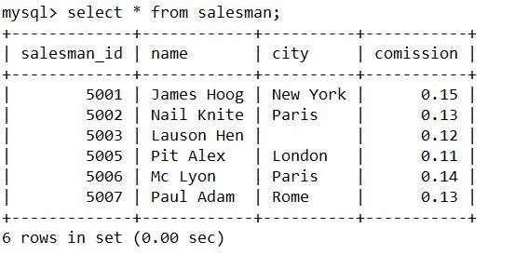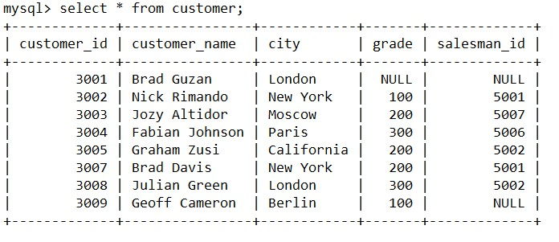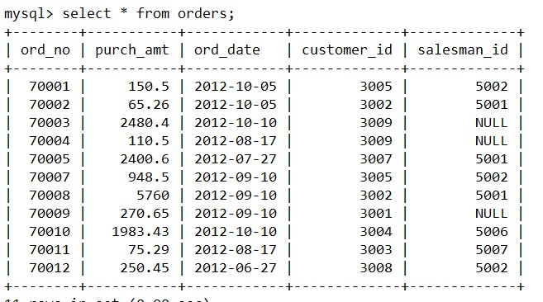

1. Display name and commission for all the salesmen.

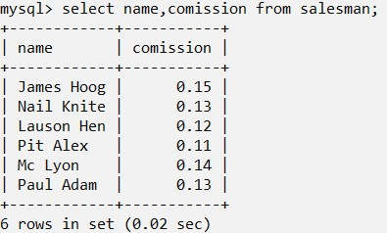

1. Retrieve salesman id of all salesmen from orders table without any repeats.

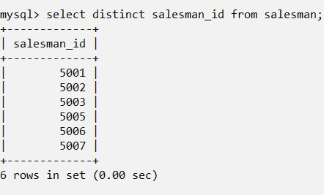

1. Display names and city of salesman, who belongs to the city of Paris.

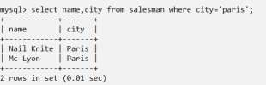

1. Display all the information for those customers with a grade of 200.

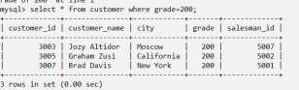

1. Display the order number, order date and the purchase amount for order(s) which will be delivered by the salesman with ID 5001

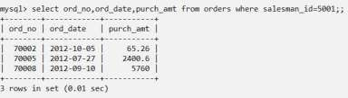

1. Display all the customers, who are either belongs to the city New York or not had a grade above 100.

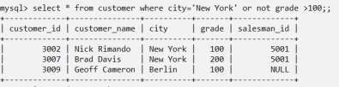

1. Find those salesmen with all information who gets the commission within a range of 0.12 and 0.14.

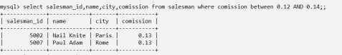

1. Find all those customers with all information whose names are ending with the letter 'n'.

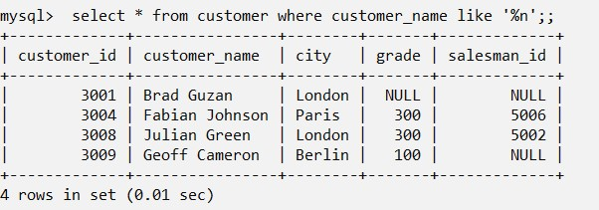

1. Find those salesmen with all information whose name containing the 1st character is 'N' and the 4th character is 'l' and rests may be any character.

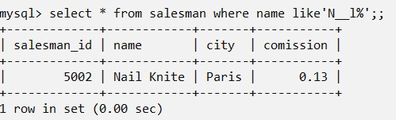

1. Find that customer with all information who does not get any grade except NULL.

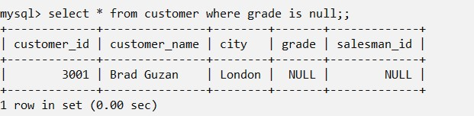

1. Find the total purchase amount of all orders.

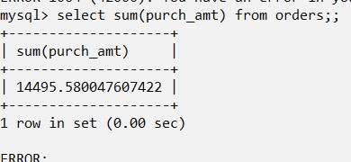

1. Find the number of salesman currently listing for all of their customers.

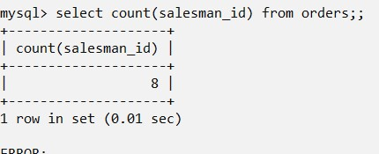

1. Find the highest grade for each of the cities of the customers.

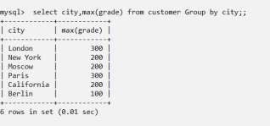

1. Find the highest purchase amount ordered by each customer with their ID and highest purchase amount.

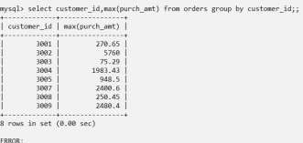

1. Find the highest purchase amount ordered by each customer on a particular date with their ID, order date and highest purchase amount.

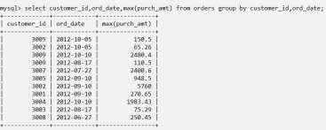

1. Find the highest purchase amount on a date '2012-08-17' for each salesman with their ID.

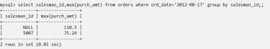

1. Find the highest purchase amount with their customer ID and order date, for only those customers who have the highest purchase amount in a day is more than 2000.

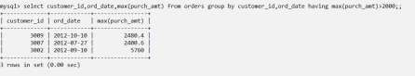

1. Write a SQL statement that counts all orders for a date August 17th, 2012.

