**PRATICAL 02**

CREATE TABLE ACTOR (

ACT_ID INT PRIMARY KEY,

ACT_NAME VARCHAR (20),

ACT_GENDER CHAR (1)

);

CREATE TABLE DIRECTOR (

DIR_ID INT PRIMARY KEY,

DIR_NAME VARCHAR (20),

DIR_PHONE INT

);

CREATE TABLE MOVIES (

MOV_ID INT PRIMARY KEY,

MOV_TITLE VARCHAR (25),

MOV_YEAR INT,

MOV_LANG VARCHAR (12),

DIR_ID INT,

FOREIGN KEY (DIR_ID) REFERENCES DIRECTOR (DIR_ID));

CREATE TABLE MOVIE_CAST (

ACT_ID INT,

MOV_ID INT,

OLE VARCHAR (10),

PRIMARY KEY (ACT_ID, MOV_ID),

FOREIGN KEY (ACT_ID) REFERENCES ACTOR (ACT_ID),

FOREIGN KEY (MOV_ID) REFERENCES MOVIES (MOV_ID));

CREATE TABLE RATING (

MOV_ID INT,

REV_STARS VARCHAR (25),

PRIMARY KEY (MOV_ID),

FOREIGN KEY (MOV_ID) REFERENCES MOVIES (MOV_ID));

INSERT INTO ACTOR VALUES (301,'ANUSHKA','F');

INSERT INTO ACTOR VALUES (302,'PRABHAS','M');

INSERT INTO ACTOR VALUES (303,'PUNITH','M');

INSERT INTO ACTOR VALUES (304,'JERMY','M');

INSERT INTO DIRECTOR VALUES (60,'RAJAMOULI', 87516110); INSERT INTO DIRECTOR VALUES (61,'HITCHCOCK', 77661389);

INSERT INTO DIRECTOR VALUES (62,'FARAN', 99867765);

INSERT INTO DIRECTOR VALUES (63,'STEVEN SPIELBERG', 89897765);

INSERT INTO MOVIES VALUES (1001,'BAHUBALI-2', 2017, 'TELAGU', 60);

INSERT INTO MOVIES VALUES (1002,'BAHUBALI-1', 2015, 'TELAGU', 60); INSERT INTO MOVIES VALUES (1003,'AKASH', 2008, 'KANNADA', 61);

INSERT INTO MOVIES VALUES (1004,'WAR HORSE', 2011, 'ENGLISH', 63);

INSERT INTO MOVIE_CAST VALUES (301, 1002, 'HEROINE');

INSERT INTO MOVIE_CAST VALUES (301, 1001, 'HEROINE');

INSERT INTO MOVIE_CAST VALUES (303, 1003, 'HERO');

INSERT INTO MOVIE_CAST VALUES (303, 1002, 'GUEST');

INSERT INTO MOVIE_CAST VALUES (304, 1004, 'HERO');

INSERT INTO RATING VALUES (1001, 4);

INSERT INTO RATING VALUES (1002, 2);

INSERT INTO RATING VALUES (1003, 5);

INSERT INTO RATING VALUES (1004, 4);

SELECT * FROM actor;

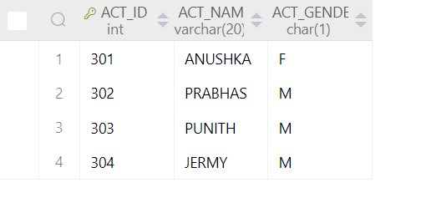

SELECT * FROM director;

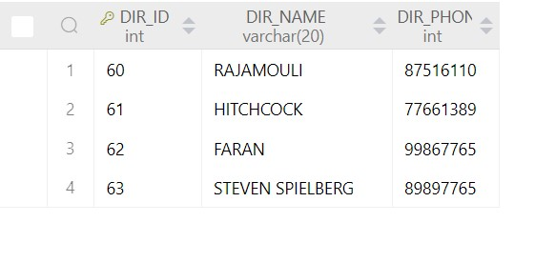

SELECT * FROM MOVIES;

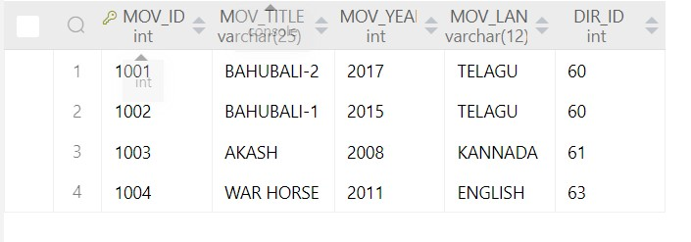

SELECT * FROM MOVIE_CAST;

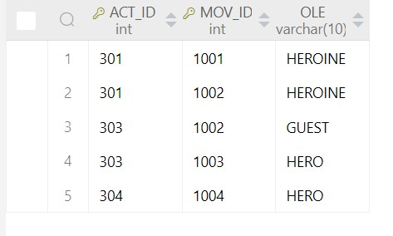

SELECT * FROM RATING;

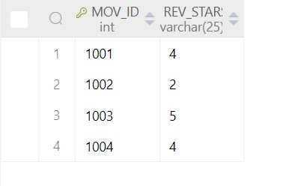

**List the titles of all movies directed by ‘Hitchcock’.**

SELECT MOV_TITLE

FROM MOVIES

WHERE DIR_ID = (SELECT DIR_ID

FROM DIRECTOR

WHERE DIR_NAME='HITCHCOCK');

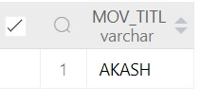

**Find the movie names where one or more actors acted in two or more movies.**

SELECT MOV_TITLE

FROM MOVIES M,MOVIE_CAST MC

WHERE M.MOV_ID=MC.MOV_ID AND ACT_ID IN (SELECT ACT_ID

FROM MOVIE_CAST GROUP BY ACT_ID

HAVING COUNT(ACT_ID)>1)

GROUP BY MOV_TITLE

HAVING COUNT(*)>1;

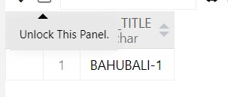

**List all actors who acted in a movie before 2000 and also in a movie after 2015 (use JOIN operation).**

SELECT ACT_NAME

FROM ACTOR A

JOIN MOVIE_CAST C

ON A.ACT_ID=C.ACT_ID JOIN MOVIES M

ON C.MOV_ID=M.MOV_ID

WHERE M.MOV_YEAR NOT BETWEEN 2000 AND 2015;

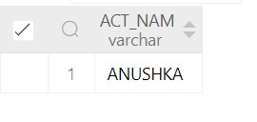

**Find the title of movies and number of stars for each movie that has at least one rating and find the highest number of stars that movie received. Sort the result by movie title.**

SELECT MOV_TITLE,MAX(REV_STARS)

FROM MOVIES

INNER JOIN RATING USING (MOV_ID)

GROUP BY MOV_TITLE

HAVING MAX(REV_STARS)>0

ORDER BY MOV_TITLE;

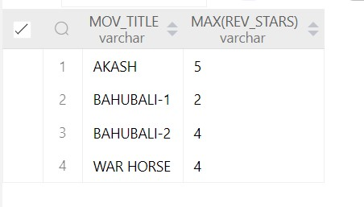

**Update rating of all movies directed by ‘Steven Spielberg’ to 5.**

UPDATE RATING

SET REV_STARS=5

WHERE MOV_ID IN (SELECT MOV_ID FROM MOVIES

WHERE DIR_ID IN (SELECT DIR_ID

FROM DIRECTOR

WHERE DIR_NAME='STEVEN SPIELBERG'));

Q3)

CREATE TABLE students ( stno INT PRIMARY KEY, name VARCHAR(50), addr VARCHAR(255), city VARCHAR(50), state VARCHAR(2), zip VARCHAR(10)

);

CREATE TABLE INSTRUCTORS ( empno INT PRIMARY KEY, names VARCHAR(50), ranks VARCHAR(20), roomno VARCHAR(10), telno VARCHAR(15)

);

CREATE TABLE COURSES ( cno INT PRIMARY KEY, cname VARCHAR(50), cr INT, cap INT

);

CREATE TABLE GRADES ( stno INT, empno INT, cno INT, sem VARCHAR(10), year INT, grade INT,

PRIMARY KEY (stno),

FOREIGN KEY (stno) REFERENCES students(stno),

FOREIGN KEY (empno) REFERENCES INSTRUCTORS(empno),

FOREIGN KEY (cno) REFERENCES COURSES(cno)

);

CREATE TABLE ADVISING ( stno INT, empno INT,

PRIMARY KEY (stno, empno),

FOREIGN KEY (stno) REFERENCES students(stno),

FOREIGN KEY (empno) REFERENCES INSTRUCTORS(empno)

);

-- Insert records into the COURSES table

INSERT INTO COURSES (cno, cname, cr, cap)

VALUES

(1, 'Math101', 3, 30),

(2, 'CS210', 4, 25),

(3, 'Physics101', 3, 20);

-- Insert records into the GRADES table

INSERT INTO GRADES (stno, empno, cno, sem, year, grade)

VALUES

(1, 101, 1, 'Fall', 2021, 85),

(2, 102, 2, 'Fall', 2021, 92),

(3, 103, 3, 'Fall', 2021, 78);

-- Insert records into the ADVISING table

INSERT INTO ADVISING (stno, empno)

VALUES

(1, 101),

(2, 102),

(3, 103);