1. What is the role of a *confusion matrix* in the evaluation of a machine trained for a pattern recognition task? In your answer, refer to a concrete example, either from literature or one you created. Anchor you answer in relevant literature.

A confusion matrix better conveys accuracy/errors of a machine learning model, as it summarizes the correct and incorrect predictions broken down by each class of data in the dataset, as well as what types of errors are being made. In this way, it displays when the model is confused making predictions.

This image gives examples of how the confusion matrix should be interpreted:

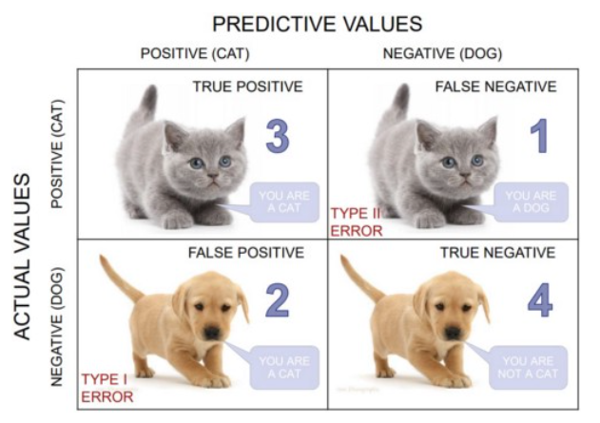

such that a false positive is a type 1 error and false negative is a type 2 error (Sharma, 2019).

Using the sklearn package in Python, a confusion matrix and a classification report can be generated, as seen below:

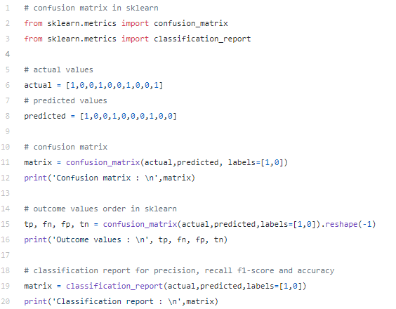

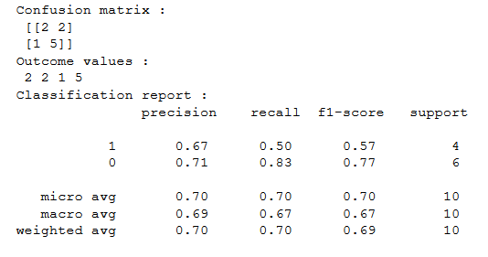(Bhandari, 2020b).

1. What is the role of the ROC curve? How would you use it to compare the performance of several classifiers? In your answer, refer to concrete examples of classifiers, either from literature or one you created. Illustrate the ROC curves and anchor your answer in relevant literature.

An ROC curve plots the true positive and false positive rates of a classification model. To compare multiple classifiers, we can find the area under the ROC curve (AUC). The AUC can be interpreted as the probability that the model ranks a random positive example more highly than a random negative example (Classification, n.d.).   
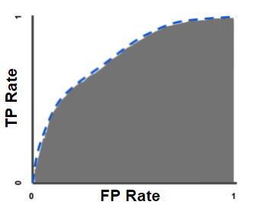(Classification, n.d.)

An example of calculating the ROC curve and AUC in Python with randomly generated data can be seen below:

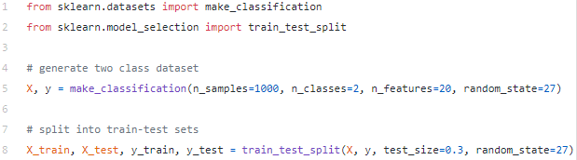

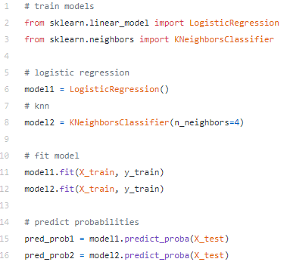

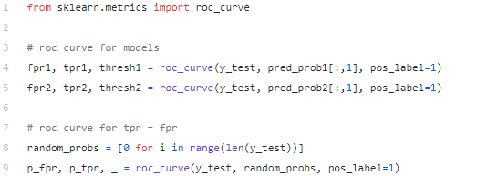

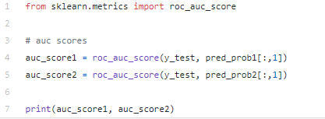



(Bhandari, 2020a).

Resources:

Bhandari, A. (2021, June 16). AUC-ROC Curve in Machine Learning Clearly Explaining. <https://www.analyticsvidhya.com/blog/2020/06/auc-roc-curve-machine-learning/>

Bhandari, A. (2020, April 17). *Everything you Should Know about Confusion Matrix for Machine Learning*. Analytics Vidhya. <https://www.analyticsvidhya.com/blog/2020/04/confusion-matrix-machine-learning/>

Classification: ROC Curve and AUC. (n.d.). *Machine Learning Crash Course*. <https://developers.google.com/machine-learning/crash-course/classification/roc-and-auc>

Sharma, P. (2019, July 21). *Decoding the Confusion Matrix*. Towards data science. <https://towardsdatascience.com/decoding-the-confusion-matrix-bb4801decbb>