This visualization represents the data obtained from the dataset "Information is Beautiful-Data Breaches".

This visualization represents the trend of records lost a per the organization. It can be seen that Web organization has the maximum number of records lost as compared to less tech savvy companies. Thus, it refutes the claim that less tech savvy companies have more data breaching.

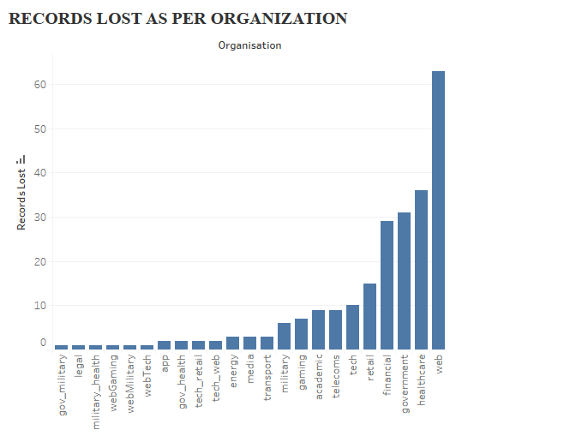

* Advantages of Version 1:

Shows the direct trend of the organizations

* Disadvantages of Version 1:

No information about the sources and reasons for loss of data

No yearwise trend of which method is increasing rapidly

* Improvements: More information on what is the actual ratio of records lost over total number of records.

Interpretation of Version 2:

This visualization represents the data obtained from the dataset "Information is Beautiful-Data Breaches". It shows the types of data that are sensitive trending through previous years. The records lost as per organization travels from left to right. Method of leaks has been identified as per the organization which would help in identifying measures to prevent such leaks. Thus, it refutes the claim that less tech savvy companies have more data breaching.

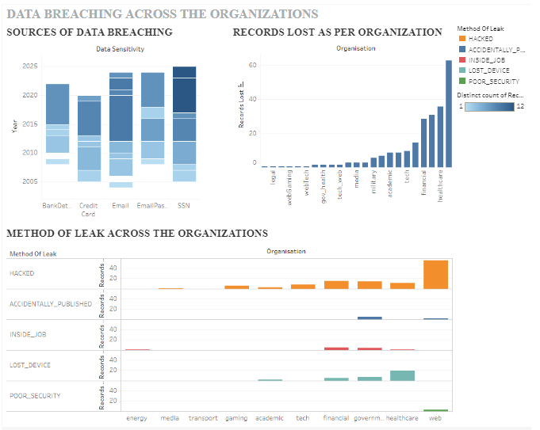

* Advantages of Version 2:

1. Sources of sensitive data are represented which would help to keep this information more secure.

2. Method of leak across the organisations-this would help to advance security

* Disadvantages of Version 2:

1. Cannot represent what kind of data is sensitive in specific organization

* Improvements:

1. Trend of which method of leak is increasing as per organization.

2. Organisation specific analysis-this would help to find solutions faster.

3. Using aggregate functions- ratios, averages for better results.