The following visualization supports the claim that financial markets do not punish data breach. As it can be seen that the financial trend has been increasing over the years. Thus, data breach has no effect on stock market.

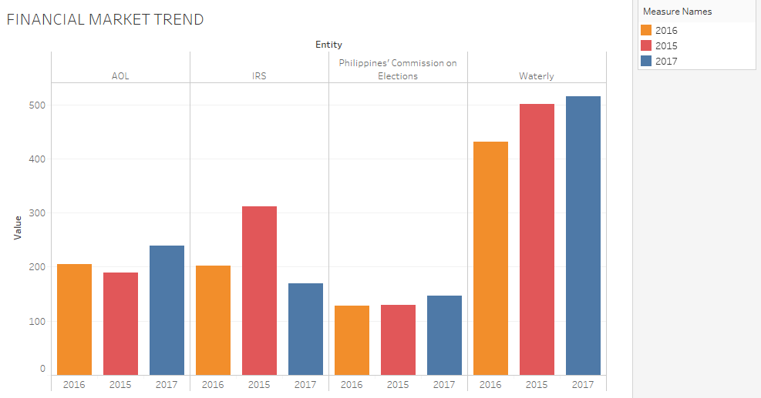

PS: I was not able to upload workbook on server due to data extraction problem.