**MSIS DASHBOARD**

The following visualization represents the information necessary for prospective stdents while choosing the university. The tuition and living cost depicts the funds required for overall graduation period. MSIS curriculum is divided in to two sets- Technical and Core. The filter on the right helps to see the sepecific core courses. The tuition and fees would help the students to determine whether they should go for such curriculum or not.

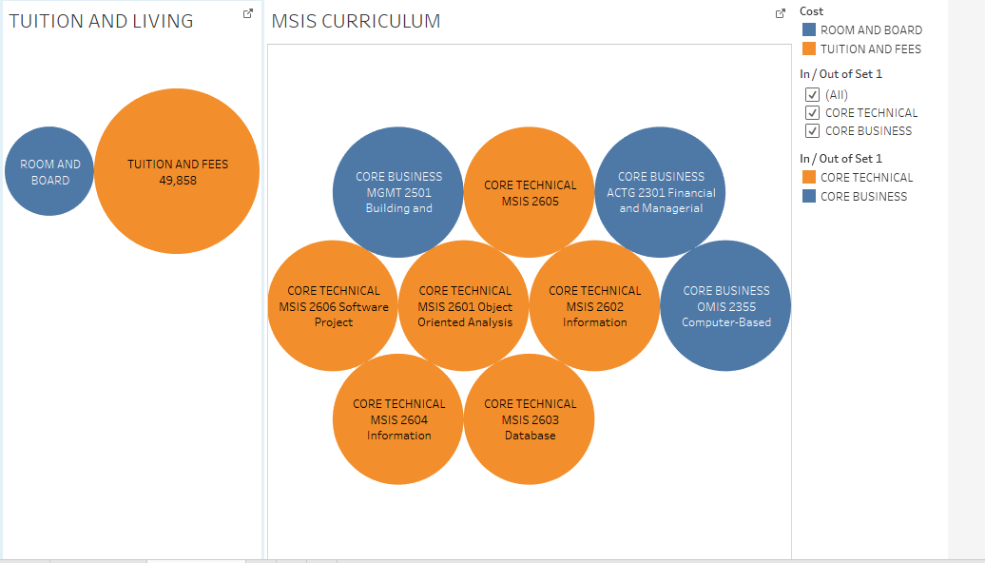

The following visualization shows the employment statistics for MSIS students. Business major shows the highest rate of employment with salary range from $71,000-$115,000. This shows that job prospects are good for MSIS students in SCU. Thus, prospective students should consider this university for its curriculum and job prospects.

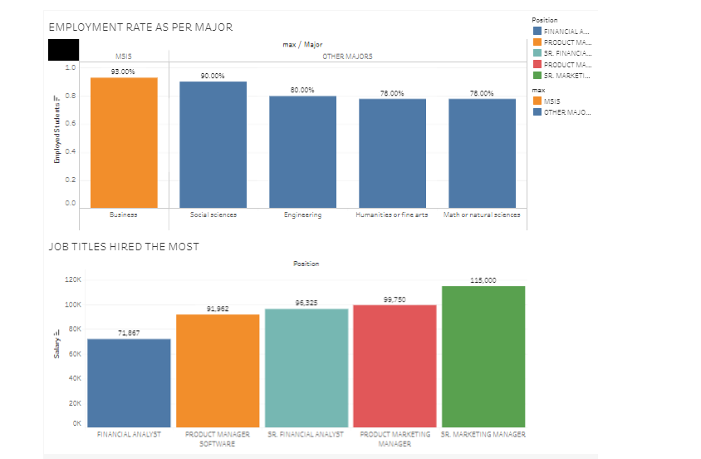

ADVANTAGES:

Simple and clear selection of whether to invest money based on learning and job salary.

DISADVANTAGES:

Requires more information such as comparison with other universities in Bay area.

IMPROVED VERSION:

Showing all the aspects on same dashboard including many other tableau functions.