**DOES INCOME INEQUALITY RESULT IN HATE CRIMES?**

Trump's position as a President has been in the news since day one. This visualization intends to point certain social crimes as a result of his power. To truly identify the facts about his Presidentship, I decided to work on this visualization. This visualization helps to check whether income inequality, poverty, unemployment are the factors responsible for the rise in number of hate crimes.

**What is the intended audience?**

The intended audience for this visualization are common people who vote for President and also people from the field of politics, which helps them to identify their respective leader.

**Current Claim:**

The current claim is Income inequality is the reason for occurring hate crimes and the number has increased after the election.

**Suggested Improvements:**

I want to improve the information delivery of the graph.

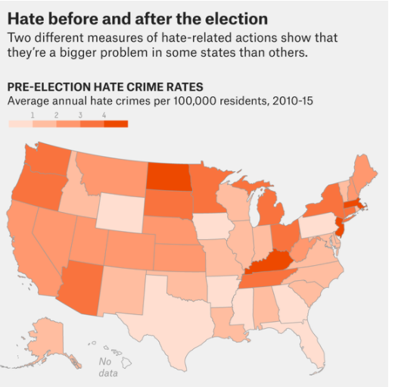

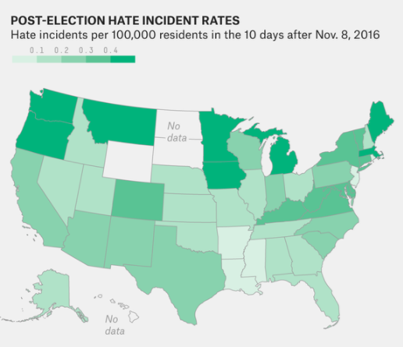

* This graph provides information just through shading which is difficult to understand.
* A person who does not know about US map cannot make any conclusions just by seeing the shaded map.
* Also, the claim says that income inequality is the reason but there is no existing visualization which can validate it.
* Overall data is not used as such how poverty, unemployment, number of shared voters are affecting the hate crime rate.

How will your redesign improve the understanding of the underlying dataset?

**1.** **Showing the State names and the rate of hate crimes with proper shading palette to make user easier to understand the difference. The user can select the state of his/her choice and get the analysis done.**

For example, in this map, Texas before election had less number of hate crimes which is shown in purple and its moving towards orange shade which is more after the election. Easier to compare!

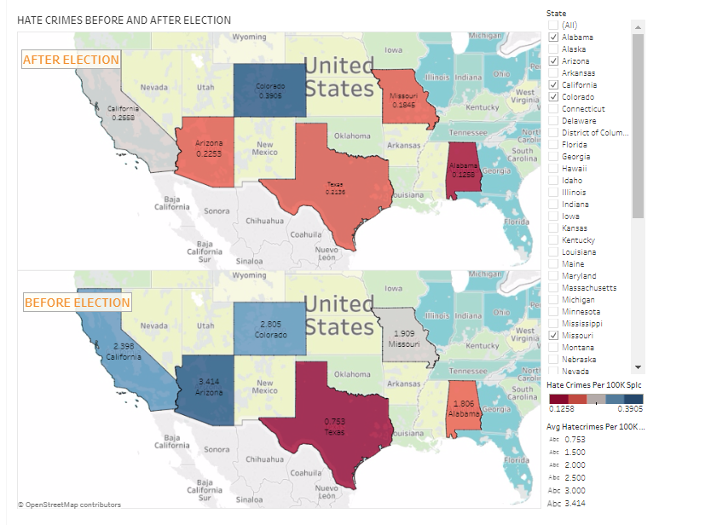

2. **This visualization shows how low Gini index does not mean lowest number of crimes.**

The article mentioned that the states with high Gini index have higher crime rate. There is unsteadiness in the pattern of Gini index and crime rate. Thus, wealth management distribution does not impact the hate crime as claimed in the article. Users can filter the states and make comparison accordingly.

For example, Idaho has higher Gini Index than Wisconsin but has lower number of crimes comparatively.

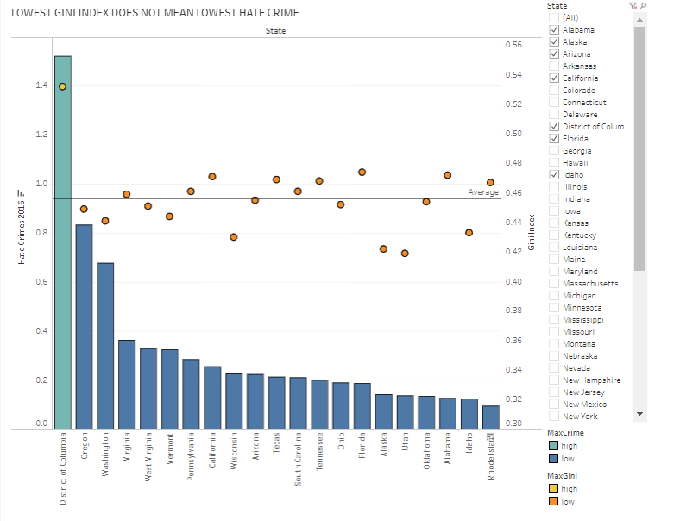

**3. Trump Voters are not the sole reason for increase in hate crimes.**

The article claims that the number of hate crimes increased after Trump’s election and thus points towards Trump’s voters as the reason for such crimes. But the analysis obtained from the data shows that the state with highest number of voters have the least difference in the number of hate crimes before and after election.

For example, Number of Trump voters are highest in Iowa but it does not show the maximum hate crimes in that state.

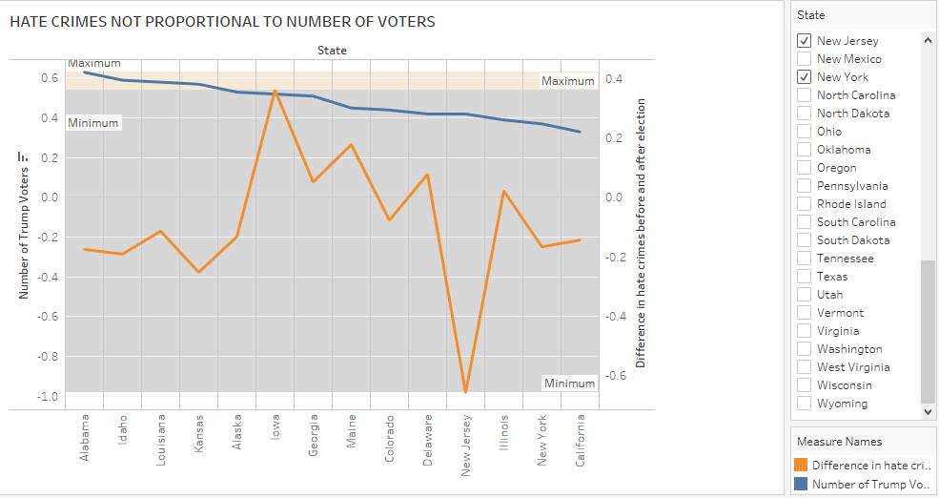

**4. Poverty is not proportional to number of hate crimes**

States with lowest poverty has highest number of crimes both before and after election. Thus, highest poverty does not necessarily mean highest crime.

For example, District Of Columbia has the minimum poverty but highest hate crime rate.

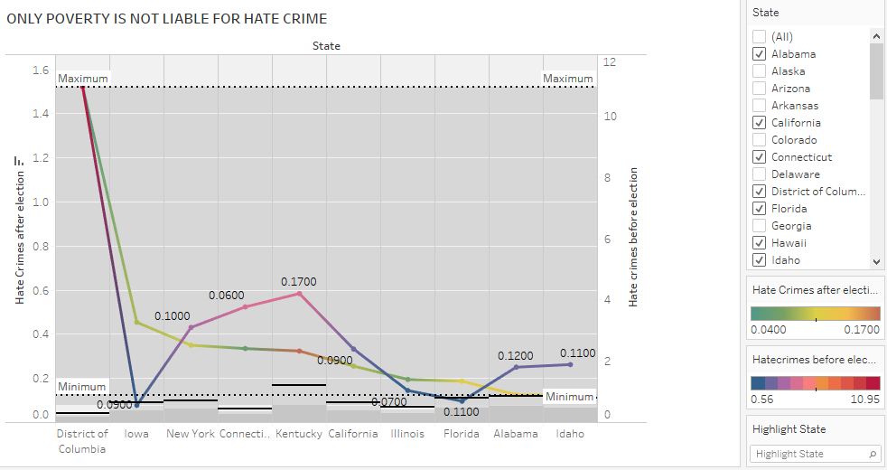

**CONCLUSION:**

Thus, from the above visualizations it has been inferred that Income Inequality does not result in Hate Crimes.