Azure Data Lake Storage Gen2 (ADLS Gen2)
Azure Data Lake Storage Gen2 is a highly scalable and secure cloud storage service optimized for big data analytics and data lakes. It builds on Azure Blob Storage capabilities but adds file system semantics, hierarchical namespaces, and enhanced performance for analytics workloads.
ADLS Gen2 is designed to store massive volumes of structured, semi-structured, and unstructured data, making it ideal for big data and machine learning scenarios.

Key Features and Use Cases:
- Hierarchical Namespace: Unlike traditional Blob Storage, ADLS Gen2 supports folders and directories, enabling efficient organization and faster file operations at scale.
- Optimized for Analytics: Supports Hadoop Distributed File System (HDFS) and integrates seamlessly with analytics frameworks like Azure Databricks, HDInsight, and Azure Synapse Analytics.
- Supports Multiple Data Types: You can store CSV, JSON, Parquet, Avro, ORC, images, videos, logs, backups, and more.
- Security and Compliance: Provides enterprise-grade security with Azure Active Directory integration, role-based access control (RBAC), and encryption at rest and in transit.
- Cost-effective and Scalable: Automatically scales to handle petabytes of data and millions of files with optimized storage tiers and pricing options.

Common Uses of ADLS Gen2:
- Building data lakes for big data analytics and machine learning.
- Storing large datasets for ETL (Extract, Transform, Load) processes.
- Integrating with analytics tools to perform complex queries and transformations.
- Secure and compliant storage for sensitive data and audit logs.
- Archiving and long-term data retention with tiered storage options.

4.1 Create an Azure Data Lake Storage
Go to Azure Portal
In the search bar, type “Storage Accounts” or “ADLS Gen2”
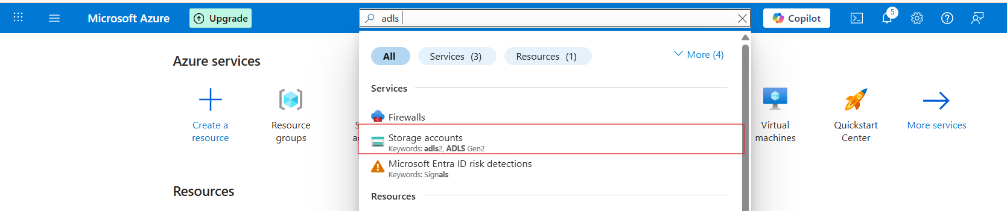
Click on storage accounts and click on create button
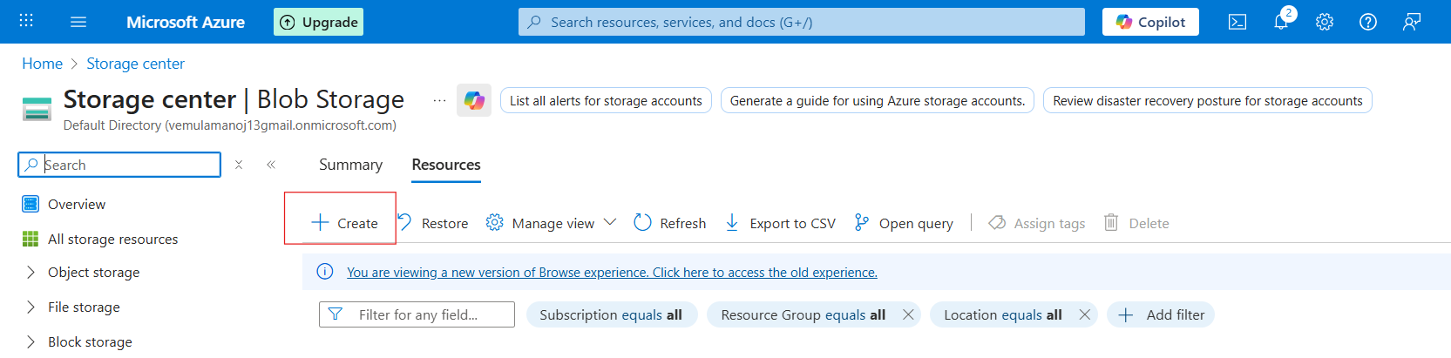

Fill required details
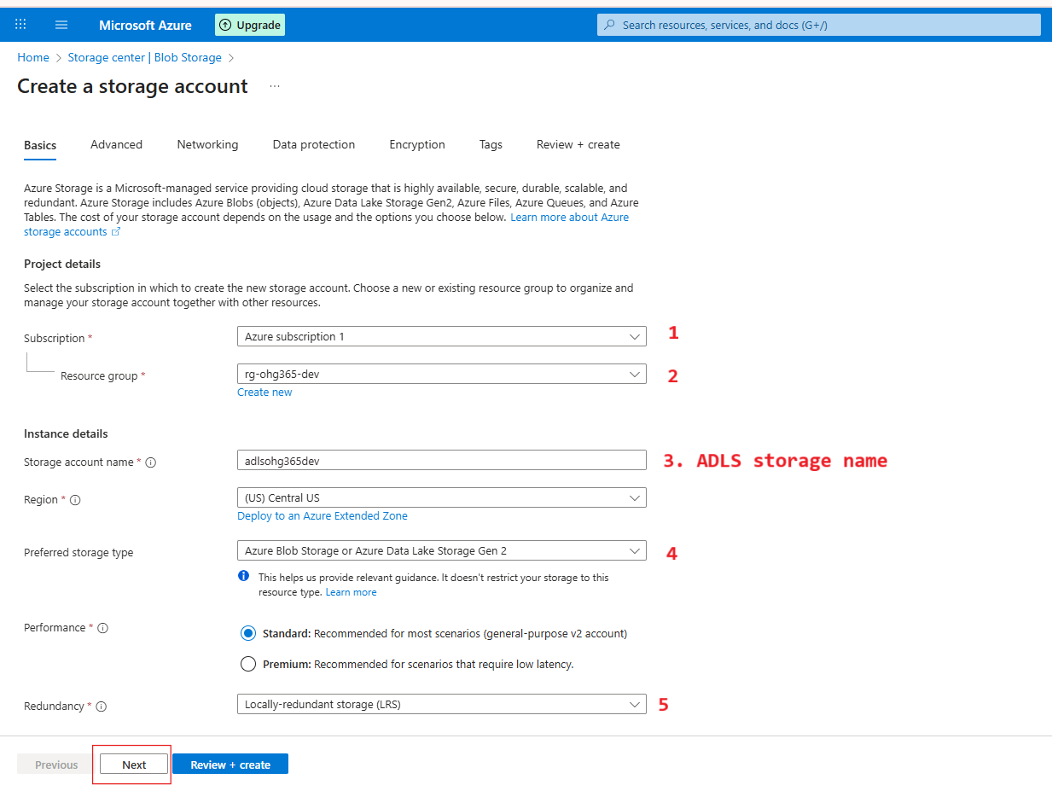

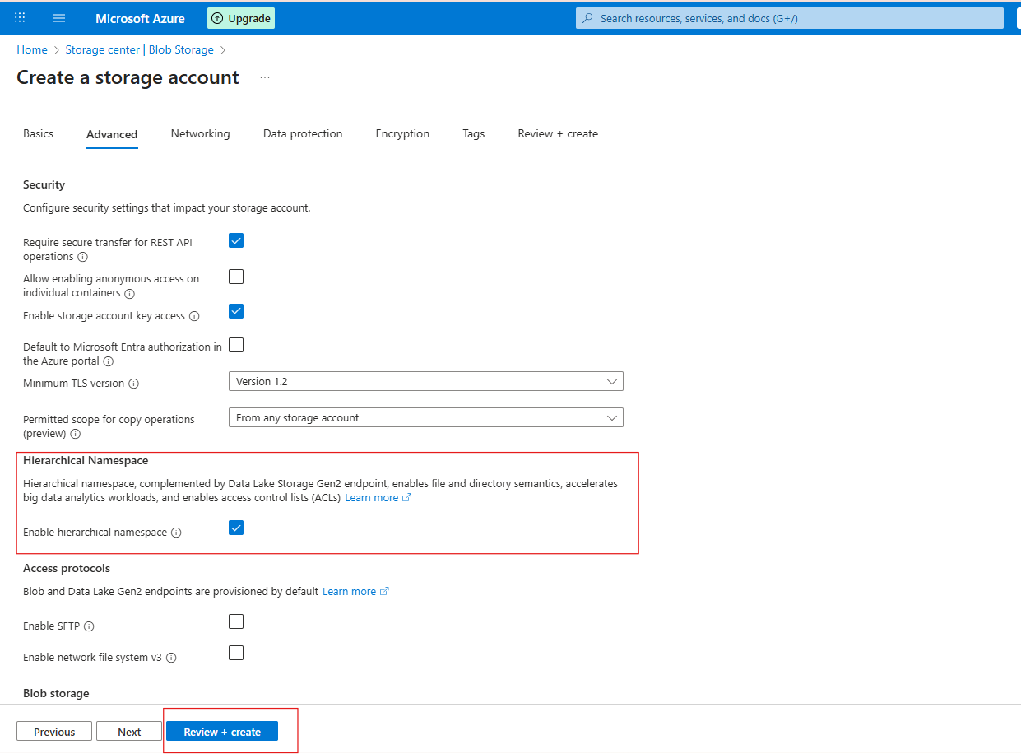
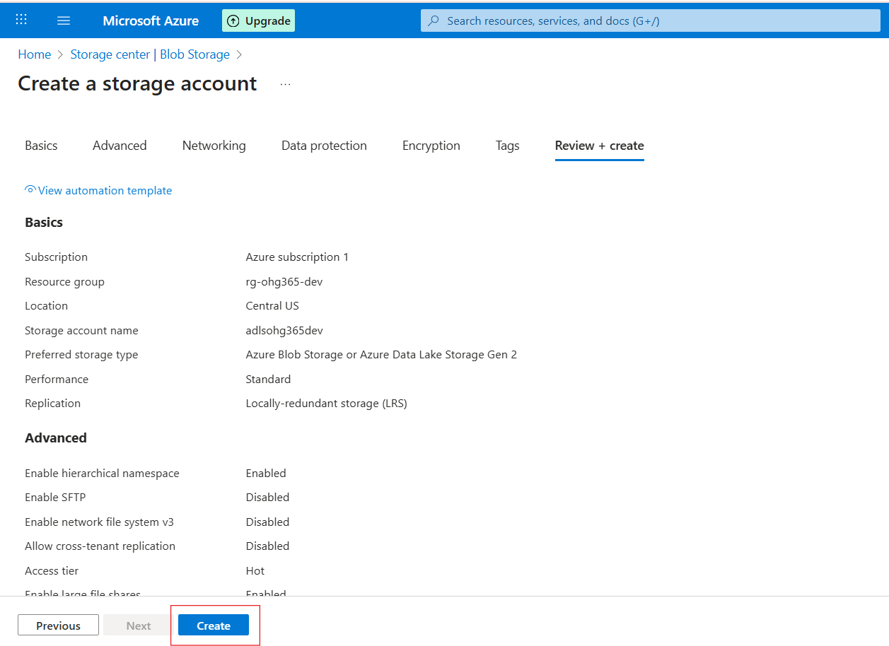

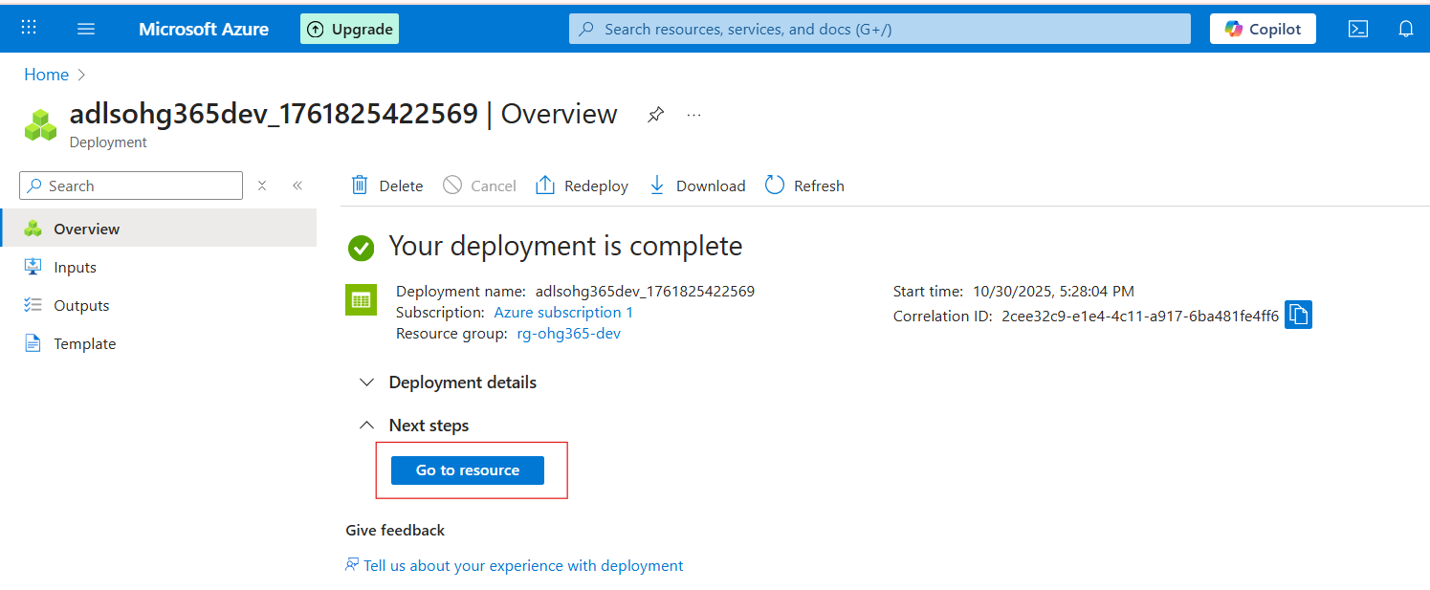

Navigate to Your Resource Group
- In the left-hand menu, click on Resource groups
- Find and click your resource group — in your case:
👉 rg-ohg365-dev
- Check for the Storage Account
- Inside the Overview tab of your resource group, you’ll see a list of all resources.
- Look for an item that looks like this:
Type: Storage account
Name: adlsohg365dev (or whatever name you used)
If it appears there, 🎉 congratulations — your ADLS Gen2 Storage account has been successfully created
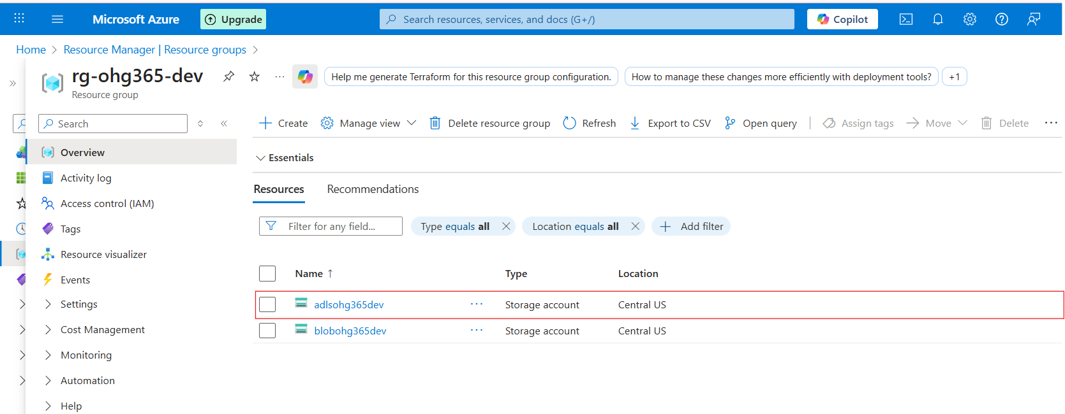

3.2 Types of Azure Storage Services:
Azure Storage provides four main types of services under one Storage Account.

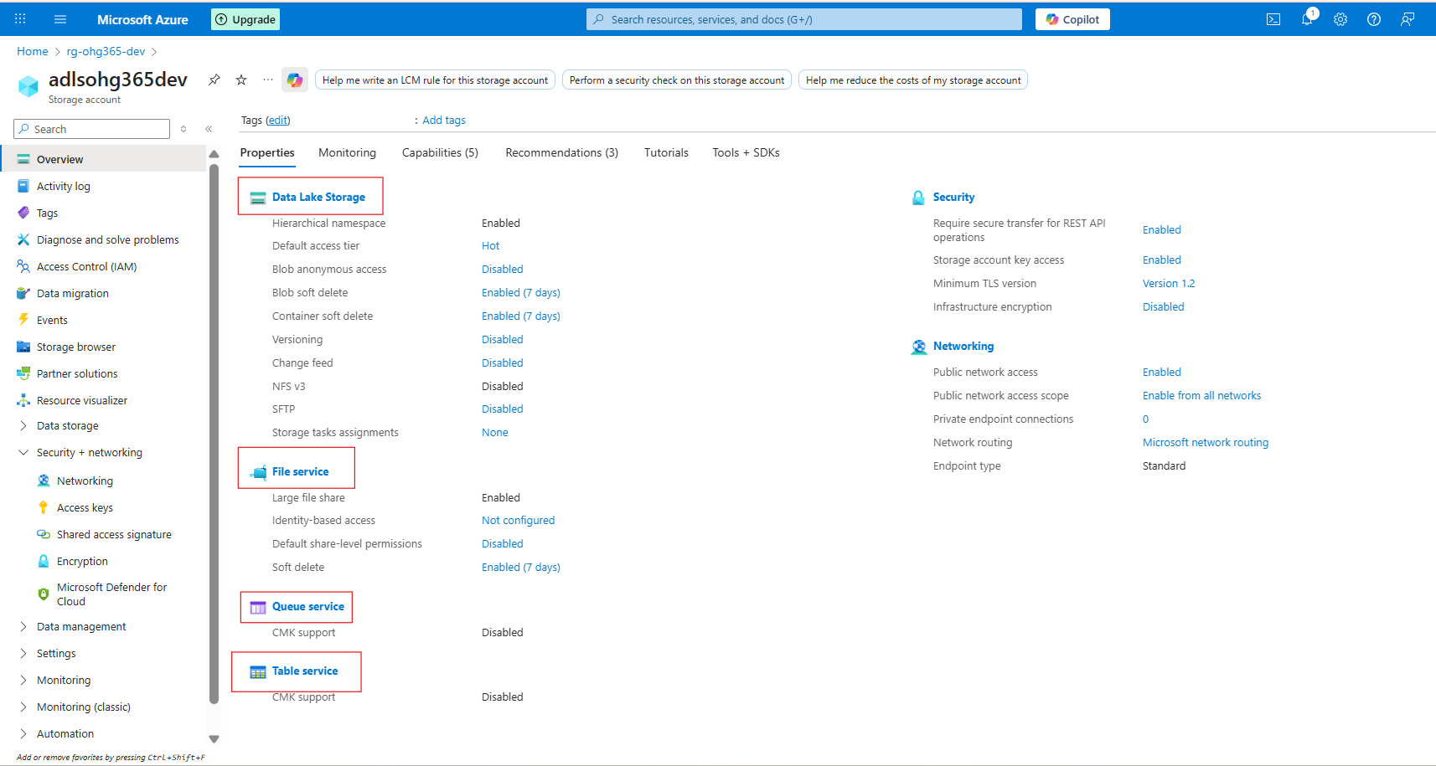

1️⃣ Data Lake Storage
🧱 Purpose: Designed to store large volumes of unstructured or semi-structured data such as files, images, videos, logs, and backups.
🔹 Key Features:
- Data is stored as Blobs (Binary Large Objects) within containers.
- Ideal for storing large, raw data that doesn’t fit into traditional databases.
- Supports various formats: text, binary, documents, media, and backups.
💾 Common Use Cases:
- Hosting media content like images and videos for websites.
- Long-term storage for backups and archival data.
- Centralized data lake for analytics and big data processing.
- Hosting static websites.
📦 Supported File Types:
.txt, .csv, .json, .xml, .jpg, .mp4, .zip, .bak, and more.

2️⃣ File Service
📁 Used for shared file storage that behaves like a traditional file server.
🔹 Description:
- Provides Azure Files, a fully managed file share in the cloud.
- Uses the SMB (Server Message Block) or NFS (Network File System) protocols — the same used by on-premises file servers.
- Can be mounted to Windows, Linux, or macOS systems.
💾 Example Uses:
- Shared network drives for teams
- “Lift and shift” of on-premises file servers
- Application configurations shared across multiple VMs
📦 Example Scenario:
You have multiple virtual machines needing access to the same configuration files — you can store those files in Azure Files and mount them just like a shared folder.

3️⃣ Queue Service
📬 Used for reliable messaging between application components.
🔹 Description:
- Provides asynchronous communication between services using message queues.
- Stores messages in a queue, which can be processed later by background services or workers.
- Ensures messages are delivered at least once and processed in FIFO (First-In, First-Out) order.
💾 Example Uses:
- Sending background jobs (like image processing or email sending)
- Decoupling app components for scalability
- Event-driven architecture
📦 Example Scenario:
A web app uploads an image → sends a message to a queue → a background process picks it up and resizes the image.

4️⃣ Table Service
🧮 Used to store large amounts of structured, non-relational data.
🔹 Description:
- Provides NoSQL key-value storage.
- Stores data in tables with entities (rows) and properties (columns).
- Flexible schema — you can add or remove columns anytime.
💾 Example Uses:
- Storing user profiles, IoT data, or metadata
- Fast lookups by key
- Lightweight applications needing scalable, cheap storage
📦 Example Scenario:
You have millions of IoT sensors sending temperature data — you can store this efficiently in Azure Table Storage.

🧠 Summary Table
Datalake Service | Type of Data | Description | Example Use Case
Blob Service | Unstructured / Semi-structured | Stores large objects (files, media, backups) | Images, videos, logs
File Service | File-based | Shared file storage via SMB/NFS | Shared drives, app configs
Queue Service | Messaging | Message-based communication between components | Background tasks, event processing
Table Service | Structured (NoSQL) | Key-value, schema-less table storage | User profiles, IoT data

Explore Datalake Service
Once your storage account is created:
- Go to your Storage Account
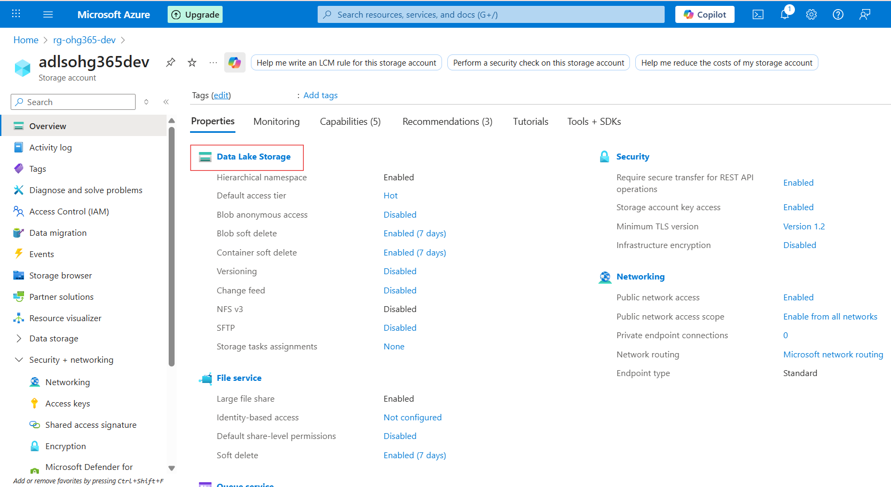

- Under Data storage, click Containers → This is where your blobs live.
- Click ➕ Container to create one:
  - Name: images, videos, or backups (any name)
  - Public access level:
    - Private (default) – Only you can access
    - Blob (anonymous read) – Anyone with the link can read blobs
    - Container (public) – Everyone can see contents
  - Click Create
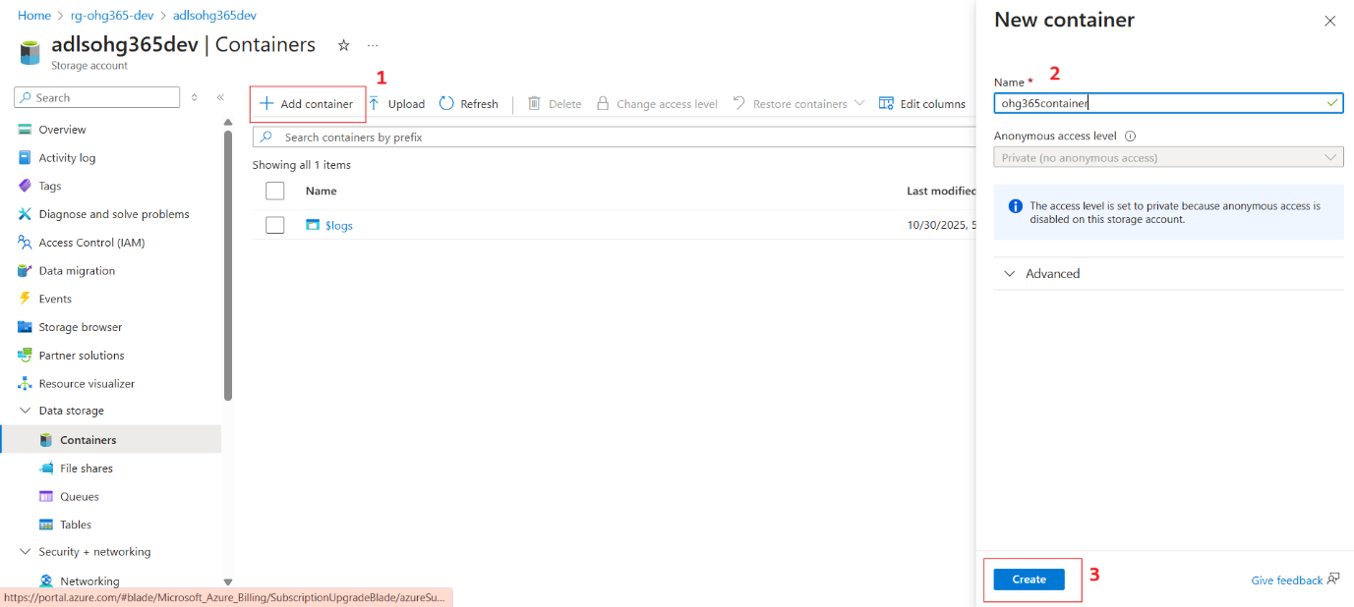

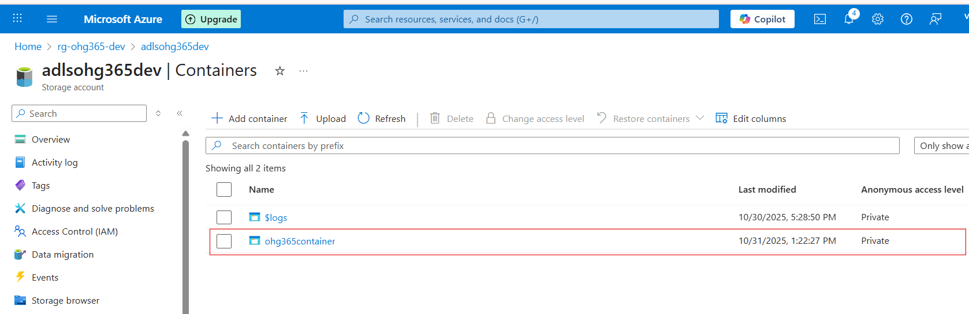

Upload & Manage Blobs
- Click your new container (e.g., images)
- Click Upload
- Choose a file from your computer (like a .jpg, .txt, or .mp4)
- Once uploaded, you can:
  - View Properties (size, type, last modified)
  - Get the URL to access the file
  - Change the access tier

Storage Account
└── DataLake Service
└── Container (like a folder)
└── Blob (the actual file)
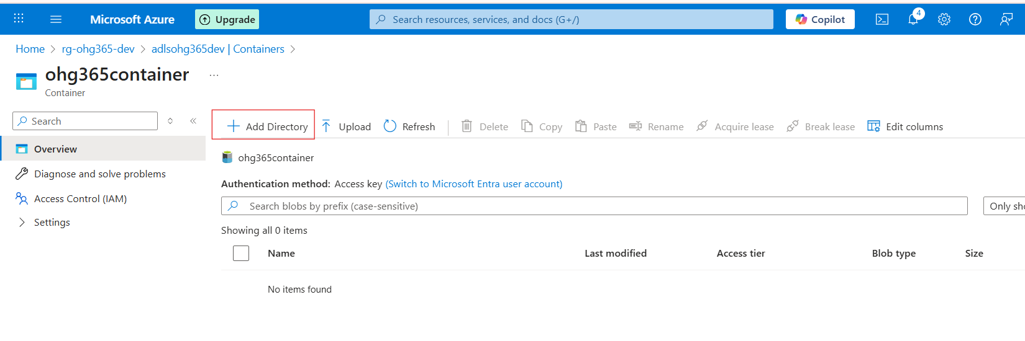

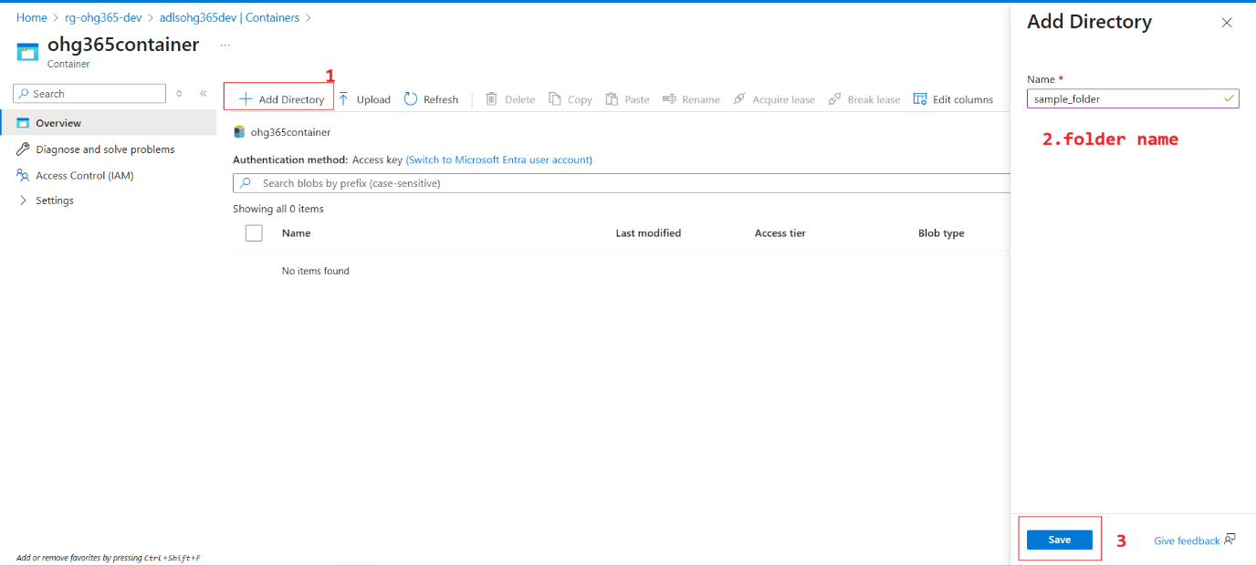

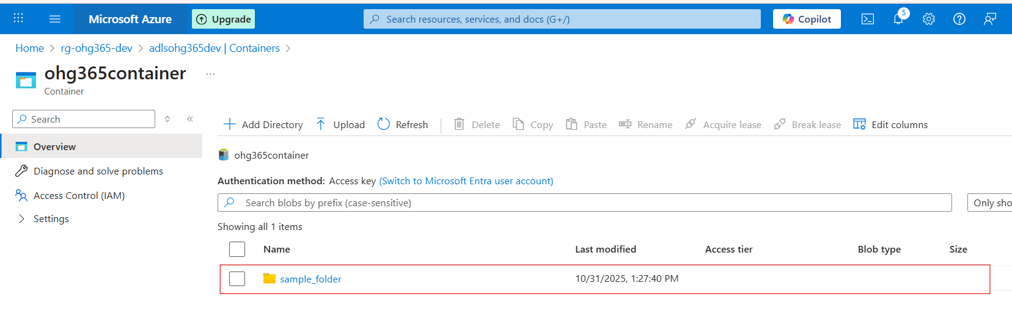
Subfolder:

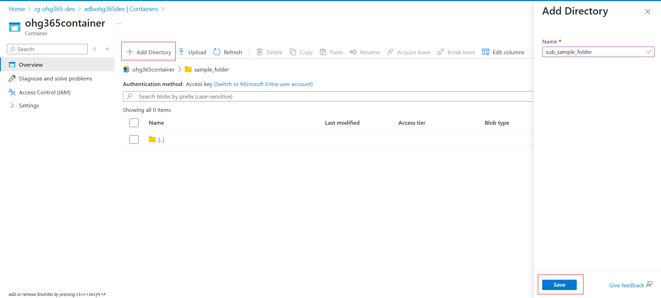
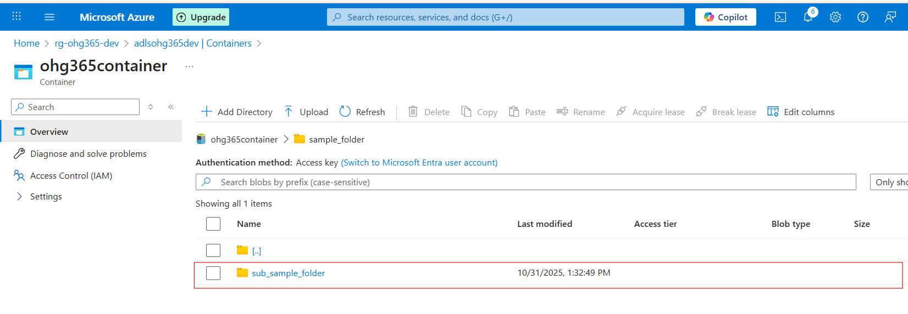
Upload file:
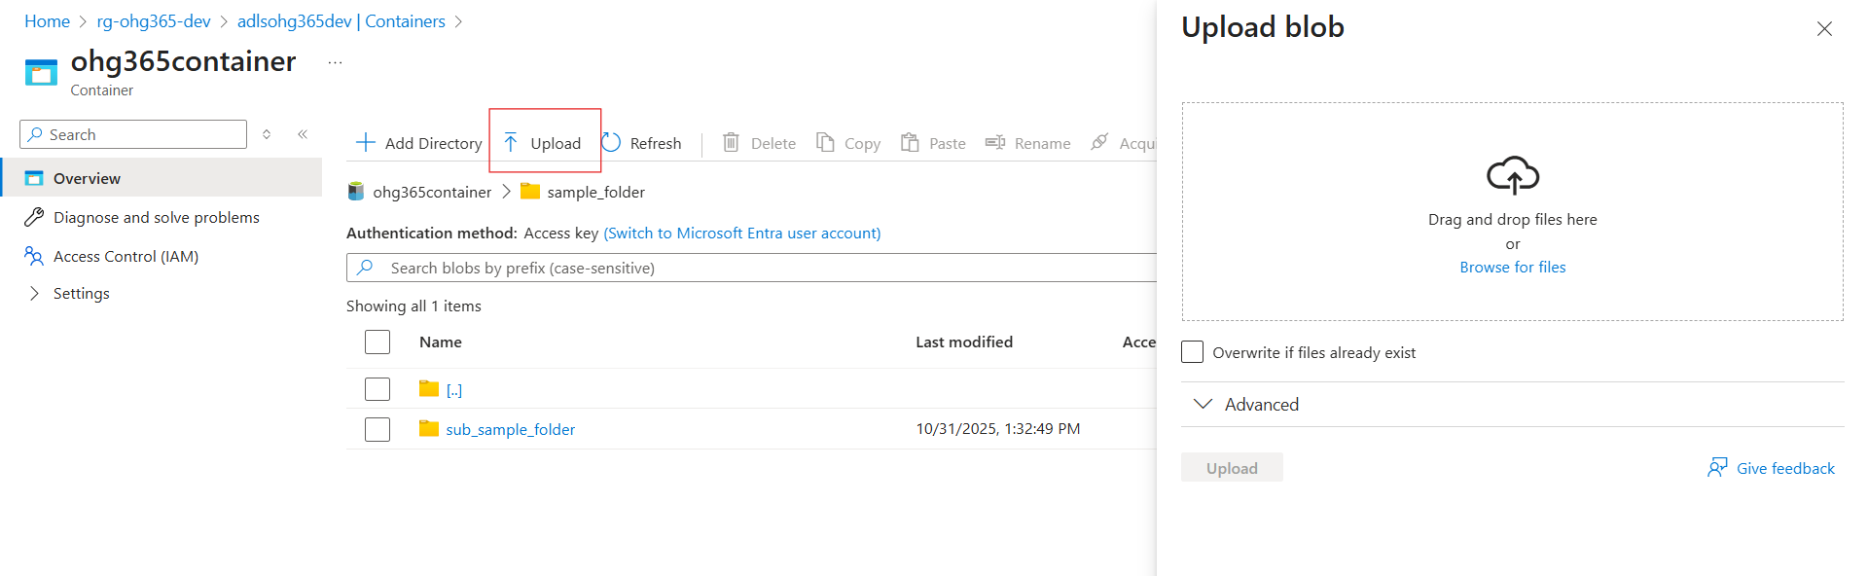

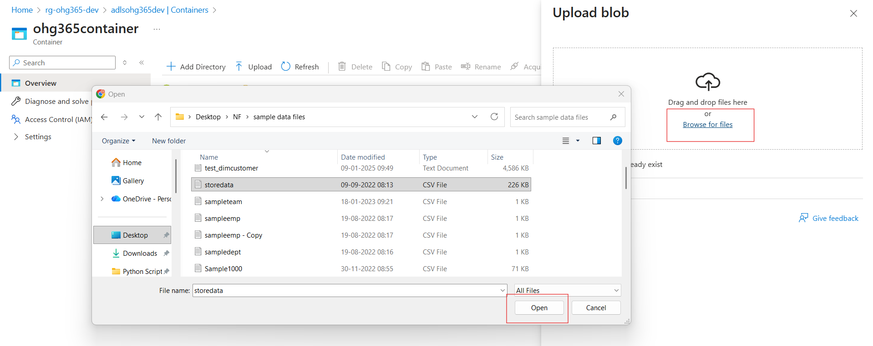

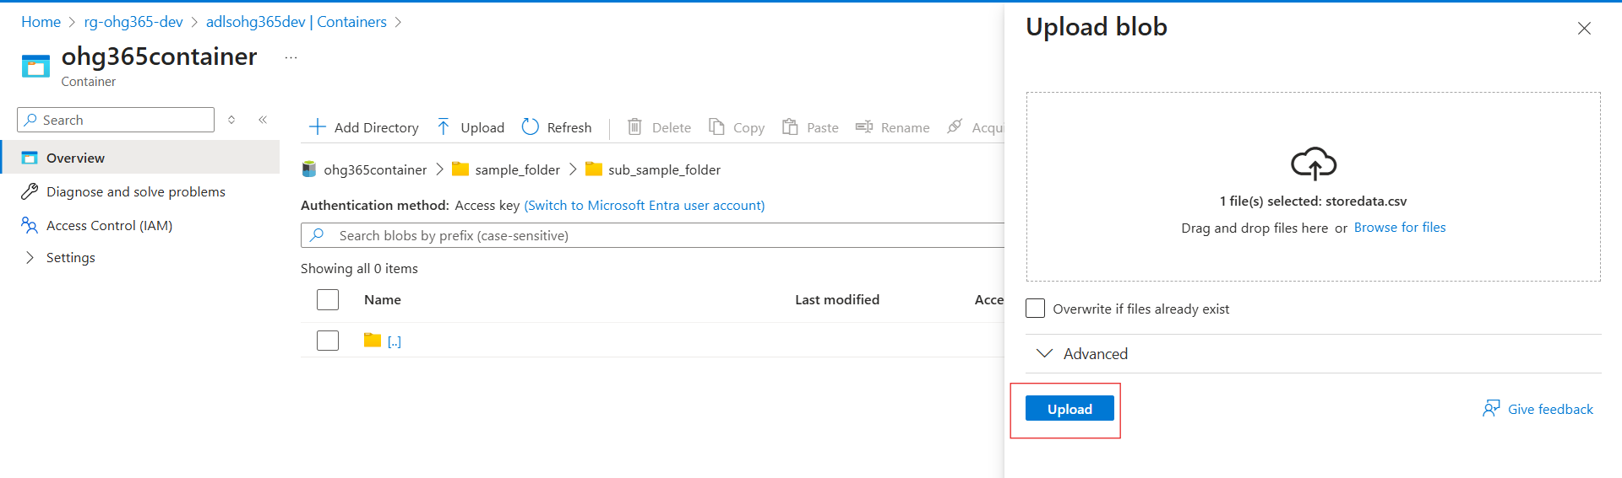
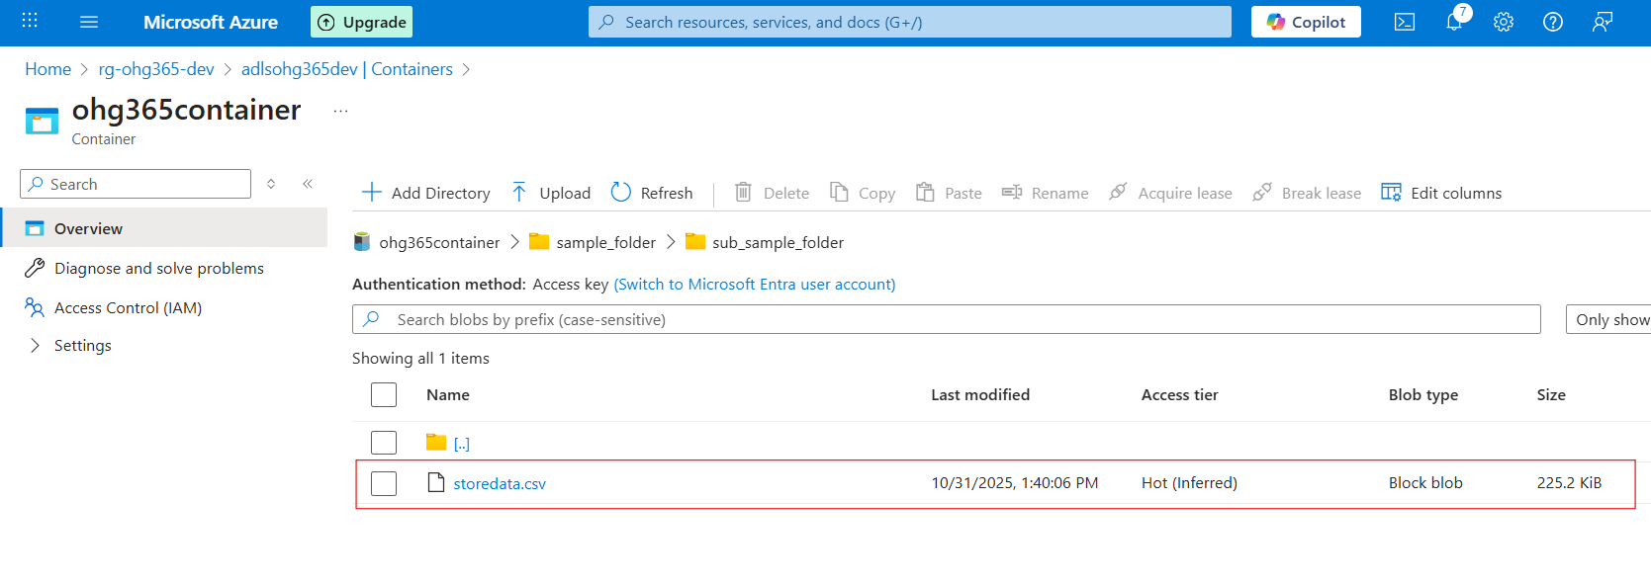
Types of Blob Types:
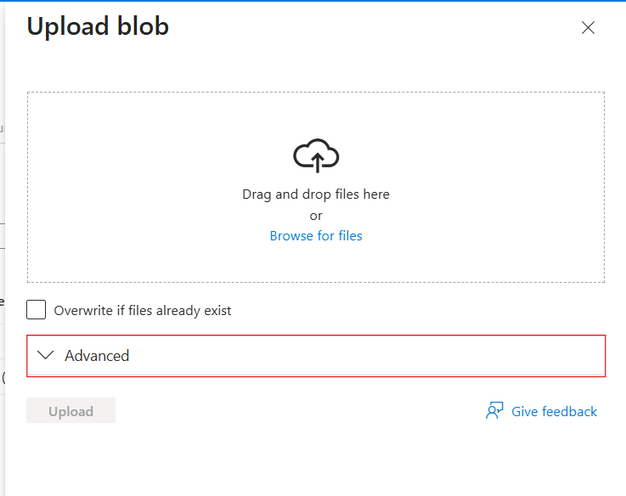

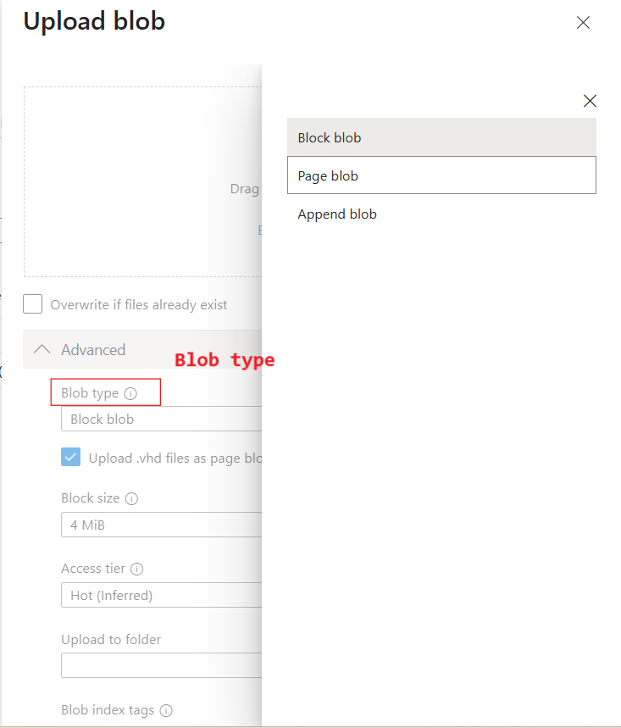

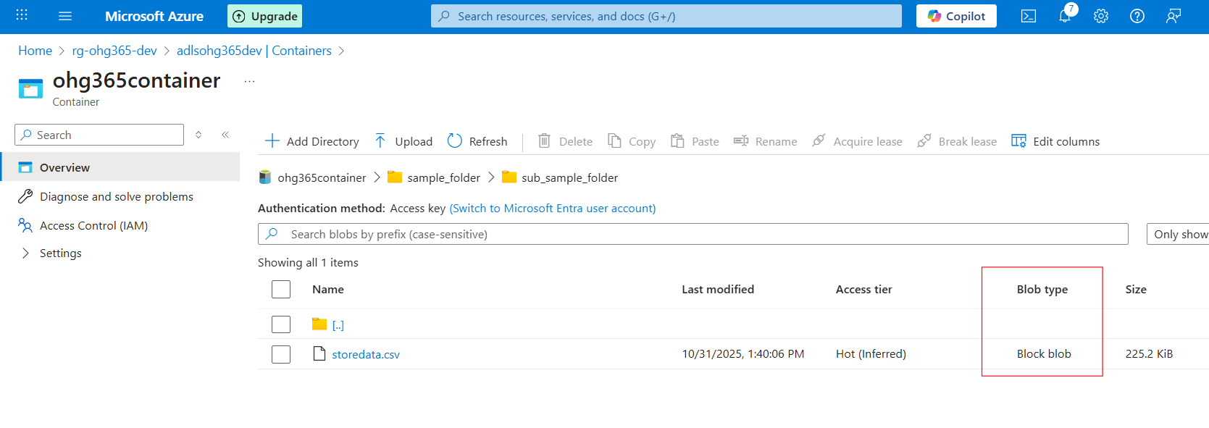

Blob Type | Best For | Example Use
🧱 Block Blob | Storing text or binary data | Images, videos, documents, CSVs
📜 Append Blob | Data that is constantly added to (append-only) | Logs, telemetry, audit data
📄 Page Blob | Random read/write access | Virtual machine disks (VHD files)

🧱 1. Block Blob
Most common blob type used in Azure.
💡 What it is:
- Stores text and binary data (files like .txt, .jpg, .mp4, .csv, etc.)
- Data is split into blocks, and each block is identified by a block ID.
- You can upload or update blocks individually and commit them together.
✅ Use Cases:
- Storing images, videos, PDFs, and backups.
- Data files for analytics (CSV, JSON, Parquet).
- Large files uploaded in chunks.
📘 Example:
You upload a 500 MB video file — Azure divides it into smaller blocks and uploads each part separately for speed and reliability.

📜 2. Append Blob
Special type of blob for data that grows over time.
💡 What it is:
- Optimized for append operations — you can only add new data to the end, not modify or delete existing data.
- Each time you add new information, it’s appended to the blob.
✅ Use Cases:
- Storing log files.
- Application telemetry or diagnostics data.
- Streaming data that’s constantly being added.
📘 Example:
You’re logging website visits. Each time a new visitor arrives, their data (timestamp, IP, etc.) is appended to the existing log file.

📄 3. Page Blob
Designed for random read/write operations.
💡 What it is:
- Data is stored in fixed-size 512-byte pages.
- Allows fast read and write access to specific parts of the blob.
- Commonly used for storing Virtual Hard Disk (VHD) files that power Azure Virtual Machines.
✅ Use Cases:
- Storing Azure VM disks (OS and data disks).
- Large databases that require random access.
- Any workload that reads/writes frequently to specific sections of a file.
📘 Example:
When you start an Azure Virtual Machine, its disk (a .vhd file) is stored as a Page Blob, allowing the VM to quickly read or write data anywhere on the disk.

Blob Type | Structure | Read/Write Behavior | Common Use
Block Blob | Data stored as blocks | Upload/replace blocks | Files, media, documents
Append Blob | Sequentially added blocks | Append-only | Logs, telemetry, streaming data
Page Blob | Fixed 512-byte pages | Random read/write | VM disks, large databases

Types of Access Tiers:
Azure lets you store data in different tiers based on how often you need it.
This helps save money 💰 by matching storage cost to usage.
Tier | Cost | Availability | Best For
Hot | 💰 Highest cost | 🔥 Always available | Frequently accessed data (e.g., active apps, websites)
Cool | 💸 Cheaper | 🕓 Slight delay in access | Infrequently accessed data (e.g., monthly reports)
Cold | 💧 Cheaper than Cool | ⏱️ Slower access | Rarely accessed data but still retrievable
Archive | 🧊 Cheapest | 💤 Retrieval takes hours | Long-term backups, compliance storage

