MDM2 – Case Study: Assistive Robotics for
Improvement of Life Quality
One‑Page Proposal

Team | 3
Members | Taraka Tummalapenta,  Vinay Padira
Project Title | Exoskeleton simulation for Intention Driven Limb Activation in Hemispatial Neglect
GitHub Repository URL | https://github.com/tarakarajesh-2110/Exoskeleton-Simulation-Framework-for-Intention-Driven-Limb-Activation-in-Hemispatial-Neglect
Contact Email | taraka.tummalapenta@stud.th-deg.de  vinay.padira@stud.th-deg.de
Industrial Application (target domain/use‑case) | Neuro rehabilitation for assistance in Limb activation therapy and imitation therapy
Keywords (3–6) | ROS2 and Gazebo, Hemispatial Neglect, EEG, IMUand camera based movement tracking, Intention driven,
Submission Date (YYYY‑MM‑DD) | 2027-01-13
Gant Chart | 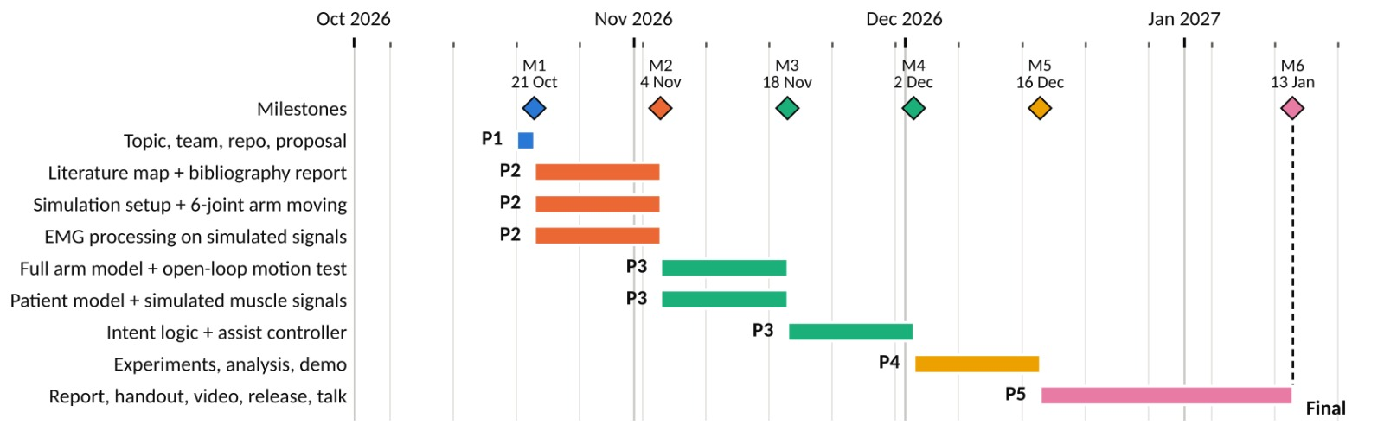

1) Problem Statement & Measurable Outcomes (3–4 sentences) | - Hemispatial neglect is a condition where patients have difficulty noticing or responding to thing on one side of their body or surroundings. We aim to simulate an exoskeleton that assists the affected arm using EEG signals and IMU, camera based movement tracking  - Measurable outcomes : intention detection and assistance, response time , safety, movement imitation
2) Motivation & Assistive Relevance (2–3 sentences) | The patients need assistance to activate and move their affected arm during rehabilitation. We will simulate a exoskeleton from movement data and EEG and IMU, camera to provide assistance to improve their condition.
3) Related Work Snapshot (2–3 key references) | Recent studies support the potential of robotic rehabilitation after stroke. Chen et al.(2021) reported promising improvements in upper limb motor function with the help of exoskeleton,while Huo et al.(2023) EMG driven rehabilitaiton robots and found positive effects on motor recovery .  This simulation will address the proposed integration of EEG and IMU , camera based bilateral movement imitation for affected arm assistance.
4) Method & Feasibility (≤6 sentences) | We need to add a custom node to generate EEG signal to represent muscle activity and simulated IMUs , camera will track arm movement. The system will combine these signals to estimate movement intention and control exoskeleton. This will measure movement accuracy , detection , response time and safety. This project is feasible without physical hardware.
5) Milestones & Timeline (short table/list) | 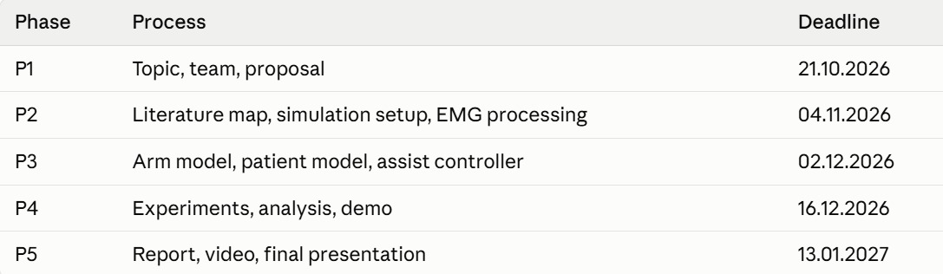
6) Risks & Ethics (1–2 sentences) | - Simulated project, reduces privacy risk  - no physical hardware , eliminates safety and injury concerns.

Phase 1 rubric (15%): Team & GitHub (2%), On‑time (2%), Topic & Proposal (5%) — Industrial Application, Problem+Outcomes, Feasibility+Timeline; Presentation (6%).

