Decompose the problem of airline travel into a series of layers. Define the functions of each layer along with the addition/removal of headers information that is added to passengers and baggage as they move down/up the airline protocol stack?

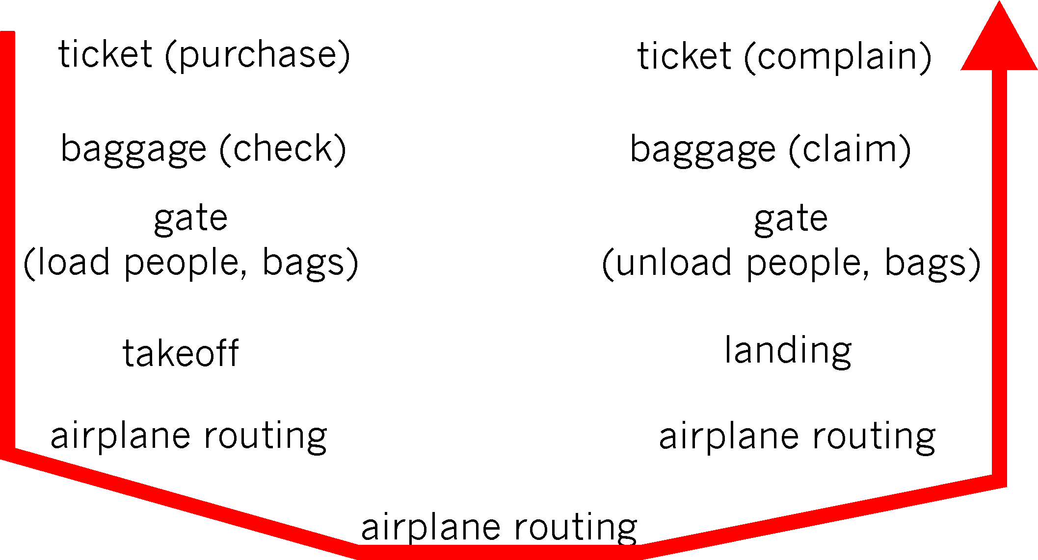

What are two reasons for using layered protocols? What is one possible disadvantage of using layered protocols?

1) You can make changes to one layer without affecting the layer above and below. Abstraction.
2) It takes something very complicated and breaks it up into something smaller and more manageable. Reduces complexity.

Consider an application that transmits data at a steady rate (e.g., the sender generates one packet of N bits every k time units, where k is small and fixed). Also, when such an application starts, it will stay on for relatively long period of time.
1. Would a packet-switched network or a circuit-switched network be more appropriate for this application? Why?
2. Suppose that a packet-switched network is used and the only traffic in this network comes from such applications as described above. Furthermore, assume that the sum of the application data rates is less that the capacities of each and every link. Is some form of congestion control needed? Why or why not?
a) A circuit-switched network would be well suited to the application, because the application involves long sessions with predictable smooth bandwidth requirements. Since the transmission rate is known and not bursty, bandwidth can be reserved for each application session without significant waste. In addition, the overhead costs of setting up and tearing down connections are amortized over the lengthy duration of a typical application session.
b) In the worst case, all the applications simultaneously transmit over one or more network links. However, since each link has sufficient bandwidth to handle the sum of all of the applications' data rates, no congestion (very little queuing) will occur. Given such generous link capacities, the network does not need congestion control mechanisms.

List five tasks that a layer can perform. Is it possible that one (or more) of these tasks could be performed by two (or more) layers?
Five generic tasks are error control, flow control, segmentation and reassembly, multiplexing,and connection setup. Yes, these tasks can be duplicated at different layers. For example, errorcontrol is often provided at more than one layer.
List two ways in which Distance Vector Routing and Link State Routing are the same. Now list two ways in which they differ.

ARP only permits address resolution to occur on a single network. Could ARP send a request to and get a reply from a remote server using an IP datagram?
Address Resolution Protocol (ARP) is only useful on a local network. Why? Because it returns the Local Area Network (LAN) media access control (MAC) address for the machine assigned a particular IP address.
MAC addresses are never propagated outside the LAN. Neither are MAC addresses absolutely guaranteed to be globally unique in any case. MAC Addresses are not a component of any routable TCP over IP (TCP/IP) protocol specification. ARP and RARP (Reverse ARP - returns the IP address associate with a given MAC address) are not routable protocols

