1. Download the Version 6.0.x from this URL : https://sourceforge.net/projects/seeddms/files

2. Run this query in mysql terminal

CREATE DATABASE `seeddms`;

CREATE USER 'seeddmsuser'@'localhost' IDENTIFIED BY 'password';

GRANT ALL PRIVILEGES ON seeddms.* TO 'seeddmsuser'@'localhost';

FLUSH PRIVILEGES;

3. Set the config in setting.xml files

<database

dbDriver = "mysql"

dbHostname = "localhost"

dbDatabase = "seeddms"

dbUser = "root"

dbPass = "root"

doNotCheckVersion = "false"

/>

4. After setup you need to create one file with name ENABLE_INSTALL_TOOL

File Path : /var/www/html/Projects/aeis_dms/conf/ENABLE_INSTALL_TOOL

Save the file with the project url accordingly.

Here is my url : http://localhost/Projects/aeis_dms/seeddms-6.0.24/install/

5. then manually type the install in browser URL and then start installation

and after successful completion looks like this

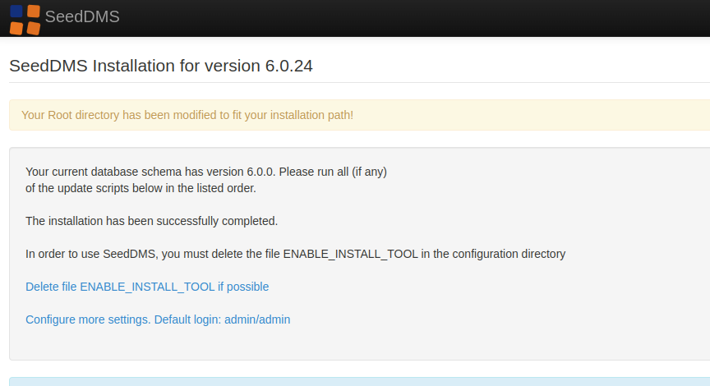

6. delete the ENABLE_INSTALL_TOOL file from the conf