The Home Task can be done using Typescript or Vanilla JS.

Design and implement an application “Currency Converter” to display a certain Euro amount in various other currencies.

Add radio button to change modes:

1) The Euro amount must be the same across all the panels with different currencies, so when changing the Euro amount/Currency amount for one of the panels, the rest should reflect accordingly;

2) The Euro amount/Currency amount is independent, so you can change amount for specific panel without affecting the rest of panels.

The panels have a title naming the currency and three text fields showing the Euro amount, the exchange rate between Euro and the currency and the amount in the panel's currency.

It should be possible to change the Euro amount as well as the amount in the respective currency. For mode 1, the new currency value is used to change the value of Euro, which in turn must change the rest of currencies in all panels.

Think about the implementation details for both modes.

For example, for mode 1 you can use Singleton to share Euro amount across the panels and Observer to notify all the Currency amounts for all panels when Euro amount (Subject) is changed.

What kinds of currencies to choose is up to you.

Don’t forget to to implement 3 components of MVC: Model, View and Controller.

Optionally, you can create each component as abstract class with basic functionality (e.g. Model as Observer or Pub-Sub) and inherit it in your application by adding specific logic.

You can find a bit of inspiration in Backbone.JS library.

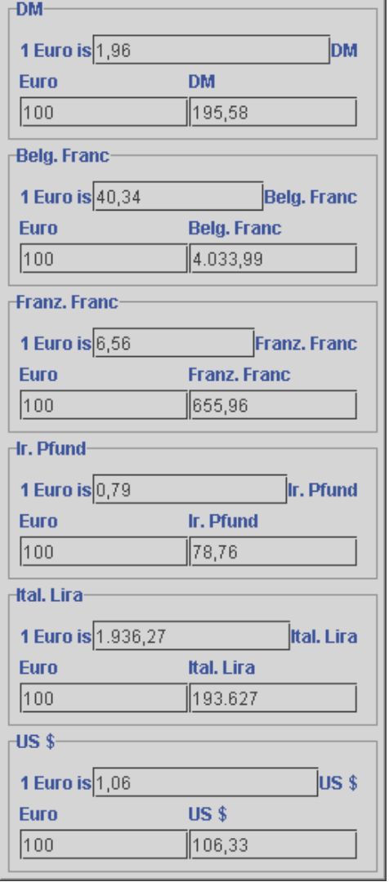

Pic 1. ExampleofCurrency Converter. You can use another exchange rates and another currencies.

Design may be as simple as possible.

You need to fetch exchange rate for all currencies from mocked server (you can crate simple server for that or just create *rates.json* file and make ajax requests to fetch data from it).

Use the previous results to design and implement a different appearance of the converter panels: the values should not be entered as text but by using sliders.

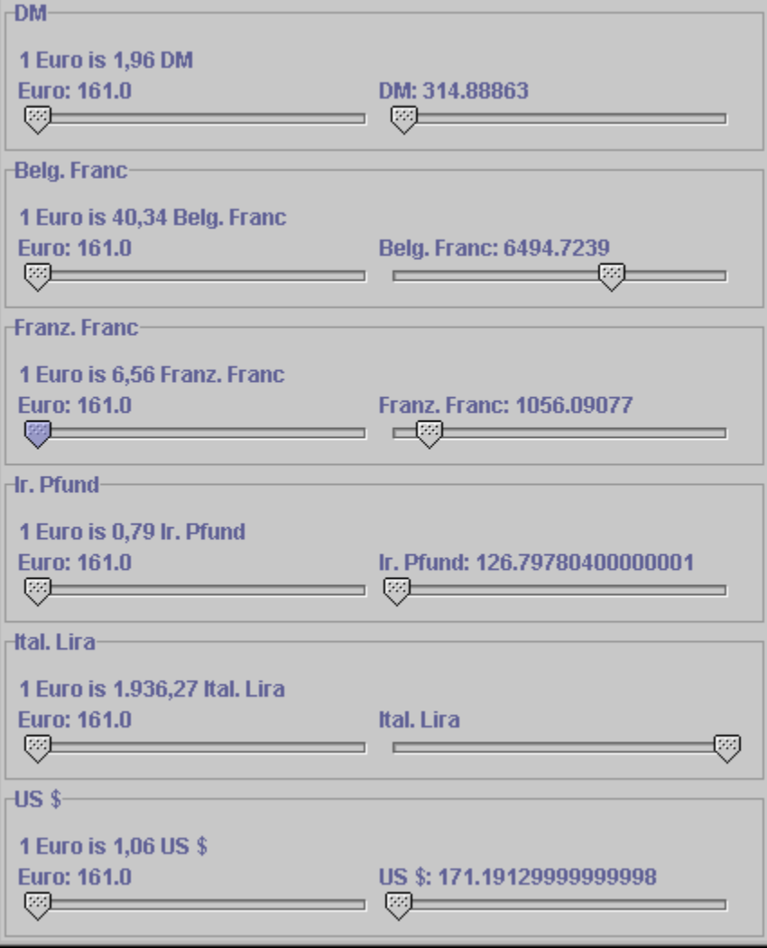

Pic 2. Another view for the same application with the same domain logic.

Would be a plus to have ability to use values of type double for view with sliders.

Think about how you want to handle displaying of different view types (view with inputs and view with slider): via the tabs, or via the dialog window at the start of application, so it’s up to you. Dynamic transition between different views (tabs) is optional.

**Important Notes:**

1. don’t use any framework please;
2. optionally you can use some template engine to render view(s) (handlebars, jade, etc.);
3. in case you decide to use observer/pub-sub, implement it by yourself;
4. you can use real server to fetch currency rate data or just mock json file.