**Introduction to Anthropometry:**

Anthropometry is the science that defines physical measures of a person’s size, form, and functional capacities. It is the systematic collection and correlation of measurements of the [human body](https://www.britannica.com/science/human-body) and helps in obtaining systematic measurements of the human body. It provides the single most portable, universally applicable, inexpensive and non-invasive technique for assessing the size, proportions and composition of the human body. It reflects both health and nutritional status and predicts performance, health and survival. It was developed in the 19th century as a method employed by physical anthropologists for the study of human variation and evolution in both living and extinct populations. Today, anthropometry plays an important role in [industrial design](https://en.wikipedia.org/wiki/Industrial_design), [clothing](https://en.wikipedia.org/wiki/Clothing) design, [ergonomics](https://en.wikipedia.org/wiki/Ergonomics) and architecture where statistical data about the distribution of body dimensions in the population are used to optimize products.

**Types of Anthropometry**

In general there are two different ways for the human body measurement. These are:

1. **Static Anthropometry:** Anthropometry can be defined with the static calculation of the dimensions of the body structure. Anthropometry can be done with static measurements of the body in a position of silence or a static position. Body dimensions measured using static position is weight, height, head size, arm length, etc.
2. **Dynamic Anthropometry:** When a static calculation related to anthropometry with body shape when not doing any position. Then according to its name, dynamic anthropometry associated with dynamic circumstances or physical traits of a person in a state of moving or pay attention to the movements that might occur when the job executes.

**There are three forms of dynamic measurement**, they are:

1. The measurement of level of skill as an approach to understand how the circumstances regarding the workings of an activity in the work and so on.
2. Measurement of the range of the required work. It is related to security and convenience in the work. For example, the employees of the factory, of course the range of employees to the machine tool will be highly influential. And this affects their work and safety needs.
3. Measuring the variability of work, based on any activity that is conducted in the mechanism of action of a person.

**Importance of Anthropometry**

Designs that are incompatible with normal anthropometric measurements of a workforce may result in unwanted incidents.

* The misfit of a heavy equipment cabin to a worker may produce operator blind spots that expose workers on foot to struck-by injuries.
* Inadequate length or configuration of seatbelts may lead to non-use of seatbelts, which affect post-crash survivability.
* Inadequate fit of personal protective equipment cannot provide workers with sufficient protection from health and injury exposures.

Existing data on the size and shape of industrial workers is limited. Because of the lack of anthropometric data for the general worker population, safety researchers have generally relied on data drawn from studies of military personnel, most of which was collected during the 1950s to 1970s. However, substantial anthropometric variability exists among the various U.S. workforce populations, and they are quite different from the average military population. Industrial workers, such as the agriculture, truck driver, and firefighter workforces, are also anthropometrically very different from the average civilian population.

Diverse workforces in many occupations, as well as new roles for women in the workforce, require body-size data for designing adequate workplaces, systems, and personal protective equipment. In the past, variance in body dimensions was typically reported as means and standard deviations for various body segments. This approach was successful in generating broad parameters for personal protective equipment (PPE) sizing but was deficient in generating the detailed fit information needed for workplace, PPE, and other equipment design.

**Data Driven Design:**

Measurements like eye height, the distance from the floor to a person’s eyes, can be taken sitting or standing. Other measurements include elbow height, hip breadth, overall stature, knuckle height, and popliteal height, or the distance from the floor to the back of the knee. These measurements play an important role in the design of architecture, furniture, tools, cars, clothes and more to fit the human body. For example, the height and width of a doorway, or the height and depth of a cabinet or countertop all rely on anthropometry.

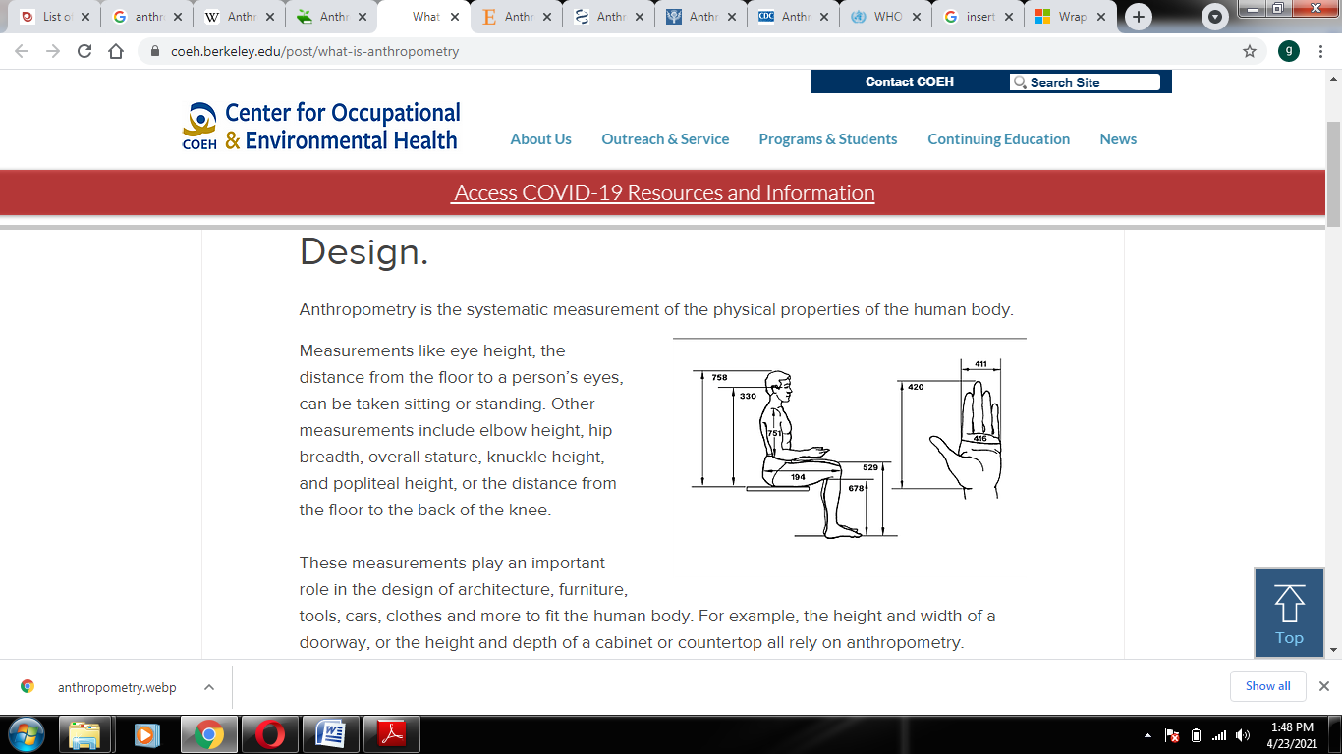We use anthropometry in ergonomics to optimize the fit and function of products, both during design and during evaluation. When evaluating the fit of a chair for a person, we must consider different leg segment measurements to optimize the height and depth of the seat pan. When determining the appropriate height of the work surface we take into account both elbow height and knee height. Measurements of the hand like breadth and length are used when evaluating the grip of a hammer or the fit of a computer mouse.

Figure 1

There are two major sets of static anthropometric measurements commonly used in ergonomics and other design related fields, the [Army Anthropometric Survey Database (ANSUR)](https://phc.amedd.army.mil/topics/workplacehealth/ergo/Pages/Anthropometric-Database.aspx), and the [Civilian American and European Surface Anthropometry Resource Project (CAESAR)](https://www.sae.org/standardsdev/tsb/cooperative/caesumm.htm).

These datasets can be used to inform the design of workplaces. When applying anthropometric data, there are three basic choices:

1. Design for the Average
2. Design for Adjustability
3. Design for Extremes

Within a given workplace, each of these principles has its application. Designers must choose who they are designing for, and which systematic approach best suits a given situation.

The basic process starts with determining the relevant body dimensions you are working with. You must take into consideration the function of your product and the fit with the human body. You also need to consider the task requirements and aspects of the workplace and environmental layout.

Next, you’ll decide which percentile you will accommodate. Measurements in the ANSUR and CAESAR databases are statistically categorized into percentile groupings or distributions and mapped out to find where the average measurements lie, creating a bell curve. The average measurements represent the 50th percentile of the population.

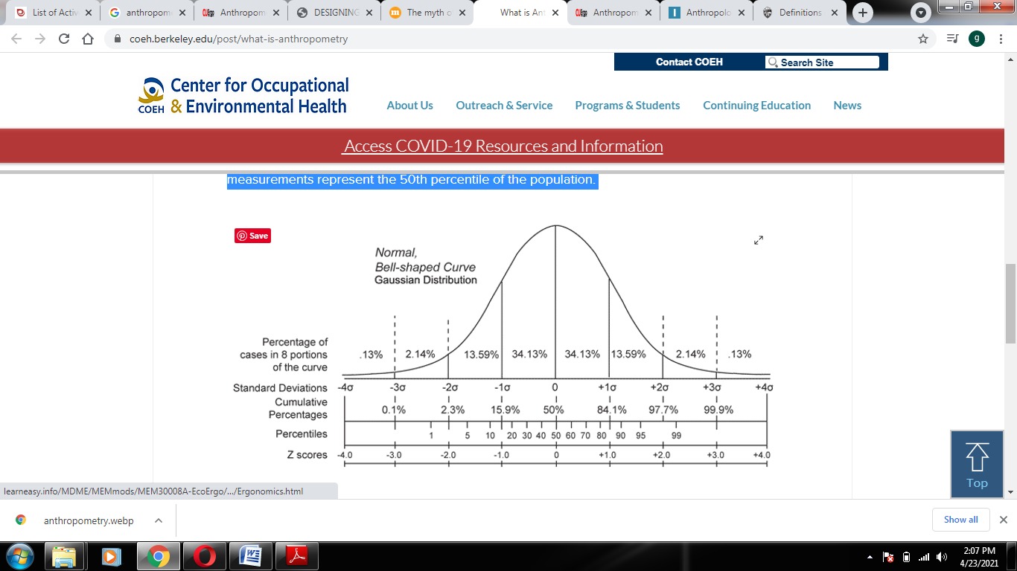

Figure 2

The common percentiles we discuss in anthropometry for ergonomics is the fifth percentile female, representing a small body, and the 95th percentile male, representing a tall or longer body, and the 50th percentile female and male, which represent the average of each gender.

Once you’ve determined the scope of your design, you will need to obtain the data you will use to inform the design, and add allowances to adjust for clothing, footwear, and other worn equipment like personal protective equipment (PPE).

**Myth of designing for the Average Human:**

There is no “average” or “ideal” person. Two individuals of average height, for example, might have very different arm lengths, leg lengths, and capabilities. Those conducting Universal Design seek to consider human variability in their work and produce designs that work equally well for everyone. Since there are no people whose body dimensions are all at the 50th percentile. Body dimensions aren't linearly correlated so people with short arms don't necessarily have short legs, etc. While the use of the 5th and 95th percentiles on one body dimension may exclude 10% of the population, the use of these on 13 dimensions actually can exclude 52% of the population. A tall individual is likely to have longer legs than a shorter individual. Yet, the ratio of leg length to stature might be close to the same for both. The ratio of arms, legs and other body parts to stature varies just as other anthropometric characteristics vary. The so-called Proportionality Constant is the average ratio of one body dimension to another across a population. These average proportions have been tabulated and are sometimes used by designers to estimate the specific body dimensions (e.g., leg length) when only general measures like stature are available. But this is not a good practice for many reasons. In particular, these ratios vary across race/ethnicity and are only accurate for “average” individuals, neglecting those whose ratios differ from the mean.

**Anthropometric Database Design Considerations**

The following are considerations that must be made when using and applying anthropometric data.

* **Percentile Range** - Design and sizing of workspace and equipment should ensure accommodation, compatibility, operability, and maintainability by the user population. Generally, design limits are based on a range of the user population from the 5th percentile values for critical body dimensions, as appropriate. The use of this range will theoretically provide coverage for 90% of the user population for that dimension.
* **User Population Definition** - Anthropometric data should be established from a survey of the actual user population. In the case of space programs, it is difficult to define the user population. Past space programs have involved a small, select, and easily defined group. As the space program expands, the user population will expand and change. With improved environmental controls, physical fitness will be a less important criterion. Skills and knowledge will be more of a factor in selection. International participation will also influence the character of the user population. (In this document) the user population has not been defined. Data are provided for the 5th percentile Asian Japanese and the 95th percentile White or Black American male projected to the year 2000. This does not necessarily define the 5th and 95th percentile of the user population. The data in this document are meant only to provide information on the size ranges of people of the world. The Japanese female represents some of smaller people of the world and the American male some of the larger. Development of a predicted user population size range requires a statistical combination of an estimated mix of these data.
* **Misuse of the 50th Percentile** - There is an erroneous tendency to consider the 50th percentile dimensional data as sufficient to accommodate the majority of users. This must not be done. The 50th percentile dimensions will accommodate only a narrow portion of the population, not a majority of the users. The full size range of users must be considered.
* **Summation of Segment Dimensions** - Caution must be taken when combining body segment dimensions. The 95th percentile arm length, for instance, is not the addition of the 95th percentile shoulder-to-elbow length plus the 95th percentile elbow-to-hand length. The actual 95th percentile arm length will be somewhat less. The 95th percentile individual is not composed of 95th percentile segments. The same is true for any percentile individual. (Refer to Reference 16, p. VIII-5, for a more complete discussion of segment combinations).
* Percentiles within a category of data are exclusive. For example, a person who is 5th percentile body size does not necessarily have 5th percentile reach or joint movement.

**Universal Design:**

Universal design is a framework for the design of living and working spaces and products benefiting the widest possible range of people in the widest range of situations without special or separate design.Designing any product or environment involves the consideration of many factors, including aesthetics, engineering options, environmental issues, safety concerns, industry standards, and cost. Often, designers focus on the average user.

According to the [**Centre for Excellence in Universal Design**](http://universaldesign.ie/What-is-Universal-Design/), universal design (sometimes also called inclusive design or barrier-free design) is the design and structure of an environment so that it can be understood, accessed, and used to the greatest extent possible by all people regardless of their age or ability.

When UD principles are applied, products and environments meet the needs of potential users with a wide variety of characteristic and they can be applied to any product or environment.

**Principles of Universal Design:**

A group of architects, product designers, engineers, and environmental design researchers established seven principles of UD to provide guidance in the design of products and environments. Following are the CUD principles of UD, each followed with an example of its application:

1. **Equitable use** – The design is useful and marketable to people with diverse abilities. For example, a website that is designed to be accessible to everyone, including people who are blind and use screen reader technology, employs this principle.
2. **Flexibility in Use** – The design accommodates a wide range of individual preferences and abilities. An example is a museum that allows visitors to choose to read or listen to the description of the contents of a display case.
3. **Simple and intuitive** – Use of the design is easy to understand, regardless of the user's experience, knowledge, language skills, or current concentration level. Science lab equipment with clear and intuitive control buttons is an example of an application of this principle.
4. **Perceptible information** – The design communicates necessary information effectively to the user, regardless of ambient conditions or the user's sensory abilities. An example of this principle is captioned television programming projected in a noisy sports bar.
5. **Tolerance for error** – The design minimizes hazards and the adverse consequences of accidental or unintended actions. An example of a product applying this principle is software applications that provide guidance when the user makes an inappropriate selection.
6. **Low physical effort** – The design can be used efficiently, comfortably, and with a minimum of fatigue. Doors that open automatically for people with a wide variety of physical characteristics demonstrate the application of this principle.
7. **Size and space for approach and use** – Appropriate size and space is provided for approach, reach, manipulation, and use regardless of the user's body size, posture, or mobility. A flexible work area designed for use by employees who are left- or right-handed and have a variety of other physical characteristics and abilities is an example of applying this principle.

**The Process of Universal Design:**

The process of UD requires a macro view of the application being considered as well as a micro view of subparts of the application. Following is a process that can be used to apply UD:

1. **Identify the application** – Specify the product or environment to which you wish to apply universal design.
2. **Define the universe** – Describe the overall population (e.g., users of service), and then describe the diverse characteristics of potential members of the population for which the application is designed (e.g., students, faculty, and staff with diverse characteristics with respect to gender; age; size; ethnicity and race; native language; learning style; and abilities to see, hear, manipulate objects, read, and communicate).
3. **Involve consumers** – Consider and involve people with diverse characteristics (as identified in Step 2) in all phases of the development, implementation, and evaluation of the application. Also gain perspectives through diversity programs, such as the campus disability services office. Make these processes known with appropriate signage, publications, and websites.
4. **Adopt guidelines or standards** – Create or select existing universal design guidelines/standards. Integrate them with other best practices within the field of the specific application.
5. **Apply guidelines or standards** – Apply universal design in concert with best practices within the field, as identified in Step 4, to the overall design of the application, all subcomponents of the application, and all ongoing operations (e.g., procurement processes, staff training) to maximize the benefit of the application to individuals with the wide variety of characteristics identified in Step 2.
6. **Plan for accommodations** – Develop processes to address accommodation requests (e.g., purchase of assistive technology, arrangement for sign language interpreters) from individuals for whom the design of the application does not automatically provide access.
7. **Train and support** – Tailor and deliver ongoing training and support to stakeholders (e.g., instructors, computer support staff, procurement officers, volunteers). Share institutional goals with respect to diversity and inclusion and practices for ensuring welcoming, accessible, and inclusive experiences for everyone.
8. **Evaluate** – Include universal design measures in periodic evaluations of the application, evaluate the application with a diverse group of users, and make modifications based on feedback. Provide ways to collect input from users (e.g., through online and printed instruments and communications with staff).

## Applications of Universal Design

UD can be applied to any product or environment, such as curricula, career services offices, multimedia, tutoring and learning centers, conference exhibits, museums, microwave ovens, recreational areas, homes, computer labs, worksites, and web pages. DO-IT (Disabilities, Opportunities, Internetworking, and Technology) produces publications and video presentations that promote UD in a variety of educational environments through its online Center for Universal Design in Education (CUDE).

**Anthropometric Measurements:**

Anthropometric measurements are a series of quantitative measurements of the muscle, bone, and adipose tissue used to assess the composition of the body. The core elements of anthropometry are height, weight, body mass index (BMI), body circumferences (waist, hip, and limbs), and skinfold thickness strength and working capacity for design purposes.

Let us discuss some of the anthropometric measurements:

1. **Weight:** The electronic digital scale should be in the kilogram mode
2. **Standing Height:** Make a personstand erect on the floor board of the stadiometer with his or her back to the vertical backboard of the stadiometer. The weight of the participant is evenly distributed on both feet. The heels of the feet are placed together with both heels touching the base of the vertical board. Place the feet pointed slightly outward at a 60 degree angle as shown in figure. If the SP has knock knees, the feet are separated so that the inside of the knees are in contact but not overlapping. The buttocks, scapulae, and head are positioned in contact with the vertical backboard.

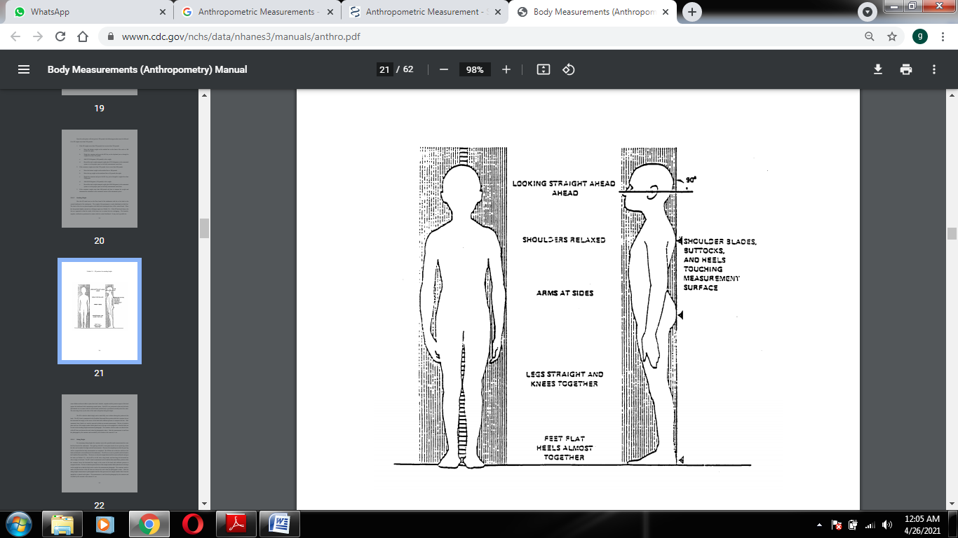

Figure 3

The person is asked to inhale deeply and to stand fully erect without altering the position of the heels. The person’s head is maintained in the Frankfort Horizontal Plane position while the examiner lowers the horizontal bar snugly to the crown of the head with sufficient pressure.

1. **Sitting Height:** For measuring sitting height, the examiner moves the specially-made measurement box onto the floor board of the stadiometer. The person sits on the box with his or her back and buttocks to the backboard of the stadiometer. The person sits as erect as possible with the head in the Frankfort Horizontal Plane. The knees are directed straight ahead with the arms and hands resting at the sides as shown in figure. Ask the person to sit tall, take a deep breath, and then bring the horizontal bar down snugly to the head. The person’s head is maintained in the Frankfort Horizontal Plane position while the examiner lowers the horizontal bar snugly to the crown of the head with sufficient pressure.

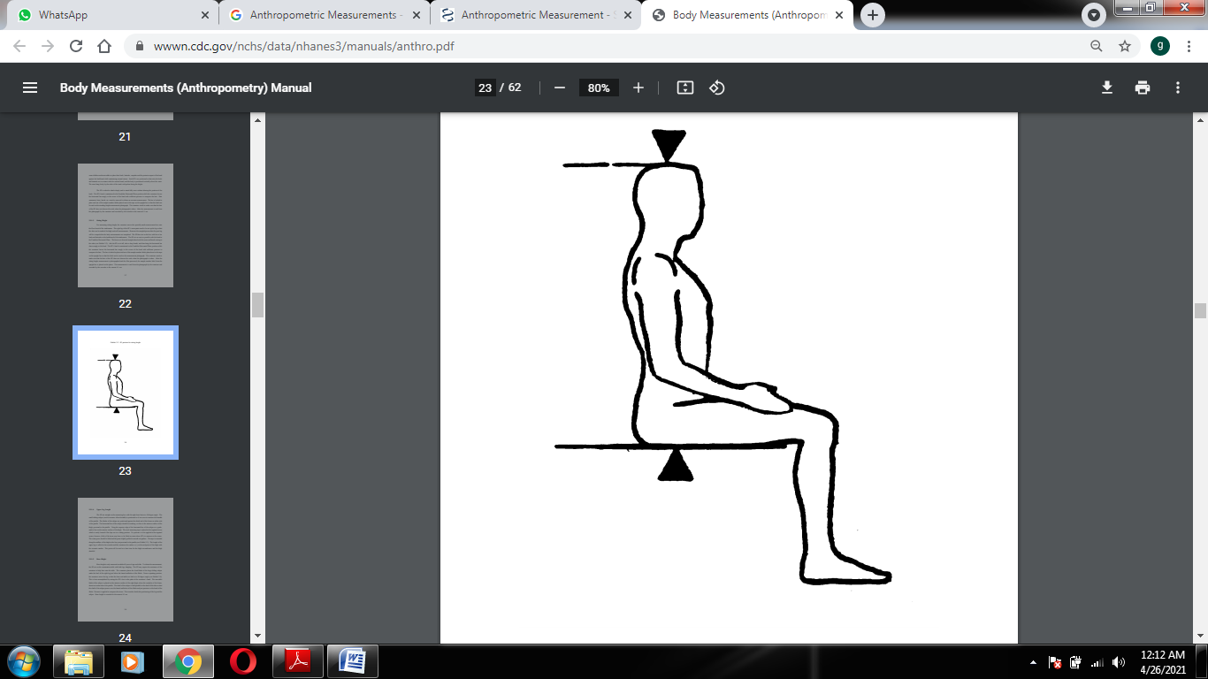

Figure 4

1. **Upper leg length:** The SP sits straight on the measuring box with the right knee bent at a 90 degree angle. The small sliding caliper (used to measure elbow breadth) is positioned as if one were to measure the breadth of the patella. The blades of the caliper are positioned against the distal end of the femur on either side of the patella. The horizontal bar of the caliper should be touching, or close to the anterior surface of the thigh, proximal to the patella. Using the superior edge of the horizontal bar of the caliper as a guide, mark a line on the anterior surface of the thigh. The steel measuring tape is placed at the inguinal crease which is easily located if the hips are in a sitting position. The tape is extended along the midline of the thigh to the line just proximal to the patella as shown in figure 5. The length of the upper leg is called to the recorder and the examiner also makes a (+) at the mid-point of the thigh with the cosmetic marker. This point will be used at a later time for the thigh circumference and the thigh skinfold.

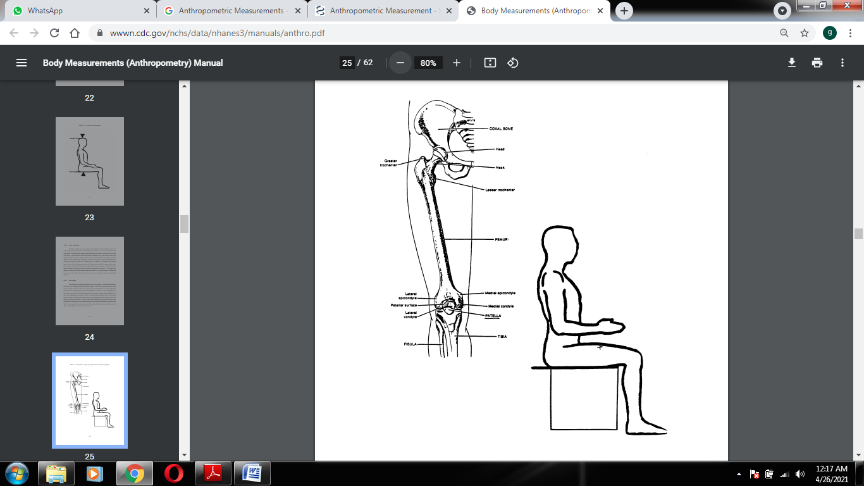

Figure 5

1. **Knee Height:** Knee height is only measured on adults 60 years of age and older. To obtain the measurement, the person is made to sit on the examination table with both legs dangling. The examiner places the fixed blade of the large sliding caliper under the heel of the right leg just below the lateral malleolus of the fibula. From a squatting position, the examiner raises the leg so that the knee and ankle are both at a 90 degree angle shown in figure 5. The moveable blade of the caliper is placed on the anterior surface of the right thigh, above the condyles of the femur, about two inches above the patella. The shaft of the caliper is held parallel to the shaft of the tibia so that the shaft of the caliper passes over the lateral malleolus of the fibula and just posterior to the head of the fibula. Pressure is applied to compress the tissue.
2. **Biacromial Breadth:** The person sits on the body measurement table which is approximately chair height. The person is asked to sit erect with the arms hanging freely at the sides. The examiner stands behind the person with the mediform sliding calipers. The examiner checks the posture of the person making sure that the shoulders are neither too far back nor forward, and that there is a noticeable curvature in the lower back. The objective is to have the person relaxed with the shoulders downward and slightly forward so that the reading is maximal.
3. **Biiliac Breadth:** The person stands erect with feet together. The person needs to hold the examination gown up so that the waist and top of hips are exposed. The examiner stands behind the person holding the large sliding calipers. At the same time, the examiner locates the right side of the iliac crest at its highest point. At this point, the arms of the sliding caliper are placed on the lateral borders of each iliac crest. The soft tissue is compressed to obtain the bone measurement without hurting the person.
4. **Upper arm length:** Have the PERSON stand erect with feet together and the right arm flexed 90 degrees at the elbow with the palm facing up. The examiner is positioned behind the PERSON. The most upper edge of the posterior border of the acromion process of the scapula is located and marked shown in figure 6. Hold the zero end of the measuring tape at this mark and extend the tape down the posterior surface of the arm to the tip of the olecranon process (the bony part of the mid-elbow).

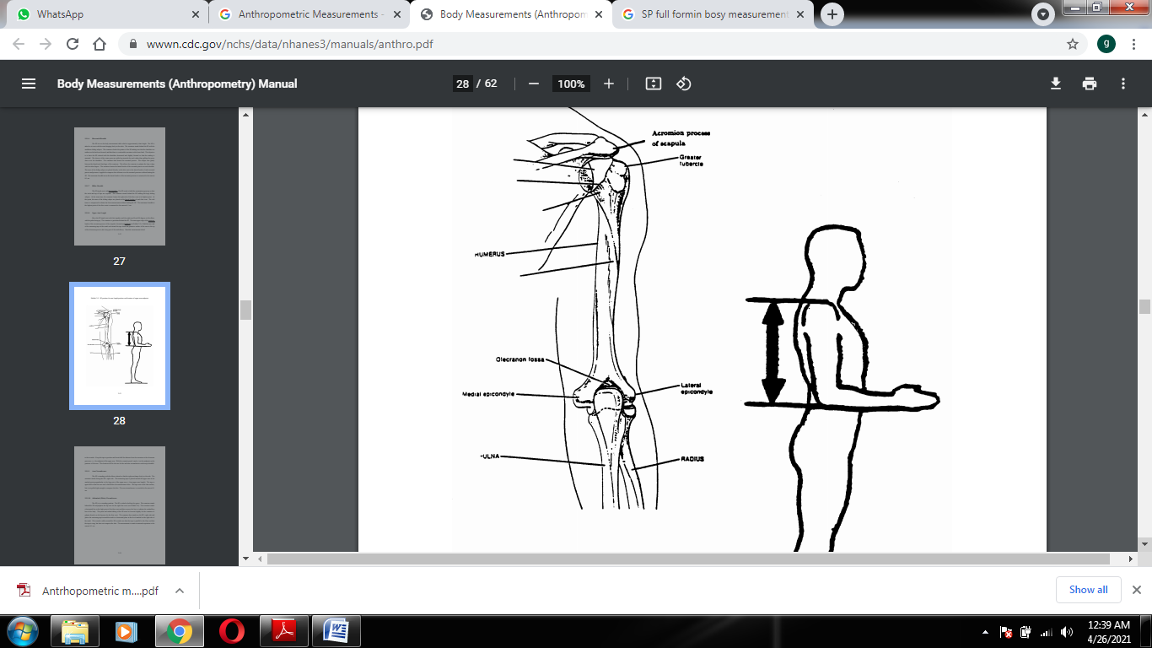

Figure 6

1. **Arm circumference:** The person is standing with the elbow relaxed so that the right arm hangs freely to the side. The examiner stands facing the person’s right side. The measuring tape is placed around the upper arm at the marked point perpendicular to the long axis of the upper arm (+ from upper arm length). The tape is again held so that the zero end is held below the measurement value. The tape rests on the skin surface, but is not pulled tight enough to compress the skin.
2. 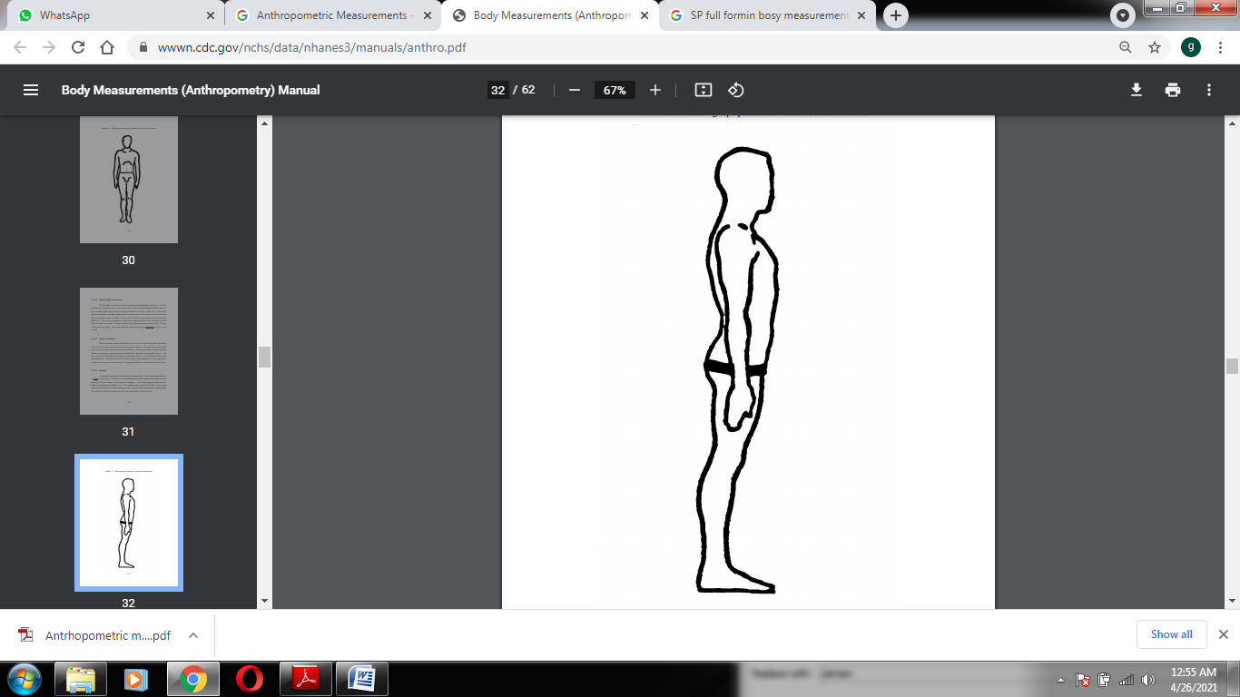**Abdominal (waist) circumference:** The person is in a standing position. The person is asked to hold up his gown. The examiner stands behind the person and palpates the hip area for the right iliac crest shown in figure 7. The examiner marks a horizontal line at the high point of the iliac crest and then crosses the line to indicate the midaxillary line of the body. The pants and underclothing of the person must be lowered slightly for the examiner to palpate directly on the hip area for the iliac crest. The examiner then stands on the person’s right side and places the measuring tape around the trunk in a horizontal plane at this level marked on the right side of the trunk. The recorder walks around the person to make sure that the tape is parallel to the floor and that the tape is snug, but does not compress the skin.

Figure 7 Measuring tape position for waist circumference

1. **Hip circumference:** The person stands erect with feet together and weight evenly distributed on both feet. The tape is placed at the maximum extension of the buttocks shown in figure 8. The recorder then adjusts the sides of the tape and checks the front and sides so that the plane of the tape is horizontal. The zero end of the tape is held under the measurement value. The tape is held snug but not tight.
2. **Thigh Circumference:** The person is standing with the right leg just in front of the left leg and the weight shifted back to the left leg. The examiner stands on the person’s right side and the measuring tape is placed around the midthigh. The tape is positioned perpendicular to the long axis of the thigh with the zero end of the tape held below the measurement value. The tape rests firmly on the skin without compressing the skin.

Figure 8 tape position for measuring hip circumference

1. 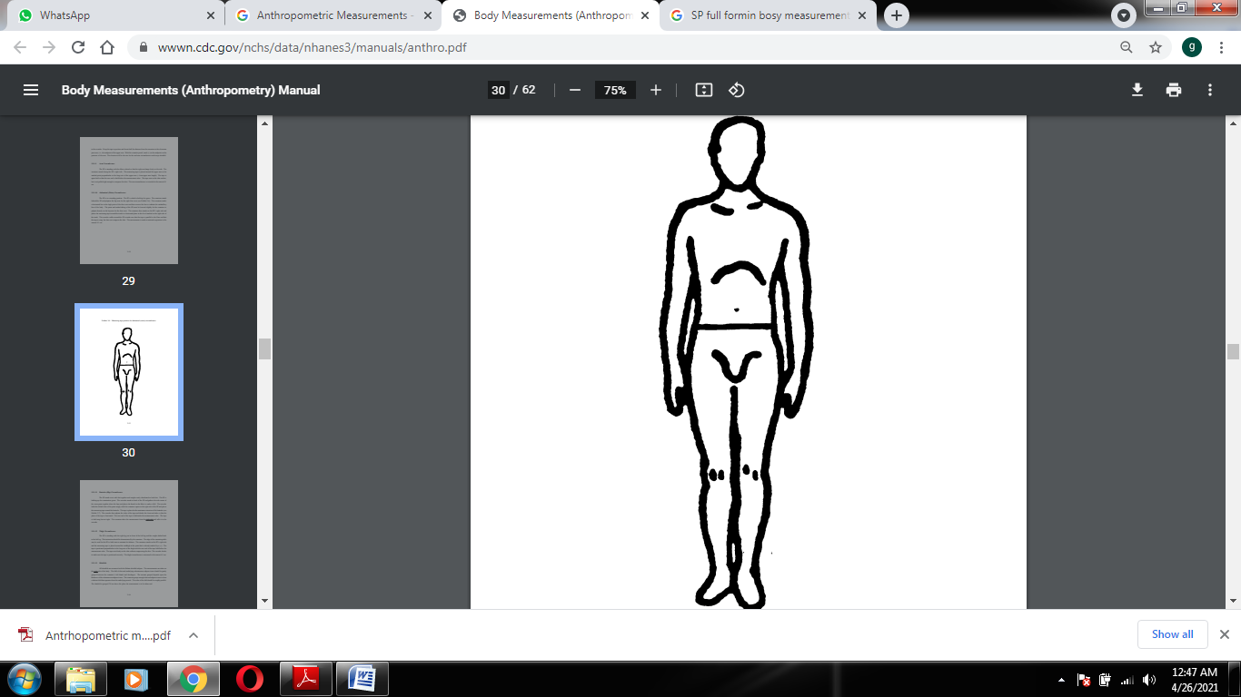**Skinfolds:** All skinfolds are measured with the Holtain skinfold calipers. The measurements are taken on the right side of the body. The fold of skin and underlying subcutaneous adipose tissue should be gently grasped between the examiner’s left thumb and forefingers. The amount grasped depends upon the thickness of the subcutaneous adipose tissue. The examiner grasps enough skin and adipose tissue to form a distinct fold that separates from the underlying muscle. The sides of the fold should be roughly parallel. The skinfold is grasped 2.0 cm above the place the measurement is to be taken and is held gently with the thumb and forefinger. The jaws of the calipers are placed at the marked level, perpendicular to the length of the fold.

* 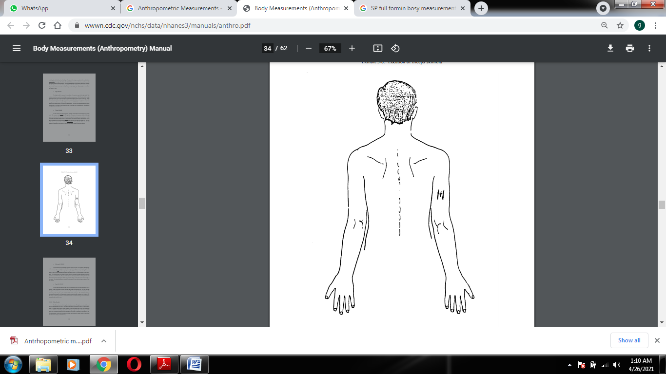**Thigh Skinfold:** The thigh skinfold is measured in the midline of the anterior aspect of the right thigh. This level has already been marked from the thigh circumference measurement. The person stands with his weight shifted back on the left leg with the right leg forward, knee slightly flexed, foot flat on the floor. This is the same position used for measuring the thigh circumferences.
* 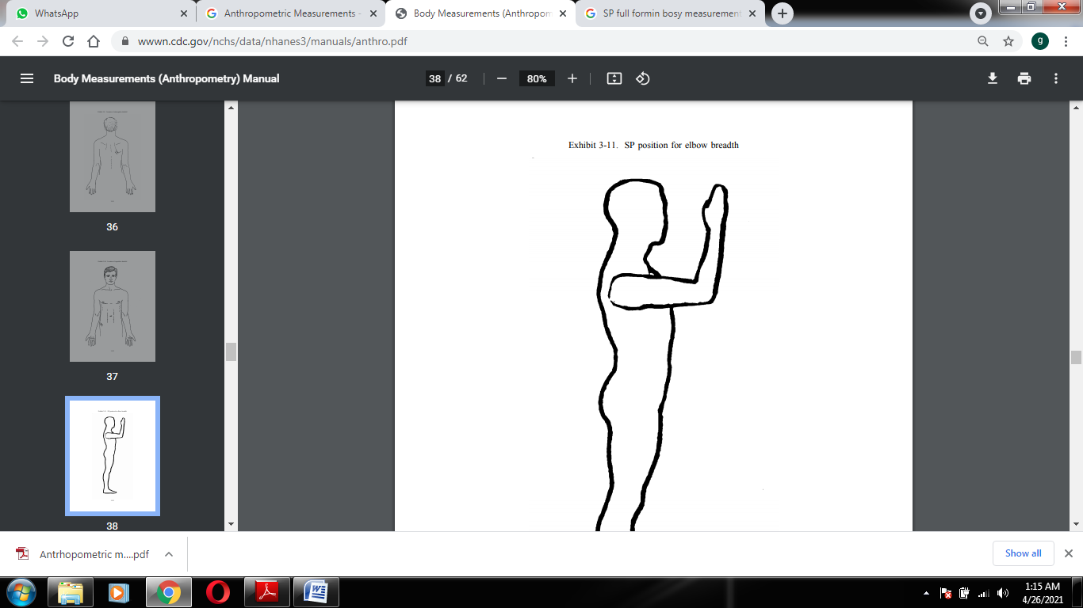**Triceps Skinfold:** The person stands erect with feet together, shoulders relaxed and the arms hanging freely at the sides. The examiner stands behind the person’s right side. The point on the posterior surface of the right upper arm is located in the same area as the marked midpoint for the upper arm circumference. A fold of skin and subcutaneous adipose tissue is grasped gently with thumb and fingers approximately 2.0 cm above the marked level with the skinfold parallel to the long axis of the arm shown in figure 9. The jaws of the calipers are placed at the marked level, perpendicular to the length of the fold.

Figure 9 Location of triceps skinfold

1. **Elbow Breadth:** The person stands erect with feet together facing the examiner. The right arm is extended forward until it is perpendicular to the body. The examiner then flexes the right arm of the person so that the elbow forms a 90 degree angle with the fingers pointing up and the posterior part of the wrist toward the examiner. With the small sliding caliper held at a 45 degree angle to the plane of the long axis of the upper arm, the greatest breadth across the epicondyles of the elbow are measured to the nearest 0.1 cm. This measurement is taken with the calipers at a slight angle because the medial condyle is more distal than the lateral condyle as shown in figure 10.

Figure 10 Person’s position for elbow breadth

1. **Wrist Breadth:** The person stands and extends the right arm keeping the arm straight and near the side of the chest. The examiner stands to the right side of the person and guides the blades of the small sliding caliper with the thumb and first finger of each hand. The examiner palpates the most prominent aspect of the ulnar styloid process with the middle or index finger of the right hand and slides the right blade of the caliper on to this landmark. The most prominent aspect of the radial styloid process is located with the middle or index finger of the left hand.