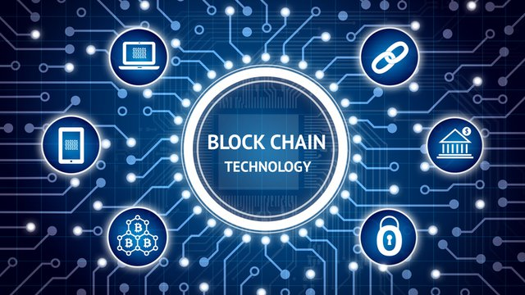

**Title: Blockchain Technology.**

**Tag-line:** *The first generation of the digital revolution brought us the Internet of information. The second generation — powered by blockchain technology — is bringing us the Internet of value***.**

**Blockchain** was invented by [Satoshi Nakamoto](https://en.wikipedia.org/wiki/Satoshi_Nakamoto) in 2008 for use in the crypto currency [bitcoin](https://en.wikipedia.org/wiki/Bitcoin), as its public transaction [ledger](https://en.wikipedia.org/wiki/Ledger). The invention of the blockchain for bitcoin made it the first digital currency to solve the [double spending](https://en.wikipedia.org/wiki/Double-spending) problem without the need of a trusted authority or central [server](https://en.wikipedia.org/wiki/Server_(computing)).

**Blockchain** is a continuously growing lists of records called blocks, which are linked and secured using [**cryptography**](https://en.wikipedia.org/wiki/Cryptography). Each block typically contains a [cryptographic hash](https://en.wikipedia.org/wiki/Cryptographic_hash_function) of the previous block, a [timestamp](https://en.wikipedia.org/wiki/Trusted_timestamping) and transaction data. It is "an open, [distributed ledger](https://en.wikipedia.org/wiki/Distributed_ledger) that can record transactions between two parties efficiently and in a verifiable and permanent way". Once recorded, the data in any given block cannot be altered retroactively without the alteration of all subsequent blocks, which requires collusion of the network majority.

In August 2014, the bitcoin blockchain file size, containing records of all transactions that have occurred on the network, reached **20 GB** ([gigabytes](https://en.wikipedia.org/wiki/Gigabyte)).In January 2015, the size had grown to almost **30 GB**, and from January 2016 to January 2017, the bitcoin blockchain grew from **50 GB** to **100 GB** in size.

A blockchain is a decentralized, distributed and public digital ledger that is used to record transactions across many computers so that the record cannot be altered retroactively without the alteration of all subsequent blocks and the collusion of the network. A blockchain database is managed autonomously using peer-to-peer network and a distributed time stamping server. **It confirms that each unit of value was transferred only once, solving the long-standing problem of double spending.** Blockchains have been described as a [value](https://en.wikipedia.org/wiki/Value_(economics))-exchange [protocol](https://en.wikipedia.org/wiki/Cryptographic_protocol). This blockchain-based exchange of value can be completed more quickly, more safely and more cheaply than with traditional systems. A blockchain can assign [title](https://en.wikipedia.org/wiki/Title_(property)) rights because it provides a record that compels offer and acceptance.