



**TRAINING REPORT**

**OF**

**SIX MONTHS INDUSTRIAL TRAINING, UNDERTAKEN**

**AT**

**SUN PHARMACEUTICAL INDUSTRIES PRIVATE LIMITED.**

**IN**

**CSE DEPARTMENT**

**ON**

**“Data Backup Inventory Management System”**

**SUBMITTED IN PARTIAL FULFILLMENT OF THE DEGREE**

**OF**

**BE (CSE)**

**Under the Guidance of:**

**Submitted By:**

**Name: Mr. Deepak Mehta**

**Name: Tarandeep Singh**

**Department: IT**

**Designation:**

**University ID No.: 1411981247**

1

Chitkara University, Himachal Pradesh, India



**Acknowledgement**

It is my pleasure to be indebted to various people who directly or indirectly contributed in the development of those who influenced my thinking, behaviour and acts during the course of study.

I express my sincere gratitude to all for providing me an opportunity to undergo the Industry Oriented Hands on Training (IOHE) in Sun Pharmaceutical Industries Private Limited, Mohali.

I am thankful to “Mr. Deepak Mehta” for his support, cooperation, motivation and constant guidance provided during the training for constant inspiration, presence and blessings.

I also extend my sincere appreciation to my fellow teammates for their cooperation, our brainstorming sessions and sharing of knowledge in this project.

Lastly, I would like to thank my parents for their moral support.

2

Chitkara University, Himachal Pradesh, India



**CERTIFICATE**

I hereby declare that the project work titled, **“Data Backup Inventory Management System”** submitted as part of Bachelor’s degree in Computer Science, at Chitkara University, Himachal Pradesh, is an authentic record of our own work carried out under the supervision of Mr.Deepak Mehta.Gayatri Guddad

mRm

**Date: Verified by: Mr.Deepak Mehta**Gayatri Guddad

mRm

Name(s):

**Tarandeep Singh**

**(1411981247)**

**Signature of Supervisor:**

3

Chitkara University, Himachal Pradesh, India



**PREFACE**

My project “Data Backup Inventory Management System” is innovated to make a working webapplication on a project in order to create an e- Information about the backup. Through this application the person who is having the rights can upload the location of the backup tapes and can send back to the required location. Moreover the admin can add different users and can provide them with the different rights to use the website. The user with the rights can add multiple backup of the tapes. This web application is made with the help of ASP.NET, HTML, CSS, JAVASCRIPT and MS SQL SERVER.

4

Chitkara University, Himachal Pradesh, India



**CONTENTS**

**Sr.** **Topic** **Page No.**

1. **Project Undertaken………………….....................................................................7**

1.1 Overview**………………………...……………………………………………….**7

1.2 Need to Choose the Project**………………………………………………………**7

1.3 Industry Application**…….,……………………………………………………….**7

1. **Introduction to Assigned Job………………………………………………………8**

|  |  |
| --- | --- |
| 2.1 | Purpose**……………………………………………………………………………….**8 |
| 2.2 | Scope**…………………………………………………………………………………**8 |
| 2.3 | Individual Job**……..………………………………………………………………...**9 |

1. **Feasibility Study…………………………………………………………………….10**

3.1 Technical Feasibility**…………………………………………………………………...**11

3.2 Economical Feasibility**……………………………………………………………..**12

3.3 Behavioral Feasibility**………………………………………………………………..**13

3.4 Project**…………………………………………………………………………………**13

1. **Requirement Analysis……………………………………………………………..15**

4.1 Functional Requirements**……………………………………………………………..**16

4.2 Non Functional Requirements**………………………………………………………..**16

4.3 Technology Used**…………………………………………………………………….**17

1. **Modular Description of Job………………………………………………………18**

5

Chitkara University, Himachal Pradesh, India



* 1. **Detailed Analysis of Individual Module…………………………………………19**
  2. **Screenshots………………………………………………………………………53**
  3. **Future Enhancements…………………………………………………………….63**
  4. **Conclusion…………………………………………………………………………64**
  5. **Bibliography and References………………………………………………………65**

6

Chitkara University, Himachal Pradesh, India



1. ***Project Undertaken***

**1.1 Objective**

The Data Backup Inventory Management System project is programmed in order to help the company in seeking backup tapes at a particular location. This project is designed in such a way that it keeps detailed information as well as separate information of all the locations from where the data is arriving and where it is stored.

The Data Backup Inventory Management System stores the information about the backup tapes more precisely we can say it store the information of the different systems at a particular location. It helps us in recovering of data according to the requirement by the employee.

The system is basically an E-information system for storing the precise location of the backup tapes.

**1.2 Need to choose the project**

* To understand the basics of the ASP.NET.
* To understand how to make the front-end.
* To understand the working of HTML, CSS, JAVASCRIPT.
* How to work with the MS SQL SERVER in a live working project.

**1.3 Industry Application**

Our organization Sun Pharmaceutical Industries Pvt. Ltd. will get help by this project in various ways:

**For Company:**

* Can be used in different branches to store precise location of tapes.
* Easy to recover data.
* Data is stored in a secure location, making it physically safe
* It keeps the track of the modifications done by any employee.

7

Chitkara University, Himachal Pradesh, India



1. ***Introduction to assigned job***

**2.1 Purpose**

The Data Backup Inventory Management System is to create an e-Information about the backup tapes stored in the location. Through this application we can easily track a tape that where it is stored, from which location it is, when the tape has arrived, from which courier it has arrived, etc. Moreover if we want to add an employee who can make changes and perform various functions on the database we have to contact to the administrator as the administrator can provide different privileges to the user.

Data Backup Inventory Management System project is aimed to developing an online Backup Tapes Information. The entire Data Backup Inventory Management System project has been developed keeping in view of the distributed client server computing technology, in mind.

**2.2 Scope**

* **Existing System**

In existing Blood Donation Management System, not all users can get access to the information because of the low working of the application or is not able to access any site. Sometimes the information is not updated or available for a particular place. In existing system the security is less and latest updates and uploads are not so frequent

* **Proposed System**

In the proposed Blood Donation Management System, in this software once the timer is being arranged, it put up updates and uploads automatically and does not need anyone to do so. Also it is easily available due to its speed and programming part and using it is quite an easy task and well as due to its speed the information which will be available by one or two clicks, will get available in few seconds only

8

Chitkara University, Himachal Pradesh, India



**2.3 Individual Job**

As a fresher firstly they gave me an external training by an internal trainer on **ASP.NET**, **HTML, CSS, JAVASCRIPT, MS SQL SERVER** also they taught us **Manual TESTING** and this training was 3 months. After that they deployed us on the testing of the existing website, and we were guided to enhance the existing project by adding various new functionalities.

9

Chitkara University, Himachal Pradesh, India



1. ***Feasibility Study***

Feasibility study is the process of determination of whether or not a project is worth doing. Feasibility studies are undertaken within tight time constraints and normally culminate in a written and oral feasibility report. The contents and recommendations of this feasibility study helped us as a sound basis for deciding how to precede the project. It helped in taking decisions such as which software to use, hardware combinations, etc. The following is the process diagram for feasibility analysis. In the diagram, the feasibility analysis starts with the user set of requirements. With this, the existing system is also observed. The next step is to check for the deficiencies in the existing system. By evaluating the above points, a fresh idea is conceived to define and quantify the required goals. Besides that, a set of alternatives and their feasibility is also considered incise of any failure in the proposed system. Thus, feasibility study is an important part in software development.

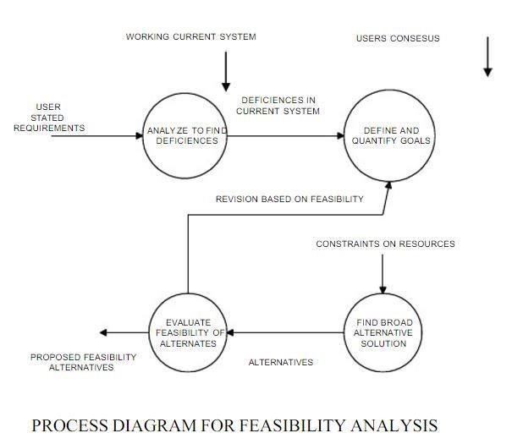

10

Chitkara University, Himachal Pradesh, India



In the SDLC (Systems Development Life Cycle) of our project we maintained a number of feasibility checkpoints between the two phases of the SDLC. These checkpoints indicate that the management decision to be made after a phase is complete. The feasibility checkpoints in our project were as follows:

* Survey phase checkpoint
* Study phase checkpoint
* Selection phase checkpoint
* Acquisition phase checkpoint
* Design phase checkpoint

**3.1 Technical Feasibility**

Technical feasibility determines whether the work for the project can be done with the existing equipment, software technology and available personnel. Technical feasibility is concerned with specifying equipment and software that will satisfy the user requirement. This project is feasible on technical remarks also, as the proposed system is more beneficiary in terms of having a sound proof system with new technical components installed on the system. The proposed system can run on any machines supporting Windows and Internet services and works on the best software and hardware that had been used while designing the system so it would be feasible in all technical terms of feasibility. The technologies such as ASP.NET, JavaScript are compatible.

H/W’s are so familiar with the today’sknowledge based industry that anyone can easily becompatible to the proposed environment

**Technical Feasibility Addresses Three Major Issues:**

* **Is the proposed Technology or Solution Practical?**

The technologies used are matured enough so that they can be applied to our problems. The practicality of the solution we have developed is proved with the

use of the technologies we have chosen. The technologies such as ASP.NET, JavaScript and **the compatible H/W’s are so familiar with the today’s** knowledge based industry that anyone can easily be compatible to the proposed environment.

* **Do we currently possess the necessary technology?**

We first make sure that whether the required technologies are available to us or nor. If they are available, then we must ask if we have the capacity. For instance,

Will our current Printer be able to handle the new reports and forms required of a new system?

11

Chitkara University, Himachal Pradesh, India



**Do we possess the necessary Technical Expertise and is the Schedule reasonable?**

This consideration of technical feasibility is often forgotten during

Feasibility analysis. We may have the technology, but that doesn’t mean we have the skills required to properly apply that technology. As far as our project is concerned we have the necessary expertise so that the proposed solution can be made feasible.

**3.2 Economical Feasibility**

Economic feasibility determines whether there are sufficient benefits increasing to make the cost acceptable, or is the cost of the system too high. As this signifies cost benefit analysis and savings. On the behalf of the cost-benefit analysis, the proposed system is feasible and is economical regarding its pre-assumed cost for making a system.

During the economical feasibility test we maintained the balance between the Operational and Economical feasibilities, as the two were the conflicting. For example, the solution that provides the best operational impact for the end-users may also be the most expensive and, therefore, the least economically feasible.

We classified the costs of Online job portal according to the phase in which they occur. As we know that the system development costs are usually one-time costs that will not recur after the project has been completed.

For calculating the Development costs, we evaluated certain cost categories viz.

* Personnel costs
* Computer usage
* Training
* Supply and equipment’s costs
* Cost of any new computer equipment’s and software.

In order to test whether the Proposed System is cost-effective or not we evaluated it through three techniques viz.

* Payback analysis
* Return on Investment
* Net Present value
* Cost-based study

12

Chitkara University, Himachal Pradesh, India



It is important to identify cost and benefit factors, which can be categorized as follows: 1. Development costs; and 2. Operating costs. This is an analysis of the costs to be incurred in the system and the benefits derivable out of the system.

* Time-based study

This is an analysis of the time required to achieve a return on investments. The future value of a project is also a factor.

**3.3 Behavioral feasibility**

People are inherently resistant to change and computers have been known to facilitate change. There is always some reluctance among the users against the introduction of new system but they were told that this system would eliminate the unnecessary overhead of database migration and conversion, which presently had to be carried out on daily basis to facilitate transactions between the different departments. The objective this feasibility phase is to take the operational staff into confidence. As the success of a good system depends upon the willingness of the operating staff, they were taken into full confidence that the new proposed system would make their jobs easier, relieve them from the unnecessary overheads and reduce the possibility of errors creeping into the system.

**3.4 Project**

The Data Backup Inventory Management System is to create an e-Information about the backup tapes stored in the location. Through this application we can easily track a tape that where it is stored, from which location it is, when the tape has arrived, from which courier it has arrived, etc. Moreover if we want to add an employee who can make changes and perform various functions on the database we have to contact to the administrator as the administrator can provide different privileges to the user.

Data Backup Inventory Management System project is aimed to developing an online Backup Tapes Information. The entire Data Backup Inventory Management System project has been developed keeping in view of the distributed client server computing technology, in mind. Through this application we can easily track a tape that where it is stored, from which location it is, when the tape has arrived, from which courier it has arrived, etc. Moreover if we want to add an employee who can make changes and perform various functions on the database we have to contact to the administrator as the administrator can provide different privileges to the user.

13

Chitkara University, Himachal Pradesh, India



Data Backup Inventory Management System project is designed such that it follows the view of distributed architecture having centralized storage of the database part. By using the

Constructs of MS-SQL Server and all the user interfaces have been designed using the ASP.NET technologies. The database connectivity is planned using the “SQL Connection” methodology. The standards of security and data protective mechanism havebeen given a big choice for proper usage. The application takes care of different modules and their associated reports, which are produced as per the applicable strategies and standards that are put forwarded by the administrative staff.

14

Chitkara University, Himachal Pradesh, India



1. ***Requirement Analysis***

Systems analysis is the study of sets of interacting entities, including computer systems analysis. This field is closely related to operations research. It is also "an explicit formal

Inquiry carried out to help someone (referred to as the decision maker) identify a better course of action and make a better decision than he might otherwise have made. “Analysis is defined

as the procedure by which we break down an intellectual or substantial whole into parts so that we can achieve our end goals. The development of a computer-based information system includes a systems analysis phase which produces or enhances the data model which itself is a precursor to creating or enhancing a database. There are a number of different approaches to system analysis. When a computer-based information system is developed, systems analysis would constitute the following:

**Steps:**

1. The development of a feasibility study, involving determining whether a project is economically, socially, technologically and organizationally feasible.
2. Conducting fact-finding measures, designed to ascertain the requirements of the system’s end-users. These typically span interviews, questionnaires, or visualobservations of work on the existing system.
3. Gauging how the end-users would operate the system (in terms of general experience in using computer hardware or software), what the system would be used for etc.

Another view outlines a phased approach to the process. This approach breaks systems analysis into 5 phases:

* Scope definition
* Problem analysis
* Requirements analysis
* Logical design
* Decision analysis

Use caseare a widely-used systems analysis modelling tool for identifying and expressing thefunctional requirements of a system. Each use case is a business scenario or event for which the system must provide a defined response. Use cases evolved out of object-oriented analysis.

15

Chitkara University, Himachal Pradesh, India



**4.1 Requirement specification**

Information gathering is usually the first phase of the software development project. The purpose of this phase is to identify and document the exact requirements for the system. The **user‘s** request identifies the need for a new information system and on investigation re-defined the new problem to be based on MIS, which supports management. The objective is to determine whether the request is valid and feasible before recommendation is made to build a new or existing manual system continues.

The major steps are:

* Defining the user requirements.
* Studying the present system to verify the problem.
* Defining the performance expected by the candidate to use requirements.

**4.2 S/W and H/W Requirement Specification**

**4.2.1 Hardware Requirements:**

* Pentium IV 1.8 GHz and Above
* 128 MB DDRAM or More
* 40 GB HDD
* Printer
* Power Backup
* Internet Connection

**4.2.2 Software Requirements:**

1. JDK 1.7
   * Eclipse Neon JEE
2. Database
   * SQL Developer 10g
3. Web Server
   * Tomcat 7.0.144
4. Operating System
   * Windows 7 / Vista / XP sp3 /10

16

Chitkara University, Himachal Pradesh, India



**4.3 Technologies Used**

**1. Presentation Layer**

* Web Interface
  + HTML (Hypertext Markup Language)
  + CSS (Cascading Style Sheet)
  + JavaScript

**2. Database Layer**



MS SQL SERVER

**3. Business Layer**

* ASP.NET

17

Chitkara University, Himachal Pradesh, India



* 1. ***Modular description of the Job***
* To develop a powerful online programming environment for ASP.NET programming.
* To manage all details of all users of the Web IDE.
* To provide support to users, so that users could share their problems with other users.
* To understand the working of ASP.NET
* To understand how to make Front-End with the help of HTML, CSS, JS, Angular JS.
* To understand the need of SQL in daily life and in the project.

18

Chitkara University, Himachal Pradesh, India



1. ***Detailed Analysis of individual module***

**HTML**

* HTML is a language for describing web pages.
* HTML stands for **H**yper **T**ext **M**arkup **L**anguage
* HTML is not a programming language, it is a **markup language**
* A markup language is a set of **markup tags**
* HTML uses **markup tags** to describe web pages
* HTML markup tags are usually called HTML tags
* HTML tags are keywords surrounded by **angle brackets** like <html>
* HTML tags normally **come in pairs** like <b> and </b>



**•** The first tag in a pair is the **start tag,** the second tag is the **end tag** Start and end tags are also called **opening tags** and **closing tags**.

* HTML Documents



HTML documents **describe web pages**



HTML documents **contain HTML tags** and plain text 

HTML documents are also **called web pages**

**CSS**

A few words about CSS

* **CSS** stands for **C**ascading Styl**e**sheets
* Styles define **how to display** HTML elements
* Styles are normally stored in **Style Sheets**
* Styles were added to HTML 4.0 **to solve a problem**
* **External Style Sheets** can save you a lot of work
* External Style Sheets are stored in **CSS files**
* Multiple style definitions will **cascade** into one

CSS provides means to customize inbuilt HTML tags HTML tags were originally designed to define the content of a document. They were supposed to say "This is a header", "This is a paragraph", "This is a table", by using tags like <h1>, <p>, <table>, and so on. The layout of the document was supposed to be taken care of by the browser, without using any formatting tags. As the two major browsers - Netscape and Internet Explorer - continued to add new HTML tags and attributes (like the <font> tag and the color attribute) to the original HTML

19

Chitkara University, Himachal Pradesh, India



Specification, it became more and more difficult to create Web sites where the content of HTML documents was clearly separated from the document's presentation layout. To solve this problem, the World Wide Web Consortium (W3C) - the non-profit, standard setting consortium, responsible for standardizing HTML - created STYLES in addition to HTML 4.0. All major browsers support Cascading Style Sheets. Styles sheets define HOW HTML elements are to be displayed, just like the font tag and the color attribute in HTML 3.2. Styles are normally saved in external .css files. External style sheets enable you to change the appearance and layout of all the pages in your Web, just by editing one single CSS document.

**JavaScript**

JavaScript is used in millions of Web pages to improve the design, validate forms, detect browsers, create cookies, and much more. JavaScript is the most popular scripting language on the internet, and works in all major browsers, such as Internet Explorer, Firefox, and Opera.

A few words about JavaScript

* JavaScript was designed to add interactivity to HTML pages.
* JavaScript is a scripting language.
* A scripting language is a lightweight programming language
* JavaScript is usually embedded directly into HTML pages
* JavaScript is an interpreted language (means that scripts execute without preliminary compilation)
* Everyone can use JavaScript without purchasing a license

Purpose of using JavaScript



**JavaScript gives HTML designers a programming tool –**

HTML authors are normally not programmers, but JavaScript is a scripting language with a very simple syntax! Almost anyone can put small "snippets" of code into their HTML pages



**JavaScript can put dynamic text into an HTML page –**

A JavaScript statement like this: document. Write("<h1>" + name + "</h1>") can write a variable text into an HTML page



**JavaScript can react to events –**

A JavaScript can be set to execute when something happens, like when a page has finished loading or when a user clicks on an HTML element

20

Chitkara University, Himachal Pradesh, India



**JavaScript can read and write HTML elements –**

A JavaScript can read and change the content of an HTML element.



**JavaScript can be used to validate data –**

A JavaScript can be used to validate form data before it is submitted to a server. This saves the server from extra processing.



**JavaScript can be used to detect the visitor's browser –**

A JavaScript can be used to detect the visitor's browser, and - depending on the browser - load another page specifically designed for that browser.



**JavaScript can be used to create cookies –**

A JavaScript can be used to store and retrieve information on the visitor's computer

**Where to Put the JavaScript**

* **Scripts in the head section:**

Scripts to be executed when they are called, or when an event is triggered, go in the head section. When you place a script in the head section, you will ensure that the script is loaded before anyone uses it.

* **Scripts in the body section:**

Scripts to be executed when the page loads go in the body section. When you place a script in the body section it generates the content of the page.

* **Using an External JavaScript:**

When you might want to run the same JavaScript on several pages, without having to write the same script on every page, then you can write a JavaScript in an external file. Save the external JavaScript file with a .js file extension. The external script cannot contain the <script> tag. To use the external script, point to the J1. Js file in the "src" attribute of the <script> tag:<script type="text/JavaScript" src="J1.js"></script>

**Angular JS**

AngularJS (commonly referred to as "Angular.js" or "AngularJS 1.X") is a JavaScript based [open-source](https://en.wikipedia.org/wiki/Open-source_software) front-end [web application framework](https://en.wikipedia.org/wiki/Web_application_framework) mainly maintained by [Google](https://en.wikipedia.org/wiki/Google) and by a community of individuals and corporations to address many of the challenges encountered

21

Chitkara University, Himachal Pradesh, India



In developing [single-page applications.](https://en.wikipedia.org/wiki/Single-page_application) The JavaScript components complement [Apache](https://en.wikipedia.org/wiki/Apache_Cordova) [Cordova,](https://en.wikipedia.org/wiki/Apache_Cordova) the framework used for developing cross-platform mobile apps. It aims to simplify both the development and the [testing](https://en.wikipedia.org/wiki/Software_testing) of such applications by providing a framework for client-side [model**–**view**–**controller](https://en.wikipedia.org/wiki/Model%E2%80%93view%E2%80%93controller) (MVC) and [model**–**view**–**view model](https://en.wikipedia.org/wiki/Model_View_ViewModel) (MVVM) architectures, along with components commonly used in [rich Internet applications.](https://en.wikipedia.org/wiki/Rich_Internet_application) In 2014, the original AngularJS team began working on [Angular (Application Platform).](https://en.wikipedia.org/wiki/Angular_(Application_Platform))

The AngularJS framework works by first reading the [HTML](https://en.wikipedia.org/wiki/HTML) page, which has embedded into it additional custom [tag attributes.](https://en.wikipedia.org/wiki/HTML_attribute) Angular interprets those attributes as [directives](https://en.wikipedia.org/wiki/Directive_(programming)) to bind input or output parts of the page to a model that is represented by standard [JavaScript](https://en.wikipedia.org/wiki/JavaScript) [variables.](https://en.wikipedia.org/wiki/Variable_(computer_science)) The values of those JavaScript variables can be manually set within the code, or retrieved from static or dynamic [JSON](https://en.wikipedia.org/wiki/JSON) resources.

According to [JavaScript](https://en.wikipedia.org/wiki/JavaScript) analytics service [Libscore,](https://en.wikipedia.org/wiki/Libscore) AngularJS is used on the websites of [Wolfram Alpha,](https://en.wikipedia.org/wiki/Wolfram_Alpha) [NBC,](https://en.wikipedia.org/wiki/NBC) [Walgreens,](https://en.wikipedia.org/wiki/Walgreens) [Intel,](https://en.wikipedia.org/wiki/Intel) [Sprint,](https://en.wikipedia.org/wiki/Sprint_Nextel) [ABC News,](https://en.wikipedia.org/wiki/ABC_News) and approximately 12,000 other sites out of 1 million tested in October 2016. AngularJS is the 6th most starred project of all time on GitHub.

AngularJS is the frontend part of the [MEAN stack,](https://en.wikipedia.org/wiki/MEAN_(software_bundle)) consisting of [MongoDB](https://en.wikipedia.org/wiki/MongoDB) database, [Express.js](https://en.wikipedia.org/wiki/Express.js) web application server framework, Angular.js itself, and [Node.js](https://en.wikipedia.org/wiki/Node.js) server runtime environment.

AngularJS is built on the belief that [declarative programming](https://en.wikipedia.org/wiki/Declarative_programming) should be used to create [user](https://en.wikipedia.org/wiki/User_interface) [interfaces](https://en.wikipedia.org/wiki/User_interface) and connect [software components,](https://en.wikipedia.org/wiki/Software_component) while [imperative programming](https://en.wikipedia.org/wiki/Imperative_programming) is better suited to defining an application's [business logic.](https://en.wikipedia.org/wiki/Business_logic) The framework adapts and extends traditional HTML to present dynamic content through two-way data-binding that allows for the automatic synchronization of models and views. As a result, AngularJS de-emphasizes explicit DOM manipulation with the goal of improving testability and performance.

22

Chitkara University, Himachal Pradesh, India



AngularJS's design goals include:

* To decouple [DOM](https://en.wikipedia.org/wiki/Document_Object_Model) manipulation from application logic. The difficulty of this is dramatically affected by the way the code is structured.
* To decouple the client side of an application from the server side. This allows development work to progress in parallel, and allows for reuse of both sides.
* To provide structure for the journey of building an application: from designing the UI, through writing the business logic, to testing.

Angular implements the MVC pattern to separate presentation, data, and logic components. Using [dependency injection,](https://en.wikipedia.org/wiki/Dependency_injection) Angular brings traditionally [server-side](https://en.wikipedia.org/wiki/Server-side) services, such as view-dependent controllers, to client-side web applications. Consequently, much of the burden on the server can be reduced.

AngularJS uses the term "scope" in a manner akin to the fundamentals of computer science.

[Scope](https://en.wikipedia.org/wiki/Scope_(computer_science)) in computer science describes when in the program a particular [binding](https://en.wikipedia.org/wiki/Name_binding) is valid. The [ECMA-262](https://en.wikipedia.org/wiki/ECMA-262) specification defines scope as: a lexical environment in which a Function object is executed in client-side web scripts; akin to how scope is defined in [lambda calculus.](https://en.wikipedia.org/wiki/Lambda_calculus)

As a part of the "MVC" architecture, the scope forms the "Model", and all variables defined in the scope can be accessed by the "View" as well as the "Controller". The scope behaves as a glue and binds the "View" and the "Controller".

In AngularJS, "scope" is a certain kind of [object](https://en.wikipedia.org/wiki/Object_(computer_science)) that itself can be in scope or out of scope in any given part of the program, following the [usual rules](https://en.wikipedia.org/wiki/Scope_(computer_science)#JavaScript) of [variable scope](https://en.wikipedia.org/wiki/Variable_(computer_science)#Scope_and_extent) in JavaScript like any other object. When the term "scope" is used below, it refers to the Angular scope object and not the scope of a name binding.

23

Chitkara University, Himachal Pradesh, India



**SQL**

**SQL** (**Structured Query Language**) is a [domain-specific language](https://en.wikipedia.org/wiki/Domain-specific_language) used in programming and designed for managing data held in a [relational database management system](https://en.wikipedia.org/wiki/Relational_database_management_system) (RDBMS), or for stream processing in a [relational data stream management system](https://en.wikipedia.org/wiki/Relational_data_stream_management_system) (RDSMS).

Originally based upon [relational algebra](https://en.wikipedia.org/wiki/Relational_algebra) and [tuple relational calculus,](https://en.wikipedia.org/wiki/Tuple_relational_calculus) SQL consists of a [data](https://en.wikipedia.org/wiki/Data_definition_language) [definition language,](https://en.wikipedia.org/wiki/Data_definition_language) [data manipulation language,](https://en.wikipedia.org/wiki/Data_manipulation_language) and [data control language.](https://en.wikipedia.org/wiki/Data_control_language) The scope of SQL includes data insert, query, update and delete, [schema](https://en.wikipedia.org/wiki/Database_schema) creation and modification, and data access control. Although SQL is often described as, and to a great extent is, a [declarative](https://en.wikipedia.org/wiki/Declarative_programming) [language](https://en.wikipedia.org/wiki/Declarative_programming) [(4GL),](https://en.wikipedia.org/wiki/4GL) it also includes [procedural](https://en.wikipedia.org/wiki/Procedural_programming) elements.

SQL was one of the first commercial languages for [Edgar F. Codd's](https://en.wikipedia.org/wiki/Edgar_F._Codd) [relational model,](https://en.wikipedia.org/wiki/Relational_model) as described in his influential 1970 paper, "A Relational Model of Data for Large Shared Data Banks." Despite not entirely adhering to [the relational model as described by Codd,](https://en.wikipedia.org/wiki/Codd%27s_12_rules) it became the most widely used database language.

SQL became a [standard](https://en.wikipedia.org/wiki/Technical_standard) of the [American National Standards Institute](https://en.wikipedia.org/wiki/American_National_Standards_Institute) (ANSI) in 1986, and of the [International Organization for Standardization](https://en.wikipedia.org/wiki/International_Organization_for_Standardization) (ISO) in 1987. Since then, the standard has been revised to include a larger set of features. Despite the existence of such standards, most SQL code is not completely portable among different database systems without adjustments.

**Design**

SQL deviates in several ways from its theoretical foundation, the [relational model](https://en.wikipedia.org/wiki/Relational_model) and its [tuple calculus.](https://en.wikipedia.org/wiki/Tuple_relational_calculus) In that model, a table is a [set](https://en.wikipedia.org/wiki/Set_(mathematics)) of tuples, while in SQL, tables and query results are [lists](https://en.wikipedia.org/wiki/List_(computing)) of rows: the same row may occur multiple times, and the order of rows can be employed in queries (e.g. in the LIMIT clause).

Critics argue that SQL should be replaced with a language that strictly returns to the original foundation

**Language elements**

The SQL language is subdivided into several language elements, including:

* *Clauses*, which are constituent components of statements and queries. (In some cases,these are optional.)
* *Expressions*, which can produce either [scalar](https://en.wikipedia.org/wiki/Scalar_(computing)) values, or [tables](https://en.wikipedia.org/wiki/Table_(database)) consisting of [columns](https://en.wikipedia.org/wiki/Column_(database)) and [rows](https://en.wikipedia.org/wiki/Row_(database)) of data

24

Chitkara University, Himachal Pradesh, India



* *Predicates*, which specify conditions that can be evaluated to SQL [three-valued logic](https://en.wikipedia.org/wiki/Ternary_logic) [(3VL)](https://en.wikipedia.org/wiki/Ternary_logic) (true/false/unknown) or [Boolean](https://en.wikipedia.org/wiki/Boolean_logic) [truth values](https://en.wikipedia.org/wiki/Truth_value) and are used to limit the effects of statements and queries, or to change program flow.
* *Queries*, which retrieve the data based on specific criteria. This is an importantelement of *SQL*.
* *Statements*, which may have a persistent effect on schemata and data, or may control[transactions,](https://en.wikipedia.org/wiki/Database_transaction) program flow, connections, sessions, or diagnostics.
* SQL statements also include the [semicolon](https://en.wikipedia.org/wiki/Semicolon) (";") statement terminator. Though not required on every platform, it is defined as a standard part of the SQL grammar.
* [*Insignificant whitespace*](https://en.wikipedia.org/wiki/Whitespace_(computer_science)) isgenerally ignored in SQL statements and queries, makingit easier to format SQL code for readability.

**Queries**

The most common operation in SQL, the query, makes use of the declarative retrieves data

|  |  |  |  |  |  |  |  |  |  |  |  |  |  |  |  |  |
| --- | --- | --- | --- | --- | --- | --- | --- | --- | --- | --- | --- | --- | --- | --- | --- | --- |
| from one | | [SELECT](https://en.wikipedia.org/wiki/Select_(SQL)) | statement. | | | | | SELECT | | or more [tables,](https://en.wikipedia.org/wiki/Table_(database)) or expressions. Standard | | | SELECT | |  |  |
|  |  |  |
| statements | |  |  |  |  |  |  |  |  | have no persistent effects on the database. Some | | | | | |  |
|  |  |  |  |  |  |  |  |  |
|  |  |  |  |  |
|  |  |  |  |  |  |  |  |  |  |  |  |  |  |  |  |  |
|  |  | non-standard | | |  |  |  |  | SELECT | | can have persistent effects, such as the | SELECT | |  | |  |
| INTO | implementations of | | | | | | | |  | |  |  | |  | |  |



syntax provided in some databases.[[19]](https://en.wikipedia.org/wiki/SQL#cite_note-ms-sql-select-into-19)

Queries allow the user to describe desired data, leaving the [database management system](https://en.wikipedia.org/wiki/Database_management_system) [(DBMS)](https://en.wikipedia.org/wiki/Database_management_system) to carry out [planning,](https://en.wikipedia.org/wiki/Query_plan) [optimizing,](https://en.wikipedia.org/wiki/Query_optimizer) and performing the physical operations necessary to produce that result as it chooses.

A query includes a list of columns to include in the final result, normally immediately following



[FROM](https://en.wikipedia.org/wiki/From_(SQL)) clause, which indicates the table(s) to retrieve data from. The FROM



the SELECT keyword. An asterisk ("* ") can be used to specify that the query should return

|  |  |  |  |  |  |  |  |  |  |  |
| --- | --- | --- | --- | --- | --- | --- | --- | --- | --- | --- |
| all columns of the queried tables. | | | | | | |  |  | is the most complex statement in SQL, with |  |
| optional keywords and clauses that | | | | | | |  | | |  |
|  | SELECT |  |  |
| include: |  |  |  |  |  |  |  |  |  |  |
| **•**The | clause can | |  |  |  | include optional subclauses to specify the rules for joining | | | |  |
|  |  |  |  |  |  |  |  |  |  |  |
|  | tables. |  |  |  |  |  |  |  |  |  |
|  |  |  |  |  |  |  |  |  |  |  |



* The [WHERE](https://en.wikipedia.org/wiki/Where_(SQL)) clause [JOIN](https://en.wikipedia.org/wiki/Join_(SQL)) includes a comparison predicate, which restricts the rows returned by the query. The WHERE clause eliminates all rows from the

result set where the comparison predicate does not evaluate to True.

25

Chitkara University, Himachal Pradesh, India



* The GROUP BY clause projects rows having common values into a smaller set of rows. GROUP BY is often used in conjunction with SQL aggregation functions or to eliminate duplicate rows from a result set. The WHERE clause is applied before the GROUP BY clause.
* The [HAVING](https://en.wikipedia.org/wiki/Having_(SQL)) clause includes a predicate used to filter rows resulting from the GROUP BY clause. Because it acts on the results of the GROUP BY clause, aggregation functions can be used in the HAVING clause predicate.
* The [ORDER BY](https://en.wikipedia.org/wiki/Order_by_(SQL)) clause identifies which column[s] to use to sort the resulting data, and in which direction to sort them (ascending or descending). Without an ORDER BY clause,

the order of rows returned by an SQL query is undefined. The DISTINCT keyword eliminates duplicate data.



**Operator**

|  |  |  |  |  |  |  |  |  |  |  |  |  |  |  |  |  |  |  |  |  |
| --- | --- | --- | --- | --- | --- | --- | --- | --- | --- | --- | --- | --- | --- | --- | --- | --- | --- | --- | --- | --- |
|  | **Operator** | | | | **Descriptio** | | | | | | | **Example** | | |  |  |  |  |  |  |
|  | **n** | | |  |  |  |  |  |  |  |  |  |  |
|  |  |  |  |  |  |  |  |  |  |  |  |  |  |  |  |  |  |
|  |  |  |  |  |  |  |  |  |  |  |  |  |  |  |  |  |  |  |  |  |
|  |  |  |  |  | Equal to | | | | | | |  |  |  |  |  |  |  |  |  |
|  | = | |  |  |  | Author = 'Alcott' | | | |  |  |  |  |
|  |  |  |  |  |  |  |  |  |  |  |  |  |  |  |
|  |  |  |  |  |  |  |  |  |  |  |  |  |  |  |  |  |  |  |  |  |
|  |  |  |  |  | Not | | |  | equal | | |  |  |  |  |  |  |  |  |  |
|  |  |  |  |  | to | | | (many | | | |  |  |  |  |  |  |  |  |  |
|  |  |  |  |  |  | Dept | | <> |  |  |  |  |  |
|  |  |  |  |  | DBMSs | | | | | | |  |  |  |  |  |  |
|  |  |  |  |  |  | 'Sales' | |  |  |  |  |  |  |
|  |  |  |  |  | accept | | | | != | i | |  |  |  |  |  |  |  |  |  |
|  |  |  |  |  |  |  |  |  |  |  |  |  |  |  |  |  |  |  |  |  |
|  |  |  |  |  |  |  |  |  |  |  |  |  |  |  |  |  |  |  |  |  |
|  |  |  |  |  |  |  |  |  |  | n |  |  |  |  |  |  |  |  |  |  |
|  |  |  |  |  |  |  | <> | | addit | |  |  |  |  |  |  |  |  |  |  |
|  |  |  |  |  | to ) |  | |  | ion | |  |  |  |  |  |  |  |  |  |  |
|  |  |  |  |  |  |  |  |  |  |  |  |  |  |  |  |  |  |
|  |  |  |  |  | Greater | | | | | |  |  |  |  |  |  |  |  |  |  |
|  | > |  |  |  | than | | |  |  |  |  | Hire_Date > '2012-01-31' | | | | | |  |  |  |
|  |  |  |  |  |  |  |  |  |  |  |  |  |  |  |  |  |  |  |  |  |

26

Chitkara University, Himachal Pradesh, India



|  |  |  |  |  |  |  |  |  |  |  |  |  |  |  |  |  |  |  |  |  |  |  |  |  |  |  |  |  |  |  |  |  |
| --- | --- | --- | --- | --- | --- | --- | --- | --- | --- | --- | --- | --- | --- | --- | --- | --- | --- | --- | --- | --- | --- | --- | --- | --- | --- | --- | --- | --- | --- | --- | --- | --- |
|  |  |  |  |  |  |  |  |  |  |  |  |  |  | Less than |  |  |  |  |  |  |  |  |  |  |  |  |  |  |  |  |  |  |
|  |  |  |  |  |  |  |  |  |  |  |  |  |  |  |  | Bonus | | | | |  |  | < | |  |  |  |  |  |  |  |
|  | < | |  |  |  |  |  |  |  |  |  |  |  |  |  |  |
|  |  |  |  |  |  |  |  |  |  |  |  |  |  |  | 50000.00 | | | | | | |  |  |  |  |  |  |  |  |  |
|  |  |  |  |  |  |  |  |  |  |  |  |  |  |  |  |  |  |  |  |  |  |  |  |  |  |
|  |  |  |  |  |  |  |  |  |  |  |  |  |  | Greater |  |  |  |  |  |  |  |  |  |  |  |  |  |  |  |  |  |  |
|  |  |  |  |  |  |  |  |  |  |  |  |  |  | than | or |  | Dependents | | | | | | | >= |  |  |  |  |  |  |  |  |
|  | >= | | |  |  |  |  |  |  |  |  |  |  |  |  |  |  |  |  |  |  |
|  |  |  |  |  |  |  |  |  |  |  | equal |  |  | 2 | |  |  |  |  |  |  |  |  |  |  |  |  |  |  |
|  |  |  |  |  |  |  |  |  |  |  |  |  |  |  |  |  |  |  |  |  |  |  |  |  |  |  |  |  |  |
|  |  |  |  |  |  |  |  |  |  |  |  |  |  |  |  |  |  |  |  |  |  |  |  |  |  |  |  |  |  |  |  |  |
|  |  |  |  |  |  |  |  |  |  |  |  |  |  | Less than or | |  |  |  |  |  |  |  |  |  |  |  |  |  |  |  |  |  |
|  |  |  |  |  |  |  |  |  |  |  |  |  |  |  | Rate | | | | | <= | |  |  |  |  |  |  |  |  |  |
|  | <= | | |  |  |  |  |  |  |  |  |  |  | equal |  |  |  |  |  |  |  |  |  |  |  |
|  |  |  |  |  |  |  |  |  |  |  |  |  | 0.05 | | | |  |  |  |  |  |  |  |  |  |  |  |  |
|  |  |  |  |  |  |  |  |  |  |  |  |  |  |  |  |  |  |  |  |  |  |  |  |  |  |  |  |  |
|  |  |  |  |  |  |  |  |  |  |  |  |  |  |  |  |  |  |  |  |  |  |  |  |  |  |  |  |  |  |  |  |  |
|  |  |  |  |  |  |  |  |  |  |  |  |  |  | Between an | |  |  |  |  |  |  |  |  |  |  |  |  |  |  |  |  |  |
|  |  |  |  |  |  |  |  |  |  |  |  |  |  | inclusive |  |  | Cost | | | | | **BETWEEN**100.00**AND** | | | | | | | |  |  |  |
|  | **BETWEEN** | | | | | | | |  |  |  |  |  |  |  |  |
|  |  |  |  |  |  | range |  |  | 500.00 | | | | |  |  |  |  |  |  |  |  |  |  |  |
|  |  |  |  |  |  |  |  |  |  |  |  |  |  |  |  |  |  |  |  |  |  |  |  |  |  |  |
|  |  |  |  |  |  |  |  |  |  |  |  |  |  |  |  |  |  |  |  |  |  |  |  |  |  |  |  |  |  |  |  |  |
|  |  |  |  |  |  |  |  |  |  |  |  |  |  | Match | a |  |  |  |  |  |  |  |  |  |  |  |  |  |  |  |  |  |
|  |  |  |  |  |  |  |  |  |  |  |  |  |  | character |  |  | First_Name | | | | | | |  |  | **LIKE** | |  |  | |  |  |
|  |  |  |  |  |  |  |  |  |  |  |  |  |  | pattern |  |  | 'Will%' | | | | |  |  |  |  |  |  |  |  |  |  |  |
|  | [**LIKE**](https://en.wikipedia.org/wiki/Like_(SQL)) | | | | | |  |  |  |  |  |  |  |  |  |  |  |  |  |  |  |  |  |  |  |  |  |  |  |  |  |  |
|  |  |  |  |  |  |  |  |  |  |  |  |  |  |  |  |  |  |  |  |  |  |  |  |  |  |  |  |  |  |  |  |  |
|  |  |  |  |  |  |  |  |  |  |  |  |  |  | Equal | to |  |  |  |  |  |  |  |  |  |  |  |  |  |  |  |  |  |
|  |  |  |  |  |  |  |  |  |  |  |  |  |  | one of |  |  |  |  |  |  |  |  |  |  |  |  |  |  |  |  |  |  |
|  |  |  |  |  |  |  |  |  |  |  |  |  |  | multiple |  |  |  |  |  |  |  |  |  |  |  |  |  |  |  |  |  |  |
|  | **IN** | | |  |  |  |  |  |  |  |  |  |  |  |  | DeptCode **IN** (101, 103, 209) | | | | | | | | | | | |  |  |  |  |
|  |  |  |  |  |  |  |  |  |  |  | possible |  |  |  | |  |  |
|  |  |  |  |  |  |  |  |  |  |  |  |  |  |  |  |  |  |  |  |  |  |  |  |  |  |  |  |  |  |  |  |
|  |  |  |  |  |  |  |  |  |  |  |  |  |  | values |  |  |  |  |  |  |  |  |  |  |  |  |  |  |  |  |  |  |
|  |  |  |  |  |  |  |  |  |  |  |  |  |  |  |  |  |  |  |  |  |  |  |  |  |  |  |  |  |  |  |  |  |
|  |  |  |  |  |  |  |  |  |  |  |  |  |  | Compare to | |  |  |  |  |  |  |  |  |  |  |  |  |  |  |  |  |  |
|  |  | **IS** | | |  |  |  | **IS NOT** | |  |  |  |  |  |  |  |  |  |  |  |  |  |  |  |  |  |  |  |  |  |
|  |  |  |  |  | *o* | | |  | null |  |  |  |  |  |  |  |  |  |  |  |  |  |  |  |  |  |  |
|  |  |  |  |  |  |  |  |  |  |  | (missing |  |  | Address **IS NOT NULL** | | | | | | | | | |  |  |  |  |  |  |
|  | *r* | | | | | | | | | | | |  |  |  |  | | | |  |  |
|  |  | data) |  |  |  |  |  |  |  |  |  |  |  |  |  |  |  |  |  |  |
|  |  |  |  |  |  |  |  |  |  |  |  |  |  |  |  |  |  |  |  |  |  |  |  |  |  |  |  |  |  |  |  |
|  |  |  |  |  |  |  |  |  |  |  |  |  |  |  |  |  |  |  |  |  |  |  |  |  |  |  |  |  |  |  |  |  |
|  |  |  | |  | | | | | | |  |  |  |  |  |  |  | |  | | | | | | | | | | | |  |  |
|  | **IS NOT DISTINCT FRO** | | | | | | | | | |  |  |  | Is equal | to |  | Debt **IS NOT DISTINCT FROM** - Receivab | | | | | | | | | | | | | |  |  |
|  | **M** | | |  |  |  |  |  |  |  |  |  |  | value | or |  | les | |  |  |  |  |  |  |  |  |  |  |  |  |  |  |
|  |  |  |  |  |  |  |  |  |  |  | both are |  |  |  | | |  |  |  |  |  |  |  |  |  |  |  |
|  |  |  |  |  |  |  |  |  |  |  |  |  |  |  |  |  |  |  |  |  |  |  |  |  |  |  |  |  |  |  |  |
|  |  |  |  |  |  |  |  |  |  |  |  |  |  |  |  |  |  |  |  |  |  |  |  |  |  |  |  |  |  |  |  |  |



27

Chitkara University, Himachal Pradesh, India

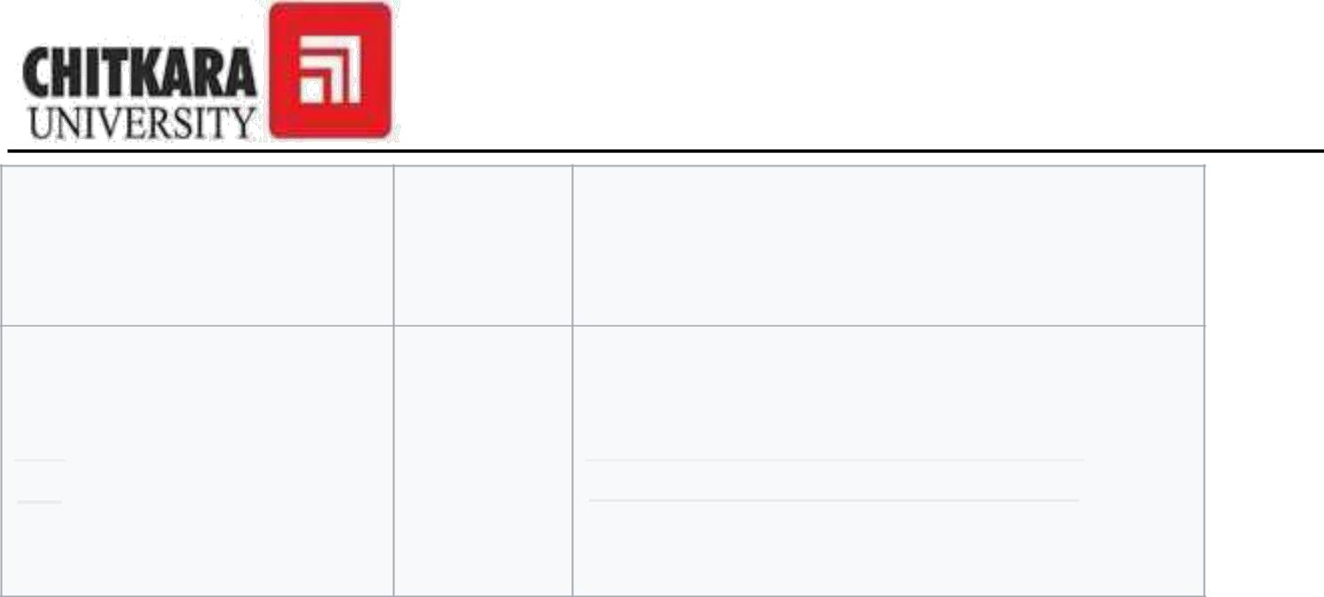

nulls

(missing

data)

Used to

change

a

 **AS**  field name  **SELECT** employee **AS** 'department1'  when

results

**ASP.NET :**

ASP.NET is a web development platform, which provides a programming model, a comprehensive software infrastructure and various services required to build up robust web applications for PC, as well as mobile devices.

ASP.NET works on top of the HTTP protocol, and uses the HTTP commands and policies to set a browser-to-server bilateral communication and cooperation.

ASP.NET is a part of Microsoft .Net platform. ASP.NET applications are compiled codes, written using the extensible and reusable components or objects present in .Net framework. These codes can use the entire hierarchy of classes in .Net framework.

The ASP.NET application codes can be written in any of the following languages:

* C#
* Visual Basic.Net
* Jscript
* J#

ASP.NET is used to produce interactive, data-driven web applications over the internet. It consists of a large number of controls such as text boxes, buttons, and labels for assembling, configuring, and manipulating code to create HTML pages.

28

Chitkara University, Himachal Pradesh, India

**ASP.NET Web Forms Model :**

ASP.NET web forms extend the event-driven model of interaction to the web applications. The browser submits a web form to the web server and the server returns a full markup page or HTML page in response.

All client side user activities are forwarded to the server for stateful processing. The server processes the output of the client actions and triggers the reactions.

Now, HTTP is a stateless protocol. ASP.NET framework helps in storing the information regarding the state of the application, which consists of:

* Page state
* Session state

The page state is the state of the client, i.e., the content of various input fields in the web form. The session state is the collective information obtained from various pages the user visited and worked with, i.e., the overall session state. To clear the concept, let us take an example of a shopping cart.

User adds items to a shopping cart. Items are selected from a page, say the items page, and the total collected items and price are shown on a different page, say the cart page. Only HTTP cannot keep track of all the information coming from various pages. ASP.NET session state and server side infrastructure keeps track of the information collected globally over a session.

The ASP.NET runtime carries the page state to and from the server across page requests while generating ASP.NET runtime codes, and incorporates the state of the server side components in hidden fields.

This way, the server becomes aware of the overall application state and operates in a two-tiered connected way.

29

Chitkara University, Himachal Pradesh, India





**ASP.NET Application Life Cycle**

The application life cycle has the following stages:

* User makes a request for accessing application resource, a page. Browser sends this request to the web server.
* A unified pipeline receives the first request and the following events take place:
  + An object of the class ApplicationManager is created.
  + An object of the class HostingEnvironment is created to provide information regarding the resources.
  + Top level items in the application are compiled.
* Response objects are created. The application objects such as HttpContext, HttpRequest and HttpResponse are created and initialized.
* An instance of the HttpApplication object is created and assigned to the request.
* The request is processed by the HttpApplication class. Different events are raised by this class for processing the request.

**ASP.NET Page Life Cycle**

When a page is requested, it is loaded into the server memory, processed, and sent to the browser. Then it is unloaded from the memory. At each of these steps, methods and events are available, which could be overridden according to the need of the application. In other words, you can write your own code to override the default code.

The Page class creates a hierarchical tree of all the controls on the page. All the components on the page, except the directives, are part of this control tree. You can see the control tree by adding trace= "true" to the page directive. We will cover page directives and tracing under 'directives' and 'event handling'.

The page life cycle phases are:

* Initialization
* Instantiation of the controls on the page.
* Restoration and maintenance of the state.

30

Chitkara University, Himachal Pradesh, India

* Execution of the event handler codes
* Page rendering.

Understanding the page cycle helps in writing codes for making some specific thing happen at any stage of the page life cycle. It also helps in writing custom controls and initializing them at right time, populate their properties with view-state data and run control behavior code.

Following are the different stages of an ASP.NET page:

* **Page request** - When ASP.NET gets a page request, it decides whether to parse and compile the page, or there would be a cached version of the page; accordingly the response is sent.
* **Starting of page life cycle** - At this stage, the Request and Response objects are set. If the request is an old request or post back, the IsPostBack property of the page is set to true. The UICulture property of the page is also set.
* **Page initialization** - At this stage, the controls on the page are assigned unique ID by setting the UniqueID property and the themes are applied. For a new request, postback data is loaded and the control properties are restored to the view-state values.
* **Page load** - At this stage, control properties are set using the view state and control state values.
* **Validation** - Validate method of the validation control is called and on its successful execution, the IsValid property of the page is set to true.
* **Postback event handling** - If the request is a postback (old request), the related event handler is invoked.
* **Page rendering** - At this stage, view state for the page and all controls are saved. The page calls the Render method for each control and the output of rendering is written to the OutputStream class of the Response property of page.
* **Unload** - The rendered page is sent to the client and page properties, such as Response and Request, are unloaded and all cleanup done.

31

Chitkara University, Himachal Pradesh, India



## 

## ASP.NET Page Life Cycle Events

At each stage of the page life cycle, the page raises some events, which could be coded. An event handler is basically a function or subroutine, bound to the event, using declarative attributes such as Onclick or handle.

Following are the page life cycle events:

* **PreInit** - PreInit is the first event in page life cycle. It checks the IsPostBack property and determines whether the page is a postback. It sets the themes and master pages, creates dynamic controls, and gets and sets profile property values. This event can be handled by overloading the OnPreInit method or creating a Page_PreInit handler.
* **Init** - Init event initializes the control property and the control tree is built. This event can be handled by overloading the OnInit method or creating a Page_Init handler.
* **InitComplete** - InitComplete event allows tracking of view state. All the controls turn on view-state tracking.
* **LoadViewState** - LoadViewState event allows loading view state information into the controls.
* **LoadPostData** - During this phase, the contents of all the input fields are defined with the <form> tag are processed.
* **PreLoad** - PreLoad occurs before the post back data is loaded in the controls. This event can be handled by overloading the OnPreLoad method or creating a Page_PreLoad handler.
* **Load** - The Load event is raised for the page first and then recursively for all child controls. The controls in the control tree are created. This event can be handled by overloading the OnLoad method or creating a Page_Load handler.
* **LoadComplete** - The loading process is completed, control event handlers are run, and page validation takes place. This event can be handled by overloading the OnLoadComplete method or creating a Page_LoadComplete handler
* **PreRender** - The PreRender event occurs just before the output is rendered. By handling this event, pages and controls can perform any updates before the output is rendered.

32

Chitkara University, Himachal Pradesh, India



* **PreRenderComplete** - As the PreRender event is recursively fired for all child controls, this event ensures the completion of the pre-rendering phase.
* **SaveStateComplete** - State of control on the page is saved. Personalization, control state and view state information is saved. The HTML markup is generated. This stage can be handled by overriding the Render method or creating a Page_Render handler.
* **UnLoad** - The UnLoad phase is the last phase of the page life cycle. It raises the UnLoad event for all controls recursively and lastly for the page itself. Final cleanup is done and all resources and references, such as database connections, are freed. This event can be handled by modifying the OnUnLoad method or creating a Page_UnLoad handler.

33

Chitkara University, Himachal Pradesh, India

**Event Arguments**

ASP.NET event handlers generally take two parameters and return void. The first parameter represents the object raising the event and the second parameter is event argument.

**Application and Session Events**

The most important application events are:

* **Application_Start** - It is raised when the application/website is started.
* **Application_End** - It is raised when the application/website is stopped.

Similarly, the most used Session events are:

* **Session_Start** - It is raised when a user first requests a page from the application.
* **Session_End** - It is raised when the session ends.

**Page and Control Events**

Common page and control events are:

* **DataBinding** - It is raised when a control binds to a data source.
* **Disposed** - It is raised when the page or the control is released.
* **Error** - It is a page event, occurs when an unhandled exception is thrown.
* **Init** - It is raised when the page or the control is initialized.
* **Load** - It is raised when the page or a control is loaded.
* **PreRender** - It is raised when the page or the control is to be rendered.
* **Unload** - It is raised when the page or control is unloaded from memory.

34

Chitkara University, Himachal Pradesh, India



**Event Handling Using Controls**

All ASP.NET controls are implemented as classes, and they have events which are fired when a user performs a certain action on them. For example, when a user clicks a button the 'Click' event is generated. For handling events, there are in-built attributes and event handlers. Event handler is coded to respond to an event, and take appropriate action on it.

By default, Visual Studio creates an event handler by including a Handles clause on the Sub procedure. This clause names the control and event that the procedure handles.

35

Chitkara University, Himachal Pradesh, India

***7. Screenshots***

**Login Form:**

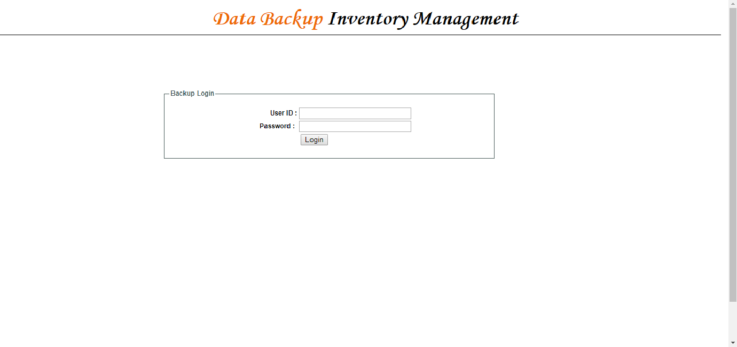

**Available Backup Summary:**

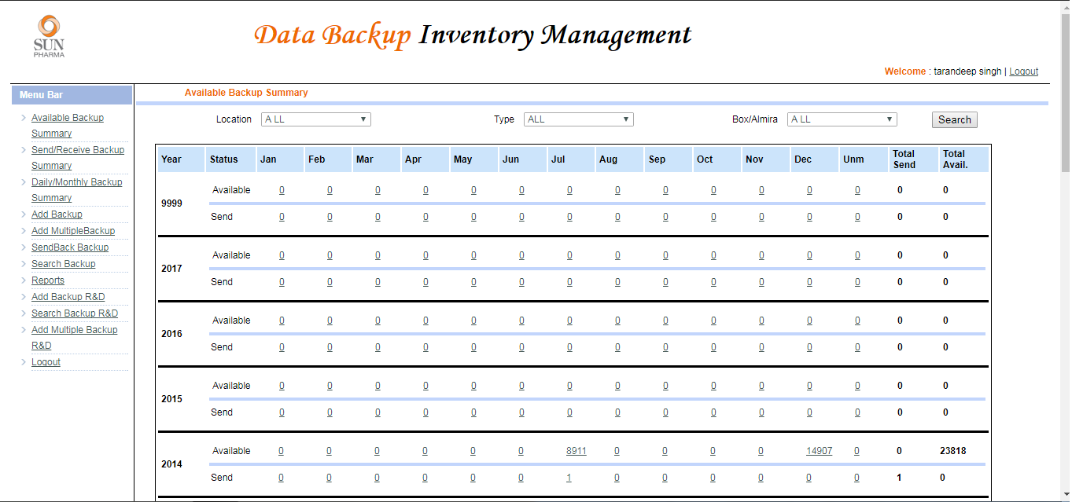

36

Chitkara University, Himachal Pradesh, India





**Received Tapes in December of 2014:**

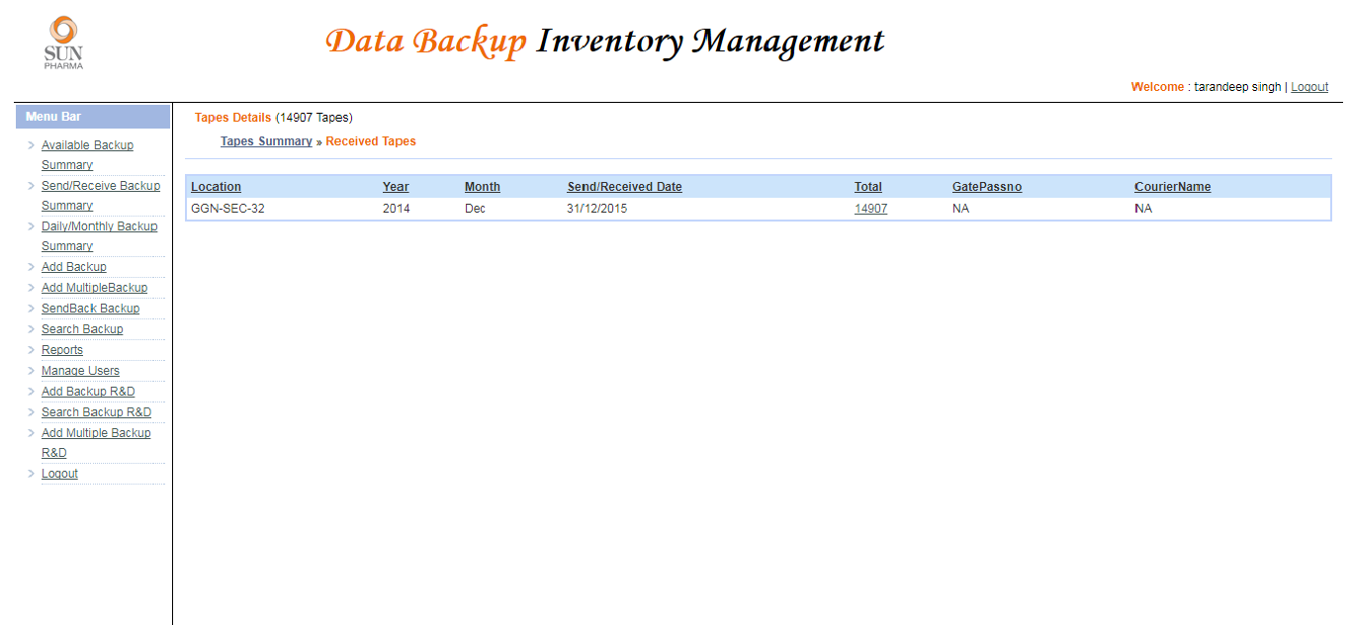

**Detailed View Of Received Tapes in December of 2014:**

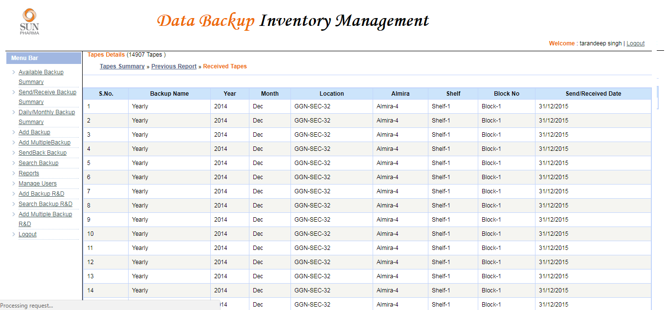

37

Chitkara University, Himachal Pradesh, India



**Daily/Monthly Backup Summary:**

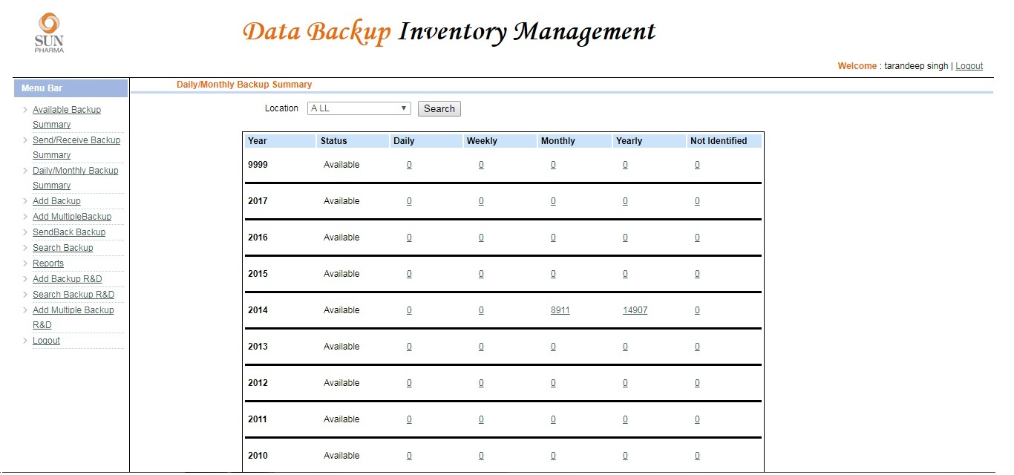

**Add Backup:**

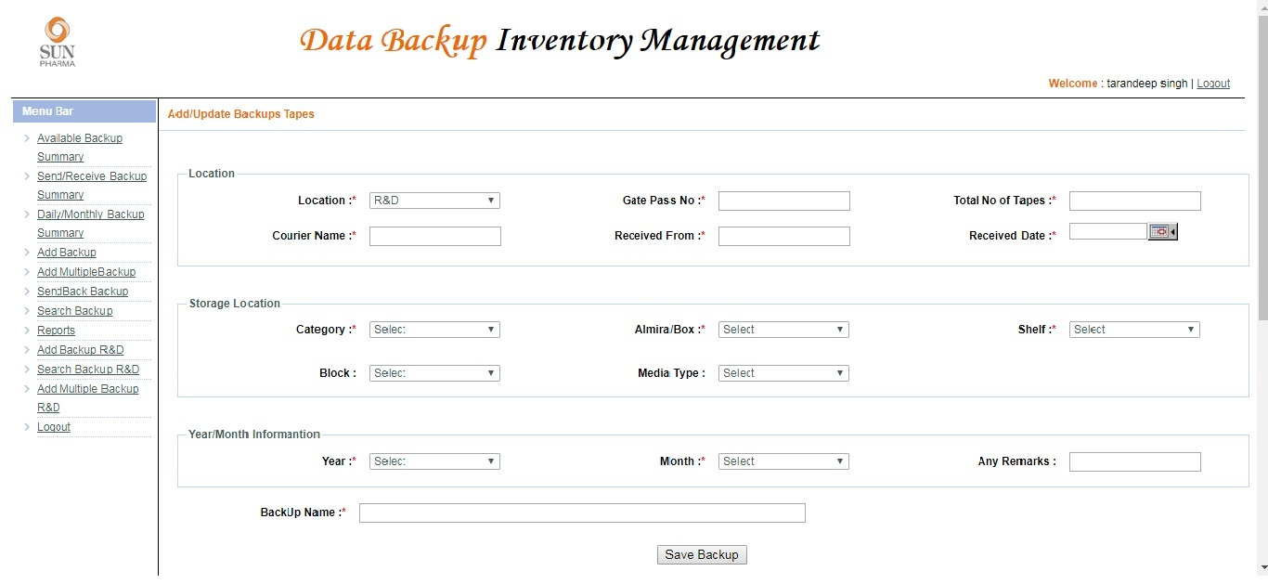

38

Chitkara University, Himachal Pradesh, India



**Add Multiple Backup:**

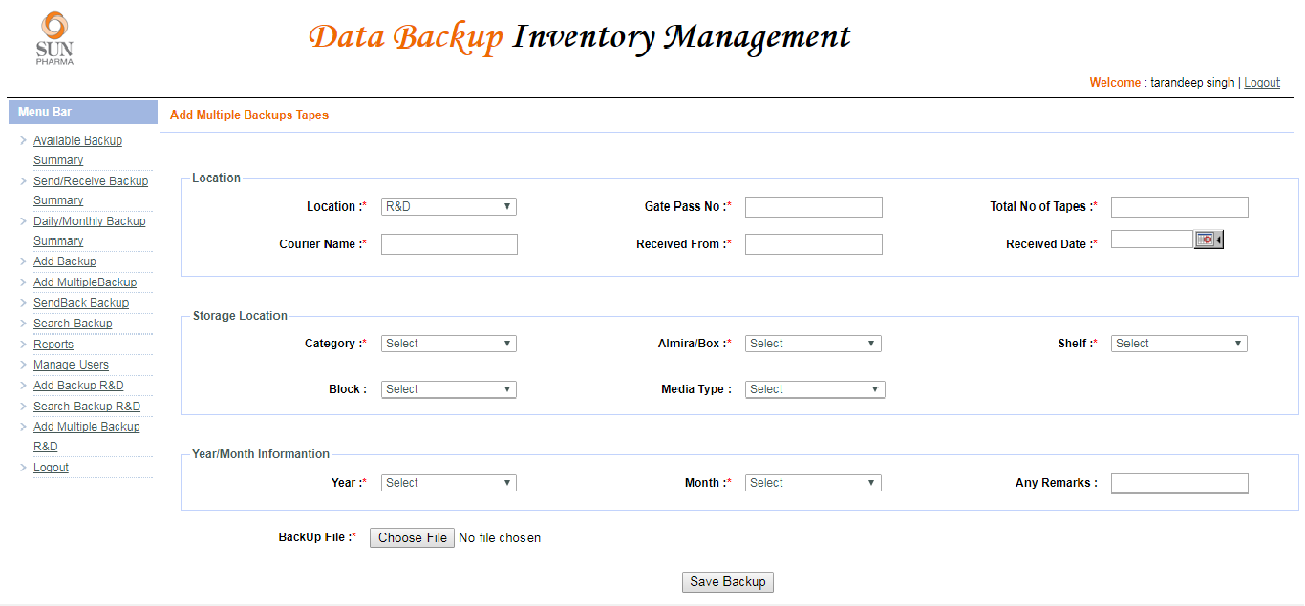

**Send Backup:**

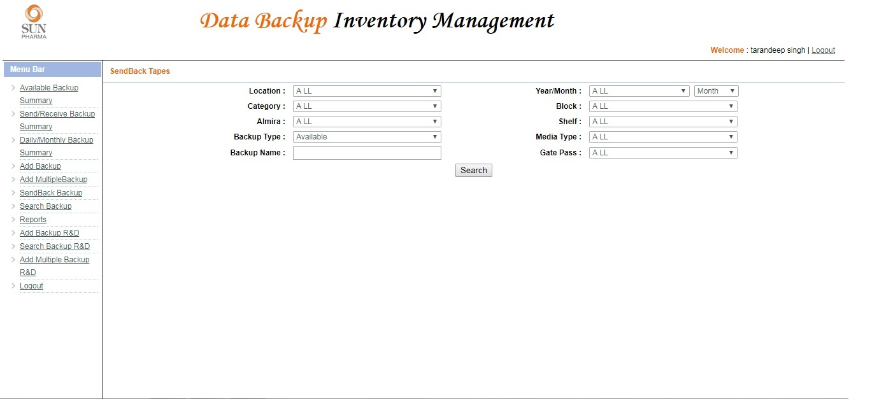

39

Chitkara University, Himachal Pradesh, India



**Search Backup:**

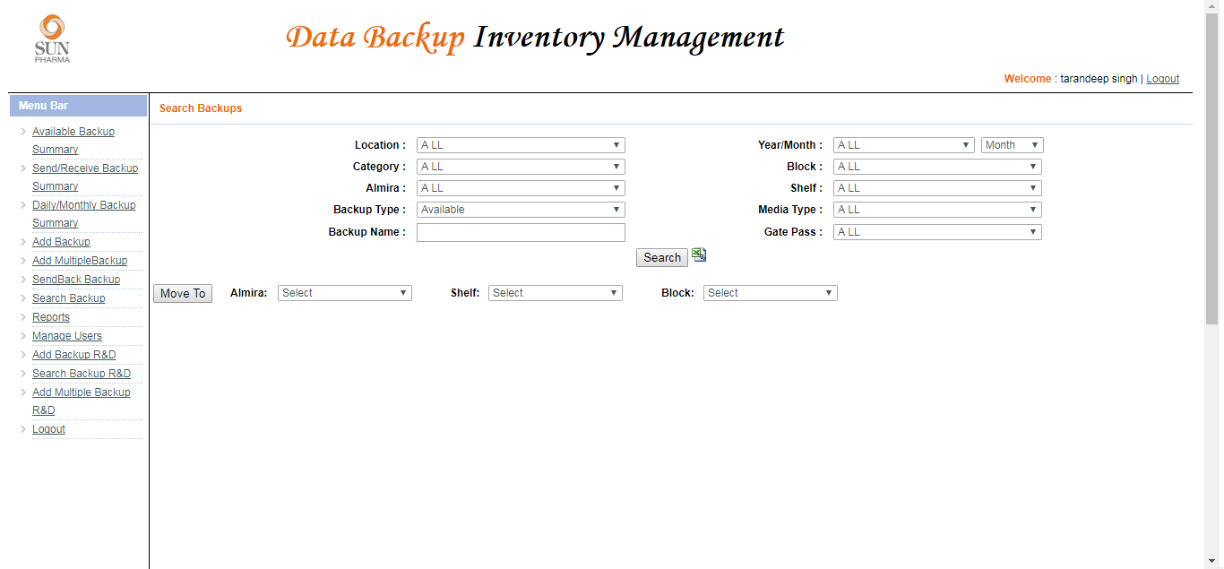

**We can download the report in the Excel format:**

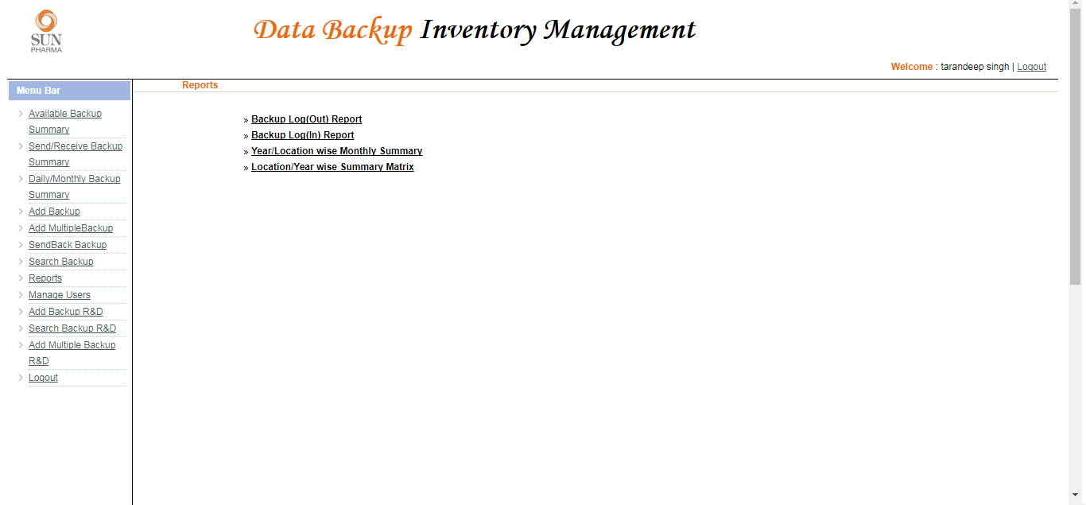

40

Chitkara University, Himachal Pradesh, India



**Admin Panel:**

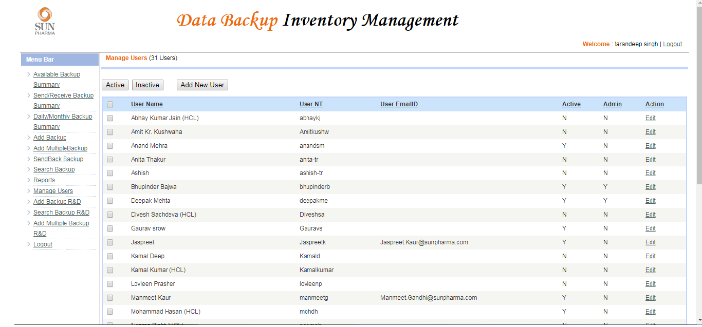

**Privileges Provided To The Admin:**

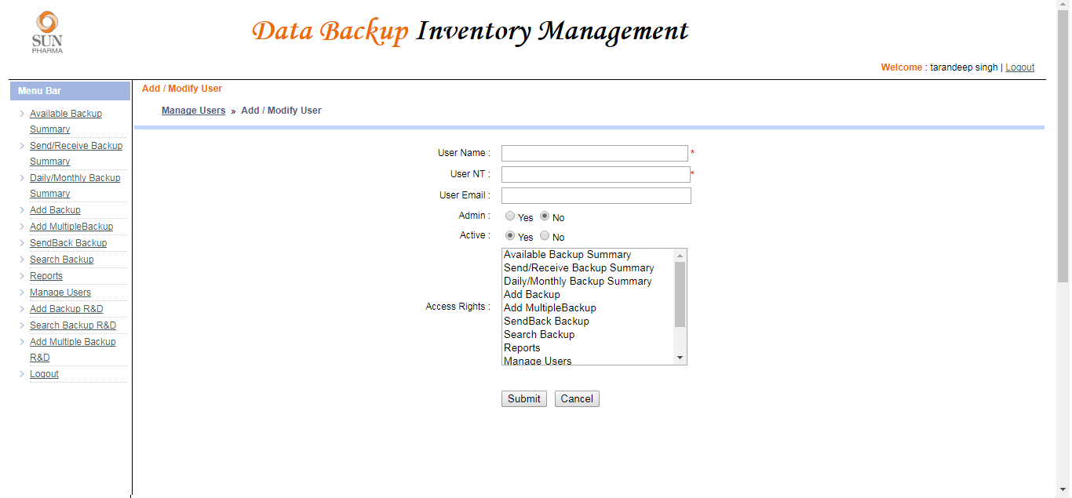

41

Chitkara University, Himachal Pradesh, India



***8.Future Enhancements***

* Future Enhancements will be making an Android application and IOS application.
* Also to include search option for patients.
* Making reports
* Blog to share ideas on projects
* Area oriented project.

42

Chitkara University, Himachal Pradesh, India



***9.Conclusion***

* We got the experience of working in a great company Sun Pharmaceutical Industries Private Limited.
* We got the practical experience on the latest technologies used in the companies.
* We got to know the working of ASP.NET and SQL.
* We also got the knowledge of the HTML, CSS and JAVASCRPIT.

43

Chitkara University, Himachal Pradesh, India



***10.Bibliography and References***

* <https://www.tutorialspoint.com/>
* <https://www.javatpoint.com/>
* <https://maven.apache.org/>
* [http://www.oracle.com/technetwork/database/databasetechnologies/sql/overview/i](http://www.oracle.com/technetwork/database/database-technologies/sql/overview/index.html)
* [ndex.html](http://www.oracle.com/technetwork/database/database-technologies/sql/overview/index.html)
* <https://w3layouts.com/>

44

Chitkara University, Himachal Pradesh, India