CashRoom Compliance System — User Manual

1. Introduction

What is CashRoom?
CashRoom is a web-based application that digitizes the daily cash reconciliation process for Compass Group facilities. Instead of paper-based cash counts and manual Excel tracking, CashRoom provides a streamlined digital workflow where operators submit cash counts, controllers verify and approve them, and management has full visibility into compliance.

Purpose and Key Benefits
- Eliminate paper-based processes — all cash counts are submitted digitally
- Real-time compliance visibility — management can see submission status across all locations instantly
- Automated notifications — email alerts for pending approvals, rejections, and visit schedules
- Audit trail — every action is logged and traceable
- Variance tracking — automatic calculation of cash variances against imprest amounts
- Visit scheduling — controllers and DGMs can schedule and track verification visits

User Roles
Role | What They Do
Operator | Submits daily cash count forms for their assigned location
Controller | Reviews/approves operator submissions, schedules weekly verification visits
DGM (District General Manager) | Schedules monthly verification visits, oversees multiple locations
Regional Controller (RC) | Views compliance dashboards and reports across all locations
Admin | Manages users, locations, system settings, and has full dashboard access

2. Getting Started

How to Access the Application
- Open your web browser (Chrome, Edge, or Firefox recommended)
- Navigate to the application URL provided by your administrator
- You will see the CashRoom login screen
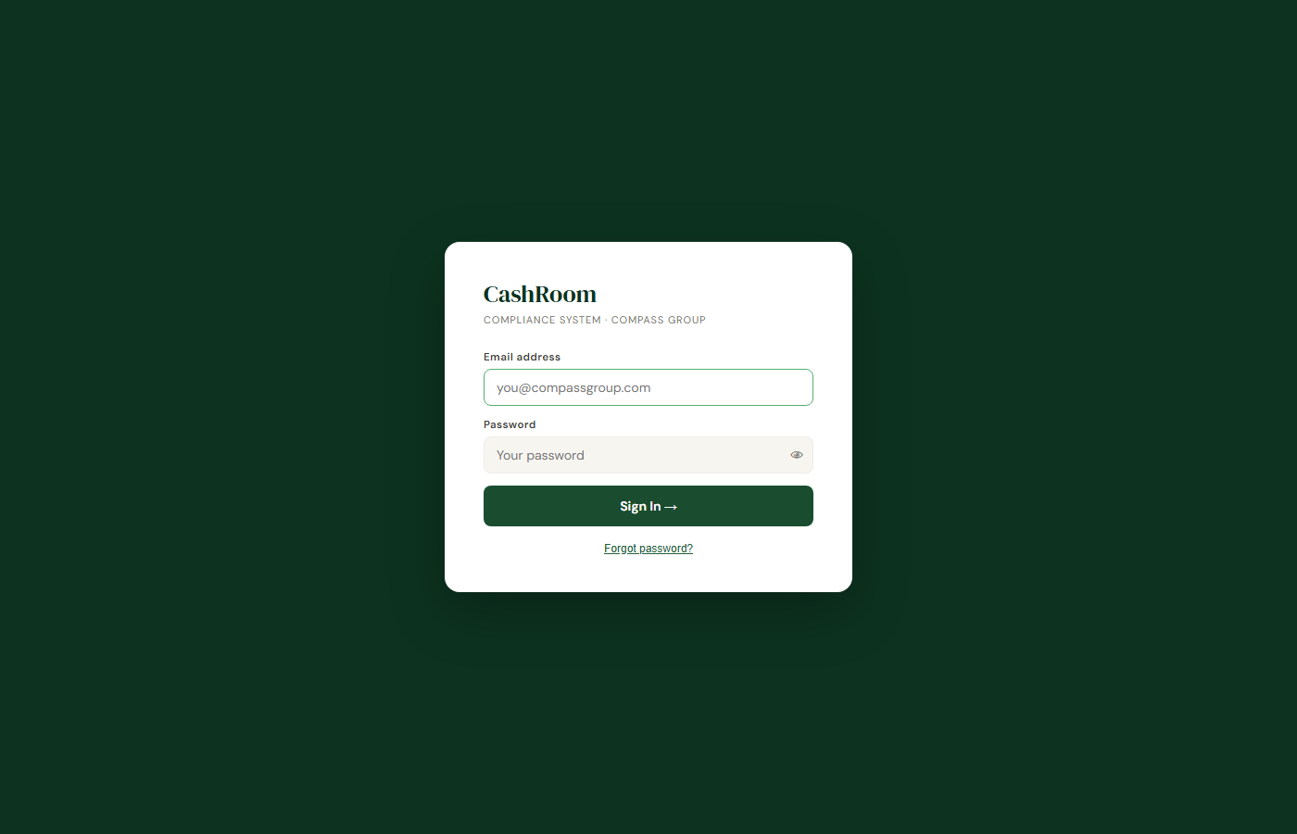

How to Login
- Enter your email address in the "Email address" field
- Enter your password in the "Password" field
- Click "Sign In"


Forgot Password
If you forget your password:
- Click "Forgot password?" on the login screen
- Enter your email address
- Click "Send" — a 6-digit code will be sent to your email
- Enter the code on the verification screen
- Click "Continue"
- Enter your new password (minimum 8 characters)
- Click "Reset" — you can now sign in with your new password
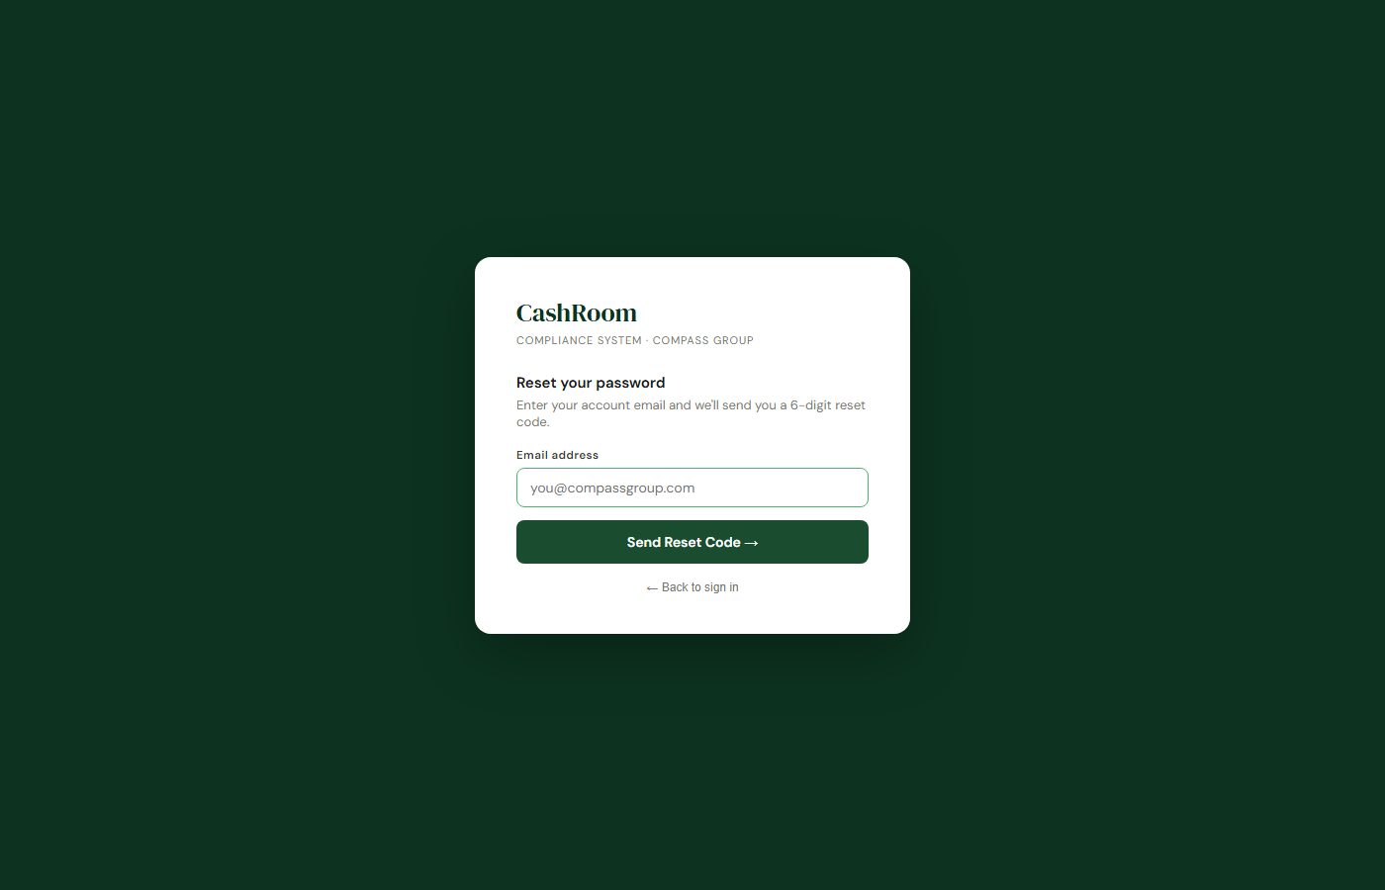

Change Password
Once logged in:
- Click "Change Password" in the top-right corner
- Enter your current password
- Enter your new password
- Confirm the new password
- Click "Change"

Basic Navigation
After logging in, you will see:
- Sidebar (left) — navigation menu with your available screens
- Header (top) — your name, role, Change Password and Sign Out buttons
- Main area (center) — the active screen content
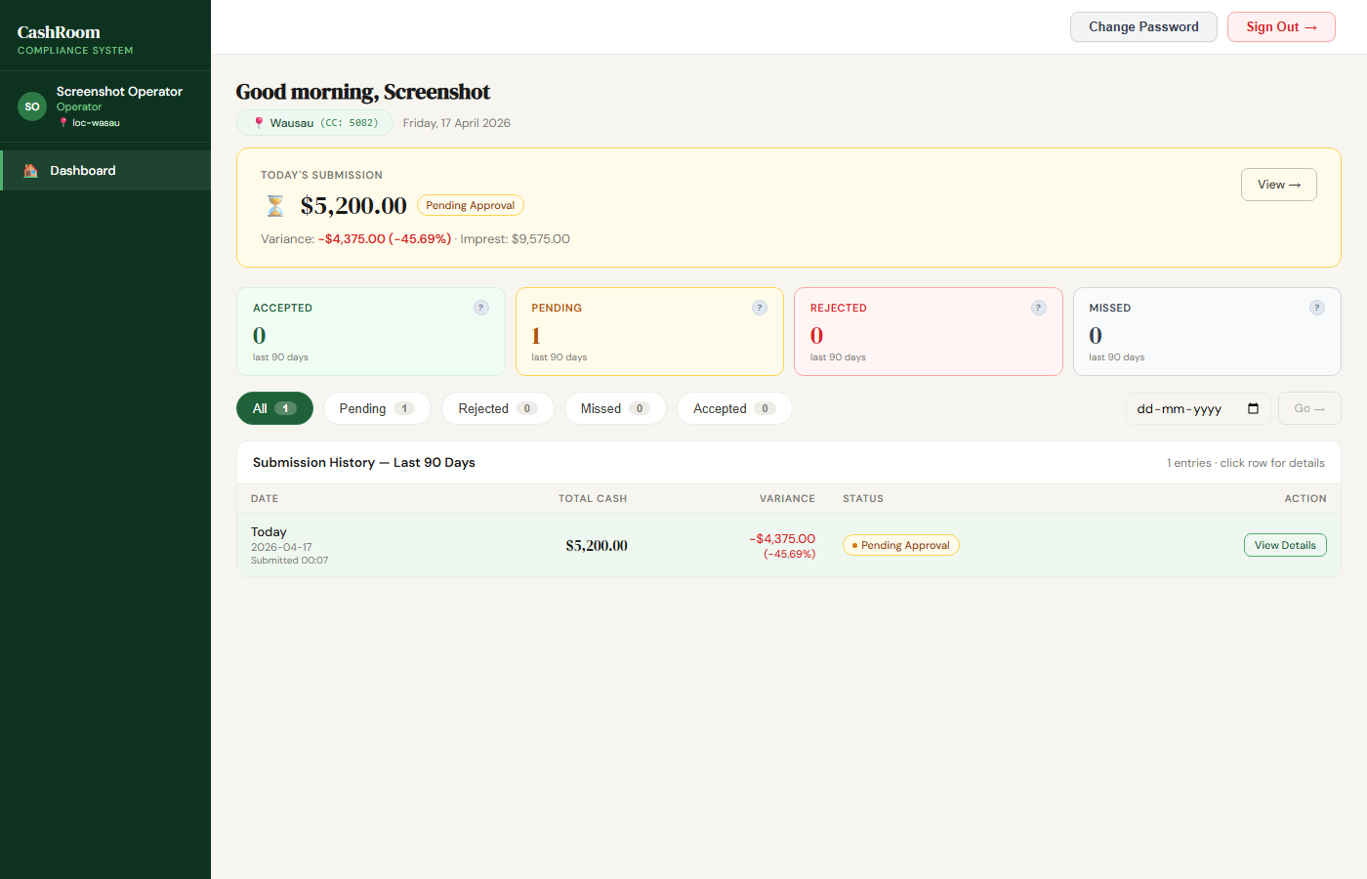

3. Step-by-Step Usage Guide

FOR OPERATORS

Submitting a Daily Cash Count
Step 1: Login and view your Dashboard
- Your dashboard shows today's date, your assigned location, and whether you've submitted today
- If "Not yet submitted" appears, click **"Submit Now"**

Step 2: Choose your submission method
- Form — fill in the digital cash count worksheet (recommended)
- Excel Upload — upload a completed Excel file
- Chat — guided step-by-step entry via chat interface

Step 3: Fill in the Cash Count Form
The form mirrors the paper Cashroom Count Worksheet with these sections:
Section | What to Enter
Section A — Changers/Coin | Count all coins and bills in changers
Section B — Loose Coin | Count loose coins (quarters, dimes, nickels, pennies)
Section C — Loose Currency | Count loose bills
Section D — Unissued Fund | Count unissued funds
Section E — Checks | List any checks
Section F — Short/Over | Record any known shorts or overs
Section G — Paid Outs | Record paid outs
Section H — Deposits | Record deposits
Section I — Other | Any other items
Section J — Replenishment | Record replenishment amounts
Section K — Coin in Transit | Record coin in transit
For each section:
- Enter the amounts in the white input fields
- Yellow fields are auto-calculated — do not type in them
- The running total updates automatically at the bottom

Step 4: Review the Summary
- At the bottom of the form, review:
- Total Fund — your total cash count
- Expected (Imprest) — the expected amount for your location
- Variance — the difference (green = within tolerance, red = exceeds tolerance)
- If the variance exceeds tolerance, you must enter a **Variance Note** explaining why

Step 5: Submit
- Click **"Submit for Approval"** to send to your controller for review
- Or click **"Save Draft"** to save and finish later

Step 6: Confirmation
- After submission, your dashboard will show the submission status:
- Pending Approval (amber) — waiting for controller review
- Approved (green) — controller approved your count
- Rejected (red) — controller rejected, you need to resubmit


Viewing a Rejected Submission
If your submission is rejected:
- You will receive an email notification with the rejection reason
- On your dashboard, you will see the rejection reason
- Click "Submit Now" to submit a corrected count
- The form will show the previous values so you can make corrections

Saving and Resuming Drafts
- If you saved a draft, click **"Resume Draft"** on your dashboard
- Your previously entered values will be loaded
- Complete the form and submit

FOR CONTROLLERS

Daily Review Dashboard
This screen shows all pending operator submissions for your assigned locations.

Reviewing a Submission:
- Find the pending submission in the list
- Click "View & Approve" to see the full cash count form
- Review each section — you can mark sections as "Approve" or "Flag"
- After reviewing all sections:
- Click "Approve" to approve the submission
- Click "Reject" and enter a reason to reject it
Understanding the KPI Cards:
KPI | What It Means
Pending | Number of submissions waiting for your review
Approved | Number approved in the selected time period
Rejected | Number rejected in the selected time period
Avg Variance | Average cash variance across submissions (+ means over, - means short)
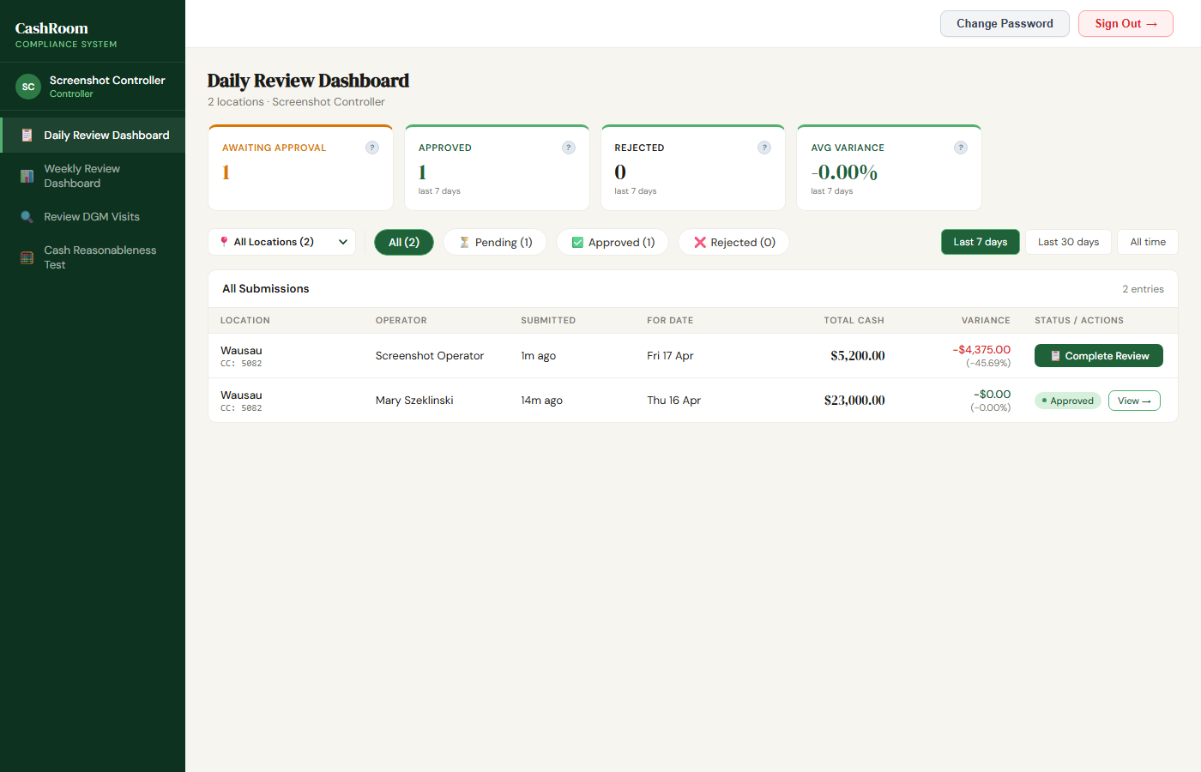

Weekly Review Dashboard
This screen shows your scheduled verification visits and their status.
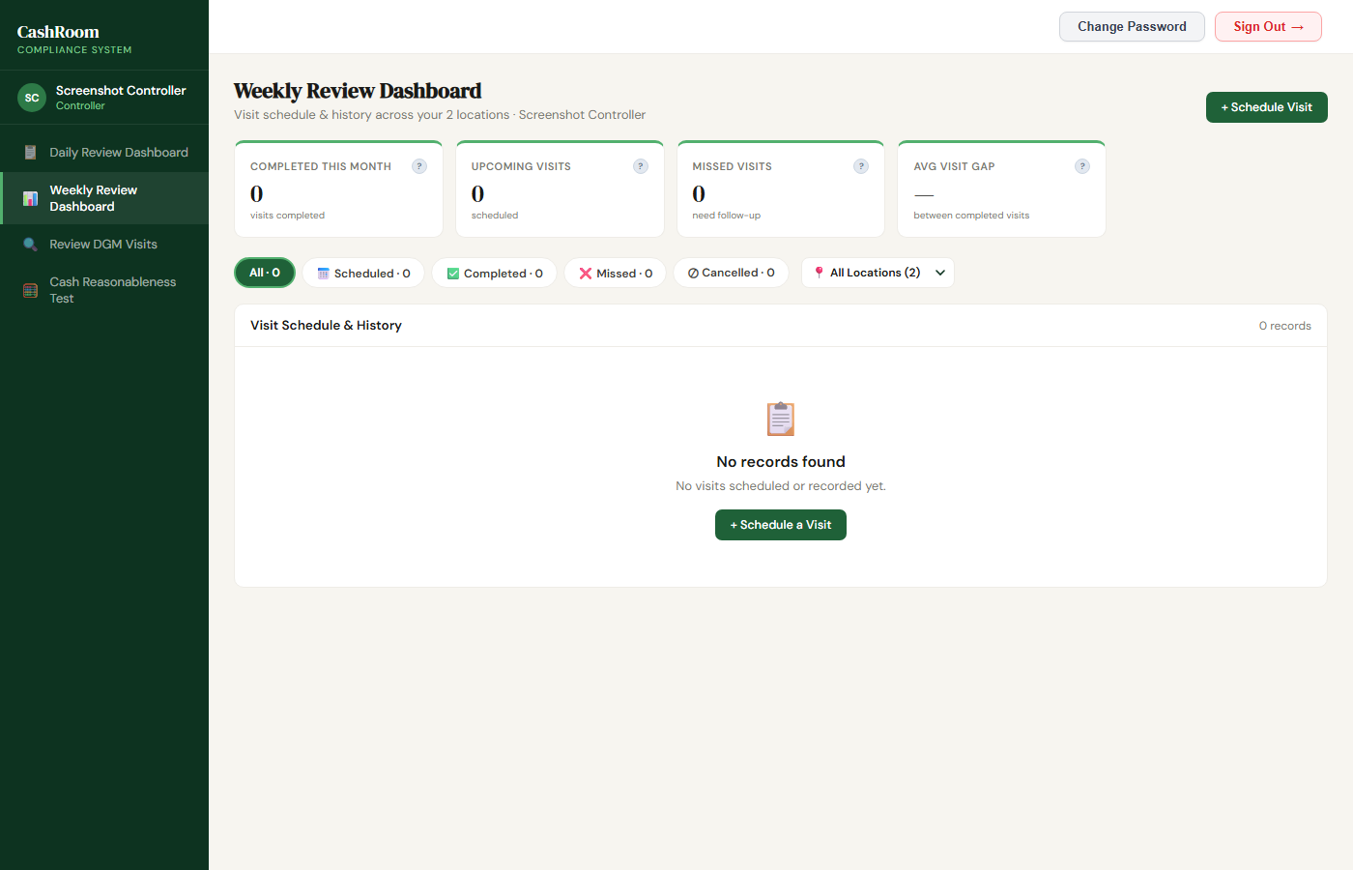
Scheduling a Visit:
- Click the Schedule button (or navigate to the schedule screen)
- Select a location from the dropdown
- Select a date (weekdays only, Mon-Fri)
- Select a time slot (09:00, 11:00, 13:00, 15:00, or 17:00)
- If a day-of-week warning appears (same location visited on same weekday recently), select a reason
- Click "Schedule Visit"

Completing a Visit:
- On the day of your visit, find the scheduled visit in the list
- Click "Mark as Completed"
- The system will show the operator's submission for that location and date:
- If the operator submitted — review the form via "View & Approve"
- If the operator hasn't submitted — you can fill the cash count form yourself
- After reviewing/filling the form:
- Add any notes (optional)
- Sign in the digital signature box
- Click "Confirm Completion"

Understanding Visit Statuses:
Status | Meaning
Scheduled | Visit is planned but not yet done
Completed | Visit was done and recorded
Missed | Visit time passed without completion
Cancelled | Visit was cancelled before the scheduled time
Table Columns Explained:
Column | What It Shows
Date | The scheduled/actual visit date
Location | Which facility was visited
Status | Current status (see above)
Total Cash | The observed cash total from the visit
vs Imprest | Difference between observed cash and expected imprest amount
Notes/Reason | Any notes from the visit or reason for missed/cancelled
Actions | Buttons to complete, miss, or cancel the visit

Cash Reasonableness Test
This screen allows you to generate and review reasonableness reports for your locations.

FOR DGM (District General Manager)

Coverage Dashboard
This is your main screen showing monthly visit coverage across your assigned locations.
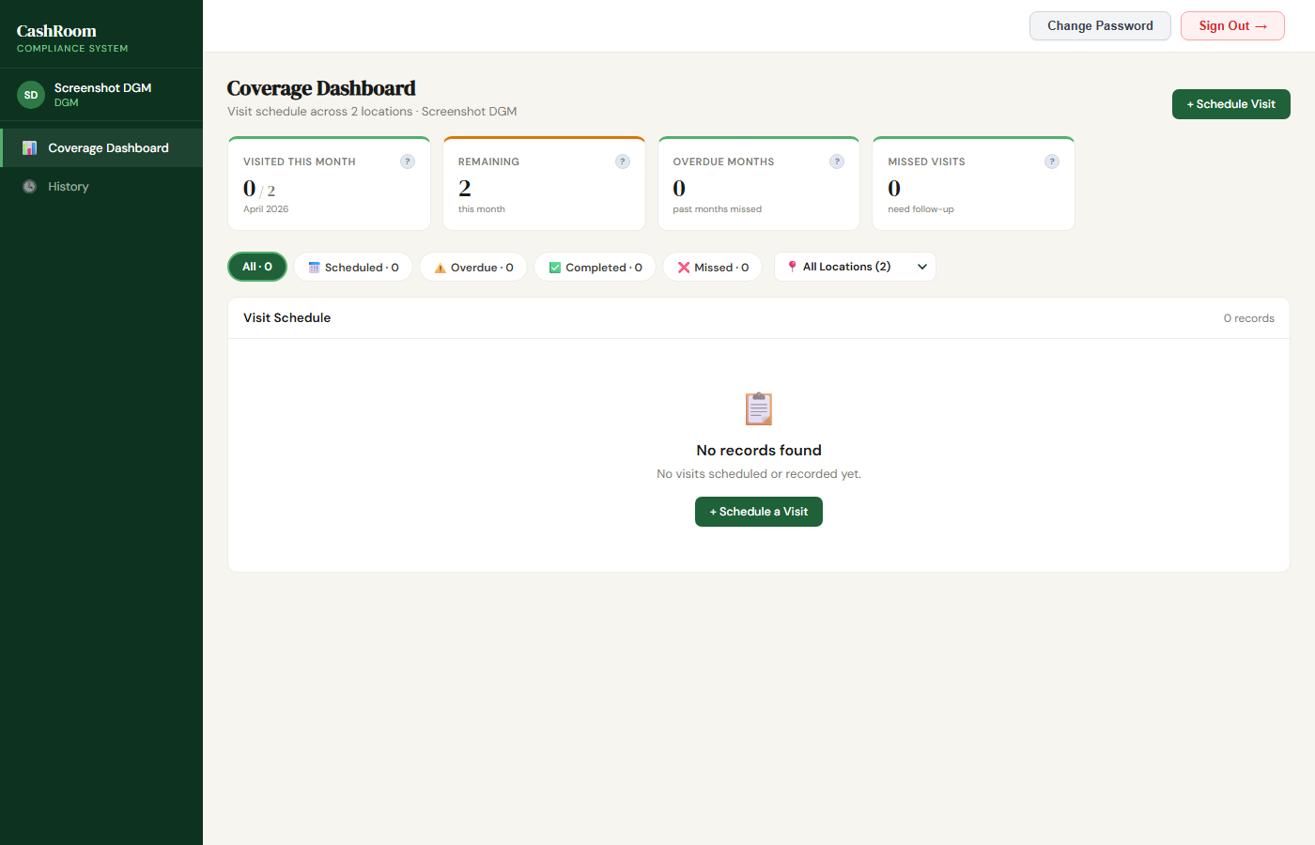
KPI Cards:
KPI | What It Means
Completed | Number of visits completed this month
Scheduled | Number of upcoming scheduled visits
Missed | Number of visits that were not completed
Avg Visit Gap | Average days between your consecutive visits
Scheduling a Monthly Visit:
- Navigate to the schedule screen
- Select a location
- Select a date (one visit per location per month)
- Add notes if needed
- Click "Schedule Visit"
Completing a Visit:
The process is the same as for controllers:
- Find the scheduled visit
- Click "Mark as Completed"
- Review the operator's submission or fill the form yourself
- Sign and confirm


History
View all your past visits with their outcomes, variances, and notes.

FOR REGIONAL CONTROLLER (RC)

Business Dashboard
Your main overview of compliance across all locations.
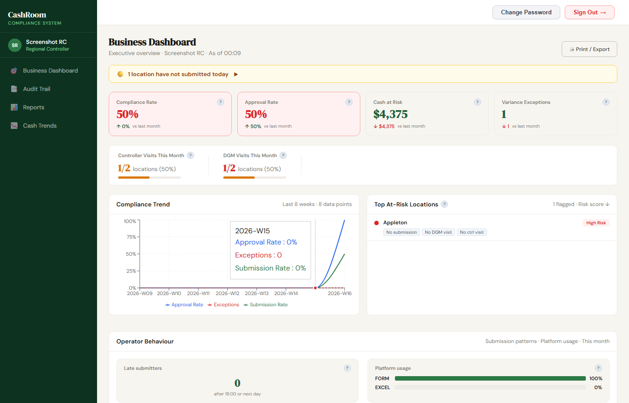
KPI Cards:
KPI | What It Means
Overall Compliance | Percentage of locations in "green" (compliant) status
Submissions Today | How many locations have submitted today vs total
Approval Rate | Percentage of submissions approved
Variance Exceptions | Count of submissions exceeding variance tolerance
Cash at Risk | Total dollar amount of variance across exception locations
Location Compliance Detail Table:
This table shows every location's current status:
Column | What It Shows
Health | Green (compliant), Amber (at risk), Red (non-compliant)
Location | Location name and ID
Today's Submission | Whether the operator submitted today and its status
Controller Approval | Whether the submission was approved/rejected/pending
Controller Visit | Days since last controller visit + "Form filled" if controller counted cash
DGM Visit | DGM visit status for this month + "Form filled" if DGM counted cash
Top At-Risk Locations:
Shows the 5 locations with the highest risk scores. Risk factors include:
- No operator submission today
- Submission rejected
- Pending approval > 48 hours (SLA breach)
- High variance
- No controller visit in 14+ days
- No DGM visit this month

DGM Coverage:
Shows which DGMs have completed their monthly visits and which locations are still pending.

Reports
Detailed reporting with date range selection:
- Submissions table — all operator submissions with status and variance
- Date-Level Detail — daily breakdown showing who submitted, who approved, visit status
- Variance Exceptions — submissions that exceeded the tolerance threshold
- Download — export data as CSV for further analysis
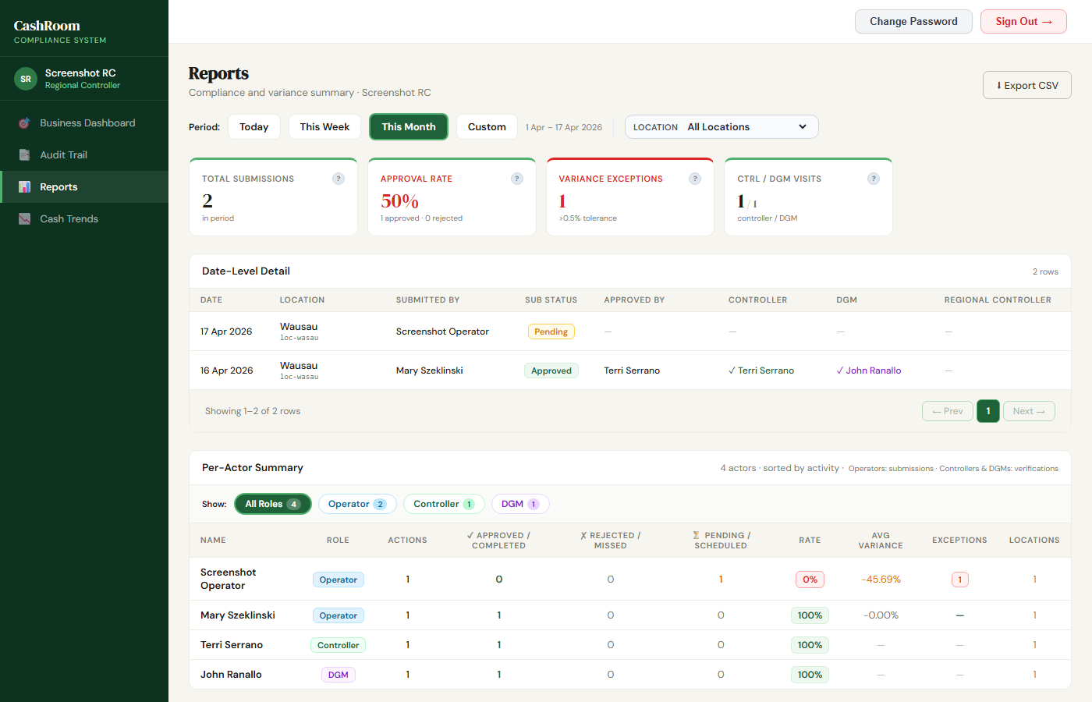

Cash Trends
Visual charts showing trends over time:
- Submission rates
- Variance patterns
- Section-by-section breakdowns

FOR ADMIN

Managing Locations
Adding a New Location:
- Navigate to Locations in the sidebar
- Click the "+ Add" button
- Fill in:
- Cost Center — the business accounting code (e.g., 5082)
- Name — location display name (e.g., "APPLETON")
- Imprest Amount — expected daily cash amount (e.g., $9,575)
- Tolerance % — acceptable variance percentage (e.g., 0.5%)
- Click "Save"
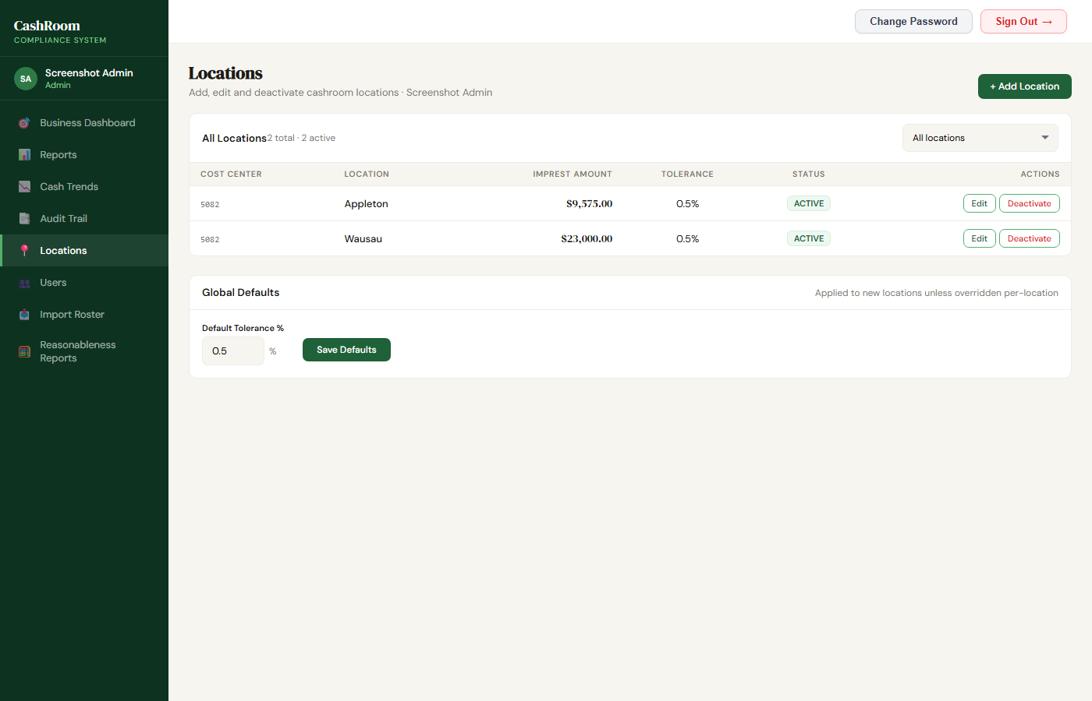
Editing a Location:
- Click on the location row in the table
- Modify the fields
- Click "Save"
Note: Multiple locations can share the same Cost Center.

Managing Users
Adding a New User:
- Navigate to Users in the sidebar
- Click "+ Add User"
- Fill in:
- Name — full name
- Email — their email address (used for login)
- Role — Operator, Controller, DGM, Regional Controller, or Admin
- Locations — assign one or more locations (not needed for Admin/RC)
- Click "Save"
- The user will receive a welcome email with their login credentials
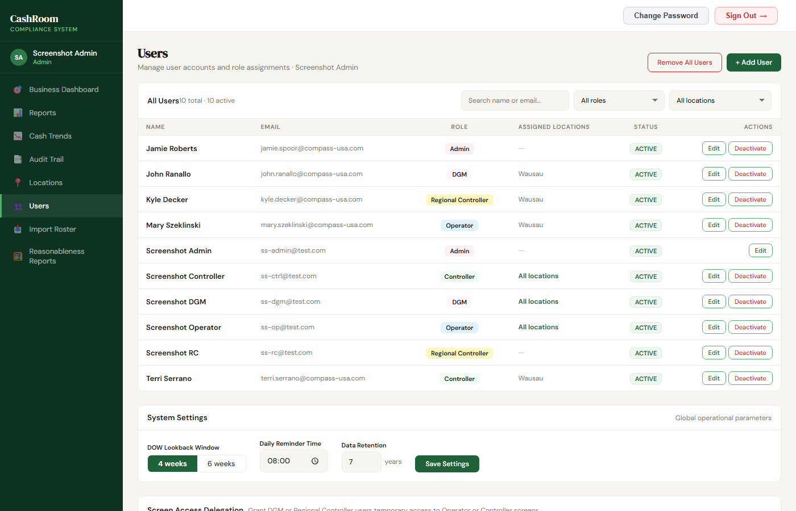

Import Roster
Upload an Excel file to bulk-create locations and users:
- Navigate to Import Roster
- Click "Browse File" or drag-and-drop your Excel file
- Preview the data — verify the columns are mapped correctly
- Click "Confirm Import"
- All users will receive welcome emails automatically
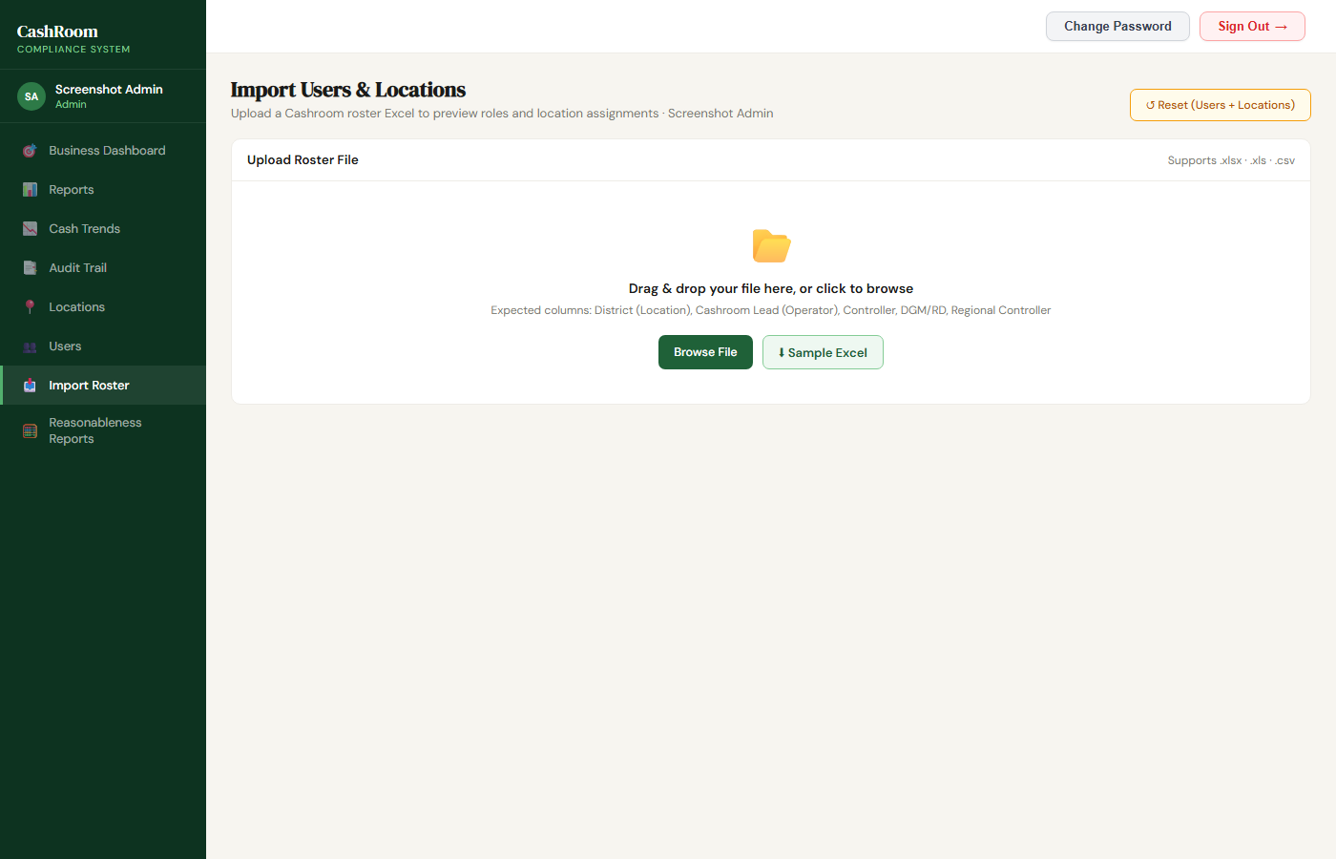

Audit Trail
View a log of every action taken in the system:
- User logins
- Submissions created, approved, rejected
- Visits scheduled, completed, missed
- Users created, modified
- System settings changed
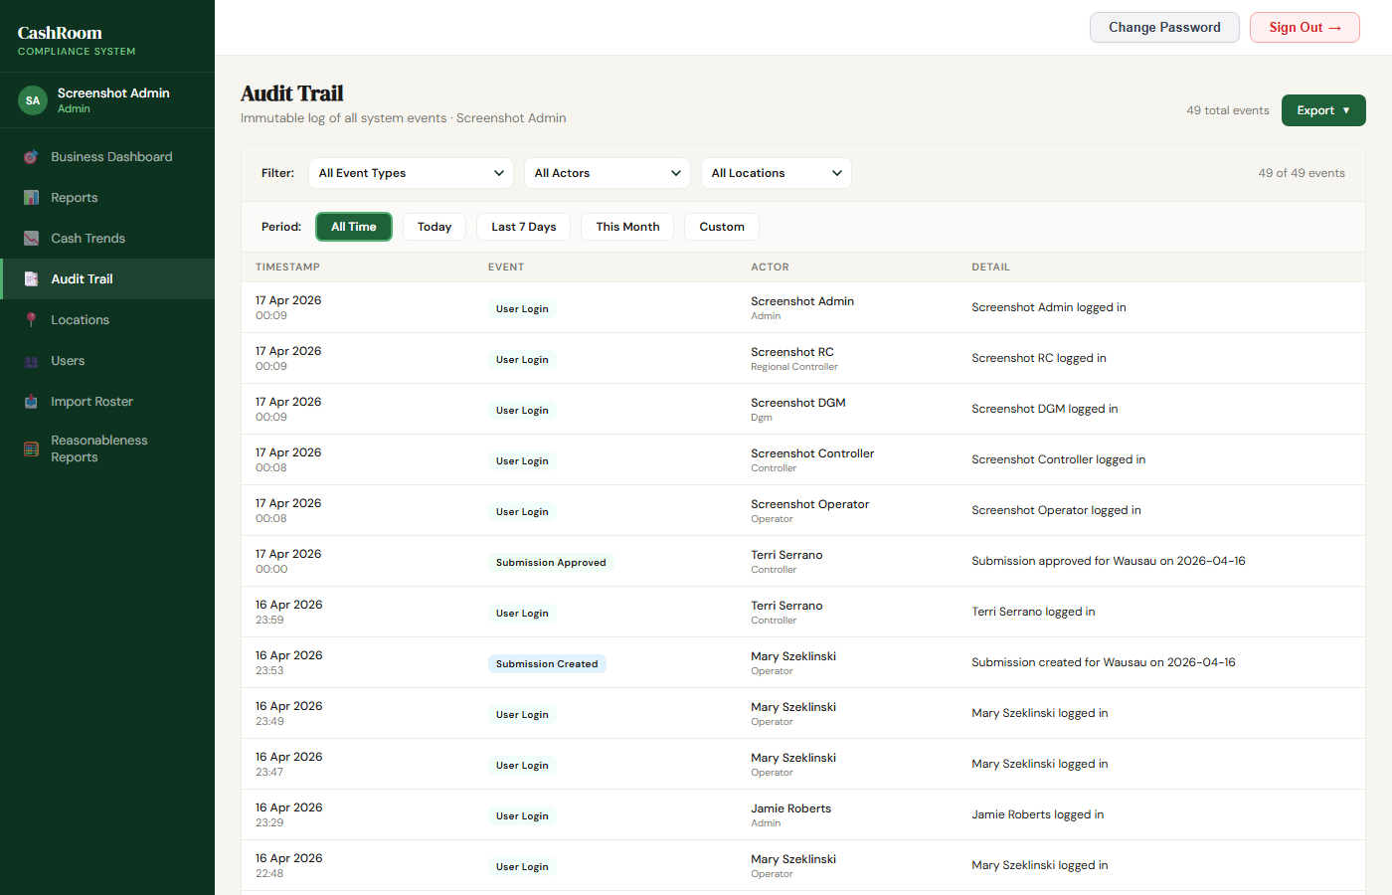

System Settings
The Admin also has access to:
- Business Dashboard — same as RC view, for full Midwest visibility
- Reports — detailed submission and compliance reports
- Cash Trends — trend analysis charts
- Reasonableness Reports — cash reasonableness test results

4. Features Overview

Buttons Guide
Button | Where | What It Does
Submit Now | Operator Dashboard | Start a new cash count submission
Save Draft | Cash Count Form | Save your work to finish later
Submit for Approval | Cash Count Form | Send completed form to controller
Approve | Controller Daily Review | Approve an operator's cash count
Reject | Controller Daily Review | Reject with a reason — operator must resubmit
Schedule Visit | Controller/DGM Schedule | Create a new verification visit
Mark as Completed | Visit Dashboard | Record that a visit was completed
Mark as Missed | Visit Dashboard | Record that a visit was not completed (past dates)
Cancel | Visit Dashboard | Cancel a future scheduled visit
Change Password | Top-right header | Change your login password
Sign Out | Top-right header | Log out of the application
Download | Reports screen | Export data as CSV file
Reset | Admin Locations | Clear all data (use with caution!)

KPI Cards Guide
KPI (Key Performance Indicator) cards appear at the top of dashboards. They show key metrics at a glance.
How to read them:
- The **large number** is the current value
- The **label** below explains what it measures
- Green = good, Amber = needs attention, Red = action required
- Hover over the **info icon** (if present) for a detailed explanation including the formula

Tables Guide
Most screens include data tables. Here's how to use them:
Filtering:
- Use the **status chips** (All, Pending, Approved, etc.) to filter by status
- Use the **location dropdown** to filter by location
- Use the **date range** selector to change the time period
Sorting:
- Click column headers to sort (where available)
Pagination:
- Use the page numbers at the bottom to navigate through large datasets
Color Coding:
- Green badges/text = approved, compliant, within tolerance
- Amber badges/text = pending, at risk, approaching tolerance
- Red badges/text = rejected, non-compliant, exceeds tolerance

Dashboard Guide
Each role's dashboard is designed to show the most important information first:
- Operator — "Did I submit today? What's my status?"
- Controller — "What needs my review? Where do I need to visit?"
- DGM — "Which locations have I visited this month? Where do I still need to go?"
- RC — "Are all locations compliant? Where are the problems?"
- Admin — "Full visibility plus system management"

5. Best Practices

For Operators
- Submit your cash count **early in the day** — don't wait until end of day
- Double-check your counts before submitting — rejections require resubmission
- If your variance is high, always add a **variance note** explaining why
- Use **Save Draft** if you need to step away and finish later

For Controllers
- Review pending submissions **within 48 hours** to avoid SLA breaches
- When rejecting, provide a **clear reason** so the operator knows what to fix
- Schedule visits for **different weekdays** to avoid patterns (the system will warn you)
- Complete visits on the scheduled day — the system tracks timeliness

For DGMs
- Complete at least **one visit per location per month**
- Check your Coverage Dashboard regularly to see which locations still need visits
- Review the operator's approved submission before completing your visit

For Admins
- Keep user information up to date — remove inactive users promptly
- Set appropriate **imprest amounts** and **tolerance percentages** per location
- Monitor the **Audit Trail** for unusual activity
- Use the **Import Roster** feature for bulk user creation when onboarding multiple locations

Common Mistakes to Avoid
- Don't share your password — each user should have their own account
- Don't submit without counting — the system tracks variances and they're auditable
- Don't ignore rejection reasons — resubmit with the corrections noted
- Don't forget to sign — visit completion requires a digital signature
- Don't schedule visits on weekends — the system only allows weekday scheduling for controllers

6. FAQs / Troubleshooting

Login Issues
Q: I forgot my password. How do I reset it?
A: Click "Forgot password?" on the login screen. Enter your email to receive a 6-digit reset code. Enter the code, then set a new password.
Q: I'm not receiving the password reset email.
A: Check your spam/junk folder. If still not received, contact your administrator to reset your password.
Q: My login says "Invalid credentials."
A: Make sure you're using the correct email address (the one you received in your welcome email). Passwords are case-sensitive. If you've forgotten your password, use the Forgot Password flow.

Submission Issues
Q: I see "A submission already exists" when trying to submit.
A: You can only submit one cash count per day per location. If you need to make changes, use the Update feature on your existing submission.
Q: My submission was rejected. What do I do?
A: Read the rejection reason provided by the controller. Make the necessary corrections and submit a new form. The system will replace the rejected submission.
Q: The form shows the wrong "Counted By" name.
A: The name shown is based on your login account. If incorrect, contact your administrator to update your profile.

Visit Issues
Q: I can't schedule a visit on a weekend.
A: Controller visits can only be scheduled on weekdays (Monday through Friday).
Q: I see "Too early" when trying to complete a visit.
A: The system shows a warning if you're completing before the scheduled time. Click "Acknowledge & Complete" to proceed anyway.
Q: I can't complete a visit — it says "window has passed."
A: The completion window is 48 hours after the scheduled time. After that, use "Mark as Missed" instead.

Display Issues
Q: I see old data or the screen doesn't look right.
A: Try a hard refresh: press **Ctrl + Shift + R** (or Cmd + Shift + R on Mac). If that doesn't help, clear your browser cache: Settings > Privacy > Clear browsing data > Cached images and files.
Q: The page shows "Internal Server Error."
A: Try refreshing the page. If the error persists, clear your browser cache and try again. If still broken, contact your administrator.

Email Issues
Q: I'm not receiving system emails (approvals, rejections, etc.).
A: Check your spam/junk folder. Ask your IT team to whitelist the system's sending email address.
Q: I received a welcome email but the password doesn't work.
A: The temporary password is case-sensitive. Copy and paste it exactly. If still not working, use the Forgot Password flow to set a new one.

Support
For technical issues or questions not covered in this manual, contact your system administrator.
*CashRoom Compliance System — Compass Group*
*Version 1.0 — April 2026*

