**Lab 6 CST8912_011**

**Tarang Savaj**

**Sava0207**

**February 23, 2025**

**Submitted to:**

**Prof. Tanishq Bansal**

**Lab-6**

**Title**

* Implementing and Testing Azure Private Link with Private Endpoints

**Introduction**

* Using Azure Private Link customers can establish private network connections from their virtual networks to platform as a service or their owned services and partner services as it eliminates public internet traffic exposure. Private Endpoints function as network interfaces to connect Vnets to Azure services through private IP addresses for maintaining internal Azure network traffic. The lab aims to establish Azure Private Link functionality through virtual network and bastion host deployment and storage account and private endpoint creation. This exercise provides hands-on experience to create secure private connections while showing how Azure Private Link enables secure network architecture and data protection through its private IP address feature.

**Steps**

* Construct the Azure Private Link using Virtual Network (8912-vnet1) located in Canada Central and integrating Azure Bastion (Bastion8912) and Subnet-1-8912. Move forward to establish Storage Account (Storage1-8912) along with Local Redundant Storage (LRS) and switch off its Public Access capabilities. The Private Endpoint (Privateendpoint-8912) enables connection of the virtual network to the storage account’s blob service through a dynamically reserved private IP address. A virtual machine named Test Virtual Machine (8912-VM1) should be created within the virtual network for the following steps to take place. The process requires using PowerShell to obtain the Storage Access Key followed by creating a private-access Blob Container (container) before checking connectivity through Azure Bastion using both PowerShell and Microsoft Azure Storage Explorer. Finish the procedure by documenting it with screenshots and properly cleanup all allocated resources. screenshots and clean up all resources.

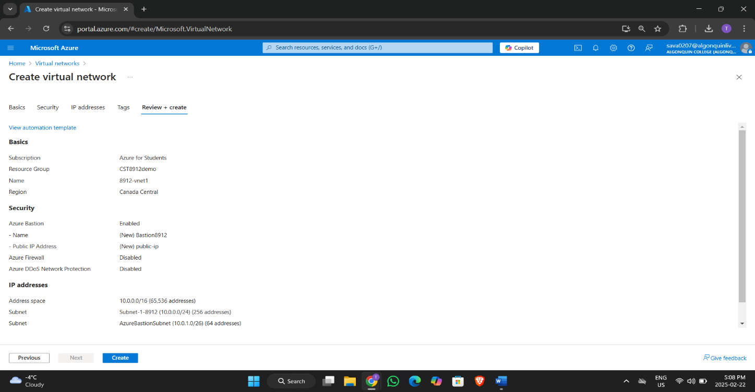

1.1 Creating Virtual Network

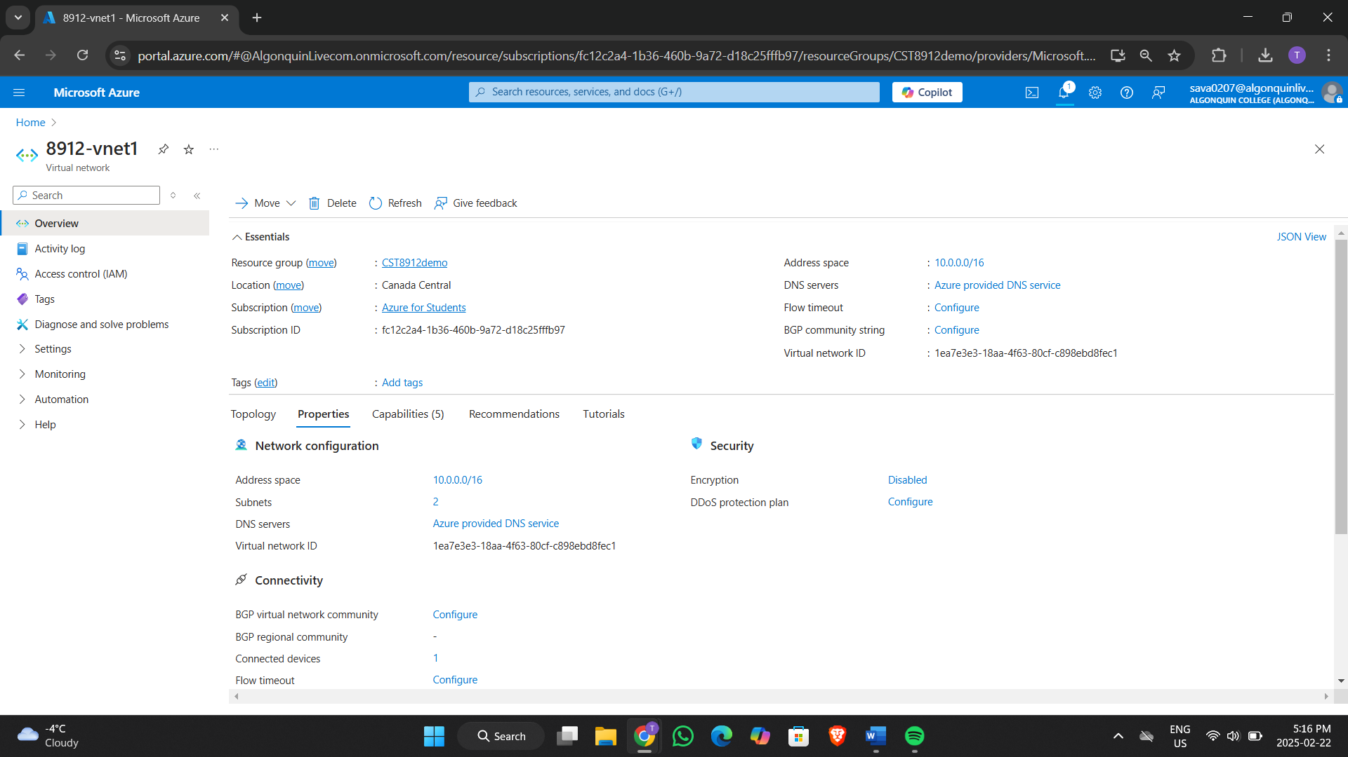

1.2 Overview of Virtual Network

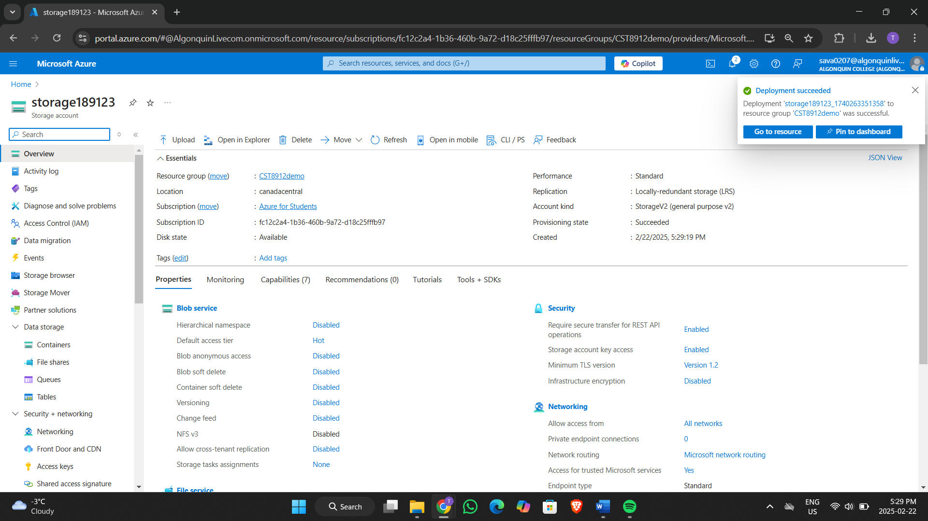

2.1 Created Storage account

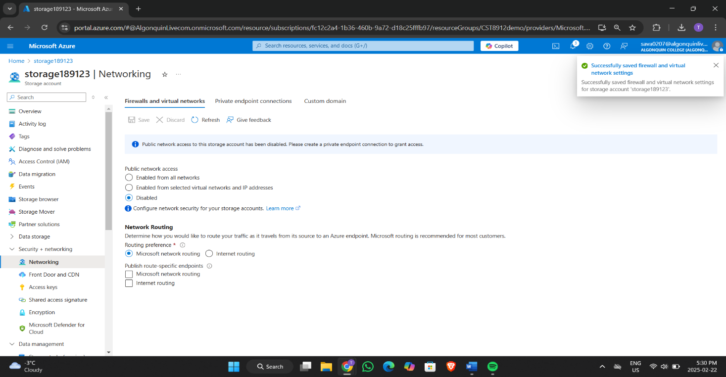

2.2 Disable public access to storage account

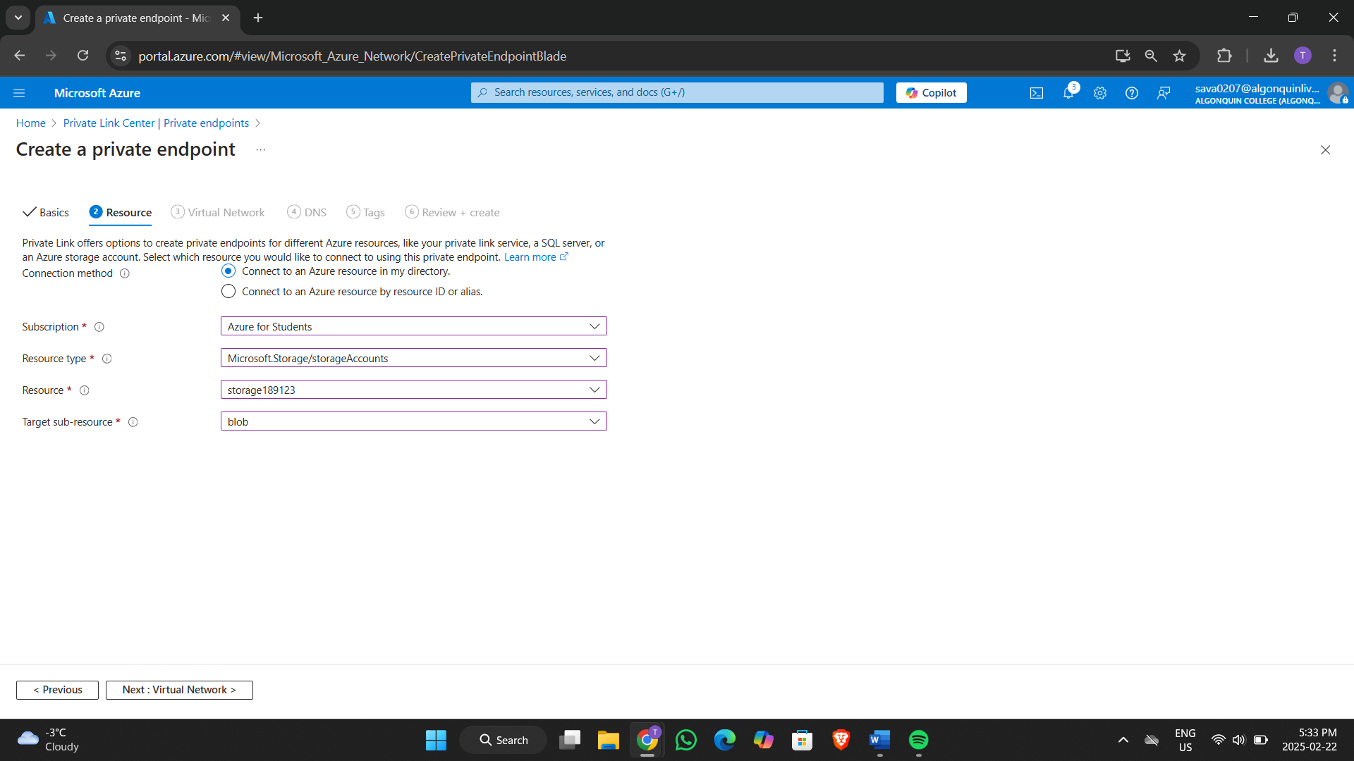

3.1 Creating private endpoint

3.2 Showing Value of Virtual Network

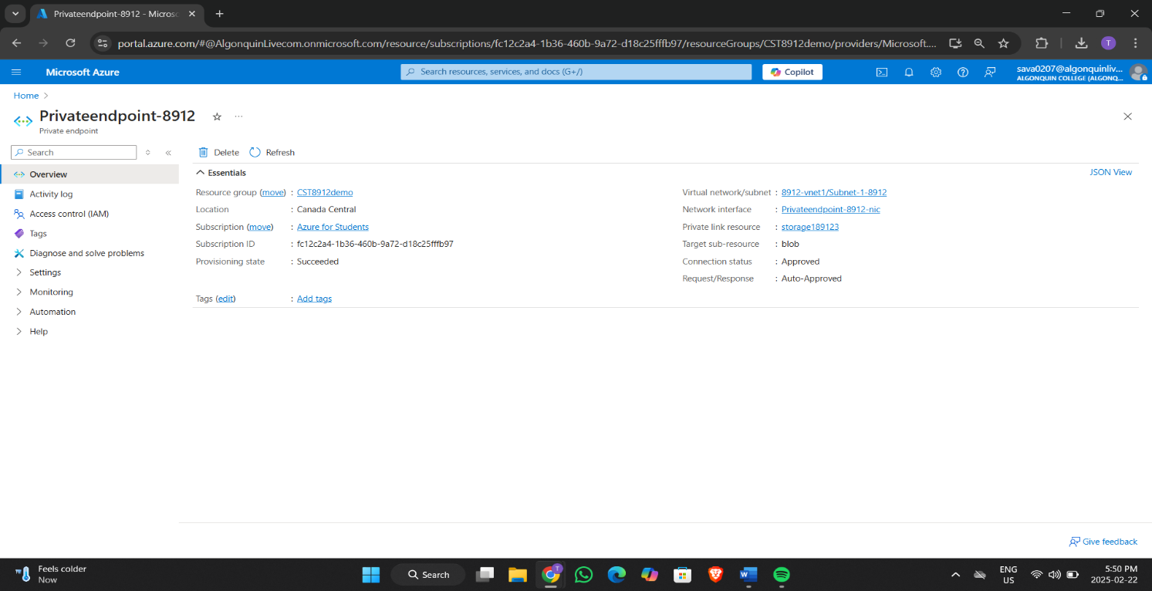

3.3 Created Private Endpoint

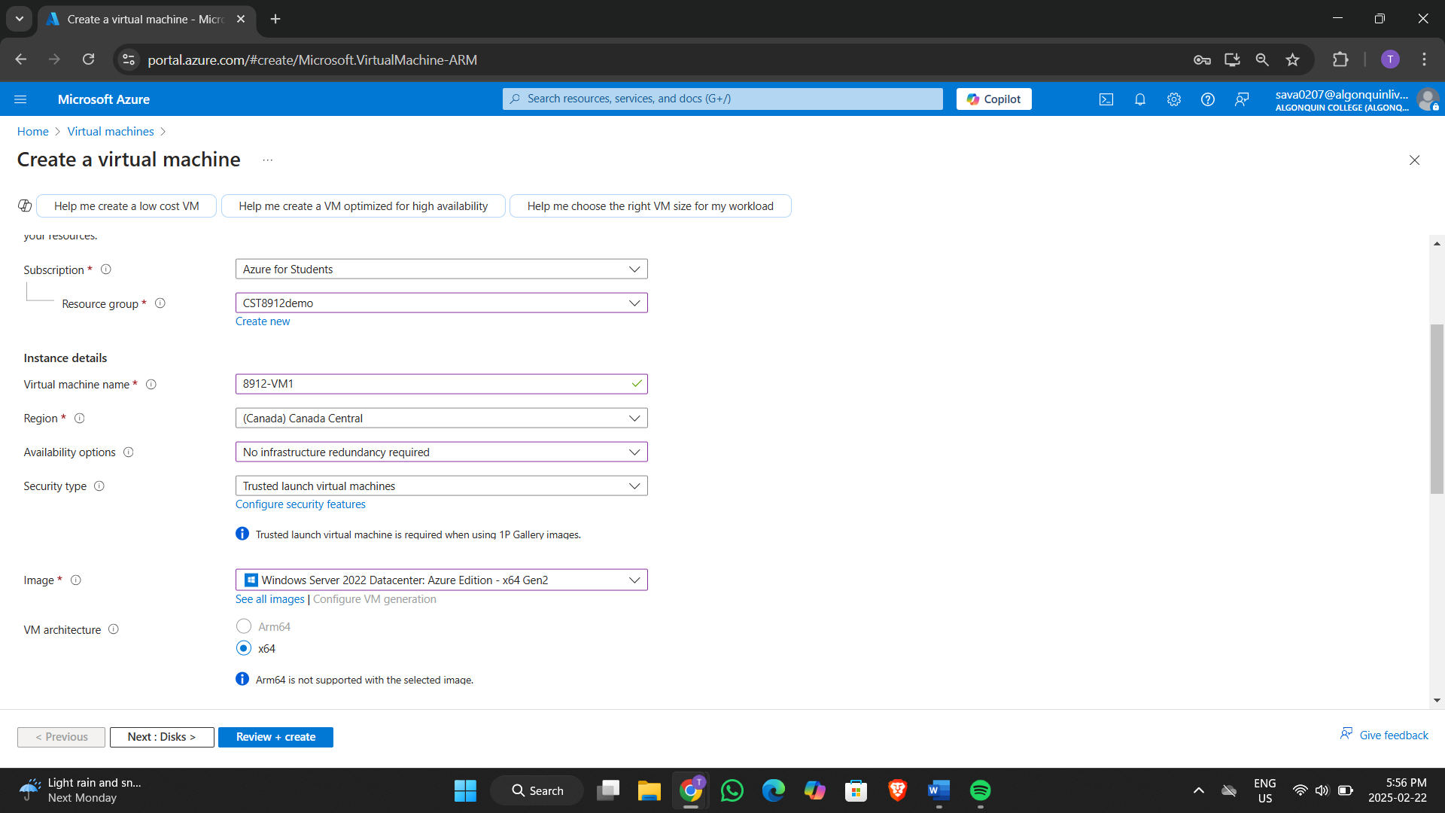

4.1 Creating Virtual Machine with given value

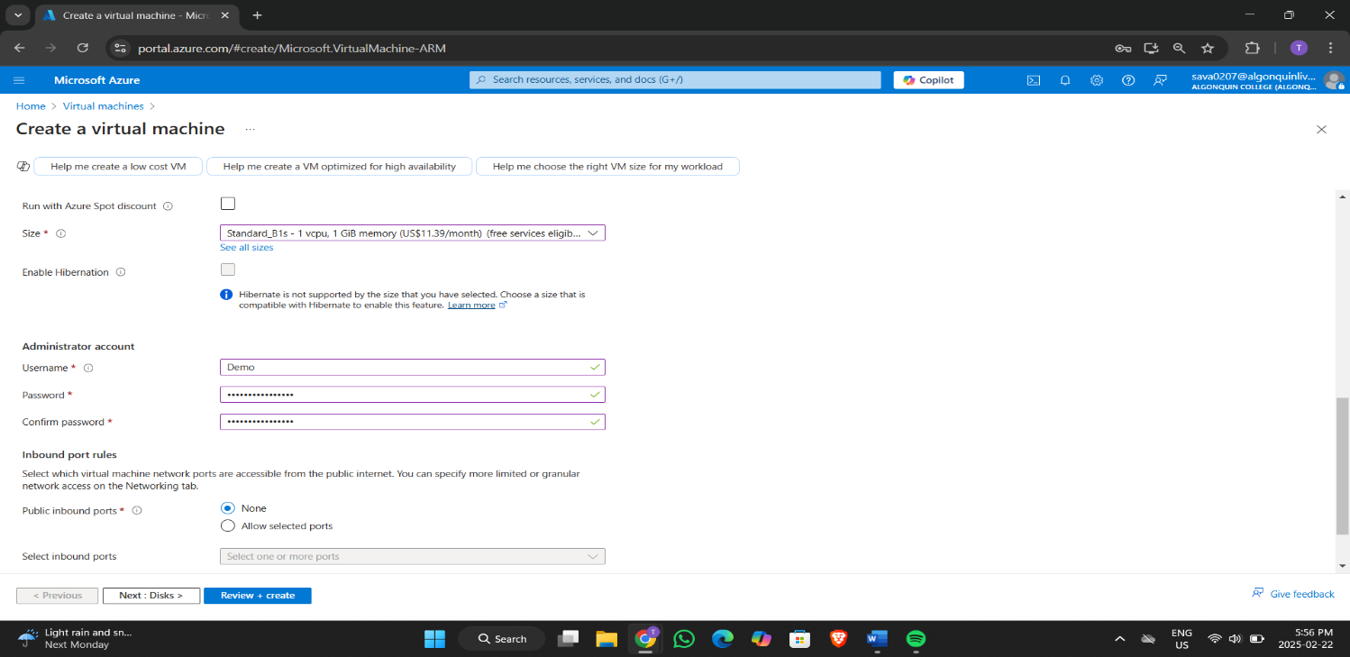

4.2 Showing the Value of Virtual Machine

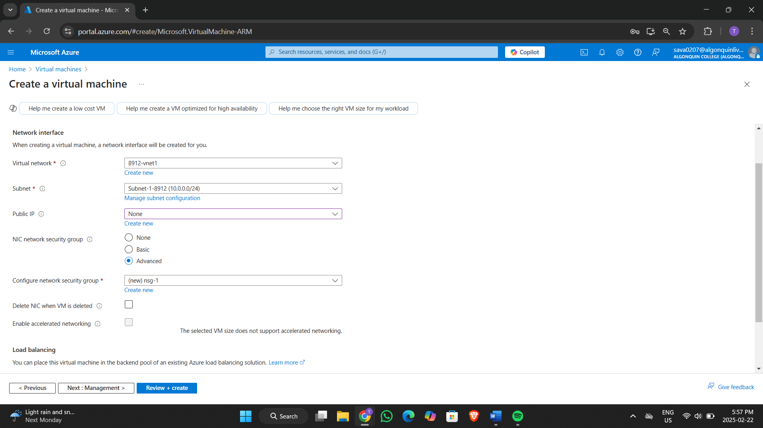

4.3 Adding all the given value

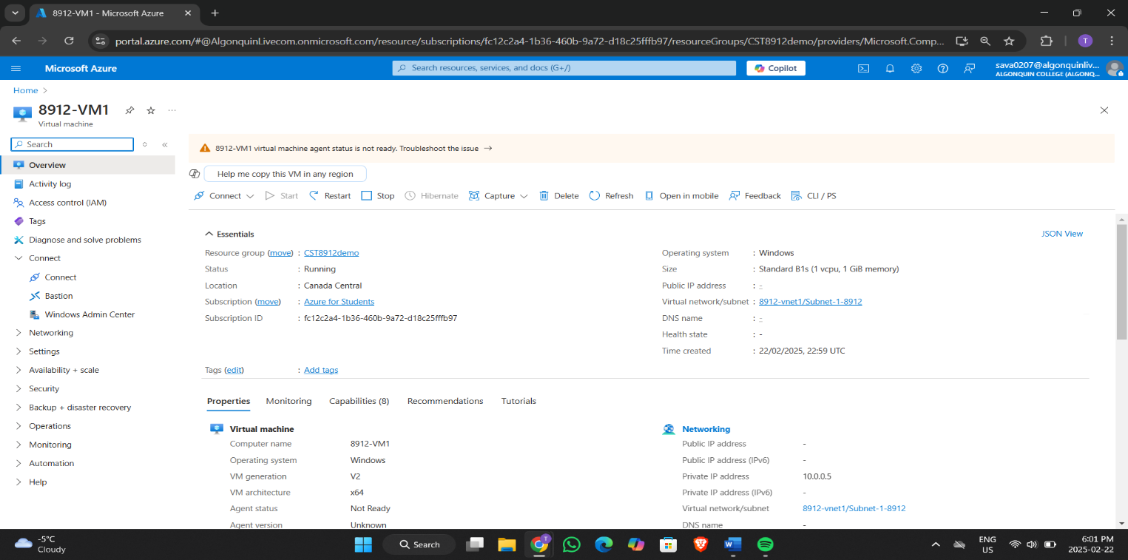

4.4 Created Virtual Machine

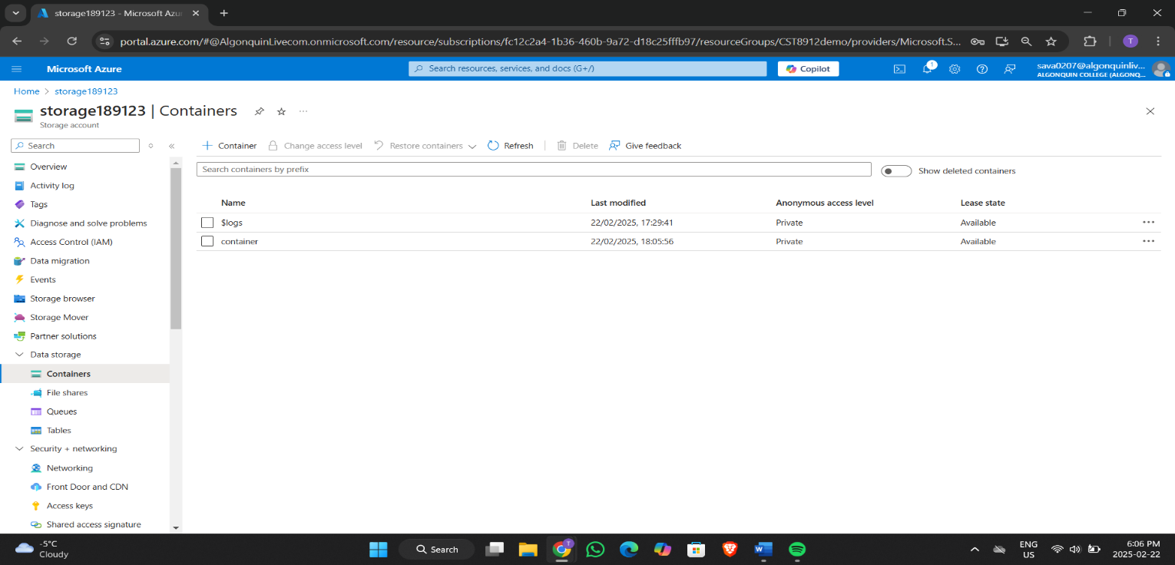

5.1 adding container in storage account

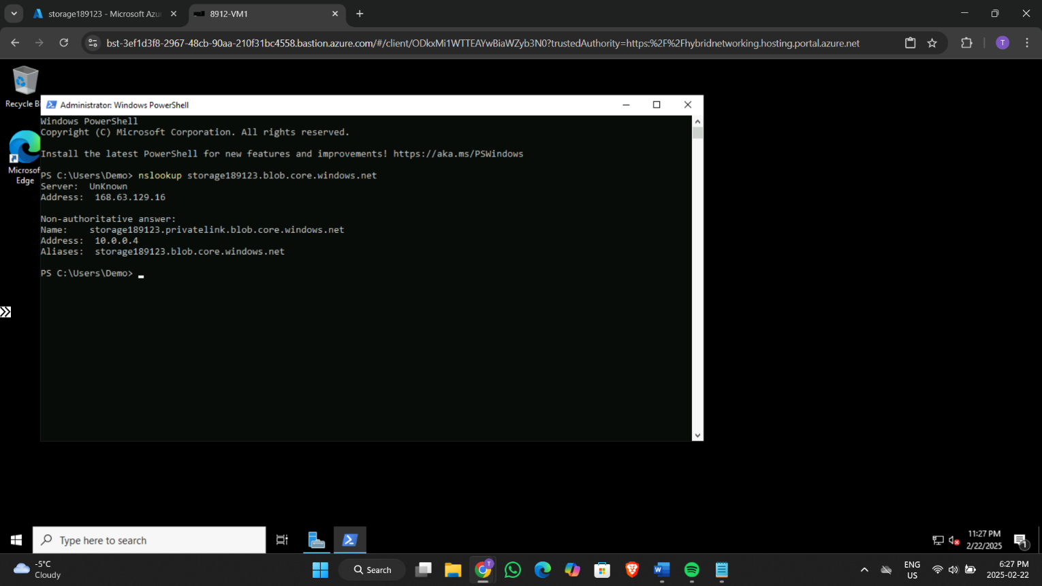

6.1 Test connectivity to private endpoint

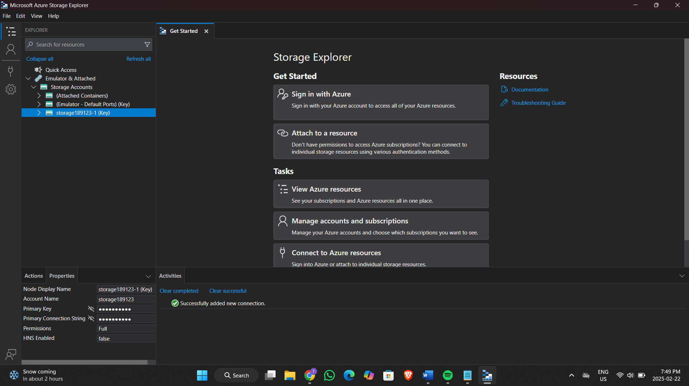

7.1 Installed Microsoft Azure Storage Explorer and adding Storage account key

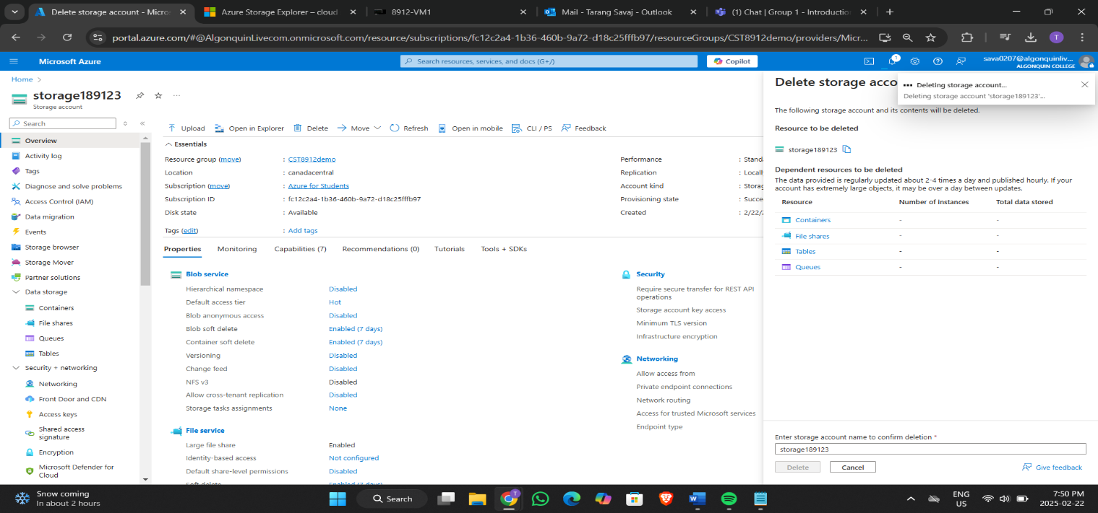

8.1 Deleting Storage account

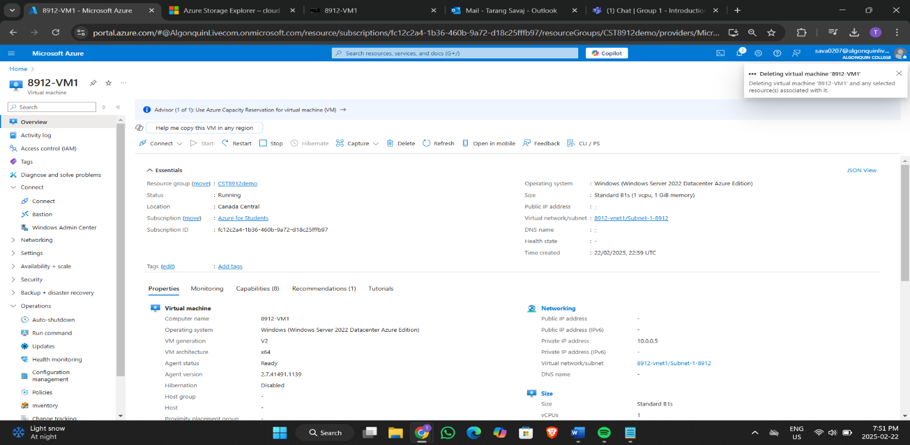

8.2 Deleting Virtual Machine

8.3 Deleting Private endpoint

8.4 Deleting Virtual network

8.5 Deleting Resource Group

**References**

* References for this task are taken from the provided lab file.