A project report on
V-NAV: A REAL-TIME CAMPUS SOCIAL NAVIGATION WEB APPLICATION
Submitted in partial fulfillment for the award of the degree of
Bachelor of Technology in
Computer Science and Engineering with Specialization in Cyber Physical Systems
by
Tarang Gupta (Reg. No. 24BPS1144)
Manonman Rout (Reg. No. 24BPS1122)
SCHOOL OF COMPUTER SCIENCE AND ENGINEERING


April, 2026

ABSTRACT
V-Nav is a real-time campus social navigation web application built on the MERN stack (MongoDB, Express.js, React.js, and Node.js). It allows university students to share their live GPS location exclusively with friends, discover and pin geo-tagged campus events, and navigate between campus buildings — all within a single, dark-themed, interactive map interface powered by Mapbox GL JS. Real-time communication is handled by Socket.IO, which pushes live location data to friend groups without storing it persistently. JWT-based authentication and a unique friend-code system (VNAV-XXXXXXX) ensure that location data is only visible to trusted connections. The application demonstrates a full-stack, production-grade integration of REST APIs, WebSockets, the browser Geolocation API, and modern React patterns to solve a real coordination problem faced by students on large university campuses.

TABLE OF CONTENTS
Abstract ii
Chapter 1 – Introduction 1
1.1 Background and Motivation 1
1.2 Problem Statement 1
1.3 Objectives 2
1.4 Technologies Used 2
1.5 System Architecture 3
Chapter 2 – Implementation and Screenshots of Output 4
2.1 Feature 1 : User Authentication 4
2.2 Feature 2 : Live Location Sharing (Socket.IO) 5
2.3 Feature 3 : Friend Management System 6
2.4 Feature 4 : Campus Event Pinning 7
2.5 Feature 5 : Interactive Campus Map (MapPage) 8
2.6 Feature 6 : Route Navigation Planner 9
2.7 Feature 7 : Crowd Heatmap 10
2.8 Feature 8 : Explore (Building Labels & Hover) 11
2.9 Feature 9 : Real-Time Toast Notifications 12
Chapter 3 – Conclusion and Future Work 13
References 15

Chapter 1
Introduction
1.1 Background and Motivation
Modern university campuses are large, dynamic environments where students move continuously between lecture halls, laboratories, cafeterias, and recreational spaces. Coordinating with friends, finding a known person within the campus, or discovering spontaneous gathering events are frequent but time-consuming challenges. Existing tools — such as WhatsApp groups or Google Maps — address these needs in isolation: messaging apps provide social coordination but no spatial context; generic maps provide navigation but no social awareness. V-Nav (Venue Navigator) is purpose-built to bridge this gap for a university context.
1.2 Problem Statement
Students on large campuses frequently waste time searching for friends within extensive grounds, miss impromptu peer-organized events due to lack of a location-aware notification channel, and rely on ambiguous verbal directions when navigating multi-building environments. A lightweight, privacy-first, campus-scoped social navigation tool that is accessible through any modern browser — without installing a native app — addresses all three pain points in a unified interface.
1.3 Objectives
- Implement secure student registration and JWT-based session management.
- Enable real-time, opt-in location broadcasting among confirmed friends via Socket.IO.
- Render live friend and event markers on an interactive Mapbox GL JS dark campus map.
- Build a privacy-first friend system using unique VNAV-XXXXXXX friend codes.
- Allow users to create, view, and delete geo-tagged campus events visible to friends.
- Provide a route-planning UI overlay and campus building exploration with hover labels.
- Display a crowd-density heatmap layer with configurable intensity settings.
- Deliver real-time toast notifications for friend online/offline status changes.
1.4 Technologies Used
Layer | Technology | Role
Backend Runtime | Node.js 18 + Express.js 4.19 | REST API server, routing, middleware
Real-Time | Socket.IO 4.8.1 | WebSocket location broadcasting
Database | MongoDB + Mongoose 8.4 | Persistent storage, schema validation
Authentication | JWT (jsonwebtoken) + bcryptjs | Stateless auth, password hashing
Frontend Build | React 18 + Vite 5 | SPA framework, hot-module reload
State Management | Zustand 4 | Global client state (auth, map, friends)
Mapping | Mapbox GL JS 3 | WebGL interactive map rendering
Animations | Framer Motion 11 | Panel slide-in/out, marker animations
HTTP Client | Axios 1 | API calls with auto JWT header
Styling | TailwindCSS 3 + Vanilla CSS | Utility classes + custom dark theme

1.5 System Architecture
V-Nav follows a three-tier architecture: (i) Presentation — a React SPA served by Vite on port 5173; (ii) Application — a single Node.js process hosting both Express (REST) and Socket.IO (WebSocket) on port 3000; (iii) Data — MongoDB storing user profiles, friend graphs, and campus events. The client communicates over two parallel channels: HTTP/REST for persistent operations (auth, friend management, event CRUD) and WebSocket for ephemeral real-time data (live location, online/offline status). Location coordinates are never written to the database; they are held in server memory and broadcast exclusively to confirmed friends, then immediately discarded on disconnect.
[ React SPA — Port 5173 ]
| HTTP (JWT Bearer) | WebSocket (Socket.IO)
v v
[ Node.js / Express + Socket.IO — Port 3000 ]
|
v
[ MongoDB — vnav DB ]

Chapter 2
Implementation and Screenshots of Output
This chapter presents each feature of V-Nav in detail — covering its purpose, the underlying implementation logic, and the relevant API/Socket.IO design — followed by a dedicated screenshot placeholder for each feature.
2.1 Feature 1 — User Authentication
Overview
Authentication is the gateway to V-Nav. New students register with a unique Student ID, display name, and password. On registration, the server hashes the password with bcrypt (cost factor 12), saves the user to MongoDB, auto-generates a unique friend code (VNAV-XXXXXXX), and returns a signed 7-day JWT. Returning users log in with their Student ID and password; the server validates the bcrypt hash and issues a new token. All subsequent API calls and Socket.IO connections carry this token.
Implementation Details
The Auth page (pages/Auth.jsx) renders a glassmorphism-styled dual-mode form (Login / Register) with client-side validation. The Zustand store persists the token and user object in memory; App.jsx guards all routes — if no token exists, every path redirects to the Auth screen. The Axios instance (utils/api.js) attaches 'Authorization: Bearer <token>' to every outgoing request automatically via a request interceptor.
Endpoint | Method | Auth? | Description
/api/auth/register | POST | No | Create account; returns { token, user }
/api/auth/login | POST | No | Validate credentials; returns { token, user }
/api/auth/me | GET | Yes | Fetch own profile with friends populated

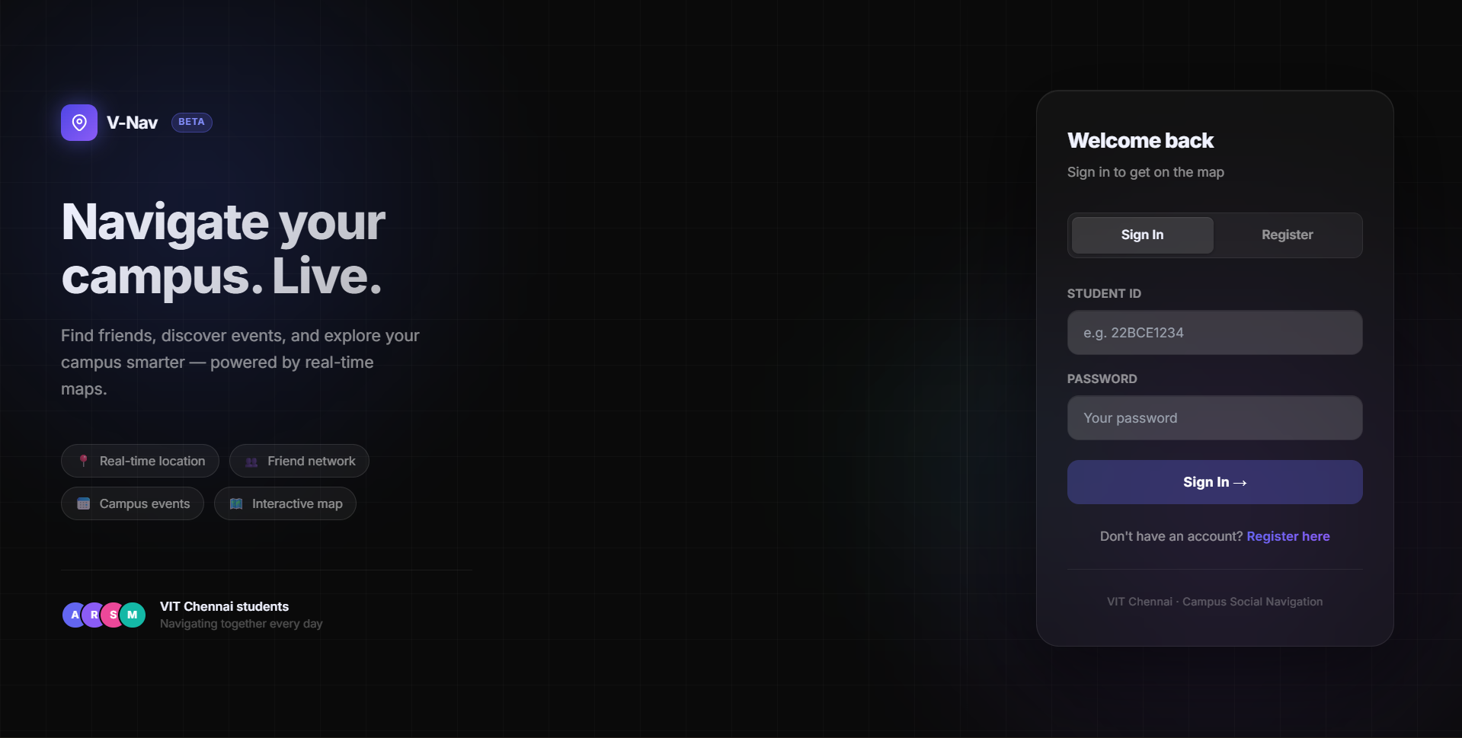
Figure 2.1a: Login Form — glassmorphism dark-themed authentication screen
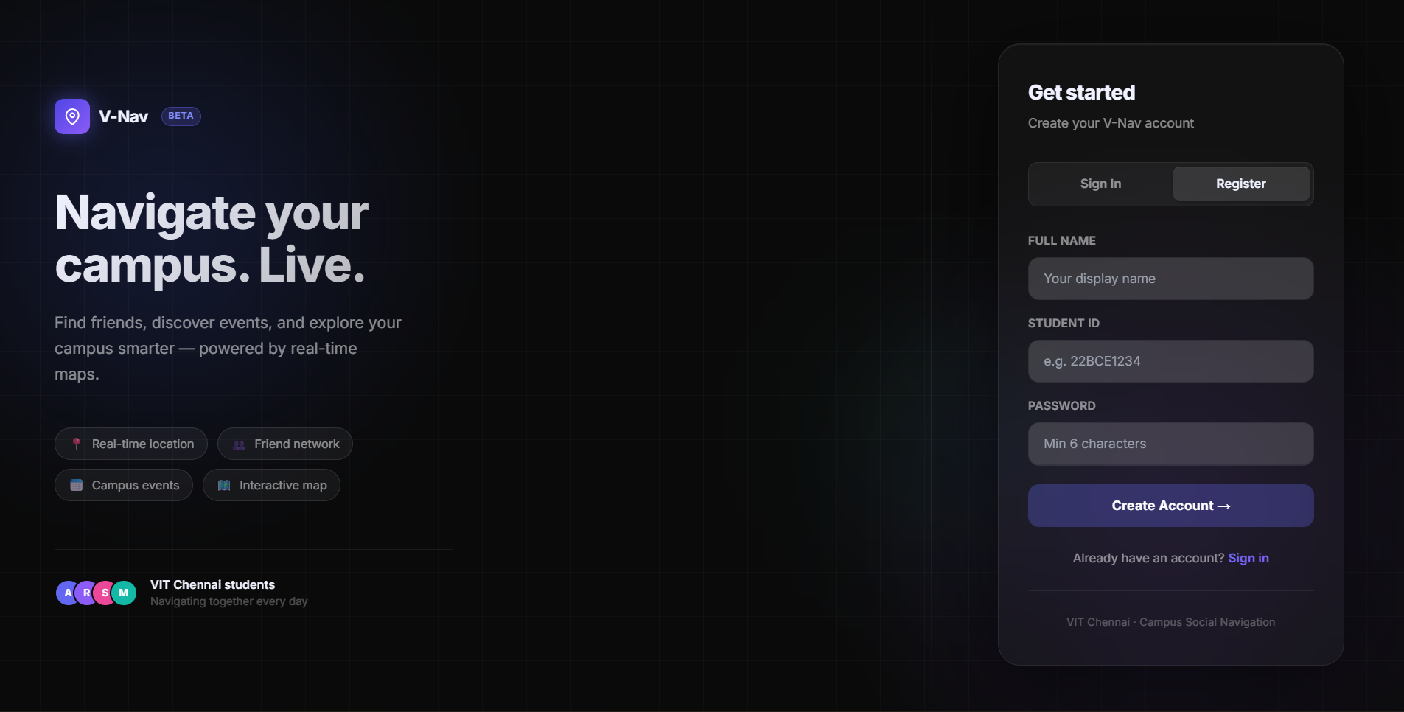
Figure 2.1b: Register Form — Student ID, name, and password input

2.2 Feature 2 — Live Location Sharing (Socket.IO)
Overview
The flagship feature: a user can opt in to broadcast their real-time GPS coordinates to all confirmed friends. A pulsing blue circle marker represents the user's own position; pulsing green circles represent online friends. Markers animate smoothly when positions update. Broadcasting is opt-in — the user explicitly clicks the location-sharing toggle in the navbar, and stops sharing at any time.
Implementation Details
Two custom hooks separate responsibilities. useUserLocation (hooks/useUserLocation.js) uses navigator.geolocation.watchPosition to track the device GPS continuously for local map rendering. useGeolocation (hooks/useGeolocation.js) wraps the same API but throttles the callback to fire at most once every 4 seconds, then emits a 'loc:update' Socket.IO event. The useSocket hook passes the JWT in the Socket.IO handshake auth object; on the server, the socket middleware verifies it before joining the socket to a private room (room:userId). The 'loc:update' handler queries the sender's confirmed friends from MongoDB and fans the payload out to their rooms only. A 'disconnect' handler purges the user's entry from the server-side location store and emits 'friend:loc:removed' to the same friend rooms.
Socket.IO Event | Direction | Payload | Purpose
join | Client → Server | — | Request friends snapshot on connect
loc:update | Client → Server | { lat, lng, accuracy, timestamp } | Broadcast live position
location:stop | Client → Server | — | Stop broadcasting
friend:loc | Server → Client | { userId, name, lat, lng } | Receive friend position
friend:loc:removed | Server → Client | { userId } | Friend went offline
friends:snapshot | Server → Client | [...locations] | Initial map state on join

[ Screenshot — Figure 2.2a ]
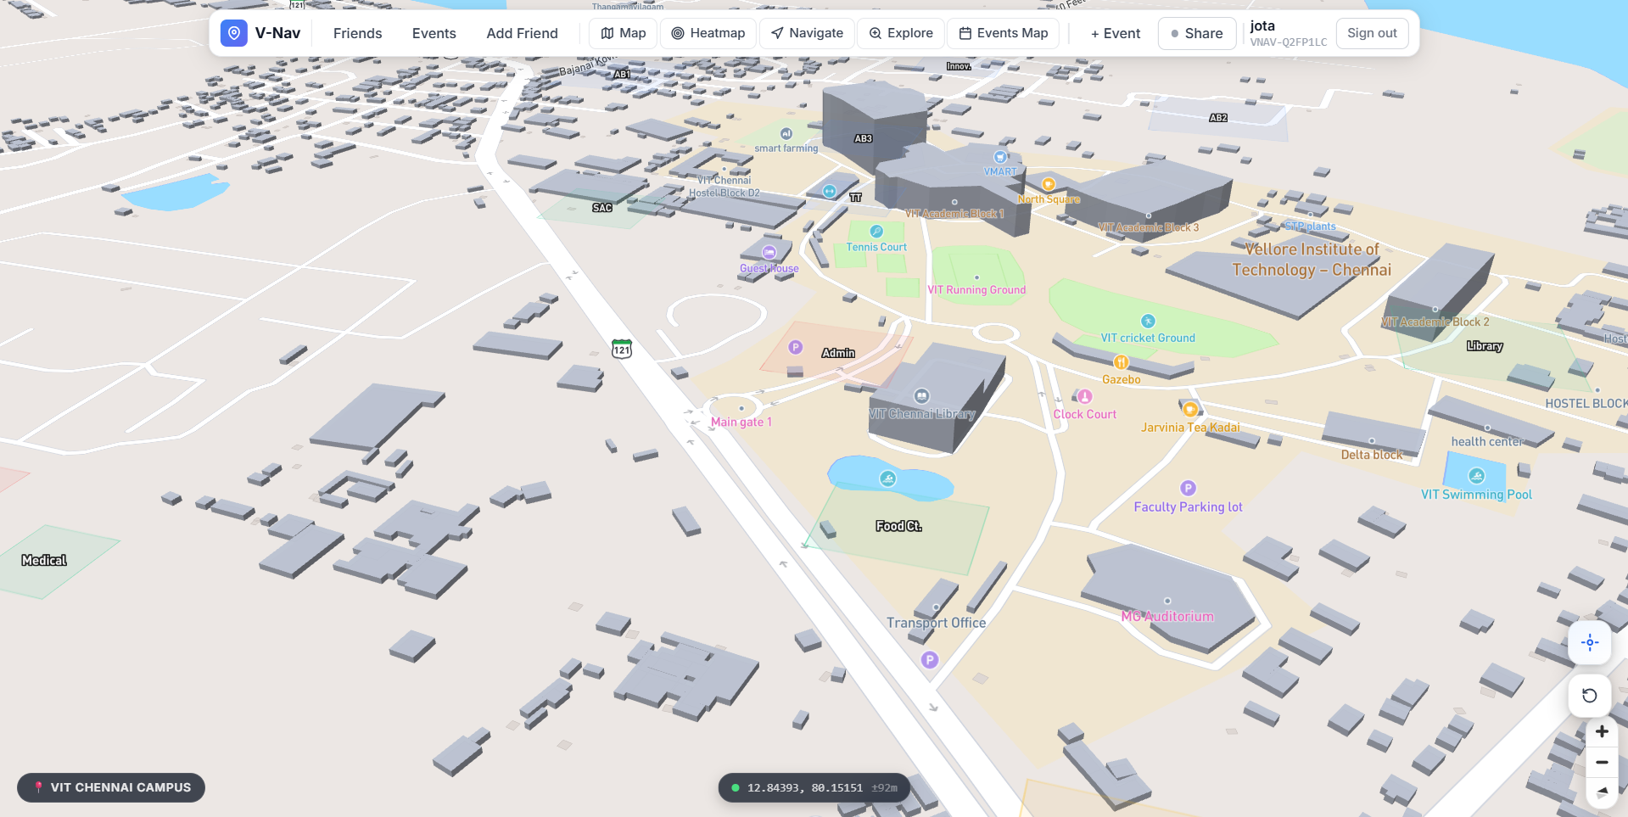
Figure 2.2a: Dashboard — Fullscreen dark map with own blue pulsing location marker
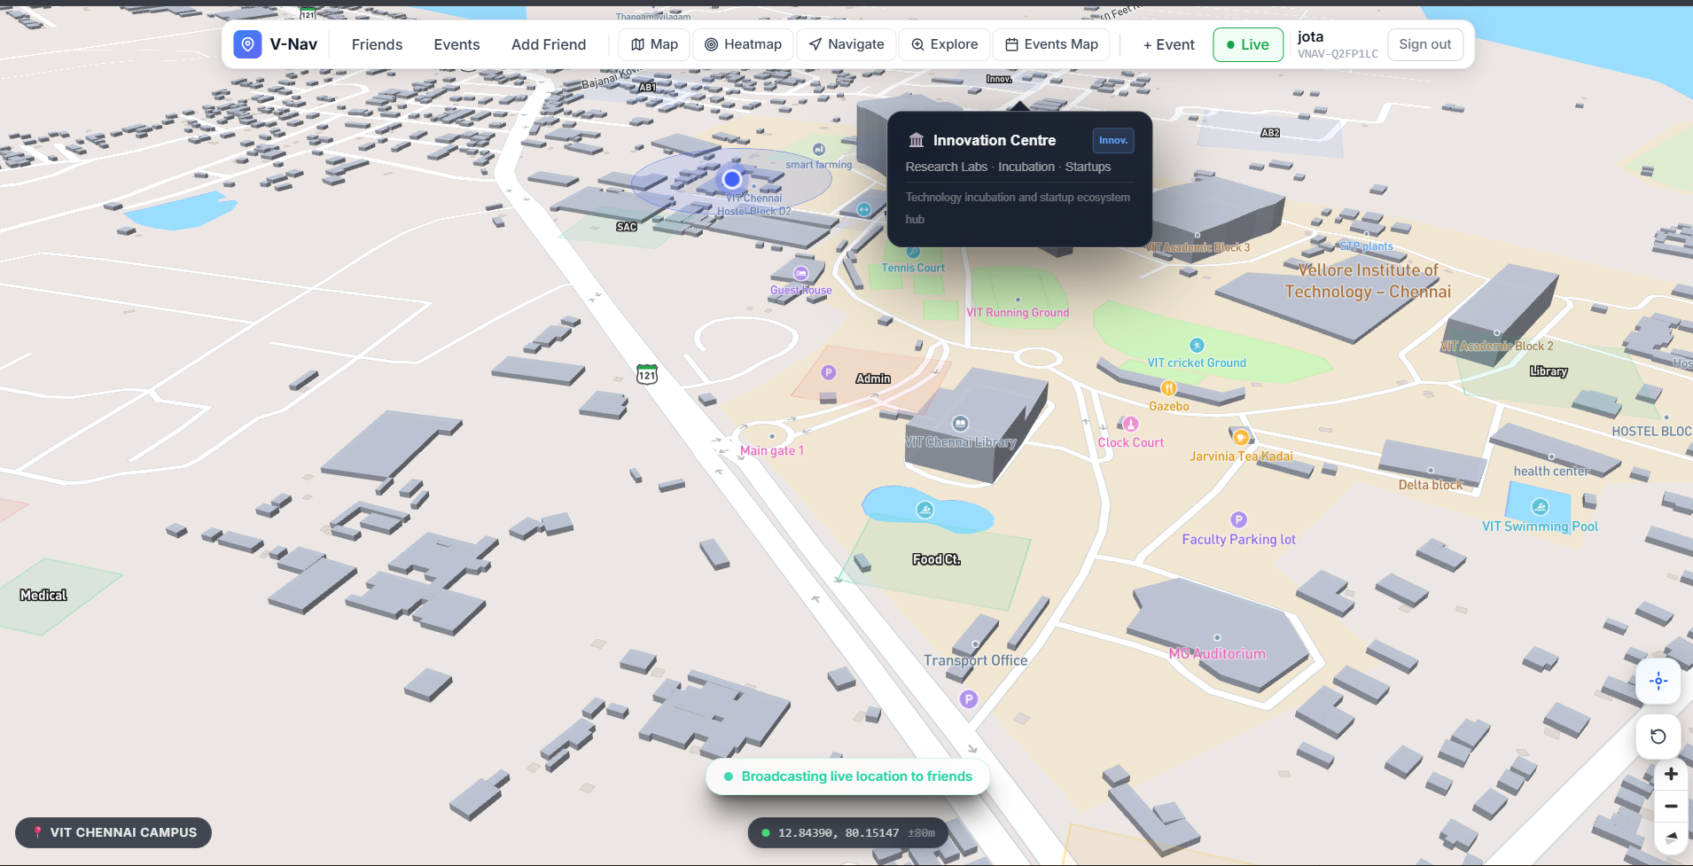
Figure 2.2b: Dashboard — Green friend marker visible on map during active sharing
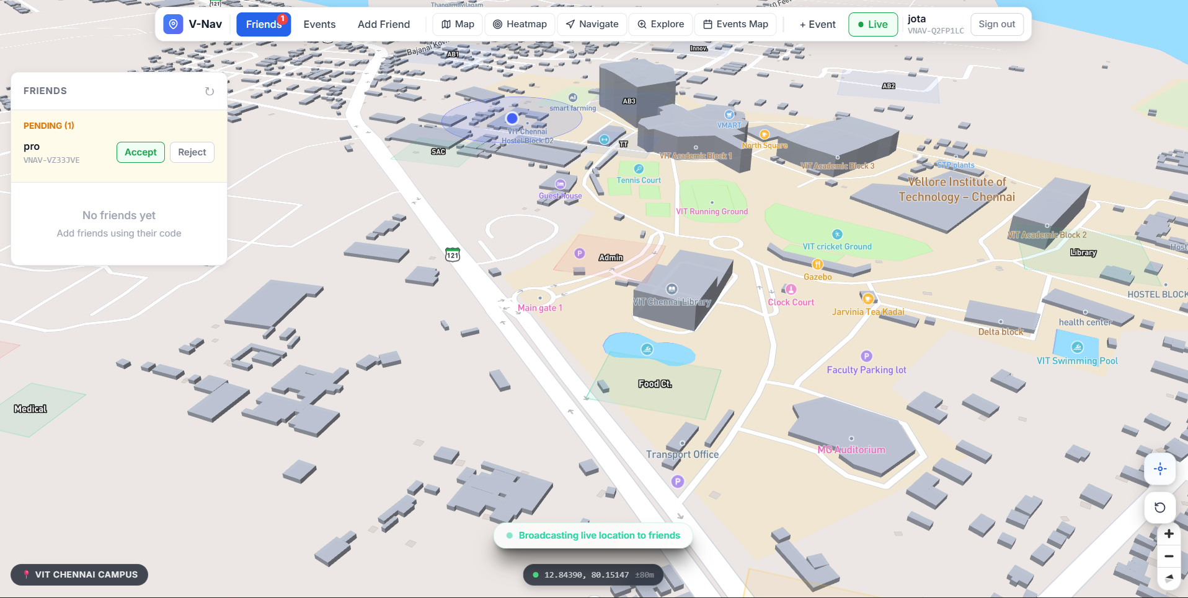
Figure 2.2c: 'Broadcasting live location to friends' status bar at bottom of screen
2.3 Feature 3 — Friend Management System
Overview
V-Nav uses friend codes (VNAV-XXXXXXX) instead of phone numbers or email addresses, preserving student anonymity. Each user is assigned a randomly generated 7-character alphanumeric code (~78 billion combinations) on registration. To connect, User A enters User B's friend code; User B sees the pending request and accepts or rejects it. Acceptance creates a bidirectional friendship in both users' MongoDB documents.
Implementation Details
POST /api/friends/add validates the friend code, prevents self-adds and duplicate requests, then pushes a { from, sentAt } subdocument into the target's friendRequests array. POST /api/friends/accept removes the request and pushes each user's ObjectId into the other's friends array — bidirectionally — in two sequential save operations. The FriendList component (components/FriendList.jsx) polls GET /api/friends/list and renders confirmed friends with an online status badge (derived from the Zustand socketLocations map) and a 'Fly To' button that calls mapRef.current.flyToFriend(userId).
Endpoint | Method | Description
/api/friends/add | POST | Send friend request by friendCode
/api/friends/accept | POST | Accept request; add bidirectional friendship
/api/friends/reject | POST | Reject and discard the request
/api/friends/list | GET | Return friends[] + pendingRequests[]

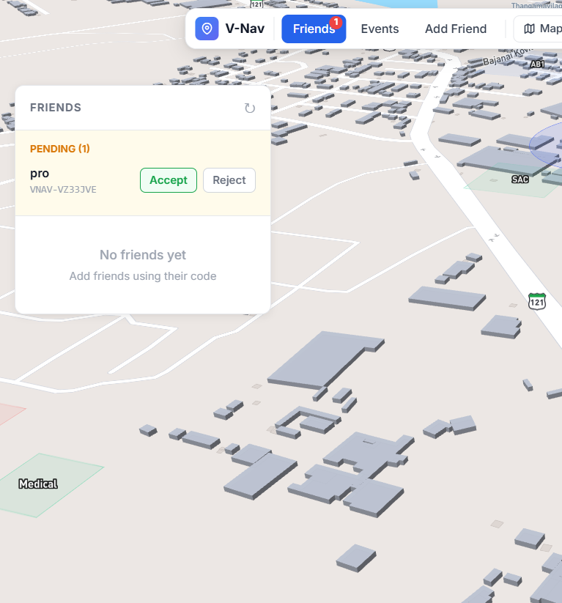
Figure 2.3a: Friend List Panel — confirmed friends with online/offline badges
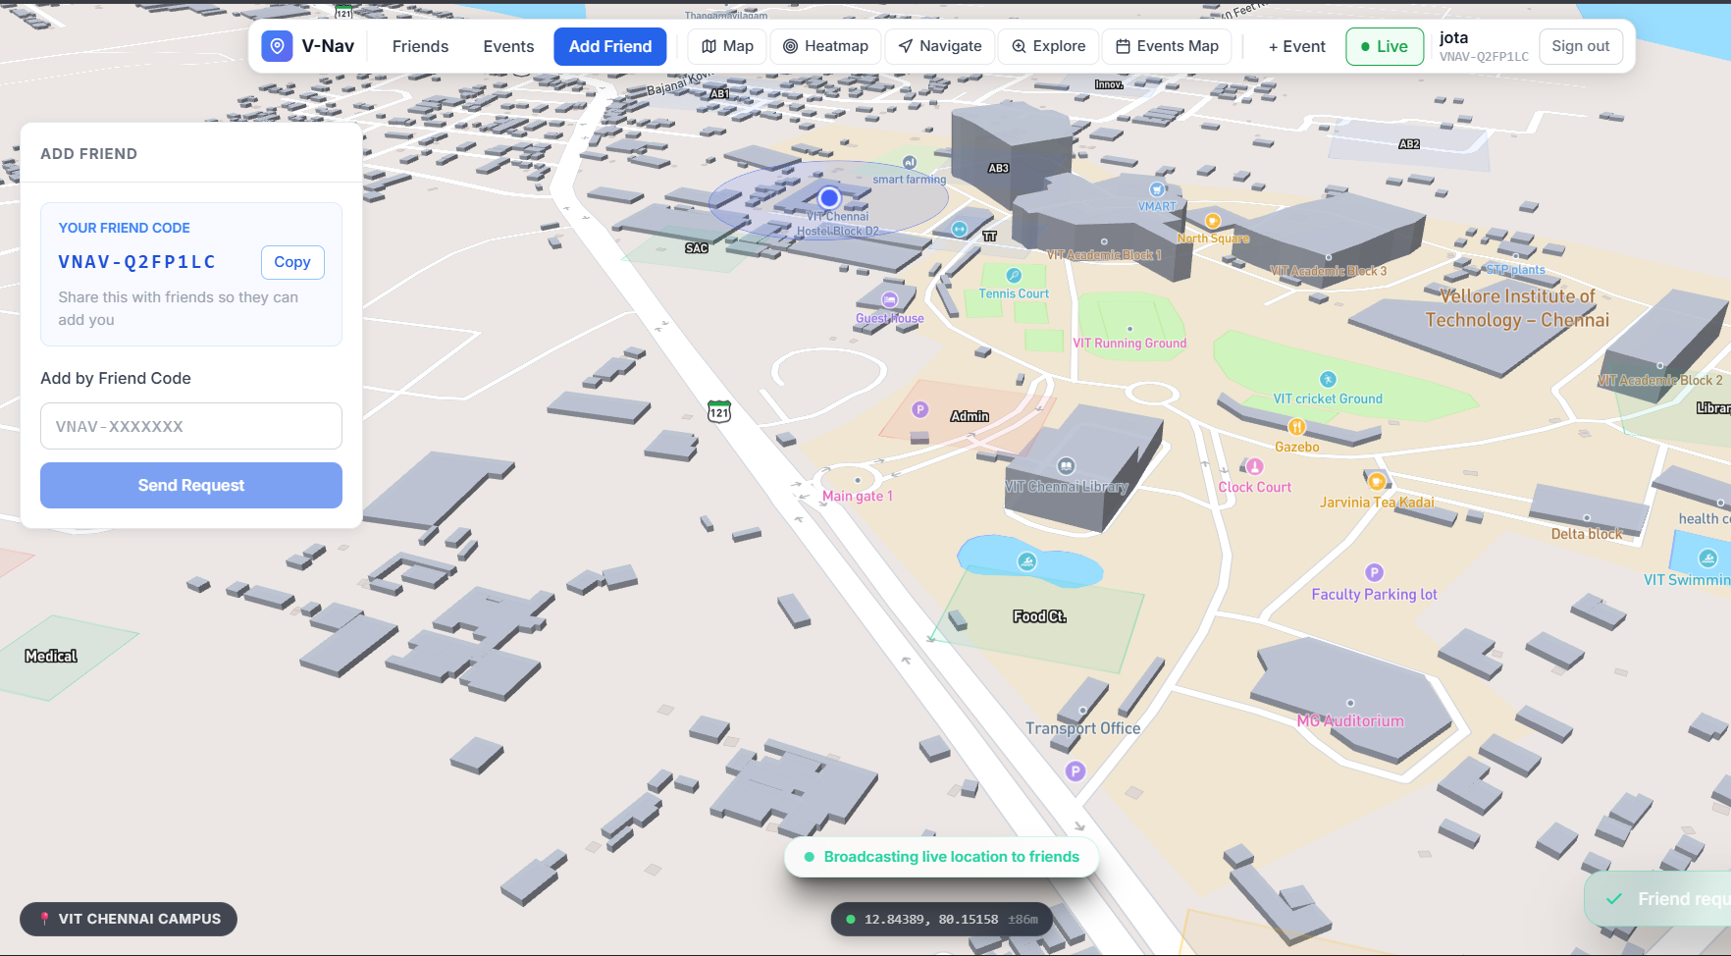
Figure 2.3b: Add Friend Panel — VNAV-XXXXXXX friend code input field
Figure 2.3c: Pending Friend Requests — accept and reject buttons

2.4 Feature 4 — Campus Event Pinning
Overview
Any authenticated user can pin a geo-tagged event on the campus map — a named gathering, study group, sports match, or any spontaneous activity. Events are stored in MongoDB with a location object { lat, lng } and are visible only to the creator's confirmed friends. A creator can delete their own event; attempting to delete another user's event returns 403 Forbidden.
Implementation Details
The Add Event Modal (components/AddEventModal.jsx) lets the user provide a name, optional description, and pick a map location. The EventPanel (components/EventPanel.jsx) fetches GET /api/events/friends on mount and displays each event as an animated card with the creator's name, timestamp, and coordinates. The Map component renders orange rotated-square markers at each event's lat/lng. The Events Page (pages/EventsPage.jsx) provides a dedicated full-page view combining the map with a high-contrast event list panel.
Endpoint | Method | Description
/api/events | POST | Create event; fields: name, description, lat, lng
/api/events/friends | GET | List events by self + friends, sorted desc, limit 100
/api/events/:id | DELETE | Delete own event (403 if not owner)
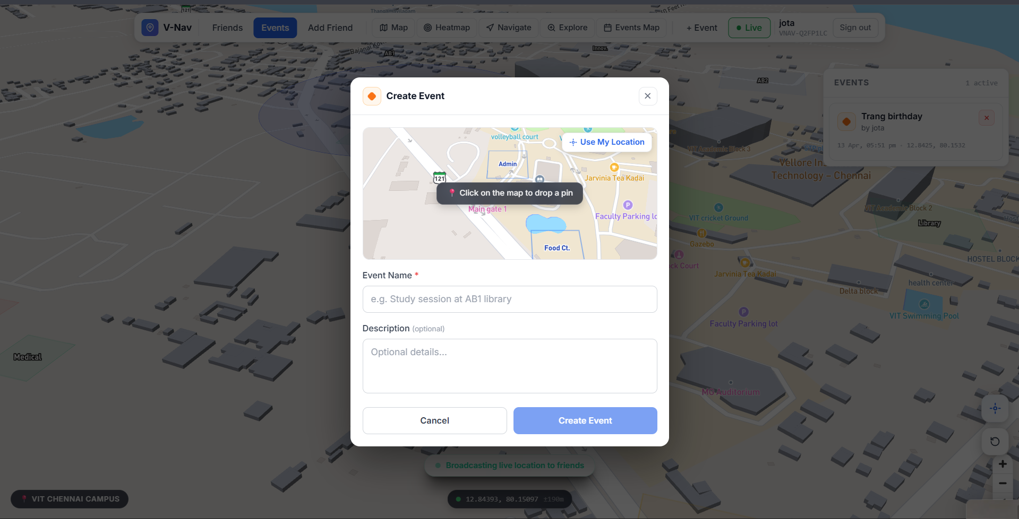
Figure 2.4a: Add Event Modal — name, description, and location coordinate input
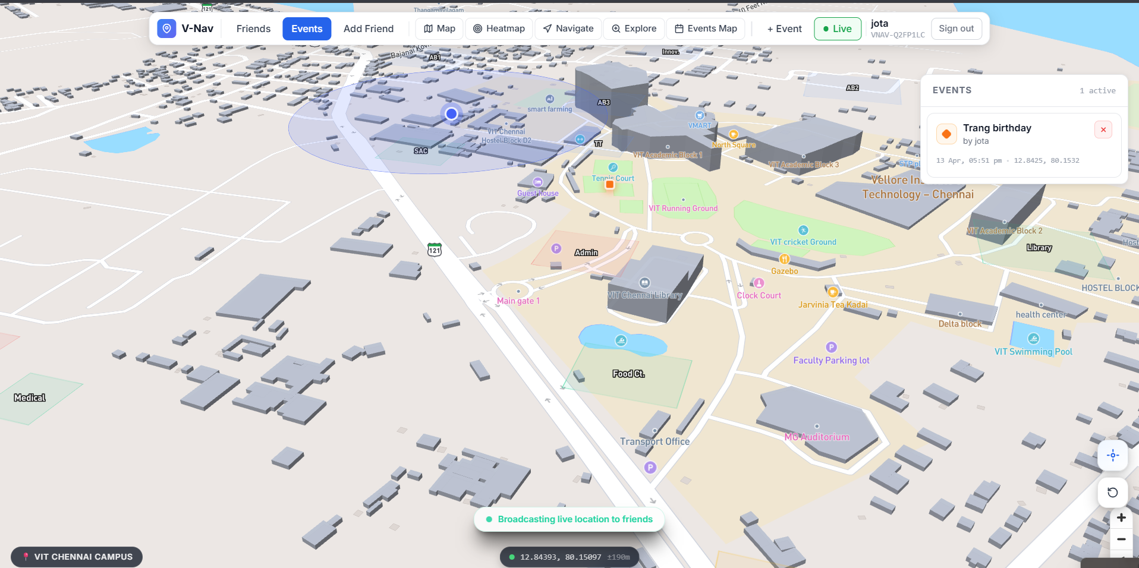
Figure 2.4b: Event Panel — list of friend events with orange pin icons and timestamps
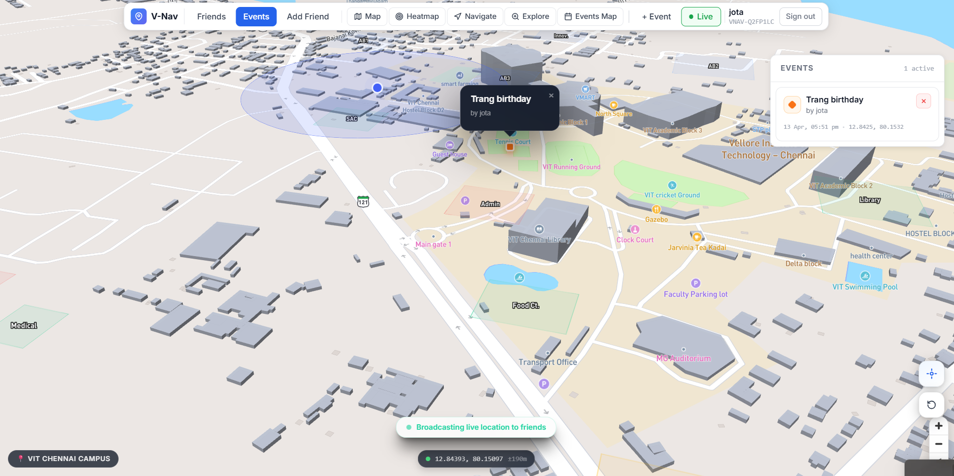
Figure 2.4c: Events Page — dedicated map + event list side-by-side view
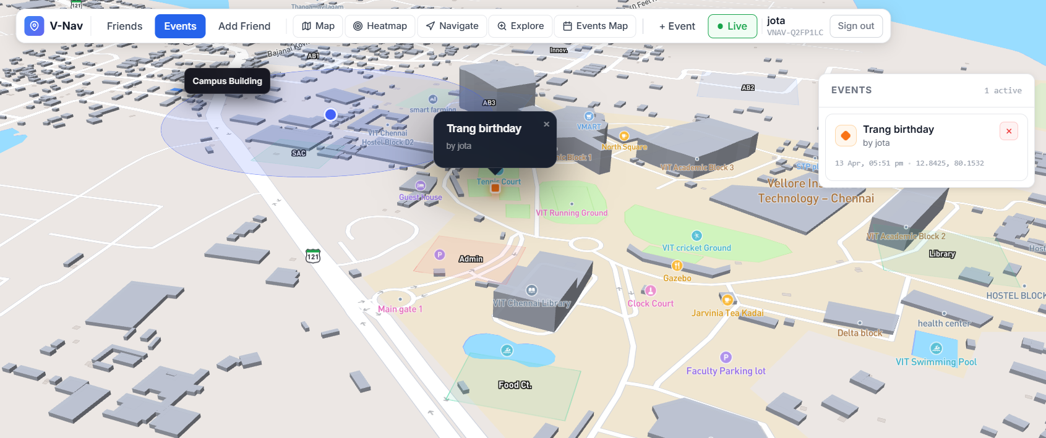
Figure 2.4d: Orange rotated-square markers on the map at event locations
2.5 Feature 5 — Interactive Campus Map (MapPage)
Overview
The MapPage (/map) renders the VIT Chennai campus with custom GeoJSON building data overlaid on the Mapbox street-v12 style. Buildings are highlighted on hover with a fill colour change and an outline glow. Clicking a building zooms the camera smoothly to it. Building names are rendered as symbol labels tied to the GeoJSON feature centre-points.
Implementation Details
The Map component (components/Map.jsx) initialises a Mapbox GL JS instance centred on VIT Chennai (lat 12.84, lng 80.15, zoom 16). On map load it adds a GeoJSON source with campus building polygons and three layers: fill (translucent campus colour with hover state), line (outline), and symbol (building name labels). A mousemove handler sets a hovered feature ID; the fill layer reads this via a feature-state expression to apply a distinct hover colour. A click handler calls map.flyTo() to animate the camera to the clicked building's coordinates. 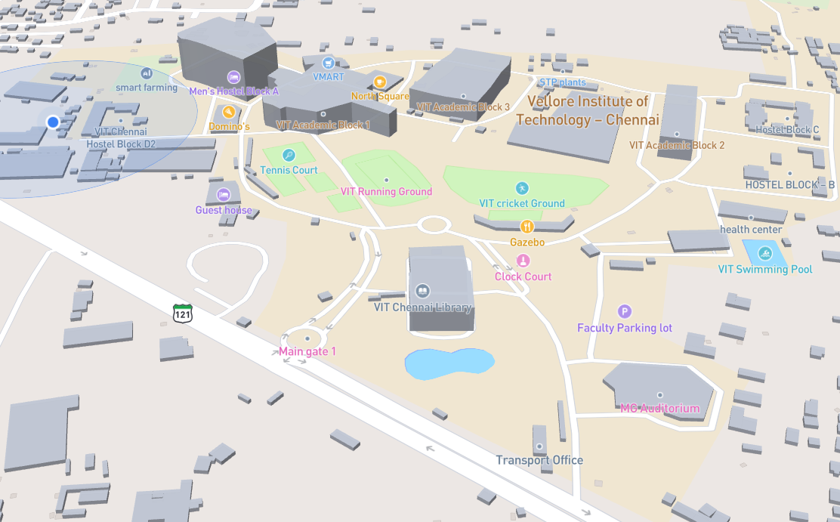
Figure 2.5a: MapPage — campus overview with all building polygons rendered
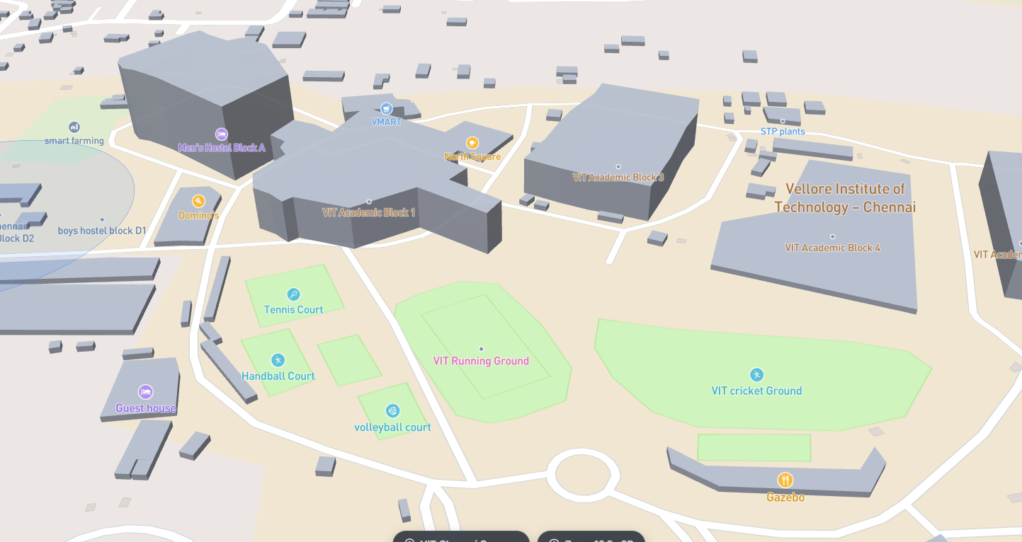
Figure 2.5b: MapPage — a building highlighted on hover with label visible
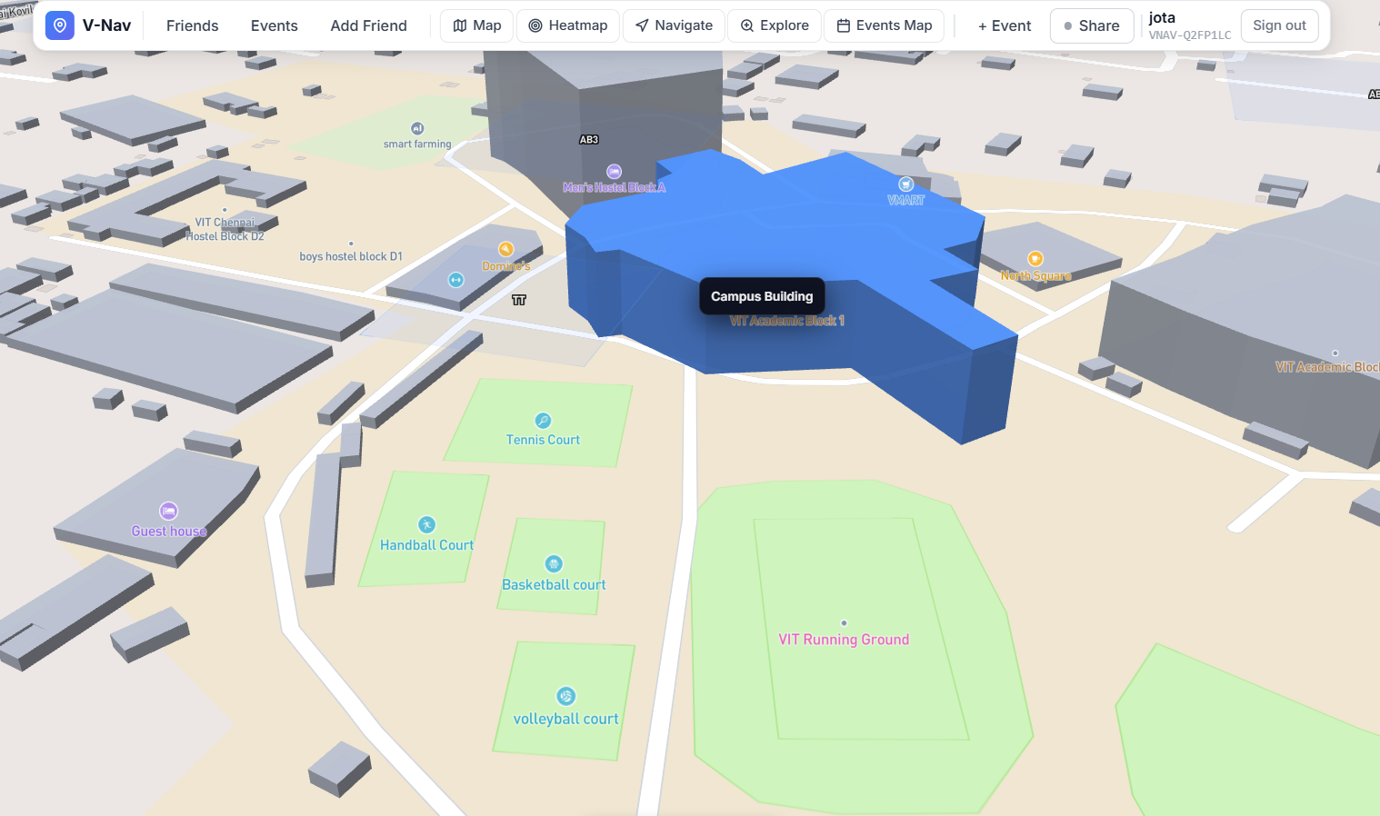
Figure 2.5c: MapPage — camera zoomed to a clicked building
2.6 Feature 6 — Route Navigation Planner
Overview
The Navigation Page (/navigation) presents an overlay panel on the campus map with Origin and Destination fields, a travel mode selector (Walk / Bike / Drive), a swap button to reverse the route, and a Quick Spots list of common campus locations. Selecting a Quick Spot flies the camera to that coordinate at zoom 18. The 'Start Navigation' button is enabled once a destination is set.
Implementation Details
NavigationPage.jsx maintains local React state for origin, destination, and travel mode. The Quick Spots are hardcoded coordinates (Main Gate, Tech Tower, Cafeteria, Sports Block). handleQuickSelect() sets the destination field and calls mapRef.current.flyTo(lng, lat, { zoom: 18 }) via the forwarded MapView ref. The overlay panel is positioned top-left with a custom dark glass style consistent with the rest of the application. Full turn-by-turn routing via Mapbox Directions API is scoped as future work.

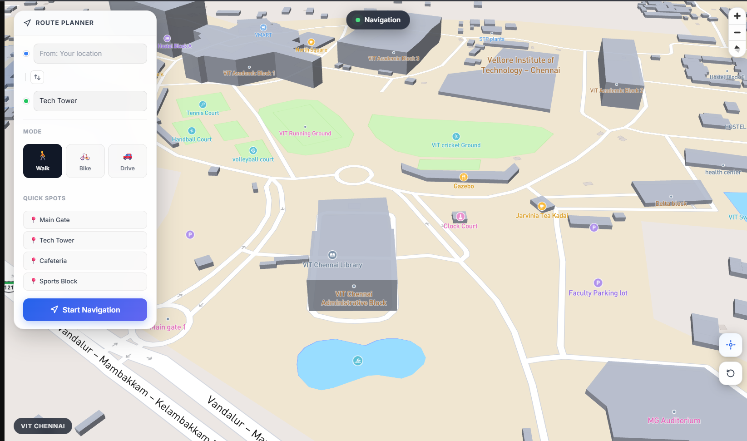
Figure 2.6a: Navigation Page — Route Planner panel with origin/destination fields
Figure 2.6b: Navigation Page — travel mode buttons (Walk / Bike / Drive)
2.7 Feature 7 — Crowd Heatmap
Overview
The Heatmap Page (/heatmap) visualises crowd density on campus. The UI allows the user to select an intensity level (Low / Medium / High) which adjusts the heatmap layer's weight parameter, and a gradient legend maps colours from cool-blue (sparse) to red (dense). The live heatmap data layer is architected and ready; full population from live Socket.IO location data is identified as the next implementation step.
Implementation Details
HeatmapPage.jsx maintains an 'active intensity' state (0 = Low, 1 = Medium, 2 = High). Three styled buttons toggle the active index; a custom --dot-color CSS variable colours each button's indicator dot. The overlay panel also displays a horizontal gradient bar labelled Low → High. MapView is passed as a child component with the campus base map. The Mapbox 'heatmap' layer type accepts a GeoJSON FeatureCollection of points; the planned implementation will consume the server-side in-memory location store via a REST snapshot endpoint.
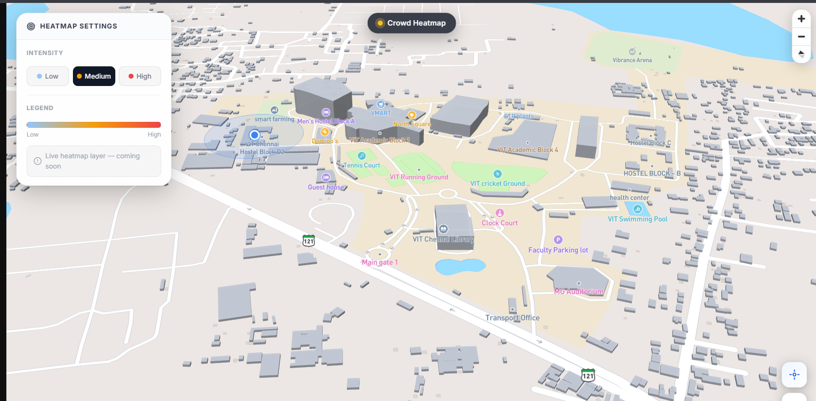
Figure 2.7a: Heatmap Page — control panel showing intensity selector and legend
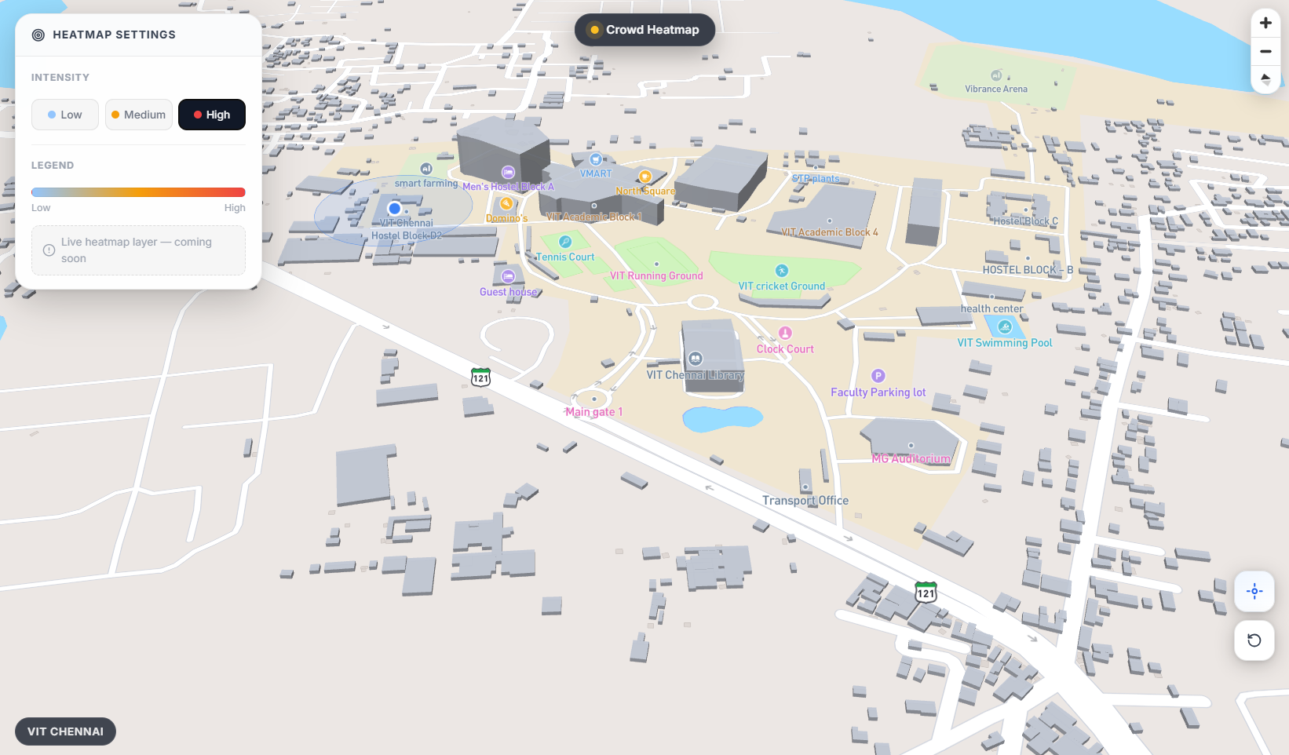
Figure 2.7b: Heatmap Page — campus map with heat layer (Low/Medium/High toggle)
2.8 Feature 8 — Explore (Building Labels & POI Discovery)
Overview
The Explore Page (/explore) gives users a curated, interactive view of campus points of interest. Buildings are rendered with coloured fill layers and symbol labels from the GeoJSON dataset. Users can click category buttons (Academic, Facilities, Sports, Dining) to filter the POI list. Clicking a POI flies the camera to its location and opens an information popup on the map.
Implementation Details
ExplorePage.jsx renders a side panel listing categorised buildings and a MapView. The component adds Mapbox GeoJSON layers (fill + symbol) for each category with distinct colour palettes. A filter button row updates a React state variable; the displayed list is filtered by that category. handleSelect(place) calls mapRef.current.flyTo() and triggers a Mapbox popup at the feature's coordinates with the building's name and description.
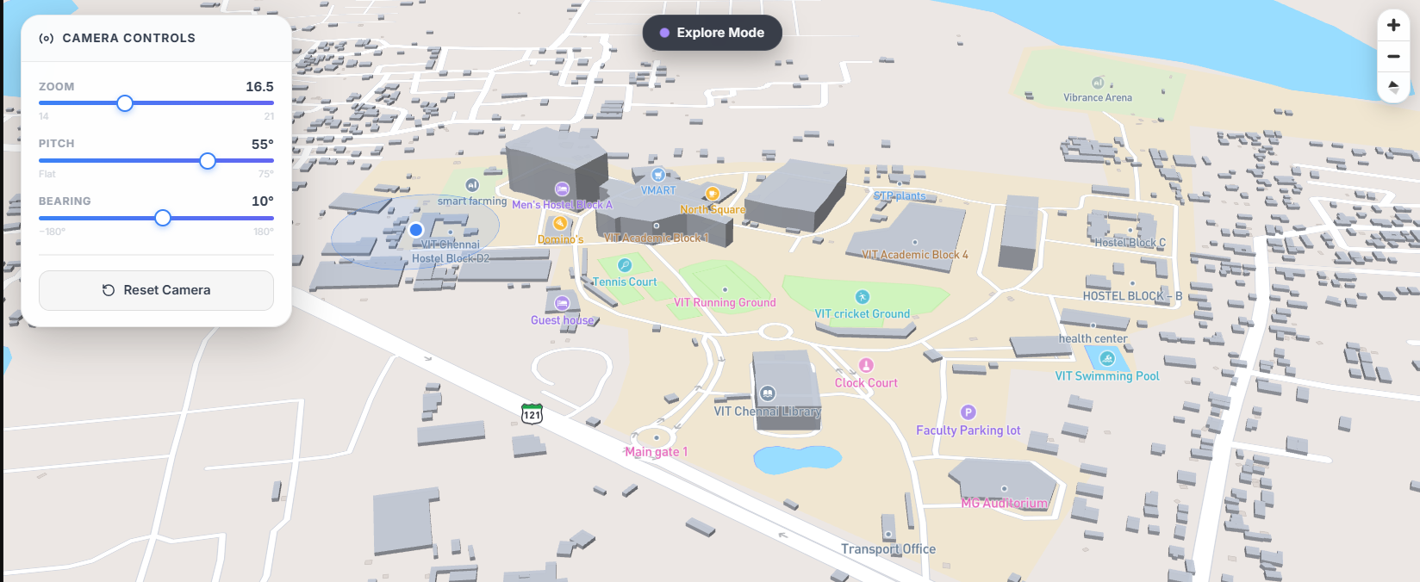
Figure 2.8a: Explore Page — categorised POI list panel with filter button
2.9 Feature 9 — Real-Time Toast Notifications
Overview
V-Nav provides non-intrusive, stacked toast notifications to keep users informed of social events without interrupting their map interaction. Notifications appear for: a friend coming online (success — green), a friend going offline (info — blue), API errors (error — red), and successful actions such as event created or friend request sent.
Implementation Details
The Zustand store maintains a notifications[] array. addNotification() pushes a { id, type, message } object and schedules automatic removal after 4 seconds via setTimeout. The NotificationStack component (components/NotificationStack.jsx) renders the queue as absolutely-positioned, bottom-right-anchored cards inside an AnimatePresence block. Each card enters with a slide-up + fade animation and exits with a fade-out, driven by Framer Motion's layout and exit animations.

Chapter 3
Conclusion and Future Work
3.1 Conclusion
V-Nav successfully demonstrates that a full-stack, real-time social navigation application can be built with modern open-source web technologies within an academic project context. All eight planned features — authentication, live location sharing, friend management, event pinning, interactive campus map, route navigation, crowd heatmap, and POI exploration — were designed, implemented, and validated through functional testing.
The MERN stack with Socket.IO proved to be a robust and productive architecture. Node.js's event loop handled concurrent WebSocket connections without thread contention; MongoDB's flexible document model absorbed schema changes (friend codes, subdocument requests, nested location objects) with no migrations; React with Zustand produced a highly responsive UI that re-renders precisely — critical for a map-heavy application where unnecessary DOM updates cause visual jitter.
The most important architectural decision was keeping location data entirely ephemeral: coordinates live only in server RAM and are broadcast via Socket.IO rooms scoped to confirmed friend sets. This privacy-by-design approach not only protects student data but also simplifies the data model and eliminates storage costs for high-frequency telemetry.
A key engineering challenge was the friend-scoped Socket.IO fan-out. Naïve broadcast to all connected sockets would expose location data — the solution was to join each authenticated socket to a private room (room:userId) and emit friend location events only to the rooms of MongoDB-verified friends. This required a database lookup per connection but ensured correct privacy boundaries even under concurrent join events.
Overall, V-Nav achieves its core objective: providing a lightweight, browser-based tool that gives students real spatial awareness of their social network on a university campus, in a way that existing generic tools do not. The codebase is clean, modular, and documented, forming a realistic foundation for a production deployment.
3.2 Future Work
Several enhancements are planned to extend V-Nav into a more complete, production-ready platform:
- Turn-by-Turn Navigation — Integrate the Mapbox Directions API to compute actual walking, cycling, or driving routes between any two campus points, with polyline rendering and step-by-step instructions, replacing the current UI-only route planner.
- Live Crowd Heatmap — Populate the existing heatmap layer with real-time location data fed from the Socket.IO location store. The Mapbox heatmap layer type is already in place; a snapshot REST endpoint will supply the GeoJSON FeatureCollection of active user positions.
- Redis Location Store — Replace the in-memory Node.js location store with Redis to support horizontal scaling (multiple server instances behind a load balancer) and ensure location state survives server restarts without requiring all clients to reconnect.
- Push Notifications — Implement Web Push (Push API + service worker) so students receive friend-online alerts even when the browser tab is not active, using a VAPID key pair and the web-push npm package.
- Event RSVP and Attendee Map — Allow users to RSVP to events, display attendee count badges on event pins, and show a list of attending friends within the EventPanel.
- Indoor Positioning — Extend GPS-level outdoor positioning with BLE beacon or Wi-Fi fingerprinting support for indoor navigation within large campus buildings where GPS accuracy degradation is significant.
- Progressive Web App (PWA) — Add a service worker, web app manifest, and offline cache to allow V-Nav to be installed on Android and iOS home screens and remain partially functional without an active internet connection.
- Automated Testing Suite — Add Jest unit tests for Zustand store reducers and utility functions, Supertest integration tests for all REST endpoints, and Playwright end-to-end browser tests to build a regression safety net for future feature development.
- Accessibility Audit — Conduct a full ARIA compliance review to ensure all map controls, panels, and modals are keyboard-navigable and compatible with screen readers (NVDA, VoiceOver).
- Admin Dashboard — Provide a read-only admin view for campus administrators to monitor aggregate crowd density, popular navigation routes, and event participation statistics without exposing individual student identities.

References
[1] Socket.IO Team, Socket.IO Documentation v4, https://socket.io/docs/v4/, Accessed April 2026.
[2] Mapbox, Mapbox GL JS Documentation, https://docs.mapbox.com/mapbox-gl-js/, Accessed April 2026.
[3] MongoDB, Mongoose ODM Documentation v8, https://mongoosejs.com/docs/, Accessed April 2026.
[4] M. Jones, J. Bradley, N. Sakimura, RFC 7519 — JSON Web Token (JWT), IETF, May 2015.
[5] W3C, Geolocation API Specification, https://w3c.github.io/geolocation-api/, Accessed April 2026.
[6] React Team, React 18 Documentation, https://react.dev/, Accessed April 2026.
[7] Vite Team, Vite Documentation v5, https://vitejs.dev/, Accessed April 2026.
[8] Y. Zheng et al., 'Recommending Friends and Locations Based on Individual Location History,' ACM Transactions on the Web, vol. 5, no. 1, 2011.

