

**Assignment 2**

**Subject:** Mobile Web Apps

**Tutor:** Dr Mahbub Ahmed

**Lecturer:** Dr Mahbub Ahmed

**Prepared By:**

Bhumi Patel (12028910)

**Contents**

Discussion of testing 2

Commentary 8

Financial case 10

Reference 11

**Figures**

Fig. 1 Connected to Database 3

Fig. 2 Home Page 3

Fig. 3 Insert Data 4

Fig. 4 Save Log Entry 4

Fig. 5 Show Logs 4

Fig. 6 Send Logs 5

Fig. 7 Sent Logs 5

Fig. 8 Get Logs 5

Fig. 9 Log entries in Cordova using cmd 6

Fig. 10 Logs saved in mLab 7

# **Discussion of testing**

* The research on the project is essentially related to deterministic standards, where one can find the idea of ​​journal applications
* Thanks to new user technologies, there are rapid changes that seem to float around innovations that also seek to exploit new opportunities.
* There are applications for the mobile user interface that will help address problems with marketing associations. The mobile user interface technology works with the primary system of Android, where there is a provider of hardware and devices to differentiate products, and various forms of competitive optimization are created. (Singh et al., 2016).
* Skills in various development techniques, thanks to knowledge, focusing on the capabilities and areas of a changing set of devices.
* The smaller form factors are created with sensor interfaces, where the orientation awareness is designed to simulate the simulation of physical behavior.

**Testing Strategy**

1. Browser Models: Chrome, Firefox, Safari
2. Mobile OS: Android, iOS
3. Devices: iPhone 5s, Nexus 5

Testing is always recommended on an actual device and it gives the real look and feel of the app.

The UI testing has been done using Phone Gap app, and it has been working as per expectation.

**Test Case:**

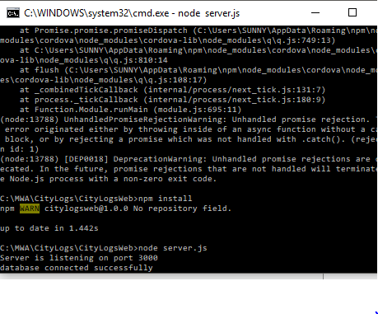

Fig. 1 Connected to Database



Fig. 2 Home Page

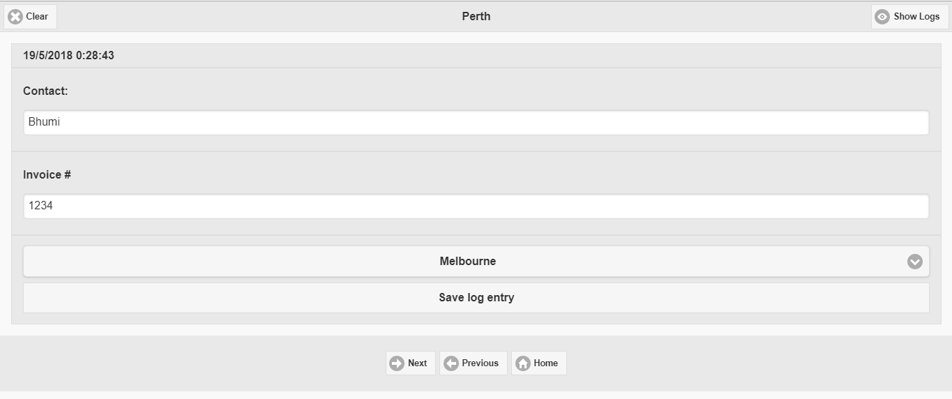

Fig. 3 Insert Data

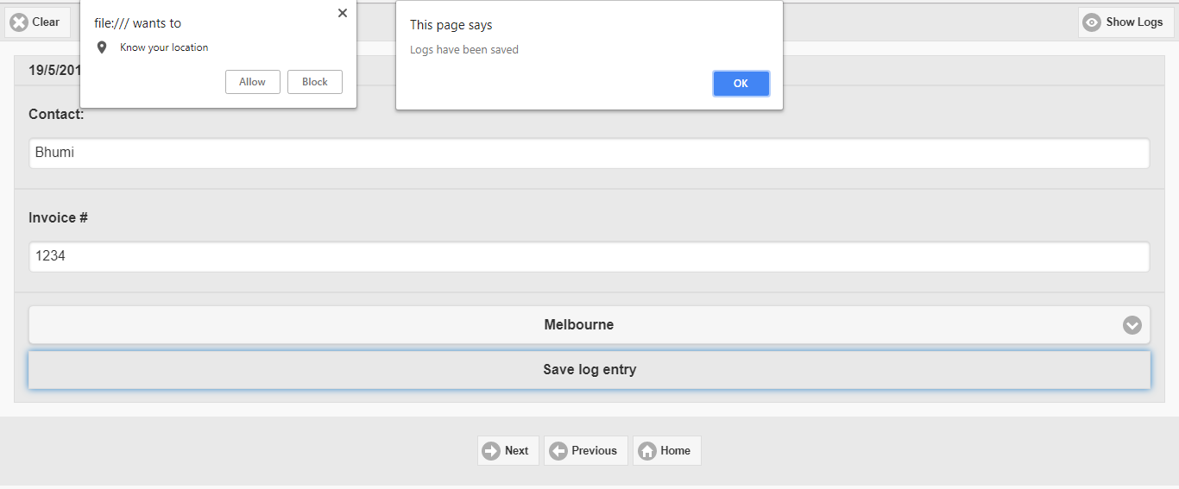

Fig. 4 Save Log Entry

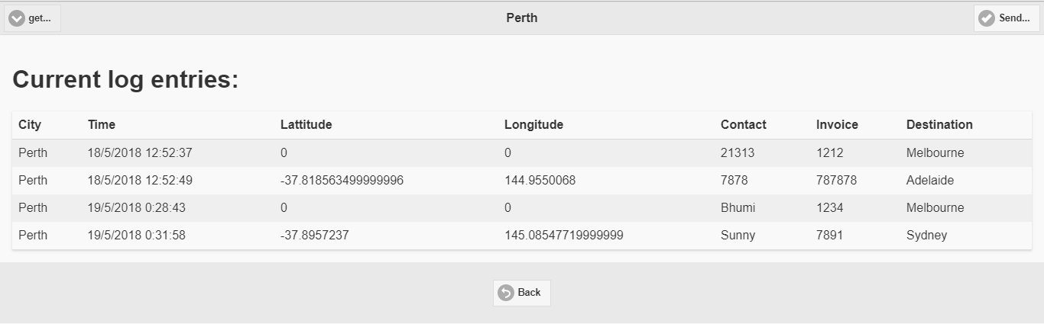

Fig. 5 Show Logs

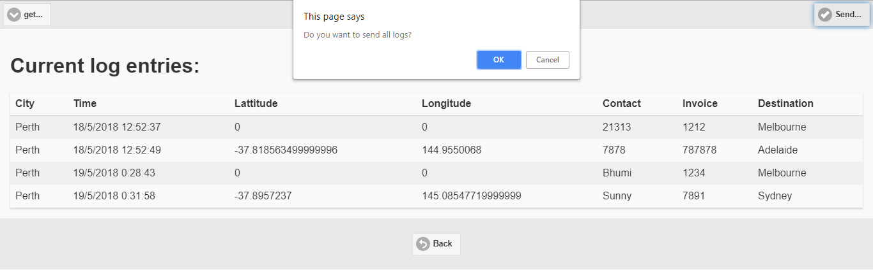

Fig. 6 Send Logs

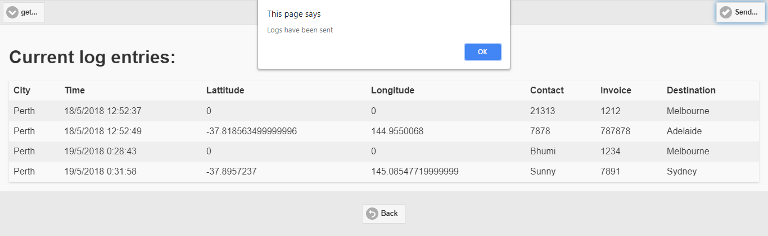

Fig. 7 Sent Logs

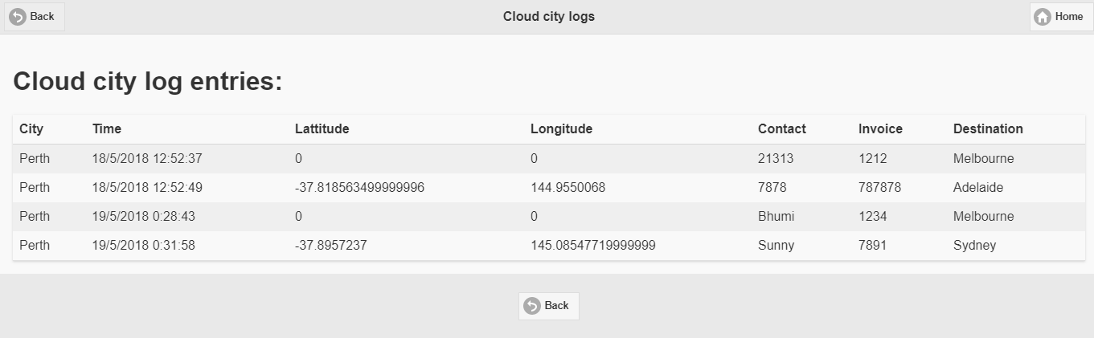

Fig. 8 Get Logs

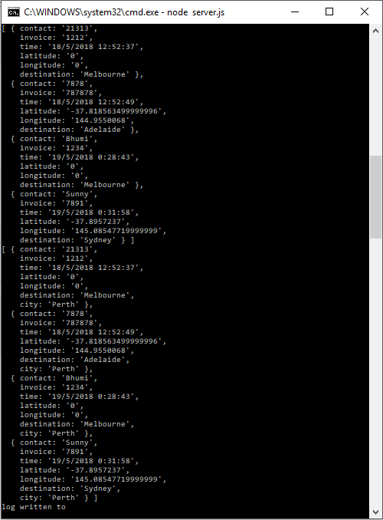

Fig. 9 Log entries in Cordova using cmd

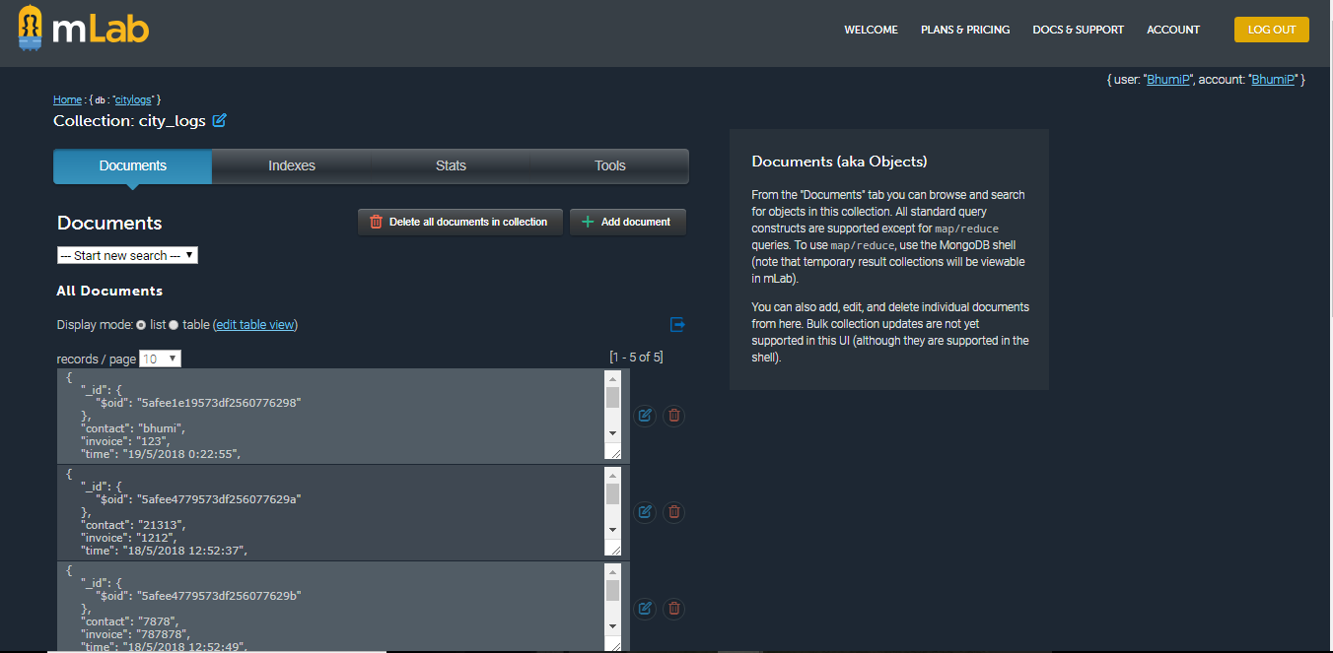

Fig. 10 Logs saved in mLab

# **Commentary**

* This includes mobile phone applications for city magazines that will be able to communicate with the server side and address existing situations.
* There are other forms of reception of the server for reservation, acceptance or rejection, depending on the information of the reserved recipient. The server must work with fixed status and register positions, which can divide the city into different regions and then turn the area around.
* The maintenance of queues with updated information about the position and the status of the magazine depends on receiving orders from customers and is sent mainly from the nearest queues. (Lee et al., 2016).
* Mobile applications are designed for users who can make a simple request using a server-side connection with a reservation request for a magazine in the city.
* You can obtain information for the reserved journal, then work on arrival.  
  One of the obstacles is to get orders for the client's customer requirements to a higher level, when he can order the records.
* Technical requirements: the system must be able to manage calls and then send them to the nearest queue using the available client and registration applications. This can help communicate with the server side, which tends to work in an Internet connection.
* The non-technical requirements depend on the development of the mobile platform.  
  Emphasis is placed on improving the functionality of the sharing of taxi applications with the appropriate use of add-ons. This will help determine the configuration of the system, as well as according to the needs and development with the improved configuration of the additional Cordova system.
* Córdoba is designed for a mobile platform based on software programming to create applications for mobile devices. Basically, CSS3, HTML5 and Java Script are used, which will depend on the APIs of the platform. (Al-Rosendelit, 2016). The models are related to the systems approach; dependence depends mainly on the service platform. The configuration depends on the work to provide planning while working on web applications, which will mainly execute the performance of the system and access to their own devices.
* The main application process is mainly to manage access using contradictions, especially in mobile browsers. Apache Cordova works with native plugins and also checks if JavaScript standards exist to communicate at their own level and on an HTML5 page. Add-ons allow you to allow accelerometers that use a camera and a compass to handle applications with similar functionality. Several types of support come with an operating system that is based on APIs and projects that require additional components. (Massobri et al., 2016).
* The "City Logs" application includes a variety of operations through which the customer can easily prevent the newspaper from receiving a customer request. While there is recording time, there is a possibility that the command will run and change the status register for free. When you register, there are no forms in the service that are rejected. Queue management is also possible due to this, when a record, when entering a new zone, can process the end of the virtual zone queue. In this case, the journal moves from the waiting list to the busy or out of work mode.
* The application is based on updating the status of the registry with the server reception applications, with the addition of a taxi to the system. The registration is ready for the system where the customer presses the button to request a taxi with the applications and sends the GPS in coordination with the server. (Modak et al., 2016).
* The requirements of the user depend on the applications to share taxis, where the participants maintain the requirements of the general taxi system, where there are different aspects of the answers. The journal exchange services also allow you to focus on a system with effective management aspects.

# **Financial case**

The app can be launched in the App Store for Apple and Play Store for Android for the financial gains.

**Time Costing**

Time costing is a cost for spending time to complete project from analysis to design phase.

**Database Costing**

Cost of the database can be measure as per the information stored, in terms of how big system is it can be estimate.

**Marketing**

Money spent for marketing to promote the system. It can be varry as per marketing strategy.

**Analysis**

The money spent for analysis to create system, analysis has been done before developing the system.

**Ethical Consideration**

There is no ethical consideration involved with the app, as no ethical boundaries has been breached.

# **Reference**

Rosenfeld, A., Keshet, J., Goldman, C.V. and Kraus, S., 2016. Online prediction of exponential decay time series with human-agent application. ECAI.

Li, W. and Zhou, Y., 2016, June. Design and application of taxi intelligent integrated service and management information system. In *Service Systems and Service Management (ICSSSM), 2016 13th International Conference on* (pp. 1-5). IEEE.

Modak, A.N., Yadav, V.R., Kumbhar, G.K. and Mane, M.B., 2016. Smart Traveler-Proficient Taxi Business Application. *Imperial Journal of Interdisciplinary Research*, *2*(6).

Massobrio, R., Fagúndez, G. and Nesmachnow, S., 2016. Multiobjective evolutionary algorithms for the taxi sharing problem. *International Journal of Metaheuristics*, *5*(1), pp.67-90.

Singh, T. and Singh, E.A., 2016. An Efficient Reduction in Time for online Cab Booking Using Data Division Cluster Search Recommender System. *International Journal of Science & Technology*, *2*(1), pp.1-5.