

Central Queensland University

### Tarang Dave

12056653

Master of Information Technology

Subject: CLOUD COMPUTING FOR SMART APPLICATIONS

Subject Code: COIT20260

Lecturer: Azmat Ullah

### Tutor: Azmat Ullah

Table of Contents

Tarang Dave 1

Tutor: Azmat Ullah 1

Abstract 3

Introduction 3

Cloud Service Providers 3

1. Identified cloud service providers 3

2. Cloud service Providers with PaaS (Platform as a Service) 4

3. Comparison: IBM Bluemix and Microsoft Azure 5

4. Reasoning Argument 5

Further Information on IBM Bluemix and Microsoft Azure 6

1. Screenshots 6

2. Tabled difference 7

3. Environment requirements 8

4. Services offered 9

5. Quality and Design 9

6. Monitoring 10

7. Documentation 10

8. Difficulties 12

9. Cost 12

10. Manage-Flexibility 12

Opinion 13

Performance 13

Improvement Area 13

Conclusion 14

References 14

# Abstract

In this report there is a discussion on two major clouds which are highly reputable due to their organization background. This paper will also compare two cloud service provider which is seen by the student in their practical’s. Paper will also provide opinion of best cloud service provider. Moreover, this paper will also provide contrast on those cloud service providers. The paper will give in-depth information about its problems and solutions presented by those service providers. In Addition, paper will provide some images which give the idea of output which cloud service provider provides. Further, it provides commentary on reasons to select cloud service provider and improvement ideas.

# Introduction

In this information era, organization requires each information stored in form of virtual. Organization uses a high amount of resources just to create environment for their clients and after a long cloud comes into existence. Cloud brought variety of application within it such as storage, memory, processors, and even internet all this with high transmission rate. Cloud is a setup of resources used by any organization and pay as per their usage or plans. Cloud supplies memory, storage capacity, processing speed and many more using it. Most of leading organization nowadays uses cloud to maintain customers data and then monitor which predict the critical information for company.

The report describes about two featured organization with their cloud services IBM Bluemix and Microsoft Azure. Comparison based on features are carried out between those two. Problems and its relevant solutions are also given in report. Report provide services, performance, growth rate and earning made by those cloud service providers. Also, opinion provided based on practical integration of Hello world project into both cloud service providers which is the main base of this report and also provide improvement ideas related to experience.

# Cloud Service Providers

As the global market is increasing every day the cloud competition is increasing rapidly. Due to increase in cloud service providers the list of cloud service providers is enough. Since the market is greater in size the service providers need to keep cloud services flexible, scalable, reliable and economical.

## Identified cloud service providers

As the top companies leading market in providing cloud services are minimal in Australia before information era. But, as there is increase in growth of businesses and demand of acquiring cloud services, many companies are out among customers. According to White (2016) the following companies are top cloud computing companies in Australia:

* Microsoft Azure
* CGI group
* Amdocs
* Chargify
* NEC
* Cerillion
* Aria Systems
* Oracle
* IBM
* Amazon Web Services

## Cloud service Providers with PaaS (Platform as a Service)

Platform-as-a-Service (PaaS) provides clients a medium to develop application and deploy on Internet. There are different kinds of PaaS providers. Cloud service provides application to host, configure and manage easily. There are different levels in which integration of application takes place such that scalability and reliability maintained. Moreover, company can comprehend from the customer using pay as per use which enhances growth and flexibility.

The requirement to add PaaS in cloud are as follows:

1. Host database tools
2. Development Platform
3. Application managing tools
4. Tools to deploy application dynamically
5. Debug capabilities

There are some following cloud service providers which provide PaaS (Platform as a Service)

1. Amazon EC2 (AWS)

It provides you to have complete control of your apps over the amazon cloud computing environment.

1. Microsoft Azure

Azure is used to deploy, manage, or build application over a large range of azure networks.

1. Google App Engine

An engine of cloud which is server less and used to build and connect cloud services provided by google.

1. SAP cloud platform

SAP cloud is more useful in real time monitoring, analytics and sentiment data processing mostly applications are business based.

1. Acquia cloud

Helps to build network business faster and in real time bound technical and business together.

1. IBM cloud

IBM provide secure, full network cloud environment, supports many applications and mostly deployment and product delivery is easier.

## Comparison: IBM Bluemix and Microsoft Azure

Considering IBM cloud with Microsoft azure there was a thin line when cloud services are new. IBM was leading when cloud services came into existence as commercial. But as Commercial market is more dependent on brand and reputability Microsoft tend to break the market after 2017.According to Dignan (2018) “When you look at the major public cloud providers, it's clear that AWS and Microsoft Azure are the two top dogs. RightScale's survey of 997 respondents across multiple industries and company sizes tells the tale.”. This statement clearly states that IBM is not on top ranking and Azure is in leading market.

Also, considering growth rate of IBM within a year 2017-2018 the growth rate is +5% and Microsoft Azure have +15% which is triple the IBM growth rate. Besides, Azure have more running application than IBM. But, IBM leads the markets showing major increase in upcoming application usage. Based on Enterprise scorecard it is clearly seen that IBM is going to lead market in future as enterprise adoption ratio is 50% which is higher than every other cloud.

Considering IBM among other companies Artificial Intelligence is quiet buking up to keep into market. While, Microsoft have several AI to implement in cloud, IBM is still trying their best with Watson platform to implant in cloud-based systems. Consequently, considering other services such as azure provide office 365 and other Microsoft built in services as add on IBM is not able to manage its services within pay as per go. According to Dignan (2018) report by RightScale it clearly states that “Microsoft on its latest quarter disclosed its commercial cloud revenue and an annual run rate north of $21 billion. IBM's as-a-service revenue, which includes software, platform and infrastructure, is more than $10 billion”. The statemkent clearly states that IBM is trying to buck up in market while Azure is leading.

## Reasoning Argument

There are mainly three reasons to choose this cloud service provider: Documentation, Cost and vast networked connection.

First, whenever to use a new cloud or a system comprises of many different services it requires documentation as guidelines for new customers. In IBM and Azure both guidelines are easily provided but in IBM videos are there which may vary after some updates. In Azure documentation is in image format which can be changed easily. Also, other services documentation is not provided by IBM while Azure provide it which makes easier to navigate easily and understand the file system of Azure. In IBM Bluemix the resources, services are types in rows which in contrast Azure provides column for types and services which makes easier to navigate.

Second, considering two main segments of cost price model which is customer satisfaction and resources utilization cost. IBM and Azure both provides free trial which makes continue to freemium in IBM for some time. But, considering that Azure provides access over more service for free trial which makes more sense than usage period. Moreover, while considering cost IBM requires more resources to pull client’s data into system by deploying serval services with it which rise pay as per use cost. While Azure is less space, more reliable and can start from scratch to deploy makes it cost efficient.

Last, it is both providing vastly interconnected network. IBM is widely popular among enterprises to reach at global while Azure is more popular for Indie companies and among customers.

# Further Information on IBM Bluemix and Microsoft Azure

## Screenshots

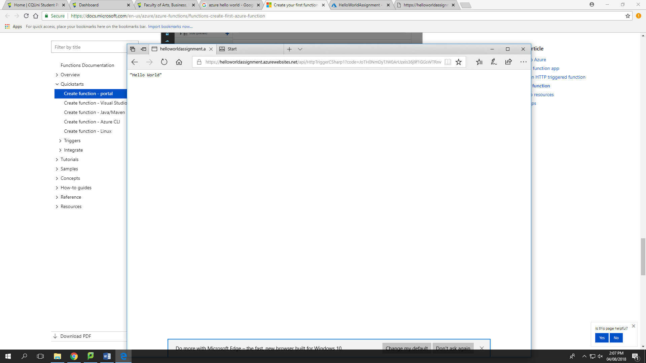

Figure 1 Azure HELLO WORLD application

In the above image it is clearly seen that text hello world is represented as xml output and also with no design and no other integration required. Also, different browsers provides different output but as a xml format. Azure integration is simple and easy to understand by naïve.



Figure 2 IBM Bluemix HELLO WORLD Application

The above image indicates IBM Bluemix hello world application which comes with a built-in design view and whose hosted URL is also smaller. Although it’s easy to manage application easily in IBM Bluemix through delivery pipeline.

## Tabled difference

According to Jyotsana (2018) the following information is carried out:

|  |  |  |
| --- | --- | --- |
| Features | IBM Cloud | Azure |
| Maximum Processors in VM | 56 | 128 |
| Maximum memory in VM (GiB) | 242 | 3800 |
| Operating Systems supported | Windows, CentOS, CoreOS, RHEL, CloudLinux, Debian, FreeBSD, Ubuntu | Windows, SLES, CentOS, CoreOS, OpenSUSE, RHEL, Debian, FreeBSD, Ubuntu, Oracle Linux |
| Scalability | Auto Scaling | Azure Autoscaling, Virtual Machine Scale Sets, Azure App Service Scale Capability (PaaS) |
| Serverless | IBM Cloud Functions | Azure Functions, Azure Event Grid |
| Backup | - | Azure Backup |
| Shared File Storage | File Storage | Azure Files |
| Hybrid Storage | - | StorSimple |
| Relational Database | Compose for MySQL, Compose for Postgre SQL | SQL Database, Azure Database for MySQL, Azure Database for PostgreSQL (Preview) |
| Load Balancing | Load Balancer | Load Balancer, Application Gateway |
| IoT | Internet of Things(IoT) | Azure IoT Hub |
| Analytics | Streaming analytics | Stream Analytics, Data Lake Analytics, Data Lake Store |
| Machine Learning | Watson | Azure Machine Learning Studio, Azure Machine Learning Workbench |
| Firewall | Firewalls | Application Firewall(preview) |

Table 1 IBM vs Azure

## Environment requirements

To host the application on cloud the types of cloud and several other features should be known. There are three types of cloud hosting providers:

Software as a Service, or SaaS, used to remote access software’s hosted on internet such as office 365. They also provide solutions to their clients via several integrated applications.

Platform as a Service, or PaaS, helps client with environment to build, modify, and deploy applications over the internet and it provides services through which client can create application on their need. Also, there are admin to that application which provides right to allocate memory.

Infrastructure as a Service, or IaaS, provide clients to manage Infrastructure such as application by their own. Also, they provide full support to application to manage by providers too.

According to Liang (2010) there are certain requirements to build cloud infrastructure are as below:

1. Heterogeneous System Support
2. Service Management
3. Dynamic Workload
4. Scalability
5. Reliability
6. Availability
7. Integration to data centre management
8. Visibility
9. Administration
10. Developer
11. End User Interface

## Services offered

IBM offers variety of different services which are innovative on creative environment and platform for client. It also supports many programming languages such as Java, Python, PHP and so on. It also provides support features for developers which requires services which are integrated but unknown. It provides many applications under catalogue of IBM cloud. Among them are as follows:

Managed: It provides services on application which are already managed by the cloud. It also provides SAP, Oracle integration over managed applications. Moreover, it manages security services on the managed cloud.

Advisory: It provides advisory board to the client for their reference of the services used. Also, adoption of the services which it is charged or going to charge on adopting services.

Development: This service is related to deployment of enterprise application over the internet.

Migration: Most crucial phase or requirement of organization is migrating data from cloud to cloud. In addition, it also provides migration over business merge or business solution.

Integration: This is typically used for client using SAP or Oracle integration among their customers or other business services and this service is mostly used for optimization.

Security: Cloud protection is crucial in IBM Bluemix. To identify the threat to restrict the access is important service provided by IBM. Other risk and responses service are also integrated in IBM cloud.

Moreover, there are certain other services that offered by IBM and azure are as follows:

Azure provide low priority Virtual machines (VMs) which is 80% cheaper and only available as part of batch initially. Relational Databases such as IBM DB2 on cloud for dedicated instances and Azure Cosmos DB which is globally distributed with multi model APIs. Also, Azure uses container as a service like DC/OS, Docker Swarm, and Kubernetes which is also used by IBM. IBM and Azure both provide Serverless connections which acts as function as a service.

## Quality and Design

To print Hello world application Azure requires 4 steps to undergo while IBM requires 5 steps. Using Portal is quiet simples than catalogue view of IBM. Services can be directly attached to application while IBM some service must be attached to application from outside. IBM doesn’t allow to select programming languages inbuilt while Azure does while creating functions. From practical point of view quality of Azure is much more reputable than IBM but still IBM cannot be considered low level.

Furthermore, Design of Azure is columnar, and IBM have tabular format. It is easy to use Azure as the most of all functions, services, resources are on same page while IBM Bluemix sidebar represent all tabs through which navigate through functions and services applied. Moreover, functions are opened in same area of column while IBM requires new page every time which time and resource consuming is. Besides, Notification bar is provided by Azure dashboard which provide all noted or in process information. Considering Deployment is seen on main dashboard in Azure while IBM requires to connect to delivery pipeline to see deploy time. In Addition, URL are provided by both Cloud service providers to launch application.

## Monitoring

The most essential part of analyst is to monitor the application. Monitoring is done through few simple integrations in IBM and it is provide free for complimentary monitoring with 10 metric rules limitation. Monitoring provide features to get insights of application. Monitoring service collects data from application and services without agents. Monitoring requires APIs to integrate into application for extensible monitoring. Provides insights to detect, identify and diagnose risk. It also provides alert for action on monitoring critical issue by triggering email or notification.

## Documentation

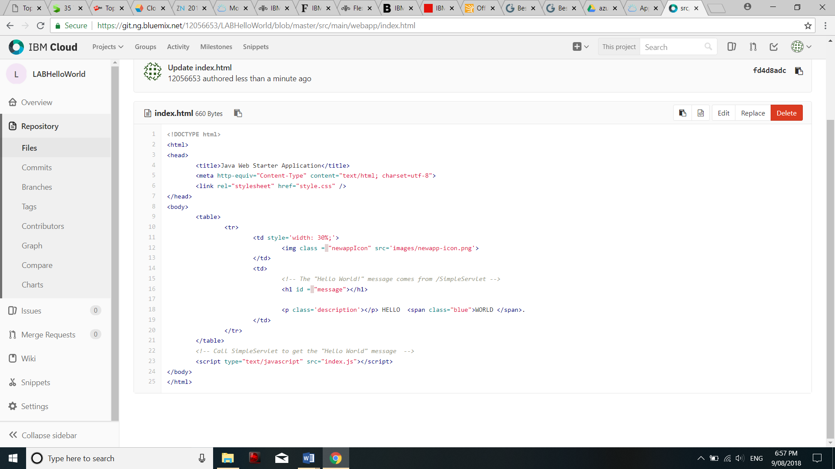

Figure 3 IBM input code

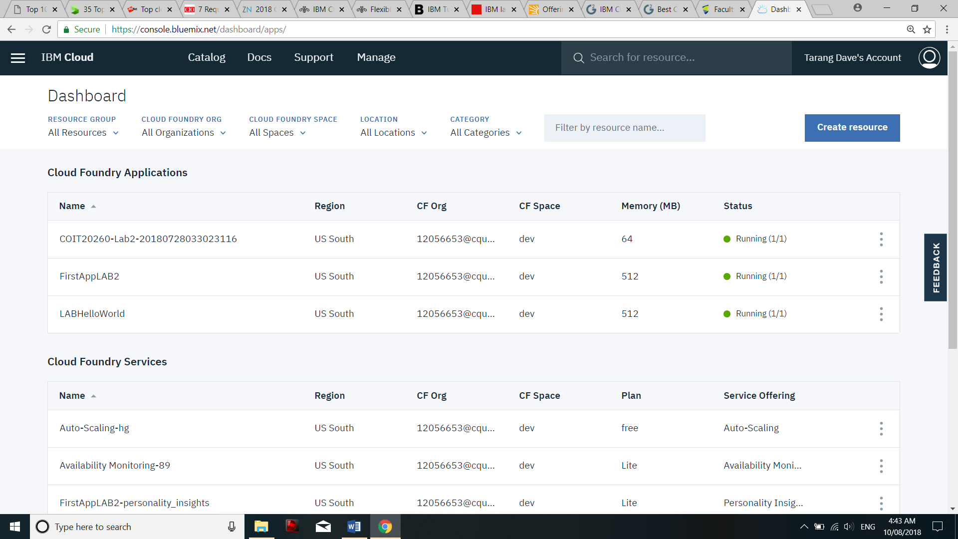

Figure 4 IBM file system resources

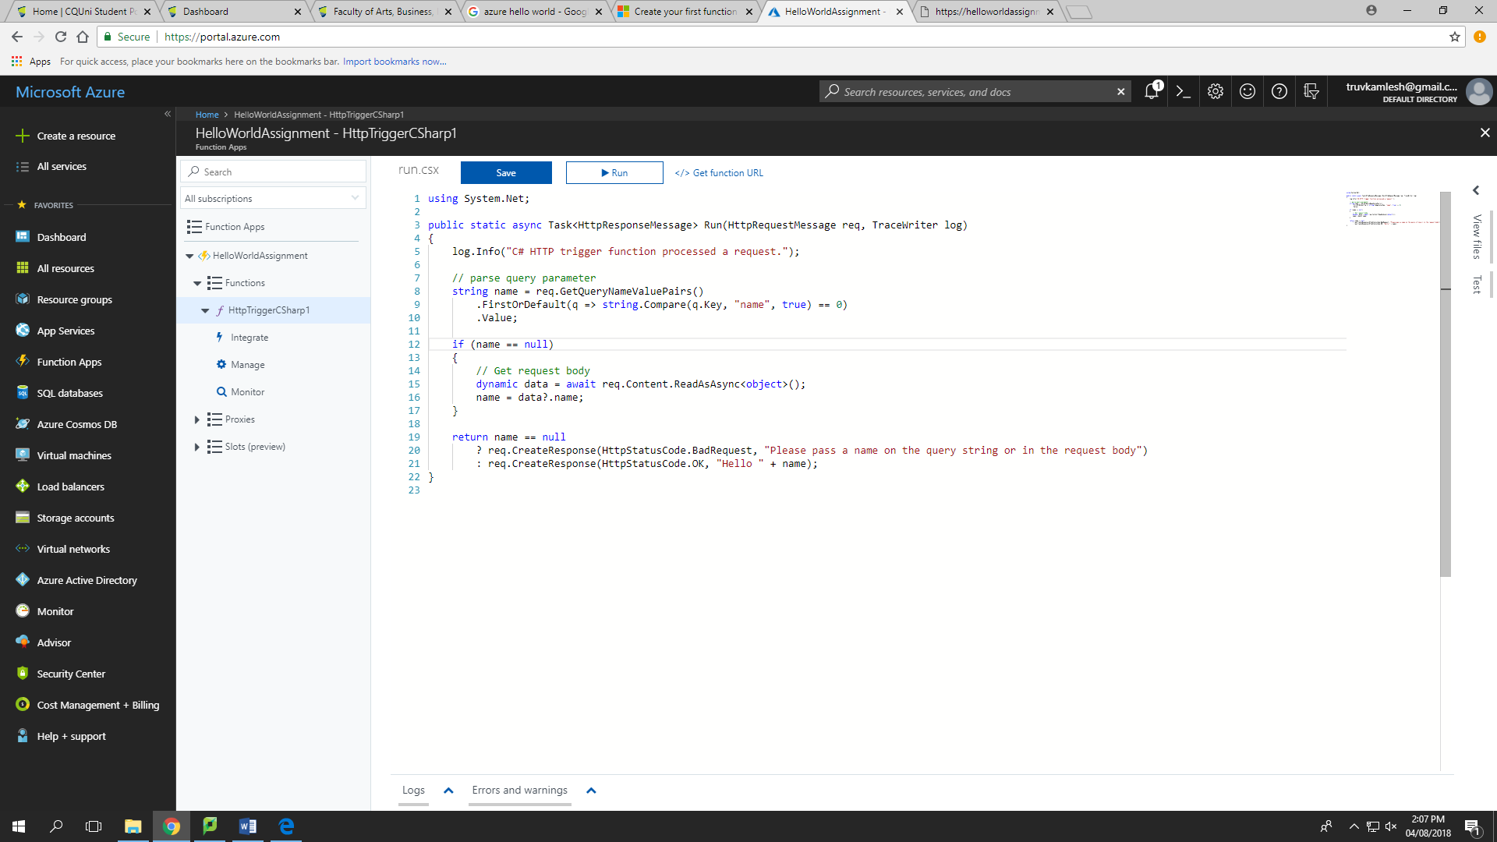

Figure 5 Azure input code

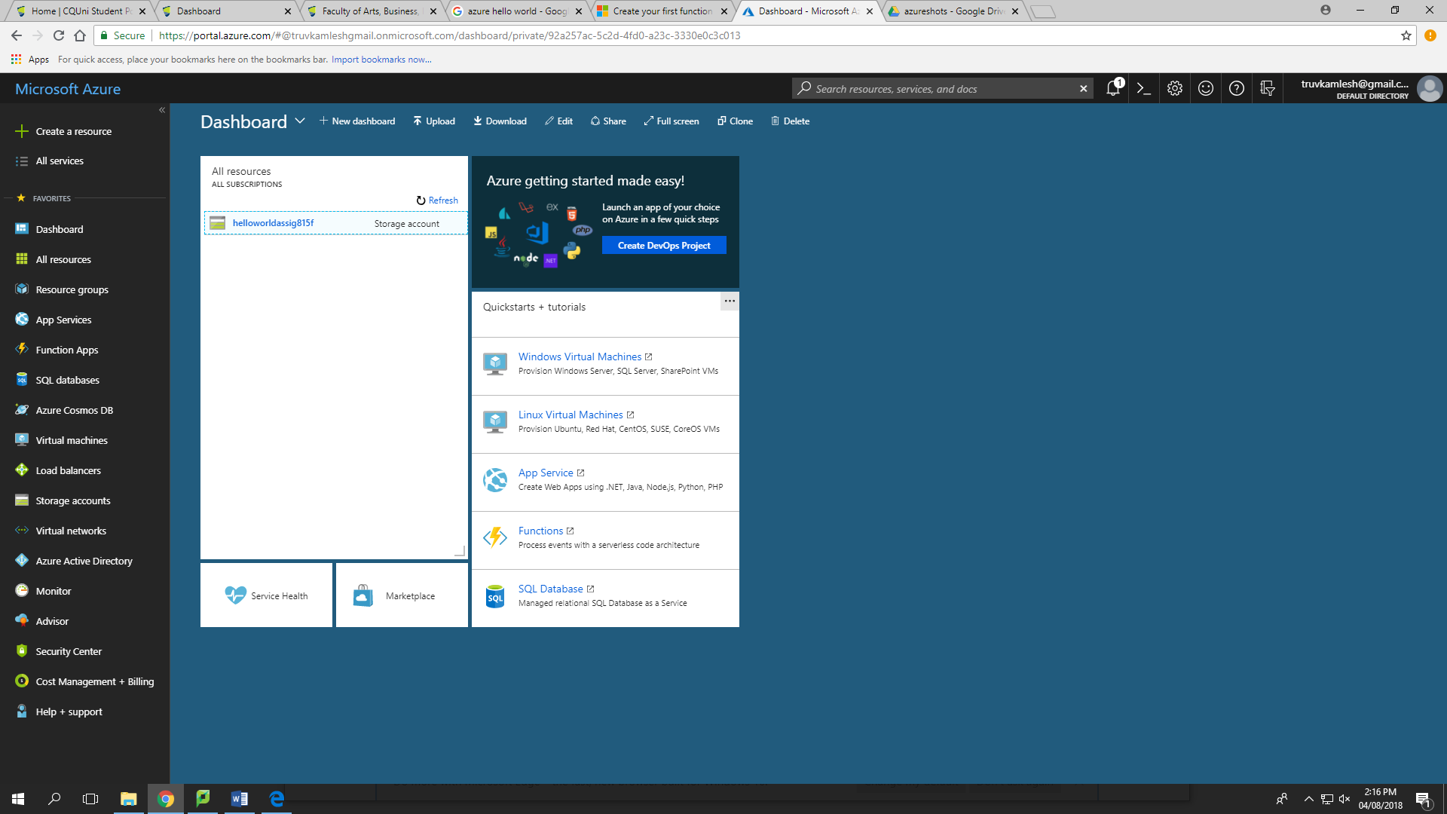

Figure 6 Azure file system resources

## Difficulties

There are certain difficulties In IBM Bluemix and Azure they are more of machine learning, lags and Artificial Intelligence. Due to this major problems IBM is losing much of its profits and its earnings is lessening. To overcome this problem IBM invented Watson an AI which is helpful for many organization predicating through patterns. It was mostly used in Hospitals and health care. As the progress of Watson was slow it deceives talent and started to dismiss.

## Cost

Cost of cloud services are defined on many principles such as type of discount, commitment time, Discount range, other program usage.

IBM uses monthly pricing and commit client every month. It provides about 10% discount range and can negotiate for other programs. While, Azure uses reserved instances for discounts type. It requires 1 to 3 years of commitment and provide up to 70% discount range and can use hybrid enterprise application as extras.

## Manage-Flexibility

For most of cloud service providers ability to cancel, flexible and changes can be done throughout the period. Depending on your structure of project the cloud services can be managed. According to Shea (2018) “High transactional workloads where performance and latency are critical factors, such as Oracle databases, can now leverage the consistent, high speed performance provided by block storage.” For using an instance IBM provides a 12TB of SSD which can be used to reserve memory for critical functions.

IBM cloud storage also provides data management functionality i.e. unstructured format to structured which is profitable for companies with unorganized data. From high amount of unstructured data organization may need to store high volume of data which is expensive. For such instances IBM provide scalability of data with flexible usage of data archiving.

Lastly, Organization required a backup in times. IBM cloud Evault Backup is capable to make multi vault redundancy of variety of application which helpful in time of disaster.

# Opinion

In my opinion azure is safe, secure, reliable, high storage capable and most useful cost effective. Considering a small start-up companies there would a major risk investing in such a major service. But it seems that these services can be useful if the data of customers increases suddenly. Major companies can decide whether they want to pay as per usage or they want to pay for numbered storage or memory. This may cost them inexpensive and azure is reputable due to Microsoft and it also provides inbuilt features which Microsoft provide such as office 365.

Moreover, flexibility of IBM Bluemix and Azure is considered similar as they both provide enough resources. But the problem of IBM is AI and lags which is quiet frustrating for customers and developers. While, Azure prove itself easy and faster than IBM Bluemix. Considering file resources design Azure and IBM both are easy to use and with few documentations anyone can create their application easily.

## Performance

In my point of view Azure versus IBM Bluemix, Azure stands different and up among all other service provider and it is cheaper with high standard of quality. Azure provide excellent quality of services compare to IBM. Considering Processing time of IBM which lags at several times due to less processors compare to Azure with high processors. It clearly states that Azure is faster than IBM. During the practical integration of Hello World application, it was clearly seen that IBM is slower compare to Azure. Also, Azure provide more memory storage than any other cloud provider so there is no doubt that IBM couldn’t compare in recent years. Considering Delivery pipeline as middleware in IBM it takes time for deploying any application on platform. While Azure doesn’t have such middleware, it is faster and secure.

## Improvement Area

IBM lags the most of leading cloud serves due to Artificial Intelligence ‘Watson’. If IBM focuses of its AI, there are more chances to revive its leading market and present some new features with automated support system. Azure is quiet well in AI, but it also requires proper integration in its systems to be more supportive. As IBM have less resources comparing to Azure and some technical problems it lags at several points which lowers the customer satisfaction ratio. Moreover, there is less marketing strategy applied by IBM to reach client at low level it always tends toward enterprise which is bigger steps for cloud service provider with issues of lags. Besides, Azure and IBM both needs continuous innovative improvement to make a better cloud service provider.

# Conclusion

In Conclusion, Microsoft Azure stands best in front of IBM Bluemix due to it higher performance and design integration. Azure design is quite easy for customer satisfaction. IBM have some issues related to its performance and cost. Service provide by both cloud Service provider are applauding. Documentation can be easier by both cloud service provider seems hard for customers. Customer reviews are also satisfactory for both cloud service providers. IBM requires to grow the area of Artificial intelligence, memory and space. Integration of HelloWorld project provide revealing fact of improvement areas pf cloud service providers.

# References

Dignan, L 2018, ‘Top cloud providers 2018: How AWS, Microsoft, Google Cloud Platform, IBM Cloud, Oracle, Alibaba stack up’, ZDNet, 14 February, viewed 3 August 2018, <https://www.zdnet.com/article/cloud-providers-ranking-2018-how-aws-microsoft-google-cloud-platform-ibm-cloud-oracle-alibaba-stack/>

Jyotsana, 2018, ‘Comparing top 4 public cloud providers in 2018: Microsoft Azure vs AWS vs IBM vs Google’, ZnetLive, 20 February, viewed 6 August 2018, <https://www.znetlive.com/blog/comparing-top-4-public-cloud-providers-in-2018-microsoft-azure-vs-aws-vs-ibm-vs-google/#cfour>

Liang, S 2010, ‘7 Requirements for Building Your Cloud Infrastructure’, CIO from IDG, 21 December, viewed 3 August 2018, <https://www.cio.com/article/2412506/cloud-computing/cloud-computing-7-requirements-for-building-your-cloud-infrastructure.html>

Shea, M 2018, ‘Flexible & secure: Cloud storage solutions for all your workload needs, IBM, 24 May, viewed 3 August 2018, <https://www.ibm.com/blogs/bluemix/2018/05/cloud-storage-solutions-for-all-workloads/>

White, G 2016, ‘Top 10 Cloud Computing Companies in Australia’, BusinessChef, 17 April, viewed 6 August 2018, <https://anz.businesschief.com/top10/2008/Top-10-Cloud-Computing-Companies-in-Australia>