

Central Queensland University

### Tarang Dave 12056653

Khushal Patel 12068569

Neelkumar Patel 12063878

Ricky Santoki 12074837

Master of Information Technology

Subject: CLOUD COMPUTING FOR SMART APPLICATIONS

Topic: Integration of Cloud computing and Internet of Things(IoT)

Subject Code: COIT20260

Lecturer: Azmat Ullah

### Tutor: Azmat Ullah

Table of Contents

Introduction 2

Article Outline 2

New Paradigm 3

Challenges 3

New Scopes and Applications: 5

Current Industry Trends: 5

Current technology: 6

Latest technology: 6

Case study 9

Amazon Web Services IoT Platform 9

Microsoft Azure IoT Hub 10

Google Cloud Platform 11

BOSCH 12

Conclusion 12

Reference 13

# Introduction

In this modern world bringing new revolution in technology everyday there are several services which are made much easier through cloud. Cloud is the best solution to most technical problem nowadays and its growing rapidly. Massive use of technology requires integration in whole. Report is based on how integration of cloud and Internet of things (IoT) revolutionizing world. Basically, cloud is collection of networks, but it requires to be connected over the Internet. There are several articles presented in report consisting ideas. Ideas such as health care system, integration methods, real time analysis and more. There are also challenges into cloud which can impact the whole network. Challenges such as security, privacy, efficiency, performance rate, and more. Moreover, scope and applications for integration of cloud is outlined.

Furthermore, there are current trends which provide integration of cloud into wireless body sensors. Using IoT technology data is feed into cloud and real time analysis can be done on patients. Some other examples provided are of video surveillance, smart models on agriculture, mobility, logistics and more. Besides, case study is provided of cloud platforms with is real time used application of integration of cloud. Likely, Amazon web services used to connect all car for enhancement of safety of drivers.

# Article Outline

The first article is about healthcare systems used by physicians to improve their patients or client’s health. The article is also about improvement in remote sensors which detect health of patient before the risk or need to visit clinic. The problem stated in this article are technology specific. Remote Sensors require patient to track the records in wearable sensors and when the patients visit clinic physicians check their records and give prescription based on that records. The problem carried out is patient prescribed after the health conditions are check at time of visit. However, cloud computing and internet of things (IoT) also have the maximal solution. Apparently, if patient’s wear body sensors and those records are stored in cloud database, physicians can check the patient’s health at all time. Also, cloud provide certain services integrated through which alert on physicians can be provided. This wireless Body area network (WBAN) is the solution provide by the article for the problem which also improves healthcare systems. The article provide efficiency in cost reduction, increasing life span, track patient’s location, live analysis of patient and so on.

Another article addresses about integration of cloud in Internet of things (IoT) which will be helpful in daily lives. The article also provides detailed knowledge on integration of cloud, its scalability in network and demanding supply of resources from several ways. Integration of cloud into Internet of things (IoT) followed by various issues for successful implementation. Besides, other limitations are also related to this integration to become more successful. Limitations are often technical, but they interact with real scenarios. Although, these limitations can become a highly efficient cloud if permission are given for real world objects. Moreover, if their integration is successful and carried out in procedural way cloud implementation can overcome these issues. The article provides implementation challenges along with the cloud integration. Cloud architecture and cloudIoT paradigm is also described in article for better cloud integration.

## New Paradigm

According to Villari (2016) “With the promise of potentially unlimited power and scalability, cloud computing (especially infrastructure as a service [IaaS]) supports the deployment of reliable services across several application domains. In the Internet of Things (IoT), cloud solutions can improve the quality of service (QoS), fostering new business opportunities in multiple domains, such as healthcare, finance, traffic management, and disaster management.” It is stated that to reach its maximum level where it can acquire full infrastructure, software scalability, flexibility in services, and integration over all devices, there should be integration of cloud computing. Moreover, to improve quality of service the cloud need to be on Internet of things(IoT).

The new paradigm which carried out for integration of cloud is Osmotic computing. Osmotic computing is paradigm with highly capable resources connected at networked edge, including data transfer support till the end data ware houses. This network edge provides automatic deployment services over all devices.

Figure Edge and cloud computing for the Internet of Things.

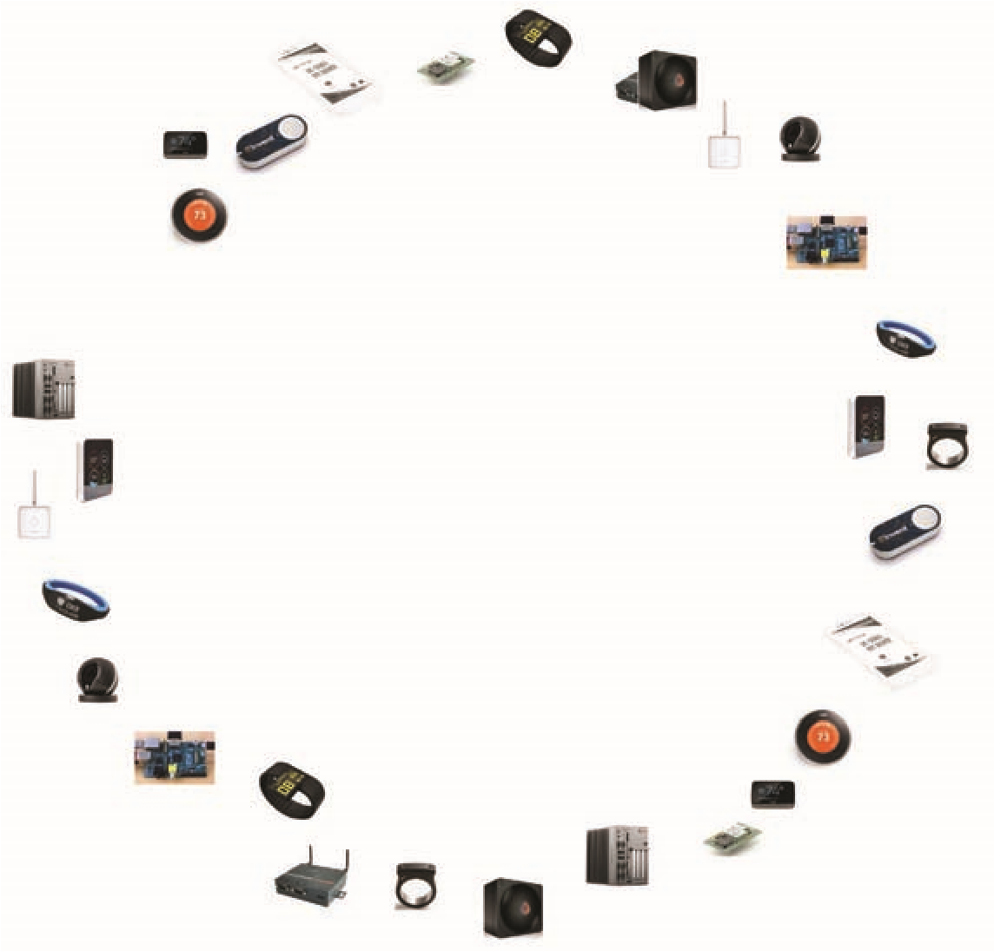

**Cloud**

**Edge**

**Public/private**

**cloud**

**Public/private**

**cloud**

**Public/private**

**cloud**

**Public/private**

**cloud**

**Edge**

**Edge**

**Edge**

**Edge**

**Edge**

**Edge**

**Edge**

**Internet**

**of things**

**Federated environment**

# Challenges

Challenges in integration of cloud computing and Internet of things (IOT)

1. Security and privacy:

With the integration of cloud services and Internet of things, we can transfer all the real-world data into cloud. This enables users to access the data from anywhere and anytime. However, this integration comes with security issues regards privacy and usage access issues. To enforce security, there must be a set of appropriate rules and regulations that govern who gets access to what kind of data. This is important because the data stored in the clouds may be sensitive and if it gets into wrong hands, it could be dangerous. Data integrity should be maintained at all costs. Multi-tenancy which refers to a software architecture in which a software or an application is running on a server and is supporting multiple tenants. This may lead to potential leaking of sensitive data. Different levels in IOT applications have different types of access which means that public key cryptography may not be applicable everywhere for securing data , As described by (Ahmed et al., 2018)” the distributed system is exposed to number of possible attacks, such as SQL injection, session riding, cross site scripting, and side-channel. Moreover, important vulnerabilities, including session hijacking and virtual machine escape are also problematic.”

1. Heterogeneity:

Heterogeneity refers to the diverse nature of different software’s, operating systems, applications, platforms, devices and services; Each cloud service provider has its own interface which it provides to the customer. Thus, it becomes difficult in integration of all such different platforms into one. Moreover, there may exist such clients that use multiple cloud platforms to make their application or software perform better, cross cloud integration of such services may prove difficult, According to (Botta et al., 2015) “ This challenge involves several aspects, where solutions are being investigated in terms of unifying platforms and middleware, interoperable programming interfaces, means for copying with data diversity.”

1. Performance:

Access to cloud and updating data on it requires high bandwidth. Integration of cloud and Internet of things has high volumes of data. This transfer of data to the cloud maybe time consuming because of low bandwidth available. Hence the key aspect in this integration is achieving network performance such that the broadband performance is able to keep up with the storage and evolution of computation. Some applications are such that they require real time reactions, if not then the security or the integrity of the data may be affected.

1. Legal Aspects:

Cloud and IOT devices generate data which comes from all over the world. All countries have different rules and regulations to international data collection and access. According to (Ahmed et al., 2018) “Legal aspects have been very significant in recent research concerning certain applications. For instance, service providers must adapt to various international regulations. On the other hand, users should give donations in order to contribute to data collection.”

1. Energy efficient:

Cloud based integration of IOT devices requires constant transmission of data from devices to cloud. This consumer a lot of node energy. Thus, generation of efficient energy while the data is being processed and transmitted remains a crucial issue. To overcome this challenge, use of compression technology is used. Other options include data caching techniques that reuse collected data with time insensitive applications.

1. Large Scale:

The cloud structure enables all devices old and new to integrate their data on the cloud. This includes storage and analysis of the data.  This integration involves collection of data from billions of devices from across the world. Large scale of devices remains a issue. Achieving storage capacity for such high volumes of data is a challenge. Moreover, after storing all the data it is very difficult to analyse this data with maximum efficiency. Monitoring this data and the devices of IOT also becomes difficult. Also, providing constant connectivity to such devices to connect with cloud so that there is minimum latency is also not easy.

1. Big data:

Big data is the term that refers to collection of huge amounts of data for further analysis and decision making. It is expected that big data will reach about 50 billion devices by the year 2020. This number of devices will generate huge amounts of data that will be difficult to store and process. Processing such huge amount of data requires a high-quality management service which the cloud service providers will have to provide. Data management service must be on point as the performance of the application / software is heavily reliant on it.  Furthermore, according to (Renner, Kliem and Kao, 2015) “data integrity is a vital element, not only because of its effect on the service’s quality, but also because of security and privacy issues, the majority of which relate to outsourced data.”

## New Scopes and Applications:

The integration of cloud computing and Internet of things opens door to many applications and uses. This will make use of smart applications and cloud to make access and analysis of data easier. Some of the new paradigms that may be introduced according to (Soni , 2018) are as follows :

* **SAaaS** : The Sensing & Actuation As A Service for facilitating the automated control logic implementation in the Cloud.
* **SenaaS** – The Sensor As A Service for facilitating the remote sensors ubiquitous management.
* **DaaS** –  The Data As A Service for facilitating the ubiquitous access to any sort of data.
* **SEaaS** – The Sensor Event As A Service for facilitating the dispatching of messages triggered by the sensor events.
* **Visas** – The Video Surveillance As A Service for facilitating ubiquitous access to the recorded video clips and implementing multifaceted analyses in the Cloud.

# Current Industry Trends:

1. Wireless body area network for healthcare

## Current technology:

According to (Ahmed et al., 2018),

* Since past few years demand for wearable sensors have been growing exponentially. However, these wearables sensors observe patterns of patient for at least 2 or 3 days before performing actual diagnosis by doctor. These all records are stored in database and physician can see all pre-diagnosed test of patients.
* Communication between IoT devices are done using Radio frequency identification. Cloud computing provide better alternative of storing all records and able to handle larger amount of data. IoT brings heterogeneous devices that are connected to each other in a network, this enables cloud to communicate with real world objects.

## Latest technology:

According to (Ahmed et al., 2018),

* Wireless body area network (WBAN) is powerful and wearable sensors used on the body or sometimes inside body to fetch information. Basically, there are two types of WBAN.
* First, WBAN has lower storage and require low power. But data security is major concern.
* Second, to overcome limitations of WBAN, it can be used with cloud computing that will provide faster processing and real time storage. Data from IoT devices are permanently stored on cloud.
* Wireless sensors need more power, more storage and higher bandwidth. This issue is solved by larger data are compressed to smaller amount even in kilobytes to transfer over network that eliminates bandwidth issues. This guarantees that quality of service in transmission of data to cloud. However, this communication requires good internet connectivity.

Cloud based WBAN and connected IoT devices is shown in figure 1 that allows patient, doctor and family member of patient to access medical records anytime.

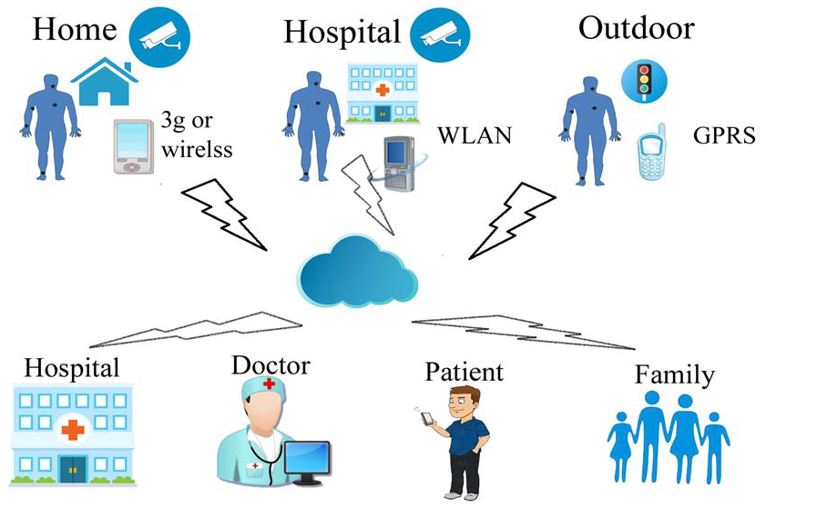

Figure Cloud Based WBAN connected IoT devices Source: Conference Paper

* When patient health is not critical, network automatically uses lower bandwidth to transfer data to the cloud. Patient’s location is track using GPS, LAN and sim card. Cloud uses data mining tools and techniques to recognise occurrences of patterns.

2.  New Models that works cloud based IoT application:

According to (Atlam, Alenezi and Alharthi, 2018),

* SaaS : Sensing as a Service which normally access to all kind of sensor data.
* EaaS: Ethernet as a Service. This service provides better control to connect to remote devices ubiquitously.
* SAaaS: Sensing and Actuation as a Service. Basically, this service automatically to control logics.
* IPMaaS: Identity and Policy Management as a Service. This service provides policy and identity management to cloud.
* DBaaS: Database as a Service. This service guarantees that database is accessible anytime on the cloud.
* SEaaS: Sensor Event as a Service. This service handles message transmission produced by senor events.
* SenaaS: Sensor as a Service. This service manages IoT device sensor data.
* DaaS: Data as a Service. This service allow access to any type of data generated from IoT device.

3. Video Surveillance:

* (Atlam, Alenezi and Alharthi, 2018) This will allow to manage, control and monitor data generated by video sensor using cloud based IoT application. It captures data from sensor automatically. Hence, this technology can be useful in movement detection and wireless cctv cameras.

4. Automotive and Smart mobility

* (Kebande, Karie and Venter, 2017) This work with GPS system to solve many challenging in real time traffic analysis and providing accurate data. For example, google maps using this feature. It shows peak hours traffic and increased duration of journey with red color line.

5. Smart Logistics

* (Sharma et al., 2016)  This helps to keep track of all good items and build relationship between consumer and producer by tracking of orders and inventory management. All datas are stored in cloud and IoT devices manages everything.

6. Environmental Monitoring

* (Gupta and Garg, 2018) this enables to check sensors data in remote geographic location and sensors are installed in that area. Data mining tools analysis occurrence of patterns of sensor generated data and produce prediction about pollution and air and water quality.

IoT devices connected to cloud with different application provided and their technologies shown in figure 2.

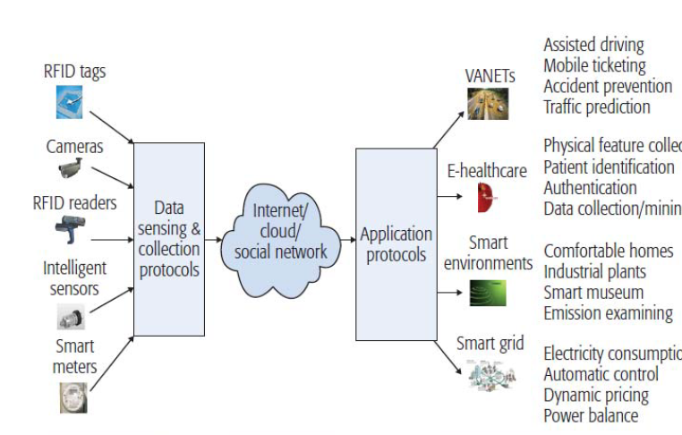

Figure Source: IEEE

7. Smart Agricultural Model

According to (Rajeswari, Suthendran and Rajakumar, 2018),

* IoT technology: There some tools and hardware that can be useful for monitoring agricultural field and collecting data. They are namely, Arduino Ethernet Shield, BeagleBone, Intel Galileo, openPicus FlyportPro,  Pinoccio, WeIO, WIZnet.
* Cloud Computing: It allows to share resources and provide storage access to store data from IoT device in a economical manner.
* Big data: This makes use of algorithms to analysis soil types and classify them into different category. Data mining tool compare with past crop sequence results to current soil analysis data. Big data uses some of the technologies like Hadoop, MapReduce, HDFS, Pig and Hive etc.
* Mobile Computing: It provides a cheaper way to communication with IoT devices. This communication is possible using ZigBee Modules, camera and actuators with microcontroller and raspberry pi over internet connection. Finally, report is sent to farmer.
* These all inform tells how much of fertilizer is required in the farm based on comparison of past sequence of result to current soil type. However, this keeps cost for agricultural in control.

Smart model for agricultural shown in figure 3. IoT devices are connected to cloud database and further using Big data analytics and final report is send to farmer using mobile computing.

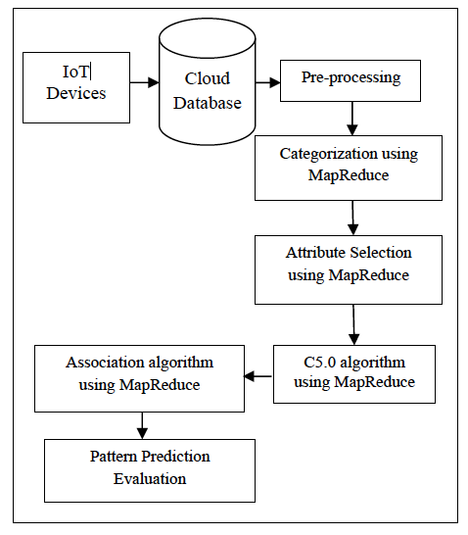

Figure Source: IEEE

# Case study

Lots of companies have integrated IoT in their cloud platform for their automating the tasks. IoT connects different machines with each other these machines are known as ‘things’ in IoT platform (Palmer, 2018).

The number of products using IoT is increasing rapidly and many companies have started to integrate IoT platform in their Cloud environment. Some of the companies to merge both platforms are as follows:

* Amazon Web services IoT platform
* Microsoft Azure IoT hub
* Google Cloud Platform
* Bosch

## Amazon Web Services IoT Platform

Amazon is a leader in providing cloud services to its consumer and amazon has started to integrate IoT platform as early as 2004 and because of their efforts and innovation it has one of the best set of tools available for IoT platform (Palmer, 2018).

Processing power of Amazon AWS is also remarkable supporting billions of devices and trillions of transactions happening between these connected devices. Along with that amazon provides software development kit (SDK) for developing application which user can run on AWS. The image x shows integration of IoT platform in cars for improving safety of connected cars.

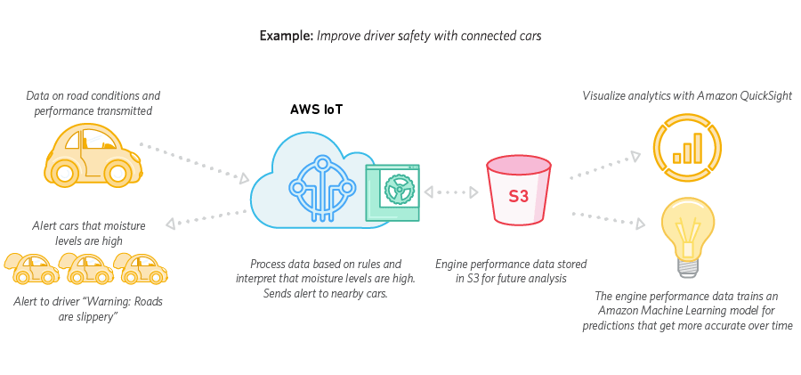

Figure Amazon IoT example for connected cars.

However, with this services amazon is quite expensive compared to other cloud IoT platform. The pricing is based on amount of data or devices the user is using through amazon services.

Overall, amazon’s integration of IoT platform has made good impression and it is quick and reliable platform for developing applications as well as it can speed up the time required to build an application the given example above in image.

## Microsoft Azure IoT Hub

Microsoft Azure is one of the famous cloud platforms that took integration of IoT services seriously. Microsoft has machine learning as well as IoT services. Microsoft is one of the service providers which give free services to its users if the messages per unit are less than 8000 per day (Palmer, 2018).

For managing their IoT platform Microsoft has even developed operating system specially for IoT platform only. Which act as complete IoT service provider. The price is done in 4 tiers and it depends on how much data the devices are generating.

However, the pricing becomes complicated if the user is integrating multiple services for their IoT platform but thanks to their pricing calculator it becomes easy to get estimation of cost for using different services.

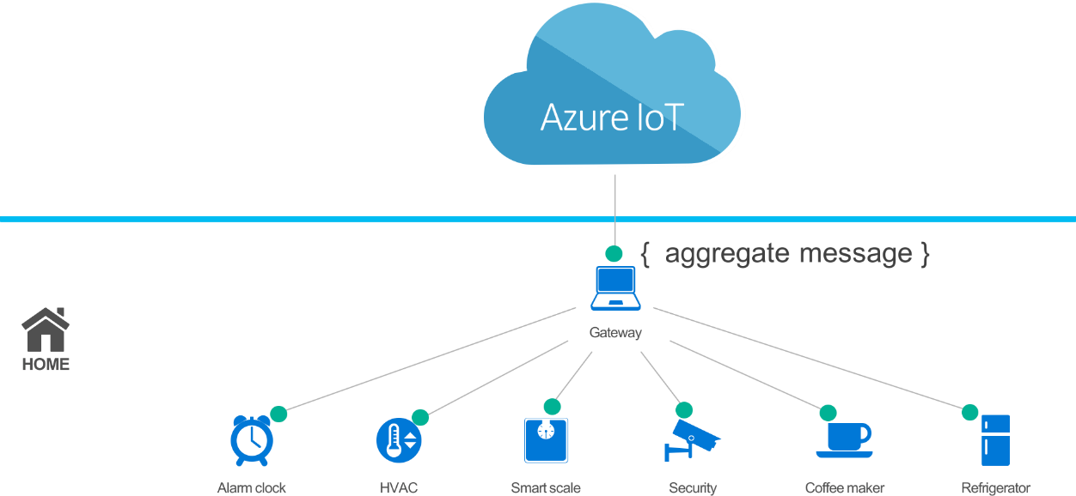

Figure Weather station by Microsoft Azure IoT

The image shows an example of Microsoft Azure IoT device which includes different devices integrated to one single gateway which can be a computer or a small Raspberry pi. This connected system act as a common weather station using which user can control all the connected device from one place (ThingLabs.io, 2018).

## Google Cloud Platform

Google in its IoT integration takes huge advantage from its heritage web scale processing. Along with IoT google also provide web-scale processing, analytics and machine learning. Google offers advance security which google defined as “Google Grade” security (Palmer, 2018).

User can take benefits of Google’s private fibre network by using Google Cloud Platform for reliable speed and connection.

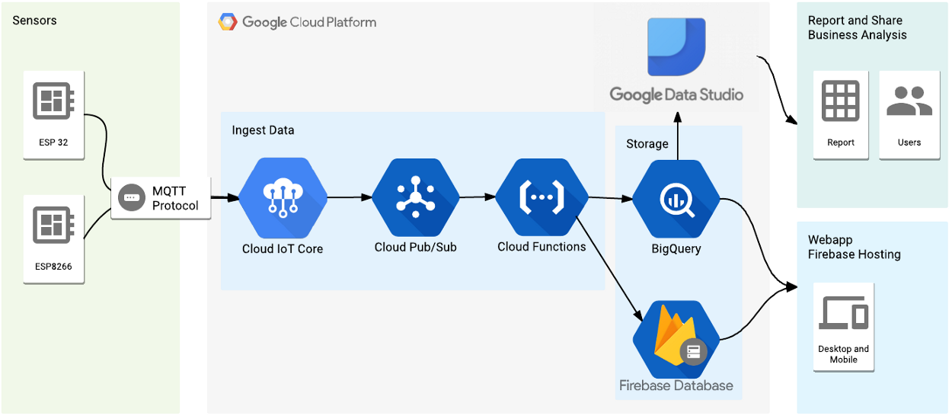

Figure Weather station by Google cloud Platform Source (Viebrantz,2018)

The image shows whether system that connects different sensors and computer system along with cloud platform.

## BOSCH

Bosch is a company originated in German working in IT industry. In the recent time Bosch has developed a cloud platform which can compete against Amazon Cloud and Microsoft Azure (Palmer, 2018).

Unlike other platform Bosch focus more on safety and security as well as their integration is much more flexible offering both open standards and open source. According to the CEO of Bosch this integration makes them full-service provider, delivering both connectivity and internet of things (Asthana, 2018).

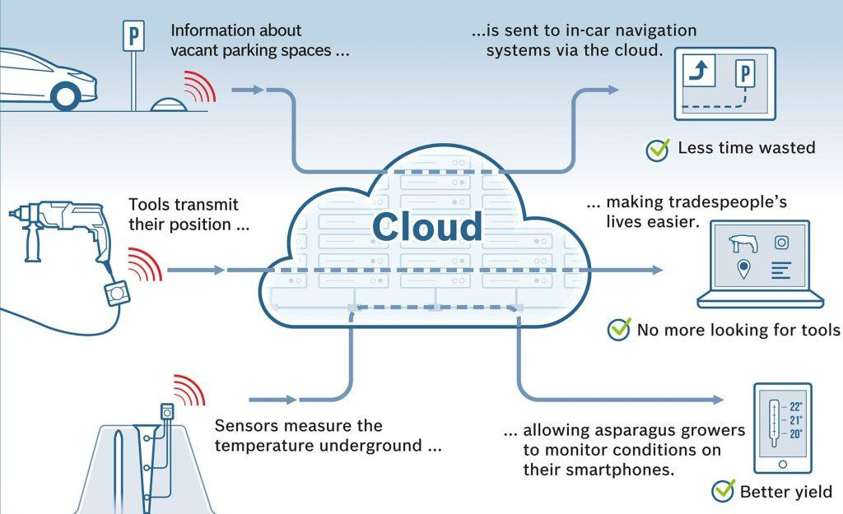

Figure Finding empty parking spaces using Bosch Cloud

The above image shows an example of integration of cloud computing and IoT to find an empty car park. Everything is connected to each other through cloud creating a cluster which makes whole system complete and ultimately saving time as well as fuels of cars.

The pricing of Bosch is simple as well. It depends upon the usages of an application or device the higher the amount of data the higher the price user must pay.

# Conclusion

In conclusion, the report stated all the criteria required for successful integration of cloud.

Report provided articles summary which are used for successful integration of cloud over heath care systems. Report provided challenges faced by current cloud service providers and cloud integration. Challenges application and scopes are also provided based on which models are defined. Also, for successful integration how to avoid those challenges are provide in this report. Furthermore, cloud current and modern technology integration methodology is explained. Also, how future can be change including cloud as service is defined into report. Case study is also provide based on integration of services into different platforms. If cloud challenges are reduced cloud can be proven a diamond in terms of services.

# Reference

Ahmed, S., Saqib, M., Adil, M., Ali, T. and Ishtiaq, A. 2018. Integration of Cloud Computing with Internet of Things and Wireless Body Area Network for Effective HealthCare. In: 2017 International Symposium on Wireless Systems and Networks IEEE, pp.1-5

Asthana, J. 2018. How Bosch is Soaring High with Internet of Things?. Newgenapps.com. 8 June. Viewed 7 September 2018. <https://www.newgenapps.com/blog/how-bosch-is-soaring-high-with-internet-of-things>

Atlam, H., Alenezi, A. and Alharthi, A. 2018. Integration of Cloud Computing with Internet of Things: Challenges and Open Issues. In: 2017 IEEE International Conference on Internet of Things (iThings) and IEEE Green Computing and Communications (GreenCom) and IEEE Cyber, Physical and Social Computing (CPSCom) and IEEE Smart Data (SmartData). pp.1-6

Botta, A., de Donato, W., Persico, V. and Pescape, A. 2015. Integration of Cloud Computing and Internet of Things: a Survey. Future Generation Computer Systems.

El-Sayed, H., Sankar, S., Prasad, M., Puthal, D., Gupta, A., Mohanty, M. and Lin, C. 2018. Edge of Things: The Big Picture on the Integration of Edge, IoT and the Cloud in a Distributed Computing Environment. IEEE Access, vol.6. pp.1706-1717.

Gupta, R. and Garg, R. 2018. Mobile Applications Modelling and Security Handling in Cloud-Centric Internet of Things. IEEE Access. pp.285-289.

Kebande, V., Karie, N. and Venter, H. 2017. Cloud-Centric Framework for isolating Big data as forensic evidence from IoT infrastructures. In: 2017 1st International Conference on Next Generation Computing Applications (NextComp). IEEE, pp.54-60

Palmer, S. 2018. 10 Best Internet of Things (IoT) Cloud Platforms - DevTeam.Space. Viewed 7 September 2018. <https://www.devteam.space/blog/10-best-internet-of-things-iot-cloud-platforms/>

Rajeswari, S., Suthendran, K. and Rajakumar, K. 2018. A smart agricultural model by integrating IoT, mobile and cloud-based big data analytics. In: 2017 International Conference on Intelligent Computing and Control (I2C2). pp.1-5

Renner, T., Kliem, A. and Kao, O. 2015. The Device Cloud - Applying Cloud Computing Concepts to the Internet of Things. In: 2014 IEEE 11th Intl Conf on Ubiquitous Intelligence and Computing and 2014 IEEE 11th Intl Conf on Autonomic and Trusted Computing and 2014 IEEE 14th Intl Conf on Scalable Computing and Communications and Its Associated Workshops. pp.396 - 401.

Sharma, A., Goya, T., Pilli, E., Mazumdar, A., Govil, M. and Joshi, R. 2016. A Secure Hybrid Cloud Enabled architecture for Internet of Things. In: 2015 IEEE 2nd World Forum on Internet of Things (WF-IoT). pp.5-8.

Soni, P. 2017. Linkdin. 20 March. Viewed 6 Sep. 2018. <https://www.linkedin.com/pulse/integration-cloud-computing-internet-things-iot-overview-pinakin-soni>

ThingLabs.io. 2018. Azure IoT Connected Weather Station. Viewed 7 September 2018. <http://thinglabs.io/azure/>

Vibrantz, A.2018. Build a Weather Station using Google Cloud IoT Core and MongooseOS.15 October. Viewed 7 September 2018. <https://medium.com/google-cloud/build-a-weather-station-using-google-cloud-iot-core-and-mongooseos-7a78b69822c5>

Villari, M. et al., 2016. Osmotic Computing: A New Paradigm for Edge/Cloud Integration. Cloud Computing, IEEE, 3(6), pp.76–83.