**ADITYA GAURAV (13BCE0471)**

**RISHABH AGARWAL (13BCE0)**

|  |
| --- |
|  |
| Online Book Database |
|  |

**ABSTRACT**

As the heading suggests the project is an online database of an online book store. The user will be able to add and modify the database, which will denote the books available with the service provider.The available bookstores can also be seen by the user.

The user has the means to see the books by a specific author.

The books of different isbn code will be displayed differently.

**INTRODUCTION**

A database is a collection of related data. Eg. Library ( Book, Member, journal) database, Railway Reservation (Train, station, passenger, ticket) database.A Database Management System is software or a set of programs which can create and manipulate the database. Eg. Oracle, Db2, Sybase, and Informix are some commercial DBMSs.Railway Reservation System, Library Management System, Online quiz, Stock Management System are some of the DBMS applications which are developed using any commercial DBMS.For developing a DBMS application collection, analysis and design of schemas at different level is important.

DESIGN PHASES

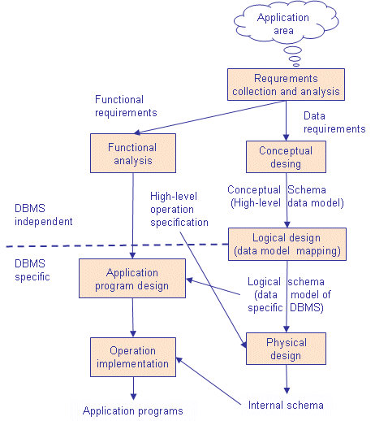**ANALYSIS**

**DATA COLLECTION AND ANALYSIS**

The data will be obtained in two ways:-

1)Initial Database by the developers

2)Books entered by the users

Since the Application was object oriented, entities were object oriented.

**FUNCTIONAL ANALYSIS**

The project is an online book database. The user will be able to add and modify the database, which will denote the books available with the service provider.

The modules used

1)Book Insertion

2)Author Details

3)Stores

**DESIGN**

BACK END DESIGN:

CONCEPTUAL SCHEMA DESIGN:

**THE ER DIAGRAM**

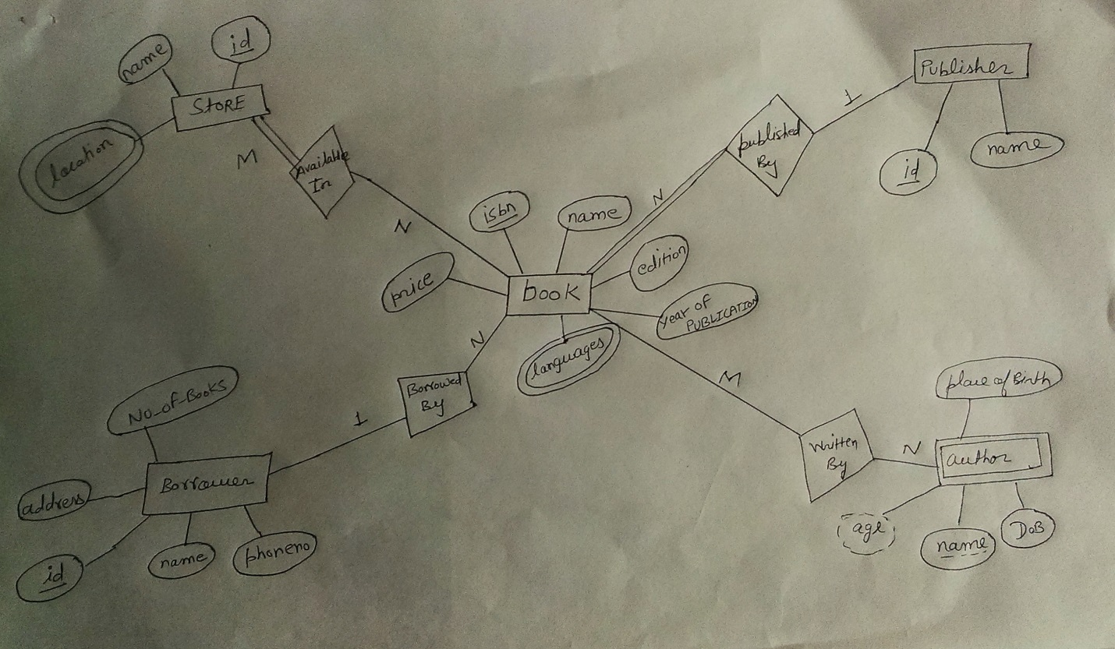

**LOGICAL SCHEMA DESIGN** <2nd Hand Online Book Database> -RELATIONAL SCHEMA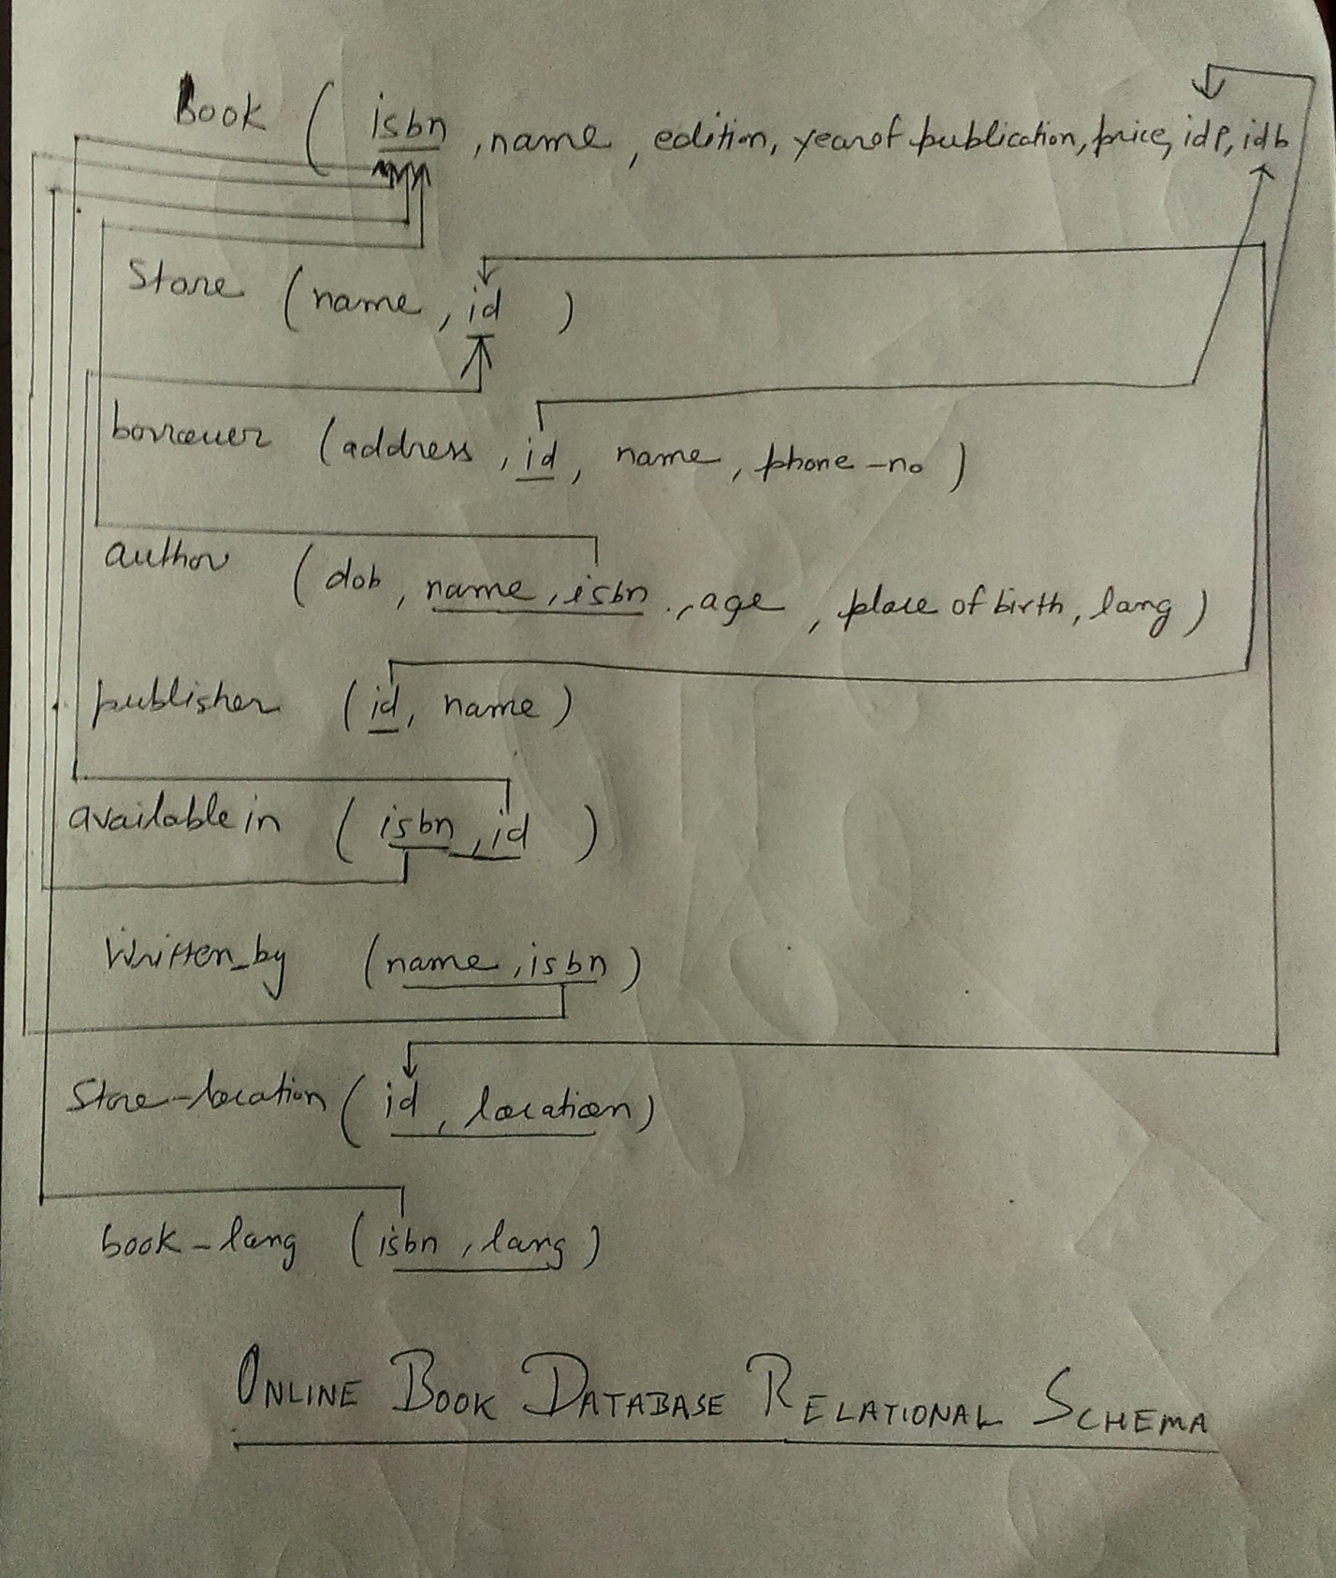

THE RELATIONAL SCHEMA DIAGRAM

**BACK END IMPLEMENTATION**

Give the complete create table (with whatever constraints you have created) and insert commands and snapshot of the tables.

**The table is :-**

create table book(name varchar(20),isbn varchar(20),edition number(10),year_of_pub number(4),price double(5,2),idbrw varchar(10),idpub varchar(10,constraint primary key(isbn),constraint foreign key(idbrw) references borrower(id),constraint foreign key(idp) references publisher(id));

create table borrower(name varhcar(20),address varchar(20),id varchar(20),phone number(10),constraint primary key(id));

create table publisher(name varchar(20),id number(1),constraint primary key(id));

create table store(name varchar(20),id number(10).constraint primary key(id));

create table author(name varchar(20),dob date,isbn varchar(20),place_of_birth varchar(20),constraint foreign key(isbn) references book(isbn) on delete cascade,constraint primary key(isbn,name));

create table store_loc(id number(1),location varchar(20),constraint primary key(id,location),constraint foreign key(id)references store(id) on delete cascade);

create table written_by(name varchar(20),isbn varchar(20),constraint primary key(name,isbn),constraint foreign key(isbn) references book(isbn) on delete cascade);

create table available_in(isbn varchar(20), id number(1),constraint primary key(isbn,id),constraint foreign key(isbn)references book(isbn) on delete cascade,constraint foreign key(id) references store(id) on delete cascade);

create table book_lang(isbn varchar(20), language varchar(10),constraint primary key(isbn,lang),constraint foreign key references book(isbn) on delete cascade);

**Commands & Snapshots**

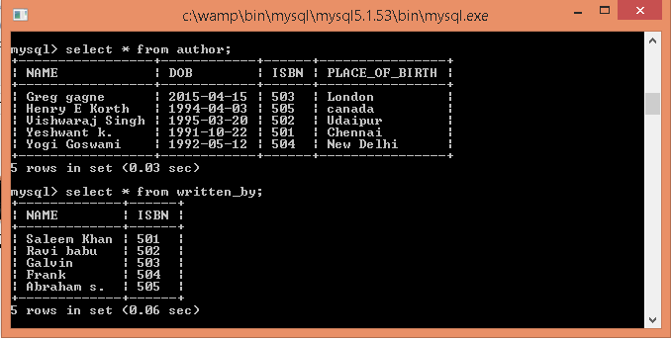

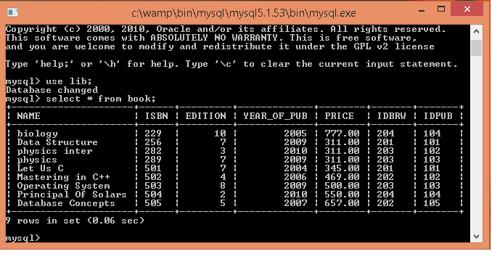

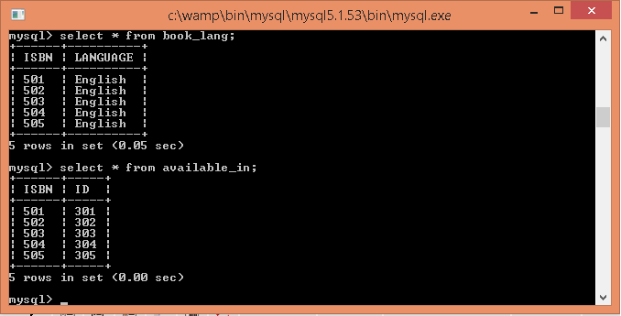

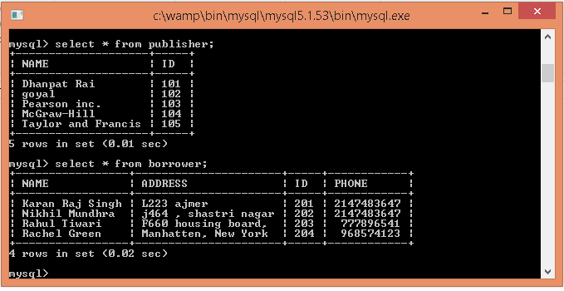

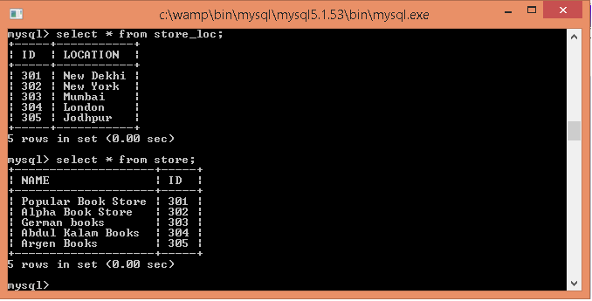



**DESIGN**

**APPLICATION PROGRAM DESIGN**:

SOFTWARE USED: < PHP and HTML>

<HTML> :Write a paragraph about the language and the important tags used and their general syntax.

<Javascript> : Write about the scripting language and the functions used for validation.

<Java> : Write about the programming Language and explain the JDBC statements

<PHP>: Same as Java

**FRONT END IMPLEMENTATION**

Give a brief description about each form. And a snapshot of the form.

Below is the homepage of the 2nd hand book database. It has the search option, author search & function to add books.

Below is the update page. Books can be added through it.



Below is the book search result page.

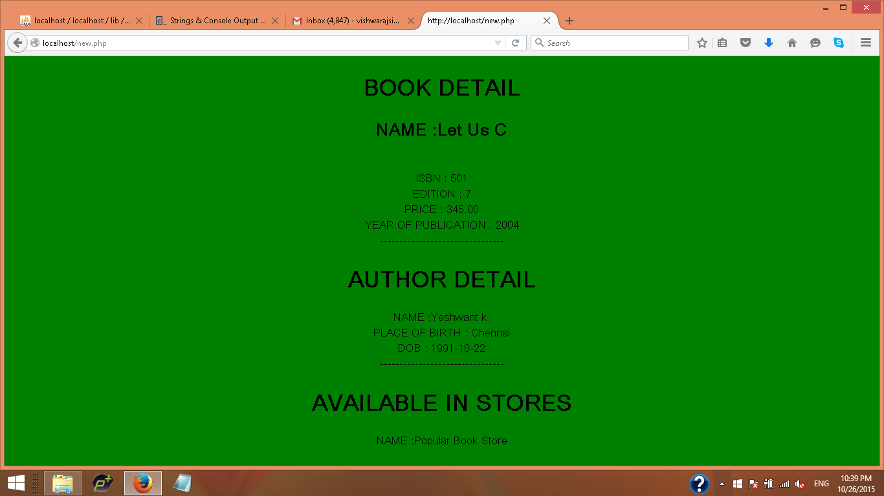

Below is the author search result page.

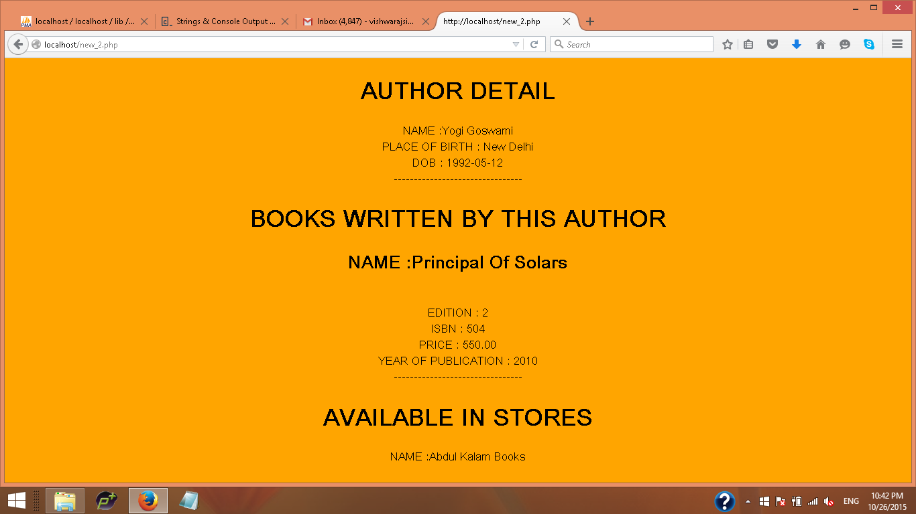

**CONCLUSION**

Second Hand market is a huge market. If used properly this can mark as a change which organizes this platform and brings in a change which revolutionizes it.

The data will be obtained in two ways:-

1)Initial Database by the developers

2)Books entered by the users

Though there is considerable risk in this idea, with proper risk management strategy, one can prevent those risks.

**APPENDIX**

**GENERAL SQL COMMANDS**:

Give the syntax for create table, with constraints, alter commands , desc, select, insert,update,delete

CREATE TABLE<tablename>(<column name 1><datatype>, column name 2><datatype> constraint <constraint name1> primary key(<column name1>) constraint<constraint name2> foreign key(<column name2>) references <tablename2>(<column name1>);

Alter Table<tablename> add (<column name><datatype>)

INSERT INTO <tablename> VALUES(val1,val2….);

SELECT* FROM <tablename>

Update<tablename>SET<col>=<new values>;

Delete FROM<tablename>;

**QUERIES USED IN PROJECT**:

CREATE TABLE BOOK(NAME VARCHAR(20),ISBN VARCHAR(20),EDITION NUMBER(10),YEAR_OF_PUB NUMBER(4),PRICE DOUBLE(5,2),IDBRW VARCHAR(10),IDPUB VARCHAR(10,CONSTRAINT PRIMARY KEY(ISBN),CONSTRAINT FOREIGN KEY(IDBRW) REFERENCES BORROWER(ID),CONSTRAINT FOREIGN KEY(IDP) REFERENCES PUBLISHER(ID));

CREATE TABLE BORROWER(NAME VARHCAR(20),ADDRESS VARCHAR(20),ID VARCHAR(20),PHONE NUMBER(10),CONSTRAINT PRIMARY KEY(ID));

CREATE TABLE PUBLISHER(NAME VARCHAR(20),ID NUMBER(1),CONSTRAINT PRIMARY KEY(ID));

CREATE TABLE STORE(NAME VARCHAR(20),ID NUMBER(10).CONSTRAINT PRIMARY KEY(ID));

CREATE TABLE AUTHOR(NAME VARCHAR(20),DOB DATE,ISBN VARCHAR(20),PLACE_OF_BIRTH VARCHAR(20),CONSTRAINT FOREIGN KEY(ISBN) REFERENCES BOOK(ISBN) ON DELETE CASCADE,CONSTRAINT PRIMARY KEY(ISBN,NAME));

CREATE TABLE STORE_LOC(ID NUMBER(1),LOCATION VARCHAR(20),CONSTRAINT PRIMARY KEY(ID,LOCATION),CONSTRAINT FOREIGN KEY(ID)REFERENCES STORE(ID) ON DELETE CASCADE);

CREATE TABLE WRITTEN_BY(NAME VARCHAR(20),ISBN VARCHAR(20),CONSTRAINT PRIMARY KEY(NAME,ISBN),CONSTRAINT FOREIGN KEY(ISBN) REFERENCES BOOK(ISBN) ON DELETE CASCADE);

CREATE TABLE AVAILABLE_IN(ISBN VARCHAR(20), ID NUMBER(1),CONSTRAINT PRIMARY KEY(ISBN,ID),CONSTRAINT FOREIGN KEY(ISBN)REFERENCES BOOK(ISBN) ON DELETE CASCADE,CONSTRAINT FOREIGN KEY(ID) REFERENCES STORE(ID) ON DELETE CASCADE);

CREATE TABLE BOOK_LANG(ISBN VARCHAR(20), LANGUAGE VARCHAR(10),CONSTRAINT PRIMARY KEY(ISBN,LANG),CONSTRAINT FOREIGN KEY REFERENCES BOOK(ISBN) ON DELETE CASCADE);

**CONNECTIVITY CODES ARE GIVEN IN THE PHP FILES.**

