Q1

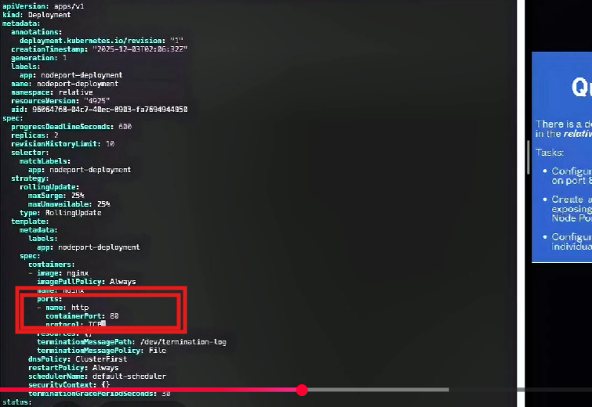
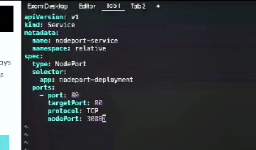

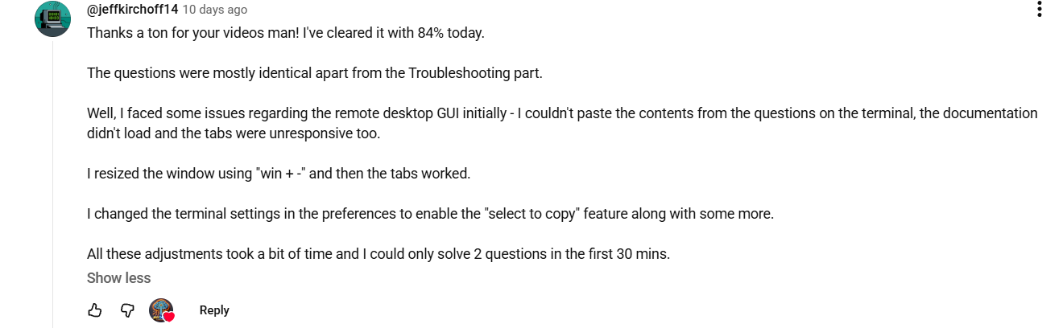

I did my exam, and had a small variant, after the curl testing, the last part needs to make the config map immutable. How to do this? copy the current cm again, and add the immutable true? or we should patch it?

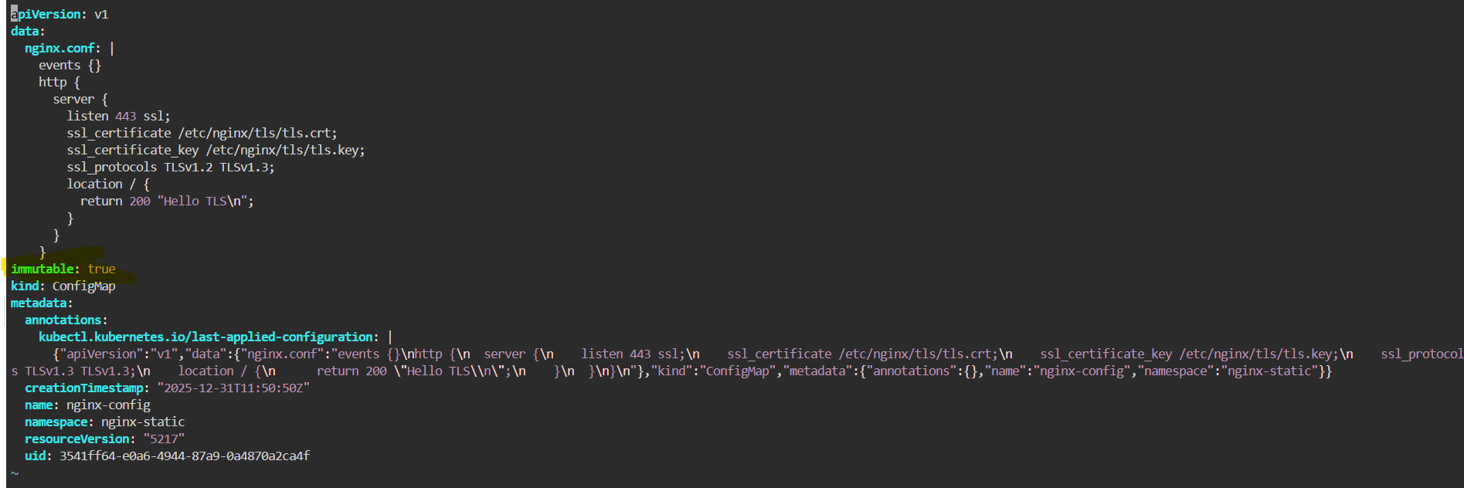

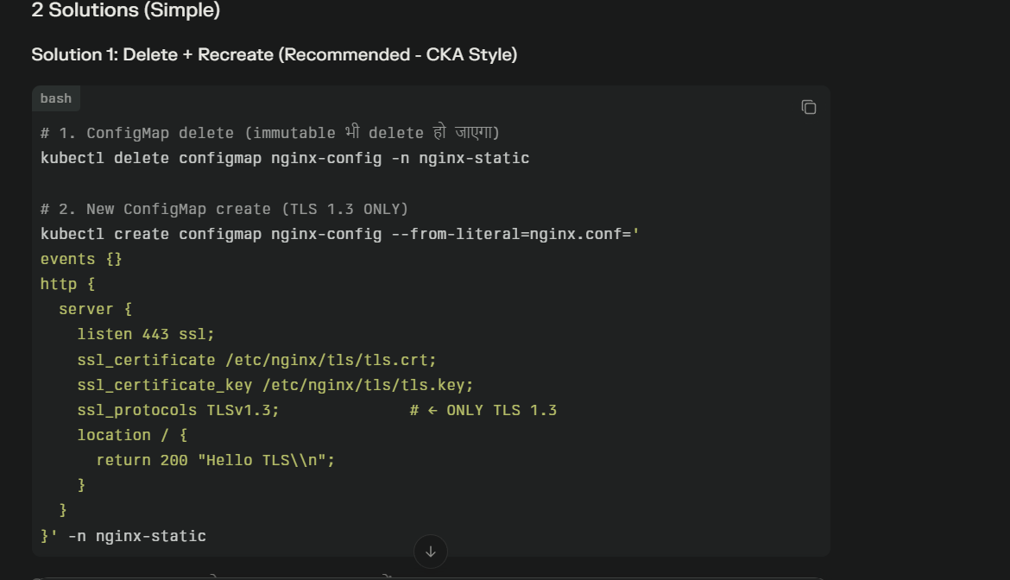

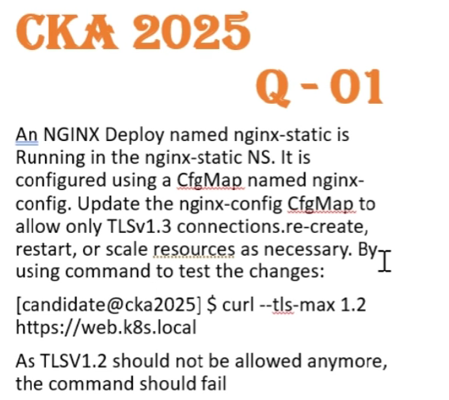

ConfigMap = NGINX के configuration files store करता है
TLS = HTTPS encryption के लिए security settings

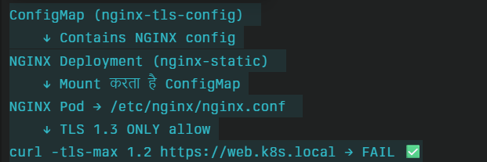

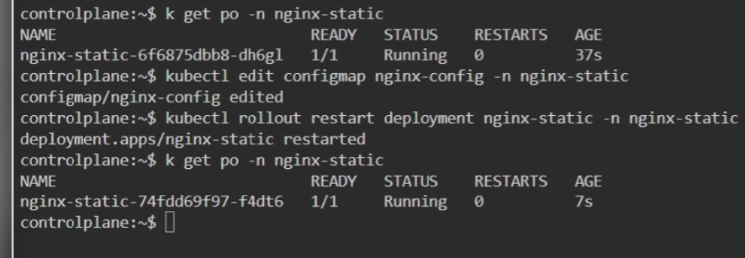

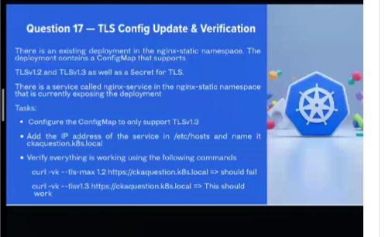
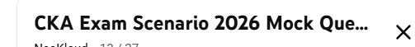

Solve a Real CKA Exam 2025 Question | Mock Q16 – CRD Explained

Need to add svc ip in /etc/hosts as well
curl --tls-max 1.3 https://web.k8s.local
curl --tls-max 1.2 https://web.k8s.local
https://www.youtube.com/watch?v=5RjiUBt1I30&list=PLvOcEsRqg0tKO1znOiZN5fhdAY2DCTvFY&index=13
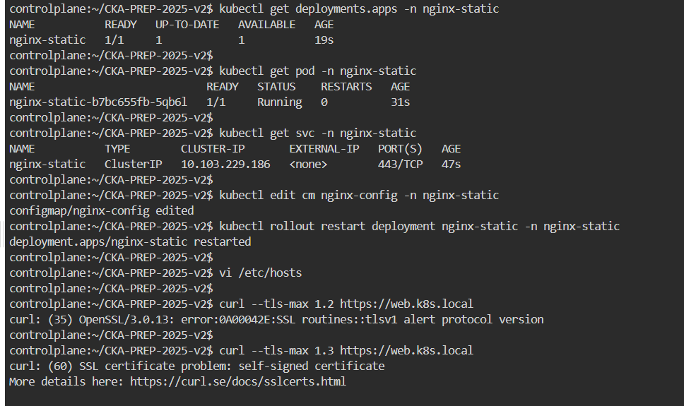

Q2
https://www.youtube.com/watch?v=RNVyopiwDGY&list=PLvOcEsRqg0tKO1znOiZN5fhdAY2DCTvFY&index=15
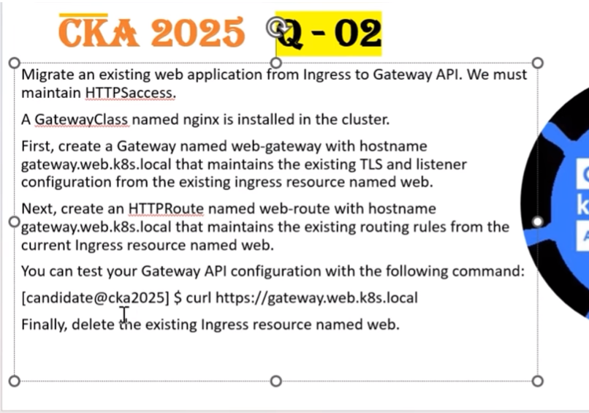
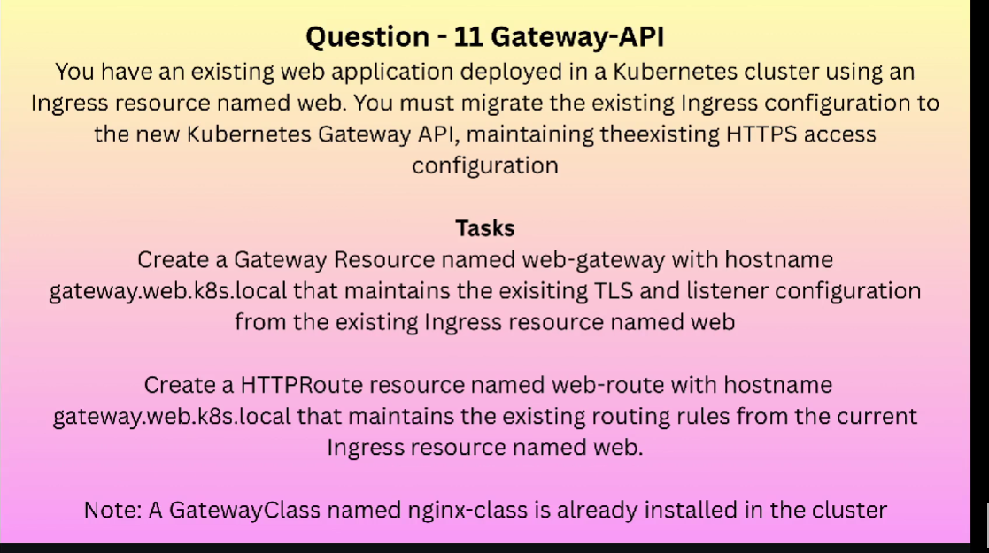

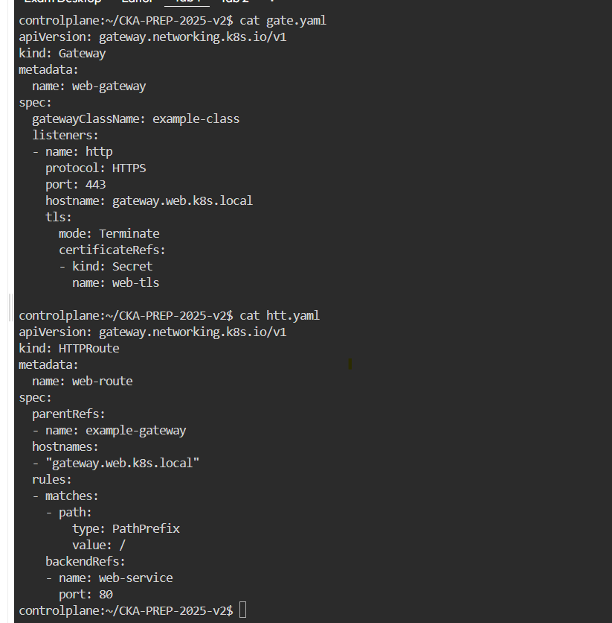
kubectl describe crd gateways.gateway.networking.k8s.io

Q3

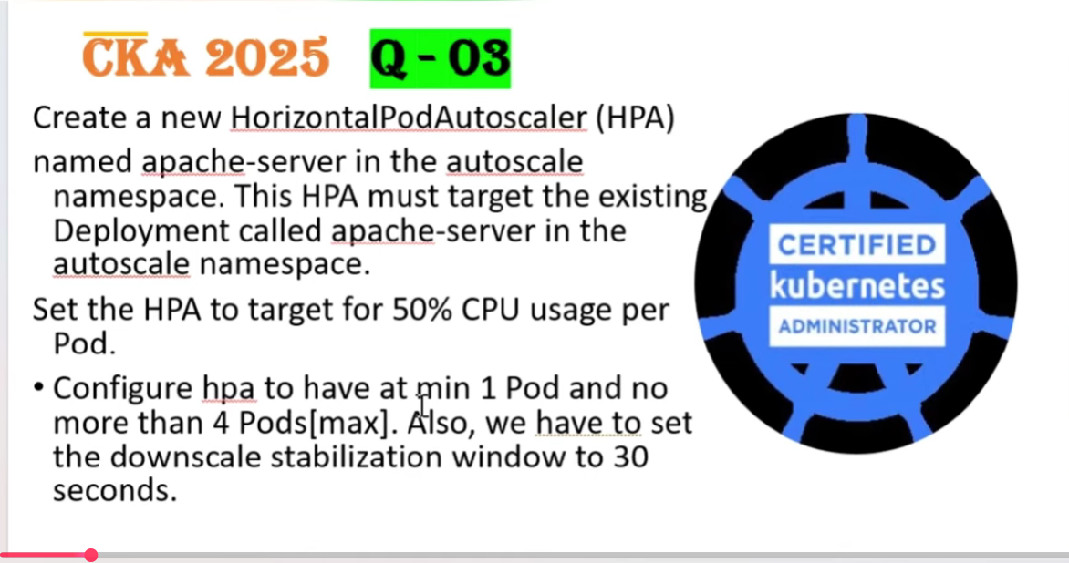

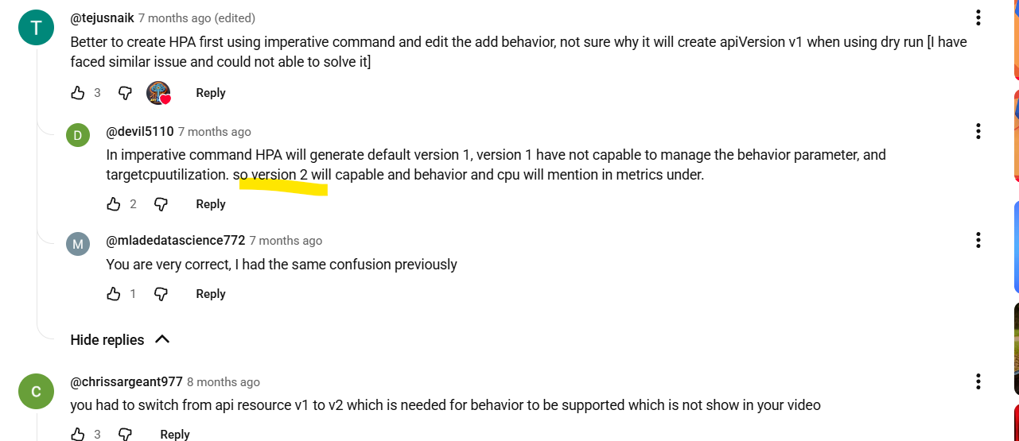

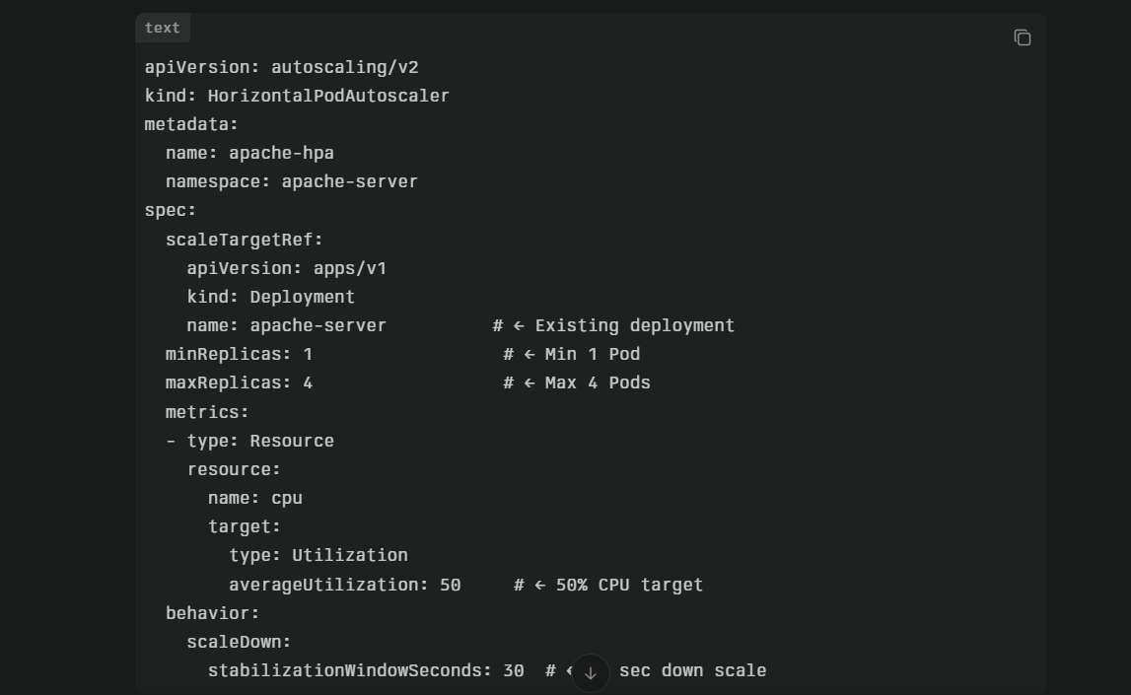

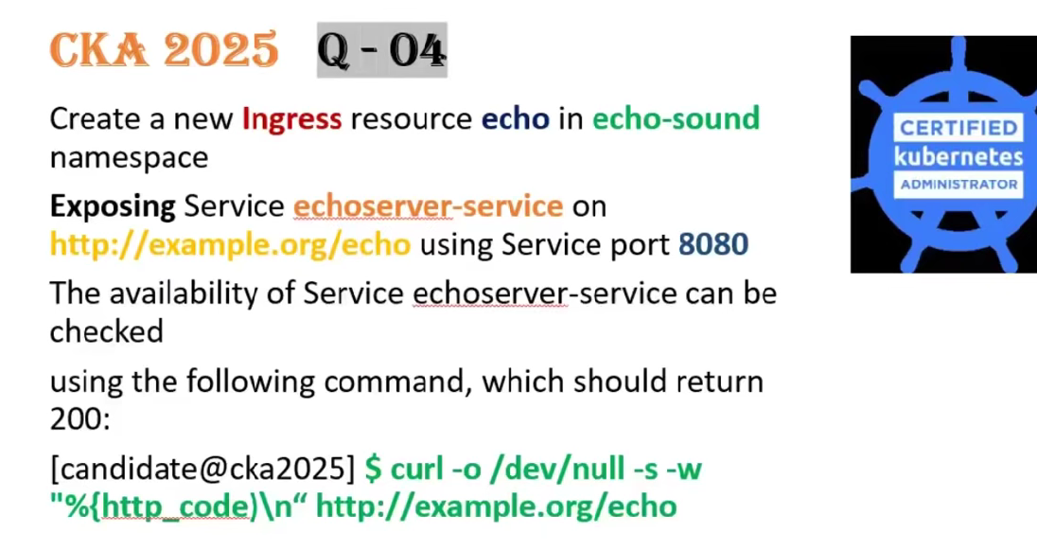
kubectl expose deployment echo -n echo-sound --port=8080 --target-port=8080 --type=NodePort --name=echo

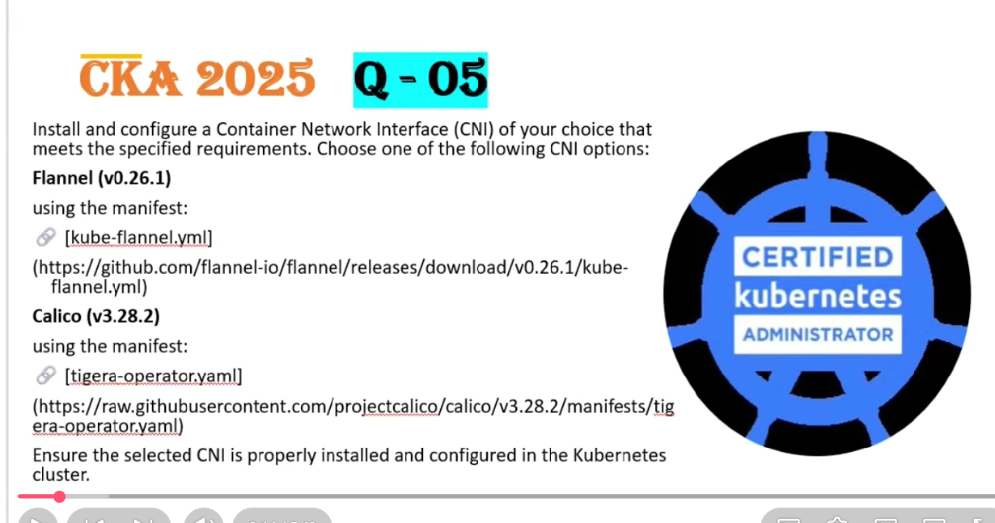

Etcd
journalctl -u kubelet -f
Pod stuck ContainerCreating | journalctl -u kubelet -f | grep pod-name
CNI install fail | journalctl -u kubelet -f | grep calico
NodeNotReady | journalctl -u kubelet -f | grep NotReady
ImagePullBackOff | journalctl -u kubelet -f | grep image

/etc/kubernetes/manifests$ vi kube-apiserver.yaml (need to change in apiserver)

sudo systemctl status kubelet
sudo systemctl restart kubelet
sudo systemctl status kubelet
127.0.0.1:2379

TLS:
http://youtube.com/watch?v=rFH2WBzAV78

