**How to use Qualcomm Flash Image Loader (QFIL)**

This is a step-by-step guide on how to use Qualcomm Flash Image Loader (QFIL) to flash stock rom / firmware to Qualcomm smartphones and tablets. QPST contains this and other tools. QFIL is chip-specific so it will only work on Qualcomm devices, not Mediatek, Spreadtrum, Intel etc.

Requirements

* Download and Install [Qualcomm USB drivers](https://forum.hovatek.com/thread-16965.html)
* [Firmware  / stock rom](https://forum.hovatek.com/forum-89.html) you wish to flash
* Download [QPST](https://forum.hovatek.com/thread-22467.html) and install
* Boot the device into [Emergency Download Mode / EDL Mode](https://forum.hovatek.com/thread-21791.html) (hold volume up + down button while off)
* PC
* USB cable

This guide will explain how to boot Qualcomm chipset devices into Emergency Download (EDL) Mode. EDL enables you read or flash a Qualcomm Android phone's stock rom.

Method 1: Button Combo

* Power off the phone
* Hold both Volume Up and Down buttons (don't release)
* Connect the phone to a PC via a USB cord while still holding both volume buttons

Method 2: ADB Method

* Setup [ADB](https://forum.hovatek.com/thread-588.html)
* Enable [USB Debugging](https://forum.hovatek.com/thread-10109.html) on the phone
* Launch ADB and run the following commands

adb devices  
adb reboot edl

The phone should boot into EDL Mode. You can verify by checking device manager for an entry like QHSUB_BULK or Qualcomm HS-USB QDLoader 9008 (if you have installed drivers)  
  
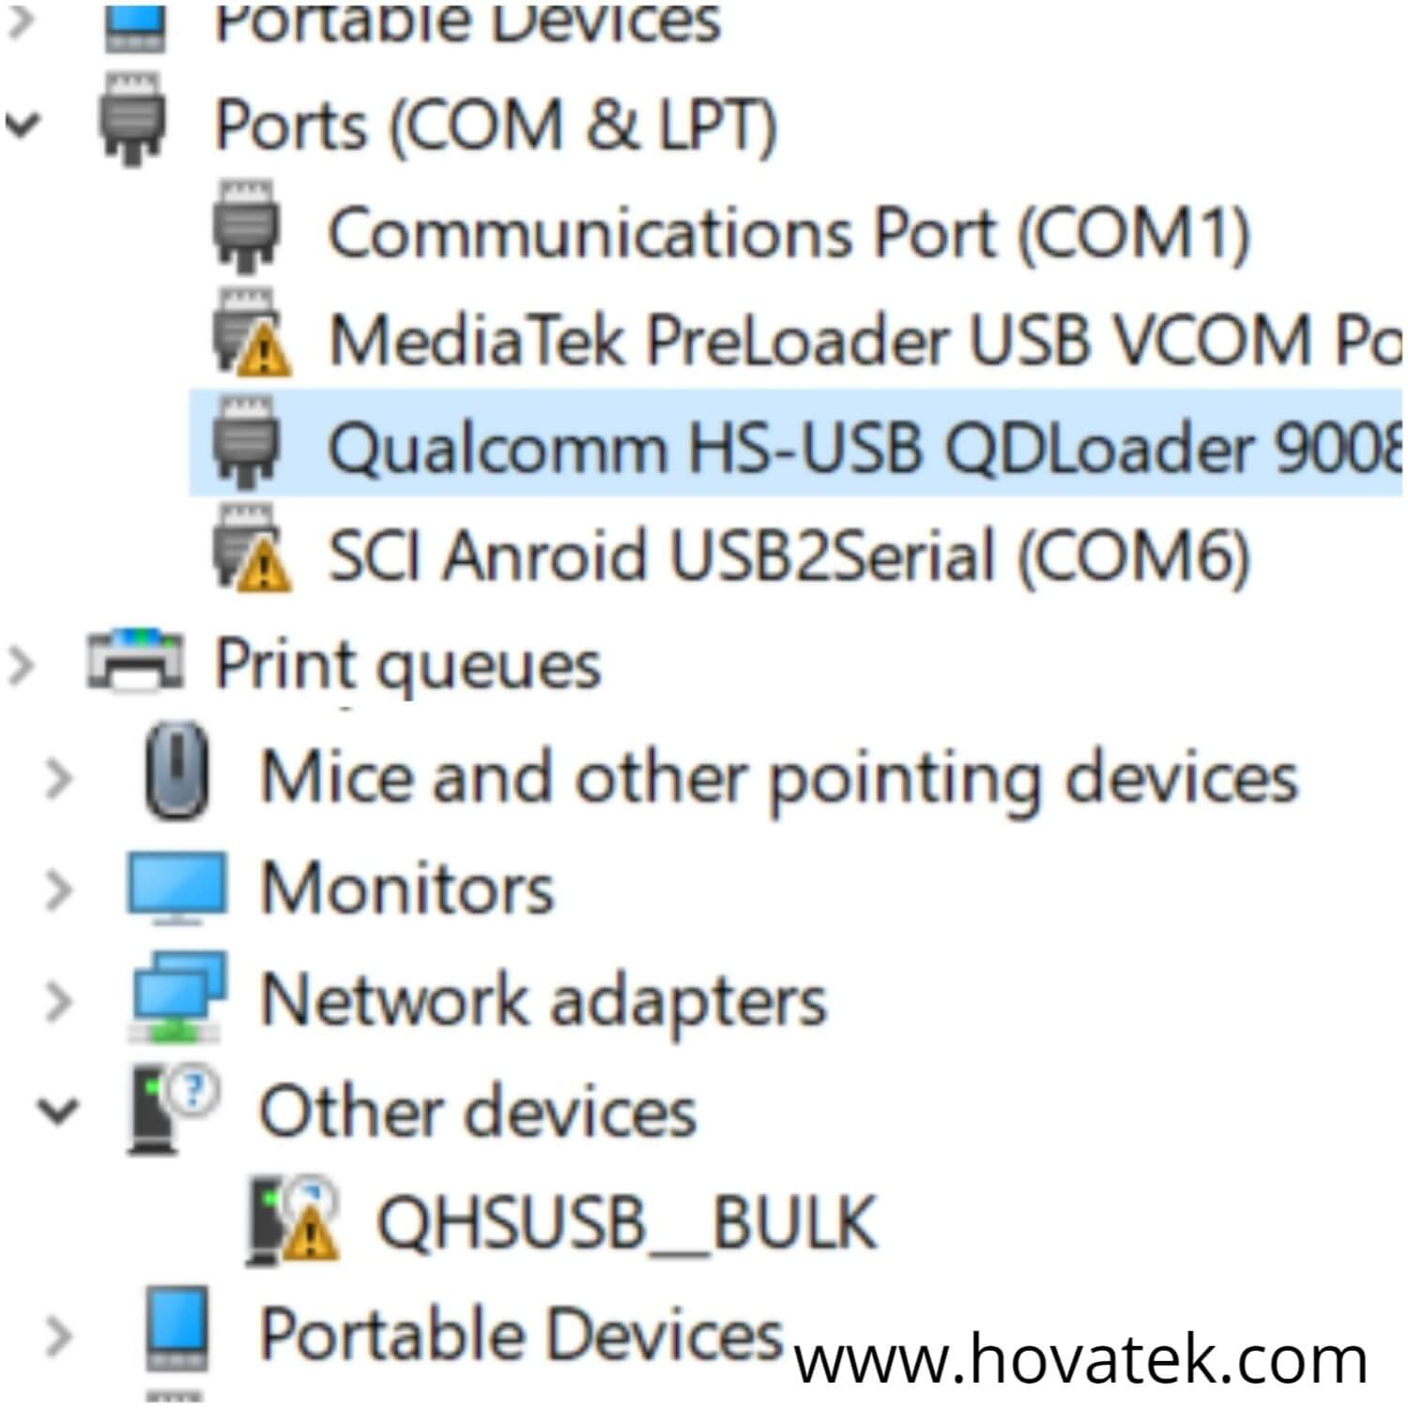

## **How to use QFIL**

See the video tutorial below or at <https://youtu.be/W9Cz4LwAzLg>

1. Launch QFIL  
     
   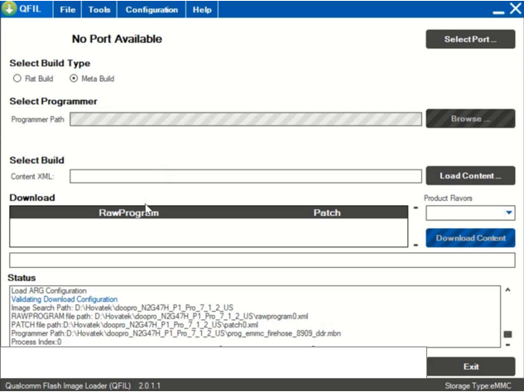
2. Connect the device to the PC while in EDL Mode (device should be in EDL before connecting to pc). No Port Available should change to Qualcomm HS-USB QDLoader 9008   
     
   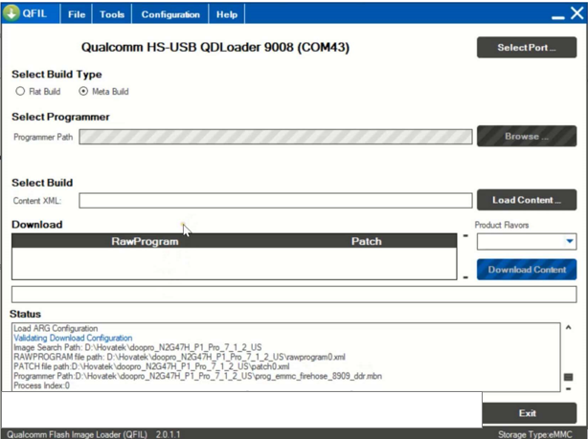
3. Under Select Build Type, tick Flat Build  
     
   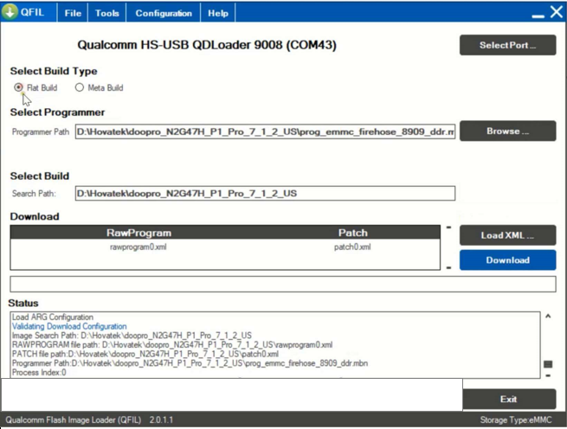
4. In "PROGRAMMER PATH" click Browse and go to the folder named Images and In the Window that pops up, select .mbn file (usually named prog_emmc_firehose_****.mbn)  
   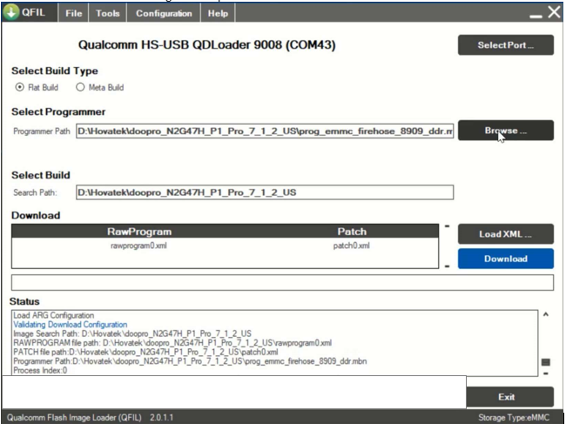
5. As soon as the MBN file is selected, Select Build will automatically select the Update or Stock ROM.  
     
   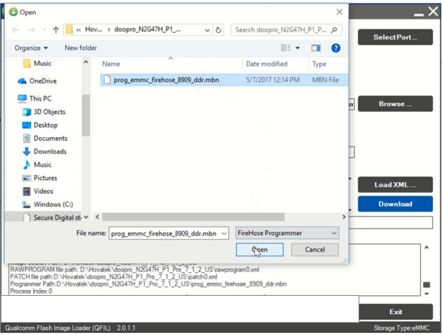
6. Click Load XML  
     
   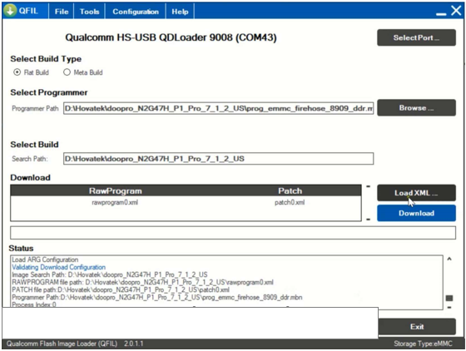
7. In the Window that pops up, highlight the rawprogram() file then click Open
8. Load XML comes with two option:

a- rawprogram_unsparse_without_qcn.xml : On choosing this file, data will not be lost.

b- rawprogram_unsparse.xml : Will lose RF Calibration data, IMEI and WiFi/Bluetooth Address.  
  
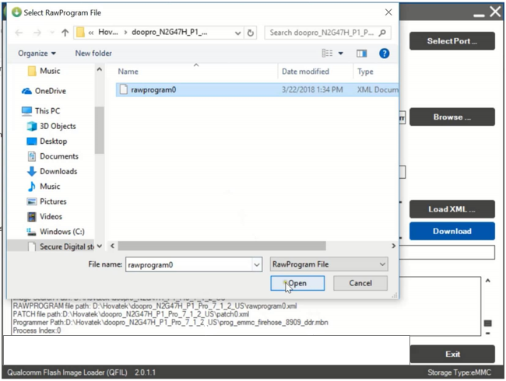

1. Another Window will automatically pop up, highlight the patch() file then click Open  
     
   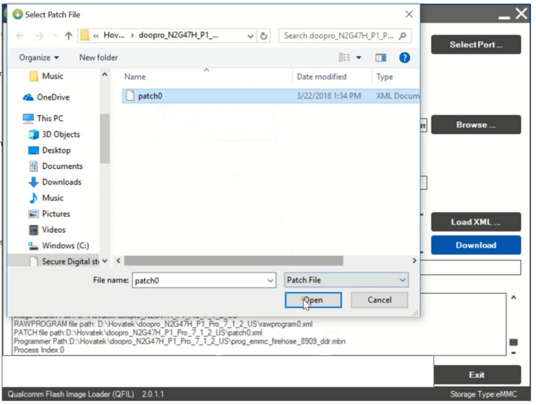
2. Click Download  
     
   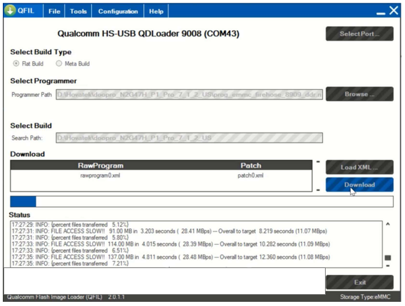
3. QFIL should start flashing the firmware, Do Not interrupt
4. You should get Download Succeed Finish Download once QFIL has successfully flashed the firmware. Disconnect the device and boot up  
     
   