**QCN BACKUP**

Connect the Device to the PC. Once the Device got detected in the PC……

Open IMEI_QRF_Customer_Service_Writer_V1.0_20180119

Open **Qualcomm Writer.exe**

Select the below two check boxes and uncheck all the remaining check boxes as shown in the below pic.

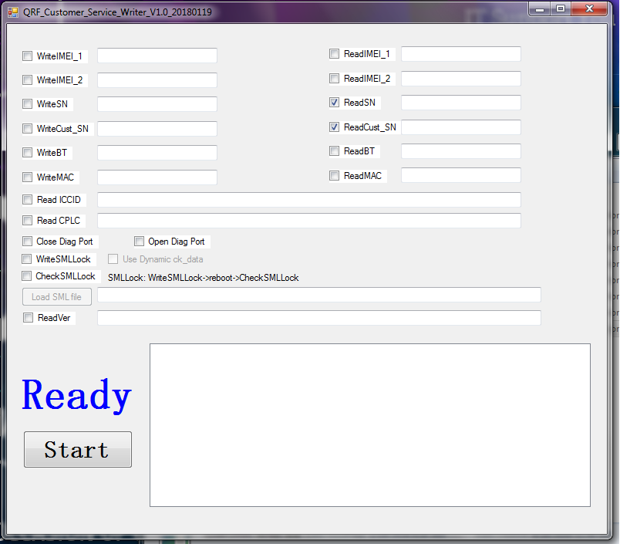

Click on READY to get the Read SN and Read CUST_SN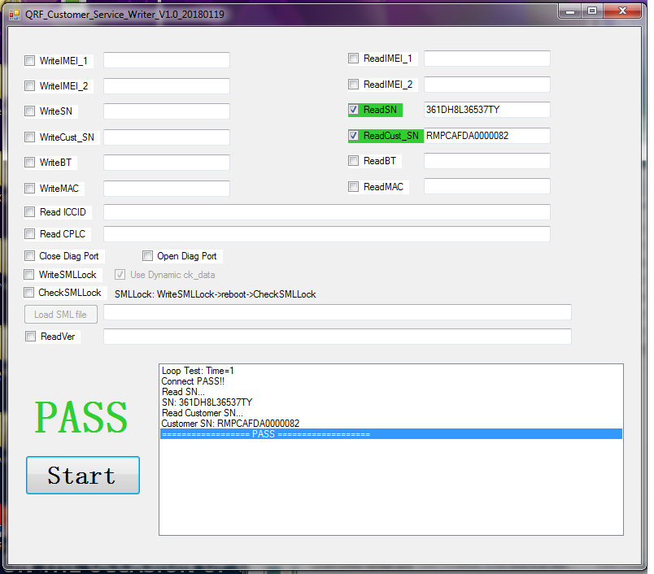

Open **SPC.exe**

Enter the Read SN and Read CUST_SN (we just got from the IMEI_QRF_Customer_Service_Writer_V1.0_20180119)

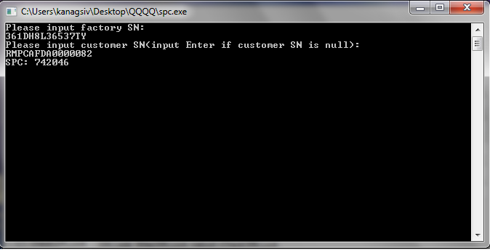

Now Open QPST tool.

Go to Start clients🡪 Select Software Downloads.

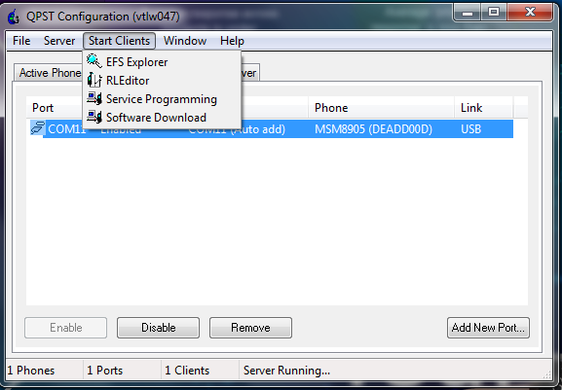

Select Back up as shown below and enter the SPC code which we get from the SPC.exe and click on START to get the Back up of the QCN.

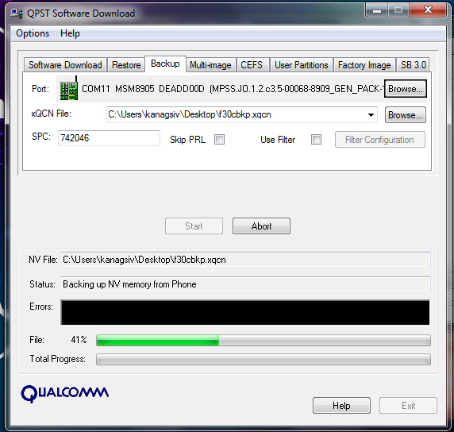

**Restoring the QCN**

Now load the QCN file which we have taken earlier.

Open QPST

Go to Start clients🡪 Select Software Downloads.

Select Restore as shown below and Select Browse and select the QCN file (which we have taken the Back up earlier) click on START to get to flash the QCN.

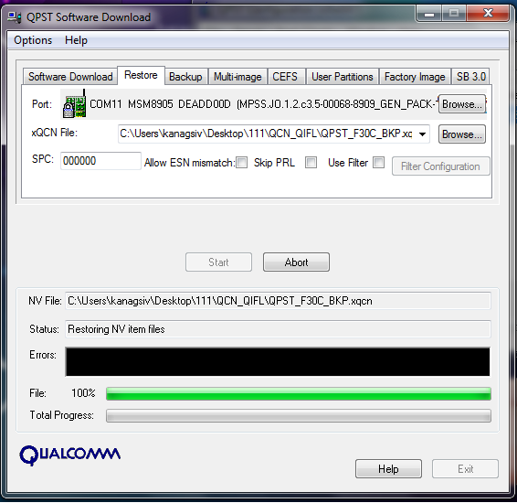

Once QCN flashing has been done, Device reboots automatically.

Insert SIM card and Boot the device.

DUT should display signal bars in the Notification bar.

Now the device is ready to start work.